CVEN9723 Group Assignment
Grand Challenges and Emerging Opportunities for the Australian Construction Industry
Case study: Parramatta Light Rail, Stage 1

Executive summary
Parramatta Light Rail Stage 1 is a twelve kilometre, sixteen stop line that connects Westmead to Carlingford via Parramatta CBD and Camellia. It commenced passenger services on 20 December 2024 after an intensive period of testing and commissioning. The project has been positioned by the NSW Government as a core enabler of integrated transport and precinct renewal in Greater Parramatta. This report identifies four interrelated challenge domains that shaped the delivery and entry into service of Stage 1, namely systems integration and safety assurance, brownfield utilities and contaminated land interfaces, multi party governance and procurement, and community access and business continuity along constrained urban corridors. It explains the root causes and the coupling between these domains, compares practices from other Australian light rail programs and international delivery models, and proposes an opportunity roadmap that is immediately transferable to Stage 2 and similar urban rail projects. The analysis is grounded in government sources, audit material, and contemporary industry guidance, and it is accompanied by original diagrams and a synthesis table to support an engineering-standard narrative. (Transport for New South Wales)

1. Introduction and case overview
Stage 1 of Parramatta Light Rail runs between Westmead and Carlingford with sixteen stops along a double track alignment of approximately twelve kilometres. The line links health, education, employment, and civic destinations across the corridor and forms part of a long term city-shaping strategy for Western Sydney. Official sources indicate that Stage 1 opened for passenger services on 20 December 2024 following completion of the test and trial programme, which was preceded by a short pause earlier in December due to discovery of faulty electrical components during energisation and testing. The programme now progresses toward Stage 2 planning and enabling works to extend the network to Sydney Olympic Park, which will connect communities north and south of the Parramatta River and further integrate the region’s transport and land use outcomes. (Transport for New South Wales)

2. Identification of the main challenges
A structured evidence review and case familiarisation identified four principal challenge domains for Stage 1. First, systems integration and safety assurance required coordination of rollingstock, signalling, traction power, communications, platform systems, and depot operations across a tight commissioning schedule. Interface maturity and configuration control are central risks in such programmes, and the temporary testing halt in December 2024 illustrates how a single non-compliant component can cascade through the verification plan. Second, brownfield utilities and contamination in corridors such as Camellia and along established arterials introduced design instability and resequencing, because undocumented assets, restricted access windows, and remediation requirements can force geometry changes and late design revisions. Third, multi party governance and procurement across agencies, road managers, utility owners, and councils amplified transaction costs and created exposure to scope drift and variations, which is consistent with lessons documented in NSW Auditor-General material on light rail and with national rail procurement guidance that warns against attempting to transfer unpriceable uncertainty to contractors. Fourth, community access and business continuity required careful traffic and staging strategies to maintain trade, pedestrian movement, and accessibility in dense centres, otherwise social licence risks compound and further constrain delivery. (ABC)

3. Root causes and intrinsic connections
The root causes of integration issues are typical of complex rail systems. Late discovery of non-compliant components, gaps in configuration management, and sequencing mismatches between fixed systems and rollingstock can arrest progress across multiple disciplines at once. Brownfield uncertainty originates from the age and documentation quality of underground services, the need for remediation of industrial land, and the alignment’s proximity to sensitive receptors and constrained work windows. Governance friction emerges when accountability is fragmented and approvals are layered, which elongates decision cycles and elevates the likelihood of contractual claims. Community impact is inseparable from the other domains because traffic management, detours, and access arrangements must adapt to design and programme change. These domains are not independent. A utility clash can prompt track or stop geometry change, which reopens signalling design and test procedures, which in turn triggers new approvals, hours-of-work constraints, and community access revisions. That loop is then reflected commercially through variations and claims. The systems diagram in Figure 1 depicts these couplings in an abstracted way that is generic to brownfield urban rail programmes.
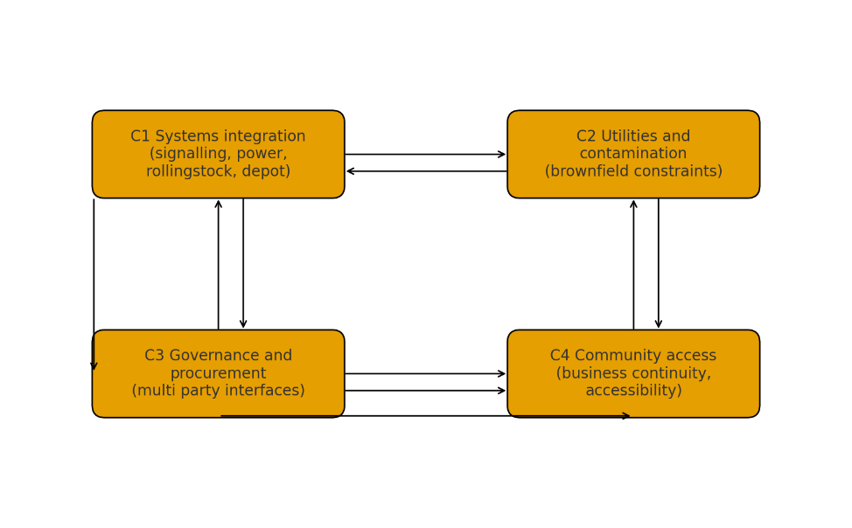
Figure 1: Interconnection of challenge domains, conceptual diagram

4. Best practice review, local and international
Australian experience offers transferable practices. In Canberra, a sustained benefits realisation approach emphasised alignment between operations and land use, which supports a corridor view of performance rather than a narrow transport-only lens. On the Gold Coast, staged delivery and a structured sustainability governance approach created clear interfaces with the city’s place outcomes and supported continuity between stages. Both programs highlight the value of benefits tracking, precinct activation, and consistent stakeholder messaging. International and cross-sector literature on alliancing and relationship-based delivery provides further lessons for high uncertainty packages. When latent conditions and interface density are significant, heavier reliance on joint risk registers, pain share and gain share mechanisms, and delegated approvals inside an alliance board can allow decisions to keep pace with field discoveries, which traditional fixed price contracts often struggle to accommodate. For the Parramatta context, these practices are most relevant for utility corridors, heritage interfaces, and complex intersections. (Australasian Railway Association)

5. Emerging opportunities and future development
There is an immediate opportunity to formalise a digital assurance and test readiness playbook that requires component provenance checks, factory acceptance traceability, and hardware-in-the-loop simulation before energisation. Such a playbook, coupled with a corridor level digital twin, would reduce the chance of late defect discovery and smooth the step from dynamic testing to trial running and passenger service. Relationship-based commercial packaging should be targeted to the uncertainty hotspots identified during constructability review. Alliancing for utility relocation subsections and early contractor involvement for complex intersections would better match risk to the party most able to manage it and would accelerate approvals by aligning governance around a single joint board. Place management should be treated as a delivery performance target rather than a communications footnote. Funding of activation measures tied to real time access and footfall metrics would protect local businesses and help sustain social licence during prolonged works. Finally, a benefits dashboard that draws on real time patronage and dwell time data would provide a feedback loop between service plans, stop design, and Stage 2 scope refinement, which is consistent with the Government’s current planning and enabling works position for the extension to Sydney Olympic Park. (NSW Government)

6. Synthesis table
The following table consolidates the challenge taxonomy, typical root causes, indicative treatments, and expected benefits as an engineering reference for Stage 2 planning and for other Australian light rail projects.
Domain | Typical root causes | Indicative treatments | Expected benefits
Systems integration and safety assurance | Late non-compliance, weak configuration control, sequencing mismatches between rollingstock and fixed systems | Digital twin, hardware-in-the-loop testing, configuration management board with formal traceability gates | Fewer late defects, smoother energisation, more reliable trial running
Brownfield utilities and contamination | Unmapped or aged assets, remediation requirements, restricted access windows | Early contractor involvement, alliancing for relocation hotspots, shared contingency and joint risk register with utilities | Faster decisions, reduced claims, stable work sequencing
Multi party governance and procurement | Fragmented accountability, layered approvals, unpriceable uncertainty | Relationship-based commercial models, delegated approvals in a joint board, clear interface control documents | Shorter decision cycles, improved productivity, fewer disputes
Community access and business continuity | Lane closures, detours, constrained kerbside access, sensitive precincts | Place-based staging, activation funding linked to access metrics, live dashboards for pedestrians and traffic | Maintained trade, stronger social licence, reduced political risk

7. Recommendations
The delivery authority should adopt a structured integration assurance regime that places digital simulation and component traceability ahead of on track energisation. Packages with high uncertainty should be repackaged under alliancing or early contractor involvement so that risk is shared and managed by the parties closest to the workface. A place-based construction access framework with activation funding and clear accessibility metrics should be used to protect local businesses and vulnerable users during extended works. A benefits realisation office should be established to track mode share, travel time, and economic indicators and to feed those data into service planning and Stage 2 design. Finally, a lessons-learned compendium should be published that covers test halts, defect discovery, and mitigations, so that insights are transferred across NSW light rail programs.

8. Conclusion
Parramatta Light Rail Stage 1 demonstrates the value of a corridor-scale approach to transport in a rapidly growing metropolitan centre. At the same time, it shows how complex systems integration, brownfield utilities, governance, and community access challenges can interact in ways that complicate delivery. By institutionalising digital assurance, using relationship-based delivery where uncertainty is intrinsic, and treating place management and benefits tracking as core delivery objectives, NSW can reduce risk and amplify outcomes for Stage 2 and for other Australian light rail programs.

References
ABC News 2024, Parramatta light rail opening delayed again after discovery of faulty components, 2 December, viewed 19 October 2025. (ABC)
Australasian Railway Association 2020, Best Practice Principles for Rail Construction Procurement, ARA, viewed 19 October 2025. (Australasian Railway Association)
Audit Office of New South Wales 2016, CBD and South East Light Rail Project, Audit Office of NSW, viewed 19 October 2025. (NSW Audit Office)
NSW Government 2025, Parramatta Light Rail Stage 1, NSW Government transport project page, viewed 19 October 2025. (NSW Government)
Transport for NSW 2025, Parramatta Light Rail project overview, Transport for NSW, reviewed 10 Feb 2025, viewed 19 October 2025. (Transport for New South Wales)
NSW Government 2025, Parramatta Light Rail Stage 2 factsheet, NSW Government, viewed 19 October 2025. (NSW Government)

