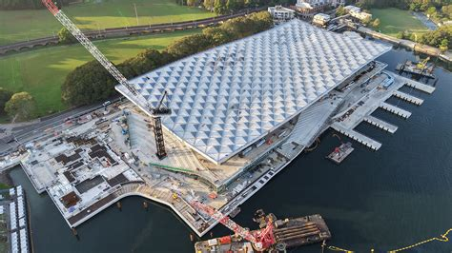

CVEN9723 Group Assignment
Grand Challenges and Emerging Opportunities for the Australian Construction Industry
Case study: New Sydney Fish Market, Blackwattle Bay

Project brief and intent
The New Sydney Fish Market is a major waterfront civic project built largely over water at the head of Blackwattle Bay. The building aims to be a working market, a public destination, and a piece of architecture that can stand comfortably in a city of icons. It must carry the daily rush of wholesalers and retailers before dawn, then pivot to a visitor experience that feels open, legible, and safe from morning to late night. It also has to behave like reliable infrastructure. Fish does not wait for missed deliveries. Ice does not make itself without power. Boats cannot queue without wharf discipline. Getting this building to work is as much about choreography as it is about concrete, steel, and timber.

Site, water, and structure
The site sits on the inner harbour, tight against Bridge Road and wrapped by a promenade that has to be open and generous on day one. The structure works like a stacked marine pier. A dense grid of piles carries the main floor plate and the edges of the terraces. Between the piles the bay continues to be water, which keeps the feeling of a building by the sea rather than a box dropped on reclaimed land. The deck acts as a diaphragm to push lateral loads into cores and walls, while the roof is light compared with the floor so that the centre of mass stays low and the building does not feel top heavy in wind.
The relationship between the piles, the cofferdam stages, and the seawall matters. Piles that carry the permanent building had to thread between temporary works, and each stage of excavation needed to resist uplift and seepage while still letting plant get close enough to drive the next row. The practical victory is not that the piles are strong. It is that the temporary works allowed predictable production rates that an urban schedule can live with.

A roof that behaves like sky
The roof looks complicated in photos, but the logic is simple. It is a large span canopy made from a grid of primary and secondary members with hundreds of faceted cassettes that bounce daylight deep into the plan and exhaust warm air to the high points. The triangles are not only decoration. They break up direct sun, reduce glare on wet surfaces, and carry a service layer above the ceiling line so that lighting, speakers, and sprinklers can be placed without fighting the structure. The canopy lifts at the harbour edge so that the building reads as an invitation from the water. At the city edge it dips to keep the scale friendly to Bridge Road.
The roof is the first thing visitors see from across the bay and the last thing crews see when they lock up after the auction. In warm weather the voids move air. In cool weather they hold it back. It is a passive device first, a sculptural one second.
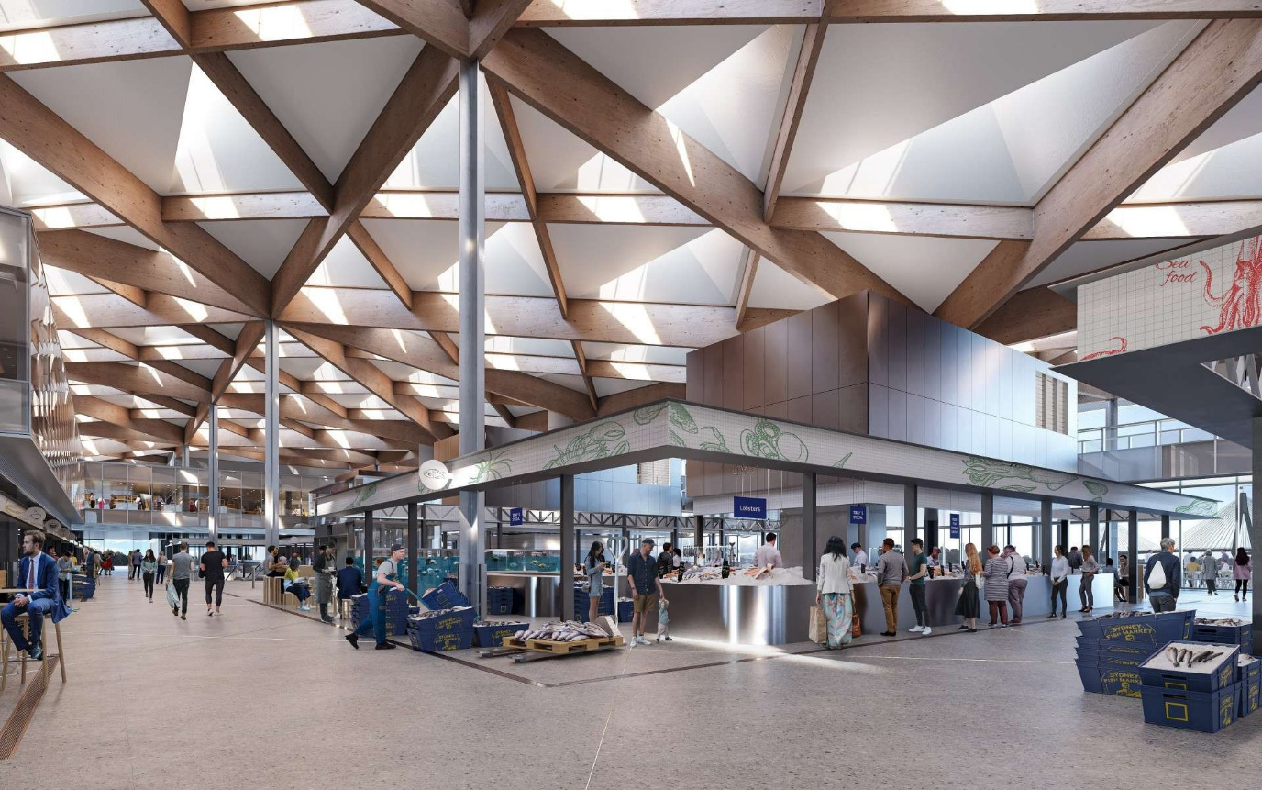

A working day from 2 am to midnight
The life of the market begins long before sunrise. Refrigerated trucks roll into loading docks while the city is quiet. Wholesalers receive, grade, and set out product for the auctions. Forklifts and pallet jacks move ice and cartons across marked lanes that should never cross with public routes. Security opens selected doors for staff only, and the building runs in a low-light mode that respects neighbours while giving workers safe visibility.
After sunrise the building shifts mood. Retailers and eateries draw power and water in predictable spikes. Waste, ice melt, and washdown water start to flow, and the back-of-house plant has to absorb all of it without drama. By mid-morning visitors arrive in numbers. The best hours are dense with people, steam, and camera phones. Late afternoon winds down wholesale traffic, and the terraces lean into hospitality. Evenings belong to the restaurants, to the water, and to the slow walk across the promenade that now connects places that used to be cut off.

Marine logistics and wharf choreography
Working boats need a wharf that does not lie to them. Fender lines must sit where the hulls expect them. Cleats need to be where deckhands reach without thinking. Lighting has to avoid blinding night vision. Waste oil and fuel spill kits must be visible, not hidden for aesthetics. The fish market lives or dies on the friction of that wharf edge. If the wharf is a pleasure to use, boats will run on time and trucks will meet them without blockages. If the wharf is clumsy, the rest of the building suffers. The project’s choice to keep a clear separation between working wharf and public terrace is the right one. Visitors want to be close to boats, but not so close that ropes and winches become hazards.

Cold chain without compromise
Ice, refrigeration, and air temperature are the real invisible architecture. The building has three cold worlds to keep separate. There is the wholesale cold world, the retail display cold world, and the back-of-house storage cold world. Moving product between them without warming it up is a design problem and an operational habit. Doors that seal well are part of it. So are fast roller shutters and ante-rooms that act like air locks. Layout matters most. When the shortest path from truck to slab cooler to display is also the safest path, the building supports good behaviour rather than relying on management to correct bad routes later.
Ice production and storage need redundancy and sensible distribution. Staff should not push heavy bins of ice across public aisles. That is tiring and wasteful. The design should let ice fall by gravity into the places it is needed most, and it should let melt water drain without pooling underfoot. The less attention people need to give to the basics, the more attention they can give to customers.

Water, waste, and smell
Markets can smell wonderful or awful depending on small details. Floor gradients that carry washdown water to the right drains make the difference between a crisp morning and a sticky afternoon. Traps and interceptors must be easy to service, placed where a worker with a wrench can actually reach them, and they must be sized for honest flows rather than optimistic ones. Fish waste needs a route that never crosses with inbound product. Bins must be sealed and picked up often. Chilled rooms for waste are not a luxury in a Sydney summer. They are a baseline.
Odour control should treat stairwells and lift lobbies as lungs, not as dead ends. Those vertical shafts either supply clean air or extract poor air. They cannot be neutral. When the air path is planned, the building smells like the sea and fried batter at the right times. When it is not, the building smells stale, and stale is what people remember.

A promenade that behaves like a street
The promenade is a piece of civic infrastructure. It carries families with prams, people with mobility aids, runners, tourists, and boat crews. It is a street without cars. The rule set is different to a shopping centre. Cyclists should be able to roll at a calm speed without conflict. Furniture must be robust and repairable. Shade trees and canopies need to make the summer walk feel shorter than it is. Wayfinding should be generous at the city edge where visitors decide which door to use. At the water, signs can relax because the path is obvious.
It is tempting to fit the promenade with art and landscaping until it looks complete. The better discipline is to leave space for events that the market will grow into. A laneway festival, a seafood school, and a seasonal night market all need room to expand without squeezing the daily trade.

Fire, life safety, and night mode
Public buildings over water demand a clear evacuation narrative. Staff need to know where to move crowds when the obvious direction is blocked. Ramps beat stairs for pushing wheelchairs. Bridges that jump over water have to be intuitive so that people follow them without a volunteer waving a flag. Sprinkler zones must consider the steam and oil of kitchens and the wet floors of fish halls. Extraction systems cannot send smoke where people are heading. Night mode safety needs fewer doors open and more staff near them. CCTV is helpful, but the feeling of safety comes from eyes on the floor, not dots on a monitor.

Noise, neighbours, and the 24-hour city
The market has to be a good neighbour or it will collect complaints that drain energy from the team. Forklift alarms, reversing trucks, and music from late trading can spread across water at night. Acoustic screens at dock lines, rubberised wheel choices for trolleys, and planned quiet hours are cheap wins that pay back. Plant noise on roofs needs baffles that do not create maintenance nightmares, and enclosures with doors wide enough for real repairs. If the design lets a mechanic remove a motor with a chain block and a trolley, noise can be fixed quickly. If an enclosure is too tight, a problem will stay a problem.

Digital operations without gimmicks
It is easy to promise a digital twin and hard to keep one useful. The market does not need a flashy dashboard as much as it needs dependable counters. How many people entered which door in the last hour. What is the median dwell time in the main hall on Sundays. How often do head counts hit a soft limit that should trigger staggered cleaning. Simple numbers drive calm decisions. Cold storage sensors should report trends rather than only alarms. Wharf bollards can carry simple load cells that report misuse. Waste rooms can have air quality sensors that warn before odour becomes a complaint. None of this needs to be visible to the public. It needs to be boring and accurate for staff.

Transport choice that feels natural
A building this popular will be judged on how people arrive. The market should make walking and public transport the lazy choice. That means clear footpaths from bus stops, legible connections to light rail and ferries, and bike parking that does not feel like an afterthought. Private car users will come, and the building should welcome them, but not at the expense of the water edge or the city edge. Pricing signals for on-street parking nearby and thoughtful delivery windows for trucks can smooth the daily peak without signage that shouts.

Vendor mix and public life
The best markets combine serious seafood with simple pleasures. There is a place for fresh fillets wrapped in paper and for eating on a bench with a view. There is also a place for a good espresso after a long shop. The ground plane should mix permanent stalls with seasonal pop-ups so that locals feel something new on repeat visits. The school program deserves a room with sinks, drains, hobs, and a view. Children remember cutting a lemon more than reading a poster. If the school teaches knife safety and basic fish prep, the market will build a new generation of confident buyers.

Climate, heat, and storms
Sydney warmth and humidity test patience and materials. The building must treat shade as infrastructure. Outdoor areas need enough depth that people can move seats without leaving shade. Misters and fans are fine for a hot week, not as a base plan. On the wet side, the bay will occasionally throw spray onto decks during nor’easters. Non-slip finishes should be chosen for how they behave five years out, not on day one. Stormwater should fall gracefully into the bay through visible chains and scuppers so that the public understands how water moves. Seeing water behave well makes people trust a waterfront.
Flood planning should assume that events will exceed design assumptions. That means a documented way to isolate power and protect plant with barriers and temporary pumps, and a way to bring it all back quickly. It also means putting irreplaceable things high and replaceable things low.

Commissioning and the first hundred days
The handover from builders to operators is when buildings live or flounder. The market’s first hundred days should focus on three rhythms. The first is a steady morning routine that sets the floors, the bins, the doors, and the docks in a predictable order. The second is a visitor rhythm that keeps aisles clear, keeps the promenade circulating, and keeps tables turning without pressure. The third is a night rhythm that closes with confidence and opens the next day without chasing yesterday’s problems.
A small on-site workshop with spares for pumps, rollers, latches, and sensors is worth more than any glossy manual. A daily stand-up that runs for ten minutes and names two wins and one fix will keep the culture constructive. A suggestion board for stallholders that actually gets read will surface issues before they find social media.

What success looks like
Success is not a ribbon cutting photo. It is a mid-week morning where boats unload without fuss, forklifts keep to their lanes, the auction finishes on time, and the first lattes are poured while the floor is still damp from a washdown that did not splash onto the public. It is a Friday night where the terraces are lively, the ramps are safe, and the air smells like salt and grills. It is a Sunday afternoon where families find seats in the shade, and staff still have energy to smile. If the market does that across seasons, the city will adopt it as part of daily life rather than a novelty to visit once a year.

