CVEN9723 Group Assignment
Grand Challenges and Emerging Opportunities in the Snowy 2.0 Pumped-Hydro Project
Prepared for: CVEN9723 Design of Construction Operations, Term 3, 2025

Executive summary
Snowy 2.0 is Australia’s largest renewable-storage project, designed to provide about 2.2 GW of fast-response capacity by linking the existing Tantangara and Talbingo reservoirs with roughly 27 km of tunnels and an underground power station. The current public schedule signals first power in the second half of 2027 and full commercial operation by December 2028 after a 2023 project reset. Costs have exceeded the earlier AUD 12 billion figure and the proponent has indicated that further funding will be required. These factors, together with challenging geology, safety events, and dependence on new transmission, make Snowy 2.0 a strong case study of grand challenges in Australian construction that interact across technical, commercial, governance and social dimensions. (Factor This™)
This report delivers:
- a concise introduction and identification of the main challenges,
- analysis of the causes and how the challenges connect,
- a review of local and international good practice for comparable works, and
- practical opportunities and an implementation roadmap for future development. These sections map directly to the assignment scope.

1. Introduction to the case project and main challenges

1.1 Project overview
Snowy 2.0 expands the original Snowy Scheme by cycling water between two storages at different elevations. Water is pumped uphill when electricity is cheap and abundant, then released through turbines to generate during peak demand. Storage duration is many hours to days, which complements batteries that usually deliver for a few hours. The delivery model places Snowy Hydro as the proponent, the Future Generation Joint Venture as the principal civil constructor for tunnels and caverns, and Transgrid as the transmission partner responsible for connection assets and the broader HumeLink augmentation. (Snowy Hydro)

1.2 Main challenges
The following challenges reoccur across project updates and independent reporting.
- Geotechnical variability and TBM stoppages. The headrace TBM Florence has faced soft ground and very hard, abrasive rock. At times it has been immobilised, which required specialist recovery and resequencing. (ABC)
- Cost escalation and financial uncertainty. Public information now points beyond the previously revised AUD 12 billion envelope, with a formal reassessment underway. (ABC)
- Schedule movement and productivity risk. Current official signals are first power in 2027 and all units by December 2028, subject to delivery risk. (Factor This™)
- Safety events and regulator intervention. Following a ventilation fan failure in February 2025, SafeWork NSW issued prohibition notices, and an independent review commenced. (NSW Government)
- Environmental and approvals complexity. Works occur in and near protected landscapes, which increases compliance and reduces flexibility for late changes. Independent environmental audits have been undertaken for the Snowy 2.0 connection. (LUMEA™)
- Grid integration dependencies. Value depends on timely commissioning of HumeLink and the dedicated connection works. HumeLink has received key planning approvals but delivery risk remains. (ABC)

Table 1. Summary of key challenges and likely project effects
Challenge | Likely effect on time | Likely effect on cost | Notes and sources
Ground variability and TBM stops | High | High | TBM immobilisation and recovery campaigns. (ABC)
Cost escalation signals | Medium to High | High | Funding requirements under reassessment. (ABC)
Safety incidents | High during stand-downs | Medium to High | Prohibition notices and restart conditions. (NSW Government)
Environmental constraints | Medium | Medium | Tighter method flexibility in sensitive areas. (LUMEA™)
Transmission dependency | Medium | Medium | Risk of stranded capacity if misaligned. (ABC)

2. Reasons for the problems and how they connect

2.1 Geology, tunnelling methods and stoppage cascades
Large-diameter TBMs rely on predictable ground. When rock strength, fracture patterns or groundwater conditions differ from the ground model, advance rates drop or the machine can seize. Recovery brings redesign, face pre-treatment, extra support and stand-down of crews and plant. Time lost underground also pushes back downstream activities such as cavern works and electromechanical fit-out. The Florence stoppages illustrate this cascade. (ABC)

2.2 Safety governance under pressure
Underground construction depends on robust ventilation, certified refuge chambers, alarms and trained evacuation. The 2025 fan incident triggered prohibition notices and a safety review. Events like this reduce workforce confidence, slow remobilisation and amplify delay. Figure 2 shows the services environment where such systems operate, which underlines why commissioning safety plant early is critical. (NSW Government)
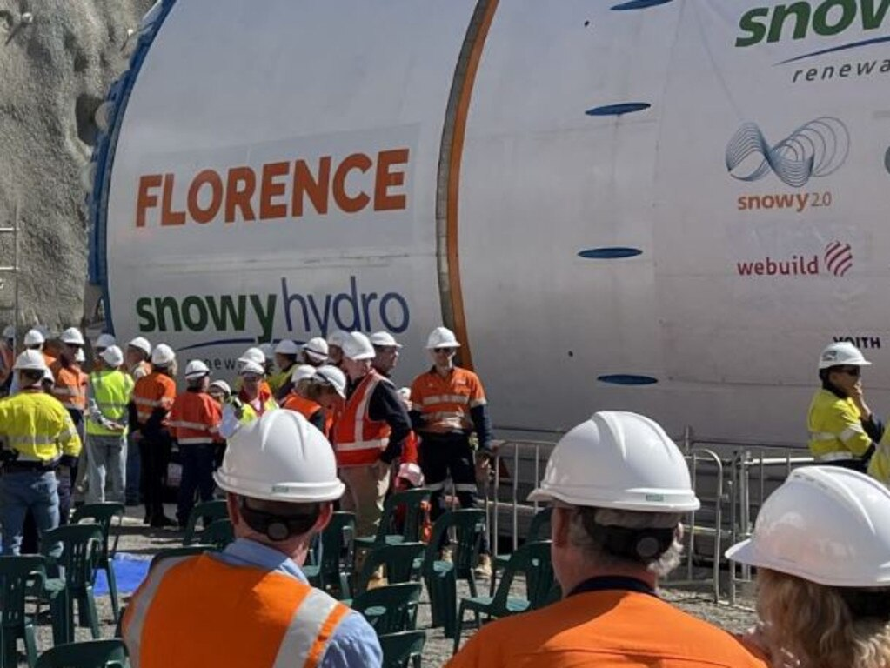
Figure 1. Florence TBM at portal during a workforce briefing. Source: news.com.au.

2.3 Environmental approvals and constructability
Construction across national park interfaces and state forest imposes strict conditions on access, spoil and corridors. While appropriate, these controls limit alignment changes and site moves once work is underway. The independent audit record for the Snowy 2.0 connection demonstrates the high level of oversight and reporting that teams must satisfy while maintaining throughput. (LUMEA™)

2.4 System-level dependency on transmission
Snowy 2.0 only captures full value if connection capacity is available. HumeLink and the Snowy 2.0 connection are critical. Figures 3 and 4 illustrate the spatial relationship. Programme misalignment can strand a generation asset or a line. Coordinated energisation planning reduces this risk. (ABC)

3. Review of good practice in similar projects

3.1 Early and staged ground characterisation
For high-risk geology, international practice is to front-load probe drilling and pilot headings, and to baseline pre-grouting or alternate method switches before the main drive reaches a hazard. This reduces immobilisation probability and shrinks the tail of the delay distribution. Applying this logic to planned segments would directly target the failure modes that have been observed.

3.2 Contracting for ground risk
Where subsurface variability dominates uncertainty, alliance or target-cost forms are routinely used so that client and contractor jointly manage change, share data and solve problems without adversarial claim cycles. Snowy 2.0’s cost reassessment underscores the value of transparent risk sharing that focuses the team on safe throughput. (Factor This™)

3.3 Safety plant as critical path work
Treat ventilation systems, refuge chambers and emergency drills as commissioning items with pass-fail gates embedded in the excavation programme. Production should not proceed unless safety systems meet specified performance and regulator sign-off is recorded. The 2025 incident shows that safety plant performance and production are inseparable. (NSW Government)

3.4 Bundled grid planning
Generation, storage and transmission are now a system package. European practice often bundles approvals and delivery milestones so that neither asset strand is stranded. HumeLink’s approvals are encouraging, however joint hold points, integrated testing windows and common calendars across the proponent and Transgrid will better protect the commercial case. (ABC)
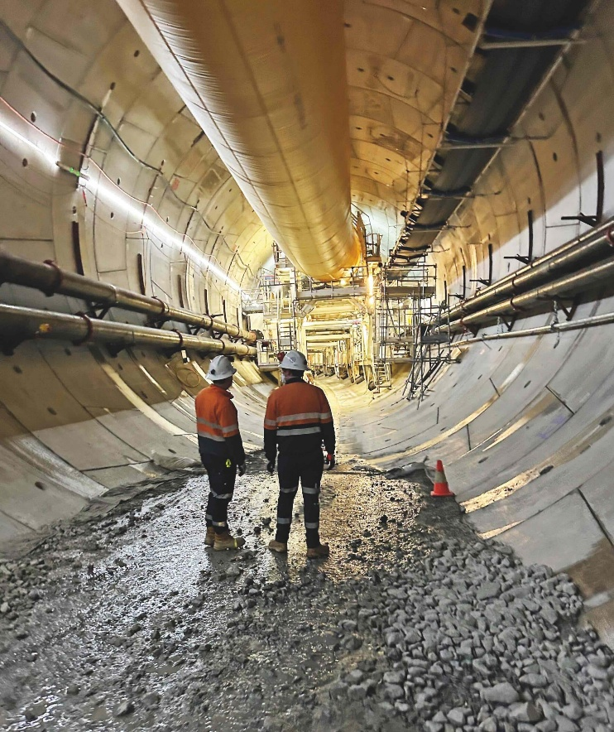
Figure 2. Inside a Snowy 2.0 tunnel with temporary services and ventilation. Source: Roads & Infrastructure.

Table 2. Good-practice crosswalk and application to Snowy 2.0
Theme | Typical elements | Application to this project
Staged ground model | Probing, pilot drives, change thresholds | Expand probing, hard-code triggers for pre-treatment and method switch
Collaborative contracting | Target cost, joint boards, shared risk register | Align incentives to P50 and safety metrics during reassessment
Safety as plant | Early procurement, acceptance tests, drills | Add regulator sign-off gates before sustained drives
Bundled transmission | Joint approvals and energisation plan | One integrated energisation plan with shared hold points

4. Emerging opportunities and future development

4.1 Building national capability
Snowy 2.0 is creating capability in long-tunnel excavation, underground caverns and high-voltage integration. This human capital will reduce risk in follow-on pumped-hydro projects, including mine-pit concepts that may require less tunnelling than Snowy 2.0.

4.2 Method innovation
For abrasive and variable lithologies, consider hybrid excavation, cutterhead changes or short drill-and-blast segments to bypass known hazards. These choices trade nominal advance rate for fewer long stoppages, which can improve overall programme certainty.

4.3 Integrated commissioning
Create a single commissioning plan across waterways, powerhouse, protection schemes and lines, with joint decision gates and agreed outage windows. This approach reduces stranded-asset risk at handover. (ABC)
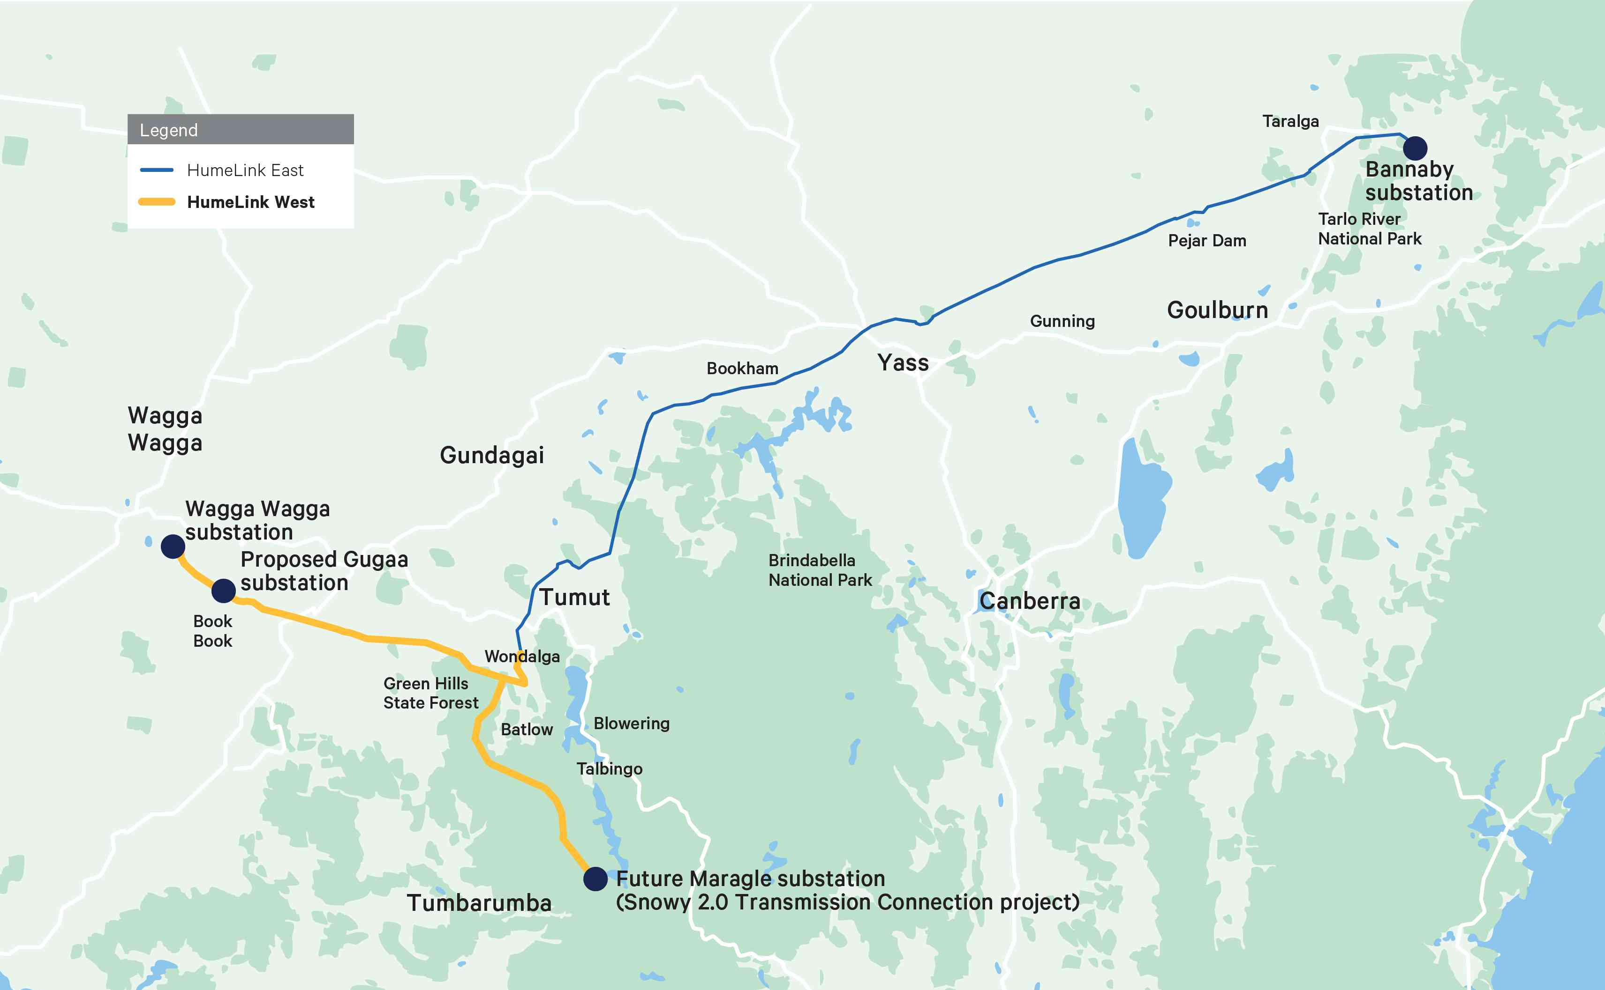
Figure 3. HumeLink West overview near Tumut that connects Snowy 2.0 to the grid. Source: Transgrid.

5. Implementation roadmap

Table 3. 90-day action plan focused on safe throughput
Priority | Action | Accountable | Outcome and measure
1 | Expand probe drilling ahead of remaining high-risk segments, with pre-grouting triggers | Ground risk board and JV | Fewer unplanned stoppages, report weekly
2 | Safety plant sprint for ventilation and refuge chambers, run drills prior to ramp-up | JV with SafeWork NSW oversight | Restart confidence, prohibition risks reduced (NSW Government)
3 | Integrated energisation plan with HumeLink and the connection project | Proponent and Transgrid | Aligned testing windows, no stranded capacity at COD (ABC)
4 | Commercial transparency during reassessment, align incentives to schedule and safety | Proponent and JV | Lower claim friction, clearer priorities (ABC)
5 | Public monthly dashboards with date ranges and uncertainty bands | Proponent | Credibility with stakeholders and workforce

6. Risk register

Table 4. Top risks, causes and mitigations
Risk | Cause | Consequence | Mitigation | Residual
TBM immobilisation | Hard, abrasive or weak ground | Long stoppages and resequencing | Staged probing, pre-treatment, hybrid methods | Medium (ABC)
Safety plant failure | Specification drift, maintenance gaps | Stand-down orders, reduced confidence | Treat as critical plant with acceptance tests and drills | Low to Medium (NSW Government)
Transmission lag | Corridor and procurement delays | Stranded capacity and lower early revenue | Joint energisation hold points and calendars | Medium (ABC)
Cost escalation | Prolonged stoppages and inflation | Funding pressure and scope change | Transparent target-cost incentives, productivity focus | Medium (ABC)

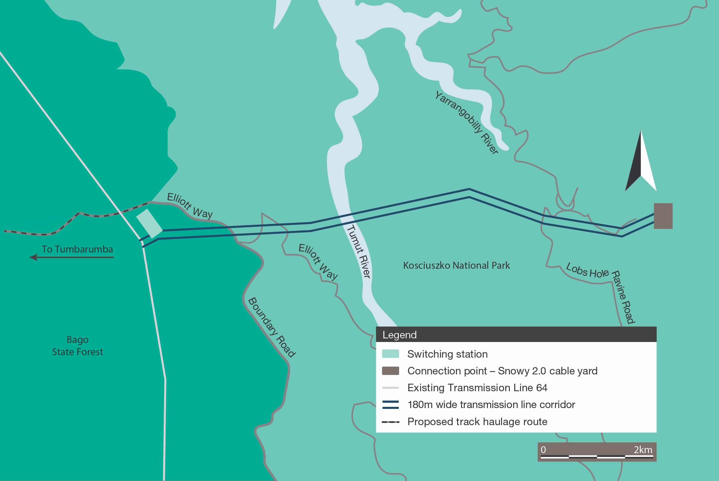
Figure 4. Transmission connection concept through Kosciuszko region. Source: Lumea.

References
ABC News 2024, ‘Tunnel boring machine wedged in hard rock, leaving Snowy 2.0 hydropower project stalled’, viewed 22 May 2024. (ABC)
ABC News 2024, ‘$4.8b HumeLink transmission line approved to connect Snowy Hydro 2.0’, viewed 19 Dec 2024. (ABC)
ABC News 2025, ‘Snowy 2.0 project safety review underway after ventilation fan implodes’, viewed 27 Feb 2025. (ABC)
ABC News 2025, ‘$12 billion Snowy 2.0 project faces further cost blowouts’, viewed 3 Oct 2025. (ABC)
Geoengineer 2024, ‘Snowy 2.0 tunnel boring machine remains stuck after a month’, viewed 30 May 2024. (geoengineer.org)
Lumea 2024, Snowy 2.0 Transmission Connection Project, Independent Environmental Audit, viewed 2024. (LUMEA™)
Renewable Energy World 2025, ‘When will Australia’s huge Snowy 2.0 pumped storage project be completed’, viewed 20 Oct 2025. (Factor This™)
Snowy Hydro 2024, ‘Project update, April 2024’, viewed 23 Apr 2024. (Snowy Hydro)

