AI design
The AI grading module designed here is the core function of the entire system, which utilizes some small-sample dataset combined with manual label to achieve an interpretable and accurate automatic grading with the grading rubrics and improve the consistency and transparency of grading. This provides the convenors and students with a more valuable and fair grading system. The overall architecture is shown in Figure 1, and its main procedures can be summarized as follows:
- Data processing: Unified the grading rubrics and the format of students’ assignment to ensure data consistency.
- Automated Scoring: Generated the scores automatically through the combination of DNN and LLM.
- Manual Validation: Introduce tutors’ scoring as the benchmark, and analysis the differences between AI and human results.
- Result output: Deliver anomaly analysis results to convenor and get the feedback for further optimization.
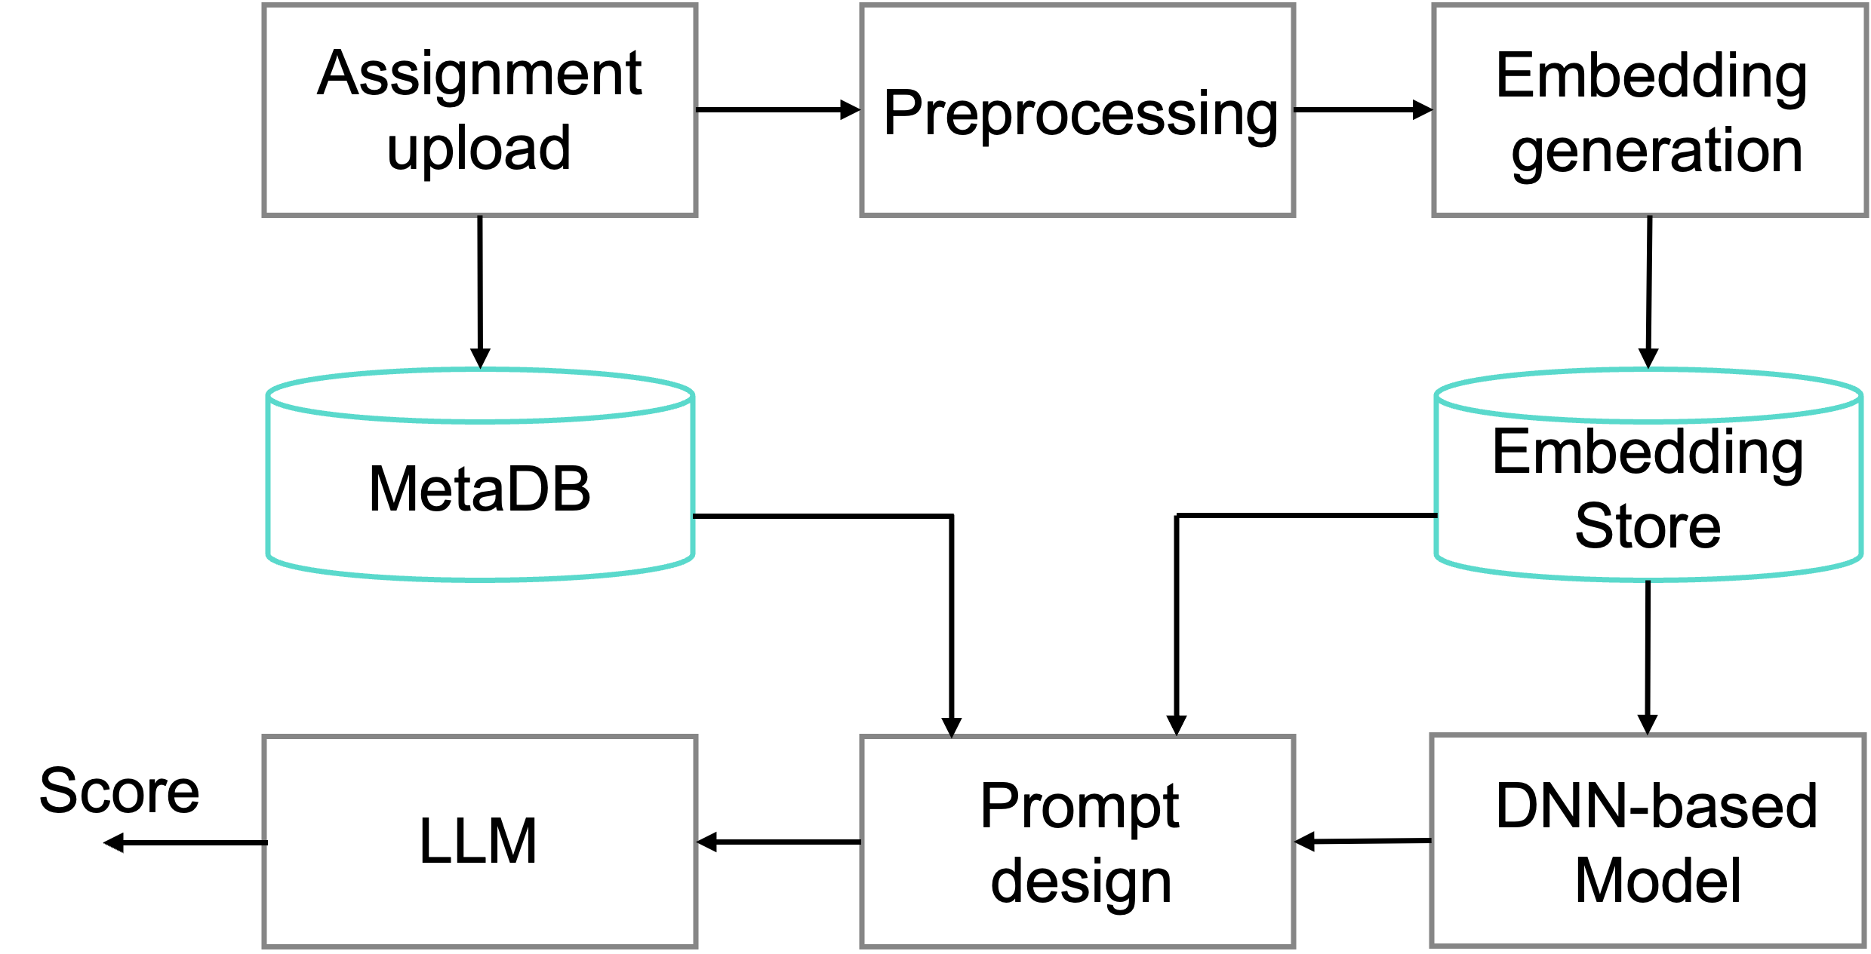
Figure 1 The overview architecture of AI grading system

Data Preparation and Preprocessing
Students’ assignment can be collected in variety forms including pdf, word even complex typography in an automated grading system. If these data are fed into the models directly without preprocessing, it can easily lead to some unstable scoring results. Therefore, the automated text cleaning, format parsing and structured rubric transformation are designed in this system, which also complete field alignment and missing value checks. Compared with manual data processing method, automated processing effectively solves the problems of high labor costs, inconsistencies caused by subjectively bias, thereby ensuring the reliability and standardization of model inputs. Its advantages are reflected in the following aspects:
- Scalability and Efficiency: enable rapid handling of large number of assignments.
- Consistency: unify structure ensures the standard data representation.
- Objectivity: reduce human error and improves the data integrity.
- Downstream Compatibility: support few-shot prompt construction and LLM integration.
Data collection and analysis will be utilized as the initial stage of the model construction. First, the requirement and the grading rubric are collected and reviewed manually to ensure the clarity of specification and machine-readable. Subsequently, 10% of the assignments will be graded by convenor separately. These samples will be used as the training set and used to align the LLM with the predefined rubric. The remaining assignments (~90%) will be marked by both tutors and AI model which can be considered as test set. Then, the designed preprocessing stage will be carried out and its workflow is shown in Fig 2.
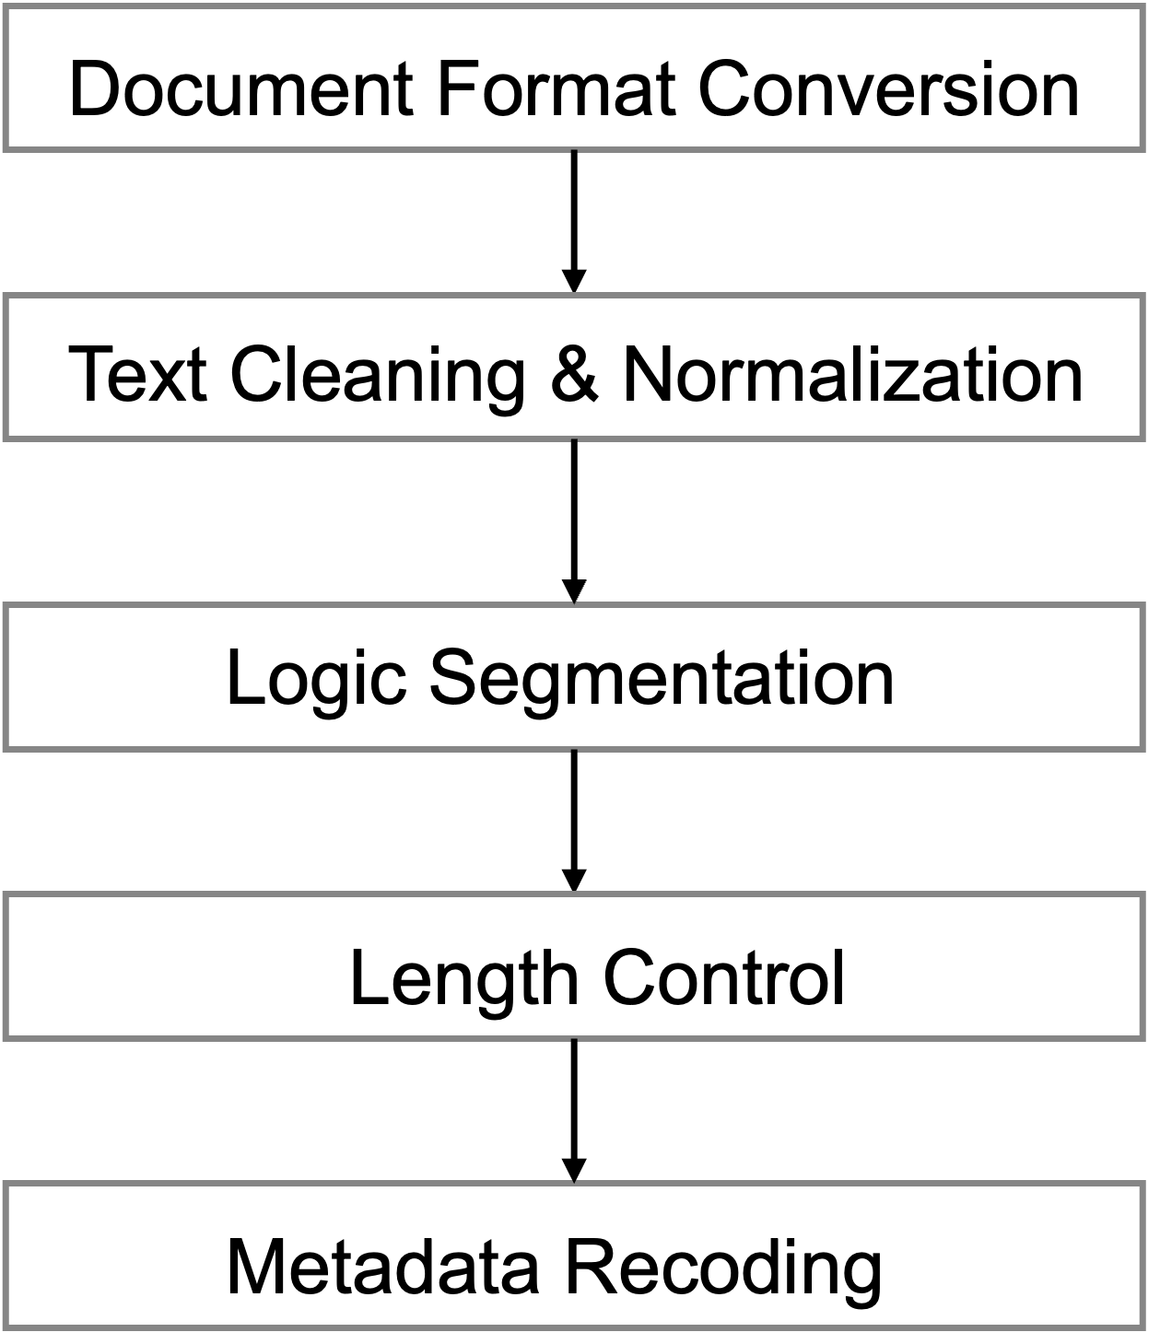
Figure2 Preprocessing workflow for automated assignment grading system.
- Document format conversion
All the students’ assignment will be converted into UTF-8 encoding plain text. OCR and libraries(python-docx) will be employed for PDF and word files, respectively, to parse the content. Then, the formatting information will be removed and only the main body text will be reserved.
- Text cleaning and normalization
Some irrelevant metadata such as students’ information (e.g. zID), headers will be removed from the body text. Also，punctuation marks will be standardized and the redundant whitespace will be eliminated to ensure the textual continuity.
- Logical segmentation
The text will be segmented by regular expression matching or heading detection according to the conventional structure of academic writing (e.g. abstract, introduction). Each segment will be mapped to corresponding rubric dimension to enable a better criterion-wise evaluation.
- Chunked input and length control
Two strategies may be adopted here for extremely long context:1) summarization with TextRank to preserve the key information or 2)sequential processing by split the raw context and aggregation.
- Metadata recording
The metadata will be bounded in the structured JSON format, which used to link the grades with student records. Specifically, these data will be excluded from model input to avoid the privacy risks.
Finally, the structured rubric data can be unified and shown in Figure3.

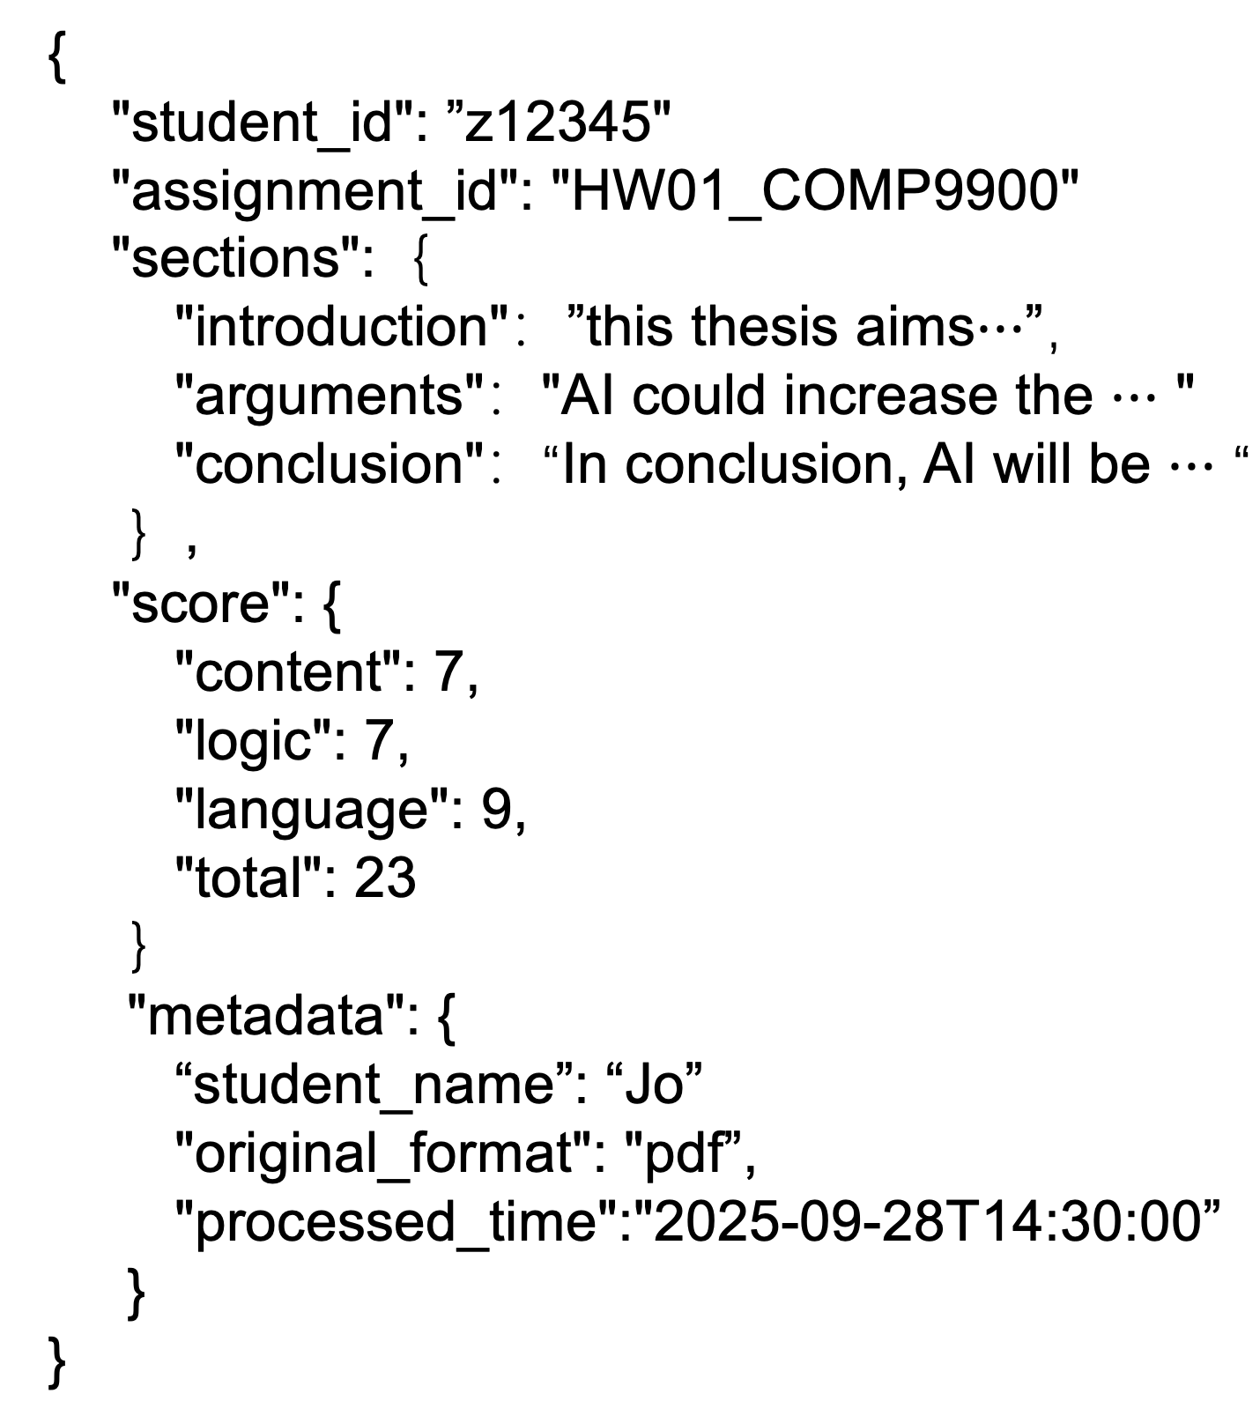
Figure3 Structured JSON output generated after preprocessing

Automated Scoring Pipeline
This component represents the core of the AI-based automated grading system, which implements the workflow by integrating the DNN-based predictor with LLM-based grading.
After preprocessing, the structured JSON will be utilized to generate the rubric-aligned embeddings according to the rubric dimensions (e.g. logic structure). Compared with traditional document-level embeddings, this approach could effectively capture the dimension-specific features, improve the accuracy of subsequent retrieval and avoid the information loss caused by compressing the document into a single vector. The generated embeddings are stored in a vector database (e.g. Milvus), which is shown in Figure4. This design offers several notable benefits:
- Rubric-aligned embeddings enhance the interpretability and fine-grained evaluation.
- DNN predictors increase the stability of predictions by capturing the grading patterns of convenor.
- Diversity few-shot examples mitigate the bias caused by the similarity, which ensure the integrity between rubric and grading styles of convenor.

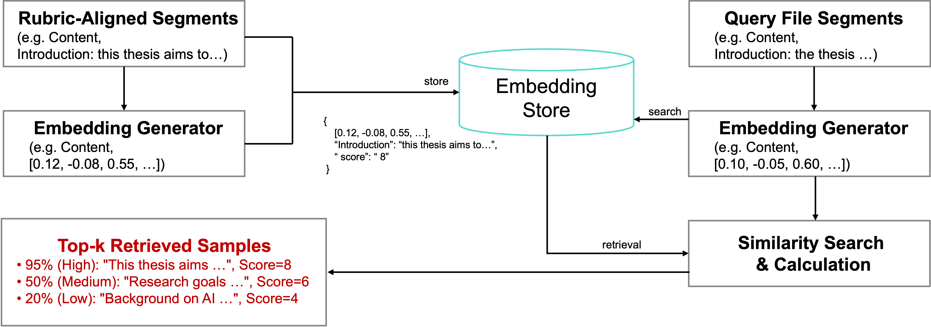
Figure4 Embedding store and similarity search for rubric-aligned segments
Alignment between the grading rubric and the AI model is achieved through few-shot prompting here. Specifically, the rubric is transformed into a structured input and combined with calibration samples as exemplars, then guiding the model to strictly adhere to the grading criteria and ensuring that the outputs remain consistent with the rules set by instructors. The calibrated model is then applied to the remaining 90% of unseen assignments. For each submission, the system generates an overall score, dimension-wise sub-scores. The feedback will be typically organized along the rubric dimensions, providing targeted explanations and suggestions for improvement, thus enabling efficient large-scale automated grading. The main processing workflow is outlined as follows:
- Embedding Store Construction
Rather than relying on embeddings derived from entire essays, a vector-retrieval system enhances the matching of new assignments with “similar segments” from historical data. This not only improves interpretability but also decrease the information loss caused by document compression. In this process, text segments corresponding to rubric dimensions will be converted into embeddings and stored in a vector database. Each entry primarily contains {embedding vector, original text segment (readable text), instructor-assigned score for the corresponding dimension}.
- DNN Training
A DNN will be introduced to learn the overall grading patterns of instructors, and to produce a “prior estimate (μ)” that provides a stable mean reference for the LLM’s predictions. Here, an appropriate DNN architecture will be constructed, with concatenated embeddings from different rubric dimensions used as input and instructor-assigned scores as supervision signals. The model is trained as a multi-output predictor, yielding both the predicted mean score μ and the associated uncertainty σ for each dimension.
- Few-shot Prompt Construction
In prompt design, both the role-play strategy and few-shot strategy will be employed. The prompt consists of four major components:
  - Role-play description.
  - Original text segments from the new assignment (segmented by rubric dimensions);
  - Exemplar segments retrieved from the embedding store at varying similarity levels (high/medium/low), along with instructor-assigned scores.
  - DNN-derived prior μ, included as a reference mean.
The LLM then outputs dimension-wise scores, explanatory justifications, and uncertainty estimates in strict accordance with the rubric. This design contributes to fairness in grading while aligning the system’s outputs with human evaluative styles.

Human-in-the-Loop Review
In addition to ensuring the reliability and fairness of AI-generated grading results, the system incorporates a bidirectional comparison between AI and human scores. This design aims to mitigate potential subjectivity in tutor grading and to enhance overall consistency. To achieve this, a strategy of “human benchmark + threshold-triggered review” is adopted, which further strengthens the system in the following aspects:
- Balance of efficiency and fairness: By restricting human review to “high-risk samples,” limited human effort is focused on the most critical cases.
- Interpretability: AI provides rationales, exemplars, and DNN priors (μ, σ), enabling instructors to quickly understand the sources of discrepancy.
- Flexibility: Thresholds are configurable, allowing adaptation to varying assignment difficulties and different instructors’ grading strictness.
The review mechanism is organized as follows:
- Tutor Benchmarking
In parallel with AI grading, tutors will independently grade the same set of assignments. These human scores will serve as the benchmark for fairness, preventing the system from relying solely on AI outputs.
- Discrepancy and Systematic Analysis
The system will calculate the differences between AI and human scores, with discrepancy detection strategies defined as follows (thresholds can be flexibly adjusted by rubric dimension or assignment type):
- Absolute difference: a risk is flagged if

$$\left|AI_{total}-Human_{total}\right|>threshold_{1}$$
- Relative difference: A review is triggered

$$\frac{\left|AI_{total}-Human_{toal}\right|}{max⁡\{Human_{total} , 1\}}>threshold_{2}$$
- Criterion-level difference: Any single rubric criterion deviating$>threshold_{3}×max⁡\{Human_{total}\}$.
- Systematic analysis: MAE, RMSE, and Pearson’s r will be computed across both total and criterion-level scores,.
- Dashboard and Convenor Feedback
The results of discrepancy analysis will be updated provided in frontend to the convenor as reference. The convenor’s activities (e.g., corrections) will be logged and subsequently used to optimized the model.

