Grand Challenges and Emerging Opportunities in the Snowy 2.0 Pumped-Hydro Project

Executive summary
Snowy 2.0 is Australia’s largest renewable-storage project, designed to deliver about 2.2 GW of fast-response, long-duration storage by linking the existing Tantangara and Talbingo reservoirs with roughly 27 km of tunnels and an underground power station. It will shift surplus wind and solar into peak periods, which is essential as coal retires. After a 2023 project reset, Snowy Hydro continues to signal first power in the second half of 2027 and commercial operation of all units by December 2028, although costs have escalated materially and are under active reassessment. (Snowy Hydro)
This report synthesises the project’s core challenges and their causes, benchmarks practices from comparable underground and pumped-hydro works, and identifies opportunities that can lift delivery performance on Snowy 2.0 and future Australian storage projects. Key findings are that ground risk, safety governance, and grid-integration dependencies are the dominant drivers of uncertainty. Best practice points to earlier and deeper geotechnical characterisation, alliance or target-cost contracting for ground-risk-heavy scopes, treating safety systems as critical-path plant, and bundling transmission planning with generation and storage to avoid stranded assets. (ABC)

1. Project context
Purpose and scope. Snowy 2.0 expands the original Snowy Scheme by connecting two existing storages at different elevations. When renewable supply is abundant and cheap, water is pumped uphill. When demand peaks, water is released through turbines to generate electricity. The storage duration is many hours to days, which complements batteries that typically provide only a few hours. (Snowy Hydro)
Delivery structure. Snowy Hydro Limited is the proponent. The main civil works are delivered by the Future Generation Joint Venture. Transmission connections are led by Transgrid through a dedicated project and through the broader HumeLink augmentation, which is critical to move Snowy 2.0 energy into the National Electricity Market. (Transgrid)
Status signals. Following the project reset, Snowy Hydro continues to indicate December 2028 for full commercial operation. In parallel, the proponent has flagged the need for additional funding as costs rise beyond prior public estimates. (Factor This™)
Figures.
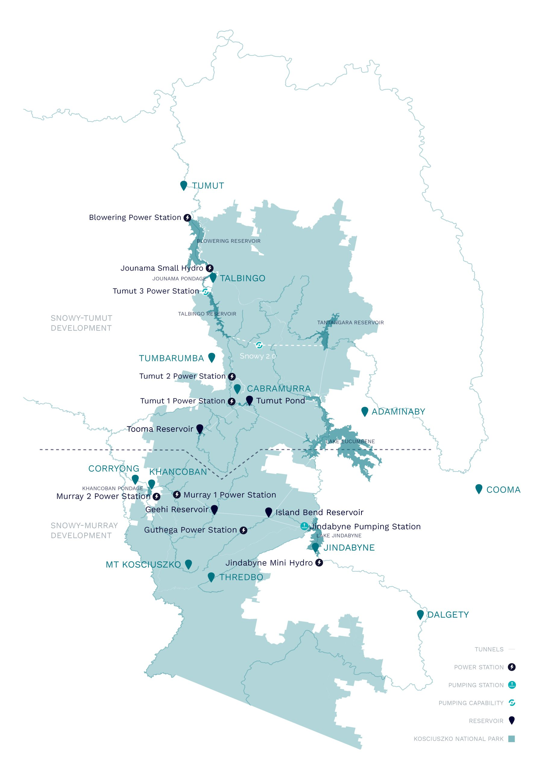
Figure 1. Map of the Snowy Scheme area with key power stations and storages.
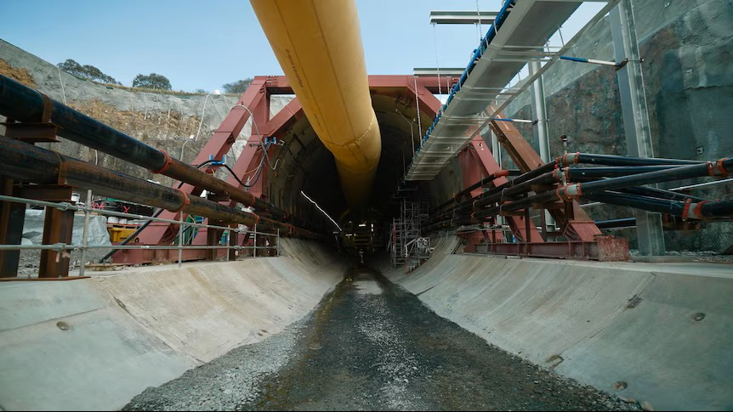
Figure 2. Entrance of the Florence TBM tunnel and construction ventilation.
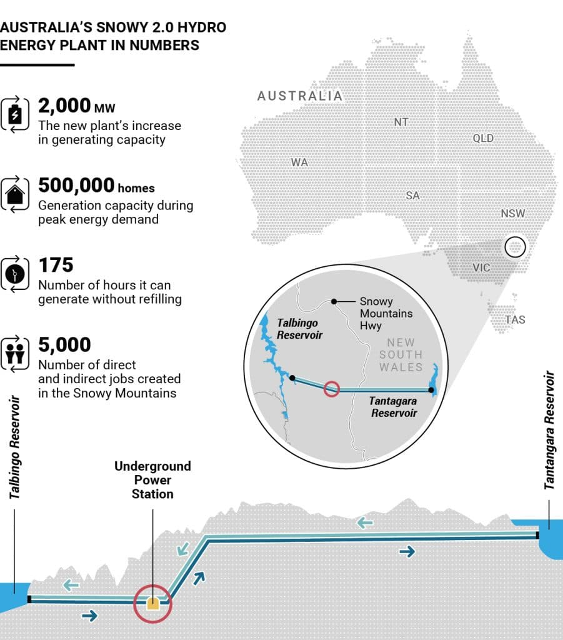
Figure 3. Snowy 2.0 concept infographic showing upper and lower reservoirs, powerhouse and flow direction.
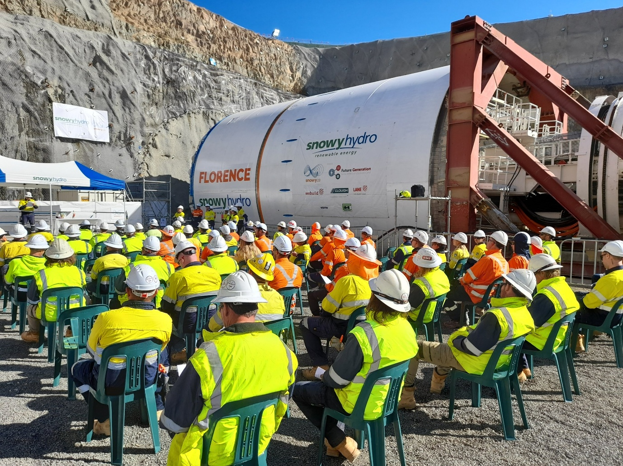
Figure 4. The Florence TBM launch face and workforce briefing.

2. Key challenges
2.1 Cost escalation and schedule risk
Public expectations formed around early cost figures have been overtaken by events, with ABC reporting in October 2025 that Snowy Hydro would need further funds above an already revised multi-billion dollar envelope. Schedule targets were reset, with first power targeted for 2027 and full operations for December 2028. Cost and schedule uncertainty remain material. (ABC)
2.2 Geotechnical complexity and tunnelling delays
Florence, the main tunnel boring machine for the headrace, has repeatedly encountered adverse conditions. After earlier issues in soft ground, it was immobilised in very hard rock in 2024 and required specialist recovery. Each stoppage cascades into redesigns, stand-down costs, and resequencing downstream works such as cavern excavation and electromechanical fit-out. (ABC)
2.3 Safety stoppages and workforce confidence
In February 2025, underground work was halted following a ventilation fan failure that produced dangerous fragments. SafeWork NSW issued multiple prohibition notices, and a broader safety review commenced. Events of this nature directly halt production and erode workforce confidence, which then amplifies delay and cost risks. (ABC)
2.4 Environmental and approvals constraints
Construction in and around Kosciuszko National Park brings strict environmental conditions and public scrutiny of access, spoil, and corridor works. Constraints can limit flexibility to re-align tunnels or relocate surface sites when ground conditions surprise, which increases schedule risk. (Transgrid)
2.5 Grid-integration dependencies
Snowy 2.0’s value depends on timely connection capacity. HumeLink and the Snowy 2.0 connection works are progressing through approvals and delivery pathways. If transmission lags generation and storage readiness, output can be stranded behind bottlenecks, which depresses early-years revenue. (ABC)

3. How the challenges connect
Table 1 summarises the main causal pathways that link technical, commercial, safety, and integration risks. The core pattern is a set of reinforcing loops in which geotechnical surprises trigger stoppages, stoppages inflate costs, cost inflation tightens governance, and governance shifts affect contractor behaviour and workforce stability.

Table 1. Challenge interconnections and feedbacks
Driver | Immediate effect | Secondary effects | Tertiary effects | Evidence signals
Variable geology and unexpected ground behaviour | TBM slowdowns or immobilisation | Recovery campaigns, redesign, resequencing | Contractual stress, productivity loss | Florence stuck in hard rock, specialist recovery required. (ABC)
Safety system failure or non-compliance | Prohibition notices, work halts | Worker confidence falls, attrition risk | Extended demobilisation, public scrutiny | Fan incident, prohibition notices across fans. (ABC)
Transient schedule optimism | Compressed investigation pre-works | Under-priced risk in baseline programs | Large re-estimates of cost and time | 2023 reset and ongoing reassessment. (Factor This™)
Transmission dependencies | Connection not ready at generation start | Reduced dispatchability, revenue lag | Stranded capacity if misaligned | HumeLink critical to Snowy 2.0 export. (ABC)

4. Stakeholders and interests

Table 2. Stakeholder overview
Stakeholder | Role and interest | Influence on risk profile
Snowy Hydro (proponent) | Cost, schedule, safety, environmental compliance, long-term asset performance | Sets tolerances, resets, and commercial model, engages with government and public
Future Generation JV (civil) | Deliver tunnels, caverns, shafts and portals | Construction methods, safety culture, productivity
OEMs and specialist subs | TBMs, ventilation, refuge chambers, electromechanical works | Reliability and commissioning readiness
Transgrid | Transmission connection and HumeLink | Synchronises system availability with Snowy 2.0 milestones (Transgrid)
SafeWork NSW | Regulator overseeing safety compliance | Can halt works, sets conditions for restart (ABC)
Communities and park authorities | Amenity, biodiversity, heritage | Access, corridor selection, spoil management

5. Best practice from comparable projects
5.1 Geotechnical investigation and staged excavation
International underground hydro and metro programs typically front-load probe drilling, pilot headings and contingency ground-improvement methods, then commit full-diameter drives. For high-risk zones, backup methods and pre-grouting are baselined, not only kept as contingency notes. The experience with Florence suggests that earlier staged characterisation and pre-treatment can reduce immobilisation risk. (ABC)
5.2 Contracting for ground risk
Alliance or target-cost contracts are widely used where subsurface variability is a dominant risk, because a fixed-price approach can incentivise claims and corner cutting when reality departs from tender assumptions. Resetting commercial settings mid-project is inferior to designing collaborative risk sharing up front. Australian transmission and major tunnelling programs increasingly use target-cost arrangements for this reason. (Factor This™)
5.3 Safety governance as critical path
On mature European rail tunnels, emergency systems and training are treated as commissioning items on the excavation program. Production cannot proceed without signed-off refuge, ventilation and egress. The 2025 ventilation incident at Snowy 2.0 shows why safety systems should be planned, procured and tested like primary plant, with performance embedded as contractual deliverables. (ABC)
5.4 Bundled system planning
Projects that coordinate storage, generation and transmission approvals and delivery reduce the risk of stranded capacity. HumeLink’s approvals and procurement cadence should be managed as a joint critical path with Snowy 2.0’s commissioning windows. (ABC)

Table 3. Best-practice crosswalk and application to Snowy 2.0
Best-practice theme | Typical elements | Application to Snowy 2.0 going forward
Staged ground characterisation | Probe drilling, pilot drives, pre-grouting, real-time ground model updates | Expand probe regimes ahead of remaining drives, hard-code change thresholds and method switches
Collaborative contracting | Target cost, shared risk registers, joint decision boards | Reinforce reset governance with transparent performance gates and jointly owned recovery plans
Safety as plant | Early procurement, acceptance tests, drills as program items | Treat refuge and ventilation as preconditions, with regulator sign-off milestones
Bundled transmission | Joint approvals, joint stakeholder engagement, co-timed energisation | Align HumeLink energisation with commissioning tests to avoid stranded capacity

6. Opportunities and options
6.1 Build national capability in underground energy infrastructure
Snowy 2.0 has already created thousands of jobs and a cohort of workers with deep experience in long-tunnel drives and cavern construction in mountainous terrain. This human capital will de-risk follow-on storage projects, including mine-pit pumped hydro options where tunnelling exposure is lower. (Snowy Hydro)
6.2 Method innovation
Where hard and abrasive lithologies are likely, hybrid methods, cutterhead redesigns, or sequential drill-and-blast through short segments can reduce immobilisation risk. Pre-grouting and reinforcement ahead of the cutter face can be normalised for known faulted zones. These choices trade nominal advance rates for reduced stoppage probability, which can improve program P50.
6.3 Integrated system commissioning
Embed a single integrated commissioning plan that covers powerhouse, waterways, protection schemes, and transmission energisation, with joint hold points across Snowy Hydro and Transgrid. This aligns scopes and avoids mismatches between turbine readiness and line availability. (Transgrid)
6.4 Safety leadership and workforce retention
Co-design safety escalation protocols with unions and the regulator, establish whistle-blower protections, and publish leading indicators, for example refuge chamber availability, fan MTBF, emergency drill cadence. This can stabilise morale and reduce stoppage risk after adverse events. (ABC)

7. Implementation roadmap

Table 4. Priority actions and 90-day plan
Priority | Action | Owner | Outcome
1 | Expand probe drilling and pre-treatment envelopes ahead of the remaining hard-rock segments | FGJV with Snowy Hydro ground-risk board | Lower chance of TBM immobilisation
2 | Safety plant program, procure and commission refuge and ventilation systems to explicit performance targets | FGJV with SafeWork NSW oversight | Faster restart after incidents, higher workforce confidence (ABC)
3 | Integrated energisation plan with HumeLink and Snowy 2.0 connection, include joint hold points | Snowy Hydro and Transgrid | Avoid stranded capacity at commissioning (Transgrid)
4 | Commercial transparency refresh, align incentives to shared P50/P80 dates and safety metrics | Snowy Hydro with FGJV | Reduces claim friction, increases focus on throughput stability
5 | Public reporting cadence on cost and schedule ranges with uncertainty bands | Snowy Hydro | Maintains public confidence during delivery reassessment (ABC)

8. Risks and mitigations

Table 5. Top risks, causes and mitigations
Risk | Cause | Consequence | Mitigation | Residual
TBM immobilisation | Abrasive rock, alignment errors, inadequate pre-treatment | Long stoppages, recovery cost | Enhanced probing, face pre-treatment, alignment control, backup methods | Medium (ABC)
Safety plant failure | Maintenance gaps, specification drift | Work bans, regulator intervention | Treat safety plant as critical equipment with MTBF targets, independent audits | Medium (ABC)
Transmission lag | Corridor approvals slippage, procurement delays | Reduced early-year revenue, stranded capacity | Joint program and hold points with Transgrid, contingency dispatch plans | Medium (ABC)
Cost growth | Prolonged stoppages, claim cycles | Funding pressure, scope deferrals | Target-cost mechanisms, transparent reset governance | Medium (Factor This™)

9. Conclusion
Snowy 2.0 remains a system-critical project for Australia’s clean-energy transition, providing large-scale, long-duration storage that complements the growth of wind and solar. Its difficulties are real, visible, and instructive. The dominant drivers are subsurface uncertainty, safety governance, and dependencies on transmission build-out. The strongest corrective levers are earlier and deeper ground investigation with staged excavation tactics, collaborative contracting that shares the variability of ground risk, safety systems treated as critical-path plant, and a single integrated plan that synchronises transmission energisation with turbine commissioning. If executed, these levers can stabilise throughput, reduce stoppage probability, and protect public confidence as the project moves into its electromechanical and commissioning phases. (ABC)

References
ABC News 2024, Tunnel boring machine wedged in hard rock, leaving Snowy 2.0 hydropower project with new issues, viewed 21 May 2024. (ABC)
ABC News 2025, Snowy 2.0 faces cost blowouts beyond previous $12 billion target, viewed 3 Oct 2025. (ABC)
ABC News 2025, Snowy 2.0 project safety review underway after ventilation fan implodes, viewed 26 Feb 2025. (ABC)
Climate Control News 2025, Shutdown due to ventilation, viewed 27 Feb 2025. (climatecontrolnews.com.au)
Geoengineer 2024, Snowy 2.0 tunnel boring machine remains stuck after a month, viewed 12 Jun 2024. (geoengineer.org)
Renew Economy 2024, Contested HumeLink transmission line gets federal green tick, viewed 19 Dec 2024. (Renew Economy)
Renewable Energy World 2025, When will Australia’s huge Snowy 2.0 pumped storage project be completed?, viewed 21 Oct 2025. (Factor This™)
Snowy Hydro 2023, Snowy 2.0 Progress Factsheet, viewed Sep 2023. (Snowy Hydro)
Transgrid 2024, Snowy 2.0 Transmission Connection, viewed 2024. (Transgrid)
ABC News 2024, HumeLink transmission line approved to connect Snowy Hydro 2.0, viewed 19 Dec 2024. (ABC)

