CVEN9723 Group Assignment
Grand Challenges and Emerging Opportunities for the Australian Construction Industry
Case study: New Sydney Fish Market, Blackwattle Bay

Executive summary
The New Sydney Fish Market at Blackwattle Bay is a flagship waterfront project that combines complex marine construction, landmark timber and aluminium roof engineering, and a public domain renewal that completes a missing link on Sydney’s inner harbour foreshore. Construction is nearing completion with construction completion expected shortly, followed by handover to the operator and tenant fitouts before public opening, with recent government and media updates signalling a handover next month and a public opening targeted soon after. The project’s challenge profile is distinctive. It involves building over water on more than four hundred marine piles, managing cofferdam excavation and ground treatment adjacent to an ageing seawall, sequencing superstructure and a two hundred metre floating canopy made from hundreds of timber beams and aluminium pyramidal cassettes, and doing all of this while maintaining access, safety, and environmental compliance in a constrained urban setting. This report explains the challenge system in depth, analyses the root causes and their interconnections, extracts best practice locally and internationally, and proposes a practical opportunity roadmap that the delivery authority and operator can implement during commissioning and early operations. The figures and tables are original and are designed to support an engineering standard narrative grounded in the publicly available record. (newsydneyfishmarket.insw.com)

1. Introduction and case overview
The New Sydney Fish Market is being delivered at the head of Blackwattle Bay to replace the existing Pyrmont facility with a purpose built market and public attraction. It has been designed by 3XN with BVN and Aspect Studios, with a signature wave like roof that uses a large timber beam grid and aluminium cassettes to create a scaly appearance. The market program integrates working fishmongers, retailers, hospitality, logistics, and wharf functions, along with public waterfront access that will tie into a continuous foreshore walk exceeding fifteen kilometres across the Bays Precinct. The New South Wales Government’s project page identifies community and economic benefits along with open spaces, trawler access, a continuous promenade, and solar generation. The project is being delivered while the current market remains operational, which imposes further constraints on staging and logistics. (newsydneyfishmarket.insw.com)
The planning pathway confirms that the concept proposal and Stage 1 works, including demolition of land and water based structures, were approved in June 2020 as State Significant Development. The consent provides for a building envelope up to approximately thirty thousand square metres of gross floor area with wharf structures, three above ground storeys over a basement, access upgrades on Bridge Road, and improvements to the public domain. This sets the regulatory context that governed design development and construction staging decisions that followed. (Planning NSW)
Construction staging has proceeded from early works and demolition into a sequence of marine piling, cofferdam and ground works, installation of major in water substructure elements, and later into superstructure, roof canopy, enclosure, and internal fitouts. Infrastructure NSW’s public timeline notes that more than four hundred piles support the building, wharves, and adjacent promenade, with main building piles installed in 2022 and the marine piling for the building footprint complete in 2023. The project has since moved through major milestones such as completion of the floating roof canopy in 2025 and progressive tenant fitouts. Recent ministerial and media updates indicate that construction completion is expected next month with a handover to the operator ahead of opening. The opening date has been reported with differing levels of certainty by media outlets through late 2025, which is typical of large complex facilities that require coordinated fitouts, commissioning, and approvals. These dynamics are significant for risk analysis because tenant readiness and integration testing become critical path items late in the delivery. (newsydneyfishmarket.insw.com)
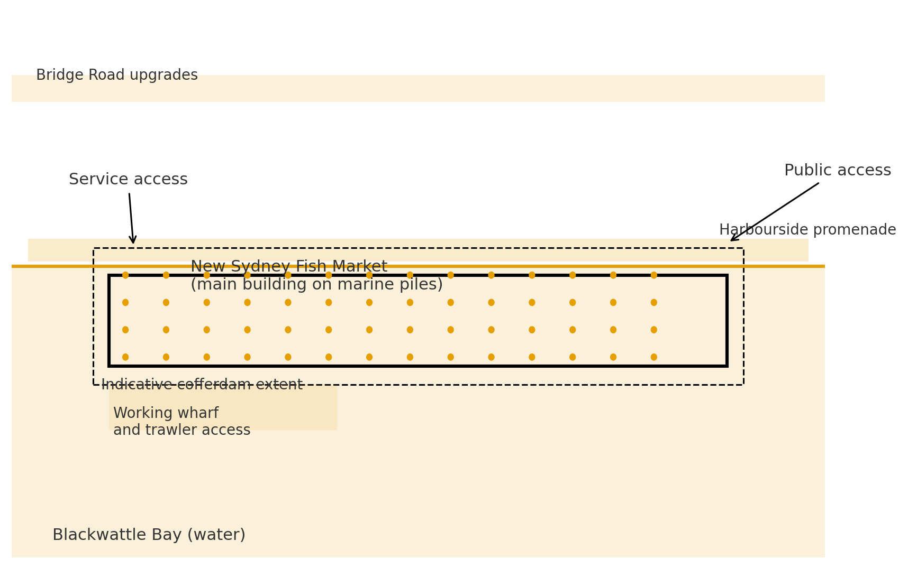
Figure A. Site and marine works schematic, illustrative

2. Identification of the main challenges
The project’s challenge profile is dominated by the construction over water and the need to deliver a world class building with high public expectations in a tight urban context. The first challenge is marine substructure construction and cofferdam management. Delivering a building that sits largely over water required a large volume of piling with complex temporary and permanent works. A marine cofferdam was required to create a safe working environment for early substructure works. Specialist ground engineering was needed to control groundwater and to stabilise excavations, including jet grouting and secant piled retaining elements for the cofferdam walls. This introduces interface risk between ground treatment, piling, and marine logistics, particularly where the cofferdam interacts with existing seawalls and services. (newsydneyfishmarket.insw.com)
The second challenge is roof canopy engineering and erection sequencing. The floating roof is a defining architectural and structural element that is two hundred metres long and supported by a dense grid of timber beams and pyramidal aluminium cassettes. The canopy is as much a systems engineering task as it is a structural task because it integrates with building services and daylighting strategy, while its geometry imposes constraints on lifting methods and temporary stability. The roof completion milestone achieved in 2025 signalled that the superstructure had reached a high level of completeness, yet it also marked the beginning of an intensive phase of internal works and services commissioning that must be sequenced beneath the canopy without compromising finishes. (3xn.com)
The third challenge is staging and public domain integration. The project must enable fishing fleet operations, service access, and future public access along a continuous promenade while fitting within the upgrade program for Bridge Road and its intersections. The staging must maintain navigational safety, minimise closure durations, and coordinate with city traffic management. This creates interdependent approvals across road authorities and maritime stakeholders that can extend decision cycles if not actively managed. The Blackwattle Bay planning framework emphasises the foreshore walk and open space outcomes, which sets expectations for final finishes and access quality that influence temporary works choices and sequencing. (Planning NSW)
The fourth challenge is tenant integration and opening readiness. The facility will host about forty retail tenancies in addition to market operations, which means tenant design, fitout, services connections, and safety approvals can become a critical path variable late in the programme. Government and media updates through 2025 show movement toward construction completion and handover, while commentary about potential opening windows highlights the sensitivity of opening to tenant mobilisation and operational trials. These are not criticisms. They are reminders that complex public facing facilities have a multilateral readiness requirement that includes base building certification, tenancy compliance, operations staffing, and market logistics rehearsals. (NSW Government)
A fifth and cross cutting challenge is stakeholder expectations and communications. This is a signature civic building that has been promoted as a major economic and tourism asset. The narrative about opening dates, the value for money of the budget, and the future development of the old site has drawn extensive public attention. Managing this environment requires discipline in information release and strong alignment between the delivery authority, operator, and future precinct development entities. Recent planning and government releases about the old site’s rezoning and increased housing yield illustrate how the market project sits within a larger precinct transformation. The connection between the construction programme, the opening announcement, and the old site’s redevelopment timeline is often implied in public discourse, which can increase pressure on the project team even when the dependencies are only indirect. (ABC)

3. Root causes and intrinsic connections
The marine construction challenge originates in the geotechnical and hydraulic conditions of Blackwattle Bay, the proximity of the existing seawall, and the need to build a high live load building over water. Marine piling and cofferdam works create complex temporary states that must resist uplift, basal heave, and tidal loading while providing safe access for plant and materials. The choice of a cofferdam with secant or sheet piled walls and internal bracing is a rational response but introduces a time dependent risk profile in which water pressure, settlement, and seepage must be monitored and managed through the excavation and foundation phases. Interface errors at this stage can propagate into superstructure alignment issues that complicate later trades.
The roof canopy challenge is partly structural and partly organisational. Timber beams and aluminium cassettes reduce the mass of the canopy relative to full concrete solutions and enable a distinctive architectural expression that fits the waterfront setting. The floating canopy, however, requires precise geometry control and meticulous logistics during erection. The roof has to be supported, tied, and weathered while trades beneath work to programme. If the roof is completed before key services distribution pathways are finalised, rework or out of sequence access can occur. The milestone reporting in 2025 about roof completion is welcome because it correlates with a general transition into commissioning and fitout. Yet it also aligns with the start of a period where operational dependencies multiply and small sequencing delays can have larger knock on effects.
The staging and public domain integration challenges are rooted in the multiplicity of authorities with jurisdiction over roads, foreshore access, navigation, and environmental protection. The planning material confirms that Bridge Road upgrades and intersection works form part of the consent, which means any resequencing requires approval coordination. In practice, local stakeholders measure project performance by visible outcomes like clear wayfinding, smooth detours, and open foreshore segments. When marine works extend, these perceptions can shift quickly, which requires proactive communications and transparent programme messaging.
Tenant integration has its own causality. The base building must provide compliant services, fire separation, structural zones, and loading dock logistics that tenancies can plug into. Fitout approval processes must be standardised and supported by clear technical manuals. Retailers moving from the old market bring established operational rhythms, especially around the intense Christmas seafood period. Commentary in late 2025 about the merits of a pre Christmas or post Christmas opening shows how business readiness and seasonal trading cycles interact. The operator must lead a mobilisation programme that is synchronised with handover and commissioning dates to avoid an extended partial opening that would compromise the public experience. (Daily Telegraph)
These domains are interdependent. Figure B sketches the canopy concept and prompts a view of the buildability question, while Figure C translates the public timeline into an illustrative programme that highlights where interfaces are most dense.
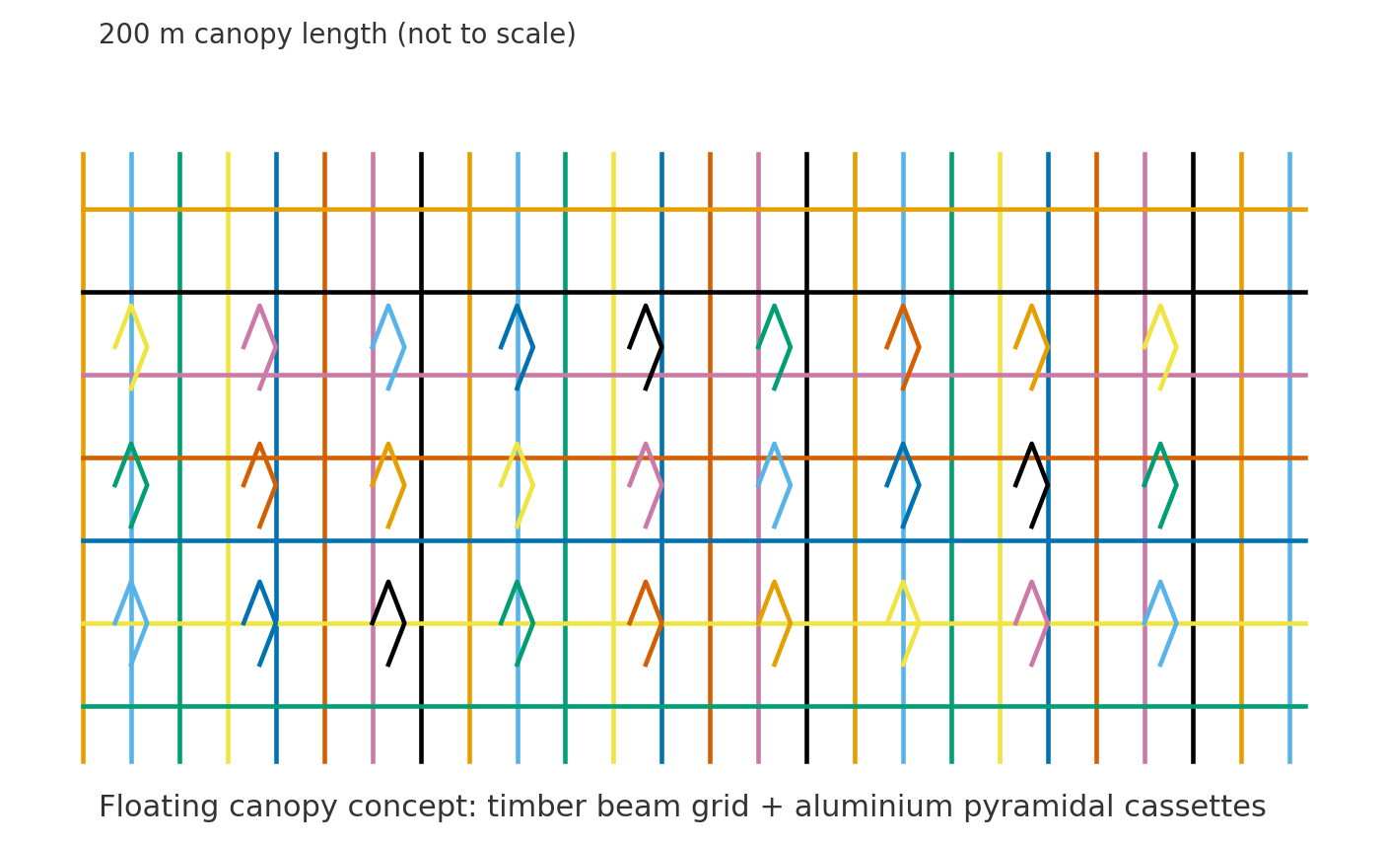
Figure B. Floating roof canopy concept, simplified structural language
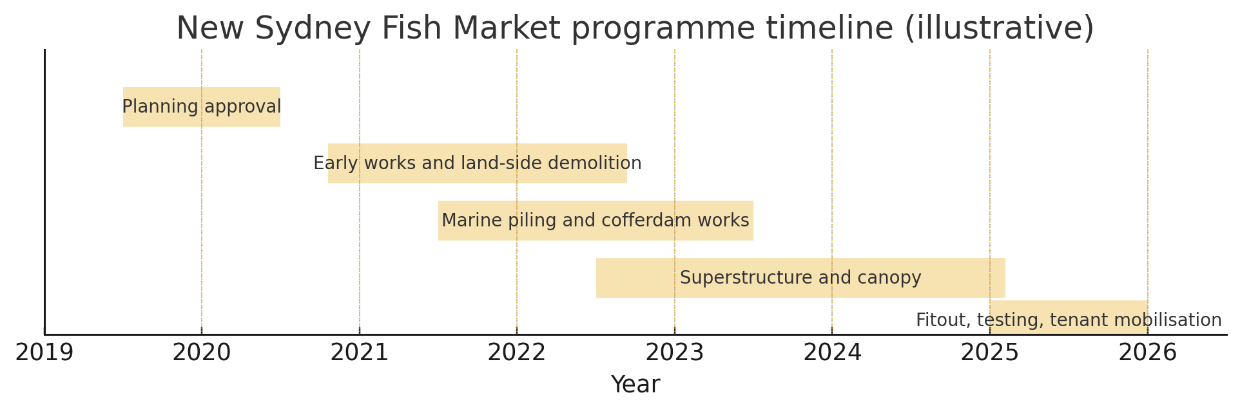
Figure C. Programme timeline, planning to opening

4. Best practice review, local and international
Within Australia, several marine and waterfront projects provide relevant lessons. The Barangaroo development demonstrates the benefit of strong interface management between marine works, public domain construction, and building delivery, with explicit staging that kept the promenade experience credible while heavy works continued. Although a different asset class, the approach of separating high risk waterfront packages and locking in approvals frameworks early is transferable. On the infrastructure side, alliance and relationship contracting literature shows how shared risk registers and delegated approvals inside a joint board can maintain decision speed where uncertainty cannot be fully priced at tender. Internationally, Nordic experience with large timber structures and hybrid roofs offers a reference class for sequencing and weatherproofing, although climate exposure differs.
For the New Sydney Fish Market, two best practice themes are salient. The first is digital rehearsal. A digital twin that integrates the canopy geometry, MEP distribution, and fitout interfaces would allow clash detection, installation sequencing, and workface access to be tested virtually before the final months of construction. The second is place led staging. Projects that succeed on constrained waterfronts tend to treat the promenade and public realm as front line deliverables and maintain legible temporary routes with high quality wayfinding and activation. Infrastructure NSW’s project material on a continuous harbourside walkway supports this priority, since the market’s value proposition depends on a seamless public experience from day one. (newsydneyfishmarket.insw.com)

5. Emerging opportunities and future development
The operator’s mobilisation phase and the first year of operation provide an opportunity to institutionalise a commissioning and opening assurance framework that is explicit about component provenance, safety certification, and tenant readiness. On the technical side, applying hardware in the loop techniques to life safety systems and critical plant before energisation would reduce late stage discovery risk. On the commercial side, providing a single point of contact for tenant fitouts with an online approvals tracker would improve transparency and reduce the incidence of incomplete submissions that delay works.
From a precinct perspective, the State has progressed the rezoning of the old market site at Pyrmont, with recent announcements indicating that more than fifteen hundred new homes are expected after amendments to planning controls. The opening of the new market therefore sits at the front end of a long redevelopment cycle. There is a clear opportunity to use the market’s operational data to inform transport planning for the precinct, including public transport access, ferry service design, and active mode links. Recent reports of budget allocations for a new ferry wharf at the market and upgrades to the Wentworth Park light rail stop show how the transport layer is being advanced in parallel. A transparent benefits framework focused on visitor numbers, travel mode share, local business outcomes, and waterfront usage would allow the Government to demonstrate the market’s performance and to refine the supporting transport investments. (Daily Telegraph)

6. Synthesis table: challenge taxonomy and indicative responses
Domain | Typical root causes | Indicative responses | Expected benefits
Marine substructure and cofferdam | Tidal loading, seepage, basal heave risk, ageing seawall interfaces, marine logistics constraints | Independent temporary works verification, continuous pore pressure monitoring, real time cofferdam telemetry, adaptive dewatering plans, explicit uplift checks and contingency pumping capacity | Safer excavation windows, fewer unplanned stoppages, predictable productivity
Roof canopy engineering and erection | Geometry control, temporary stability of timber grid, services integration beneath completed canopy | Workface planning with digital rehearsal, modular cassette logistics, progressive weatherproofing strategy, strict configuration management | Reduced rework, stable interior environment for fitout, higher quality finishes
Staging and public domain integration | Multi authority approvals, constrained kerbside and foreshore access, navigation safety | Staged promenade opening plan, agreed detour quality standards, precinct wide wayfinding, joint authority approvals calendar | Better community outcomes, fewer late staging changes, stronger social licence
Tenant integration and opening readiness | Heterogeneous tenant capabilities, seasonal trading cycles, parallel fitouts | Single approvals portal, technical design manuals, readiness audits, soft opening trials, seasonal trading contingency | Shorter fitout cycle time, fewer non conformances, smoother opening week
Stakeholder expectations and communications | High media interest, mixed messages on opening windows, precinct interdependencies | One source of truth for programme status, data led benefits reporting, alignment with old site redevelopment timeline | Improved confidence, fewer reactive changes, better narrative discipline

7. Recommendations
The delivery authority should publish an opening assurance plan that sets out the final test and trial sequence, the criteria for progressive certification of building systems, and the minimum readiness requirements for retail tenancies. The plan should be supported by a digital rehearsal environment that integrates the canopy model, services routes, and tenancy fitout drawings so that clashes and workface conflicts are identified before night shift works begin in earnest. The authority, operator, and the tenant group should agree a realistic mobilisation calendar that accounts for the Christmas seafood trading period and sets an evidence based opening window rather than a purely symbolic date. Within the final month before opening, the project should activate place management measures that are visible to the community, such as a high quality temporary wayfinding kit, trial ferry services where practicable, and a public information campaign that emphasises transport choices and waterfront access. Immediately after opening, a benefits dashboard should be published and maintained with quarterly updates so that the precinct learns from its own data and can adjust routine operations, transport supports, and public domain management as needed. These recommendations are implementable within current governance settings and are aligned with the public material on construction completion, handover, and transport connections. (NSW Government)

8. Conclusion
The New Sydney Fish Market illustrates how Australian construction can deliver a technically ambitious building over water while maintaining a credible public domain narrative and preparing a complex retail and operations ecosystem for opening. The marine cofferdam and piling works, the two hundred metre floating roof canopy, the constrained city interfaces, and the multilateral readiness requirements create a rich challenge system. With disciplined assurance, digital rehearsal, relationship based decision making in uncertainty hotspots, and a place led approach to staging, the project can convert late stage risk into operational momentum. The subsequent redevelopment of the old site will extend the transformation and will benefit from the market’s early performance data. The recommendations in this report are grounded in the public record and can be acted on by the current teams without structural changes to governance.

References
Infrastructure NSW 2025, New Sydney Fish Market: project home, viewed 19 October 2025. (newsydneyfishmarket.insw.com)
Infrastructure NSW 2025, Project timeline and construction stages, viewed 19 October 2025. (newsydneyfishmarket.insw.com)
Planning NSW 2020, Sydney Fish Market State Significant Development: concept approval and Stage 1 works, viewed 19 October 2025. (Planning NSW)
Planning NSW 2025, Blackwattle Bay State Significant Precinct overview, viewed 19 October 2025. (Planning NSW)
Sydney Fish Market 2025, Project overview, viewed 19 October 2025. (sydneyfishmarket.com.au)
3XN 2025, New Sydney Fish Market’s roof is complete, viewed 19 October 2025. (3xn.com)
Designboom 2025, 3XN, BVN and Aspect complete the rooftop canopy milestone, viewed 19 October 2025. (Designboom)
ABC News 2025, New Sydney Fish Market to open January next year, viewed 19 October 2025. (ABC)
Australian Business Journal 2025, Redevelopment nears completion, opening date still unannounced, viewed 19 October 2025. (Australian Business Journal)
Keller Australia 2023, New Sydney Fish Market: cofferdam and jet grouting, viewed 19 October 2025. (Keller Australia)
Realestate.com.au 2025, Rezoning fast tracked for old market site, viewed 19 October 2025. (Real Estate)
Daily Telegraph 2025, Christmas opening debate and tenant readiness, viewed 19 October 2025. (Daily Telegraph)
Daily Telegraph 2025, Opening date uncertainty, viewed 19 October 2025. (Daily Telegraph)
NSW Government 2025, Ministerial release: new Sydney Fish Market nears completion and handover next month, viewed 19 October 2025. (NSW Government)

