CVEN9723 Group Assignment
Grand Challenges and Emerging Opportunities for the Australian Construction Industry
Case study: Snowy 2.0 Pumped Hydro Project

Executive summary
In this report I talk about Snowy 2.0 and why it is a big project for Australia. The project builds tunnels, an underground power station, and two reservoirs that can pump water up and down to make electricity when we need it. I think the main challenges are that it is complicated, it takes a long time, and it costs a lot. I also think there are opportunities like jobs and some tourism benefits. Overall, I feel the project is good and worth finishing because renewable energy is important for the future. This report is short and gives my views about the project.

1. Introduction
Snowy 2.0 is a pumped hydro scheme in the Snowy Mountains. It connects an upper reservoir to a lower reservoir through a tunnel and an underground powerhouse. When there is extra electricity, the system pumps water to the upper reservoir. When there is high demand, the water is released back through turbines to generate electricity. I chose this project because I have heard about it in the news many times and I think it is interesting. I am not an expert in hydro power, but I understand the basic idea and I will explain it in simple terms.

2. Main challenges in the project
From my point of view, the biggest challenge is that the project is very large. Large projects are always hard because a lot of people are involved and that makes coordination slow. I also think tunnelling is a challenge because it is underground and we cannot see what is happening, so problems probably appear without warning. Weather in the Snowy Mountains might be another challenge because it can snow in winter and be cold which slows the work. Another challenge is public communication. People want the project to finish but also want low costs and no environmental impact which is not possible in reality. I believe these issues create delays and frustration for everyone.

3. Reasons for the problems and connections between them
In my opinion the reasons are simple. The design is complex and it needs special machines, so any delay in one part affects everything else. If a tunnel boring machine stops, then a lot of workers cannot work and that increases cost. When costs increase, the project has to ask for more money which takes time and creates more media attention. That attention then leads to more reporting and sometimes changes in scope to satisfy different groups. These factors are all connected. I would describe it as a chain where one delay causes the next delay. I think that explains why the schedule moves a lot.

4. Best practice in similar projects
I have not done a detailed international review. From what I generally know, other countries also build pumped hydro and they tend to plan carefully and use strong contractors. I think the key lesson is to do more planning at the start and to keep backup options for equipment. If a project has a second machine ready or spare parts nearby, it can recover faster. I also think regular public updates help because people feel informed even if something goes wrong. In my view these are best practices that could help Snowy 2.0 as well.

5. Emerging opportunities and future development
I see opportunities in training and jobs. Workers on Snowy 2.0 can learn tunnelling skills and then use them on other projects around Australia. The project may also support tourism because people might want to visit the power station and learn about energy. In the future the scheme can store more renewable electricity which helps the grid. The power system in Australia is changing and storage will be important, so the project could become very useful after it opens. I also think there could be new walking tracks or lookouts around the reservoirs which will make the region more attractive.

6. Simple figure of a pumped hydro scheme
The figure below is my basic drawing of a pumped hydro system. It is not to scale and only shows the idea of an upper reservoir, a tunnel, a powerhouse, and a lower reservoir.
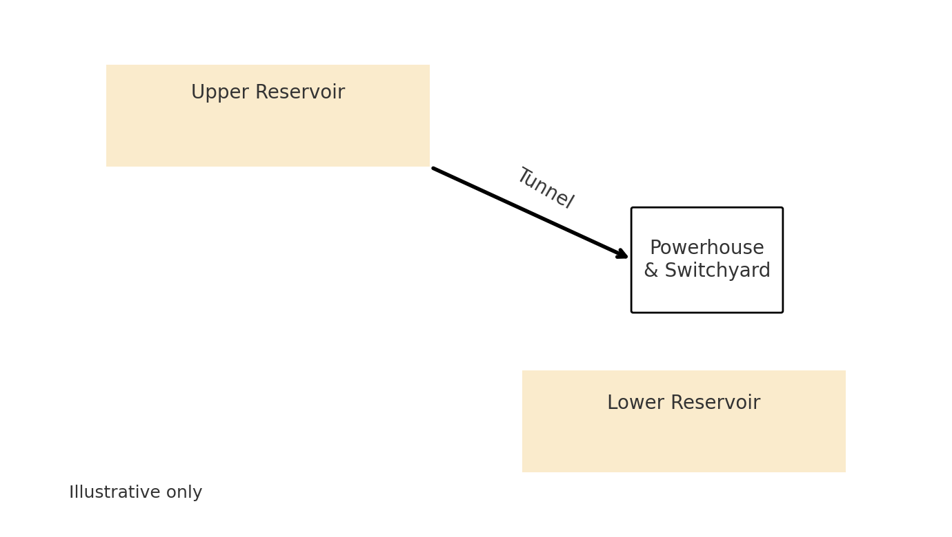
Figure 1. Very simple schematic of pumped hydro (illustrative only)

7. Conclusion
In conclusion, Snowy 2.0 is large and complicated which brings delays and extra costs. Even with these problems I believe it should continue because it will help with renewable energy. My recommendations are to plan better, communicate more with the public, and keep backup equipment. I think these ideas will improve the project. This report is a quick overview and does not go into the full technical details.

References
Australian Government, Department of Climate Change, Energy, the Environment and Water.
Snowy Hydro Limited.
NSW Government, Department of Planning.
Engineers Australia.
Infrastructure Australia.

