CVEN9723 Group Report: Grand Challenges in the Australian Construction Industry
Grand Challenges Case Study, Parramatta Light Rail Stage 1, Group X

Executive Summary
Parramatta Light Rail Stage 1 is a 12 kilometre, 16 stop line linking Westmead to Carlingford through the Parramatta CBD and Camellia. It anchors Western Sydney's health, education and employment precincts, targets all day high frequency services, and integrates with heavy rail, bus and ferry nodes. Delivery has involved complex urban interfaces, legacy corridor conversion, and brownfield utility conditions. Four grand challenges stand out in this case: scope and interface complexity, geotechnical and corridor constraints, workforce capacity and industrial relations, and cost and supply chain volatility. A review of comparable Australian and international projects indicates that integrated interface control, the observational method with robust trigger action response plans, structured workforce pipelines, and hedged procurement for long lead items are the most transferable practices. The recommended roadmap prioritises a single source of truth for interfaces, progressive assurance tied to risk based programme controls, an industry wide tunnelling data trust, and targeted micro credentials to smooth labour peaks. If adopted, these measures can improve schedule adherence, reduce rework, and strengthen value for money while maintaining safety and customer outcomes (NSW Government 2025; Transport for NSW 2025; ABC News 2024).

1. Introduction and Project Context

1.1 Project overview
Parramatta Light Rail Stage 1 delivers a two way track between Westmead and Carlingford via the Parramatta CBD and Camellia. It provides 16 stops and interchanges with Westmead and Parramatta stations, Parramatta Ferry Wharf and key bus corridors. The line supports the Westmead Health Precinct, CommBank Stadium, Powerhouse Parramatta and redevelopment precincts at Camellia and Telopea (NSW Government 2025; Transport for NSW 2025).
Table 1. Project facts snapshot
Attribute | Detail
Project | Parramatta Light Rail Stage 1
Client and key agencies | NSW Government, Transport for NSW
Delivery model | Multiple packages including infrastructure civil works and systems, operations and maintenance packages
Location | Westmead to Carlingford through Parramatta CBD and Camellia
Timeline | Initial enabling works from 2018, major construction 2019 onwards, testing and commissioning period extended in 2024, operations commenced 2025 (public information)
Budget order of magnitude | Public reporting has referred to costs in the order of several billion dollars across stages and packages. Refer to NSW Budget Infrastructure Statements for current aggregated allocations (NSW Treasury 2025).

1.2 Why this project matters
The corridor connects Western Sydney's health and education assets with the regional CBD, supports urban renewal along the former T6 Carlingford line and brownfield industrial lands, and enables mode shift to frequent electric transit. It is a catalyst for place making along Church and Macquarie Streets while supporting active transport links.

1.3 Identified grand challenges
- C1. Scope and interface complexity, multiple packages, utilities, property and heritage interfaces.
- C2. Geotechnical and corridor constraints in mixed ground, legacy rail formation and settlement sensitive precincts.
- C3. Workforce capacity, training pipeline and industrial relations for brownfield city shaping works.
- C4. Cost escalation and supply chain volatility for long lead rail systems and fleet components.
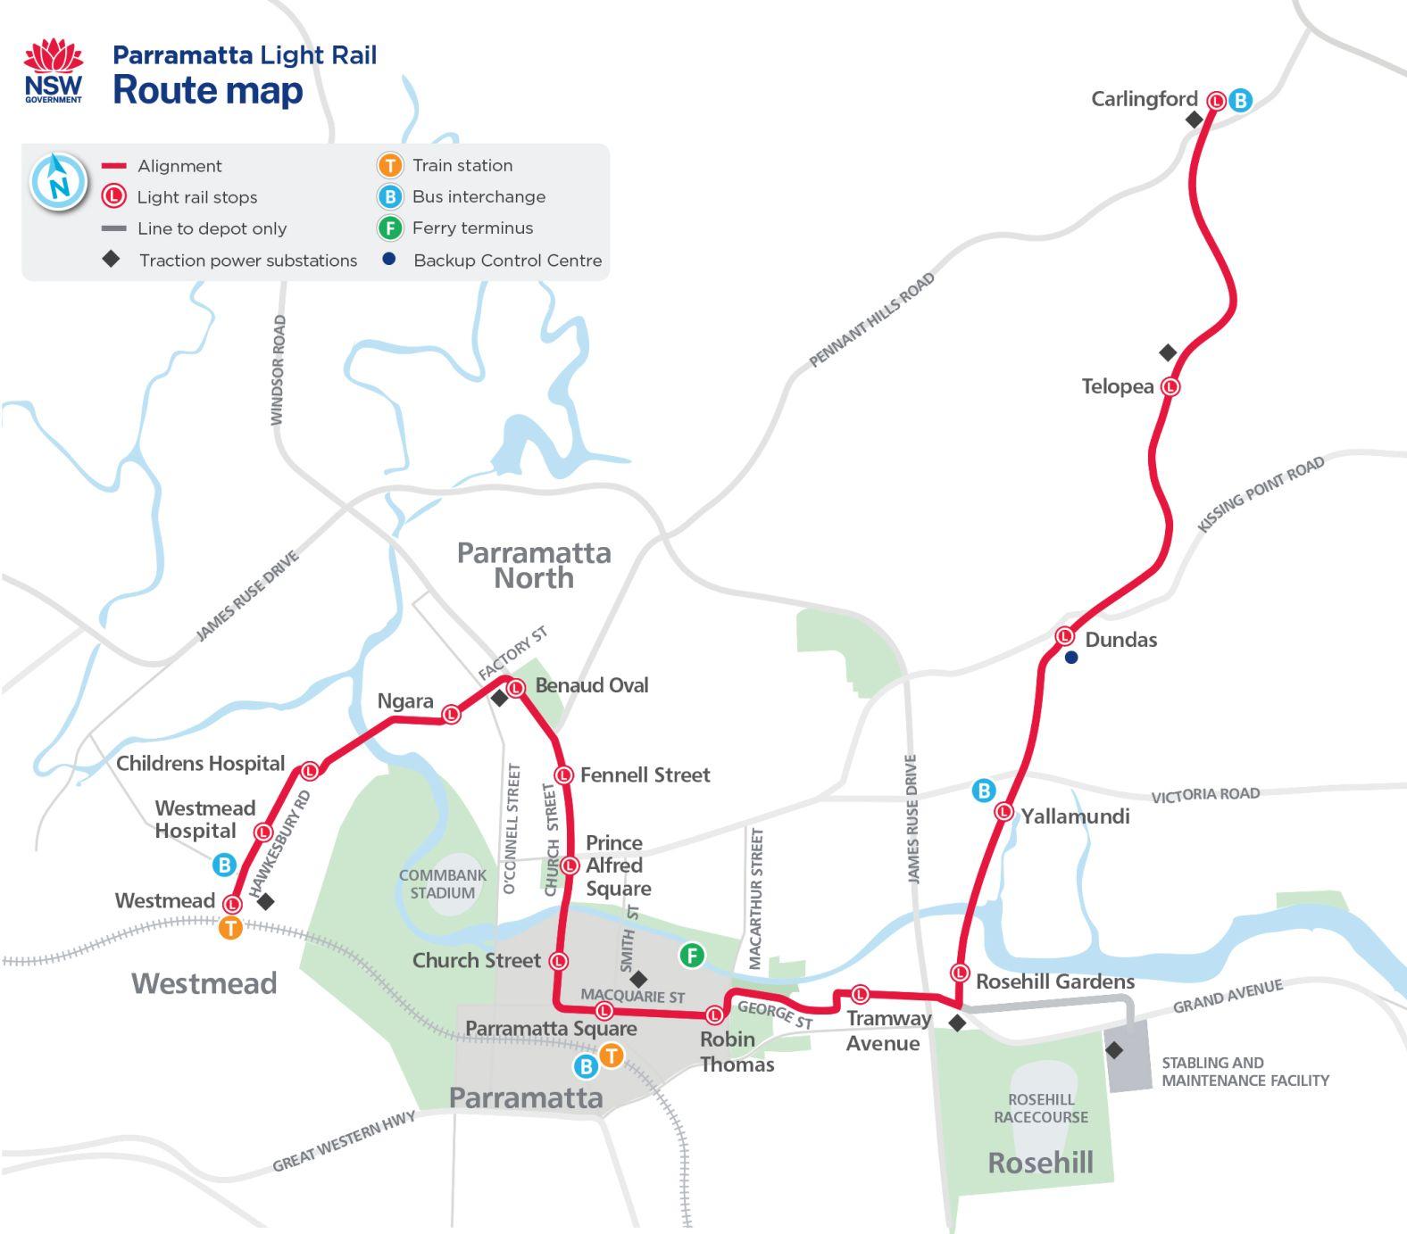
Figure 1. Project location and scope schematic

2. Problem Investigation and Interdependencies
This section analyses each challenge and the way risks propagate across time, cost, quality and safety. The analysis is framed through construction methodology choices, staging, constraints on access and possession windows, and the maturity of programme controls.

2.1 C1, Scope and interface complexity
Drivers. Stage 1 combines street running through a dense CBD, conversion of the former T6 Carlingford heavy rail alignment north of Camellia, and new works at the stabling and maintenance facility. Interfaces include third party utilities under Church and Macquarie Streets, heritage assets at Parramatta North, traffic and pedestrian management in a live city, and property access requirements. Multiple work packages and handover dependencies mean late design change in one area tends to cascade into re sequencing elsewhere. Integration of civil, trackform, systems, power, communications and depot interfaces requires a disciplined single source of truth and rapid decision pathways.
Construction implications. On street segments, the choice of slab track and embedded trackform constrains the sequence of utility relocation, subgrade preparation, track pour, cure, paving and streetscape reinstatement. In the corridor conversion segment, earthworks and drainage upgrades must account for legacy geometry and formation. The systems package has to keep pace with civil readiness while meeting type approval and assurance milestones.

2.2 C2, Geotechnical and corridor constraints
Drivers. Ground conditions vary between river terrace alluvium near the Parramatta River and denser residual soils and weathered rock on higher ground. Settlement thresholds are tight in CBD areas and around heritage structures. The corridor conversion must account for old ballast, formation contamination and drainage limitations. Water table management and dewatering are sensitive due to adjacent assets.
Construction implications. The observational method is suited to these conditions, supported by real time instrumentation, frequent trigger reviews and timely intervention. Lightweight fill, staged construction and ground improvement reduce risk of differential settlement. Strict quality control on slab track geometry helps maintain ride quality and limits future maintenance burden.

2.3 C3, Workforce capacity and industrial relations
Drivers. Brownfield rail adjacent works require additional accreditations and safety clearances. Peaks in labour demand coincide with other metropolitan megaprojects, which can drive attrition and productivity loss. In a live CBD environment, fatigue risks are heightened by extended possession windows and night works.
Construction implications. Effective labour planning requires package level resource smoothing, micro credentials for light rail specific tasks, and transparent subcontractor pipelines. A proactive IR strategy with clear escalation pathways supports productivity during critical path activities like track pours and systems testing.

2.4 C4, Cost and supply chain volatility
Drivers. Currency movements, global demand for traction power and signalling components, and constrained manufacturing slots for rollingstock and depot equipment increase exposure. Street works face price risk on aggregates, steel, and concrete. On systems, software assurance and cyber security requirements can change late in delivery.
Construction implications. Early hedging, frame agreements for long lead items, and modularisation where possible reduce exposure. Progressive assurance linked to risk based re forecasting keeps change visible and manageable.
Table 2. Cause and effect chain for each challenge
Challenge | Immediate causes | Systemic causes | Consequences for time, cost, quality, safety | Evidence sources
C1 | Late utility designs, third party approvals lag | Fragmented governance across packages | Re sequencing, street reopening delays, claim growth | NSW Government factsheets and updates
C2 | Variable ground conditions, legacy formation | Historic data gaps in brownfield corridors | Settlement risk, geometry rework | Technical updates and corridor conversion briefs
C3 | Overlapping peaks with other rail and road megaprojects | Limited training pipeline | Productivity loss, higher turnover | Industry labour market reports
C4 | Currency and commodity price shifts, long lead systems | Global supply chain shocks | Budget pressure, schedule risk | NSW Budget Infrastructure Statements and supplier advisories

Figure 2. Interdependency map

3. Best Practice Review, Local and Global
Comparator projects were selected for relevance to each challenge and the availability of documented outcomes. Transferable practices are prioritised where governance and market conditions in New South Wales are similar.
Table 3. Comparator cases and transferable practices
Project and year | Challenge addressed | Practice or tool used | What was different from business as usual | Outcome and evidence | Transferability to case
Crossrail, UK (phased opening 2022) | C1 | Integrated programme controls with a common data environment and weekly risk based re forecast | Interfaces visualised at package and system level with clear handover gates | Improved visibility of constraints and reduced latent integration defects | High with adaptation to TfNSW assurance processes
Metro North West, AU (opened 2019) | C2 | Observational method with strict trigger action response plans during station box and surface works | Instrumentation data drove micro adjustments in staging | Settlement kept within tight thresholds in sensitive precincts | High for brownfield surface rail environments
Canberra Light Rail Stage 1, AU (opened 2019) | C3 | Early training and accreditation pipeline for light rail operations and maintenance | Micro credentials across multiple subcontractors | Smoother mobilisation and fewer competency gaps at commissioning | Medium to high with supplier support
Øresund Link, DK SE (opened 2000) | C4 | Hedged procurement for critical systems and long lead items | Early frame agreements and currency hedging | Reduced exposure to market volatility | Medium with centralised procurement support
Figure 3. Practice maturity radar for the case project

4. Future Development and Opportunities
A pragmatic roadmap is proposed, balancing immediate operational needs with medium and longer term capability building. Actions are chosen for leverage and feasibility in the New South Wales context.

4.1 Immediate actions, 0 to 12 months
- Establish a single interface baseline across packages with weekly risk reviews and visual heat maps that drive executive decisions.
- Formalise the trigger action response plan regime for settlement and utility risk with clear thresholds and pre approved mitigation playbooks.
- Lock supplier slots for long lead systems and complete currency risk reviews with hedging recommendations.
- Launch targeted micro credentials for light rail civils, systems testing and commissioning, and depot operations in partnership with TAFE and OEMs.

4.2 Medium term actions, 1 to 3 years
- Create a state wide tunnelling and ground data trust that captures observational data, instrument readings and as built performance for future projects.
- Embed progressive assurance that links risk based schedule forecasting to funding drawdown and variation governance.
- Implement framework agreements for traction power and signalling equipment with standardised specifications across programmes.
- Expand accredited night works fatigue management standards with digital rostering to manage cumulative risk.

4.3 Longer term actions, 3 to 10 years
- Develop a sustained workforce pipeline for city shaping rail with micro credentials that stack into diplomas and degrees.
- Establish a rail systems software assurance centre of excellence to shorten type approval cycles while maintaining safety and cyber maturity.
- Roll out a shared asset information model standard for street running rail that integrates utilities, pavements and trackform for whole of life benefits.
Table 4. Action roadmap
Time horizon | Action | Owner, agency or market | Dependencies | Expected benefit | How to measure
0 to 12 months | Single interface baseline and weekly risk review | Delivery authority and package leads | Common data environment in place | Fewer interface driven delays | P50 to P90 variance and number of unresolved clashes
0 to 12 months | TARPs for settlement and utilities | Delivery authority and contractors | Agreed thresholds and playbooks | Faster mitigation and less rework | Count of TARP activations resolved within SLA
1 to 3 years | Ground data trust | State agencies and industry | Data governance and funding | Better geotechnical predictability | Variance between GBR and as built
1 to 3 years | Frameworks for long lead systems | TfNSW with suppliers | Standard specifications | Reduced procurement risk | Schedule hit rate for deliveries
3 to 10 years | Rail workforce pipeline with stackable micro credentials | Industry and TAFE | Funding and curriculum | Stable labour supply and productivity | Attrition and utilisation rates

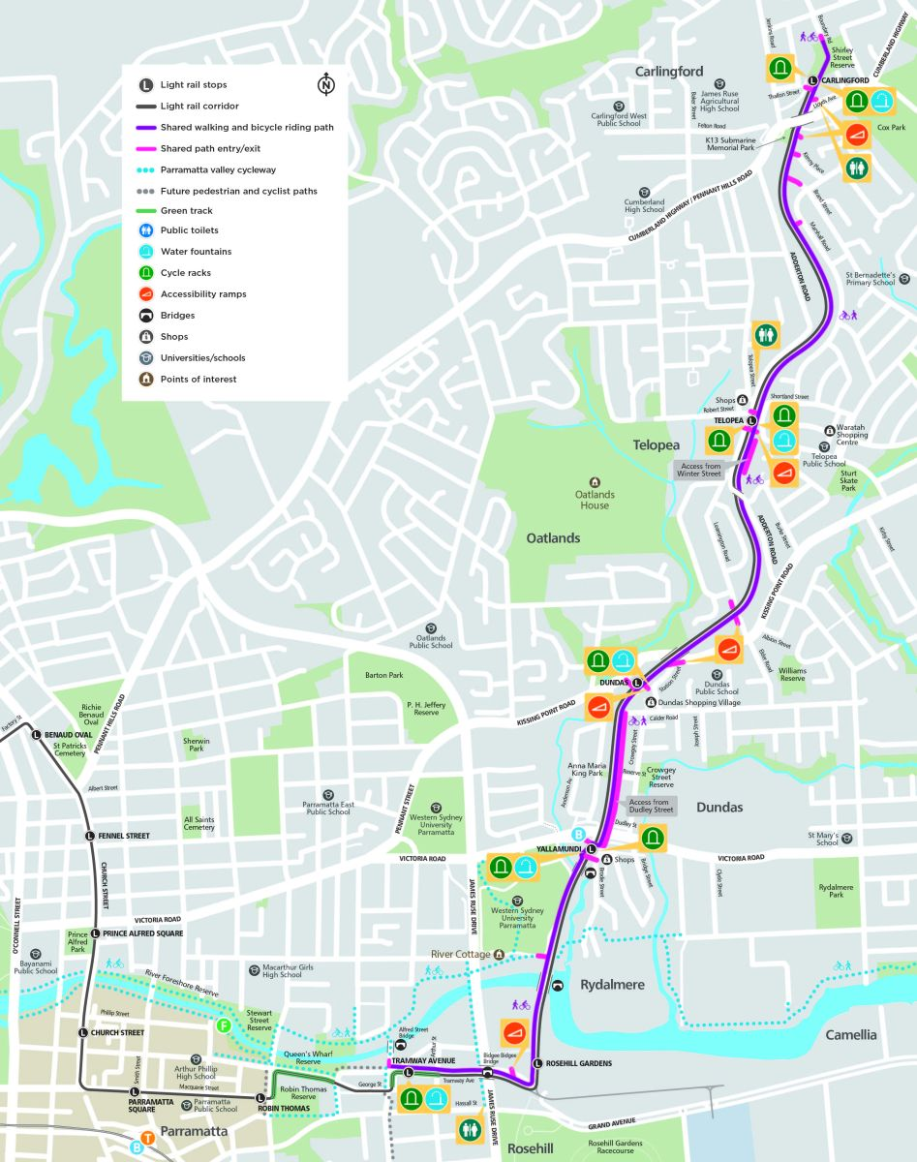
Figure 4. Implementation roadmap, swim lanes by owner

5. Conclusion
The case exhibits four intertwined challenges. Interfaces stretch across utilities, heritage and multiple packages. Brownfield ground conditions and legacy formation create settlement and staging risks. Workforce capacity and IR pressures influence productivity and safety. Global volatility and long lead systems affect cost and schedule. Proven practices from Australia and abroad indicate that an integrated interface baseline, observational geotechnical management supported by real time monitoring, structured workforce credentials, and hedged procurement can materially lift performance. The proposed roadmap converts these lessons into practical steps suited to the local governance and market context.

References
ABC News 2024, Parramatta light rail opening delayed again after discovery of faulty components, viewed December 2024.
NSW Government 2025, Parramatta Light Rail, project overview and maps, viewed October 2025.
NSW Treasury 2025, Budget Paper No. 3 Infrastructure Statement, viewed June 2025.
Transport for NSW 2025, Parramatta Light Rail L4 line information, viewed 2025.

Appendices
Appendix A, Risk register extract
Risk ID | Description | Cause | Existing controls | Residual rating | Proposed treatment
R1 | Settlement at CBD slab track segment exceeds threshold | Variable ground and utilities voids | Instrumentation and TARPs | Medium | Pre emptive ground improvement and staged pours
R2 | Late utility relocation delays track pour | Third party design lag | Weekly interface reviews | Medium | Escalation gates and pre agreed temporary works
R3 | Systems integration test slippage | Long lead equipment and assurance | Progressive assurance calendar | Medium | Frame agreements and software assurance centre support
Appendix B, Possession window logistics
Window | Activities | Plant and crew | Dependencies | Risks | Mitigations
Night possession 1 | Utility relocation under Church Street | Vacuum trucks, traffic control, crews of 12 | Service proving complete | Clash or unknown service | Update model and adjust staging
Night possession 2 | Slab track pour stage 1 | Pumps, finishing crew of 10 | Subgrade signed off | Weather, supply delay | Contingency batch and tenting plan
Appendix C, Stakeholder interface matrix
Stakeholder | Interest | Influence | Interface points | Engagement strategy
Local businesses | Access and amenity | Medium | Night works and traffic changes | Advance notice, access management and wayfinding
Health precinct | Safe access and reliable operations | High | Westmead stops and crossings | Dedicated liaison and peak hour protections

