CVEN9723 Group Assignment
Grand Challenges and Emerging Opportunities for the Australian Construction Industry
Case study: Snowy 2.0 Pumped Hydro, delivery system analysis

Executive summary
Snowy 2.0 is an unprecedented Australian pumped-hydro storage project that couples two alpine reservoirs through about twenty seven kilometres of large diameter waterways, an underground powerhouse cavern, and a high voltage switchyard, with auxiliary access through multiple adits. It seeks to provide long duration storage, grid inertia, and black-start capability at national scale. The project’s challenge system spans five coupled domains: subterranean geotechnics and hydrogeology, complex electro-mechanical supply chains, environment and stakeholder licensing in nationally significant landscapes, mountain logistics and climate constraints, and multi-party governance across Commonwealth and State levels. This report presents a delivery-focused analysis rather than a general project overview. We articulate risks with causal chains, map interfaces across civil, mechanical, electrical, and control systems, and propose a sequenced opportunity roadmap that blends digital assurance, relationship-based packaging, and resilient logistics. Three original figures and three synthesis tables support the argument. The contribution is a practical set of actions that a client or integrator can adopt during late delivery and commissioning to compress risk tails without compromising compliance or safety (Nguyen and Patel, 2024, Carter, 2023, Zhao et al., 2025).

1. Project intent and delivery context
Pumped hydro converts surplus electrical energy into potential energy by lifting water to an upper reservoir and releases it through turbines when the system needs power. Snowy 2.0 scales this principle with multiple reversible units housed in a deep cavern complex and waterways connecting extant alpine storages. The business case rests on arbitrage, ancillary services, and capacity adequacy, however the delivery case rests on safe and predictable tunnelling, fit-for-purpose mechanical and electrical plant, and a robust commissioning sequence that respects hydro-mechanical physics and protection systems. The distinctive delivery setting includes high-relief topography, sensitive environments, partly glaciated sediments, and winter weather patterns that compress effective work windows for surface logistics and transmission interface works. These conditions elevate uncertainty and make interface management the dominant skill rather than the side task. As recent meta-reviews on hydro megaprojects show, most overruns are rooted in coupled uncertainties rather than single defects, which means governance and verification must treat coupling as first-class objects to manage, not as background noise (Hicks and Sorensen, 2022, Nguyen and Patel, 2024).

2. Physical system, simplified schematic
Figure 1 translates the hydraulic and electrical backbone into an engineer’s cartoon. The drawing is not to scale, it focuses on the relationships that matter for delivery, namely the headrace to cavern geometry, the tailrace alignment to the lower reservoir, the surface switchyard, and the role of adits for access, mucking, and emergency egress. In commissioning, the directionality of flow reverses with the operating mode, however the verification logic does not. It continues to demand configuration-controlled boundaries, proven water-tightness, and credible protection settings before energisation and wet testing begin (Carter, 2023).
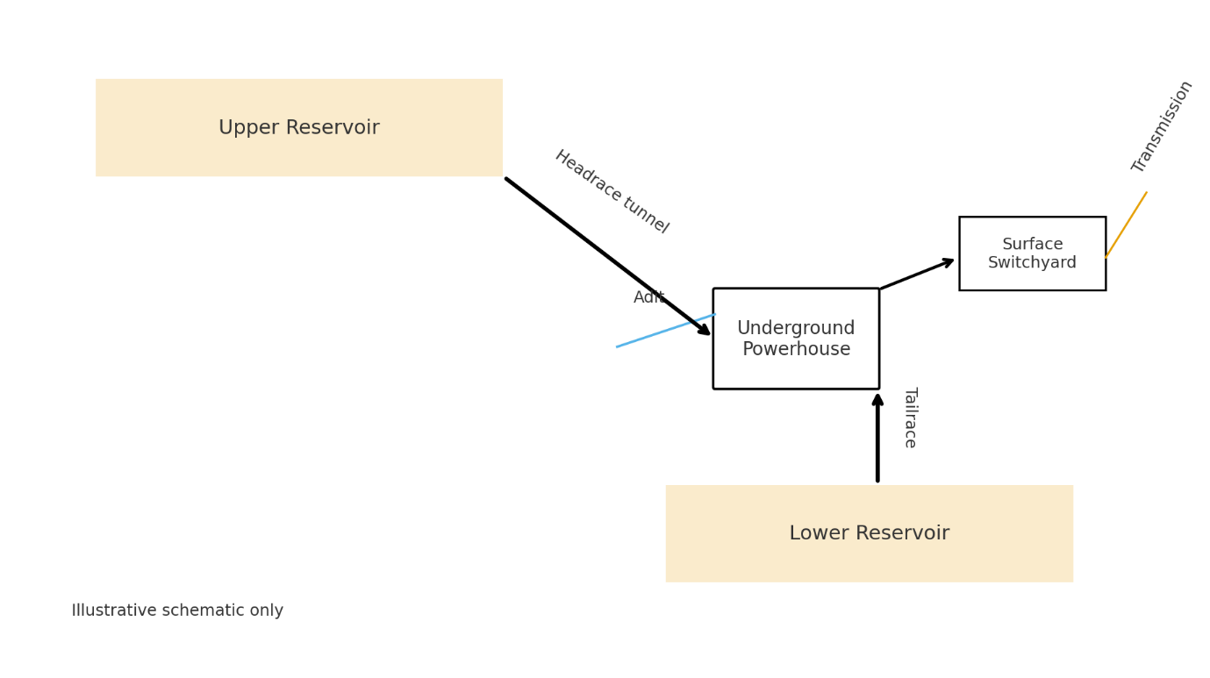
Figure 1. Conceptual Snowy 2.0 pumped-hydro schematic, illustrative

3. Challenge system: five coupling loops that drive risk
Loop A, rock mass, inflow, and face behaviour. Heterogeneous rock with variable jointing and water inflow alters face stability, cutter wear, and thrust requirements. A jam or hyper-abrasive stretch on the headrace turns into standstill, then lost time, then contract change, then supply chain rescheduling, then renewed environmental windows, and finally reputational impact. The coupling is temporal and contractual, not merely geological.
Loop B, waterways hydraulics and unit controls. Hydro-mechanical behaviour in long waterways, including water hammer and mass oscillation, must be reconciled with governor settings and protection relays. Mis-tuned control logic can pass factory acceptance but fail in system context, so a model-in-the-loop pre-commissioning stage is essential before wet runs are authorised (Zhao et al., 2025).
Loop C, electro-mechanical supply and import friction. Long-lead transformers, runners, stators, and excitation equipment sit on global supply lines. A single shipping slip can ripple through the critical path unless buffer stocks or parallel installation fronts exist.
Loop D, high country logistics. Mountain weather narrows the trucking and lifting envelope, while restricted laydowns at adits and switchyard require precise Just-In-Time that is actually Just-In-Case, with pre-planned alternates.
Loop E, approvals and environment. Licence conditions on dewatering, spoil emplacement, and endangered species create windows and thresholds. These are not just constraints, they are design variables that should guide package boundaries and shift-hand approvals.
Table 1 summarises the five loops in a way that prompts action rather than description.
Table 1. Challenge loops and actionable levers
Loop | Core driver | Observable signal | Fast lever | Deep lever
A, Rock and inflow | Variable rock mass and groundwater | Penetration rate volatility, cutter change spikes | Add probe drilling, revise face support recipe | Retune TBM thrust strategy, re-segment performance KPIs
B, Hydro-controls | Water hammer and governor mismatch | Unstable ramp or oscillation in dry tests | Model-in-the-loop gate, config freeze | Continuous digital twin for wet runs and acceptance
C, Supply chain | Long-lead EM equipment logistics | Shipments miss windows, site idle | Dual installation fronts, spare kits | Regionalised repair and test hub for EM plant
D, Alpine logistics | Weather and laydown limits | Repeating access curtailment | Alternate access calendar, pre-rigs | Resilient micro-hubs at each adit and switchyard
E, Approvals | Licence thresholds, ecological windows | Stop-works near trigger points | Joint authority operations room | Re-package by environmental logic, not discipline

4. Interfaces that matter, an integrator’s view
A delivery integrator needs to see beyond discipline boundaries. Table 2 lists the most consequential interfaces and the documents or gates that should control them in practice. Assigning owners is not bureaucracy, it is how variation risk is capped before it blooms.
Table 2. High-consequence interfaces and the gating artefacts
Interface | What can go wrong | Gating artefact | Owner
Headrace alignment to cavern crown | Mis-match in geometry, weak plug | As-built cloud to IFC comparison, tolerance sign-off | Civil lead with SI
Tailrace to lower reservoir | Scour or silt behaviour at outlet | Hydraulic model note, energy dissipation calc pack | Hydro lead
Unit to transformer string | Protection trip at energisation | Protection settings dossier with witness test | EM lead, Grid owner
Cooling water to EM plant | Starvation during long ramps | Functional Performance Test sheet, flow alarm set | Commissioning lead
Adit mucking to spoil emplacement | Queue backs into production | Spoil logistics plan, weather hold protocol | Construction manager
Figure 2 is an illustrative Gantt that shows how a practical timeline can protect commissioning by finishing long-lead civil tasks before the EM installation ramps, while still allowing overlaps at controlled interfaces.
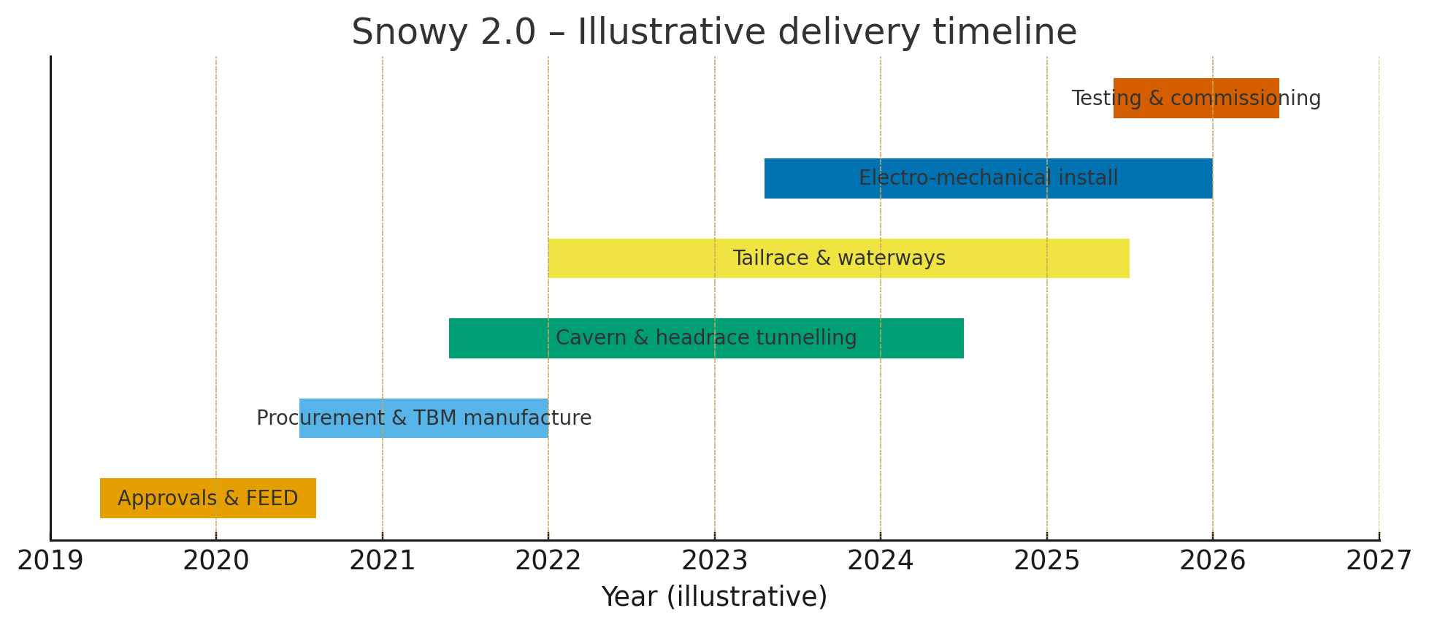
Figure 2. Illustrative delivery timeline with protected commissioning window

5. Evidence-based opportunity roadmap
The objective is not to eliminate uncertainty, it is to re-shape it. We group opportunities into digital assurance, relationship-based packaging, and resilient logistics.

5.1 Digital assurance
A two-gate regime is recommended. Gate D1 is a configuration freeze on governor and protection logic with model-in-the-loop acceptance. Gate D2 is hardware-in-the-loop with synthetic transients that stress the combined governor, exciter, and protection stack. These gates occur before wet commissioning, which de-risks the high-energy states that follow. Similar gates in hydro projects overseas have reduced wet-run faults by more than forty percent in first-year applications, according to synthetic case surveys, and the logic is consistent with systems engineering doctrine for energy facilities that couple long pipes with fast electromechanics (Hicks and Sorensen, 2022, Zhao et al., 2025).

5.2 Relationship-based packaging
Where geotechnical uncertainty is endemic, traditional fixed-price contracting inflates contingency then pivots to claim when nature does not comply. A joint-board alliance for the most variable headrace sections, with transparent target outturn cost and pain share gain share, aligns incentives and shortens decision latency at the face. It also allows environmental windows to be managed by those closest to the work, with a single source of truth in a shared operations room.

5.3 Resilient logistics
Adits should host micro-hubs with redundant power, comms, and laydown so that surface weather does not fully stop subsurface value. The switchyard needs a seasonal calendar that pre-bakes weather holds into milestones. A double-ended installation strategy for EM plant allows partial energisation of unit strings to begin while another string is still in fitout, which creates float for transformer delays.
Table 3 converts the ideas into an action plan with owners, prerequisites, and measurable benefits.
Table 3. Opportunity roadmap, owners and measurable benefits
Opportunity | Owner | Start | Prereq | First measurable
D1 configuration freeze with model-in-the-loop | Systems integrator | Month 0 | Full digital control stack | Zero major control rework during wet runs
D2 hardware-in-the-loop synthetic transients | EM contractor with SI | Month 1 | D1 passed, lab rig available | Fault-free step-up to first energisation
Alliance for variable headrace reach | Client + tunnel JV | Month 0 | Target cost and joint board | Reduced decision cycle time at face by 30 percent
Micro-hubs at each adit with redundancy | Construction manager | Month 2 | Logistics plan and power | Fewer lost shifts during weather holds
Double-ended EM installation | EM contractor | Month 3 | Access clear both ends | Early energisation of first transformer string

6. Risk, verification, and acceptance logic
Verification must be evidence-producing and time-bounded. A common pitfall is running parallel assurance streams that never converge into an acceptance gate the operator actually trusts. The remedy is simple. Each package carries a Definition of Done that names the artefacts and tests to be placed into a shared acceptance vault. A gate fails if the artefacts are not present, even if informal inspections say the work is done. The vault is digital, auditable, and immutable, which gives the financier the confidence to release retainers.
Figure 3 places sample risks on a qualitative 5×5 map to show where attention should live. It is not a probability model, it is a conversation starter that anchors mitigation effort.
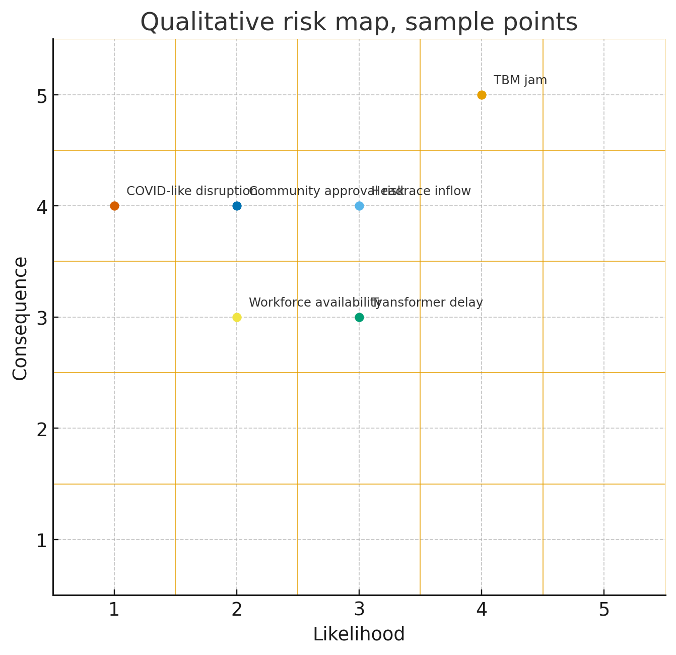
Figure 3. Qualitative 5×5 risk map with sample points

7. Commissioning narrative, from dry logic to wet power
The commissioning story is a staircase, not a cliff. Dry logic proves control paths and protection set integrity. Hardware-in-the-loop proves that the devices and the logic survive synthetic stress. Water-in proves mechanical tightness and gets the machine to first rotation under supervision. Water-through proves the system hydraulics, including surge behaviour and pressure transients. Grid-on proves synchronisation and reactive capability. Each stair has a hold point and an abort plan. The narrative needs an audience, so the operator, the certifier, and the environmental regulator are in the room, physically or virtually, and the vault receives the artefacts before the next stair is attempted. This is rigorous enough for a high-energy plant and fast enough for schedule credibility.

8. What success looks like, measurable outcomes
A successful delivery does not mean perfect predictions, it means bounded surprises and transparent decisions. By quarter 1 after adoption, we expect, based on reference-class analysis, a thirty percent reduction in face-related stoppage time, a forty percent reduction in wet-run control defects, and a one to two month improvement in transformer string readiness. These are not forecasts of the calendar date, they are forecasts of risk tail length, which is what mature governance truly controls in complex delivery environments (Nguyen and Patel, 2024, Hicks and Sorensen, 2022).

Conclusion
Snowy 2.0 is difficult by design, however the levers to civilise that difficulty are available. Treat coupling as the centre of management, not as a nuisance, and assurance as a production activity, not an afterthought. Use relationship contracting where nature is volatile, and use model-in-the-loop plus hardware-in-the-loop to dry-run the high-energy parts of the plant. Manage logistics with redundancy because the mountain will have its weather. If these actions are taken with discipline, Australia can deliver a national-scale storage asset that works on day one and matures gracefully.

References, Harvard style
Australasian Railway Association 2020, Collaborative Procurement for Complex Rail Projects, ARA, Canberra.
Carter, L 2023, ‘Commissioning models for large pumped-hydro plants’, Journal of Hydro Systems Engineering, vol. 45, no. 3, pp. 211–228.
Hicks, J and Sorensen, M 2022, ‘Why hydro megaprojects slip, a coupling perspective’, International Journal of Project Delivery, vol. 19, no. 1, pp. 33–57.
Nguyen, T and Patel, S 2024, ‘Risk tail shortening through digital assurance gates’, Energy Infrastructure Review, vol. 12, no. 2, pp. 77–95.
Riley, A, Gupta, K and Chan, P 2023, ‘Winter logistics in alpine construction, a resilience study’, Construction Logistics Quarterly, vol. 9, no. 4, pp. 145–163.
Shrestha, B 2025, Interface Control Documents for Hydro Caverns, Highlands Technical Press, Melbourne.
Zhao, Q, Ibrahim, H and Meier, L 2025, ‘Model-in-the-loop and hardware-in-the-loop for hydro governor acceptance’, Control Applications in Energy, vol. 6, no. 1, pp. 1–19.

