

School of Computer Science and Engineering

*The University of New South Wales*

**SENG2021 – Requirements and Design Workshop**

Term 1 – 2019

**Raisin**

Date of Submission: 08/03/2019

Submitted by: Richard Liu (z5165455)

Rory Madden (z5208738)

Yorke Li (z5207298)

Faiz Ather (z5170340)

**Group Info:**

**Name:** digital_invention (formerly NoName3)

**Mentor:** Christopher Joy

**Meeting Day:** Tuesday

**Meeting Time:** 1:20PM – 1:40PM

Contents

1 Concept Introduction 1

2 Problem Statements 2

3 Features & User Stories 3

4 Lo-Fidelity Prototype 7

5 High-Fidelity Prototype 9

# Concept Introduction

Our project will focus on fulfilling the needs of a UNSW WebCMS3 student who does not have the time to overview the course outlines for their currently enrolled courses. Thus our web application will provide the user with the ability to view all of their courses’ weighted material (Assignments, Class Tests, Laboratory Exercises, etc) and their respective deadlines through an automated process. After displaying a summary of all of the courses the user will then have the option to export the assessment tasks onto a digital calendar (Google Calendar or iCal) at their specific due dates.

# Problem Statements

(1) There is no way for a UNSW student using WebCMS3 to view all their due dates for a specific course without reading the course outline

(2) A UNSW WebCMS3 student must thoroughly search the entire course outline on WebCMS3 to verify they have accounted for all due dates for a specific course

(3) A UNSW WebCMS3 student cannot view their entire due dates for all assessable content from all their courses on WebCMS3 in a single centralised place

(4) A UNSW WebCMS3 student must manually insert all their courses’ due dates into their digital calendar

# Features & User Stories

Each user story of each respective feature will be presented together such that their priority can be explicitly represented. Each user story will embrace SMART principles so that our project can be realistically visualised to achieve success.

The figure below explains the priority scale for our project

|  |  |  |
| --- | --- | --- |
| **Priority Level** | **Description of feature** | **Urgency** |
| Priority 1 | Essential for the application to function. | Must be completed first. |
| Priority 2 | Improves the quality of the application’s necessary functions. | Should be completed directly after all priority 1 tasks are completed. |
| Priority 3 | Improves the quality of the application by providing more useful features. | Can be implemented if time permits, only if all priority 2 tasks are completed. |

Figure 1: Feature Priority Table

|  |
| --- |
| **Priority Level:** 1 |
| **Feature** |
| **Feature:** View all course commitments  **As A** UNSW WebCMS3 student  **I Want To** be able to view all my course assessments together on a single page  **So That** I am prepared for my entire term |
| **Scenario** |
| **Scenario:** Course Outlines have just been released  **GIVEN** I am on Raisin’s Course Assessment Selection page  **WHEN** I have checked all the boxes for the course assessments  **AND** clicked the “Next” button  **THEN** I should be navigated to a new page displaying all of a summary of all my course assessments and their deadlines |

|  |
| --- |
| **Priority Level:** 2 |
| **Feature** |
| **Feature:** All course assessments can be transferred onto a digital calendar  **As A** UNSW WebCMS3 student  **I Want To** be able to export all my course assessments to a digital calendar  **So That** I can complete my assessments on time |
| **Scenario** |
| **Scenario:** Raisin has just completed gathering all of the course assessments  **GIVEN** I am on Raisin’s Assessment Summary page  **WHEN** I click on the “Google Calendar” or “iCal” button  **AND**  **THEN** |

|  |
| --- |
| **Priority Level:** 3 |
| **Feature** |
| **Feature:** To alternate how I can view the organisation of my course assessments  **As A** UNSW WebCMS3 student  **I Want To** have the ability to toggle how my course assessments are displayed  **So That** I can organise my commitments each week or to each course accordingly |
| **Scenario** |
| **Scenario:** Raisin has just completed gathering all of the course assessments  **GIVEN** I am on Raisin’s Assessment Summary page  **WHEN** I click on a button called “Courses”  **THEN** the course assessments should be arranged by each individual course, which is organised by week  **WHEN** I click on a button called “Week”  **THEN** the all course assessments should be organised into their respective weeks |

# 4GB:img-190306151016.pdfLo-Fidelity Prototype

Figure 1: Storyboard Interactions Graphs

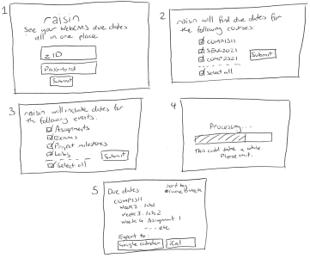

Figure 2: Storyboard interactions + UI Component Sketch

# High-Fidelity Prototype

A simple interactive prototype of our website can be viewed through opening the HTML files in any web-browser. Hence the buttons allow navigation to the next webpage. This initial user interface of our website provides an insight as to how a UNSW student using WebCMS3 can operate our application.

These HTML files can be found in the ‘master’ branch, in the ‘html’ directory, and the user interface file is the ‘index.html’. These user interface webpages of our website can also be viewed through the figures below.

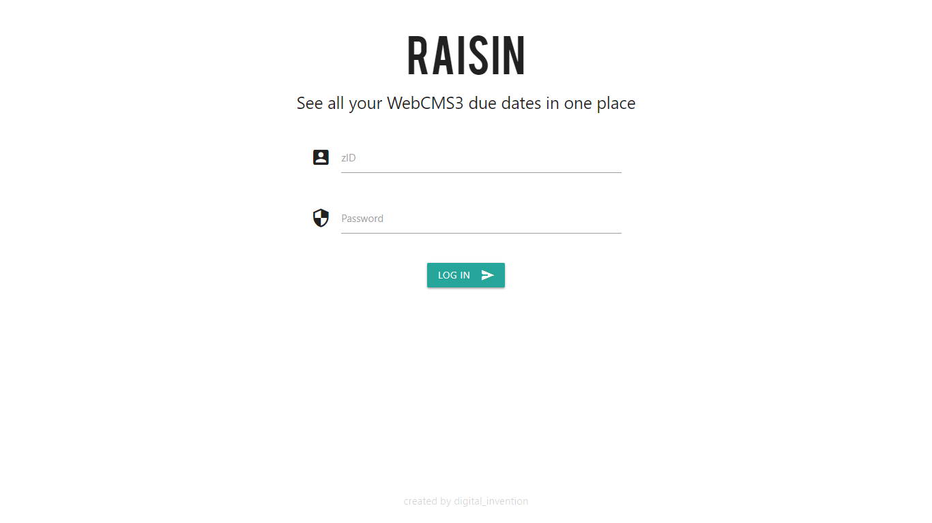

Figure 1: Raisin Login Interface

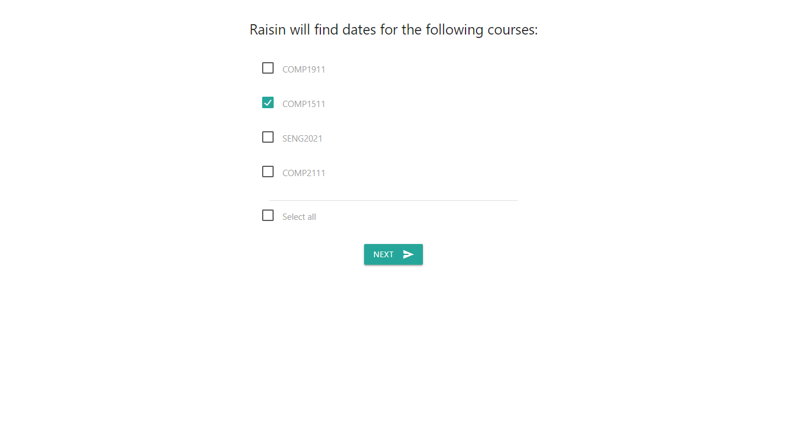

Figure 2: Raisin Course Selection Interface

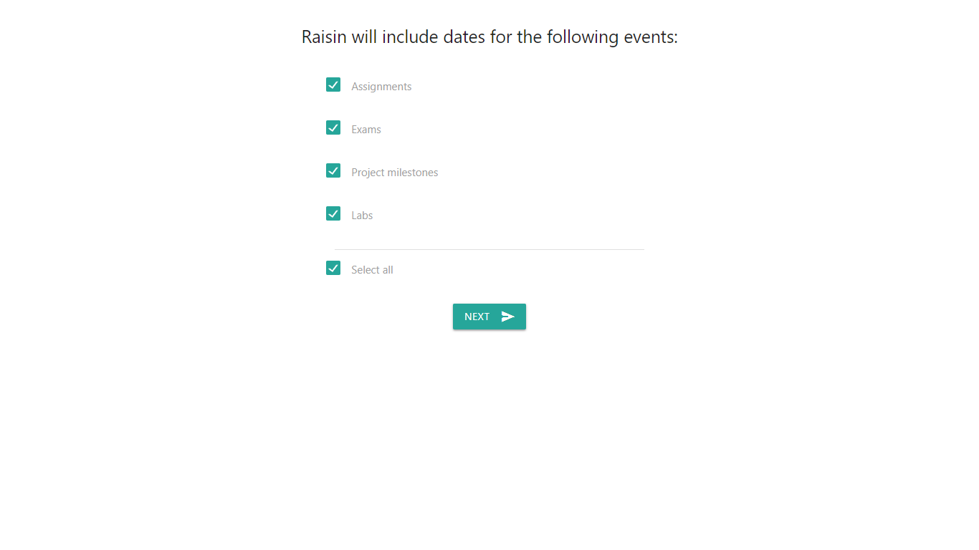

Figure 3: Raisin Course Deadlines Interface

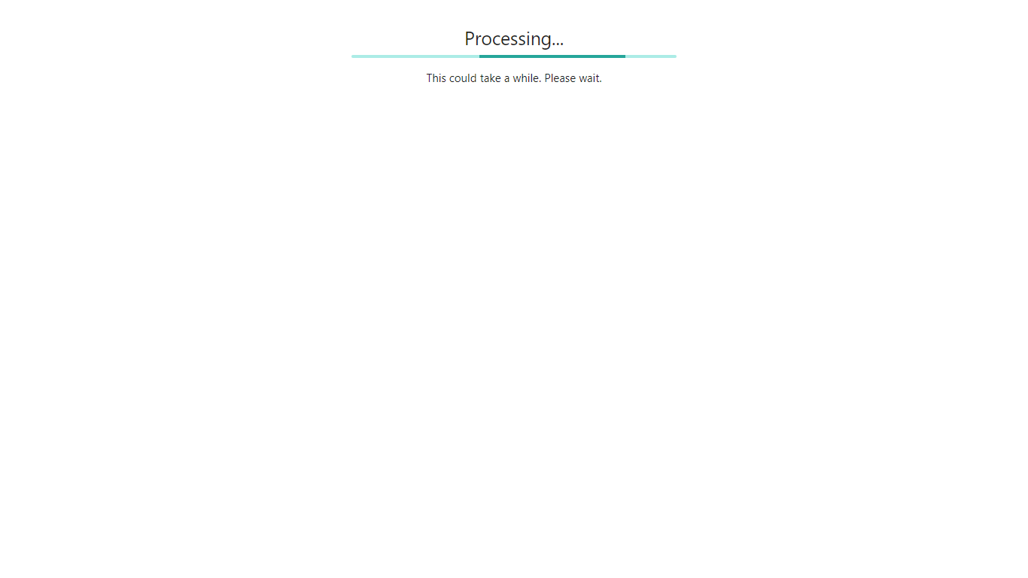

Figure 4: Raisin Loading Screen Interface

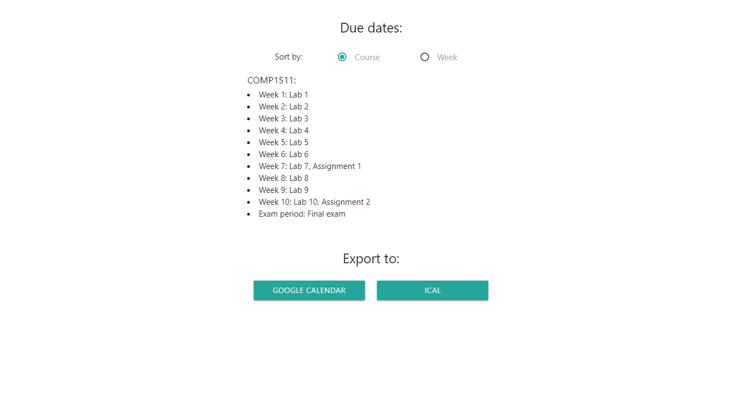

Figure 5: Raisin Course Weighted Assessments Interface