Ethical and Technical Analysis of NSO Group and Pegasus Spyware

Jasper Fries
jasper.fries@digipen.edu

INTRODUCTION
This paper investigates the ethical questions surrounding the use of spyware by governmental organizations to spy on populations. Government surveillance is analyzed in the context of Jamal Khashoghi’s murder, and the international outcry that followed when NSO Group’s spyware Pegasus was revealed to be associated with his death, among others. Is it ethical for a government or public agency to spy on a population without their consent in the interest of national security? We will approach this question from two perspectives: a government using spyware against its own population, and against other countries' populations.

BACKGROUND INFORMATION

Stakeholders
- Spyware Companies: Organizations that produce (and potentially market) spyware, such as the NSO Group. They have an interest in the continued use of spyware, as they have made significant investments in spyware and stand to gain much from its continued use. This also includes governments that develop their own sophisticated spyware, such as the US or China.
- Spyware Clients: Governmental organizations that have a significant interest in spyware but find it less effective to develop it themselves. This includes many smaller, more authoritarian governments that want to monitor or control dissidents inside their countries.
- Influential people and those challenging the status quo: Politicians, reporters, activists, wealthy individuals, and so on are all valuable targets for monitoring by their own government. Spyware is being used against them, potentially to their detriment.
- General population: The general population of a country, which is more stable due to its use of spyware. It could be positive or negative for them, depending on whether they support the status quo.
- High-value foreign individuals: Very powerful foreign leaders (such as Emmanuel Macron) who are targeted by foreign nations’ spyware.
It should be noted that there is significant overlap among these stakeholder groups. A powerful official in a government that purchases and uses spyware may be a high-value target for another country. A member of the public who feels the benefits of stability from their government’s use of spyware may unwittingly be spied on for being a journalist or otherwise influential individual.

NSO Group
The NSO Group is an Israeli Cyber-Intelligence firm founded in 2010. Their main product is the spyware Pegasus, which they sell to both democratic and authoritarian governments. In 2016, the NSO Group charged governments $650,000, plus a $500,000 set up fee to install Pegasus spyware on 10 phones.

Pegasus Spyware
The spyware Pegasus takes complete control of infected mobile devices without the user knowing. As targets continue their typical use of their phone, Pegasus records all photos, files, and messages on or sent by the device. This includes content present on the device since before it was infected, and content deleted from the device after it was infected. It can also activate the microphone, camera, or access secondary apps like WhatsApp to acquire additional information.

EVENT ANALYSIS

Events before
Analysis of the events that are antecedents to the ethical question (What happened before?)
In 2020, the non-profit organizations Forbidden Stories and Amnesty International were given a leaked list of over 50,000 phone numbers claimed to be targets of the Pegasus spyware. This launched an international investigation involving over 80 reporters from 17 different news organizations [8]. As part of the investigation, named Pegasus Project, they searched through the phone numbers for both influential individuals and people who would be willing to hand over their phones for forensic analysis to check for the spyware and confirm the validity of the list.

Events during
The resulting investigation showed that the Pegasus spyware had been widely misused by the NSO Group’s government customers. According to Forbidden Stories:
“The leaked data showed that at least 180 journalists have been selected as targets in countries like India, Mexico, Hungary, Morocco and France, among others. Potential targets also include human rights defenders, academics, businesspeople, lawyers, doctors, diplomats, union leaders, politicians and several heads of states.”[8]
Despite claims about vetting customers and the enforcement of proper use of Pegasus, the NSO group decided to sell its product to many authoritarian regimes with poor human rights records, including Azerbaijan, the United Arab Emirates, and Saudi Arabia.

Assassination of Jamal Khashoggi
In October 2018, Jamal Khashoggi was murdered at the Saudi consulate in Istanbul. The murder was carried out by assassins dispatched by Saudi Arabia, which is a client of the NSO Group [6]. The investigation coordinated by Forbidden Stories revealed that the phone of Jamal Khashoggi’s wife, Hanan Elatr, was infected with Pegasus several months before his death. Sometime between November 2017 and April 2018. In addition, four days after Jamal Khashoggi’s murder, the phone of his fiancée, Hatice Cengiz, was infected with Pegasus. These events exposed a concerning example of Pegasus spyware being leveraged against a journalist. While the NSO Group claims that they police the responsible use of their Pegasus spyware, which is specifically intended for use against criminals and terrorists, the assassination of Jamal Khashoggi contributed to international outcry about its widespread misuse.

Foreign Surveillance on French Politicians
According to the Pegasus Project, the mobile phone of François de Rugy was targeted with Pegasus spyware while he was France’s environment minister. The list of phone numbers also included the French president Emmanuel Macron and much of his cabinet. In total, 14 current members of France’s government appear in the list.[13]
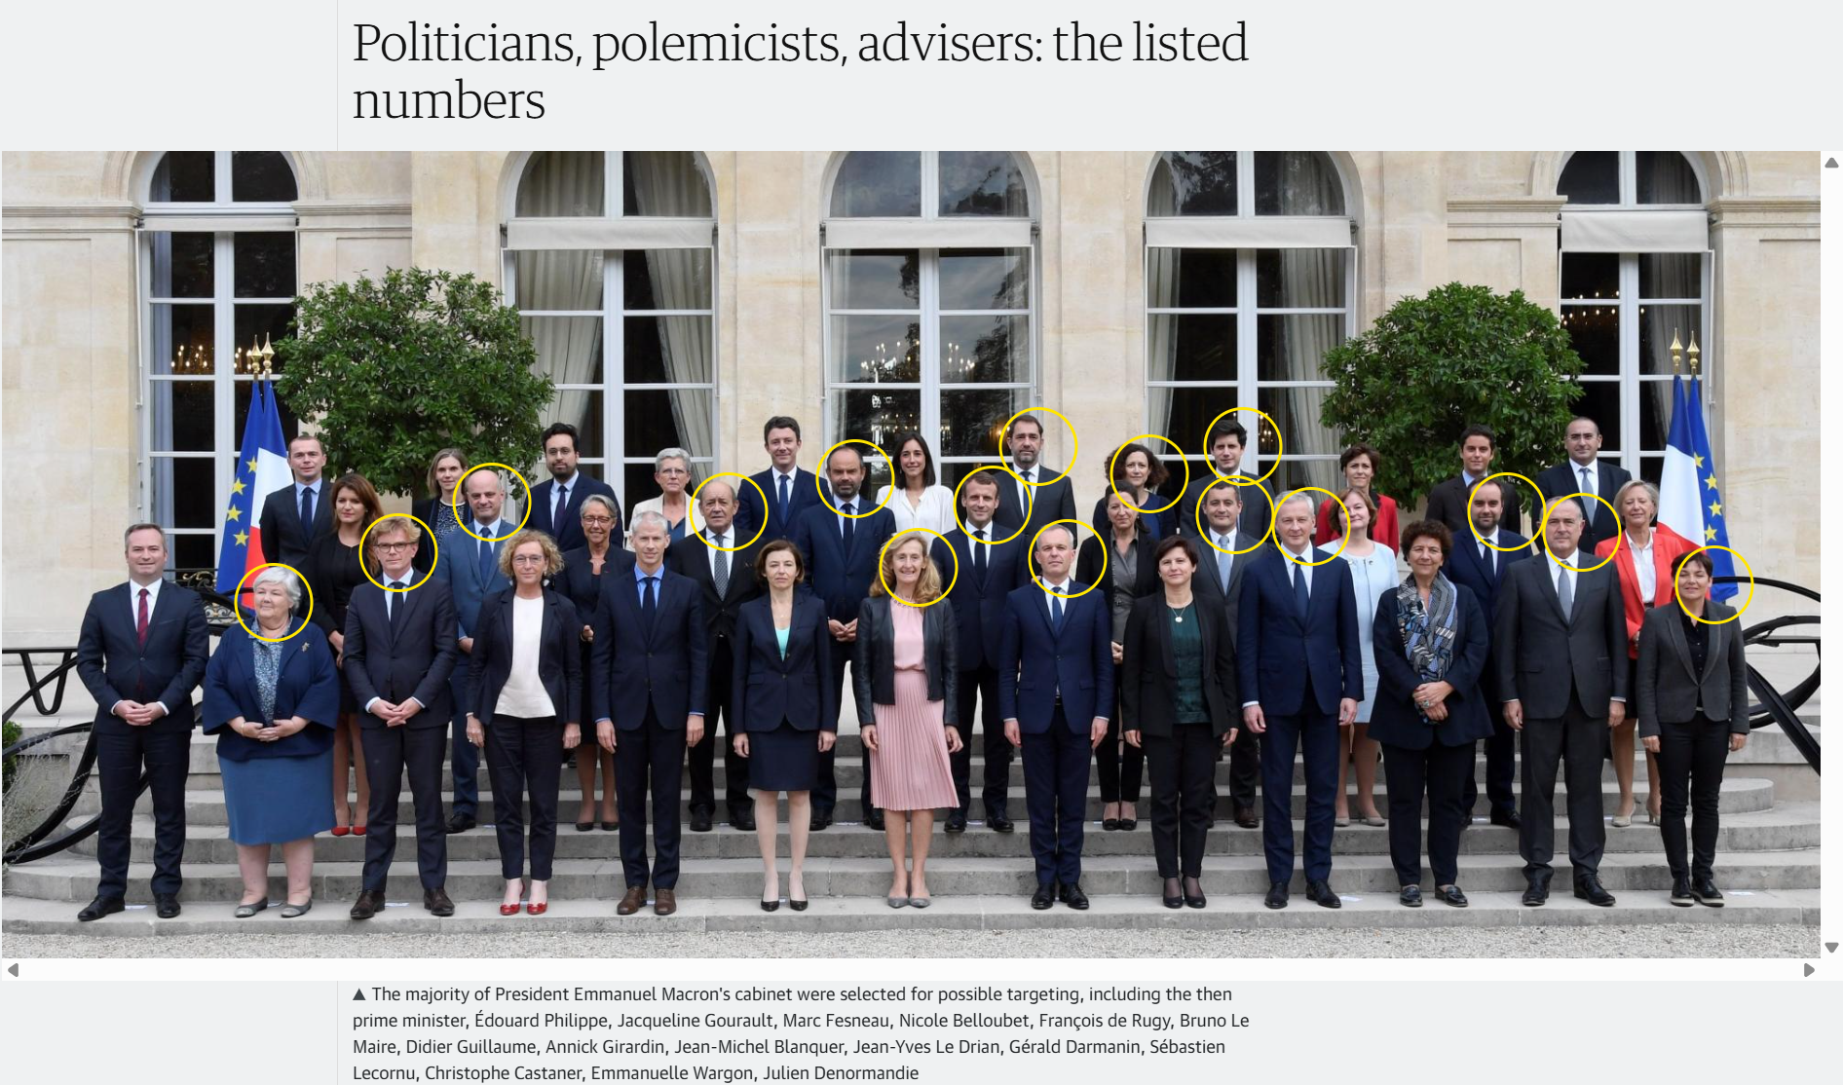
Image [13]
The Pegasus Project suggests that Morocco was likely using Pegasus to spy on Emmanuel Macron and his cabinet. Separately, the organization Citizen Lab confirmed with separate research that a Moroccan NSO Client infected telephones in Belgium in 2020, and in France from 2018 to 2021.[13] The blatant use of Pegasus by a country against one of its closest allies, targeting its most powerful government officials, heavily contributed to the concerns of the international public and the European Union about the NSO Group, Pegasus, and similar spyware.

Events after
The exposure of these high-profile incidents led to the European Union’s formation of PEGA: The Commission of the Committee of Inquiry to investigate the use of Pegasus and equivalent surveillance spyware [11]. It also prompted a European Union hearing and the independent responses of individual companies and governments.

Response of Countries
- The US Department of Commerce blacklisted the NSO Group. This makes it Illegal for US companies to work with the NSO Group, making it impossible for them operate in the US and severely damaging their credibility. This prompted the NSO Group’s CEO-Designate, Isaac Benbenisti, to resign.[14]
- 10 UK members of parliament sent a letter to the British Prime Minister, Boris Johnson, calling on the government to end cybersecurity partnerships with countries that have misused Pegasus, and to sanction the NSO group.[15]
- In Israel, despite the government's close relationship and oversight of the NSO Group, it established a task force to reevaluate the policy of exporting cybersecurity tools.[14] The Israeli government has also decreased the number of countries it allows the NSO Group to sell Pegasus to from 102 to 37. This includes removing Morocco, the UAE, and Saudi Arabia: some of the most criticized countries following the Pegasus Project.
- The EU’s Committee of Inquiry to investigate the use of Pegasus and equivalent surveillance spyware (PEGA) created a series of recommendations for reforms to more effectively regulate and protect against spyware like the Pegasus, organizations like the NSO Group, and governments’ use of such spyware. [11]
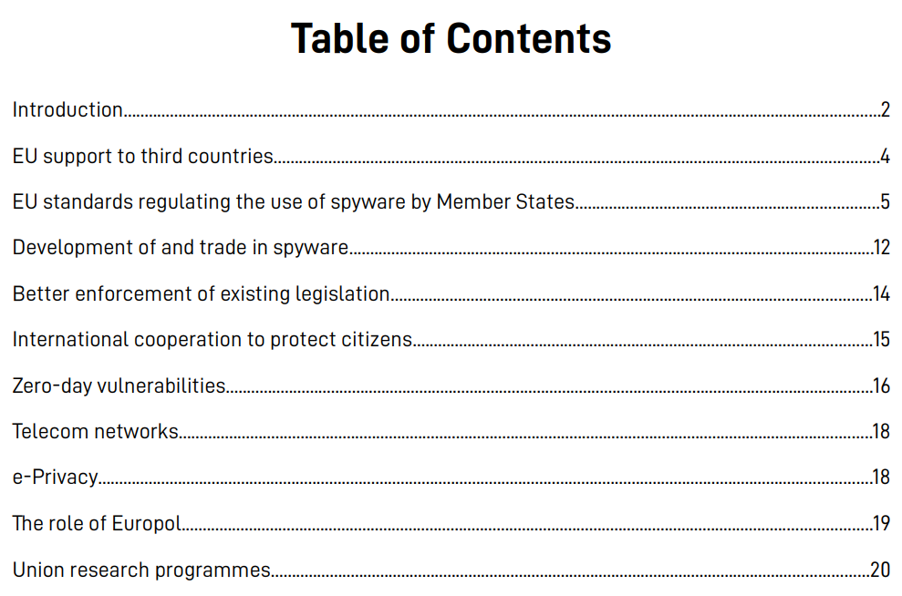
Table of contents for PEGA’s recommendations to the EU parliament.[11]

Response of Companies
- Amazon Web Services and other US companies shut down all cloud accounts linked to the NSO Group (as part of the US sanctions)
- Apple sued the NSO Group for targeting Apple customers and announced a new “lockdown mode” to prevent spyware like Pegasus from infiltrating their devices.
- WhatsApp sued the NSO Group for infecting devices through an exploit in the app. Recently, in October 2025, WhatsApp successfully won the lawsuit against the NSO Group by arguing that the app markets digital privacy as a service, and the NSO Group damaged WhatsApp by compromising that privacy. WhatsApp was awarded $4 million in damages and an injunction that forbade the NSO Group from targeting WhatsApp users.[16]

NSO and Pegasus Today
In October 2025, a U.S. investment group led by the Hollywood producer Robert Simonds acquired a controlling share in the NSO Group.[17] However, the company will remain in Israel, and under the supervision and regulation of the Israeli ministry of defense and government. The NSO group has attempted to be removed from the government’s blocklist frequently, and as recently as May 2025. This acquisition is likely part of the NSO Group’s effort to enter the U.S. market and sell Pegasus to American police forces.

TECHNICAL ANALYSIS

The Pegasus Payload
The Spyware Pegasus and the NSO Group’s ability to install it remotely onto a phone should be thought of as two separate pieces of software. In normal circumstances, the owner of an IOS device has limited authority over their device. For example, you might not be able to remove certain pre-installed apps or install unauthorized apps. On iOS, this process of taking control of the phone's root is called “Jailbreaking.” The Pegasus software requires a device to be jailbroken and given root access to access everything on the phone. With this, it can remotely activate the camera, microphone, or location tracking, access all files on the device, including images, recordings, iMessages, and the unencrypted local copies of 3rd party messaging apps like WhatsApp or Signal. Additionally, although the goal of Pegasus is to be hidden from the user, this same level of access could be used to send messages impersonating the user, or delete specific files from the device, or partially or permanently shut down the device.[7]
To jailbreak the device, install Pegasus, and give it root access, the NSO Group has developed and used a variety of exploits that involve as little interaction from the target as possible. While many of these have been one-click, requiring the target to click on a link or similar action, the exploit used in 2021 against the victims above is zero-click and required no interaction from the user. In addition, this was a zero-day exploit, meaning it was not known to Apple at the time, and worked against even the most updated devices.[18]

Forced Entry: Zero-Click Attack Vector

Background Information
Citizen Lab discovered the exploit, FORCEDENTRY, while analyzing the phone of a Saudi activist, which had been infected with Pegasus. The exploit was effective against Apple’s phone, Mac, and watch devices. The exploit was first used in February 2021 at the latest and was patched 7 months later in September. The exploit targets iMessage and has been attributed to the NSO Group due to a forensic artifact called CASCADEFAIL, where the evidence of tampering with the device is incompletely deleted in a specific way, something Citizen Lab claims to have only seen with Pegasus spyware.[18]

Note on the Sources
The two main sources for this technical analysis come from Project Zero, a team of security researchers at Google focused on making it harder to find zero-day vulnerabilities. The researchers at Project Zero worked with Citizen Lab, which originally discovered the exploit, and Apple’s Security and Engineering and Architecture (SEAR) group to analyze the exploit. Despite substantial resources dedicated to understanding this exploit, it took months for Project Zero to figure out how it worked. The article analyzing the first half of the exploit, “A deep dive into a NSO zero-click iMessage exploit: Remote Code Execution,” was published on 2021-11-15, while the second part, “FORCEDENTRY: Sandbox Escape,” was released on 2022-3-31. Because of this time gap, many articles from other groups were published when the story broke; these articles used information from Citizen Lab and/or Project Zero, but before Project Zero uncovered the full chain of exploits needed for the zero-click attack to work. [21][22][23]

PDF as a GIF
For certain pre-installed apps on IOS that Apple developed, Apple trusts them to operate outside of the more secure app “sandbox” when convenient. One such case is when iMessage receives a file with the .GIF extension. Apple wanted GIFs received on iMessage to loop endlessly, so before a message is displayed or before a notification appears, iMessage copies the GIF using the CoreGraphicsAPI, before modifying the loop count field to loop infinitely. However, the call in IMGIFUtils, copyGifFromPath, renders the original GIF file to a new GIF file, instead of simply copying the bytes. In addition, the rendering with the CoreGraphicsAPI checks the header of the file to determine how to render it, not the .GIF extension. The render call accepts more than 20 different image formats, which are rendered with the authority of the CoreGraphics API. Parsing is an operation notorious for exploits, as a malicious actor will actively seek to break the assumptions the parsing method relies upon to execute code at a higher level of privilege. The result is a very large attack space, which well-resourced organizations (such as the NSO Group) can look to find exploits. FORCEDENTRY used this trick to send PDF files with a .gif extension, which caused CoreGraphics to parse them, and the JBIG2 compression they were formatted with.[21]

JBIG2 Compression
JBIG2 is a compression format from the late 1990’s intended for extremely high compression of black and white text documents. In a text document, there are many repeated characters, each made up of many pixels. Rather than storing every individual pixel, JBIG2 compression would search for areas with similar characters, such as the letter e, then record one copy of the symbol, and each location where that symbol should be pasted. In some ways, this form of compression is very similar to how we can use very small text files to display many ASCII characters: each character in the text document is specified by a few bits, while what an ‘a’ or a ‘b’ looks like on screen is only defined once. This type of technique is called Segmentation and substitution.[21]
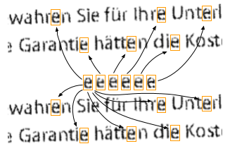
[21]

JBIG2 Lossless Compression
However, one of the major issues with this type of compression is accuracy. With many symbols and alphabets, the differences between characters can be so small that they might be mistaken for the same character. With some documents, a swapped letter might be acceptable, but for technical plans, invoices, or budgets, the difference between a 6, an 8, or a 9 could be catastrophic.[25]
To cope with this, JBIG2 also has a lossless compression mode. The lossless compression mode works similarly, but with an additional step and a stored value. For each location where the symbol would be substituted, a difference between that and the original letter is stored. When the substituted letter is written there during decompression, the difference is XORed with the substituted letter to write an accurate representation of the original.
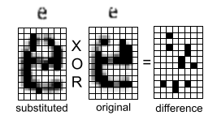[21]
However, the JBIG2 format is very flexible about how to encode, store, and use the differences and substitutions to write the original. The format allows decoding with any of the logical operators AND, OR, XOR, or XNOR. It also allows the original to be written in multiple steps, and to effectively read what values have already been encoded on the output canvas: a series of bits representing the rendered PDF.[21]
Another aspect that makes JBIG2 more vulnerable to exploitation for Apple devices is that CoreGraphics uses Xpdf to render JBIG2-encoded PDFs. As Xpdf is open-source, it is significantly easier to search the code for vulnerabilities. However, given the sophistication of this attack, the NSO Group is unlikely to have been deterred by the JBIG2 being a proprietary implementation and needing to analyze the assembly instead of source code. [21]

Integer Overflow and Unbounding
The JBIG2 format is a series of drawing commands called segments, which will be executed in a single pass. Segments are defined by the base class JBIG2Segment and the subclasses JBIG2Bitmap and JBIG2SymbolDict.
The JBIG2 decoder stores the number of segments in a 32-bit integer named numSyms. For each SymbolDict segment, its size is added to numSyms, which is later used to allocate a syms buffer and store all the Bitmap pointers in it.
The initial vulnerability comes from an integer overflow caused by adding to numSyms, making it a small, controlled value for the buffer allocation. The Bitmap pointers are then written to the undersized syms buffer, overflowing it and corrupting the memory past it. Normally, this would attempt to write over 32 GB of memory and crash. However, with careful manipulation of the previous memory allocations through a process called heap grooming, the syms buffer is allocated near the GList backing buffer, so that after a few writes, it will corrupt the GList with pointers to Bitmaps, replacing its pointers to SymbolDicts. The loop that writes the Bitmap pointers checks if it points to a SymbolDict before attempting to get and write each Bitmap from it, and those SymbolDict pointers are stored in the GList. By replacing them with Bitmaps, the virtual function seg->getType() succeeds, but returns Bitmap, which prevents writing any further into the buffer. Notably, Apple devices have Pointer Authentication: a security feature that checks if an object’s class is correct before executing a virtual function call. However, JBIG2Bitmap and JBIG2SymbolDict both derive from JBIG2Segment, so this bypasses Pointer Authentication.
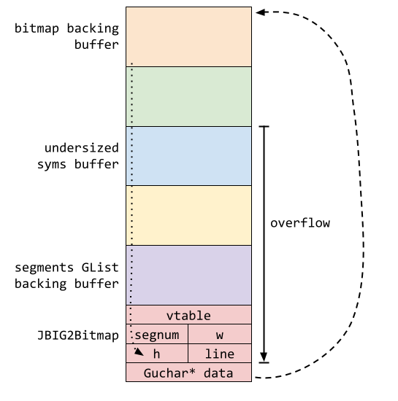
[21]
Directly after the GList in memory, there is a Bitmap object which represents the current page and defines where the current drawing commands can render (write to) in memory. The overflow above is structured so that it stops after overwriting the vtable, segnum, width, height, and line variables with pointers to Bitmaps. Because of the structure of the iOS address layout, these pointers will almost certainly have an address between 0x100000000 and 0x1ffffffff. This memory corruption results in the height variable having a random but very large value between 0x100000 and 0xffffffff. The height is used for bound checking to ensure that the JBIG2 drawing calls are writing within the allocated page backing buffer intended for decryption. The now very large value for height effectively “unbounds” the JBIG2 segment commands, allowing them to read and write in a significantly larger area of memory. The heap grooming preformed previously also put the current page’s backing buffer before the syms buffer in memory, allowing segment commands to read and write the Bitmap’s own fields after being unbounded (as seen in the diagram above). This allows for directly writing specific values into the width, height, and line, fully. Complete control over these values allows for reading or writing to completely arbitrary locations in memory by offsetting from the backing buffer.

Dealing with ASLR
There is a long history of exploits that exploit an overflow to write to arbitrary memory locations, elevate privileges, and execute their own code. One of the modern preventative measures against this is ASLR: Address Space Layout Randomization. When exploiting a program without ASLR, one would analyze the program's memory beforehand and identify something to change in the stack, heap, shared libraries, or program instructions, then hard-code the exploit to modify that specific location in memory. In programs with ASLR enabled, what is at each memory address is randomized, and such an exploit would almost certainly fail to overwrite the intended memory. ASLR is heavily limited in how it can randomize memory: the major memory segments, such as the stack and heap, can be offset in memory with various techniques, but not randomized much further.[26] Therefore, with some computation during the exploit, the location of major memory segments, and the address the exploit should modify can be consistently found, bypassing ASLR. One common way to bypass ASLR is to use the PDF file format’s support for JavaScript to perform these computations, which is why Apple’s CoreGraphics intentionally does not interpret JavaScript inside PDF files.[21]

JBIG2 Decompression as a Weird Machine
To bypass Apple's ASLR, FORCEDENTRY needs some way to perform these arbitrary computations. To do this, the exploit uses the flexibility of JBIG2 refinement steps. These steps can reference the unbounded output Bitmap and previously created segments, and write the output to the output Bitmap or any segment. Each refinement operation can apply either AND, OR, XOR, or XNOR, and instead of operating on a rectangular glyph, a 1-by-1 glyph can be used to operate on individual bits, and other sizes can be used to perform operations. The output of the operation AND can be XORed with 1 to get the functionality of a NAND gate. NAND gates are a universal logic gate, meaning a circuit can be built from them to compute any computable function.[21]
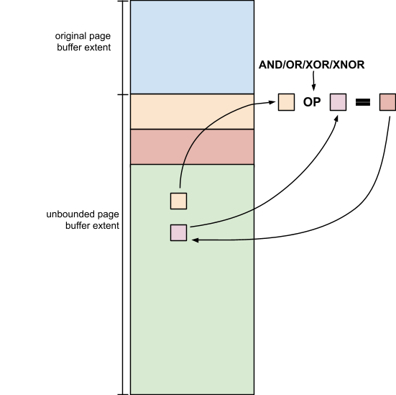
[21]
The FORCEDENTRY exploit uses this single JBIG2 decompression pass to emulate an entire computer architecture to perform the rest of this exploit. It uses over 70,000 segment commands that define these logical bitwise operations to define an architecture with registers, a 64-bit adder, and a comparator to perform the same types of operations that similar exploits would have used JavaScript for. To recap, the exploit can now execute arbitrary computations and modify arbitrary memory while inside the decompression pass of the CoreGraphics PDF parser, which is inside the IMTranscoderAgent sandbox. The purpose of a sandbox is to isolate the code executing inside of it from the rest of the operating system for security purposes. To get to the root, the exploit now has to escape this sandbox using its ability to execute arbitrary code and modify arbitrary memory inside the sandbox.[21]

Sandbox Escape Summary
FORCEDENTRY’s escape from the IMTranscoderAgent sandbox is very notable because it only uses logic bugs to escape. Most exploits and the current state-of-the-art mitigations focus on memory-related vulnerabilities. This includes the Pointer Authentication and ASLR discussed above, as well as Memory tagging. One could even assume that no runtime mitigation technique will ever work against logic bugs: the code is executing normally, exactly as it was written. Project Zero’s article on the sandbox escape says: “In fact, it’s unclear where the features that it uses end, and the vulnerabilities which it abuses begin.” [22]
The only job that the JBIG2 weird machine performs is to deserialize and evaluate an NSFunctionExpression. At the time of this exploit, Objective-C objects were not protected by Pointer Authentication, so the weird machine builds a fake Objective-C object designed to deserialise and evaluate an NSFunctionExpression when it is deallocated. In 2007, NSFunctionExpressions were given additional functionality to invoke arbitrary methods with the FUNCTION keyword. They were also given the CAST keyword, giving them access to all Objective-C types. NSFunctionExpressions are known for the power they give an attacker, and were used in the 2019 Real World CTF challenge. It uses this evaluation of the NSFunctionExpression to cover its tracks by deleting the original .gif file. Then it builds a payload NSPredicate object and triggers a logic bug to evaluate it in the CommCenter process, outside of the IMTranscoderAgent sandbox. This NSPredicate payload then exploits further logical bugs to be exploited, and uses the elevated privileges of being executed by the CommCenter process to install Pegasus with total control over the device.[22]

Preventive Measures
In many ways, the vulnerabilities exploited in FORCEDENTRY are a case of “this is why we can’t have nice things.” Many of the vulnerabilities originated from code that solved the problem at hand in a convenient way, but also compromised security. Even small changes like copying GIF files sent to iMessage to make them loop indefinitely add a significant amount of technical complexity to a system when done at scale. A system with the scale of technical complexity for modern phones and computers will always have vulnerabilities. Currently, tech companies are primarily focused on protecting their systems from novice and mid-level threats and actors, not highly sophisticated actors like the NSO Group or governments that invest millions into a single zero-day exploit.
The most effective way to mitigate against these types of highly sophisticated actors is to mitigate the attack surface. Not only that, but mitigate the attack surface in places where it matters most to users. One example of this would be the iMessage attempting to copy files with the .gif extension. This feature exposed an exceptionally large attack surface of over 20 image formats, and any type of compression format any of those could use. While most malicious actors wouldn’t have the resources to search through all of those possibilities to find a zero-click exploit, the NSO Group did, and many other organizations would too. However, there is a very limited number of zero-click exploits for IOS devices currently, as evidenced by the NSO Group’s history of using one-click exploits instead before developing FORCEDENTRY. As awareness among the general public of good digital practices has increased over the years, people are significantly less likely to click a questionable link sent by text message, drastically reducing the potential harm. By focusing bounties and other forms of cybersecurity research on preventing a manageable task (zero-click rather than one or two clicks) and educating the public with digital literacy that aligns with those security practices, we can mitigate the most intrusive vulnerabilities.

ETHICAL ANALYSIS
Present your analysis of the events and a formal argument to support or refute the ethical question at the heart of the issue.

Rule Utilitarianism
The basis of Utilitarianism is evaluating whether something is ethical based on its net impact. In this framing, the initial question can be separated into two.

Is it beneficial for governments to spy on their own population without their consent?

Is it beneficial for governments to spy on other countries’ populations without their consent?

Social Contract Theory
The basis of Stuart Rachels’ version of Social Contract Theory is that morality is the set of rules governing behavior that rational people accept, on the condition that other people accept them too. This includes both explicit and implicit rules.

Can a country have a Social Contract that allows its government to spy on its own population?

Can a country have a Social Contract that allows its government to spy on its other countries' populations?

Conclusion
Identify why the central question concerning these events is relevant (in particular) to the discussion in this course, and (in general) to the larger society.

Relevance to computing professionals
How have these events shaped your understanding of what it means to be a “successful business/professional in computing”?
Are there any significant takeaways that you can apply to your projects/experience in DigiPen?

REFERENCES
- https://www.britannica.com/topic/Pegasus-spyware
- https://www.occrp.org/en/project/the-pegasus-project/where-nso-group-came-from-and-why-its-just-the-tip-of-the-iceberg
- https://www.forbes.com/sites/the-wiretap/2025/10/14/happy-gilmore-producer-buys-israeli-spyware-giant-nso/
- https://www.theguardian.com/news/2021/jul/23/how-nso-became-the-company-whose-software-can-spy-on-the-world
- https://forbiddenstories.org/pegasus-the-new-global-weapon-for-silencing-journalists/
- https://www.theguardian.com/world/2021/jul/18/nso-spyware-used-to-target-family-of-jamal-khashoggi-leaked-data-shows-saudis-pegasus
- https://www.pbs.org/wgbh/frontline/documentary/global-spyware-scandal-exposing-pegasus/ Documentary
- https://forbiddenstories.org/about-the-pegasus-project/
- https://www.amnesty.org/en/latest/news/2023/06/eu-final-vote-on-spyware-inquiry-must-lead-to-stronger-regulation/
- https://www.europarl.europa.eu/news/en/press-room/20230609IPR96217/spyware-meps-call-for-full-investigations-and-safeguards-to-prevent-abuse
- https://edri.org/wp-content/uploads/2023/02/EDRi-Amendments-PEGA-Draft-Recommendations.pdf
- https://www.theguardian.com/us-news/2021/nov/03/nso-group-pegasus-spyware-us-blacklist
- https://www.theguardian.com/world/2021/jul/20/french-ministers-phone-shows-traces-linked-to-nso-spyware
- https://www.occrp.org/en/news/israeli-spyware-producer-sued-banned-a-year-after-pegasus-revelation
- https://www.theguardian.com/world/2021/nov/11/no-10-accused-failing-act-states-accused-nso-pegasus-spyware-abuses-boris-johnson
- https://cyberscoop.com/whatsapp-wins-injunction-against-nso-group-spyware-damages-reduced/
- https://techcrunch.com/2025/10/10/spyware-maker-nso-group-confirms-acquisition-by-us-investors/
- https://citizenlab.ca/research/forcedentry-nso-group-imessage-zero-click-exploit-captured-in-the-wild/
- https://citizenlab.ca/research/the-great-ipwn-journalists-hacked-with-suspected-nso-group-imessage-zero-click-exploit/
- https://citizenlab.ca/research/nso-q-cyber-technologies-100-new-abuse-cases/
- https://projectzero.google/2021/12/a-deep-dive-into-nso-zero-click.html
- https://projectzero.google/2022/03/forcedentry-sandbox-escape.html
- https://projectzero.google/about-pz.html
- https://www.trendmicro.com/en_us/research/21/i/analyzing-pegasus-spywares-zero-click-iphone-exploit-forcedentry.html
- https://www.dkriesel.com/en/blog/2013/0802_xerox-workcentres_are_switching_written_numbers_when_scanning
- https://securitymaven.medium.com/demystifying-aslr-understanding-exploiting-and-defending-against-memory-randomization-4dd8fe648345

