The Ethics of Pegasus Spyware and State-Sponsored Surveillance
Roman Marquez-Twisdale
r.marqueztwisdale@digipen.edu

background information:
Throughout this paper we will discuss the use of spyware for population surveillance in the interests of national security. Specifically, we will discuss the use of Pegasus, a piece of spyware developed by the NSO group, a for-profit Israeli cyber-arms organization and we will analyze investigations into the NSO group and Pegasus. We will attempt to reason about the ethics surrounding the use of Pegasus and dive deep into its technical abilities

NSO Group
The NSO group developed the spyware known as Pegasus. To the NSO group, its success is their success. “Co-founded by two high-school friends in 2010, NSO Group specialized in breaking into mobile phones from the very beginning. As the devices spread across the planet, governments eager to listen in came calling. The company grew into a major player in the spyware market, with dozens of clients, over 700 employees, and revenues of $250 million as of 2018.” (7)

Nation State Governments
As mentioned in the previous subsection, the customers of NSO, and consumers of Pegasus are nation state governments. These governments are allegedly purchasing such a product to help ensure greater national security for themselves. Exactly what national security means will be discussed in the ethical analysis portion of this paper. Nation state governments can benefit from the use of Pegasus to support their interests, but are also very much at risk of such a tool being used by their enemies against them.

Nation State Populations
The NSO group’s product targets smart phones. As such, it is not a leap to say that Pegasus targets all people. The populations of all nation states are in the crosshairs of this technology. To these populations, spyware can once again be a benefit, constraint, or outright danger depending on who you are.

Journalists
Journalists are a part of the world’s population, but their relationship with surveillance is unique. It is the job of a journalist to surveil the world around them, record what they see, and report any findings of consequence to organizations that will help shine a spotlight on their findings so that society may have a better chance of recognizing and managing harmful forces. It is usually the case that journalists target and expose entities that would rather not be in the public’s eye. A successful journalist must operate unseen. Surveillance directly counters the need to be unseen. From a journalist’s perspective, Pegasus is a harmful force.
https://rm.coe.int/pegasus-spyware-report-en/1680a6f5d8 (1)
https://securitylab.amnesty.org/case-study-the-pegasus-project/

current event analysis:
After the NSO group started selling their first version of Pegasus spyware, the company has been on the radar of most journalists. Especially after the Edward Snowden’s whistle blowing in 2013 which exposed a similar system employed by US intelligence agencies, mass surveillance has been a hot topic. And after the assassination of Saudi journalist in Turkey which many thought Pegasus played a role in, the NSO group has been in a very uncomfortable spotlight. The main investigation we will focus on, The Pegasus Project, started after a leaked list of roughly 50,000 phone numbers fell into the hands of Forbidden Stories, a nonprofit media organization in Paris, and Amnesty International, a global organization with a goal of exposing human rights violations. “Forbidden Stories, a Paris-based nonprofit media organisation, and Amnesty International initially had access to the leaked list and shared access with media partners as part of the Pegasus project, a reporting consortium.” (4) This list of phone numbers is believed to be a list of targets for the Pegasus spyware. After receiving this list, various media partners of Forbidden Stories and Amnesty International became suspicious of the NSO group. At this point the investigation had begun, and the motivation to figure out exactly what impact Pegasus was having on the world grew quickly. The Pegasus Project consists of 17 media organizations from 10 different countries.
https://www.theguardian.com/world/2021/jul/18/revealed-leak-uncovers-global-abuse-of-cyber-surveillance-weapon-nso-group-pegasus (4)
https://www.britannica.com/topic/Pegasus-spyware
https://www.pbs.org/wgbh/frontline/documentary/global-spyware-scandal-exposing-pegasus/
https://arabcenterdc.org/resource/the-full-story-behind-the-nso-hack-the-israeli-military-allied-surveillance-industry-and-transnational-repression/ (2)

response to the event:
Describe the response / fallout to the investigation.
- QUOTE: “In December 2018, Omar Abdulaziz, the friend of Jamal Khashoggi, took NSO to court in Israel. The following year, Amnesty International and even Facebook joined the growing list of plaintiffs after more than 1,500 people’s phones were revealed to have been targeted through a security flaw in the encrypted messaging service WhatsApp.” (3)
- QUOTE: “From this list, an analysis of 67 smartphones provided evidence that 37 belonging to journalists, human rights activists, business executives, and two women close to Saudi activists and Washington Post columnist Jamal Khashoggi were targeted or successfully infected by the Pegasus spyware. The tests for the remaining 30 were inconclusive either because phones were replaced or because Android devises do not log the needed information for the investigation.” (2)
- QUOTE: “The NSO hacking revelation, while only one piece of the puzzle, has perhaps been the most prominent due to the scale and scope of the violation as well as the level of individuals targeted by the Pegasus software. These included French President Emmanuel Macron, the presidents of Iraq and South Africa, Qatar’s royal family members, Morocco’s King Mohammed VI, the current prime ministers of Pakistan, Egypt, and Morocco, and seven former prime ministers. Khashoggi’s killing has gained international prominence for its brutal and lawless nature, but it also has shed light on the role of tech firms in transnational repression, as many of his family members and friends were targeted by Pegasus or hacked before and after his assassination.” (2)
https://forbiddenstories.org/the-rise-and-fall-of-nso-group/ (3)
https://gjia.georgetown.edu/2024/09/04/cyber-mercenaries-limiting-government-use-of-commercial-spyware/
https://www.theguardian.com/world/2023/may/09/eu-parliament-report-calls-for-tighter-regulation-of-spyware

Technical Analysis
Provide a detailed description - use pseudo-code, block diagrams, and other necessary means to convey your research and analysis.

Analysis Context
Spyware must be able to access the environments it is designed to interface with. There have been many approaches to gaining this access, but most of them require some level of user interaction. One of the reasons the NSO group’s product was so effective is due to the way it reaches its target. The method has been referred to as a “FORCEDENTRY exploit”. The NSO group found a way to install Pegasus onto devices without needing the user of those devices to be involved. In this section, we will explore the workings of such an exploit as it was analyzed by Citizen Lab, a team of security analysts employed by Google tasked with finding zero-day vulnerabilities. “Citizen Lab was able to recover these Pegasus exploits from an iPhone and therefore this analysis covers NSO's capabilities against iPhone. We are aware that NSO sells similar zero-click capabilities which target Android devices”. (5) As previously stated, we will focus solely on the exploit as is pertains to Apple devices. To support our analysis, we will be referencing two articles published by Citizen Lab. The first was published in mid-December 2021 and outlines the initial remote code execution stage of FORCEDENTRY. The second was released at the end of March 2022 and focuses on how the exploit was able to remain outside of existing defense mechanisms.

Vulnerability Origins
The attack surface is accessed via a relatively innocent feature within iMessage. “The initial entry point for Pegasus on iPhone is iMessage. This means that a victim can be targeted just using their phone number or AppleID username.” (5) The FORCEDENTRY exploit starts by sending a gif. Well, not exactly. iMessage has native support for sending gifs and for optimization purposes is pre-rendering those images before displaying them to users. “Apple wanted to make those GIFs loop endlessly rather than only play once, so very early on in the iMessage parsing and processing pipeline (after a message has been received but well before the message is shown), iMessage calls the following method in the IMTranscoderAgent process (outside the "BlastDoor" sandbox), passing any image file received with the extension .gif” (5)
This line invokes the systems surrounding vulnerability. “Under the hood it uses the CoreGraphics APIs to render the source image to a new GIF file at the destination path.” (5) This isn’t necessarily an issue, but at the time, the implementation performed this step outside of BlastDoor. “BlastDoor isolates, parses, transcodes, and validates untrusted data arriving in Messages, IDS and other vectors to help prevent attacks.” (6) Before rendering occurs, it is necessary to determine the image’s filetype and parse it. Surprisingly, this process does not use the file extension. “The ImageIO library, as detailed in a previous Project Zero blogpost, is used to guess the correct format of the source file and parse it, completely ignoring the file extension.” (5) And it is this flexibility that makes exploit possible. There are known vulnerabilities when parsing PDFs, so Pegasus sends a PDF disguised as a .gif and exploits these vulnerabilities to gain access to the system.

PDFs and JBIG2
NSO uses a PDF disguised as a gif to access vulnerabilities in the PDF parser implementation contained within Apple’s CoreGraphics API. PDFs have supported a compression technique known as the JBIG2 standard since the late 1990’s. JBIG2 allows for extreme compression when working with images containing only black and white pixels. Most of the PDF parser logic within CoreGraphics was Apple proprietary code. But their JBIG2 parsing logic used the open source Xpdf toolkit as part of their implementation. JBIG2 contains vulnerability and supplies the tools that NSO uses to embed their spyware into a device. NSO used the extreme compression capabilities of JBIG2 which are supported by two main features.

Segmentation and Substitution
A “glyph” is a collection of repeating letters within a text document. JBIG2 attempts to break text documents into segments – glyphs. The goal is to replace these segments/glyphs with smaller objects holding the same information. “The compression algorithm is to simply substitute all sufficiently-similar looking regions with a copy of just one of them” (5)
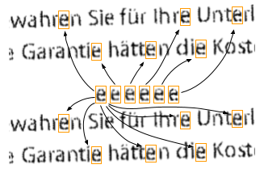By replacing all similar glyphs within a text document with a reference to a single compressed version of that glyph, we compress the information greatly. Recreating the text document is as simple as inserting the uncompressed glyph into all recorded locations which contained the same glyph pattern. Like many compression algorithms, there is some risk involved. “There's a significant issue with such a scheme: it's far too easy for a poor encoder to accidentally swap similar looking characters, and this can happen with interesting consequences.” (5)

Refinement Coding
The technique we just discussed is lossy, but JBIG2 also supports less-lossy and lossless compression algorithms. “It does this by also storing (and compressing) the difference between the substituted glyph and each original glyph. Here's an example showing a difference mask between a substituted character on the left and the original lossless character in the middle” (5) 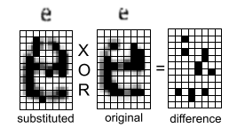By storing this difference and reapplying it with a logical operator, the loss can be managed. Due to the use of logical operators in this process, JBIG2 streams, which can be thought of as a collection of drawing commands, support the use of most logical operators through this process of “refinement”. “Rather than completely encoding the entire difference in one go, it can be done in steps, with each iteration using a logical operator (one of AND, OR, XOR or XNOR) to set, clear or flip bits. Each successive refinement step brings the rendered output closer to the original and this allows a level of control over the "lossiness" of the compression. The implementation of these refinement coding steps is very flexible and they are also able to "read" values already present on the output canvas.” (5) As we will see later, this is crucial for the exploit.

CoreGraphics Parser Vulnerability
By sending a pdf as a .gif, NSO was able to trigger the JBIG2 decoder within the CoreGraphics stack. By handcrafting the JBIG2 stream embedded within a PDF, they caused an integer overflow to occur within Apple’s PDF parser implementation. NSO used this overflow to set the value of a local variable to something small and exact. This variable is later used to allocate a buffer on the heap. Data is then written to this undersized buffer later in the implementation. Generating a small buffer to work with is essential. If the buffer was allocated with the appropriate size, it would be impossible to write past the end of the buffer.

Tying it all together
In the next few sub-sections we will see how the tools for implementing such a powerful compression technique and the CoreGraphics PDF decoder implementation paired with deep knowledge of a system and a great capacity for precision allowed NSO trick a simple feature into an unexpected process, gain access to remote regions of memory, build a basic computer architecture from scratch, run a custom scripting language on said computer architecture, and ultimately install their custom spyware Pegasus onto any IOS device without needing the user of that device to do a single thing.

Buffer overflow exploit
After doctoring the value of a local variable to be small to affect the size of a dynamically allocated heap buffer, NSO write past that buffer in order to access a JBIG2Bitmap object. NSO will use that bigmap as a playground. By manipulating that bitmap in precise ways, they will be able to construct the necessary logic to install their spyware, but first they must deal with the inevitable crash which would insue from a standard buffer overflow. “To avoid that crash the heap is groomed such that the first few writes off of the end of the syms buffer corrupt the GList backing buffer. This GList stores all known segments and is used by the findSegments routine to map from the segment numbers passed in refSegs to JBIG2Segment pointers. The overflow causes the JBIG2Segment pointers in the GList to be overwritten with JBIG2Bitmap pointers at (4).” (5) Before you can write to this undersized buffer, there is a conditional statement checking for type correctness. By rewriting the contents of the Glist backing buffer with JBIG2Bitmap pointers, they prevent further write operations (which would result in a crash) while simultaneously allowing the conditional check to run without errors. It was essential that BOTH issues were handled correctly to avoid a crash.

Boundless unbounding
To do what NSO set out to do, they need space. NSO needs room to work. They accomplish this by something referred to as Boundless Unbounding. “Directly after the corrupted segments GList, the attacker grooms the JBIG2Bitmap object which represents the current page (the place to where current drawing commands render).” (5) 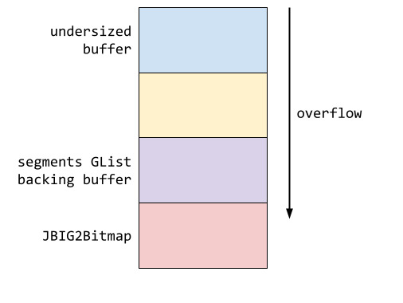The goal is to use the “current page” as a workshop. JBIG2Bitmaps are mostly wrappers around a backing buffer representing a canvas for drawing commands. NSO wants to use this canvas for their own drawing commands. “By carefully structuring refSegs they can stop the overflow after writing exactly three more JBIG2Bitmap pointers after the end of the segments GList buffer. This overwrites the vtable pointer and the first four fields of the JBIG2Bitmap representing the current page.” (5) 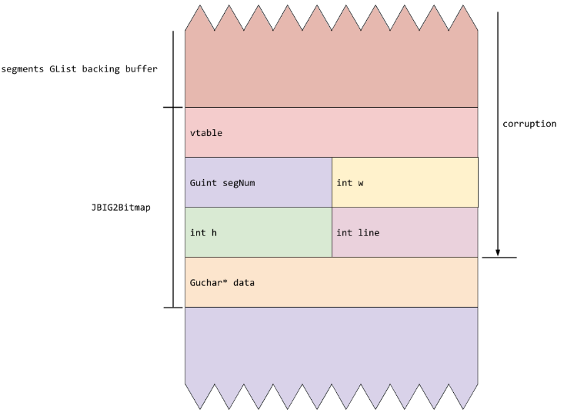During these writes, the original values are being replaced by pointer values. And due to the hardware of the IOS devices, it is easy to predict what those values will be. “Due to the nature of the iOS address space layout these pointers are very likely to be in the second 4GB of virtual memory, with addresses between 0x100000000 and 0x1ffffffff.” (5) With a little forethought, it is possible to doctor the values held by the page height value “h” with very large value. “Since that h value is used for bounds checking and is supposed to reflect the allocated size of the page backing buffer, this has the effect of "unbounding" the drawing canvas. This means that subsequent JBIG2 segment commands can read and write memory outside of the original bounds of the page backing buffer.” (5) During this process NSO was also adjusting the pointer to the page’s backing buffer so that after unbounding, it would be able to read and write to its own fields. This means that by rendering bitmaps to the correct page coordinates, the height, width, and line values can be set to precise values and used to access memory at arbitrary offsets from the backing buffer. 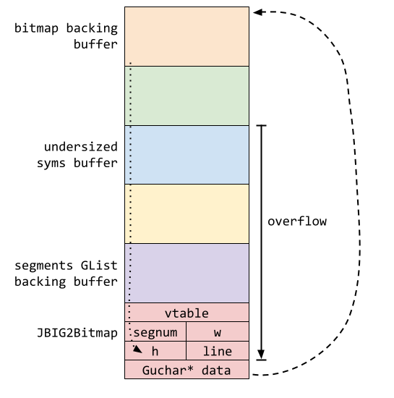With just this, NSO could set arbitrary offsets to try and access critical memory locations. This would be a very direct way to gain more influence on the system. But this requires knowing where critical memory locations are.

Logical Operators
At this point, NSO has access to a canvas which they can perform JBIG2 refinement operations on. All logical operators previously mentioned in the subsection 5.2.2 can be used within this unbounded canvas. These operators are normally used within the JBIG2 framework to manipulate pixel data during image refinement, but what else could they be used for? With the ability to access memory at arbitrary offsets from the BIG2Bitmap’s backing buffer, NSO can use these operators on regions of memory within their unbounded range. 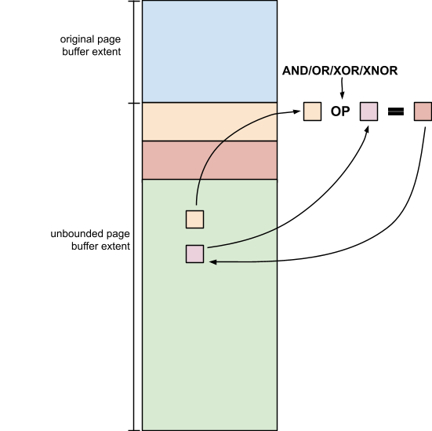NSO uses these operators and the unbounded canvas generated by previous corruption to simulate a logical environment in which to house computational functionality. At this point, the door is open, NSO just needs to step inside and get to work. “JBIG2 doesn't have scripting capabilities, but when combined with a vulnerability, it does have the ability to emulate circuits of arbitrary logic gates operating on arbitrary memory. “ (5) Regardless of the possibility, exploiting this opportunity is still no easy task. “Using over 70,000 segment commands defining logical bit operations, they define a small computer architecture with features such as registers and a full 64-bit adder and comparator which they use to search memory and perform arithmetic operations.” (5) Over the course of a single JBIG2 decompression pass, and through the creative repurposing of refinement step operations, NSO was able to create a logical framework upon which to operate. The bootstrapping programs build for this FORCEDENTRY exploit are built to run on this rudimentary logical architecture. “It's not as fast as Javascript, but it's fundamentally computationally equivalent.” (5)

https://www.amnesty.org/en/latest/research/2021/07/forensic-methodology-report-how-to-catch-nso-groups-pegasus/
https://en.wikipedia.org/wiki/Pegasus_(spyware)
https://ijclinic.law.uci.edu/clipping-pegasuss-wings/basics-of-pegasus/
https://www.geeksforgeeks.org/blogs/what-is-pegasus-spyware-and-how-it-works/
https://www.theguardian.com/news/2021/jul/18/what-is-pegasus-spyware-and-how-does-it-hack-phones
https://www.occrp.org/en/project/the-pegasus-project/how-does-pegasus-work

ethical analysis and conclusion:
Present your analysis of the events and a formal argument to support or refute the ethical question at the heart of the issue. Identify why the central question concerning these events is relevant (in particular) to the discussion in this course, and (in general) to the larger society.
- QUOTE: “transnational repression, which is the practice of authoritarian governments targeting dissidents, journalists and activists outside of their sovereign borders to silence dissent.” (5)
- QUOTE: “Short of not using a device, there is no way to prevent exploitation by a zero-click exploit; it's a weapon against which there is no defense.” (5)
- QUOTE: “PDF was a popular target for exploitation around a decade ago, due to its ubiquity and complexity.” (5)
https://rm.coe.int/pegasus-spyware-report-en/1680a6f5d8
https://www.europarl.europa.eu/RegData/etudes/STUD/2022/740514/IPOL_STU(2022)740514_EN.pdf
https://www.hrw.org/news/2022/01/26/human-rights-watch-among-pegasus-spyware-targets

beyond the superficial:
Is there more information that you can provide, as a practitioner in computer science, towards the ethical responsibilities of the technical parties involved in this series of events?
• How have these events shaped your understanding of what it means to be a “successful business/professional in computing”?
• Are there any significant takeaways that you can apply to your projects/experience in DigiPen?
Use one or more of the following Workable Ethical Theories to provide your reasoning. You may combine concepts / theorems / frameworks from multiple theories to support your argument (you do not need to use EVERY framework):
• Kantianism
• Act Utilitarianism
• Virtue Ethics
• Social Contract Theory
Your report should be submitted using the ACM template, and be 6-8 pages in length (6 pages minimum), excluding the list of references. You are required to search for reliable sources and cite them with appropriate reference format.

REFERENCES
- Beer, Ian and Bowman, Groß., Samuel. 2021. A deep dive into an NSO zero-click iMessage exploit: remote code execution. Google Project Zero. (Dec. 2021). DOI=https://projectzero.google/2021/12/a-deep-dive-into-nso-zero-click.html (5).
- Beer, Ian and Bowman, Groß., Samuel. 2022. FORCEDENTRY: Sandbox escape. Google Project Zero. (Mar. 2022). DOI=https://support.apple.com/guide/security/blastdoor-for-messages-and-ids-secd3c881cee/web (6)
- Lozovskyeer, Ilya. 2021. Where NSO group came from – and why it’s just the tip of the iceberg. The Pegasus Project. (Jul. 2021). DOI=https://www.occrp.org/en/project/the-pegasus-project/where-nso-group-came-from-and-why-its-just-the-tip-of-the-iceberg (7)
- Kirchgaessner, Stephanie, Lewis, Paul, Pegg, David, Cutler, Sam, Lakhani, Nina, Safi, Michael. 2021. Revealed: leak uncovers global abuse of cyber-surveillance weapon. The Pegasus Project. (Jul. 2021). DOI=https://www.theguardian.com/world/2021/jul/18/revealed-leak-uncovers-global-abuse-of-cyber-surveillance-weapon-nso-group-pegasus (4)

ABSTRACT
In this paper, we describe the formatting guidelines for ACM SIG Proceedings.
CCS Concepts
• Information systems➝Database management system engines • Computing methodologies➝Massively parallel and high-performance simulations. This is just an example, please use the correct category and subject descriptors for your submission. The ACM Computing Classification Scheme:
http://www.acm.org/about/class/class/2012. Please read the HOW TO CLASSIFY WORKS USING ACM'S COMPUTING CLASSIFICATION SYSTEM for instructions on how to classify your document using the 2012 ACM Computing Classification System and insert the index terms into your Microsoft Word source file.
Keywords
Keywords are your own designated keywords separated by semicolons (“;”).

INTRODUCTION
The proceedings are the records of the conference. ACM hopes to give these conference by-products a single, high-quality appearance. To do this, we ask that authors follow some simple guidelines. In essence, we ask you to make your paper look exactly like this document. The easiest way to do this is simply to download a template from [2], and replace the content with your own material.

PAGE SIZE
All material on each page should fit within a rectangle of 18 × 23.5 cm (7" × 9.25"), centered on the page, beginning 1.9 cm (0.75") from the top of the page and ending with 2.54 cm (1") from the bottom. The right and left margins should be 1.9 cm (.75").
The text should be in two 8.45 cm (3.33") columns with a .83 cm (.33") gutter.

TYPESET TEXT

Normal or Body Text
SAMPLE: Permission to make digital or hard copies of all or part of this work for personal or classroom use is granted without fee provided that copies are not made or distributed for profit or commercial advantage and that copies bear this notice and the full citation on the first page. To copy otherwise, or republish, to post on servers or to redistribute to lists, requires prior specific permission and/or a fee.
Conference’10, Month 1–2, 2010, City, State, Country.
Copyright 2010 ACM 1-58113-000-0/00/0010 …$15.00.
DOI: http://dx.doi.org/10.1145/12345.67890
Please use a 9-point Times Roman font, or other Roman font with serifs, as close as possible in appearance to Times Roman in which these guidelines have been set. The goal is to have a 9-point text, as you see here. Please use sans-serif or non-proportional fonts only for special purposes, such as distinguishing source code text. If Times Roman is not available, try the font named Computer Modern Roman. On a Macintosh, use the font named Times. Right margins should be justified, not ragged.

Title and Authors
The title (Helvetica 18-point bold), authors' names (Helvetica 12-point) and affiliations (Helvetica 10-point) run across the full width of the page – one column wide. We also recommend phone number (Helvetica 10-point) and e-mail address (Helvetica 12-point). See the top of this page for three addresses. If only one address is needed, center all address text. For two addresses, use two centered tabs, and so on. For more than three authors, you may have to improvise.

First Page Copyright Notice
Please leave 3.81 cm (1.5") of blank text box at the bottom of the left column of the first page for the copyright notice.

Subsequent Pages
For pages other than the first page, start at the top of the page, and continue in double-column format. The two columns on the last page should be as close to equal length as possible.

Table 1. Table captions should be placed above the table
Graphics | Top | In-between | Bottom
Tables | End | Last | First
Figures | Good | Similar | Very well

References and Citations
Footnotes should be Times New Roman 9-point, and justified to the full width of the column.
Use the “ACM Reference format” for references – that is, a numbered list at the end of the article, ordered alphabetically and formatted accordingly. See examples of some typical reference types, in the new “ACM Reference format”, at the end of this document. Within this template, use the style named references for the text. Acceptable abbreviations, for journal names, can be found here: http://library.caltech.edu/reference/abbreviations/. Word may try to automatically ‘underline’ hotlinks in your references, the correct style is NO underlining.
The references are also in 9 pt., but that section (see Section 7) is ragged right. References should be published materials accessible to the public. Internal technical reports may be cited only if they are easily accessible (i.e. you can give the address to obtain the report within your citation) and may be obtained by any reader. Proprietary information may not be cited. Private communications should be acknowledged, not referenced (e.g., “[Robertson, personal communication]”).

Page Numbering, Headers and Footers
Do not include headers, footers or page numbers in your submission. These will be added when the publications are assembled.

FIGURES/CAPTIONS
Place Tables/Figures/Images in text as close to the reference as possible (see Figure 1). It may extend across both columns to a maximum width of 17.78 cm (7”).
Captions should be Times New Roman 9-point bold. They should be numbered (e.g., “Table 1” or “Figure 2”), please note that the word for Table and Figure are spelled out. Figure’s captions should be centered beneath the image or picture, and Table captions should be centered above the table body.

SECTIONS

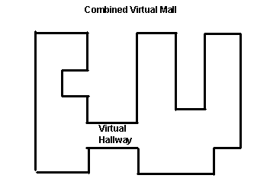
The heading of a section should be in Times New Roman 12-point bold in all-capitals flush left with an additional 6-points of white space above the section head. Sections and subsequent sub- sections should be numbered and flush left. For a section head and a subsection head together (such as Section 3 and subsection 3.1), use no additional space above the subsection head.
Figure 1. Insert caption to place caption below figure.

.

Subsections
The heading of subsections should be in Times New Roman 12-point bold with only the initial letters capitalized. (Note: For subsections and subsubsections, a word like the or a is not capitalized unless it is the first word of the header.)

Subsubsections
The heading for subsubsections should be in Times New Roman 11-point italic with initial letters capitalized and 6-points of white space above the subsubsection head.

Subsubsections
The heading for subsubsections should be in Times New Roman 11-point italic with initial letters capitalized.

Subsubsections
The heading for subsubsections should be in Times New Roman 11-point italic with initial letters capitalized.

ACKNOWLEDGMENTS
Our thanks to ACM SIGCHI for allowing us to modify templates they had developed.

REFERENCES
- Bowman, M., Debray, S. K., and Peterson, L. L. 1993. Reasoning about naming systems. ACM Trans. Program. Lang. Syst. 15, 5 (Nov. 1993), 795-825. DOI= http://doi.acm.org/10.1145/161468.16147.
- Ding, W. and Marchionini, G. 1997. A Study on Video Browsing Strategies. Technical Report. University of Maryland at College Park.
- Fröhlich, B. and Plate, J. 2000. The cubic mouse: a new device for three-dimensional input. In Proceedings of the SIGCHI Conference on Human Factors in Computing Systems (The Hague, The Netherlands, April 01 - 06, 2000). CHI '00. ACM, New York, NY, 526-531. DOI= http://doi.acm.org/10.1145/332040.332491.
- Tavel, P. 2007. Modeling and Simulation Design. AK Peters Ltd., Natick, MA.
- Sannella, M. J. 1994. Constraint Satisfaction and Debugging for Interactive User Interfaces. Doctoral Thesis. UMI Order Number: UMI Order No. GAX95-09398., University of Washington.
- Forman, G. 2003. An extensive empirical study of feature selection metrics for text classification. J. Mach. Learn. Res. 3 (Mar. 2003), 1289-1305.
- Brown, L. D., Hua, H., and Gao, C. 2003. A widget framework for augmented interaction in SCAPE. In Proceedings of the 16th Annual ACM Symposium on User Interface Software and Technology (Vancouver, Canada, November 02 - 05, 2003). UIST '03. ACM, New York, NY, 1-10. DOI= http://doi.acm.org/10.1145/964696.964697.
- Yu, Y. T. and Lau, M. F. 2006. A comparison of MC/DC, MUMCUT and several other coverage criteria for logical decisions. J. Syst. Softw. 79, 5 (May. 2006), 577-590. DOI= http://dx.doi.org/10.1016/j.jss.2005.05.030.
- Spector, A. Z. 1989. Achieving application requirements. In Distributed Systems, S. Mullender, Ed. ACM Press Frontier Series. ACM, New York, NY, 19-33. DOI= http://doi.acm.org/10.1145/90417.90738.

Columns on Last Page Should Be Made As Close As Possible to Equal Length

If necessary, you may place some address information in a footnote, or in a named section at the end of your paper.

