Using the Windows App Certification Kit (Windows ACK)

October 26, 2012

Abstract

This paper provides info about the Windows® ACK and its use in the various app certification programs for Windows operating systems. It provides guidelines for developers for using the kit and the associated certification processes. We assume that you are familiar with the Windows 7 Software Logo Kit (WSLK) and program.

This info applies to:   
 Windows 8

Windows 7

References and resources discussed here are listed at the end of this paper.

The current version of this paper is at:   
 [Using the Windows App Certification Kit](http://go.microsoft.com/fwlink/?LinkID=228259)

**Disclaimer**: This document is provided “as-is”. Information and views expressed in this document, including URL and other Internet website references, may change without notice. Some information relates to pre-released product which may be substantially modified before it’s commercially released. Microsoft makes no warranties, express or implied, with respect to the information provided here. You bear the risk of using it.

This document does not provide you with any legal rights to any intellectual property in any Microsoft product. You may copy and use this document for your internal, reference purposes.

© 2012 Microsoft. All rights reserved.

C:\Users\jenlin\AppData\Local\Microsoft\Windows\Temporary Internet Files\Content.Outlook\KN5ONHWU\dep_MicrosoftLogotype.png

Document History

| **Date** | **Change** |  |  |  |
| --- | --- | --- | --- | --- |
| October 26, 2012 | Updated to reflect rebranding | | | |
| February 2012 | Updated to align with Release Preview | | | |
| September 2011 | First publication | | | |

Contents

[Introduction to the Windows ACK 3](#_Toc338766264)

[Evolution of the WSLK 3](#_Toc338766265)

[WSLK background 3](#_Toc338766266)

[Introducing the WindowsACK 3](#_Toc338766267)

[What’s new in the WindowsACK 4](#_Toc338766268)

[Using the Windows ACK 4](#_Toc338766269)

[Configuring a test environment 4](#_Toc338766270)

[Accessing and installing the kit 5](#_Toc338766271)

[Automating the validation process 5](#_Toc338766272)

[App technical requirements 7](#_Toc338766273)

[Windows 7, desktop app, and driver add-in technical requirements 7](#_Toc338766274)

[***Legacy:***  7](#_Toc338766275)

[Windows Store apps technical requirements 8](#_Toc338766276)

[Validating your apps 9](#_Toc338766277)

[Step 1 - Launch the Windows App Certification Kit 9](#_Toc338766278)

[Step 2 - Selecting the workflow 9](#_Toc338766279)

[Step 3- Provide info about your app 10](#_Toc338766280)

[Step 4 - Save the validation report 12](#_Toc338766281)

[Submission for certification 13](#_Toc338766282)

[Using the Windows ACK to validate your Windows 7 apps 13](#_Toc338766283)

[Submission for Windows 7 Logo certification 13](#_Toc338766284)

[Reading the validation report 14](#_Toc338766285)

[Support and feedback 15](#_Toc338766286)

[Windows ACK feedback 15](#_Toc338766287)

[Windows 7 support 15](#_Toc338766288)

# Introduction to the Windows ACK

## Evolution of the WSLK

### WSLK background

For Windows® 7, the software logo program shifted to a self-certification program and the Windows® Software Logo Kit (WSLK) was introduced. The kit consisted of an executable program driving a series of test content in support of 9 technical requirements for the Windows® 7 Software Logo Program. Information on the Windows® 7 Software Logo Program can be found at: [The Windows 7 Software Logo Program](http://msdn.microsoft.com/en-us/windows/dd203105.aspx)

### Introducing the WindowsACK

Starting with Windows 8 Developer Preview, we have introduced the Windows ACK to replace the WSLK. The Windows ACK has replaced the WSLK for all Windows application certification programs including:

* Windows 7 Software Logo Program
* Windows 8 Desktop App Certification
* Windows 8 Desktop Device App Certification
* Windows Store App Pre-Certification

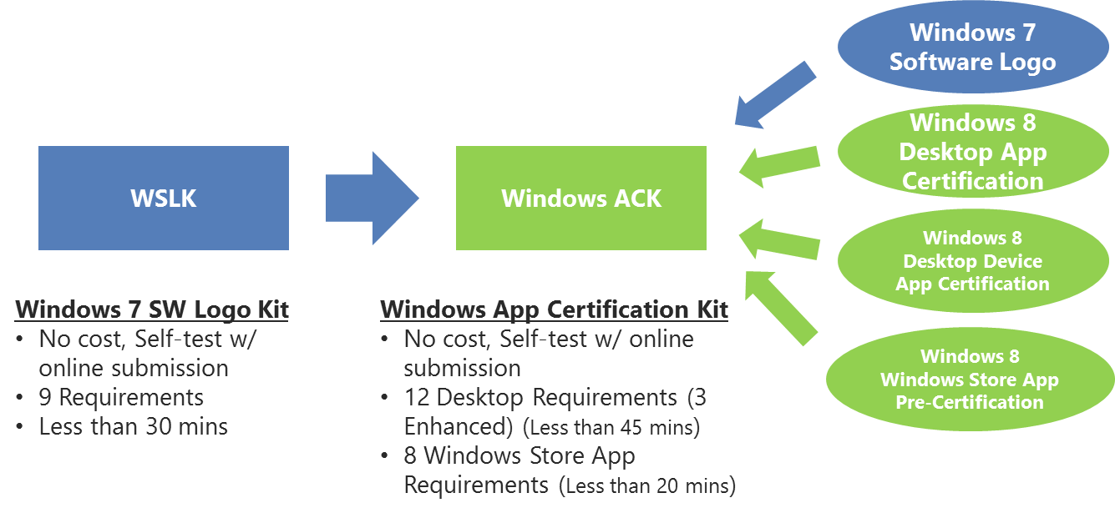

### What’s new in the WindowsACK

#### New UI and workflow

In response to partner feedback, we made several enhancements to the kit to improve the ease of use:

* New simplified user interface
* Improved multi-user test – eliminates need to manually set up and start a second user account
* Auto detection of app type – will get you started in the right direction

#### Localization

The current release of Windows ACK is available in 13 languages to aid in worldwide usage.

#### New and revised requirements

We added new requirements for reliability, security, and the new app model. For an overview of the requirements, see the sections below for the particular app model processes.

Additionally, 3 of the 9 requirements inherited from Windows 7 for Desktop Apps have revised requirements where the “Pass with warnings” option has been eliminated. This change will not affect applications submitted for Windows 7 Software Logo certification only.

## Using the Windows ACK

### **Configuring a test environment**

You should perform all tests on a computer that is running a clean installation of Windows. Other than the application being tested, don’t install additional applications or utilities such as antivirus software or a third-party firewall, because they may taint the outcome of the tests.

Turning off screen saver and configuring auto logon would simplify the monitoring of the progression.

#### ****Minimum system requirements****

Your system must meet these minimum requirements:

* 1-GHz 64-bit (x64) processor
* 2 gigabytes (GB) RAM
* 40-GB hard drive
* Windows 8 (or Windows 7 Ultimate/Enterprise, 64-bit for Windows 7-only testing)

### Accessing and installing the kit

#### Through the Windows SDK

Windows ACK is available as part of the Windows Software Development Kit (http://msdn.microsoft.com/en-us/windows/desktop/aa904949).

#### Through Microsoft Visual Studio 11 Express for Windows 8

Windows ACK is integrated within Microsoft Visual Studio 11 Express for Windows 8 (http://msdn.microsoft.com/en-us/windows/apps/br229516).

To access Windows ACK, just click the Windows App Cert Kit tile as shown here.

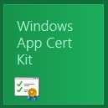

### Automating the validation process

Version 1.0, also known as the “Windows Software Logo Toolkit”, offered a scriptable mode which helps you integrate the kit onto existing automation in your company. We wanted to make the validation process part of the regular testing. Version 2.0 offers the same facility with much more flexibility.

The command-line mode now allows generating the final report without the need to go through the UI in cases of PASS and PASS WITH WARNINGS. For apps that FAILED the validation and require a WAIVER, we added a new command-line switch to allow invoking the respective UI. For more info on the command-line options, type WSLK /? from a console window.

|  |  |
| --- | --- |
| Verbs: | |
| Test | Executes the testing session. |
| Finalizereport | In case of any waiver instructions, you will need to exercise this option. The output of "test" will indicate if report finalization is required. |
| Reset | Resets the testing process. |
| Options (test) | |
| -apptype <type> | Specifies the (required) application type.  Can be either windowsstoreapp | desktop | desktopDevice. |
| -packagefullname <packagefullname> | Specifies the (required) installed package full name (Windows Store Apps only). |
| -setuppath <path> | Specifies the (required) setup executable or MSI full path. |
| -setupcommandline <commandline> | Specifies the (optional) setup command line. |
| -waittimeout <timeout> | Specifies the (optional) install or uninstall wait timeout in seconds |
| -appusage <usageType> | Specifies the (optional) application usage type. Can be either peruser | permachine. Default value is permachine. |
| -reportoutputpath <name> | Specifies the (required) report output full path and file name. |
| Options (finalizereport) | |
| -reportfilepath <name> | Specifies the full path (including filename) of the report that has to be finalized. |

Here are some command line examples:

appcert test -apptype windowsstoreapp -packagefullname microsoft.devx.appx.helloworld\_1.0.0.0\_neutral\_NorthAmerica\_ac4zc6fex2zjp -reportoutputpath c:\Output\MyReport.xml

appcert test -apptype desktop -setuppath d:\cdrom\setup.exe -setupcommandline "-install -quiet" -waittimeout 900 -appusage permachine -reportoutputpath c:\Output\MyReport.xml

appcert test -apptype desktopDevice -setuppath d:\cdrom\setup.exe -setupcommandline "-install -quiet" -waittimeout 900 -reportoutputpath c:\Output\MyReport.xml

appcert test -apptype desktop -setuppath d:\cdrom\setup.exe -appusage peruser -reportoutputpath c:\Output\MyReport.xml

appcert finalizereport -reportfilepath c:\Output\MyReport.xml

appcert reset

## App technical requirements

The tables here show the current and planned technical requirements for Windows certification of apps.

### Windows 7, desktop app, and driver add-in technical requirements

Desktop app requirements for Windows® 8 are posted on [MSDN](http://msdn.microsoft.com/library/windows/desktop/hh749939). The Windows 7 requirements continue to be available on [MSDN](http://go.microsoft.com/?linkid=9668061).

Table 1. Desktop app technical requirements

|  |  |  |  |  |
| --- | --- | --- | --- | --- |
| Requirement | Windows 7 | Windows 8 | Desktop Device App | Highlights |
| Clean, reversible installation | ✓ | ↑ | ↑ | Must include Version & Publisher in ARP; no left-overs on un-install |
| Install to correct location | ✓ | ✓ | ✓ |  |
| Digitally sign files & drivers | ✓ | ↑ | ✓ | Must sign main MSI and main EXEs; drivers must be Windows certified except value-added |
| X64 support | ✓ | ✓ | ✓ |  |
| OS version check | ✓ | ✓ | ✓ |  |
| UAC compliance | ✓ | ↑ | -- | Main EXEs must be marked as invoker; those manifested to require Administrator must be Authenticode signed |
| Adhere to restart manager | ✓ | ✓ | -- |  |
| Don’t load in safe mode | ✓ | ✓ | -- |  |
| Multi-user support | ✓ | ✓ | -- | Simplified kit user experience |
| Application reliability |  | ✓ | ✓ | No crashes or hangs during test; no Application Compatibility Modes;  avoid loading arbitrary binaries using AppInit\_DLLs |
| Support Windows security features |  | ✓ | ✓ | Pass BinScope |
| Don’t disable Windows security features |  | ✓ | ✓ | Pass Attack Surface Analyzer test |

### ***Legacy:*** 

↑ = Error Level Increased

✓ = No Change

### Windows Store apps technical requirements

The Windows Store app requirements for Windows® 8 are posted on [Windows 8 app certification requirements](http://msdn.microsoft.com/en-us/library/windows/apps/51A7C609-94AB-49ab-B8E0-F26FF776DDB4.aspx).

Table 2. Windows Store app technical requirements

|  |  |
| --- | --- |
| Requirement | Details |
| Eliminate app failures | The app must not crash or hang. App failures, such as crashes and hangs, disrupt and frustrate customers. Eliminating such failures improves app stability and reliability, and overall, provides customers with a better experience. |
| App manifest | The app manifest must contain all the required attributes. |
| Use Windows security features | The app must use proper compiler flags |
| Use supported platform APIs | The app must use only APIs from the Windows Software Development Kit (SDK) for Windows Store apps |
| Launch-time performance | Your app must meet the basic performance criteria on a low power computer:   * The app must launch in 5 seconds or less * The app must suspend in 2 seconds or less   Low-power computers are described in [Testing your app with the Windows App Certification Kit](http://msdn.microsoft.com/en-us/library/windows/apps/hh694081.aspx#remarks_low_power_computer). |
| Suspend performance | The app must have a fast and responsive suspend experience while consuming a reasonable amount of system resources (CPU, file IO, memory, etc.) and making sure that resources are released efficiently. |
| App package resource validation | The app manifest must have valid resources defined in the resources.pri file, as per the Appx Packaging Specification and Appx Manifest Schema. |

## Validating your apps

Regardless of the type of software certification required, the step-by-step process is consistent across the various scenarios.

### Step 1 - Launch the Windows App Certification Kit

The Windows ACK can be launched through its own tile. After launching the kit, you’ll be presented with multiple choices. We refer to these as workflows, each of which is applicable only to the respective certification it supports.

**Launching Windows ACK**

1. Log on as Administrator.
2. Click the tile titled **Windows App Cert Kit**.
3. Click **YES** to the **UAC** prompt.

### Step 2 - Selecting the workflow

The Windows ACK houses 3 workflows:

Each entry on the home page represents an independent workflow designed to run a predetermined set of validation cases specific to each supported certification.

1. From the home page, select the workflow you want. In the image here, **Validate Windows Store App** is highlighted, denoting selection of the workflow for Validating a Windows Store App with the Windows 8.

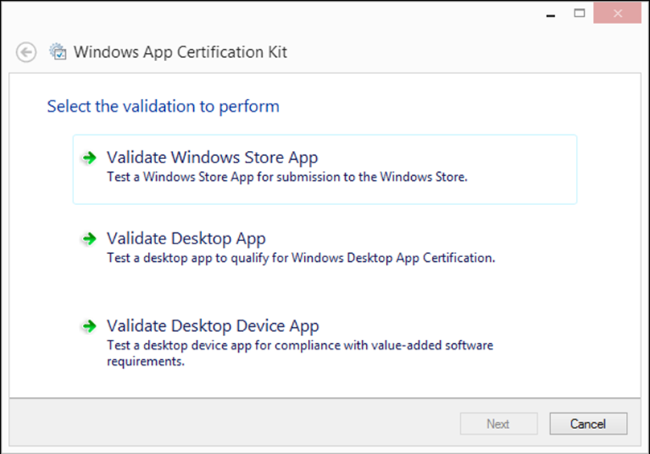

1. Making the selection automatically advances to the next step, and triggers the scan operation.

### Step 3- Provide info about your app

In this step you’ll be prompted to provide info related to your app; for example, setup file location, install type, and so on.

#### Selecting apps to validate

If you have selected the Windows Store App workflow, The Windows ACK scans the system for installed apps matching the app type selected in step 2, and lists all apps found.

##### ****Selecting an installed**** Windows store a****pp****

1. Scroll through the list and pick the app for validation.

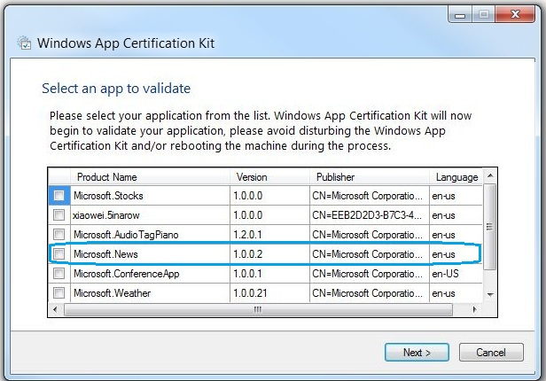

1. Click the **Next** button to start the validation process. Don’t interact with the desktop or any of the running processes during the validation.

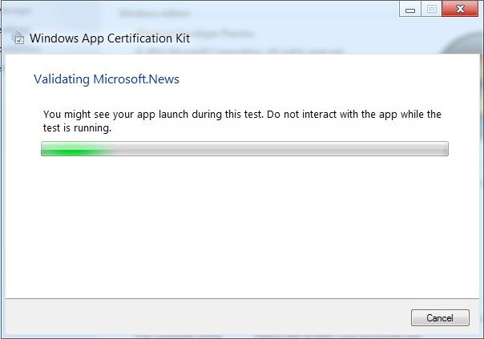

##### ****Installing and selecting a desktop app****

1. Click the **Browse** button, and navigate to your desktop app.

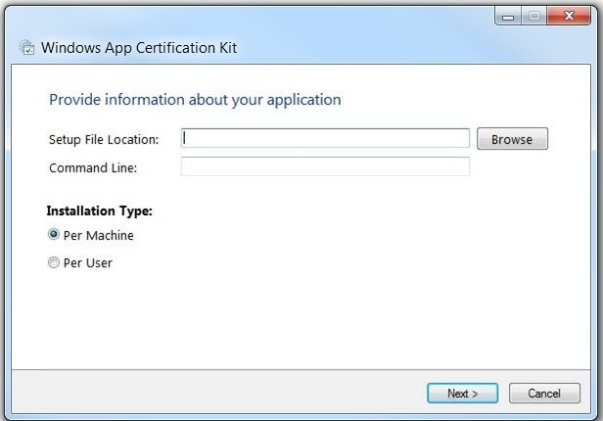

1. Leave the **Command Line** empty.
2. Pick either **Per Machine** or **Per User** under **Installation Type**, and click **Next**.

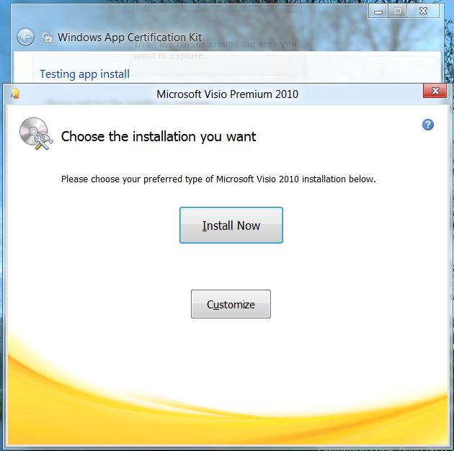

1. Click **Install Now**, and follow the installation process.
2. If prompted to reboot the system to complete setup, choose **No**.

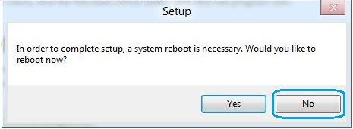

1. Click **Next**.

### Step 4 - Save the validation report

After the validation process concludes, Windows ACK generates a report. You’ll be prompted to save the report to a designated location.

1. When prompted to save the report, browse to the location where you want to save the report file, such as **Desktop**.

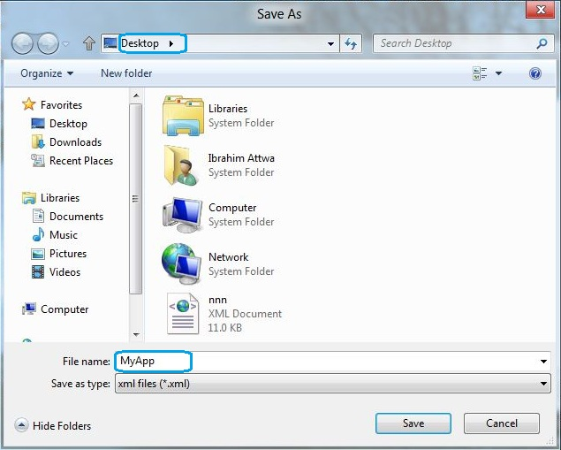

1. Type a unique name for the report in the **File Name** field and click **Save**.
2. To view the report, click the **hyperlink**, and then click **Exit**.

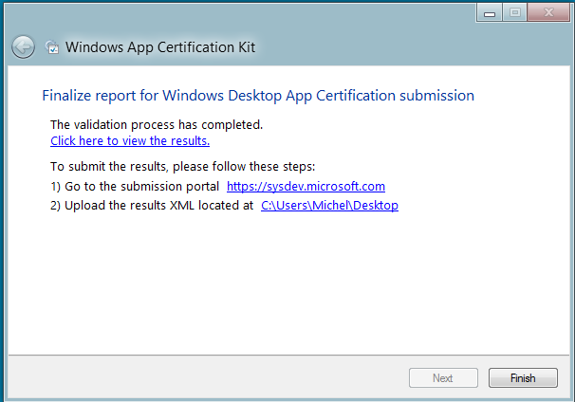

### Submission for certification

You are ready to submit apps for certification on Windows 8 to the new portal submission process (https://sysdev.microsoft.com).

### Using the Windows ACK to validate your Windows 7 apps

Since the Windows ACK have been released, it has replaced the WSLK and became the test kit for Windows 7 Software Logo Certification too. If you plan to continue to have applications to logo for Windows® 7, you will need to switch to the Windows ACK for your validation testing and report.

The Windows ACK can detect if it is running on Windows 7 and will automatically launch with the proper workflow for Windows 7 apps. The step-by-step process will be consistent with the process detailed earlier.

### Submission for Windows 7 Logo certification

You need to submit results from the WindowsACK for Windows 7 Apps to the new portal submission process (<https://sysdev.microsoft.com>).

## Reading the validation report

The Windows ACK report is broken down into sections. The top section contains info related to the app, and the second section has the overall score of the app. The rest of the report outlines the individual results at the requirement level.

#### ****Overall score:****

1. **The overall score can be one of these:**

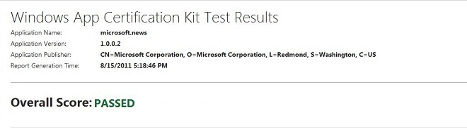

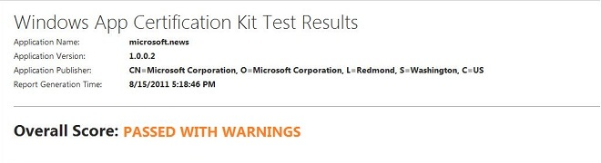

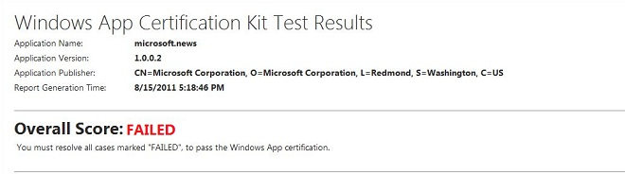

**Passed** is the highest score an app can achieve, and it denotes that the app has passed all required validation.

**Passed with warnings** denotes the app has passed overall, but one or more requirements passed with warnings. Although this overall score will not cause the app to be rejected during onboarding, we strongly recommend that you investigate and address all **warnings**.

**Failed** denotes the app has failed one or more requirements, and will be rejected during onboarding.

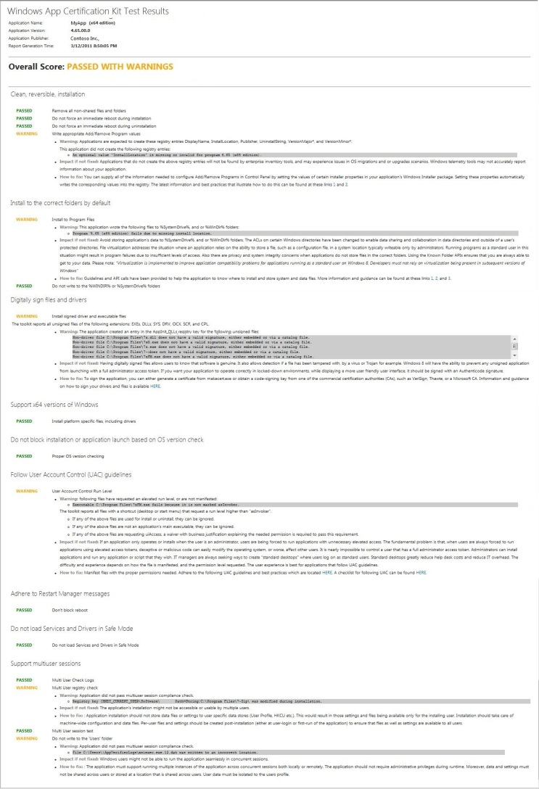

## Support and feedback

### Windows ACK feedback

Submit your feedback on the Windows ACK through the Partner portal.

### Windows 7 support

Support for the current Windows 7 Software Logo program using the WSLK for validation and submission, continues to use the [swlogo@microsoft.com](mailto:swlogo@microsoft.com) alias. This support channel can’t help with Windows ACK or Windows 8.