**Contents**

1: About ........................................................................................................................ 2

2: Quick Start ................................................................................................................ 4

3: Features .................................................................................................................... 6

4: Frequently Asked Questions ................................................................................... 8

5: Command Summary .............................................................................................. 10

USER GUIDE

**1: About**

Do-*er* List is a beginner-friendly desktop program that aids you in the planning and completion of your daily tasks. It does not matter if you are planning a big birthday surprise event or recurring task of handling the laundry every now and then, Do-*er* List is here to resolve your problems!

Featuring a minimalistic and intuitive display largely keyboard-input commands to operate our program, we have done away the need of a mouse so you can schedule their tasks on the fly with their laptops. Be-gone with the woes of trawling through clunky interfaces of other scheduling apps to find those edit or remove buttons with your unresponsive touch-pad while waiting for the bus!

Just type it in, hit enter, and your commands will be executed as you desired!

Eager and excited? Then proceed on!

**2: Getting Started**

Most of us are overwhelmed with new tasks and events to do on a daily basis that ranges from assignments to group project meetings. You may experience frustration with the constant need to wonder what to do next and such distractions may hinder your productivity.

That is when Do-*er* List comes into the picture. With Do-*er* List, managing tasks and events of your life has never been simpler! It is exceptionally simple to create a task, edit or delete it. Navigate through the tasks like a boss! It is time for you to take control of your life and never feel at a loss again!

**User Interface Overview**

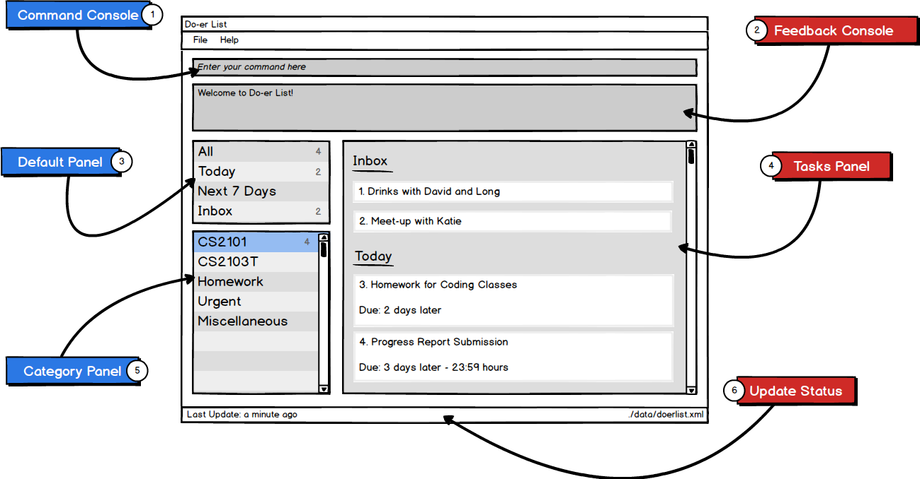

|  |  |
| --- | --- |
| Labels | Description |
| 1 | Command console allows you to input and execute your commands |
| 2 | Feedback consoles shows if your command is executed properly or not |
| 3 | Contains all of your default categories |
| 4 | Display all the tasks in a panel |
| 5 | Shows all the custom categories that you have created |
| 6 | Indicates the file storage directory and the last time you have edited |

### https://lh4.googleusercontent.com/_9oWP_Ep3CNIYwRqOuoX8YajUvz_5kgxBF6yDkUaOUvpcTZId9BWddJO46sUOYQ3Eshy9Up_CW_c0yd8g70yamMhXkfULD1XyEGfL5RG_ynf2gqgyoSyY2Q5Xo0XTJc5MipC743e2.1.1 Launch

You can always start Do-*er* List whenever you want to view your tasks at hand. Just double click on the program icon to get started.

From there, you can input command in the dialogue box and press ENTER to execute it. The results will shortly appear.

### https://lh5.googleusercontent.com/RVgM7A4WcclCeE4gvmwxJP9nOAkQSGMKZ7sK_15PaUgdGaUQrcu1TueXknCVzE1qsCqjkGBaHtvAjzJ1lM9pfEt_xdnjSZWs0W_5zBJufQbXLI_ffDyxlenIliISY4izAkbzwyiC2.1.2 Your friendly guide

First of all, whenever you forget how to use Do-*er* List, you can always count on this command

**>> help**

that will display all the available commands and how to use them. Moreover, if you just forget how to use one specific command, for example, the "add" command, you can always specify it like this

**>> help add**

and the usage of the "add" command will be shown. Not just the "add" command, any command will also work.

If you carelessly mistype a command, the help command window will also show up. How convenient is that!

### 2.1.3 Add Tasks

This morning, Robin just told you to go out and drink with him and his friends. Robin never invited you before and thus this is an important event and you want to note it down in your to-do list, simply type:

**>> add -t Drinks with Robin -d Have Fun {tonight 8->tonight 10}**

and the event is scheduled in Do-*er* List.

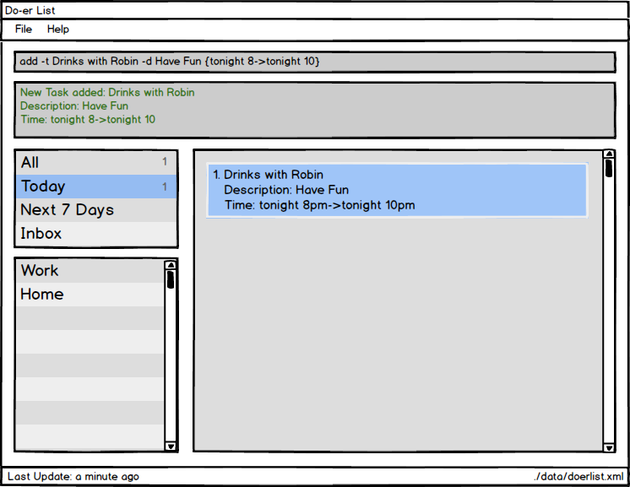

"Drinks with Robin" is the title of the event. "Have fun" is the description of the event and the time is tonight from 8 to 10.

Like we have mentioned before, Doer-List is featured rich, we want you to do as much as possible with a single command line. You can add title, description and start time and end time for the event. You can also categorize an event. Moreover, you can type them in any order. So yes, you can enter the time first before thinking of a cool name for the event. How awesome is that!

|  |
| --- |
| The general command is:  **>> add -t TITLE [-d DESCRIPTION] [{[START]->[END]}] [-c CATEGORY] ...**  A task can have more than one category (including 0)  The START or END parameter can be in natural language (next 5 hours, today, tomorrow, next 3 days, next week, next month) or in standard format “2016-10-3 10:00”. For example: **>>** **add -t Do post-lecture quiz {today->tomorrow} -c CS2103**  If the START date is missing, the Do*er*-List set it to today by default. For example,   **>>** **add -t Do CA1 -d Oral Presentation {->next 2 days} -c CS2101**  If the there is not START->END parameters or END date is missing, the Do*er*-list will create task without start date and end date and move it to Inbox build-in category. |

### 2.1.4 Editing tasks

Oops! You are actually going to drink with David, not Robin, how silly of you! Fret not, you just enter this "edit" command:

**>> edit 1 -t Drinks with David**

and the task you just scheduled changed to "Drinks with David".

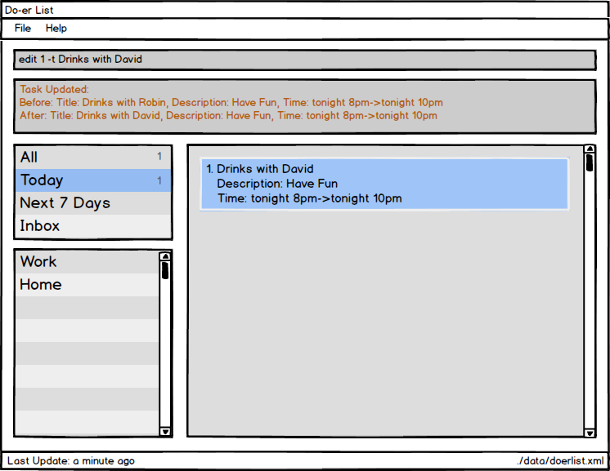

|  |
| --- |
| The general command is:  **>> add index [-t TITLE] [-d DESCRIPTION] [{[START]->[END]}] [-c CATEGORY] …**  You can also edit the description, the time or the categories, as much as you want. The index of the task is the index displayed on the screen. For example, if you just want to change the due date of the second task to the next five days, simply type this command: **>> edit 2 {->next 5 days}** |

### 2.1.5 Mark task as done

You have just come back home after drinking with David. You want to mark the task as "done". Type this command:

**>> mark 1**

and the task will be shown as completed

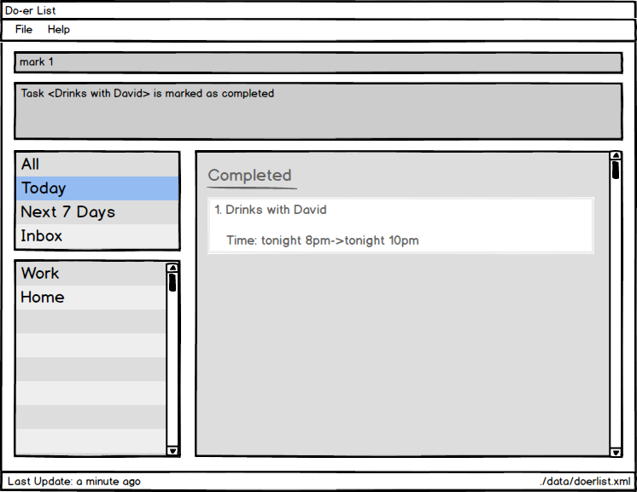

|  |
| --- |
| The general command is:  **>> mark index**  The task must exist in the Do-er List |

### 2.1.6 Unmark a "done" task

How forgetful you are! You actually have yet to drink with David. However, you have already marked the task as "done". Fret not! Do-er List gives the users the power to reverse such mistake. Simply type this command

**>> unmark 1**

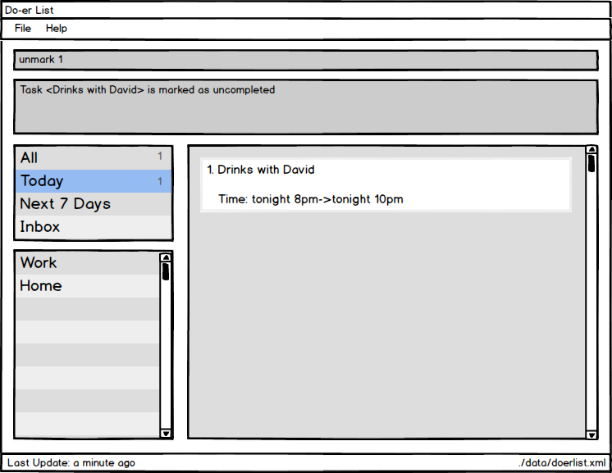

|  |
| --- |
| The general command is:  **>> unmark index**  The task must exist in the Do-er List |

### 2.1.7 List tasks

You also want to check all tasks under a specific category. To do this, simply type this command

**>> list today**

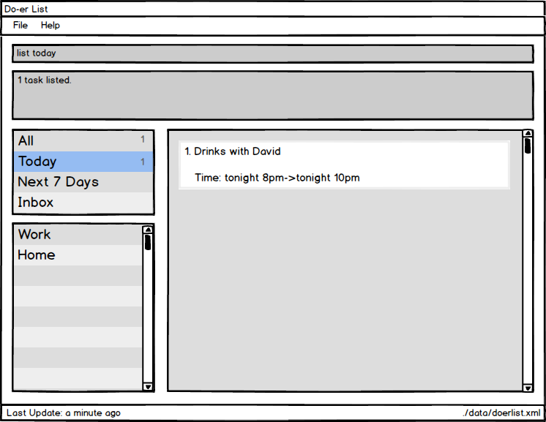

|  |
| --- |
| The general command is:  **>> list [CATEGORY]**  This command will list all tasks under the `CATEGORY`.  If the CATEGORY parameter is not supplied, all tasks will be listed to you. |

### 2.1.8 find tasks

You remember that you need to have drinks with someone but only remember some keywords in the task title or description. By using find command, Do-er List will search tasks for you and then you find that you need to have drinks with David and Jason.

**>> mark 1**

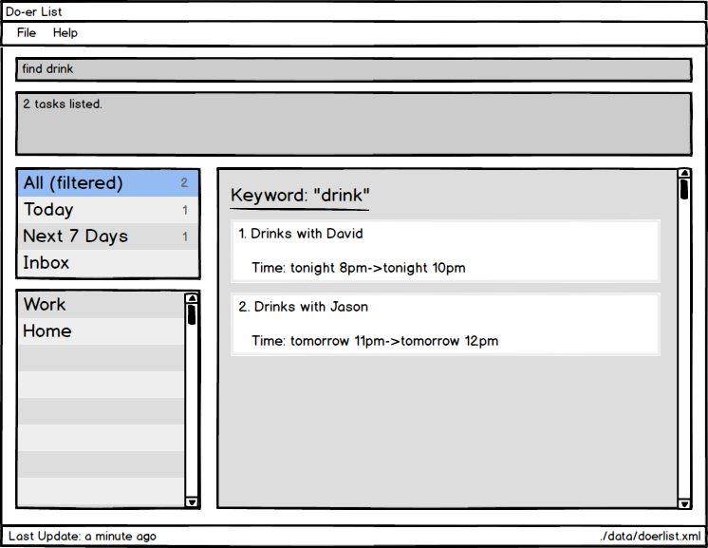

|  |
| --- |
| The general command is:  **>> find KEYWORD [MORE_KEYWORDS]**  This command will search all tasks whose title or description contains keywords  The search is **not** case sensitive. e.g “lecture” will match “LecTure”  The order of the keywords does not matter. e.g. “go to lecture” will match “Lecture go to”  All data in the Do-*er*List matching at least one keyword will be returned (i.e. OR search). e.g. “lecture” will match “have lecture” |

### 2.1.9 view tasks

You add some descriptions when creating task “Drinks with Jason”. Do-er list will not display the descriptions of tasks by default as the descriptions may be very long. However, you can view them by using view command. Simply type this command

**>> view 2**

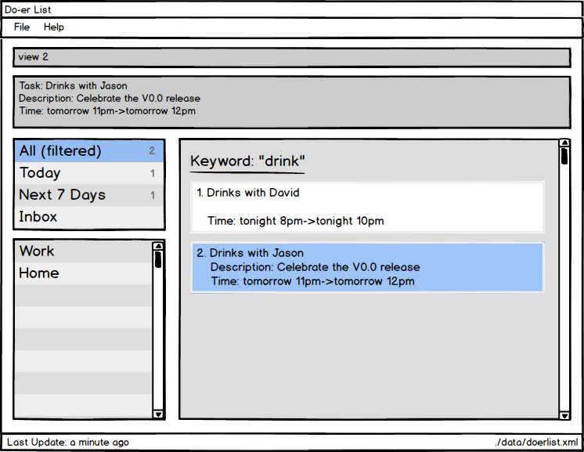

|  |
| --- |
| The general command is:  **>> view INDEX**  This command will display the description of a task specified by INDEX  The index refers to the index number shown in the most recent listing.  The index must be a positive integer 1, 2, 3, ... |

### 2.1.10 delete tasks

You just heard from Jason that he had a headache and the drinking is canceled. What a pity! You don’t need to keep track of the task and want to remove it. You can simply type this command

**>> delete 2**

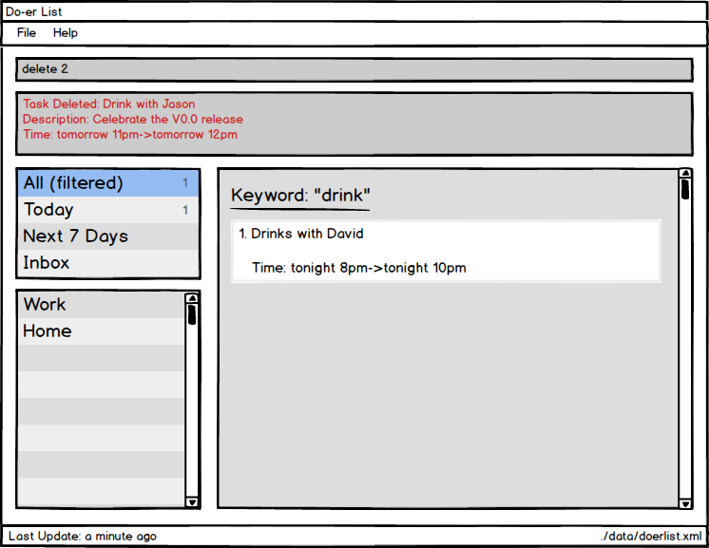

|  |
| --- |
| The general command is:  **>> delete INDEX**  This command will delete the task at the specified INDEX.  The index refers to the index number shown in the most recent listing.  The index must be a positive integer 1, 2, 3, ... |

### 2.1.11 undo operation

Good news! Jason tells you that he is able to come tonight and he want to use the alcohol to cure himself. You feel he is crazy but anyway you need to recover the task you just delete. You can use “undo” command to undo the most recent operation that involves data change.

**>> undo**

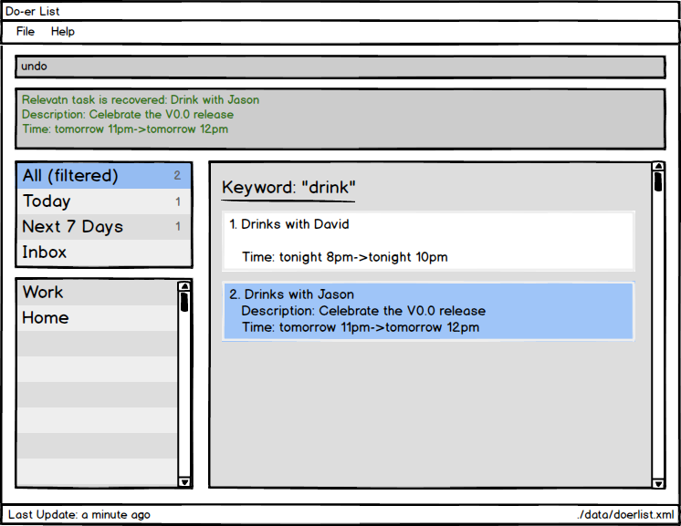

|  |
| --- |
| The general command is:  **>> undo**  Undo the most recent operation which modify the data in the Doer-list |

### 2.1.12 redo operation

Jason just told you he couldn’t come again. Just joking. If you just do “undo” command and want to redo the operation. Simply type this command

**>> redo**

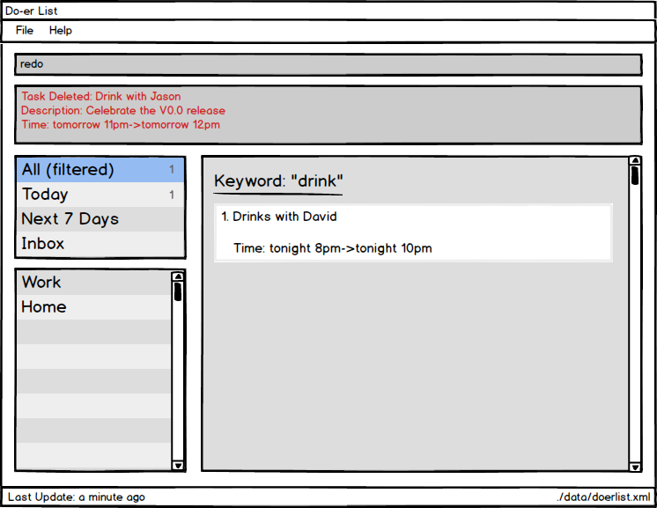

|  |
| --- |
| The general command is:  **>> redo**  Redo the operation caused by using “undo” command |

### 2.1.13 find all due task

After drinking with Jason, you need to get back to your work. You want to check the due tasks by tomorrow. To do this, simply type this command

**>> taskdue tomorrow**

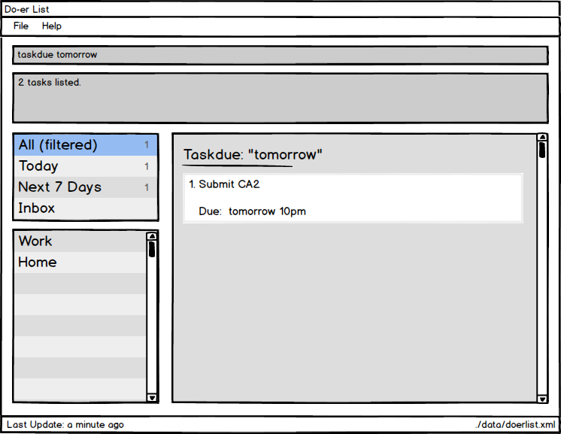

|  |
| --- |
| The general command is:  **>> taskdue END_DATE**  This command will find all tasks that due by END_DATE.  The **END_DATE** can be in natural language (E.g. next X hours, today, tomorrow, next X days, next week, next month) or in standard format (E.g. 2016-10-3 10:00) |

### 2.1.14 Exit

You can exit the programme by typing

**>> exit**

### 2.1.15 Saving data

The Do*er*-list data are saved in the hard disk automatically after any command that changes the data.

There is no need to save manually.

**3: Frequently Asked Questions**

**Q**: How do I transfer my data to another Computer?  
**A**: Install the app in the other computer and overwrite the empty data file it creates with the file that contains the data of your previous Address Book folder.

**Q**: How do I   
**A**: Install the app in the other computer and overwrite the empty data file it creates with the file that contains the data of your previous Address Book folder.

**4: Getting Started**

| **Command** | **Format** |
| --- | --- |
| Help | help [COMMAND] |
| Add | add -t TITLE [-d DESCRIPTION] [{[START]->[END]}] [-c CATEGORY] ... |
| Edit | edit INDEX [-t TITLE] [-d DESCRIPTION] [{[START]->[END]}] [-c CATEGORY] ... |
| Mark Done | mark TASK_NUMBER |
| Mark Undone | unmark TASK_NUMBER |
| List | list [CATEGORY] |
| Find | find KEYWORD [MORE_KEYWORDS] |
| View | view INDEX |
| Delete | delete INDEX |
| Undo | undo |
| Redo | redo |
| Task Due | taskdue END_DATE |