Randomized Flashing Lights Timings
Bryce Place
CMP408: IoT and Cloud Development
2025/26

Note that Information contained in this document is for educational purposes.
Contents
1 Introduction 1
1.1 Background 1
1.2 Aim 1
2 Procedure 2
2.1 Overview of Procedure 2
2.2 Sub-Heading 2
3 Discussion 4
3.1 General Discussion 4
3.2 Countermeasures 4
3.3 Future Work 4
References 5
Appendices 7
Appendix A 7
Appendix B 7
Appendix C - Suggestions for formatting figures/tables/screenshots in the body of the text 7

Introduction

Background
Internet of Things(IoT) have been spiking in prevalence globally for what has felt like decades. Just last year, according to reports from Sinha at IoT analytics, in 2025 alone IoT devices have grown 14.8%, totaling 21.1 billion devices globally (Sinha, 2024). With the abundance of IoT devices exponentially increasing worldwide, a fundamental understanding of their frameworks and design is necessary in a cyber security field. Botnets such as Mirai and Shadowv2 have reeked havoc on vulnerable IoT devices as these devices are often left unsecure compared to their OS-based counterparts(Cloudflare).
RaspberryPi devices are small, single-board computers that are particularly useful in the exploration of IoT devices. With these low powered devices, connecting small IoT devices such as cameras, LED lights, buttons, humidity detectors, and more are as simple as a Lego set. For the sake of this project, a RaspberryPi Zero will be utilized as a central unit to connect various IoT devices to. Utilizing lightweight languages such as Python or C, programming to these connected IoT devices is effective and efficient. Python in particular has an expansive set or integrated libraries that are useful for effective programming, connecting to the GPIO pins that the devices are connected to with only a few lines of code.
Additionally, cloud services have been expanding their presence as more and more companies outsource their server usage to third parties such as Amazon, Google, or Microsoft. These services provided pay as you go database construction and storage that allows for companies to handoff logistical workload off to these third parties where they otherwise might be inexperienced. The project development will plan on implementing the Amazon AWS cloud services provided to demonstrate the effectiveness of these prevalent services, connecting the IoT devices information into the databases.

Aim
The following are the various goals hoped to be achieved during the development process of this project:
- Create a randomized python script that correctly turns on a off various LED fixtures attached to the Raspberry Pi framework.
- Utilize a loadable kernel module to flicker the lights on an off with the pi framework.
- Save the times in which lights have been turned on an off.
- Input these timings into an AWS Cloud based database as well as the frequency of inputs upon each light.

Procedure

Overview of Procedure
A RaspberryPi Zero was utilized as the main host machine for this project. This machine had its OS installed onto a 32 gigabyte SD card, provided by the university. The 23, 24 and 14 GPIO pins were attached to LED lights of different colors, ground on an external board. These LEDs are the main IoT component utilized for the rest of the project involved. The LEDs were attached to a pinboard next to the RaspberryPi that was connected via ssh tunneling to a Fedora VM instance running on the same network as the Pi, as seen below.
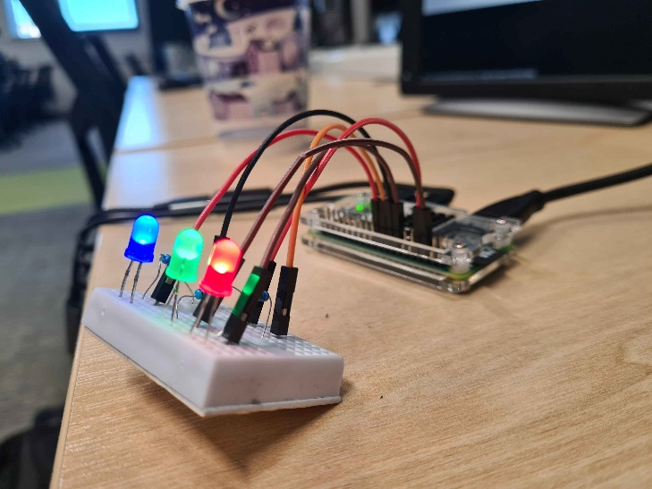
Figure 2.1.1 Picture of hardware project components.
Once physical installment was assembled and ready, the programmers made a python variant of the final project on the pi itself, confirming that the idea was feasible. This python program is provided in Appendix A and involved three LED lights flickering at pseudo-random. Before kernel work began, this isolated python script was created utilizing the imported GPIO library. This library circumvented the need for an LKM during key testing phases and was immensely helpful at properly displaying the feasibility of the project. Removing the GPIO library and incorporating cdev and io controller libraries that handled importing kernel level functionality was implemented over the course of several weeks. This Kernel module was made utilizing a customized Linux makefile provided by Dr Abdul Razaq, which compiled the lower level c programming into a usable module.
There were four controller variables created within the c kernel program, three for each individual LED and a forth to controller switch all lights to off once the program had concluded. These controllers were utilized through the toggle method created in the python script, where the lights are “toggled” off and on depending on their state. The open_dev() function initializes the GPIO pins to begin communicating with the script by calling the operating system open function and creating a dev level filepath named “randled”. This filepath provides a location where the two programs can communicate in memory, as the python code is converted into kernel based commands for the raspberry pi to read.
The AWS student account provided offered a variety of functionality that showcased the potential of cloud based computing. However, due to permission restrictions there were several features that made proper implementation a struggle. Notably, any interaction with the IAM framework was denied which resulted in several attempts to connect to the LEDs empty. With that, construction on the project began by implementing several Lambda functions and connecting a DynamoDB table to the python script through a server ran on EC2. Utilizing a third party ssh tool in PuTTy, the programmers were able to configure the raspberry pi to the AWS account credentials supplied by the university.
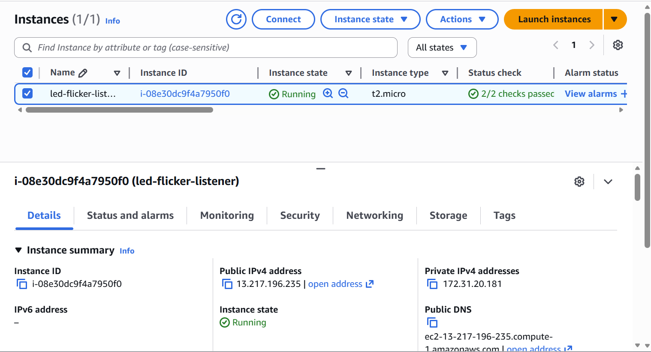
Figure 2.1.2 Screenshot of the AWS EC2 instance.
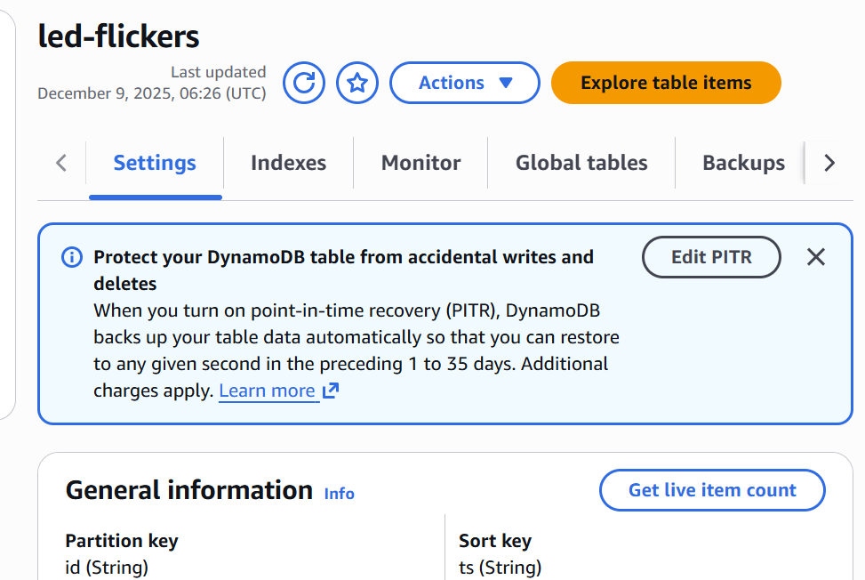
Figure 2.1.3 Screenshot of DynamoDB LED table.

Conclusion

General Discussion
- Iot discussion
- Lkm discussion
- Cloud services discussion

Future Work
- Fedora VM modifications
- Tunneling study
- RaspberryPi Improvements

References
Sinha, S. (2024) State of IoT 2024: Number of connected IoT devices growing 13% to 18.8 billion globally, IoT Analytics. Available at: https://iot-analytics.com/number-connected-iot-devices/. [Accessed on November 28, 2025]
Cloudflare (no date) ‘What is the Mirai Botnet? | Cloudflare UK’, Cloudflare. Available at: https://www.cloudflare.com/en-gb/learning/ddos/glossary/mirai-botnet/. [Accessed on November 28, 2025]

Appendices

Appendix A

Appendix B

Appendix C -

