Bailing The Titanic: An Exploration on Phishing Malware Exploitation Techniques commonality analysis

Annie Place
BSc Ethical Hacking

Faculty of Design, Informatics and Business
Abertay University
DUNDEE, DD1 1HG, UK

ABSTRACT
Online communication is an inevitability. With how companies are forced to structure themselves there ais no feasible way to operate wide scale operations without quick and seamless communication. However, this vector proves time and time again to be the most vulnerable as social engineering methods from threat actors continue to adapt and exploit the ineptitudes of individuals.
The Aim of this project is to examine the many different tendencies that phishing malware use to infect systems at large and reconstruct the commonality that is used to exploit users.
Utilizing Ghidra and other disassembling tools, many different known and studied phishing malware will be disassembled and examined specifically in search of their technique of spreading. With several samples disassembled the common throughline that these use to manipulate email services will be reassembled in a Virtual Machine environment as a means of demonstrating the ease of exploitation these samples follow.
The project will examine and scrutinise the security of email service providers, analysing their measures of mitigating attacks from simple to complex malware spread. All findings that jeopardize the security or integrity of services examined will be provided to the respective parties.
The newfound information provided by this study will assist the field in looking to build a more secure email framework that looks to prevent mass vulnerabilities throughout a network. If any exploits are found to be still in use the end users are possible future victims of the next bug to take form.
Keywords
Malware, Phishing, Email, Ghidra, Disassembly,

CyBOK

This section is only for BSc Ethical Hacking, BSc Cybersecurity and BSc Computer Science with Cybersecurity students. All other students should delete this section.

List which Knowledge Areas from the CyBOK are relevant to this project. See spreadsheet on MLS for a list of the Knowledge areas, and more detail here: https://www.cybok.org/knowledgebase1_1/

For example: KA2 Human Factors, KA5 Malware and Attack Technologies, KA15 Web & Mobile Security.

1. INTRODUCTION

Insert your introduction text here. Remember that the introduction should set the scene for your project by describing a current situation or problem. Start in quite general terms so that your reader has a chance to align themselves but then focus towards the specifics of your chosen topic. Hopefully in this section it will become clear that there is a need for the work you are planning to carry out

Headings for the sections (INTRODUCTION etc) should be in 12 point Bold, Times New Roman. The main body of the text continues in 9 point Times New Roman.
You are advised to simply cut and paste your text into these sections and so preserve the formatting information

The page size is A4 , the top and bottom margins are 2.54cm and the left and right margins are 1.9cm. The document is in 2 columns each of width 8.2cm with a 0.8cm gutter; all of these are usually simple to set up in Word if you wish to create your own template. As you can see the text is both left and right justified.

You can use references here.

2. BACKGROUND (Approx ¾ page)

In this section you should be giving the background to your project – what is the current state of the art or understanding. What problem are you going to address and who says that it’s a problem anyway. This section should make it clear that your project is an investigation at Honours level and follows on logically from other work that’s of relevance and importance to other workers in your field.

You MUST use references here.

2.1 Subsections
Subsection headings are also 12 point Bold, Times New Roman but only the first letter of the title is capitalized
Remember that you should be citing references within the text in these sections using the Harvard style of referencing (Harvard (2011)) since this is the accepted method within the university.

You can find detailed guidance on how to reference all styles of material within the guide available on the Library Portal or from the Library itself in a booklet form.

2.2 Tables
Sometimes you may wish to include a table in your document.

Place tables as close to the point at which you refer to them as possible. A large table may extend across both columns if required.

Captions for the table should be in 9 pint Bold, Times New Roman and they should be numbered (Table 1) – please note that the word “Table” should be spelt out in full and the caption should appear above the table and centred.

Table 1 – An Example table for the text

Graphics | Top | Centre | Bottom
Tables | End | Last | First
Figures | Good | Similar | Very well

2.3 Figures
Figures can help describe something very effectively but be careful of just using screen shots since these can run to many MB without you noticing it.

Captions for figures should also be 9 point Bold, Times New Roman but are centred below the figure. Use the full word “Figure” in the caption

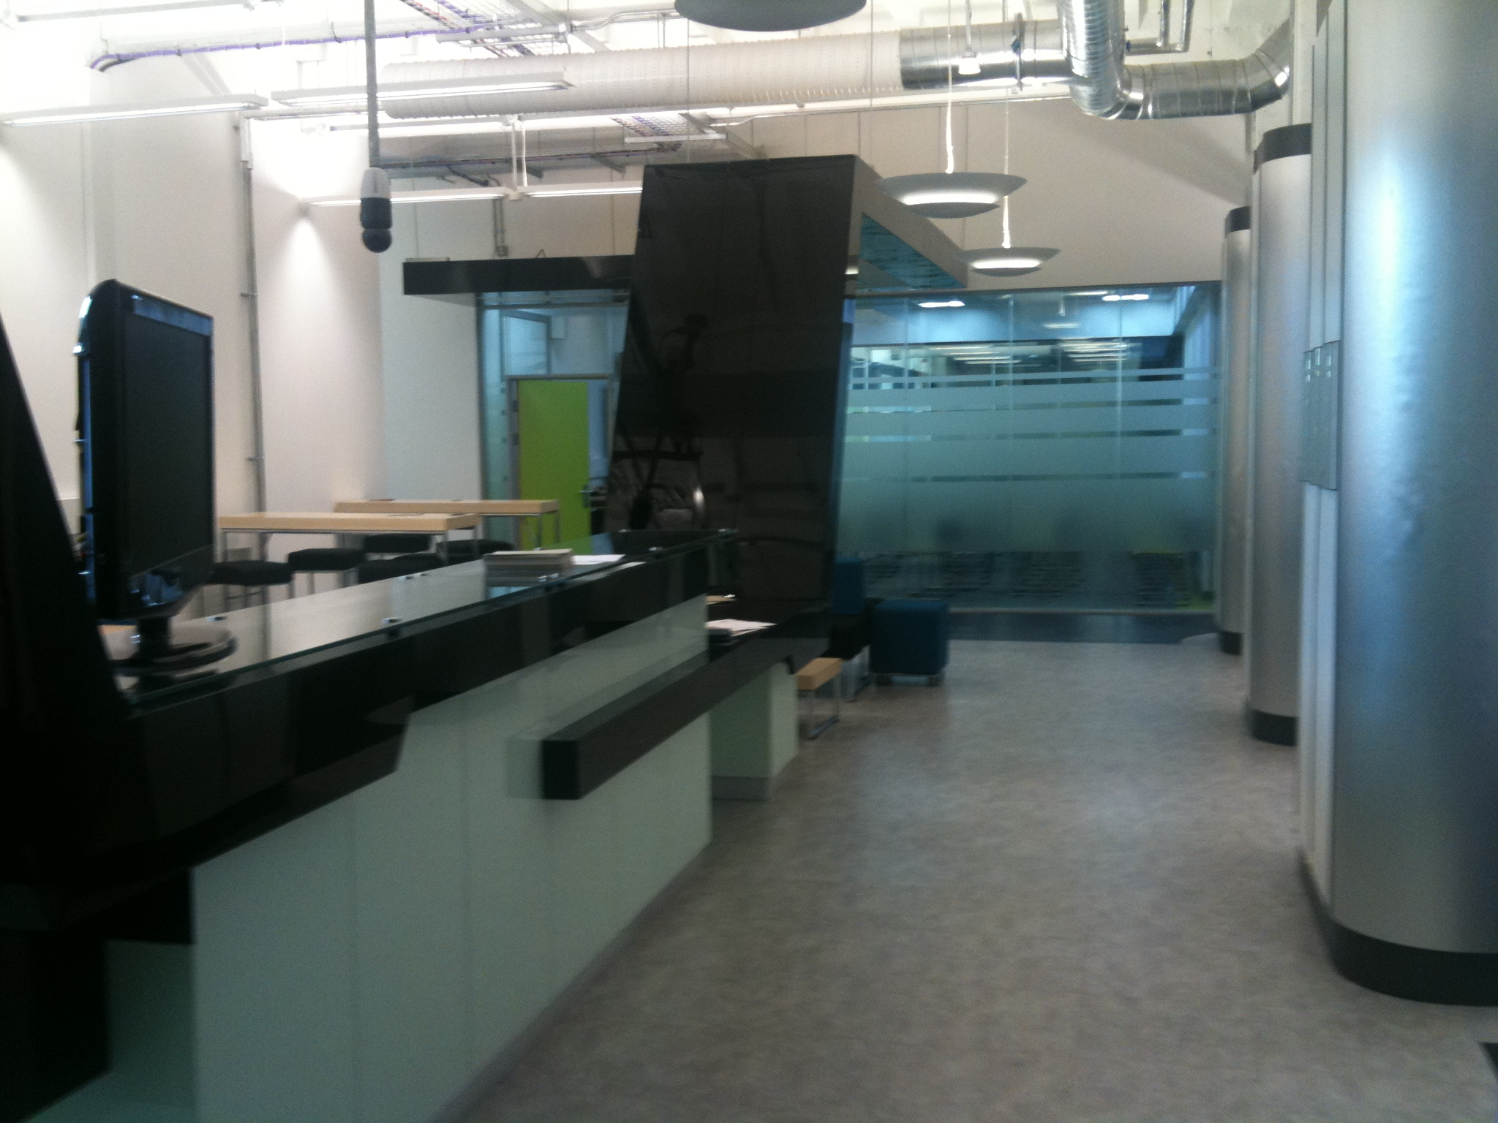

Figure 1 – A view of the entrance on level 2 of Abertay University

Remember that you should give due credit to figures that you use by giving a reference after the caption – the above photo is one I took and so I have given myself permission to use it.

The next section is the Method section and the two-column format continues.
(Approx ¾ page)

3. PROJECT ARTEFACT (Approx ¾ page)

In this section of the proposal, you should explain what you are going to build/develop/produce as a solution to the problem or challenge you have identified for your project. That solution is called an “artefact”.

All students undertaking CMP400 are required to produce an artefact. Students must engage in practical work using computing/IT technology, typically manifested through the creation of an artefact, which serves as the centrepiece of your project. Dissertations and projects based only on literature reviews or surveys are not acceptable. Please describe here the artefact that will be produced for your project.

In essence, an artefact is:
- A tangible deliverable—something created, built, or developed during the project that solves, or takes steps towards solving, the problem or challenge you have identified through your research and set out in your earlier sections of this proposal. It could be a piece of software, a prototype or an online web tool but it must be a tangible item.
- It’s the practical embodiment of the theoretical and design aspects of your work, showcasing real applied effort to identify and respond to a problem, challenge or social issue.

4. METHOD
4.1 Disassembly
4.2 Malware Analysis
4.3 Secure VM Construction
4.4 Reassembly
4.5

In this section you will describe what practical work you actually intend to carry out. You should mention what choices exist and explain why you have chosen a particular method and what you expect the results can tell you.

Of course at this point you have not actually done anything and so you are speculating to some extent but by looking at what other people have done (and referencing that work) you should be able to identify what is possible given your own limitations in terms of time and skills.
(Approx ¾ page)

5. SUMMARY(Approx ¼ page)

You should finish you proposal with a summary of what you see your project as contributing to the subject area. Why is it worth doing and who might benefit from your results?

6. REFERENCES

https://link.springer.com/chapter/10.1007/978-3-031-85994-6_9
https://threadreaderapp.com/thread/1912439023982834120.html
https://easydmarc.com/blog/google-spoofed-via-dkim-replay-attack-a-technical-breakdown/
https://www.cybok.org/media/downloads/Malware_Attack_Technologies_v1.0.1.pdf
https://librarysearch.abertay.ac.uk/discovery/fulldisplay?docid=alma991812530803201&context=L&vid=44UAD_INST:44UAD_V1&lang=en&search_scope=MyInst_and_CI&adaptor=Local%20Search%20Engine&tab=Everything&query=any,contains,Phishing&offset=0

All of the references that you have cited in the text must now be listed here in alphabetical order using the Harvard Cite Them Right style of referencing. Again we remind you that guidance is available from
https://intranet.abertay.ac.uk/library/referencing/
which explains how to reference all the material you are likely to come across from journal papers to blogs or YouTube. The reference you give must enable anyone to obtain the reference, not just people with an Abertay University IT account for example

The reference list should be 9 point Times New Roman but only left justified, e.g.:

Other, A, N, date, “Title of the article”, Name of the Journal, Volume number, pages

See the guides for other examples of style.

Note that we expect you to have no more than 8 references but you should have at least 3 good quality references meaning that they have been published in a peer-reviewed academic journal or other academic publication (a conference proceedings for example).

Finally, note that we have tried to make the two columns on this last page roughly the same length by inserting blank lines in the first column

