Artefacts for Malware Classification
Annie Place
CMP400: Honours Project Proposal and Execution
2025/26

Note that Information contained in this document is for educational purposes.
Contents
1 Research Question 1
1.1 Research Questions 1
2 Gantt Chart 2
3 Risk Analysis 3
3.1 Malware Risks 3
3.1.1 Infection Risks 3
3.1.2 Unsecure VM Construction 3
3.2 Non-Technical Risks 3
3.2.1 Scope Creep 3
3.2.2 Legality of Malware Assembly 4
3.3 Risk Analysis Matrix 4
4 Literature Review 5
4.1 Detection 5
4.2 Classification Groups 5
4.2.1 Signature 5
4.2.2 Behaviour 5
4.2.3 Heuristic 6
4.2.4 Model Checking 6
4.2.5 Deep Learning 6
4.3 Further Topic Discussion 6
5 Virtual Machine Implementation 7
5.1 Concerns 7
5.1.1 Security 7
5.1.2 Memory Consumption 7
5.2 Behaviours Sought After 7
5.2.1 Secure Environment 7
5.2.2 Malware Analysis Specialization 7
5.2.3 Additional Tools 7
5.2.4 Lightweight 7
5.3 Possibilities Being Discussed 8
5.3.1 VMWare Workstation vs VirtualBox 8
5.3.2 REMnux vs FlareVM 8
5.4 Verdict 9
6 Malware Family Research and Discussion 10
6.1 What Categories are Being Discussed? 10
6.1.1 Trojans 10
6.1.2 Ransomware Encryption 10
6.1.3 APT 10
6.1.4 Mobile 10
6.1.5 IoT 11
6.1.6 OS 11
6.2 What Behaviours do Different Categories Exhibit? 11
6.2.1 Questions to Answer 11
6.2.2 Characteristic for Sorting 11
6.3 Phishing as a Service 11
7 Possible Alterations To Project 13
7.1 project artefact adjustment 13
References 14

Research Question

Research Questions
The following are inquiries that this research project aims to answer by the end of experimentation:
- Are there any commonalities amongst malware families as they relate to their method of transporting their malicious software from system to system?
- If there are no commonalities, why might that be?
- If there are commonalities, what steps can be taken to prevent the spread of these common through points?
- In the case where transportation commonalities cannot be inferred, are there meaningful similarities between malware families whereas a taxonomical methodology can be used to better organize their behaviours?

Gantt Chart
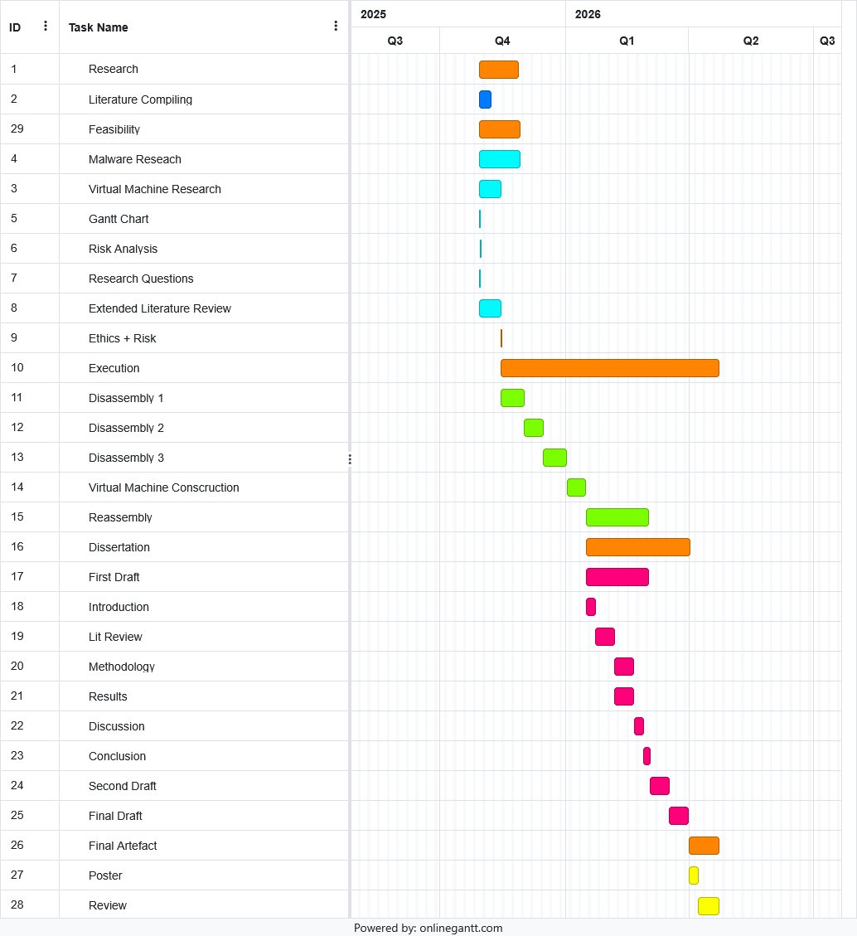
Figure 2.1. Gantt Chart For the Malware Commonality Research Project.

Risk Analysis

Malware Risks

Infection Risks
The malware sources I will be extrapolating from claim to offer safely compressed downloads for the malware packets. However, there is no assured way that I will have in knowing if the downloads are not infecting my machine. Microsoft Defender as well as other anti-cheat extensions to my browser are only so helpful in preventing the ongoing risk that a leak of malware onto my machine would cause.
The preventative measure I will be taking is ensuring that these compressed zip file downloads are conducted within a secured Virtual Machine, ensuring their hash sums are identical to those hash sums displayed on the source websites. VirusTotal is the tool that will be used for ensuring these hash sums are correctly identified. These files once downloaded on my virtual machine will be unzipped and examined properly, ensuring they are not to escape the testing environment.

Unsecure VM Construction
A Virtual Machine is an oftentimes secured environment for disassembling and examine malware samples. These samples existing in the environment if constructed with the correct precautions are unable to further infect other aspects of the host or network at hand, keeping these files in scope. However, the possibility that the VM network was not correctly configured or the files detect that they are within a Virtual Machine are ever present. Different hostile packages have been known to delete themselves upon detection within a virtual machine, and thus these packets will need to be carefully examined.
The solution to an unsecure Virtual Machine would be to follow the correct networking precautions whilst assembling the software. Practices such as clean snapshot usage and read-only file transfer methods whilst handling the malware on the machine will ensure secure dynamic malware testing. Comparing checksums of the files at various different testing phases will ensure the integrity of the project is sound. Finally, I will ensure the VM is offline and unable to communicate with any internet protocols whilst active on the machine.

Non-Technical Risks

Scope Creep
With any project there is a concern that the testers eyes were bigger than their stomach. The scope of the project always has an opportunity to be smaller or larger than the much anticipated research was theorized to encompass. With this there is the possibility that the contents within the project are unable to be examine within the specified timeframe. The solution to these matters is to constantly map out workflow and ensure that the pace of project is consistent with the Gantt Chart above. Furthermore, the work dedicated to the project will constantly be related back to the research questions at hand, ensuring that the target of answering said questions is met. On top of these concerns, the project supervisor will be in constant contact with me during the allotted time of the project.

Legality of Malware Assembly
With the latter half of the project revolving around the assembly of the commonalities from different malware packets, there in lies the risk that assembling such a package would breach several laws and regulations. Due to the project being related to the coursework at hand, the agreements I signed off on a the beginning of my education at Abertay University deal with any ramifications related to the assembly of such a package. The software assembled once linked to and displayed with the machine at hand will be removed from the home devices and only exist in an environment linked to the research.

Risk Analysis Matrix
Impact of Risk
 | Low | Moderate | High
High
Moderate |  | Unsecure  VM  Construction | Legality  Of Malware  Construction
Low | Scope Creep |  | Malware  Infection
Probability of Risk

Literature Review

Detection
Malware detection, as stated by Omer Aslan, is the process of analysing a suspicious file and identifying whether it is benign or malicious(Aslan, 2021). This process is in modern times handled through a long and arduous process utilizing different antimalware softwares and analysis techniques such as static and dynamic analysis. These combined techniques help to determine the purpose of a program and if the code within is potentially hazardous. Automating this process has been a challenge, as stated by Razcan Pascanu and company, as threat actors will program their infections to rewrite and reorder themselves to avoid detection(Pascanu, 2015).

Classification Groups

Signature
Signature-based malware classification utilizes a sequence of bits which uniquely identify the program structure(Aslan, 2021). Aslan continues to describe the uniqueness of signatures based on program-usage. As a signature is extracted and analysed from the program, the static features are identified before the signature is identified and created. Signatures once created are stored in a database by these programs and compared to previous database entries. Any matches can be assumed to be the same family of malware and thus classification is established.
Signature malware classification is used extensively by antivirus softwares and is a quick malware identification method compared to later methods (Aslan and Samet, 2017). However, a major downside of this classification method is its inability to identify and properly classify zero-day malware sample, and due to its human interactive dependency it struggles to detect newer malware variants. Despite these shortcoming there have been evolutions in the field of signature malware detection that might provide solutions to these avenues.
Automatic signature extraction as discussed by Kent Griffin in his collaborative Automatic Generation of String Signatures for Malware Detection paper describes a potential avenue that would mitigate the issues presented previously by Aslan and company (Griffin, 2009). Aslan summation of the proposed model summates that a method could be developed for automatic extraction of the string signatures by utilizing a range of library identification techniques collaborated with diversity-based heuristics. The research Griffin conducts claimed that generated signatures were mostly seen in malware files, reducing the implied false identification shortcoming mentioned previously.

Behaviour
A behavioural detection model consists of dynamically observing and inferring the malicious intent of a program by identifying features such as system calls, API calls or changes in file, registry and computer networks (Aslan, 2021). The frequency and intent of these features greatly impact a detection softwares diagnosis on a potentially malicious program. Behaviours fall into different grouping categories based on their tendencies and frequencies, creating sequential identities that can be used to properly identify different familial components of malware files. However, dynamic testing of a malware requires a safe, virtual environment that certain samples will detect and obfuscate their behaviours within. Virtual environments tend to change the behaviours of malware samples previously stated, which leaves this classification method vulnerable to inaccuracies.

Heuristic
Heuristic based detection models are combined detection approaches within one system(Aslan, 2021). Alzarooni continues in their PhD dissertation explaining each individual phase of the heuristic model(Alzarooni, 2012). The first phase described trains the malware detection software with data of malware samples and their behaviours before the second phase of monitoring detection can begin. The training of the malware detection software can be conducted by a variety of different methods, most notably LLMs have been widely considered in the literature from the past five years since they made their way into the public zeitgeist. However, even with the LLMs steady improvement with each iteration, heuristics have had a high false positive detection rate, leaving researcher unsatisfied with this detection model.

Model Checking
Model checking detection utilizes linear temporal logic algorithms synchronized with identified feature dependencies of programs that are then compared to the features of the potentially malicious package at hand(Aslan, 2021). This comparison determines whether or not the program is malicious by determining the weight and frequency of these malicious specifications. Features such as “hiding” or “spreading” in memory or injecting activities tend to be identified as possible specifications that these LTL formulas are inputted with. The major advantage that this rigorous approach to malware detection provides is the additional identification of obfuscated and compressed/packaged techniques.

Deep Learning
Deep learning detection utilizes the pseudo-artificial intelligence models and artificial neural networks to identify malware samples(Aslan, 2021). Deep/Machine learning nauseating over presence in every facet of modern livelihood has resulted in a plethora of efficiencies in specific fields at the cost of precision. These models and their natural malleability whilst having an impossibly complex algorithmic mechanism result in several false positives and unidentified detections, however with time efficiency of models has increased.

Further Topic Discussion
Within the examined text there will be a further discussion about and exploration of the following topics:
- Under prevalence of Machine Learning in detection?
- In the field usage of Machine Learning and Deep Learning Algorithms
- Due to the continuous widespread of Machine and Deep Learning, the context of organization these packets will be under the umbrella of Machine Learning. Using Machine Learning as a fundamental characteristic of all malware classification as well as a considered characteristic.
- How well does ML detect different packages compared to others?
- How do Biologistic determine taxonomical organization?

Virtual Machine Implementation

Concerns

Security
As the virtual machine will be the tool used for dynamic evaluation of the malware packages, I must ensure its environment is secure and controlled. As such, when reading reviews on different virtual machine software I shall be keeping a note of any security concerns felt from different users on forums that I will be researching upon. These forums can be smaller internet forums or popular reviewing platforms. All sources for these reviews will be taken note of and sources properly during the time of review.

Memory Consumption
Within these reviews, there will be information related to any concerns with the software to load on the computers they are running on. As this project will mainly take place on my XPS 13 laptop, the performance of such a machine requiring excessive amounts of memory allocation will be accounted for. The laptop at hand has 16 gigabytes of memory allocated on the machine, so any virtual machines that are required to have an excess of 8 gigabytes will be discouraged from usage.

Behaviours Sought After

Secure Environment
From the previous section, the importance of a secure malware testing environment takes precedent above all other preferred behaviours. If there are any security concerns presented, the software will have to be heavily considered with proper steps to mitigate those concerns as they arise.

Malware Analysis Specialization
Certain Virtual Machine environments are specifically designed for malware testing. These tools will be extensively looked at and considered over their counterparts as their specificity is heavily related to the project at hand. The reliability of these software tools to assist against the presented malware analysis will be considered heavily whilst researching their behaviours.

Additional Tools
Additionally, any third-party tools that are preinstalled or implemented upon the virtual machine could prove to be helpful during the ongoing research. Any tools that could assist in static/dynamic malware analysis methods as well as any disassembling efforts could be an asset for the project at hand. Any known software that might have these tools implemented more optimally would be desired.

Lightweight
As has been discussed previously, a low memory usage Virtual Machine would be imperative for the project at hand. With a lightweight machine being used for hosting the software, the value that a similarly lightweight VM software brings is necessary.

Possibilities Being Discussed

VMWare Workstation vs VirtualBox
Before considering many options for virtual machine software, it is important to rule out many impractical properties. Hypervisors are often categorized in two primary categories, type 1 and type 2. For runtime efficiencies mainly type 1 are implemented at the cost of them wiping any software they are installed upon. There is an added risk that practical research files will be obstructed from these processes and thus the testers swayed against considering more engrained hypervisor containers that fell into the type 1 behavioural category.
To properly examine different hyper box options, the feasibility of each piece of software must be evaluated. The benefits of running differing platforms can be accounted for by their efficiency and security performances. VMWare is a company that specializes in software products catered to many IT enterprises (IBM SOURCE). Their background consists on many avenues that all surround their most notable specialty: Virtualization Sandboxes. Their software considered for use during this project is their Workstation application. A type 2 hypervisor such as Workstation or Fusion is considered for use over their more OS intensive counterparts such as ESXi or Proxmox as they would require full data wipes from any host planning on running their software.
VMWare Workstation is a virtualization sandbox designed for Windows. Their more hardware intensive counterpart Fusion was not considered as most of the testing will be conducted on a 16 gigabyte memory laptop where performance factors were taken into account. Workstation is able to run virtual instances of the majority of operating systems available. Their ability to snapshot instances of any hypervisor allows for save states that secure any security faults are reverted as they appear. Workstation’s popularity stems greatly from its recently free to use price point. This price point has allowed this software to overseed its hypervisor competition as the most widely used software for virtualization.
Workstation performance is far and away the more efficient software compared to its VirtualBox counterpart. From a study conducted by xda-developers, the time taken to enter an out of box experience after selecting their hard disk drive was over 3 minutes faster in Workstation than in VirtualBox(xda-developers SOURCE). Workstation, while performing better than VirtualBox, is extensively more secure, providing secure boot options, authentication protocols, advanced encryption methods, and role-based access to processes (storware.eu SOURCE). For these reasons, as well as the previously experience with Workstation the researches have had, Workstation was chosen as the hypervisor software to run the secure virtualization instance upon.

REMnux vs FlareVM
As proclaimed by their own website, REMnux is a Linux toolkit designed for reverse engineering and analysing malicious software(REMnux, 2025). The behaviours utilized by this virtual machine are quite distinctly catered to the work for this project. The specificity that a malware disassembly hypervisor provides is eternally helpful as categories are developed and examined within the malware processes. REMnux provides several known third party applications and interfaces that will assists in the examination of this malicious software packages. As disassembly persists, tools such as nasm, docker, deobfuscation tools from cyberchef to python based malware decoders, as well as several known pe related tools are immensely useful for malware disassembly and will be utilized extensively if this hypervisor software is selected for this project. Ghidra, DEI, shellcode implementation, as well as other static and dynamic analysis tools are preinstalled and implemented into the virtual machine container for use, adding to the use cases for the malware processes. The biggest downside is that dynamic analysis for malware packages designed for windows system would be less valuable in a Linux-based container, and as the majority of malicious software’s designed presently are for windows operating systems this could pose a great analysis risk later on during testing.
There are similar windows-based containers to REMnux, such as FlareVM, that are also being considered. The benefits of being windows-based allows for the dynamic testing of windows malware packages. Albeit a good majority of malware packages are not dependent on the operating system they are installed upon, the dynamic testing of a sizable majority would benefit from analysis within a windows container. However, dynamic analysis is not the only analysis method useful for the examination process, and for this reason the testers have determined that the combination of REMnux for static analysis as well as disassembling process whilst a FlareVM Virtual Machine handles the dynamic analysis of the malicious software packages will be conducted during the project.

Verdict
As previously stated, a combination of FlareVM and REMnux will be utilized upon a VMware Workstation hypervisor. These implementation insure the utmost security from the virtual machine container as well as the correct amount of tools for testing the waters. These tests will be contained within the scope of the project with containers that are designed for malicious software analysis whilst considering the hosts efficiency and runtime. This combination of containers will uniquely allow for a specifically in depth analysis on different malware families as they are categorized with commonalities determined as analysis persists between samples.

Malware Family Research and Discussion

What Categories are Being Discussed?

Trojans
Trojans, as described by the open source malware software MalwareBytes, are malware that use simple social engineering tricks to tempt users into running their processes(Malwarebytes, 2025). Derived from the fabled Trojan Horse in Greek mythology, trojan viruses will often mimic the naming conventions of other processes inside the operating system, often leaving them undetected. The purpose of a trojan can be as simple as reading user inputs to rewriting files unbeknownst to the user. The range of raw functionality has led to the researchers considering a hierarchal super category where all viruses mimicking the behaviours of a trojan would be routed underneath.

Ransomware Encryption
More than likely the most headlined category of malicious software ransomware impacts mainly companies and businesses at large. Ransomware uses encryption techniques to effectively lock out host devices and networks until a prompted ransom is met. The dangers from ransomware are more evident to the layman than the dormant tumours of trojan viruses. Data leakage and selling, business halting, as well as the physical damages upon the machines and network devices at hand are all potential risks when dealing with a ransomware attack. Phishing scams as well as remote desktop protocols are both well known categories within the ransomware commonality framework. The prevalence of these malware packages as well as their radically behavioural differences compared to their trojan counterparts have led to the researchers considering a super category of ransomware packages.

APT
Advanced Persistent Threats are sophisticated cyberattacks in which intruders establish an undetected presence in the network in order to steal sensitive data over a prolonged period of time(CrowdStrike, 2025). These infections are much more heinous due to their tendencies rooted in espionage. The louder, more obnoxious ransomware infections can grab the attention of headlines more so than a slow leprosy-like infection would. Their methods of transmission are similar to above examples, however their behavioural differences have lead researchers to consider a hierarchal category pertaining to any infections mimicking their profile. The biggest issue in categorically defining APTs and Trojans is their inherently overlapping nature. Trojans can be apart of an advanced persistent threat and thus defining them separately would behaviourally be disingenuous. The conclusion from this would be to lower APTs or Trojans down the trunk as a subcategory of the other.

Mobile
From RATs and other trojan to ransomware and crypto mining packets, mobile devices are prime targets for several threat actors. Mobile devices are particularly vulnerable as even the more tech savvy do not secure their devices with anti-malware methods. A sub categorical hierarchy defining the devices that infections are designed for could be a method of defining these packages.

IoT
Internet of Things devices have spread en masse across the globe as more and more home appliances implemented internet access. The security risk a fridge, security camera, humid detector, and others present are left unchecked by the majority of people. Trojans designed for their simplistic, low power services are able to snoop network traffic without detection as these devices are often set to factory security settings. The vulnerabilities from these devices alone have led researchers to consider a hierarchal category defining these systems.

OS
The majority of malware packages are operating system dependent. Linux based exploits are going to differ greatly from their MacOS and Windows counterparts. The infrastructure of the operating systems design is imperative to the behaviours that a malware package will exhibit as well as their likelihood of detection. Some packages struggle to find the correct permissions for their services on differing operating systems and thus are ineffective on the wrong service. However, there are language based software that exploits the code of certain implemented languages such as Java that leave all system compromised. Even still, for the majority of cases a hierarchal categorization based on Operating System may prove to be useful to researchers.

What Behaviours do Different Categories Exhibit?

Questions to Answer
The following are questions researchers have established in order to properly determine the behaviours of different malware families:
  - Why was the malware package created?
  - What is the malicious programs goal?
  - Who designed the package?
  - When was the package designed?
  - Where does the malware infect the host?
  - How is the malware infecting the host?

Characteristic for Sorting
As it stands the characteristics that researchers are eyeing to begin with relate to the various systems that different packages interact as well as the “noise” exhibited during examination. Noise has been defined for this project as the amount a victim hosts user should be aware of the infection at a glance. A small performance decrease would be considered a very quiet infection where ransomware attacks would be consider quite loud. Noise is a very defining characteristic that delimits APTs and RATs from their encrypted counterparts.

Phishing as a Service
In recent years there has been a rise in services that advertise as allowing introductory hackers into the field with framework APIs. A common version of this is Phishing as a service, which allows for users to have access to a phishing kit that provides this malicious service without any prior knowledge. This allows for anyone to attempt threat acting on systems adding to a greater security risk. Morphin Meerkat as well as other PhaaS programs are relevant to malware categorization as they in it and of themselves are malicious code whilst also providing a malware sample for delivery. Defining what a malicious program for the purposes of this taxonomy is of the utmost importance due to this abstraction. Although PhaaS programs often will have Trojans and other bugs reattached, the purpose of the API to insight a phishing attack overseas all other infections present as they would be considered isolated malware samples attached to another malware. Distinction of malware compounds and malware elements are vital in the hierarchal definitions to be established during this research project.

Possible Alterations To Project

project artefact adjustment
Originally the planned demo artefact at the end of the project was projected to be a reassembled commonality software showcases the links between different malware families. However, with the purposeful adjustment of the project to contain a more practical approach to commonality research, the demonstration artefact was adjusted to become a taxonomical tree organizing different present day malware families within commonality categorization. This artefact can be displayed through several different means, an interactable webpage, a posterboard displaying the tree, or potentially something not thought of.

References
Aslan, Ö. and Samet, R. (2017) Investigation of Possibilities to Detect Malware Using Existing Tools, IEEE Xplore. Available at: https://doi.org/10.1109/AICCSA.2017.24.
Aslan, O. and Yilmaz, A.A. (2021) ‘A New Malware Classification Framework Based on Deep Learning Algorithms’, IEEE Access, 9, pp. 87936–87951. Available at: https://doi.org/10.1109/access.2021.3089586.
Aslan, Ö.A. and Samet, R. (2020) ‘A Comprehensive Review on Malware Detection Approaches’, IEEE Access, 8(1), pp. 6249–6271. Available at: https://doi.org/10.1109/ACCESS.2019.2963724.
Baker, K. (2025) What is an Advanced Persistent Threat (APT)? | CrowdStrike, Crowdstrike.com. Available at: https://www.crowdstrike.com/en-us/cybersecurity-101/threat-intelligence/advanced-persistent-threat-apt/. (Accessed: 20 November 2025).
Berrios, S. et al. (2025) ‘Systematic Review: Malware Detection and Classification in Cybersecurity’, Applied Sciences, 15(14), pp. 7747–7747. Available at: https://doi.org/10.3390/app15147747.
Griffin, K. et al. (2009) Automatic Generation of String Signatures for Malware Detection, Semantic Scholar. Available at: https://doi.org/10.1007/978-3-642-04342-0_6.
Khalid, M., Abdelrahman, Y. and Alzarooni (2012) Malware Variant Detection CORE View metadata, citation and similar papers at core.ac.uk provided by UCL Discovery. Available at: https://files.core.ac.uk/download/pdf/8774672.pdf (Accessed: 22 November 2025).
Landau, S. (2025) Morphing Meerkat: An Advanced Phishing Platform, Checkpoint.com. Available at: https://emailsecurity.checkpoint.com/blog/morphing-meerkat-an-advanced-phishing-platform (Accessed: 20 November 2025).
Mimecast (2025) Key Ransomware Statistics for Organizations (Updated July 2025), Mimecast. Available at: https://www.mimecast.com/content/ransomware-statistics/. (Accessed: 20 November 2025).
NordPass (2025) What is phishing-as-a-service (PhaaS)?, NordPass. Available at: https://nordpass.com/blog/phishing-as-a-service/. (Accessed: 20 November 2025).
Pascanu, R. et al. (2015) Malware classification with recurrent networks, IEEE Xplore. Available at: https://doi.org/10.1109/ICASSP.2015.7178304.
Trojans | Malwarebytes Labs (no date) Malwarebytes. Available at: https://www.malwarebytes.com/blog/threats/trojans. (Accessed: 20 November 2025).
What is Mobile Malware? Types & Prevention Tips | CrowdStrike (2025) Crowdstrike.com. Available at: https://www.crowdstrike.com/en-gb/cybersecurity-101/malware/mobile-malware/ (Accessed: 20 November 2025).

