BABU BANARASI DAS
UNIVERSITY
2026-2027
SCHOOL OF COMPUTER APPLICATIONS
NoSQL Project On
Hotel Booking Management System Using MongoDB
Submitted to:Submitted by: Aryan pathak
Mr. Harendra Singhstudent's name
Department: BCA (DS & AI)Roll no: () 52
Date: 25th Septemberuniversity roll no;1250258137

1. CREATE DATABASE
MongoDB Query:
use HotelDB
Explanation: Creates or switches to the HotelDB database.
Output Screenshot:
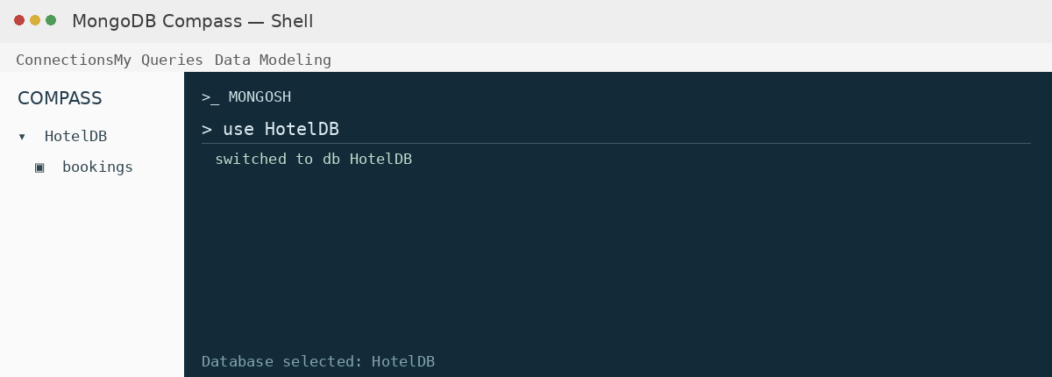

2. CREATE COLLECTION
MongoDB Query:
db.createCollection("bookings")
Explanation: Creates a collection named bookings.
Output Screenshot:
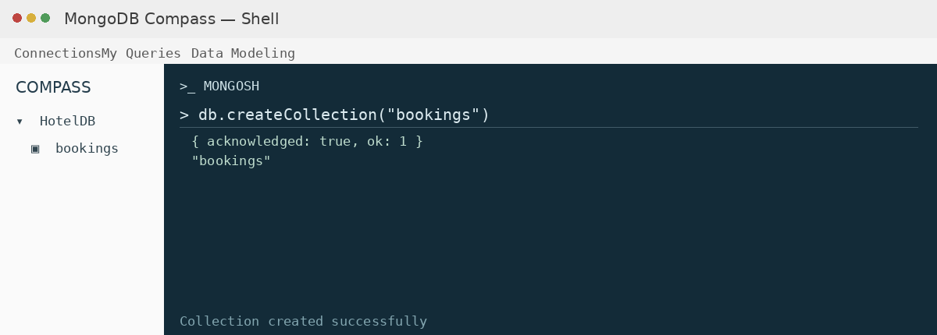

3. INSERT 50 BOOKINGS
MongoDB Query:
db.bookings.insertMany([
{bookingId:1, name:"Rohan", age:24, amount:6200, hotel:"Taj Delhi"},
{bookingId:2, name:"Sneha", age:42, amount:6000, hotel:"Oberoi Mumbai"},
{bookingId:3, name:"Vikram", age:55, amount:4700, hotel:"Oberoi Mumbai"},
{bookingId:4, name:"Pooja", age:32, amount:4450, hotel:"Taj Delhi"},
{bookingId:5, name:"Karan", age:21, amount:7800, hotel:"Oberoi Mumbai"},
{bookingId:6, name:"Neha", age:33, amount:8300, hotel:"Lemon Tree Jaipur"},
{bookingId:7, name:"Rajesh", age:41, amount:3100, hotel:"Lemon Tree Jaipur"},
{bookingId:8, name:"Anjali", age:50, amount:8000, hotel:"Hyatt Lucknow"},
{bookingId:9, name:"Siddharth", age:21, amount:7600, hotel:"Lemon Tree Jaipur"},
{bookingId:10, name:"Divya", age:28, amount:4800, hotel:"Radisson Pune"},
{bookingId:11, name:"Manish", age:29, amount:6300, hotel:"Hyatt Lucknow"},
{bookingId:12, name:"Ritu", age:54, amount:4950, hotel:"Radisson Pune"},
{bookingId:13, name:"Arjun", age:26, amount:9200, hotel:"Taj Delhi"},
{bookingId:14, name:"Meera", age:35, amount:3600, hotel:"Hyatt Lucknow"},
{bookingId:15, name:"Sandeep", age:41, amount:8000, hotel:"Oberoi Mumbai"},
{bookingId:16, name:"Tanya", age:25, amount:6600, hotel:"Oberoi Mumbai"},
{bookingId:17, name:"Pankaj", age:53, amount:5750, hotel:"Taj Delhi"},
{bookingId:18, name:"Kavita", age:52, amount:9300, hotel:"Oberoi Mumbai"},
{bookingId:19, name:"Nitin", age:50, amount:7950, hotel:"Taj Delhi"},
{bookingId:20, name:"Swati", age:26, amount:9100, hotel:"Taj Delhi"},
{bookingId:21, name:"Deepak", age:47, amount:5600, hotel:"Lemon Tree Jaipur"},
{bookingId:22, name:"Simran", age:18, amount:5300, hotel:"Hyatt Lucknow"},
{bookingId:23, name:"Rahul", age:26, amount:9400, hotel:"Oberoi Mumbai"},
{bookingId:24, name:"Varun", age:28, amount:6350, hotel:"Oberoi Mumbai"},
{bookingId:25, name:"Lokesh", age:47, amount:8800, hotel:"Radisson Pune"},
{bookingId:26, name:"Payal", age:40, amount:7050, hotel:"Taj Delhi"},
{bookingId:27, name:"Gaurav", age:31, amount:4000, hotel:"Lemon Tree Jaipur"},
{bookingId:28, name:"Sunita", age:46, amount:6950, hotel:"Oberoi Mumbai"},
{bookingId:29, name:"Aarti", age:39, amount:9000, hotel:"Taj Delhi"},
{bookingId:30, name:"Mukesh", age:55, amount:6600, hotel:"Taj Delhi"},
{bookingId:31, name:"Rekha", age:39, amount:4400, hotel:"Oberoi Mumbai"},
{bookingId:32, name:"Farhan", age:27, amount:8400, hotel:"Lemon Tree Jaipur"},
{bookingId:33, name:"Bhavna", age:22, amount:8600, hotel:"Hyatt Lucknow"},
{bookingId:34, name:"Sachin", age:55, amount:4700, hotel:"Hyatt Lucknow"},
{bookingId:35, name:"Geeta", age:59, amount:4700, hotel:"Taj Delhi"},
{bookingId:36, name:"Ashok", age:58, amount:2900, hotel:"Oberoi Mumbai"},
{bookingId:37, name:"Kriti", age:23, amount:3700, hotel:"Oberoi Mumbai"},
{bookingId:38, name:"Harsh", age:47, amount:8000, hotel:"Lemon Tree Jaipur"},
{bookingId:39, name:"Ira", age:21, amount:6350, hotel:"Taj Delhi"},
{bookingId:40, name:"Nikhil", age:25, amount:5550, hotel:"Hyatt Lucknow"},
{bookingId:41, name:"Aditi", age:30, amount:6000, hotel:"Radisson Pune"},
{bookingId:42, name:"Sameer", age:24, amount:6950, hotel:"Lemon Tree Jaipur"},
{bookingId:43, name:"Pallavi", age:29, amount:3950, hotel:"Oberoi Mumbai"},
{bookingId:44, name:"Rakesh", age:45, amount:5200, hotel:"Hyatt Lucknow"},
{bookingId:45, name:"Zara", age:20, amount:2500, hotel:"Taj Delhi"},
{bookingId:46, name:"Dinesh", age:42, amount:4400, hotel:"Radisson Pune"},
{bookingId:47, name:"Mansi", age:47, amount:3950, hotel:"Oberoi Mumbai"},
{bookingId:48, name:"Tarun", age:55, amount:8400, hotel:"Oberoi Mumbai"},
{bookingId:49, name:"Jaya", age:55, amount:6250, hotel:"Taj Delhi"},
{bookingId:50, name:"Yash", age:22, amount:4350, hotel:"Oberoi Mumbai"}
])
Explanation: Inserts multiple hotel booking documents into the collection.
Output Screenshot:
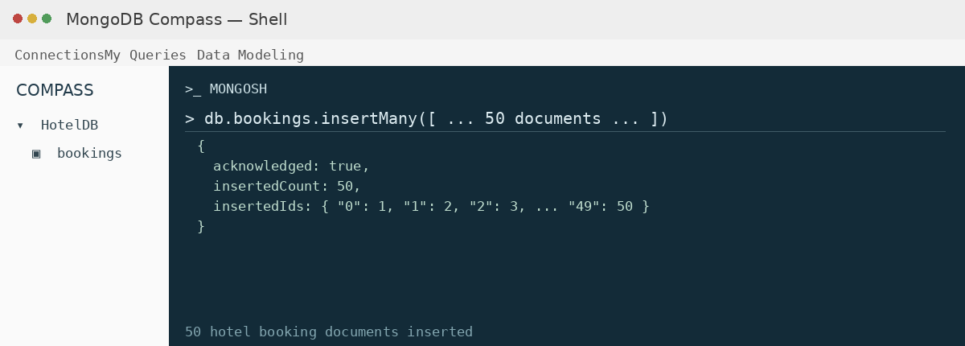

4. DISPLAY ALL BOOKINGS
MongoDB Query:
db.bookings.find()
Explanation: Retrieves all documents from the bookings collection.
Output Screenshot:
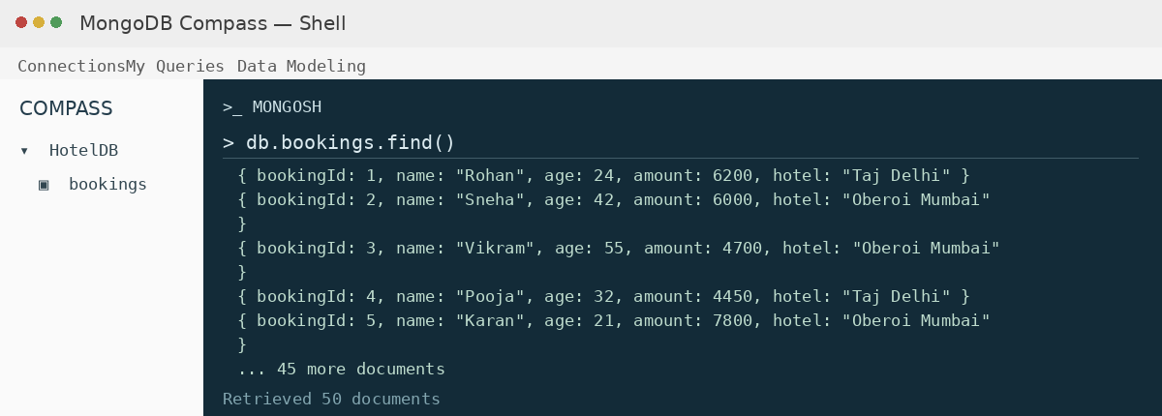

5. EQUAL TO — $eq
MongoDB Query:
db.bookings.find({amount: {$eq: 6200}})
Explanation: Finds bookings whose amount is exactly 6200.
Output Screenshot:
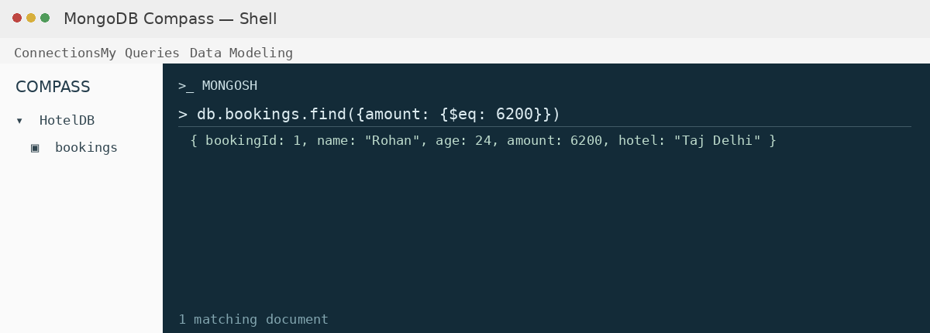

6. GREATER THAN — $gt
MongoDB Query:
db.bookings.find({amount: {$gt: 8500}})
Explanation: Finds bookings whose amount is greater than 8500.
Output Screenshot:
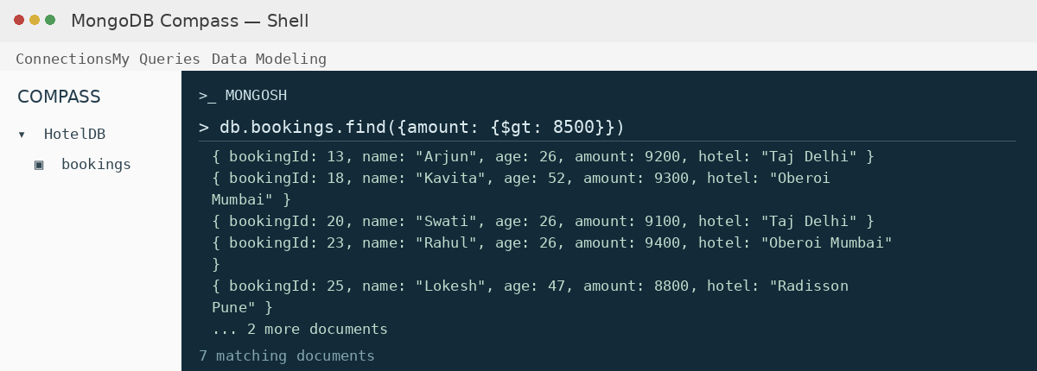

7. LESS THAN — $lt
MongoDB Query:
db.bookings.find({amount: {$lt: 3500}})
Explanation: Finds bookings whose amount is less than 3500.
Output Screenshot:
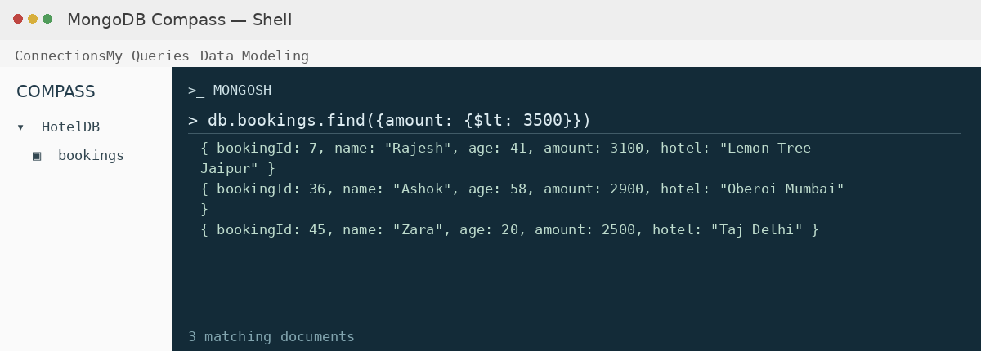

8. GREATER THAN OR EQUAL TO — $gte
MongoDB Query:
db.bookings.find({amount: {$gte: 9000}})
Explanation: Finds bookings whose amount is 9000 or above.
Output Screenshot:
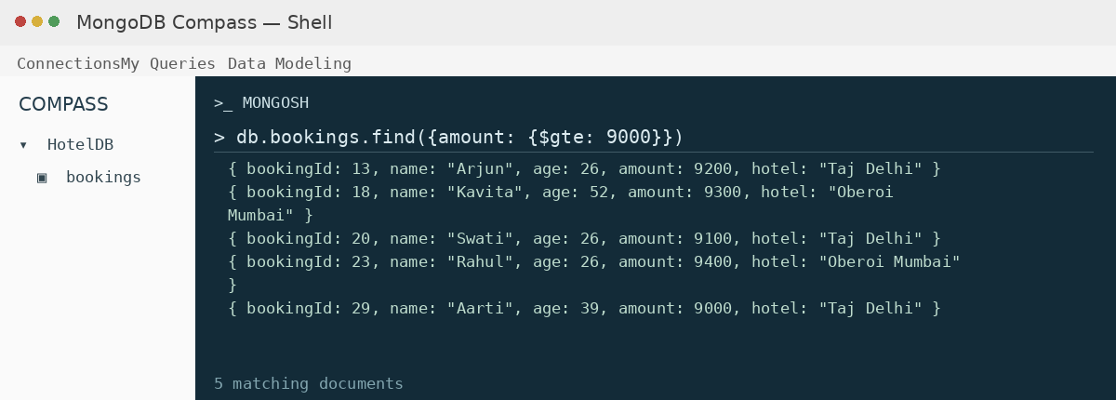

9. LESS THAN OR EQUAL TO — $lte
MongoDB Query:
db.bookings.find({amount: {$lte: 4000}})
Explanation: Finds bookings whose amount is 4000 or below.
Output Screenshot:
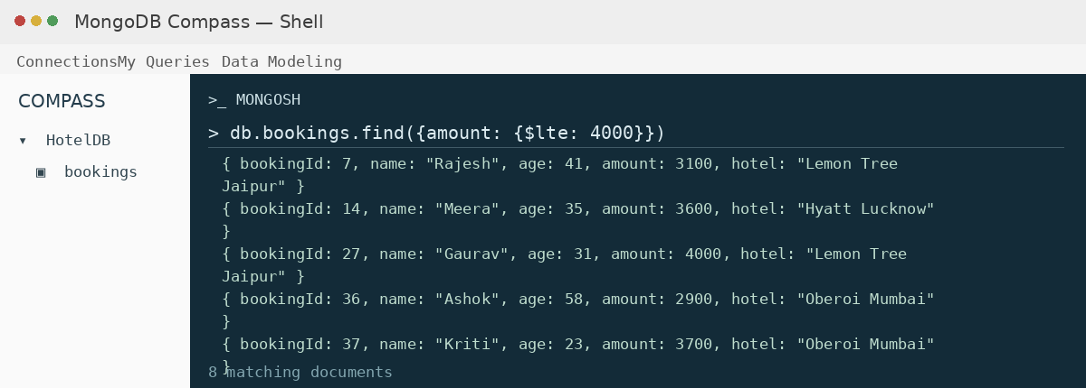

10. UPDATE OPERATION
MongoDB Query:
db.bookings.updateOne(
{bookingId:5},
{$set:{amount:9500}}
)
Explanation: Updates the amount to 9500 of the booking with bookingId 5.
Output Screenshot:
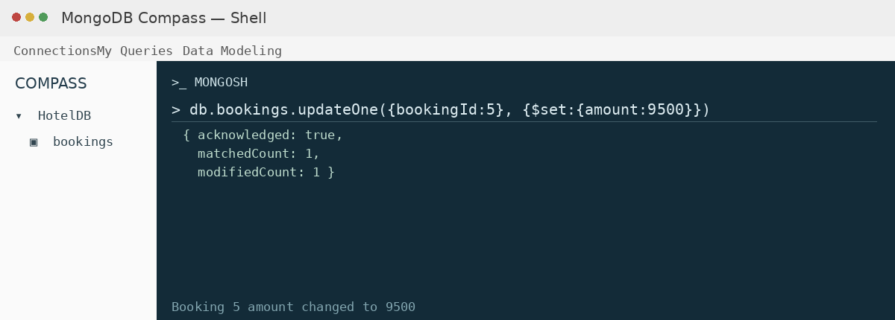

11. DELETE ONE OPERATION
MongoDB Query:
db.bookings.deleteOne({bookingId:10})
Explanation: Deletes one document matching bookingId 10.
Output Screenshot:
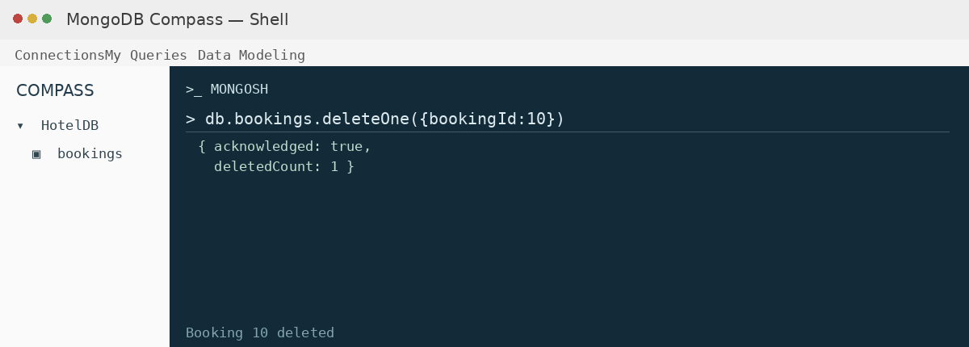

12. DELETE MANY OPERATION
MongoDB Query:
db.bookings.deleteMany({
amount: {$lt:3500}
})
Explanation: Deletes all bookings having an amount below 3500.
Output Screenshot:
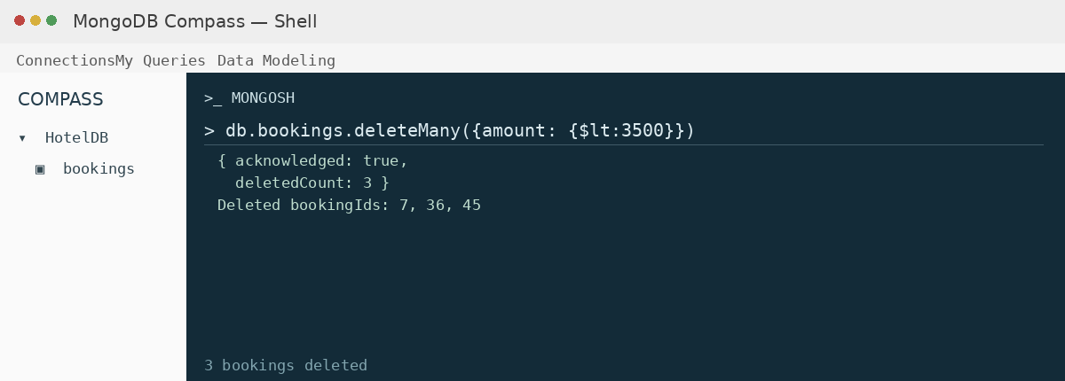

13. AND OPERATION — $and
MongoDB Query:
db.bookings.find({
$and:[
{amount:{$gt:8000}},
{age:26}
]
})
Explanation: Finds bookings satisfying both conditions (amount greater than 8000 and age equal to 26).
Output Screenshot:
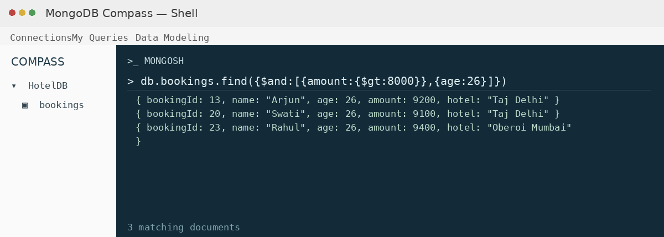

14. OR OPERATION — $or
MongoDB Query:
db.bookings.find({
$or:[
{hotel:"Taj Delhi"},
{hotel:"Oberoi Mumbai"}
]
})
Explanation: Finds bookings made at Taj Delhi or Oberoi Mumbai.
Output Screenshot:
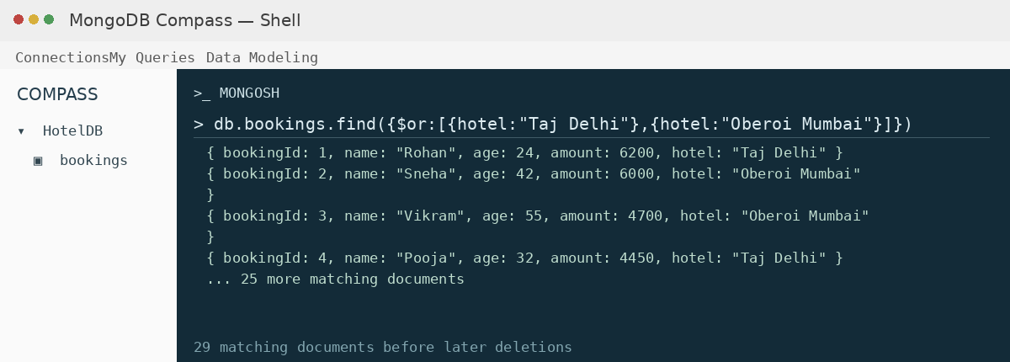

15. SORT OPERATION
A. MongoDB Query:
db.bookings.find().sort({amount: 1})
Explanation: Sorts bookings by amount from lowest to highest. Use 1 for ascending order.
Output Screenshot:
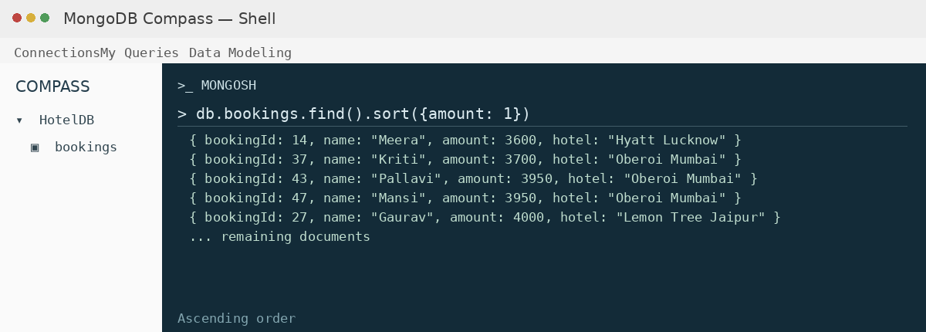

B. MongoDB Query:
db.bookings.find().sort({amount: -1})
Explanation: Sorts bookings by amount from highest to lowest. Use -1 for descending order.
Output Screenshot:
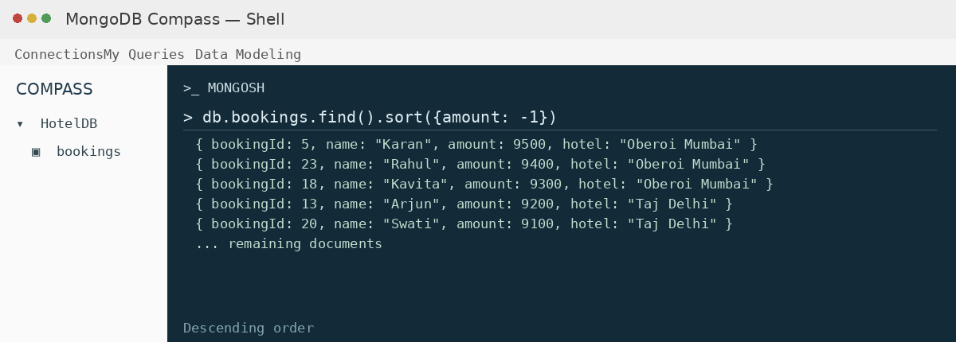

16. LIMIT OPERATION
MongoDB Query:
db.bookings.find().limit(5)
Explanation: Displays only the first five documents.
Output Screenshot:
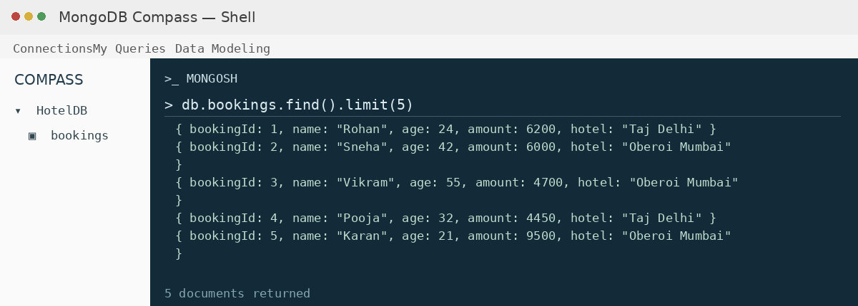

17. SEARCH BY HOTEL
MongoDB Query:
db.bookings.find({hotel:"Taj Delhi"})
Explanation: Finds all bookings made at Taj Delhi.
Output Screenshot:
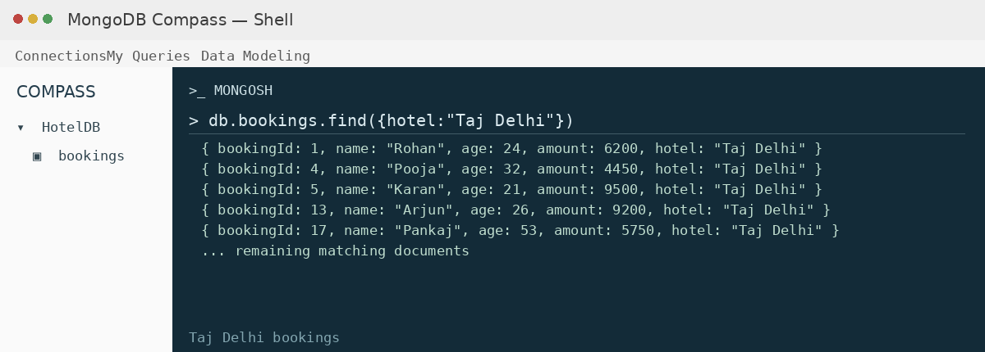

18. COUNT DOCUMENTS
MongoDB Query:
db.bookings.countDocuments()
Explanation: Counts documents currently present in the collection (performed after the delete operations).
Output Screenshot:
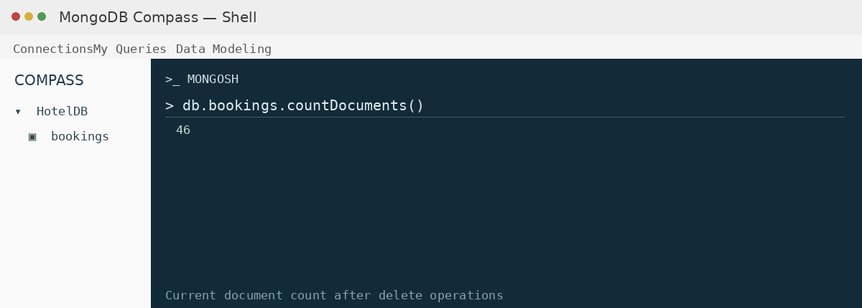

MONGODB OPERATORS USED
Operator | Meaning | Example
$eq | Equal to | amount: {$eq:6200}
$gt | Greater than | amount: {$gt:8500}
$lt | Less than | amount: {$lt:3500}
$gte | Greater than or equal to | amount: {$gte:9000}
$lte | Less than or equal to | amount: {$lte:4000}
$and | All conditions true | $and:[...]
$or | At least one condition true | $or:[...]

CONCLUSION
This project provided practical knowledge of NoSQL databases using MongoDB. A Hotel Booking Management System containing booking information was created and different MongoDB operations were performed on the data.
Through this project, I learned how to insert, retrieve, update, and delete documents. I also learned how to arrange data in ascending and descending order, how comparison operators such as $eq, $gt, $lt, $gte, and $lte work, along with logical operators such as $and and $or.
Overall, this project helped me understand how MongoDB can be used to manage and query hotel booking data efficiently.

