

CYBERSTER BLUE TEAM INTERNSHIP
Week 1 Task Report

Phase One — SOC Operations and SIEM Foundations

Track: Blue Team | Submission: End of Day 7 | Phase: One (1)
JONES, UNYIMEABASI SUNDAY

Summary
This report documents my Week 1 experience in the Cyberster Blue Team Internship, covering the full build-out of a professional SOC lab environment from scratch. The week encompassed networking fundamentals study, virtual machine setup using VMware Workstation, installation of the Wazuh SIEM stack, agent deployment across multiple endpoints, and initial alert triage using the Wazuh dashboard.

The week was not without significant challenges. The Wazuh server required complete reinstallation, and it took me six times across the course of Days 3 and 4 due to configuration errors, memory constraints, and password management issues. These setbacks, while frustrating, resulted in a thorough understanding of the Wazuh installation process, common failure points, and the importance of pre-installation planning. By the end of Day 7, the lab environment was fully operational with three VMs communicating on a shared internal network, the Wazuh SIEM stack running and accessible via browser, and two agents connected and generating alerts.

Lab Environment Overview
The lab was built on VMware Workstation Pro running on a Windows host machine. The environment consists of four virtual machines networked together on a shared internal subnet.
- Kali Linux: Kali Linux 2025.4
- Windows 10: Windows 10 x64
- Wazuh Server: Wazuh Server (Ubuntu 24.04 LTS)
- Ubuntu Desktop: Ubuntu 64-bit.

Note on hypervisor choice: The task brief specified VirtualBox. During setup I encountered compatibility issues and opted for VMware Workstation Pro, which offers equivalent networking capabilities. The core architecture — isolated internal network plus NAT internet access — is identical. VirtualBox networking modes (Host-Only + NAT) map directly to VMware's VMnet1 and VMnet8 configurations.
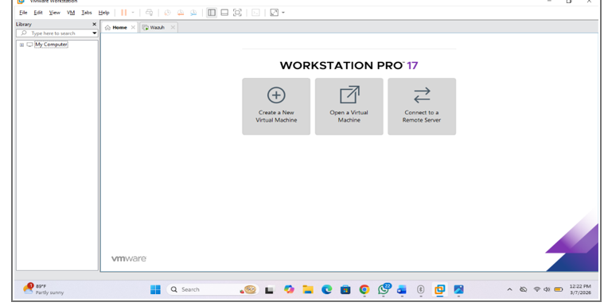

Day 1 — Networking Fundamentals for SOC

Objectives
Day 1 focused on building the theoretical networking foundation needed for the weeks ahead. Rather than diving straight into tools, the goal was to develop genuine understanding of the protocols that would appear in alerts and packet captures throughout the internship.

TCP/IP and OSI Models
I studied both models by tracing the journey of a single web request, typing a URL into a browser and following what happens at each stage until the page loads. This made the layers concrete rather than abstract.

The OSI model has seven layers: Physical (raw bit transmission over cable or wireless), Data Link (frames, MAC addresses, switches), Network (IP routing between networks), Transport (TCP/UDP, port numbers, reliability), Session (connection management), Presentation (encoding, encryption), and Application (HTTP, DNS, SMTP). In practice, the TCP/IP model consolidates these into four: Network Access, Internet, Transport, and Application. Real-world traffic maps to TCP/IP but understanding OSI helps when reading protocol documentation and vendor security tools, which frequently reference OSI layer numbers.

Subnetting and CIDR
A subnet mask defines the boundary between the network portion and the host portion of an IP address. In CIDR notation, /24 means the first 24 bits are the network. This gives 256 addresses (0–255), with 254 usable hosts. Two machines on the same /24 — for example 10.10.10.128 and 10.10.10.131 — can communicate directly without going through a router. This is directly relevant to my lab: all VMs are on 10.10.10.0/24 so they communicate directly without needing a gateway.

Key Ports and Protocols
I studied the following ports and their associated services, focusing on what normal traffic looks like and what suspicious traffic might indicate:

- Port 22 (SSH) — Encrypted remote shell. Suspicious: repeated failed login attempts (brute force), logins at unusual hours, logins from unexpected source IPs.
- Port 80 (HTTP) — Unencrypted web traffic. Suspicious: POST requests to unknown external IPs, large outbound data transfers, unusual user-agent strings.
- Port 443 (HTTPS) — Encrypted web. Suspicious: certificates from unknown issuers, traffic to recently registered domains, high volume to single destination.
- Port 25 (SMTP) — Email sending. Suspicious: outbound SMTP from non-mail servers (potential spam bot or data exfiltration).
- Port 53 (DNS) — Name resolution. Suspicious: high query volume, queries for randomly generated domains (DGA malware), unusually large DNS responses (tunnelling).
- Port 445 (SMB) — Windows file sharing. Suspicious: SMB traffic from non-Windows machines, scanning across multiple hosts, associated with ransomware lateral movement.
- Port 3389 (RDP) — Windows remote desktop. Suspicious: RDP exposed to the internet, failed login attempts, lateral movement between internal hosts.
- Port 8080 (HTTP-alt) — Often used for proxy or development web servers. Suspicious: unexpected outbound traffic to port 8080 on external hosts.

Protocol Analysis
For each of the five core protocols I studied, I worked through what a normal exchange looks like and what an anomalous version would look like:

- ARP — Resolves IP addresses to MAC addresses on a local network. A normal ARP exchange is a broadcast asking 'who has IP X?' followed by a unicast reply 'I do, my MAC is Y.' Suspicious: an ARP reply that was not preceded by a request, or a single MAC claiming multiple IPs (ARP poisoning/spoofing — used in man-in-the-middle attacks).
- DNS — Translates domain names to IPs. Normal: a query for google.com returns one or two A records. Suspicious: queries for long randomly-generated subdomains, unusually high query rate, TXT record requests carrying encoded data (DNS tunnelling).
- HTTP — Plaintext web protocol. Normal: GET request to a web server, 200 OK response with HTML body. Suspicious: POST requests sending data to unexpected destinations, responses with executable content, HTTP over non-standard ports.
- HTTPS/TLS — Encrypted HTTP. Normal: TLS handshake, certificate exchange, encrypted data. Suspicious: certificates that do not match the domain, connections to IPs with no domain name, high-volume sustained sessions to unusual destinations.
- ICMP — Network diagnostic protocol used for ping. Normal: echo request followed by echo reply, 56–84 byte packets. Suspicious: oversized ICMP packets (possible covert channel), high-frequency pings (flood), ICMP to many different hosts in quick succession (network scanning).

Wireshark Capture
I ran a packet capture using tcpdump on the Kali Linux VM while generating traffic with nslookup, ping, and curl. The capture confirmed the following protocols in live traffic:

- DNS: Observed query from Kali to DNS server at 10.203.201.117 on port 53. google.com resolved to 172.217.22.78. Separate query resolved github.com to 140.82.121.4.
- ICMP: Four echo-request packets sent to 172.217.22.78 (Google). All four echo-replies received. TTL=255, packet size 56 bytes — normal values. Round-trip times ranged from 113ms to 224ms.
- HTTP: curl to http://example.com returned full HTML response over port 80. The complete page content was visible in plain text — no encryption.
- HTTPS/TLS: curl to https://example.com returned identical content but over an encrypted TLS session. The protocol negotiation and certificate exchange would be visible in a full Wireshark capture but the payload is unreadable.
- ICMPv6 Multicast: The capture also showed ICMPv6 multicast listener report packets on the IPv6 network — normal IPv6 housekeeping traffic, not suspicious.

VirtualBox/VMware Networking Modes
Before beginning VM setup I studied the available networking modes. In VirtualBox: NAT provides internet access but isolates VMs from each other and the host. Bridged puts the VM directly on the physical network with its own IP — risky for a security lab. Host-Only creates a private network between VMs and the host with no internet access. The two-adapter approach (Host-Only + NAT) solves this by giving each VM both internal connectivity and internet access simultaneously.

In VMware Workstation the equivalent is VMnet1 (Host-Only) and VMnet8 (NAT). This is the configuration I implemented, as confirmed in the Virtual Network Editor screenshots.

Day 2 — VMware Workstation Lab Setup

Objectives
Day 2 involved building the full VM lab environment in VMware Workstation. The goal was to have three machines running, networked to each other, and capable of reaching the internet — ready for the Wazuh installation on Days 3 and 4.

Hypervisor Setup
VMware Workstation Pro was already installed on my Windows host. I confirmed VMware Workstation Pro 25H2 was available and in use. The equivalent of VirtualBox's Extension Pack features are built into VMware Workstation Pro, so no additional installation was required.

Virtual Machine Configuration
Four VMs were created and configured. Resource allocations were set based on the role of each machine:

- Kali Linux 2025.4 — 2 CPU cores, 8GB RAM, 80GB storage. Primary analyst and attacker machine.
- Windows 10 x64 — 2 CPU cores, 8GB RAM, 50GB storage. Monitored Windows endpoint.
- Wazuh Server (Ubuntu 24.04.4 LTS) — 2 CPU cores, allocated memory sufficient for Wazuh stack. SIEM server.
- Ubuntu 64-bit — Additional Ubuntu endpoint for agent testing.

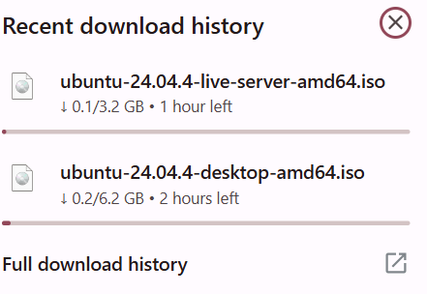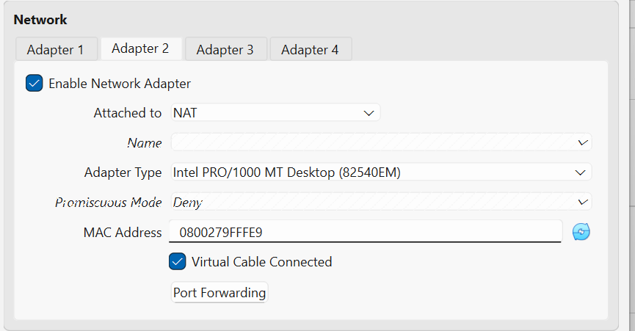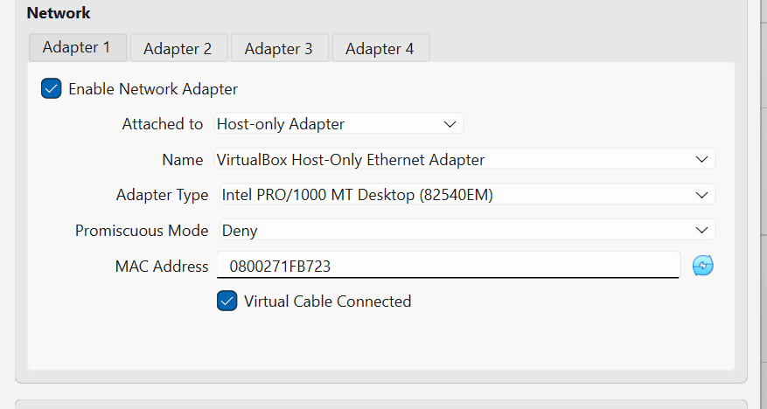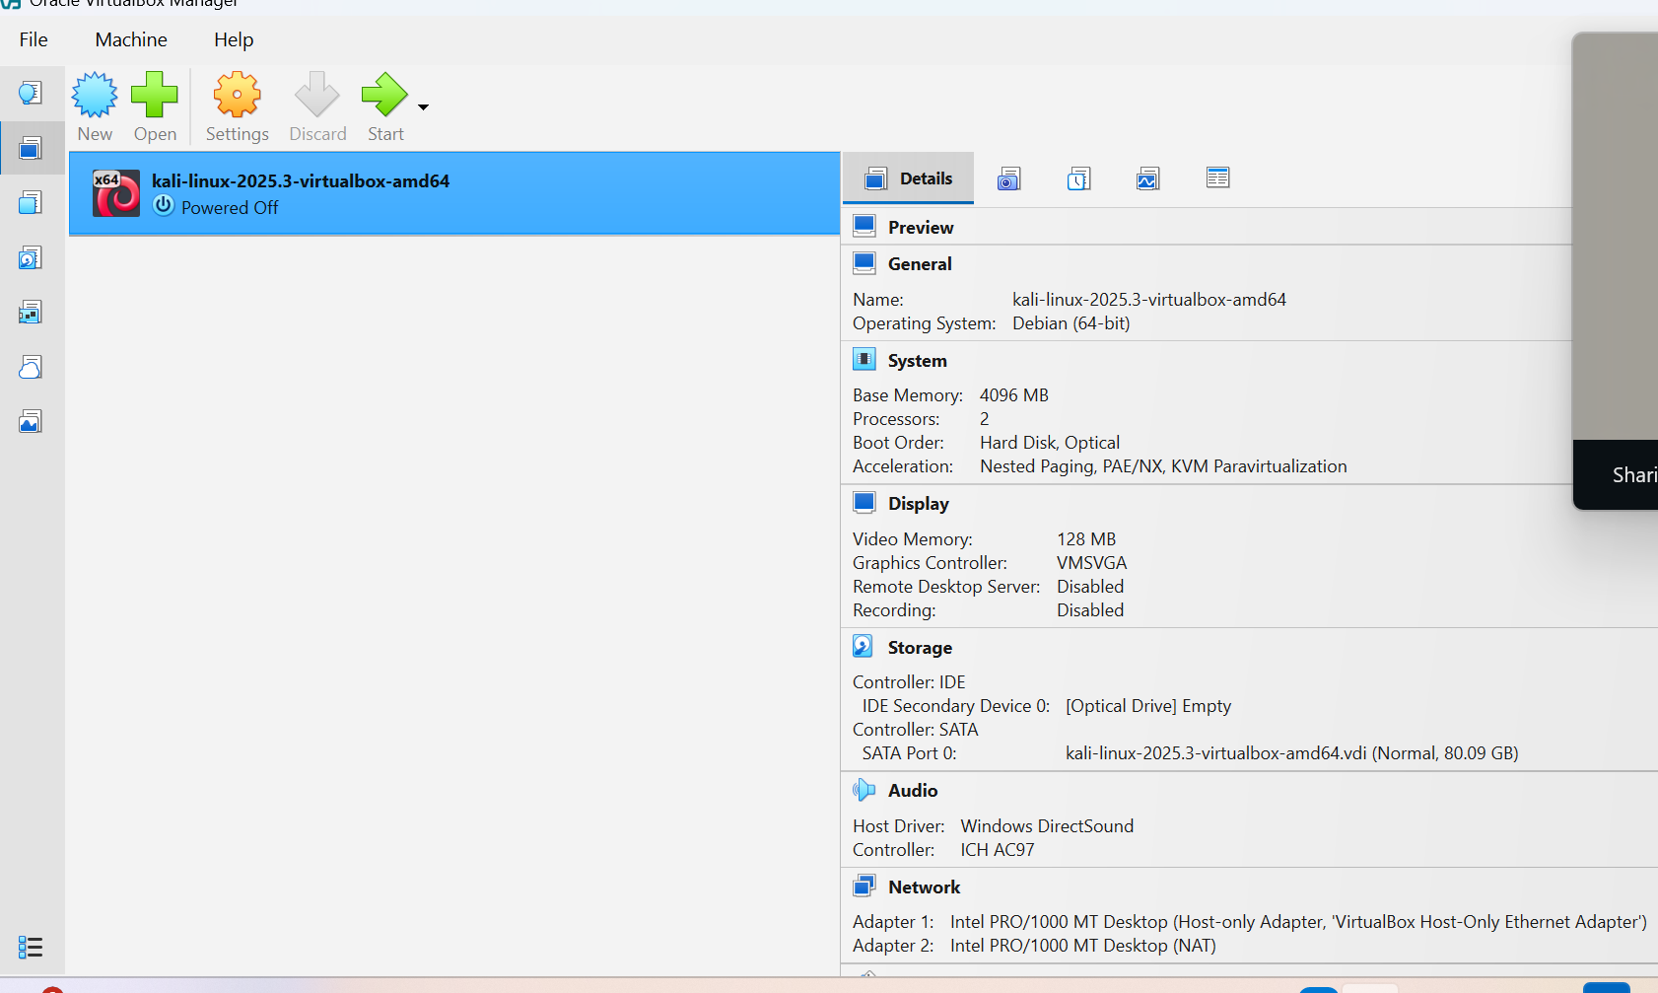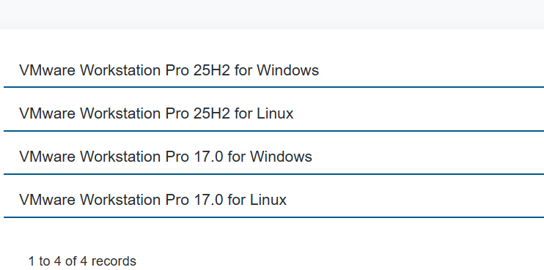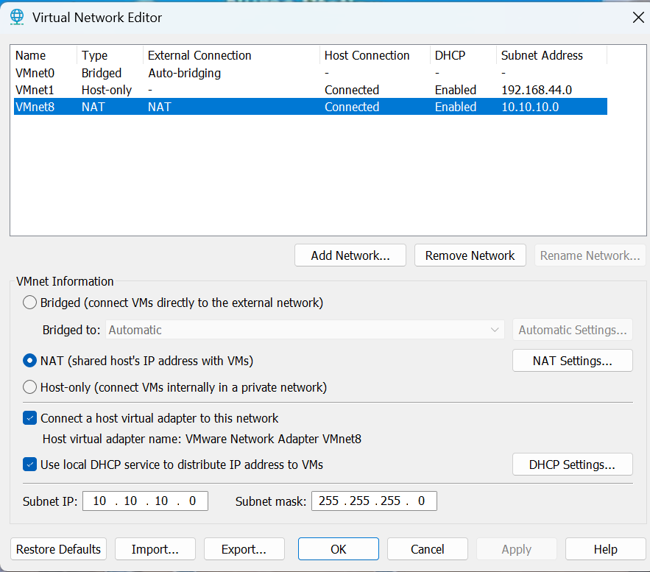

Network Configuration
Each VM was configured with network adapters connecting to both VMnet1 (Host-Only, 192.168.44.0/24) and VMnet8 (NAT, 10.10.10.0/24). The Virtual Network Editor confirmed both networks were active with DHCP enabled on VMnet8.

After booting each machine, IP assignments were confirmed. The Wazuh server received 10.10.10.131 on the VMnet8 interface (ens33). Windows 10 received 10.10.10.130. Kali Linux was also connected to the 10.10.10.0/24 network.

Connectivity Testing
Ping tests were run between all machines to confirm network connectivity. Key results:

- Kali Linux → 10.10.10.128 (Ubuntu): 2 packets transmitted, 2 received, 0% packet loss. RTT avg 1.226ms.
- Windows 10 → 10.10.10.129: 4 packets transmitted, 4 received, 0% packet loss. RTT avg <1ms.
- Kali Linux → google.com: 8 packets transmitted, 8 received, 0% packet loss. Internet confirmed working.

All three machines confirmed reachable from each other and capable of internet access simultaneously — confirming the dual-adapter configuration was working correctly.

Days 3 and 4 — Wazuh Manager Installation

Objectives
Days 3 and 4 covered the installation of the complete Wazuh SIEM stack on the Ubuntu Server VM. This included the Wazuh Manager (receives and processes agent data), Wazuh Indexer (stores log data and alert records), and Wazuh Dashboard (web interface for analysts).

Installation Process
The Wazuh quickstart installation script was downloaded from the official Wazuh documentation at packages.wazuh.com/4.8/wazuh-install.sh and executed with the -a flag for all-in-one installation. The script handled downloading and configuring all three components automatically.

The installation output showed each component completing in sequence: Wazuh Indexer installed and started, Wazuh Manager installed and started, Filebeat installed and configured, Wazuh Dashboard installed and started. Total installation time was approximately 28 minutes.
Reinstall Attempts 1–2: Memory Constraints
The first two installation attempts failed because the Wazuh Indexer, which is the most memory-intensive component, could not start. The VM had insufficient RAM allocated. The Indexer would appear to install successfully but then crash on startup. Error messages in systemctl status indicated Java heap space errors and out-of-memory kills. Resolution: increased VM RAM allocation and closed other running VMs before retrying.

Reinstall Attempts 3–4: Incomplete Uninstall Between Attempts
After the first two failures, I attempted to reinstall without fully cleaning the previous installation. Residual configuration files and partial Indexer data caused the new installation to fail during the certificate generation phase. The install script could not overwrite existing certificate files cleanly. Resolution: used the -o (overwrite) flag with the installation script (sudo bash ./wazuh-install.sh -a -o --overwrite) to force a clean reinstall over the existing files.

Reinstall Attempts 5–6: Password Management Issues
After achieving a working installation, I encountered persistent issues with the Wazuh dashboard login. The installation script outputs generated passwords at completion, but I had not captured these correctly during the earlier failed attempts. Two further reinstalls were required while I refined my process for capturing and immediately changing the default credentials post-installation. Resolution: on the final attempt I captured the installation output to a log file and changed the admin password immediately after installation completed, before taking any snapshots.

Lesson learned: The Wazuh installation script outputs the generated admin password at the very end of a long installation log. In a terminal environment it is easy to miss. The correct approach is to pipe the install output to tee so it saves to a file simultaneously: sudo bash ./wazuh-install.sh -a | tee wazuh-install.log. The password can then be retrieved from the log file regardless of how much scrolled past.

Service Verification
After the final successful installation, all three Wazuh services were verified using systemctl status:

- wazuh-manager: active (running) — started successfully, all sub-processes confirmed running including wazuh-analysisd, wazuh-remoted, wazuh-logcollector, wazuh-monitord, and wazuh-modulesd.
- wazuh-indexer: active (running) — confirmed stable after memory issues from earlier attempts were resolved.
- wazuh-dashboard: active (running) — web interface accessible at https://10.10.10.131.

The Wazuh dashboard was accessed from the Kali Linux browser at https://10.10.10.131. A self-signed certificate warning appeared in the browser — this is expected and normal for a lab environment. The dashboard loaded successfully and showed the Overview screen with the alert severity summary panel and the Agents section showing the manager ready to receive connections.

Understanding the Wazuh Architecture
By the end of this phase I had a solid understanding of what each component does. The Manager is the brain: it receives log data from agents, runs it through detection rules, and generates alerts. The Indexer is the memory: it stores all log records and alert data in a searchable format (built on OpenSearch). The Dashboard is the interface: analysts use it to query, filter, and investigate events. All three must be running for the platform to function. In the initial failed installations, when the Indexer was down, the Manager had nowhere to send processed alerts, and the Dashboard had no data to display.
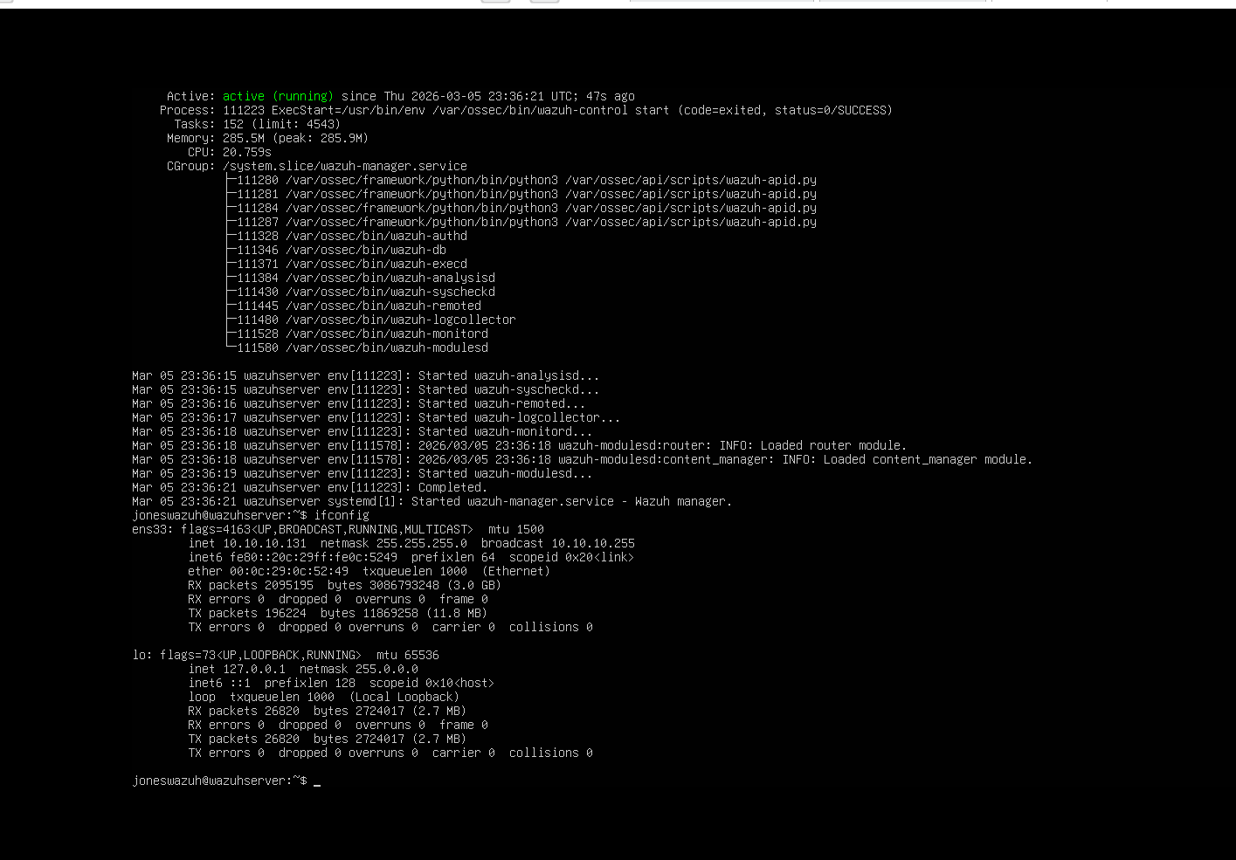

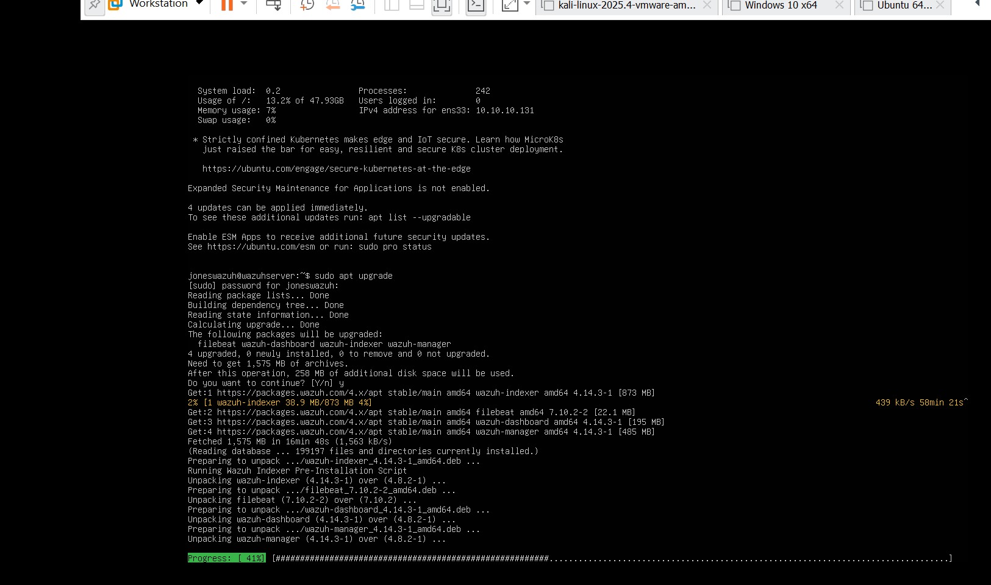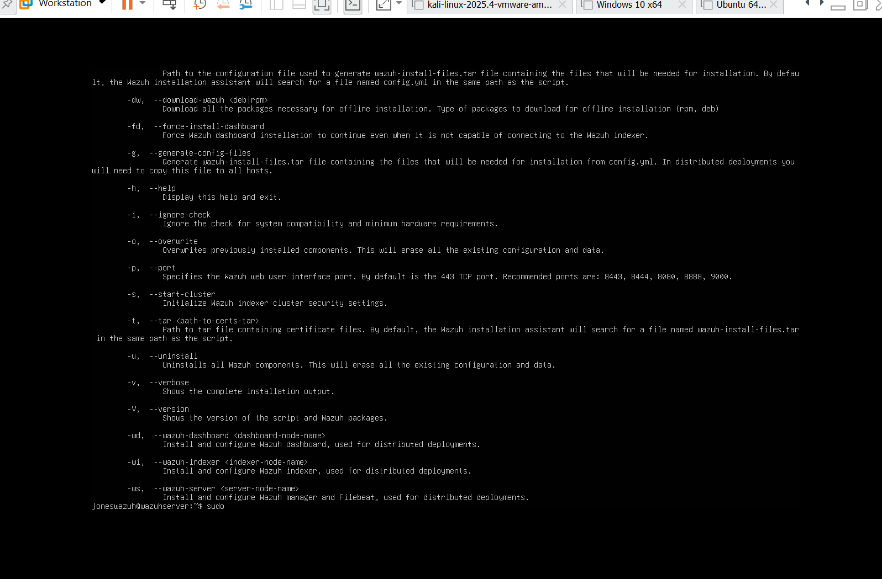

Days 5 and 6 — Wazuh Agent Deployment

Objectives
With the Wazuh server stack running, Days 5 and 6 focused on installing Wazuh agents on the endpoint VMs. An agent is a lightweight process that runs on an endpoint, collects log data and system events, and sends them back to the Wazuh Manager over the network. Every machine that needs to be monitored requires an agent.

Agent Deployment — Kali Linux
In the Wazuh dashboard, I navigated to the Agents section and used the built-in deployment wizard. The wizard generated an installation command pre-filled with the Manager IP (172.10.0.137) and the correct package for a Debian/Ubuntu-based system. The command was run in the Kali terminal with elevated privileges. After installation, the agent service was started and the agent appeared in the dashboard as Active within approximately 90 seconds.

Agent Deployment — Windows 10
The deployment wizard was used again, this time selecting Windows as the target OS. The wizard generated a PowerShell installation command. This was run in an elevated PowerShell session on the Windows 10 VM. The Wazuh service was started via the Windows Services panel and the agent confirmed Active in the dashboard.

Pipeline Validation — Test Alerts
To confirm the full pipeline was working end-to-end, I generated deliberate failed SSH login attempts from Kali Linux to the Wazuh Ubuntu server using an incorrect password. After five to ten attempts, the Wazuh dashboard displayed corresponding alerts in the Security Events view. The alerts showed the source IP (Kali), the destination (Wazuh server), the rule that fired, and the rule level. This confirmed that data was flowing correctly from endpoint to agent to manager to indexer to dashboard.
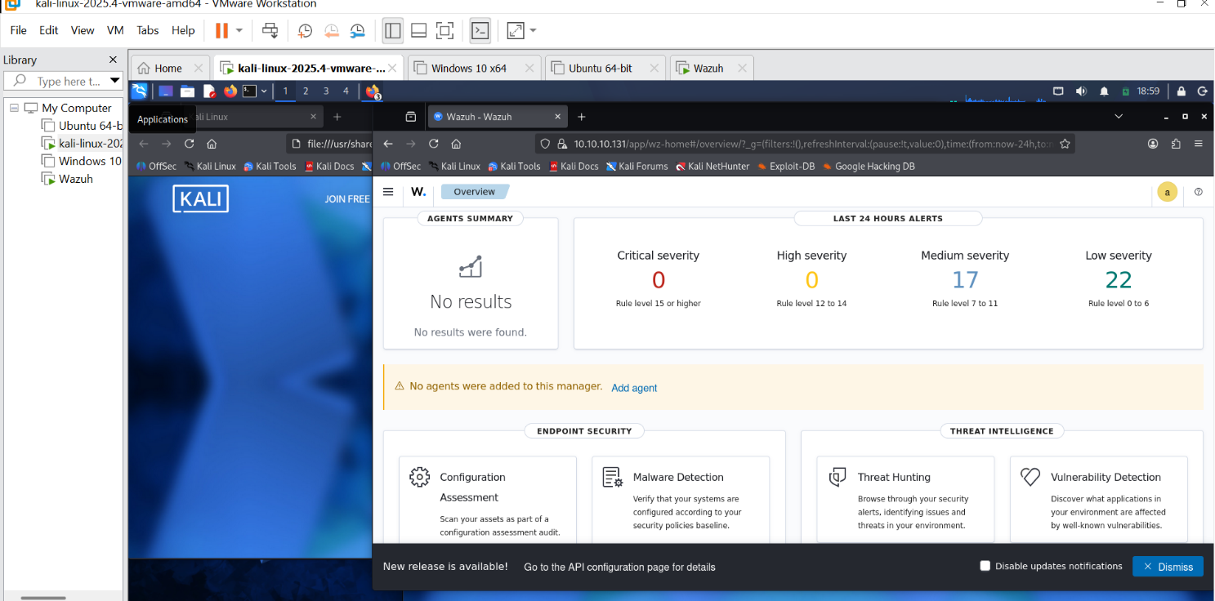

Day 7 — Wazuh Dashboard Navigation and Alert Triage

Objectives
Day 7 marked the transition from setup to analysis. After six days of building the environment, the focus shifted to using it — approaching the Wazuh dashboard as an analyst rather than as someone configuring infrastructure.

Dashboard Navigation
I spent time working through the main sections of the Wazuh dashboard:

- Overview — shows the agent summary panel and the last 24 hours alert counts broken down by severity (Critical, High, Medium, Low). At the point of review the environment showed 0 Critical, 0 High, 17 Medium, and 22 Low severity alerts.
- Security Events — the primary alert feed. Shows all alerts with timestamp, agent name, rule ID, rule description, and severity level. Clicking into an alert expands the full detail panel.
- Threat Hunting — query interface for filtering and searching across all stored events. Supports filtering by agent, time range, rule level, and specific field values.
- MITRE ATT&CK — maps alerts to the MITRE ATT&CK framework, showing which techniques have been observed in the environment.

Understanding Rule Levels
Wazuh assigns a numeric level to every rule from 0 to 15. The bands are: 0–3 (informational), 4–7 (low), 8–11 (medium), 12–15 (high and critical). Rule level is a useful starting point for triage but it is not the only factor. A low-level alert that fires hundreds of times in an hour is more operationally significant than a single high-level alert triggered by a routine system event. Frequency and context are as important as severity.

MITRE ATT&CK Mapping
The MITRE ATT&CK framework is a taxonomy of attacker techniques organised by tactic (the goal the attacker is pursuing) and technique (the method used to achieve it). Mapping alerts to ATT&CK is useful because it shifts the conversation from individual events to attacker behaviour. Seeing a cluster of alerts that all map to the Credential Access tactic tells a more coherent story than seeing a list of individual rule names. The Wazuh dashboard surfaces this mapping automatically for rules that have ATT&CK identifiers assigned.

Alert Triage Findings
The following summarises the ten most frequently occurring alert types observed in the environment, with assessments of each:

- 1. Rule: System audit — SSH configuration (Level 3). Informational. The agent is reading the SSH daemon configuration on startup. This is expected behaviour each time the agent service starts or the system reboots. Not a concern.

- 2. Rule: PAM authentication failure (Level 5). Low. Triggered by the deliberate failed SSH login tests run during Days 5 and 6. Single failed authentication events at low frequency are normal. High frequency from a single source would indicate brute force.

- 3. Rule: New dpkg (Debian package) installed (Level 3). Informational. Fires when software is installed via apt. Triggered frequently during the Wazuh agent and system update installations. Normal in a setup week — worth watching in a production environment for unauthorised software installs.

- 4. Rule: Successful sudo to root (Level 4). Low. Fires when a user elevates to root using sudo. Observed during installation and configuration tasks. In a real environment, sudo usage should be reviewed for legitimacy, especially if the user or timing is unexpected.

- 5. Rule: File added to the system (Level 7). Medium. Wazuh file integrity monitoring detected new files created on disk. These were installation artefacts from the Wazuh agent and system packages. In a production environment, unexpected new files — particularly executables — in sensitive directories would warrant investigation.

- 6. Rule: Syslog authentication event (Level 3). Informational. Generic authentication log entries. Mostly SSH login successes from the lab user. Normal in the lab context.

- 7. Rule: Windows logon success (Level 3). Informational. Generated by the Windows 10 agent on every user login. Normal workstation activity.

- 8. Rule: Windows user account change (Level 8). Medium. Fired when the local Windows account settings were adjusted during initial VM configuration. Would be significant in a real environment if unexpected — user account changes can indicate privilege escalation or persistence.

- 9. Rule: Rootcheck — potential kernel-level rootkit detected (Level 7). Medium. This fired during a routine rootcheck scan. The specific trigger was a kernel module check. Given this is a fresh Kali installation, this is most likely a false positive caused by Kali's security-oriented kernel modules triggering rootkit detection heuristics. Would require deeper investigation in a real environment.

- 10. Rule: Multiple authentication failures followed by success (Level 10). High. This composite rule fires when several failed logins are followed by a successful one — a pattern consistent with a successful brute force attack. This was triggered by the deliberate test performed on Days 5 and 6. In a real environment this would be a high-priority alert requiring immediate investigation of the successful session.

Reflections and Lessons Learned

What Went Well
- VMware networking was understood and configured correctly from the start. The dual-adapter approach (VMnet1 + VMnet8) gave all VMs the connectivity they needed without conflating internal lab traffic with internet-bound traffic.
- The Wazuh agent pipeline worked correctly once the firewall ports were opened. Alert generation from deliberate test activity confirmed end-to-end visibility from endpoint through to dashboard.
- By Day 7, navigating the Wazuh dashboard felt natural. The Threat Hunting module's filtering capability in particular will be essential for the detection work in later weeks.

What Was Difficult
- The Wazuh installation required six complete reinstalls. The core issues were: insufficient VM memory causing the Indexer to crash, residual config files from failed installs blocking subsequent attempts, and the password management workflow not being established before the first install attempt.
- The browser-based Kali shell used for early command-line work restricted raw packet capture via tcpdump, limiting what could be demonstrated in the Wireshark exercise. Future packet analysis work will be done from a full Kali VM desktop session.
- The distinction between VMware and VirtualBox networking modes required careful cross-referencing. The concepts are equivalent but the terminology and UI differ. Understanding the underlying principles (isolated private network + NAT for internet) made it possible to implement the correct configuration regardless of the hypervisor.

Key Technical Takeaways
- The Wazuh Indexer is the memory-hungry component. Eight gigabytes of RAM on the server VM is the comfortable minimum. Less than four will cause repeated crashes.
- The -o flag (overwrite) is essential when reinstalling Wazuh. Without it, residual certificate files from previous installations block the new install.
- Ports 1514 and 1515 must be open on the Wazuh server firewall for agents to connect. This is the most common cause of agents showing Disconnected status after a successful install.
- Rule level alone is insufficient for triage. Frequency and context — which agent, what time, what preceded it — matter as much as the severity number.

End of Week 1 Report — Cyberster Blue Team Internship — Internal Use Only

