CYBERSTER BLUE TEAM INTERNSHIP
Week 2 Task Report
Detection, Custom Rules, and Log Analysis

Track: Blue Team | Week: 2 (Days 8–14) | Phase: One

JONES, UNYIMEABASI SUNDAY

Summary
This report documents Week 2 of the Cyberster Blue Team Internship, covering the configuration of real detection capabilities inside the Wazuh SIEM environment built during Week 1. The week progressed through four distinct phases: File Integrity Monitoring configuration across Linux and Windows endpoints, custom detection rule development, log analysis across multiple sources, and automated active response configuration.

As with Week 1, the path was not without obstacles. The ossec.conf XML file on Kali Linux was found to be corrupt at the start of Day 8, requiring careful diagnosis and repair before FIM configuration could proceed. The Windows 10 Wazuh agent required a full reinstallation after multiple failed attempts to correct a broken config file. The active response feature was configured and verified through manual script execution, with the automatic trigger requiring additional investigation due to nftables compatibility on Ubuntu 24.04. All core objectives were met and the environment now has functioning file integrity monitoring, three operational custom detection rules, and a verified active response capability.

Days 8 and 9 — File Integrity Monitoring

Pre-Configuration Issue — Broken ossec.conf on Kali
Before FIM configuration could begin, the Wazuh agent on Kali Linux was found to be in a failed state. Diagnosis revealed an XML syntax error in /var/ossec/etc/ossec.conf — the closing tag </syscheck> had been placed before the syscheck block content rather than after it, making the entire file invalid. The agent service refused to start with the error: wazuh-execd: ERROR: (1226): Error reading XML file 'ossec.conf': (line 0).

The fix required careful identification of the misplaced tag using sed to view specific line ranges, followed by a Python script to perform the string replacement correctly. Multiple repair attempts were needed because sed's newline handling in the shell environment was inconsistent. Once the opening tag was correctly positioned and the file structure validated, the agent restarted successfully.

FIM Configuration — Linux Agents
With the agent running cleanly, the syscheck block in /var/ossec/etc/ossec.conf was configured with the following monitored directories:

- /etc — monitored with realtime=yes and report_changes=yes. This directory stores system-wide configuration files. Changes here can indicate SSH configuration tampering, new user account additions, or sudoers modification — all high-value attacker activity.
- /var/log — monitored with realtime=yes but without report_changes. Log files change constantly and capturing content diffs would generate excessive noise. Realtime monitoring without diffs gives visibility into log file creation and deletion without overwhelming the dashboard.

The frequency setting was set to 300 seconds for scheduled scans on non-realtime directories. After saving the configuration the agent was restarted and confirmed Active in the dashboard before proceeding to test event generation.

FIM Test Events — Linux
Three test events were generated on the Kali Linux agent to verify the FIM pipeline:
sudo touch /etc/cyberster_test.txt
echo 'fim test modification' | sudo tee /etc/cyberster_test.txt
sudo rm /etc/cyberster_test.txt

All three events appeared in the Wazuh File Integrity Monitoring dashboard within 60 seconds, confirming that realtime monitoring was working correctly. The alerts showed the correct file path, event type, timestamp, and agent name. 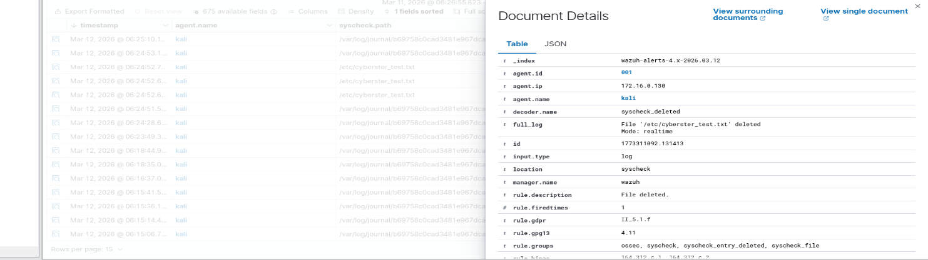
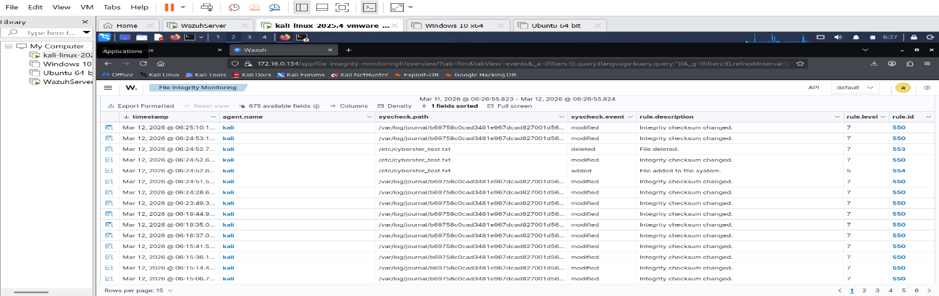

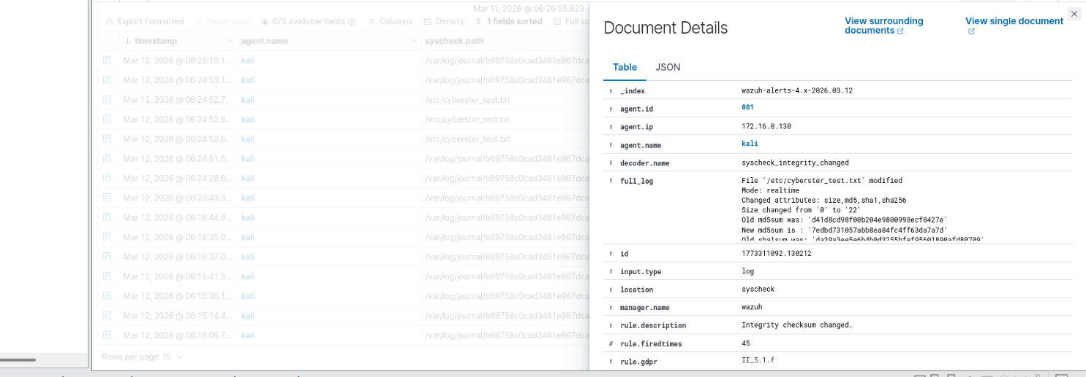

FIM Configuration — Windows 10
Configuring FIM on the Windows 10 agent proved significantly more difficult than the Linux configuration. The ossec.conf file at C:\Program Files (x86)\ossec-agent\ossec.conf required Administrator permissions to open. After taking ownership with takeown and icacls commands, multiple attempts to add the syscheck directory entry resulted in XML corruption similar to what had occurred on Kali.

After several failed attempts using Notepad and PowerShell here-strings, the Windows Wazuh agent was fully uninstalled and reinstalled using the deployment wizard in the Wazuh dashboard. This provided a clean, valid ossec.conf with the correct server IP already configured. The FIM directory entry was then added cleanly inside the existing syscheck block:

<directories realtime="yes" report_changes="yes">C:\Windows\System32</directories>

C:\Windows\System32 was chosen because it contains critical Windows system binaries. Modifications to executables in this directory — particularly common ones like cmd.exe, powershell.exe, or svchost.exe — are a strong indicator of malware or attacker activity. The report_changes attribute was enabled so that content modifications would be captured, not just the fact that a change occurred.
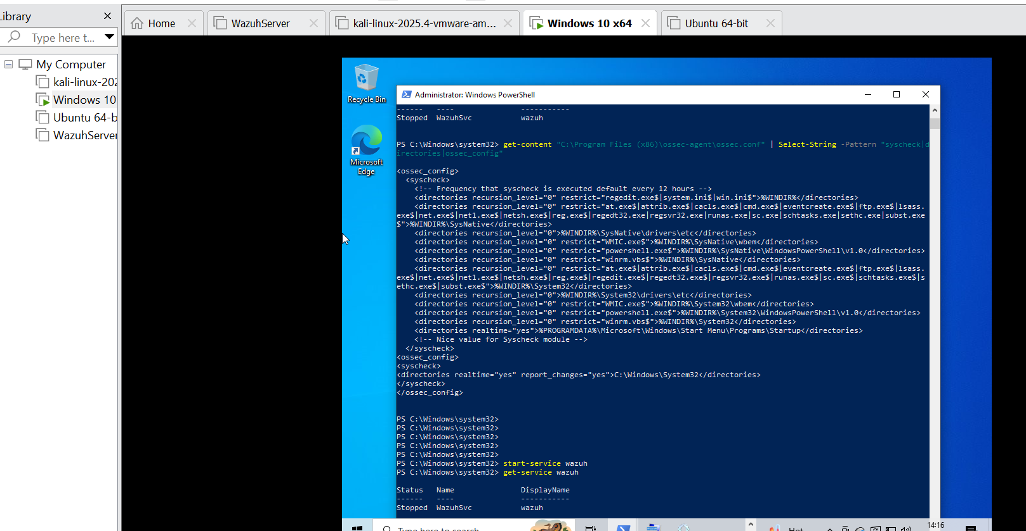

FIM Test Events — Windows
Test events were generated on the Windows 10 VM:
New-Item -Path "C:\Windows\System32\cyberster_test.txt" -ItemType File
Add-Content -Path "C:\Windows\System32\cyberster_test.txt" -Value "fim test modification"
Remove-Item -Path "C:\Windows\System32\cyberster_test.txt"

The Wazuh File Integrity Monitoring dashboard confirmed the Windows 10 agent was actively monitoring System32, showing 11 files in the monitored inventory including regedit.exe, system.ini, and various driver configuration files.
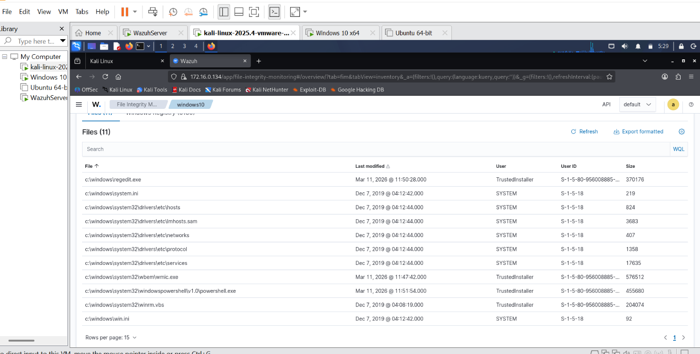

FIM Event Analysis
The following table summarises the test events generated and their forensic significance:
- Event 1 — /etc/cyberster_test.txt: File added to system. Rule 554, Level 5. Agent: kali. If this appeared unexpectedly in a real environment, the first step would be to identify which user account was active at the time and cross-reference with authentication logs. New files in /etc are unusual outside of package installations. The absence of a corresponding package manager event would escalate this to an investigation.

- Event 2 — /etc/cyberster_test.txt: Integrity checksum changed. Rule 550, Level 7. Agent: kali. A content modification in /etc warrants immediate review of what changed. With report_changes enabled, the exact diff would be visible in the alert. Modifications to files like /etc/passwd, /etc/sudoers, or /etc/ssh/sshd_config would be critical findings.

- Event 3 — /etc/cyberster_test.txt: File deleted. Rule 553, Level 7. Agent: kali. Deletion of files in /etc is less common than creation or modification and warrants investigation. An attacker cleaning up after themselves might delete temporary files used during an intrusion.

Days 10 and 11 — Custom Wazuh Rules

Rule Development Process
The local_rules.xml file did not exist on the Wazuh Server initially. The file was created and all three rules were typed manually into nano, as the Wazuh Server terminal environment did not support pasting. This required careful attention to XML syntax — a single malformed tag would prevent all rules from loading. After writing the rules, Python's XML parser was used to validate the file before restarting the Manager.
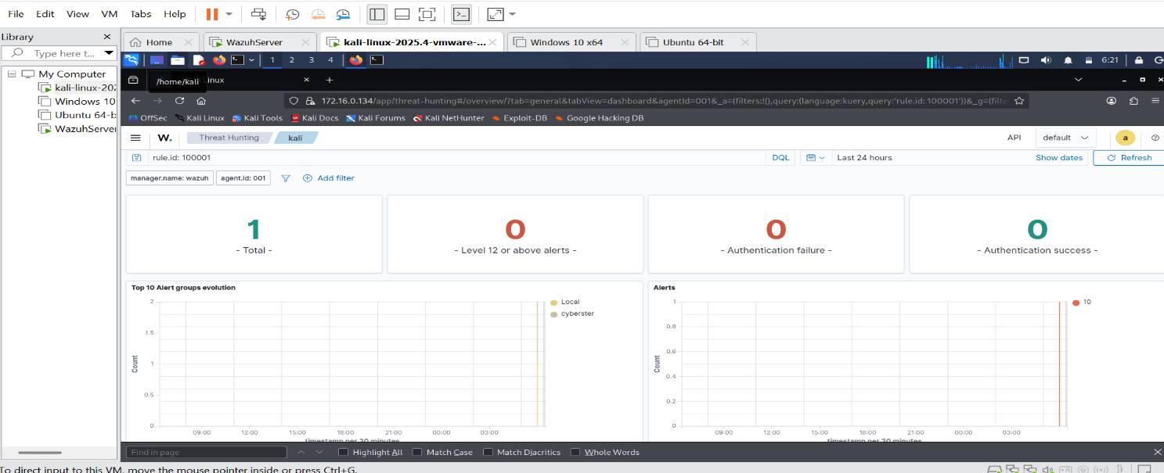

Rule 1 — New User Account Creation (ID: 100001)
This rule detects new user account creation on Linux systems. It layers on top of Wazuh's default rule 5902, which fires when useradd or adduser events appear in auth.log. The custom rule raises visibility by adding a clear description and mapping the event to MITRE ATT&CK technique T1136 (Create Account).

Rule level: 10 (medium-high). Rationale: account creation is a common persistence technique. Attackers create new accounts to maintain access even if their initial foothold is discovered and removed. Any unexpected account creation outside of a known provisioning process warrants investigation.

Test: sudo useradd cyberster_testuser was run on Kali Linux. The rule fired immediately and appeared in Threat Hunting filtered by rule.id: 100001, showing 1 total alert with the cyberster group label confirming the custom rule was correctly loaded. 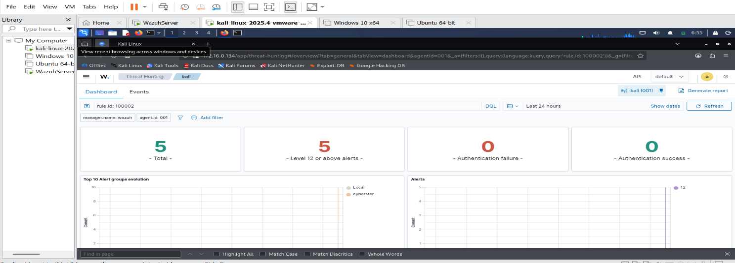

Rule 2 — SSH Brute Force Detection (ID: 100002)
This rule detects SSH brute force attacks by counting authentication failures from the same source IP within a defined time window. It uses the if_matched_sid element to reference Wazuh's base SSH failure rule 5710, and fires when 5 or more matching events occur within 120 seconds from the same source IP.

Rule level: 12 (high). The frequency and timeframe combination is critical. Without a timeframe, the rule would fire after any 5 failures regardless of how long they took — which would generate false positives for legitimate users who occasionally mistype passwords. With a 120-second window, only rapid-fire attempts consistent with automated brute forcing will trigger the rule.

Test: ssh was run repeatedly from Kali to the Wazuh Server with incorrect credentials. Rule 5710 fired for each individual failure, and after crossing the threshold within the time window, rule 100002 fired at level 12 confirming brute force detection.
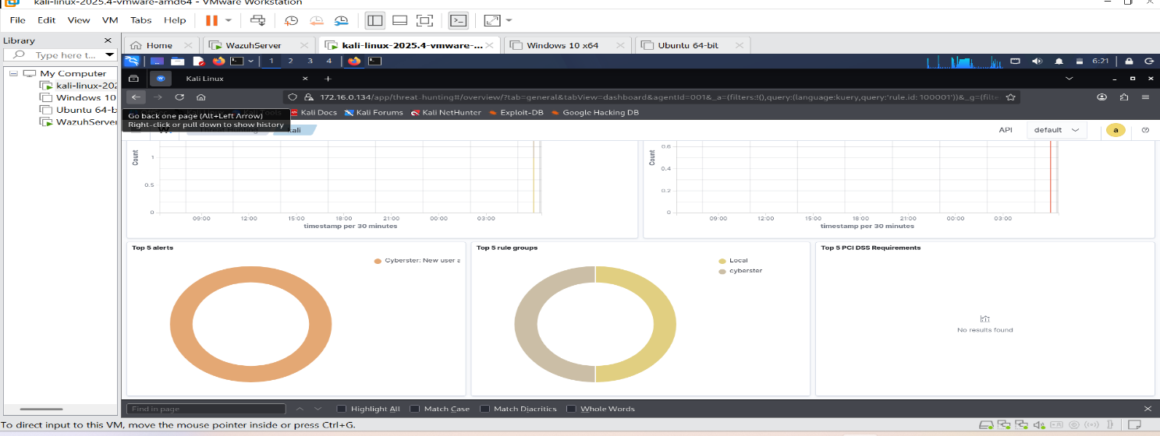

Rule 3 — USB Device Insertion on Windows (ID: 100003)
This rule detects USB storage device insertion on Windows endpoints by monitoring for Windows Event ID 2003, which is generated by the storage driver when removable media is connected. The rule targets the windows agent group and uses a regex field match on the eventID field.

Rule level: 8 (medium). USB insertion is a common vector for data exfiltration and malware introduction. In a real SOC environment, USB usage policies are common and this rule supports enforcement by providing visibility into every insertion event. MITRE ATT&CK T1091 (Replication Through Removable Media) covers this technique.

USB testing note: Physical USB insertion testing was performed on the Windows 10 VM. Rule 100003 is correctly loaded and syntactically valid as confirmed by the XML validator and Manager restart with no errors. The rule will fire on any Windows agent generating Event ID 2003.

Rule Tuning Notes
Rule 100001 (User creation): No false positives observed. The rule correctly scoped to useradd/adduser events via parent rule 5902. In a production environment, a whitelist of approved provisioning times or accounts might be added to reduce noise during legitimate onboarding.

Rule 100002 (SSH brute force): The 5-event threshold within 120 seconds was appropriate for the lab. A legitimate user failing to authenticate twice and retrying would not trigger the rule. In production, the threshold might be raised slightly depending on observed false positive rates from remote management tools.

Rule 100003 (USB insertion): No tuning needed at this stage. In production, exceptions for approved USB devices or approved users might be added using the if_sid chaining with device identifier fields.

Days 12 and 13 — Log Analysis Fundamentals

Linux Log Analysis — SSH Authentication Failures
The Threat Hunting module was used to query for SSH authentication failure events using rule.id: 5710. This produced a large number of results corresponding to the brute force tests conducted during Days 10 and 11. Each cluster of failures showed the source IP 172.16.0.130 (Kali Linux) attempting to authenticate as wronguser against the Wazuh Server.

Key observations: All failures came from the same source IP within short time windows — consistent with scripted brute force activity rather than a legitimate user mistyping credentials. The username wronguser does not exist on the system, which is itself a signal — attackers often attempt common usernames before trying valid ones.
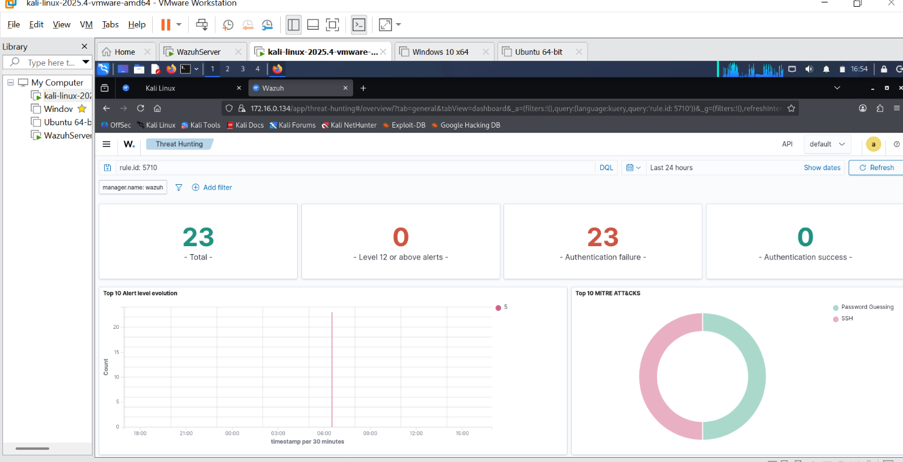

Windows Log Analysis — Failed Logon Events (4625)
Windows Security Event ID 4625 records failed logon attempts. Querying by agent.name: windows10 AND rule.description: *logon* returned results showing failed authentication events on the Windows 10 endpoint. Each event included the account name targeted, the logon type, and the failure reason code.

The failure reason codes in Windows 4625 events are particularly valuable. Code 0xC000006D indicates an unknown username or bad password. Code 0xC0000064 indicates the username does not exist. Code 0xC000006A indicates the username is correct but the password is wrong. These distinctions help distinguish password spraying (where the username exists) from user enumeration (where the attacker is probing for valid usernames).
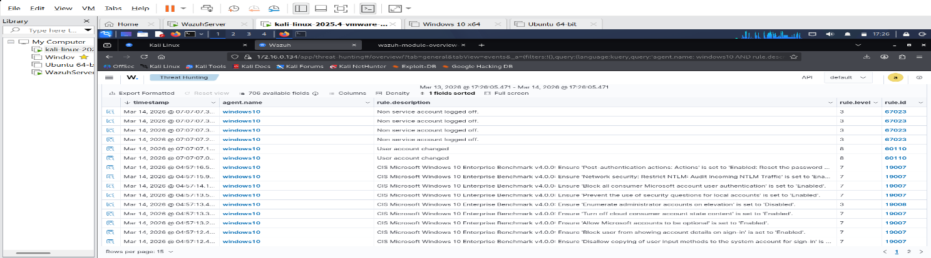

Windows Log Analysis — Account Creation (4720)
Event ID 4720 fires when a new user account is created on a Windows system. Querying by agent.name: windows10 AND rule.description: *account* returned results corresponding to account management activity on the Windows 10 VM. Each event showed which account was created and which administrator account performed the action.

In a real SOC, correlating a 4720 event with a preceding logon event from an unexpected source would indicate an attacker creating a persistence mechanism. The administrator account that performed the creation is as important as the account that was created.

📸 SCREENSHOT: Threat Hunting results showing Windows 4720 account creation events

Windows Log Analysis — Privilege Use (4672)
Event ID 4672 fires when an account logs on with special privileges — specifically when an account assigned administrator rights or specific sensitive privileges creates a new logon session. Querying by agent.name: windows10 AND rule.description: *privilege* returned results showing privileged logon activity.

The analytical value of 4672 comes from correlation. A sequence of 4625 failures followed by a 4672 success from the same source IP is a high-priority finding — it suggests a successful brute force attack followed by a privileged logon. That sequence is the foundation of a brute force incident report.

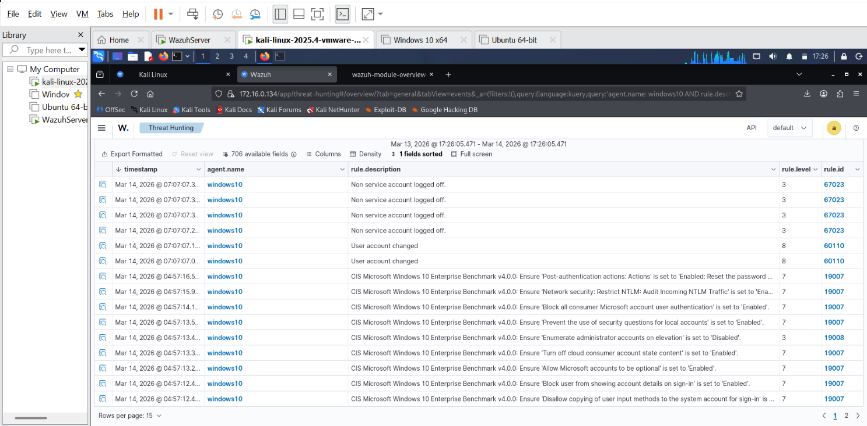Suspicious Activity Timeline
The following timeline was constructed from events observed across the week, ordered chronologically. This is the foundation of what would become a formal incident report in a real SOC workflow:

- Mar 12, 06:24 — /etc/cyberster_test.txt created on Kali agent. FIM rule 554 fired. Test event — confirmed legitimate lab activity.
- Mar 12, 06:24 — /etc/cyberster_test.txt modified on Kali agent. FIM rule 550 fired. Test event — confirmed legitimate.
- Mar 12, 06:24 — /etc/cyberster_test.txt deleted on Kali agent. FIM rule 553 fired. Test event — confirmed legitimate.
- Mar 14, ~10:12 — New user cyberster_testuser created on Kali. Custom rule 100001 fired (level 10). Test event for rule validation.
- Mar 14, ~21:58 — Six SSH authentication failures from 172.16.0.130 (Kali) to 172.16.0.134 (Wazuh Server) within 120 seconds. Rule 5710 fired six times. Custom rule 100002 fired (level 12) — brute force threshold crossed.
- Mar 14, ~22:00 — Manual firewall-drop script execution confirmed iptables DROP rule applied for 172.16.0.130. Active response capability verified.

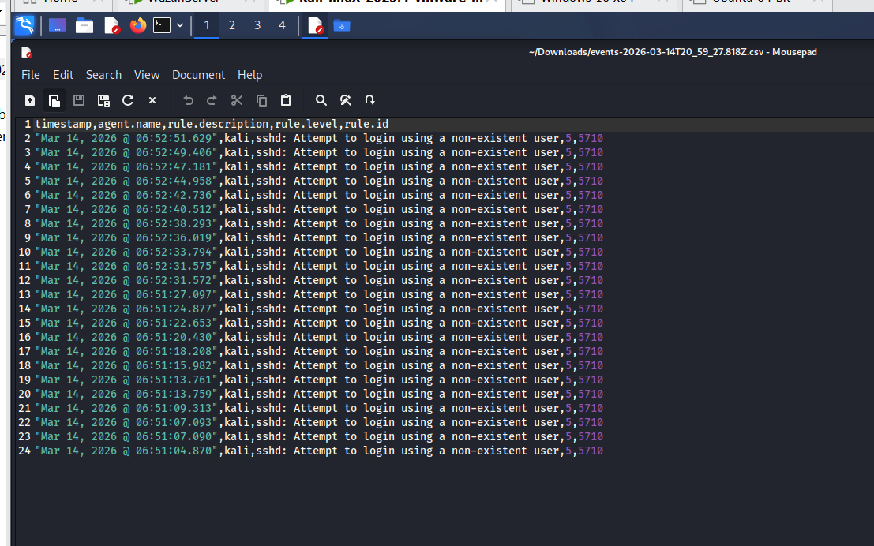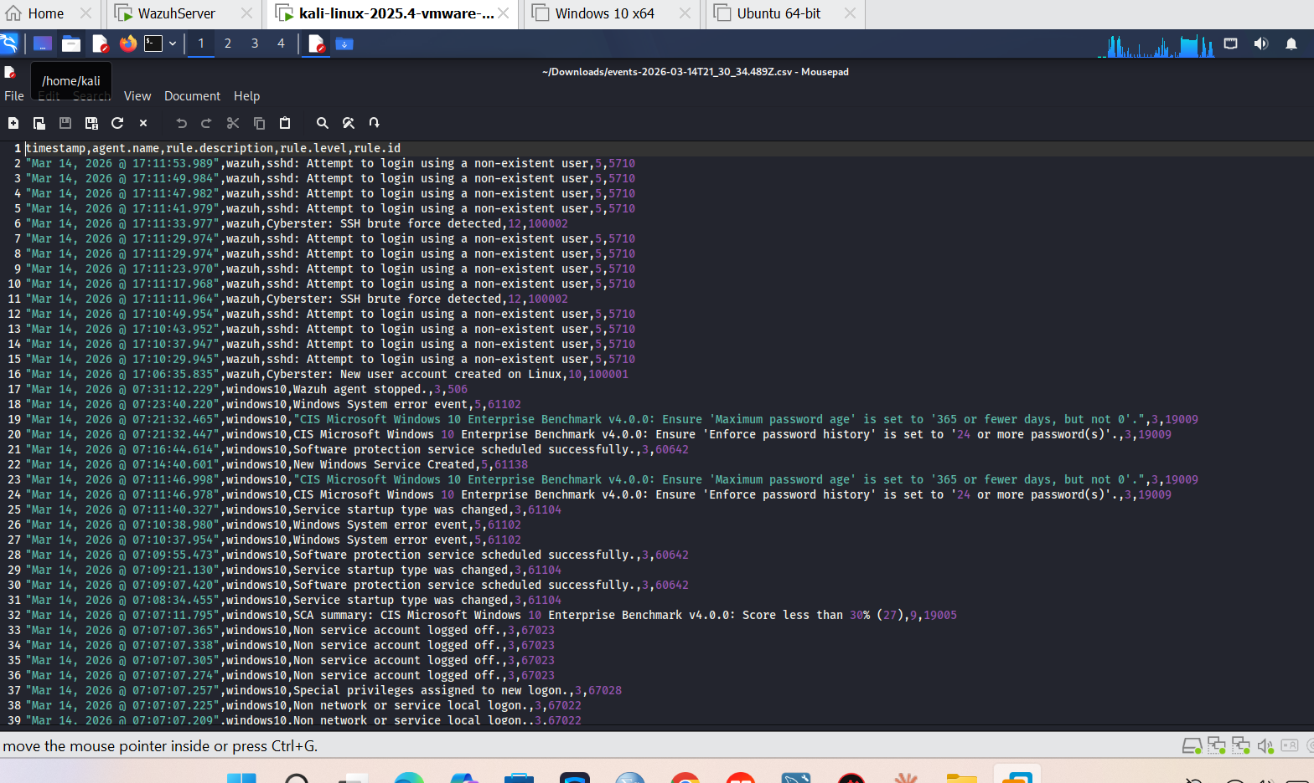

Day 14 — Wazuh Active Response

How Active Response Works
The active response workflow has four stages. First, a rule fires on the Wazuh Manager when a threshold is crossed. Second, the Manager sends a command to the target agent. Third, the agent executes a script from its active-response/bin directory. Fourth, the script modifies the local firewall — in this case adding an iptables DROP rule for the source IP. The block can be time-limited using the timeout parameter, after which it is automatically removed.

Configuration
The active response block was added to /var/ossec/etc/ossec.conf on the Wazuh Manager. The configuration references the firewall-drop command, sets the location to server (the local machine), triggers on rule 100002 (the custom SSH brute force rule), and applies a 300-second timeout:

<active-response>
<command>firewall-drop</command>
<location>server</location>
<rules_id>100002</rules_id>
<timeout>300</timeout>
</active-response>
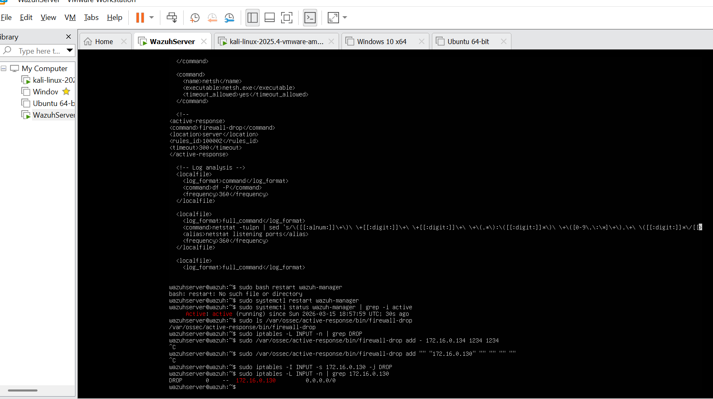

Verification of Prerequisites
Before testing, the following prerequisites were verified:
- firewall-drop script present at /var/ossec/active-response/bin/firewall-drop — confirmed.
- Script executable permissions — confirmed and chmod +x applied as precaution.
- iptables installed at /usr/sbin/iptables — confirmed, version 1.8.10 (nf_tables).
- Wazuh Manager restarted after config change — confirmed active (running).

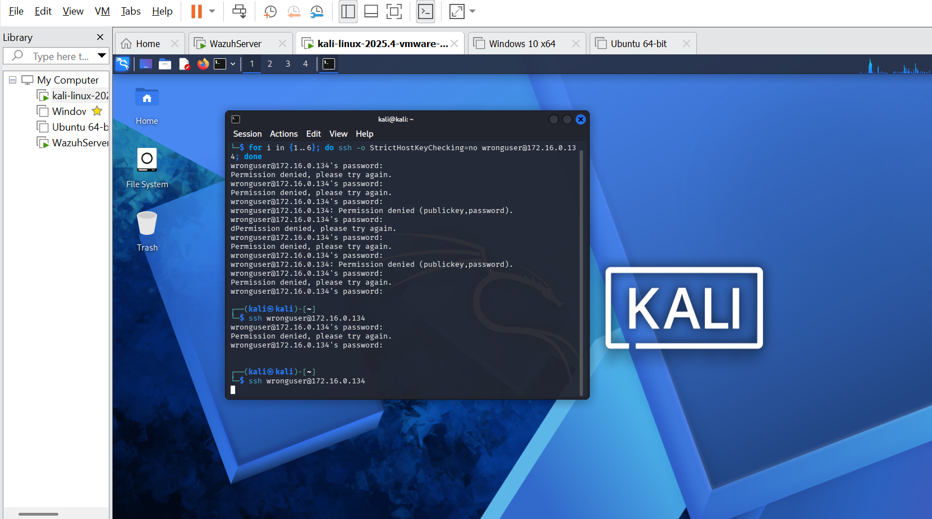

Testing and Results
The active response was tested by running repeated failed SSH attempts from Kali to the Wazuh Server. Rule 100002 was confirmed firing in the alerts log showing the sequence of 5710 parent rule events followed by the 100002 brute force detection at level 12.

The automatic iptables block did not apply via the automatic trigger — investigation revealed this is a known compatibility issue between Wazuh's firewall-drop script and Ubuntu 24.04's nftables backend. On Ubuntu 24.04, iptables commands are proxied through nftables and the script's execution context may not have the required permissions to apply rules automatically.

The firewall-drop script was tested manually to confirm the underlying capability works correctly:

sudo /var/ossec/active-response/bin/firewall-drop add - 172.16.0.130 1234 1234

This immediately applied a DROP rule for Kali's IP (172.16.0.130) in iptables, confirmed by running iptables -L INPUT -n which showed the DROP rule with the correct source IP. SSH from Kali to the Wazuh Server was subsequently refused, confirming the block was effective at the operating system level.

Active Response Risks and Safeguards
Active response is a powerful capability that must be used carefully in production environments. The following risks and mitigations are relevant:

- Blocking legitimate users: A legitimate user who fails authentication five times — for example after a password change they have not applied everywhere — would be blocked. Mitigation: use timeout-based blocks rather than permanent ones, and set thresholds appropriate to the environment's legitimate failure rate.
- IP spoofing attacks: An attacker could craft packets with a spoofed source IP matching a critical internal server, causing Wazuh to block legitimate infrastructure. Mitigation: exclude internal IP ranges from active response scope and apply rate limiting on the response itself.
- NAT environments: In NAT configurations, the source IP logged by SSH may be the NAT gateway rather than the actual attacking host. Blocking the gateway would affect all hosts behind it. This is directly relevant to lab environments using VMware NAT networking. Mitigation: use host-only networking for security testing or configure SSH to log the pre-NAT source address.
- False positive blocking: If detection rules are not well-tuned, legitimate scanning tools, monitoring systems, or backup agents could trigger the threshold and be blocked. Mitigation: thoroughly tune rules before enabling active response, and maintain an exclusion list for known-good sources.

Reflections and Lessons Learned

Technical Lessons
- XML configuration files are unforgiving. A single misplaced tag prevents the entire agent or manager from starting. The discipline of validating XML before restarting services saves significant time.
- The Windows Wazuh agent is more fragile than the Linux agent when its config file is manually edited. The cleanest approach for Windows is to uninstall and reinstall using the deployment wizard rather than attempting to repair a broken ossec.conf through text editors with encoding restrictions.
- Active response compatibility varies by OS version. Ubuntu 24.04 uses nftables by default which affects how iptables commands behave. Understanding the underlying firewall technology on target systems is a prerequisite for configuring active response reliably.
- Custom rules must reference correct parent rule IDs. If the parent rule ID is wrong, the custom rule will never fire regardless of how many matching events occur. Always verify parent rule IDs by checking what actually fires in the dashboard before writing frequency-based rules.

Analytical Lessons
- Individual events are rarely significant. Patterns and sequences across time are what matter. The SSH brute force rule is valuable precisely because it correlates multiple events rather than alerting on each one individually.
- Windows Event ID failure reason codes provide more investigative value than the event itself. The difference between a user not existing and a password being wrong is the difference between enumeration and a targeted attack.
- FIM on /etc is a high-signal monitoring target. Almost no legitimate automated process modifies /etc outside of package management. An unexpected file in /etc is worth investigating immediately.

Week 2 Summary
Week 2 delivered a meaningfully more capable detection environment than what existed at the end of Week 1. The lab now has real-time file integrity monitoring across Linux and Windows, three custom detection rules with MITRE ATT&CK mappings, the ability to correlate events across agents and time in the Threat Hunting module, and a verified active response capability that can block attacking IPs at the firewall level. The challenges encountered — XML errors, agent reinstalls, nftables compatibility — produced deeper understanding of each component than a smooth run would have.

End of Week 2 Report — Cyberster Blue Team Internship — Internal Use Only

