Title

Sub-title

Author

Date

**Abstract heading**

Abstract text

KeywordTok(NormalTok)

KeywordTok("StringTok")

# Heading 1

## Heading 2

## Heading 2 again

# New heading 1

## Another heading 2

### Heading 3

First paragraph

Body text

Table/figure notes (‘Block Text’ style)

$$\text{Equation: }e=mc^{2}$$

Table caption

|  |  |  |
| --- | --- | --- |
| Table header (first column) | Table header | Table header (last column) |
| Table body (first column) | Table body | Table body (last column) |
| Table total row (first column) | Table total row | Table total row (last column) |

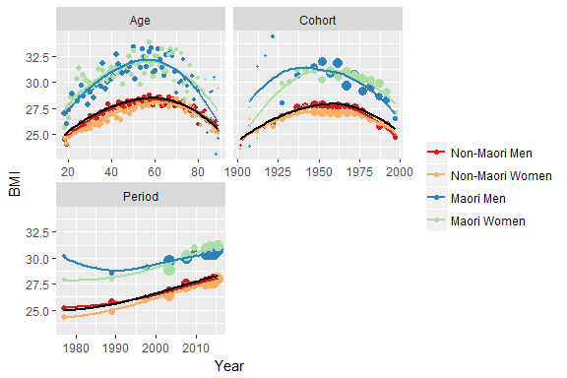

Figure caption

# References [Heading 1]

Flegal KM, Carroll MD, Ogden CL, et al. Prevalence and trends in obesity among US adults, 1999-2008. *JAMA* 2010; 303: 235–241.