Title

Sub-title

Author

Date

**Abstract heading**

*Abstract sub-heading*

Abstract text

KeywordTok(NormalTok)

KeywordTok("StringTok")

# Heading 1

## Heading 2

### Heading 3

#### Heading 4

First paragraph.

Body text

Block Text (used for figure/table notes)

$$\text{Equation: }e=mc^{2}$$

Table caption

|  |  |  |
| --- | --- | --- |
| Table header (first column) | Table header | Table header (last column) |
| Table body (first column) | Table body | Table body (last column) |
| Table total row (first column) | Table total row | Table total row (last column) |

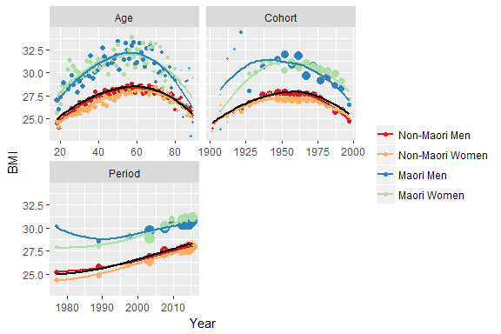

Figure caption

# References [Heading 1]

1. Flegal KM, Carroll MD, Ogden CL, et al. Prevalence and trends in obesity among US adults, 1999-2008. *JAMA* 2010; 303: 235–241.