Activity 1. Test cases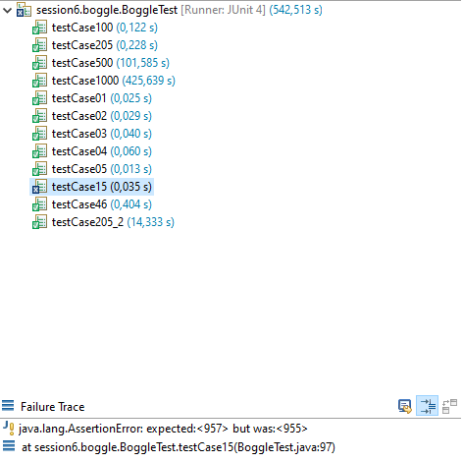

The test case 15 probably won’t work due to the QS that exists in table, but I thought the implementation I did supported more than one letter in the board (subtracting the length of the word).

**UPDATE:** After changing the file of the table 15, the test now succeeds.

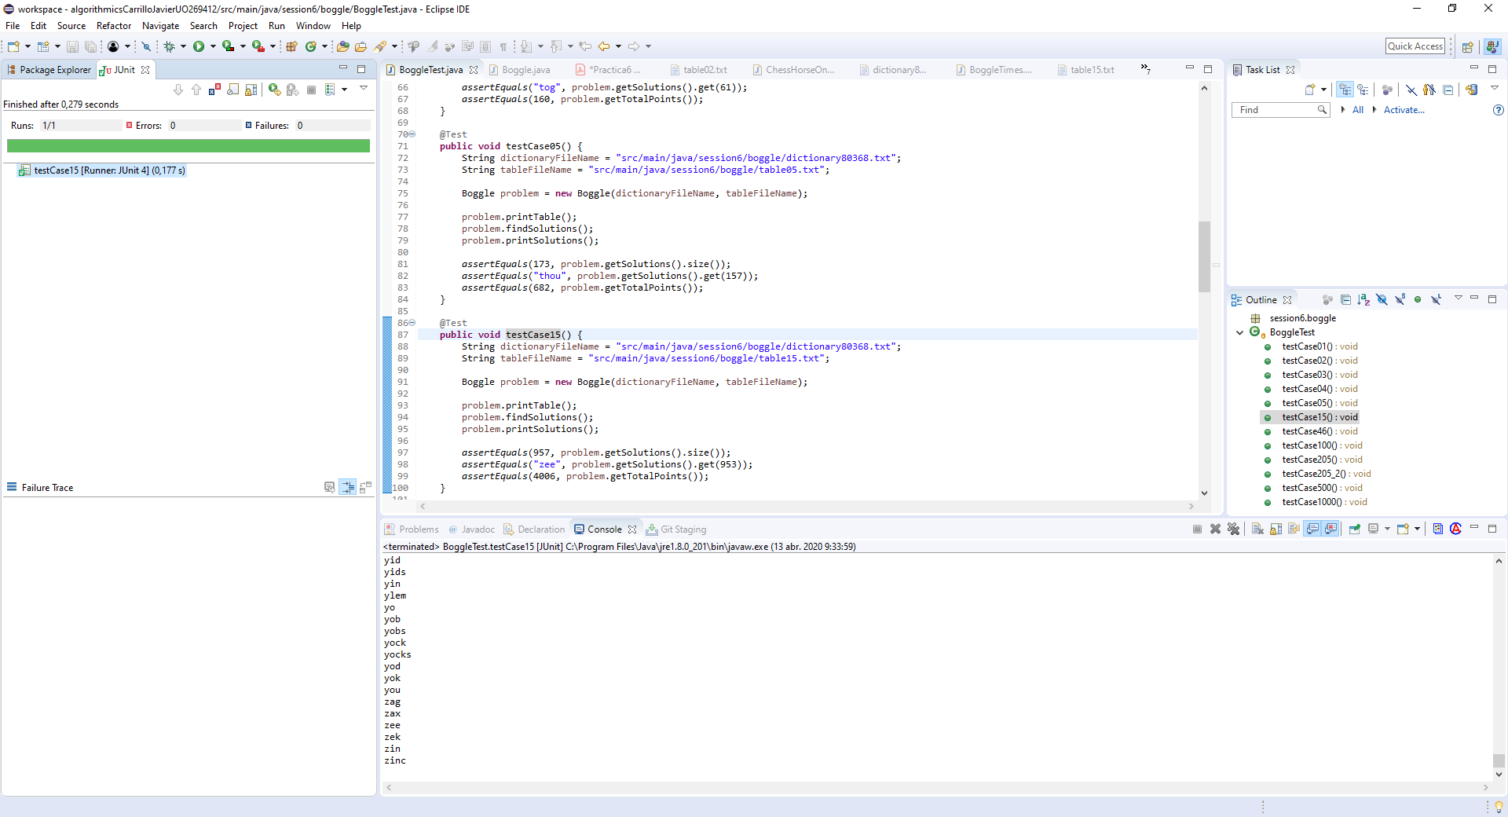

Activity 2. Times for different executions

|  |  |
| --- | --- |
| n | Time (ms) |
| 1 | 1 |
| 11 | 14 |
| 21 | 38 |
| 31 | 177 |
| 41 | 324 |
| 51 | 419 |
| 61 | 807 |
| 71 | 1233 |
| 81 | 2079 |
| 91 | 2841 |
| 101 | 3552 |
| 111 | 5611 |
| 121 | 6485 |
| 131 | 7247 |
| 141 | 7166 |
| 151 | 7961 |
| 161 | 8905 |
| 171 | 10862 |
| 181 | 11931 |
| 191 | 12581 |
| 201 | 13974 |
| 211 | 14941 |
| 221 | 15760 |
| 231 | 18127 |
| 241 | 20203 |
| 251 | 21739 |
| 261 | 22934 |
| 271 | 26570 |
| 281 | 28403 |
| 291 | 31014 |
| 301 | 32708 |
| 311 | 36493 |
| 321 | 39354 |
| 331 | 39470 |
| 341 | 43131 |
| 351 | 46380 |
| 361 | 48507 |
| 371 | 52903 |
| 381 | 55728 |
| 391 | 59437 |
| 401 | 61236 |
| 411 | 64851 |
| 421 | 68463 |
| 431 | 76052 |
| 441 | 77368 |
| 451 | 82050 |
| 461 | 85080 |
| 471 | 87219 |
| 481 | 92181 |
| 491 | 95852 |
| 501 | 102314 |

The complexity of the problem follows a linear complexity, as can be seen taking some theorical values (theorical value of n = 401 -> 60957, close to the 61236 obtained. Theorical of n = 261 -> 22605, close to the 22934 obtained.)

Activity 3. Code improvements

When first approaching the problem, I used an array list to avoid any kind of complications regarding the structure that stores the dictionary and focus on the backtracking implementation. After finally passing some tests, I realized that this structure was far from optimal so I exchanged it for an Hashtable of strings. Realizing it was still slow, I implemented an Hashtable of strings and booleans, the booleans indicating if that word in the dictionary was already in the solutions. Realizing it was still small, I thought about dividing the Hashtable into different hashtables that would store sections of the dictionary (one from a to m, other to m to r and so), thus converting the structure into a hashtable<hashtable<string,boolean>, string>. However, while looking for ways to implement a better dictionary, I found the prefix tree structure (which used a far more developed “sectioning” than the one that I planned to, so I implemented that structure in the end).