Practica 6-Extra – UO305955
Optimizando
n | Tiempo(ms)
4 | 0
5 | 0
6 | 0
7 | 1
8 | 0
9 | 3
10 | 4
11 | 45
12 | 91
13 | 568
14 | 2873
15 | 18441

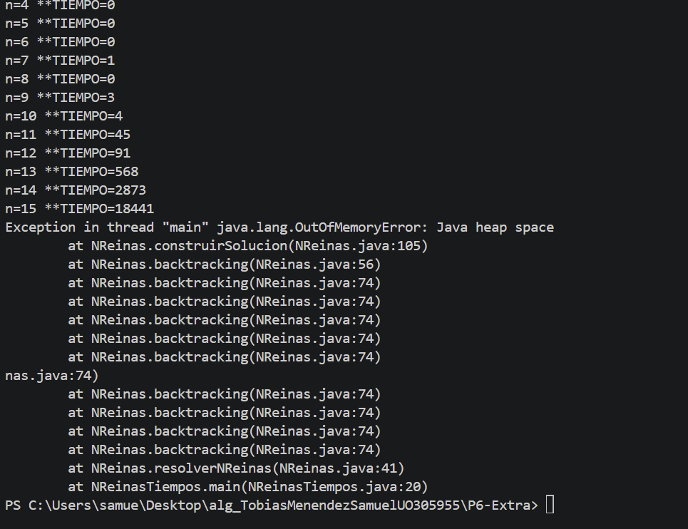

Sin optimizar
n | Tiempo(ms)
4 | 0
5 | 0
6 | 0
7 | 0
8 | 0
9 | 30
10 | 32
11 | 82
12 | 418
13 | 1995
14 | 11983
15 | 84627

