[1 mark] Introduction: This document is a template for multiple choice questions to be imported into Assessly exam software. These documents are imported, and use formatting to tell the software where questions, answers and sections start and end. Try to follow this example consistently to avoid processing errors.  
New lines can be added within a question body by pressing *shift + enter*.This is called a ‘soft return’. To see soft returns as  **show formatting with the button in word’s command ribbon:**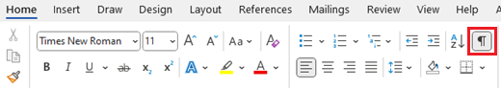  
 You can use as many soft returns as you want in a question or answer:  
  
But if you just hit enter or return it will insert a ‘hard return’. These show up in formatting as icons – they indicate the start of a new paragraph in Word. In our Assessly these are used to indicate the end of a question body or answer. If we place a hard return here:

Then this becomes the first answer. Another hard return here:

And this is becomes the second answer. We can place soft returns in answers like this:  
So this line will still be part of the second answer. Hard return:

Third answer

Fourth answer

Fifth answer. If this is the last answer (typically teleform exams will use five but Assessly supports 2-7 answers), then we’ll want to use two hard returns to indicate the end of the answers for this question.

[1 mark] Correct Answers: By default, the first answer is assumed to be the correct answer. This can be changed in the app.

Correct answer

False

False

False

False

[1 mark] Fixed Answer Positions: By default, all answers are shuffled by clicking Randomiser > Shuffle. Some answers like ‘all of the above’ or ‘non of the above’ would typically be placed last so we want to define that and preven those answers from being shuffled. This positioning has to be set manually – Assessly does not check automate this in case of wording inconsistencies.   
In this example we could put ‘All of the above’ first if it was the correct answer, then we go to Randomiser > Show Answer Controls:  
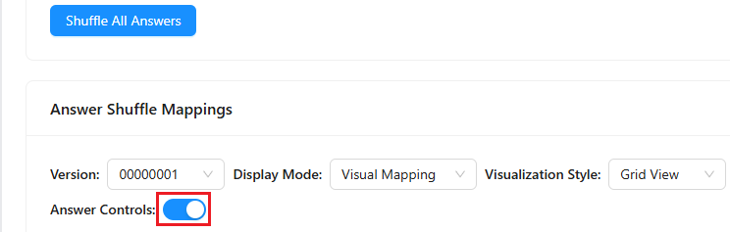  
Then set the first answer to ‘map to’ position E so it always appears last:  
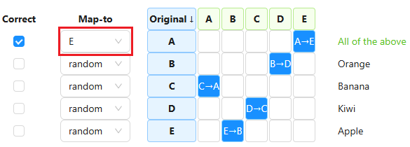

All of the above

Orange

Banana

Kiwi

Apple

[1 mark] More Details: You’ll notice the marks tag at the start of questions. This is used both to set the marks for each question (Assessly will read this value and use it during auto-marking – it can be changed in app). The marks tag is also used to help Assessly find the start of new questions, so please use them. If the marks tag is not present, the app will try to infer the start of questions with the double hard-return placements, but this is less reliable.  
  
Supported fonts are mainly Times New Roman for normal text and Courier New for code blocks. Body text will probably be exported from Assessly in size 12 and Courier New for code blocks will use font size 10 or 11.  
  
Supported font modifiers are **bold** *italic* underline ***bold-italic*** **bold-underline** and *italic-underline.*   
  
Font modifiers: **bold** *italic* underline ***bold-italic*** **bold-underline** *italic-underline* ***bold-italic-underline.***   
  
Superscript and subscript are supported if set from within Word. Sometimes pasting subscripts and superscripts into Word will use a type of encoding not supported by Assessly. If this happens you can revise in this document or reset the subscripts/superscripts in the app via the question rich text editor.

**Answers support the same font modifiers.**

*Italic answer*

Underline answer

***Bold-italic answer***

*Italic-underline answer*

[1 mark] Other Supported Content: MS Word equations like $ax^{2}+bx+c= ?$ are largely supported by Assessly – they are passed through to the export, but are not editable in Assessly and will be shown with a placeholder like [math:math-1] in previews. LaTeX equations are partially supported – they will show in previews in App – double dollar signs $$ $$ either side of the equation will tell Assessly it’s a LaTeX equation. At this stage, export of LaTeX equations may not be supported. Using images for equations is the safest method if word or latex equations are not successful. Word equations can appear in-line or on their own as ‘block equations’ as they’re called: $$\sum_{k=0}^{n-1}{(a+kd)}$$

Answers can also contain equations $\frac{-b±\sqrt{b^{2}-4ac}}{2a}$

Second answer: $\sum_{k=0}^{n-1}{(a+kd)}$

Third answer: $\int_{a}^{b}{{(x-c)}^{2}}$

Fourth answer: $\overline{\overline{(A∙B)}∙(\overline{B}∙C)}+ \overline{(B∙\overline{C})}$

Fifth answer: $\overline{A}∙\overline{B}∙C+\overline{A}∙B∙C+ A∙B∙\overline{C}+ A∙\overline{B}∙C$

[1 mark] Tables: Tables are not currently supported by Assessly. Please take a screenshot (or snip with windows button + snip) and place any tables in the as an image. Images sizes and basic alignment should be maintained through to export and can be adjusted in app. A table like this will likely just be removed during import:

|  |  |
| --- | --- |
| C0R0 | C0R1 |
| C0R1 | C1R1 |

It should not cause other issues with the process but it is safer to avoid using tables in this multiple choice question document.

First answer

Second answer

Third answer

Fourth answer

Fifth answer

[1 mark] Answer Count: Less than the normal number of answers *can* be used but is not entirely recommended. This question should raise warnings in Assessly’s Builder > Summary tab, but should also export without issues.

True

False

[1 mark] Sections: This template does not use sections. Refer to the template with sections to see how to nest questions in sections or create information blocks that aren’t questions.

First answer

Second answer

Third answer

Fourth answer

Fifth answer

[5 marks] Can hard-returns (paragraph breaks) be placed anywhere in questions?

No, that indicates the end of the question body so there should be one and only one at the end

No, they can’t be used anywhere

Yes, formatting doesn’t matter in these files

Yes, they should be used on every new line

Yes, the first question in this file clearly shows lots of new lines in the question body

[5 marks] What are the tags like [1 mark] used for?

All of the above

Marking the start of a question

Telling assessly what the question is marked out of

Helping to show the author the marks

Indicating roughly how the marks will show on the export

[5 marks] How is the correct answer identified?

It always has to be the first answer in this document

It can be changed to any answer but by default the first is used

Multiple correct answers can be set in the app

It doesn’t matter, answers are randomised anyway

Answers B and C