[1 mark] Which of the following conversions are CORRECT? All values are unsinged integer values.  
  
i. 10000000012 = 51310  
ii. 001000010.1012 = 66.7510  
iii. 100001012 = 13310  
iv. 01000112 = 4310

i and iii

i only

ii, iii and iv

iii only

i and iv

[1 mark] Which of the following conversions are CORRECT? All values are unsinged integer values.  
  
i. 7016 = 1608  
ii. 1F016 = 1111100002   
iii. 041010 = 19A16  
iv. 74710 = 4878

i, ii, and iii

i, ii and iv

iii only

i and iv

i only

[1 mark] Which of the following calculations are CORRECT? All values are in unsigned integer values.  
  
i. 10012 + 11112 = 001112  
ii. 101002 – 1012 = F16  
iii. 100002 – 1112 = 10012  
iv. 3A16 – 2616 = 101002

ii and iii

iii and iv

i, ii and iii

ii and iv

ii only

[1 mark] Which of the following option(s) are CORRECT for the given statement?  
  
Left shift by 4 means,  
  
i. multiply by 4  
ii. multiply by 16  
iii. divide by 16  
iv.divide by (1/16)

ii and iv

iv only

ii only

iii only

i only

[1 mark] Which of the following statement(s) are FALSE?  
  
i. In ASCII encoding, “Z” is 5A16 then “Y” is 5916  
ii. In ASCII encoding, “0” is 3016 then “1 2 3” is 31 32 3316  
iii. ASCII is a fixed length encoding scheme   
iv. UTF-8 is a fixed length encoding scheme

iv only

i and ii

i, ii, iii, and iv

i, iii, iv

i only

[1 mark] Which of the following conversions are CORRECT? All the hexadecimal values are in textbook floating-point format. (Rounding might be required for mantissa)  
  
i. -51310 = C04A16  
ii. 404916 = 25110  
iii. Textbook floating-point conversion expands the range of numbers represented by 16 bits.

i and iii

i only

i, ii, and iii

iii only

ii and iii

[1 mark] Which of the following statements are CORRECT about compression?  
  
i. Run-length encoding (RLE) is generally useful for compressing text messages.  
ii. A compression ratio of more than 1 indicates that compression has not been achieved.  
iii. Lossless compression is used when perfect restoration of data is required

iii only

i and iii

i, ii, and iii

ii only

ii and iii

[1 mark] Which of the following Huffman encodings are CORRECT given the Huffman tree?  
  
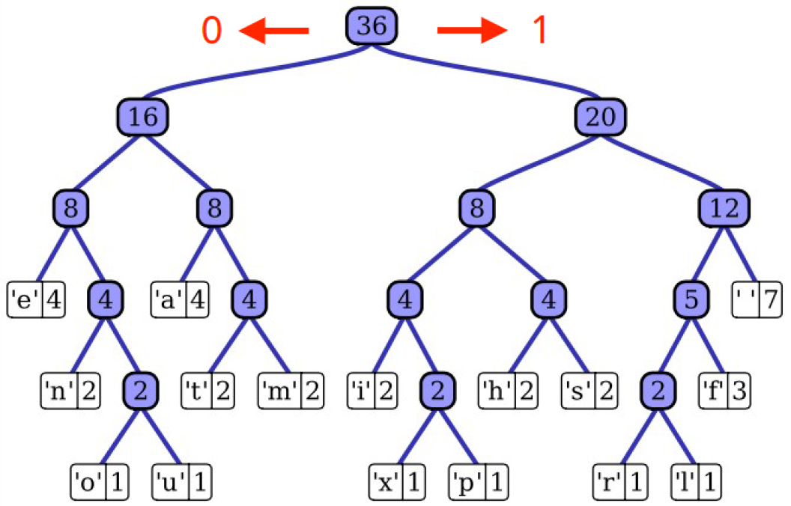  
  
i. 0110100011000000 is the Huffman encoding for "tire".  
ii. 110000001100100111 is the Huffman encoding for "relu".  
iii. 10100001100100110 is the Huffman encoding for "hello".

i and ii

ii only

i and iii

i, ii and iii

ii and iii

[1 mark] Which Boolean expression does the below circuit represent? You may use the truth table to work out the outputs.

None of the options

[1 mark] Which of the following Boolean expressions matches the circuit below?  
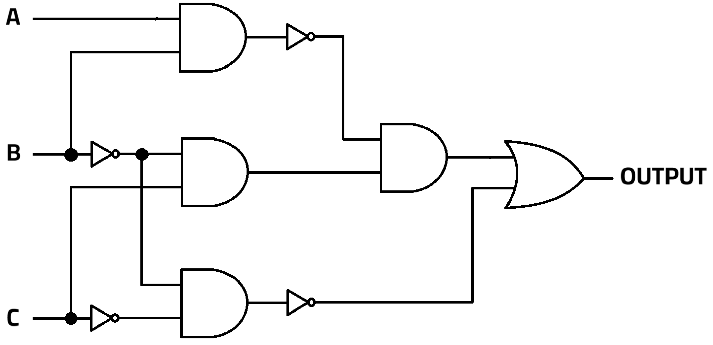

None of the options

[1 mark] Which of the following Boolean expressions would give the truth table below?

[1 mark] Which of the following statements are CORRECT about circuits?  
  
i. Combinational circuits have state  
ii. Adder is not an example of control circuit  
iii. Multiplexor is an example of sequential circuit  
iv. Combinational circuit with memory becomes sequential circuit.

ii and iv

i and iii

ii, iii, and iv

i, ii, iv

i, ii and iv

[1 mark] Which of the following statements are CORRECT?  
  
i. Multiplexor has N input lines and output lines  
ii. An n-bit adder can be constructed from (n-1) number of 1-bit adders.  
iii. An adder can be used for subtraction, multiplication and division  
iv. The Boolean expression for 1-bit equality circuit is where a and b are two inputs.

iii and iv

iii only

i, ii and iii

ii, iii, and iv

i, iii, and iv

[1 mark] How an ADDER can be used for SUBTRACTION as A-B?  
 where A and B are two inputs and are in 2’s compliment.  
  
i. Add A and 1’s compliment of B with initial carry 0  
ii. Add A and 1’s compliment of B with initial carry 1  
iii. Add A and B with initial carry 1  
iv. Add A and 2’s compliment of B with initial carry 1

ii only

iii only

i only

None of the options

iv only

[1 mark] Consider a machine where its memory is organized using a two-dimensional grid (as below image), Which of the following statements about this machine are CORRECT?  
i. The is N bits in size.  
ii. The size of MDR = width of the memory cell  
iii. If N = 8, the two-dimension grid approach yields 32 output lines, compared to 256 in the one- dimension approach.  
iv. If N = 8, regardless one-dimensional or two-dimensional structure, the total number of memory cells are 256

All of the options

i and iv

i, ii and iii

iii and iv

i and ii

[1 mark] What is the output produced by the following assembly language program?  
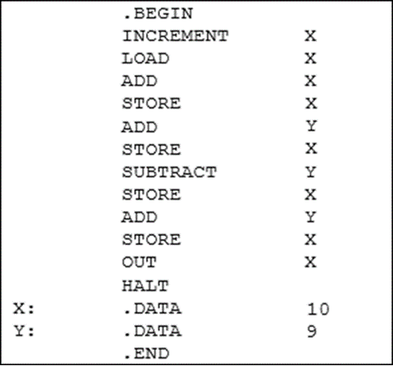

31

21

40

30

41

Here is an assembly language program using the textbook language. Use this program to answer the next two questions (Q17 and Q18). Assume that the first instruction is stored at address 0. Machine code uses 16 bits as per lectures.

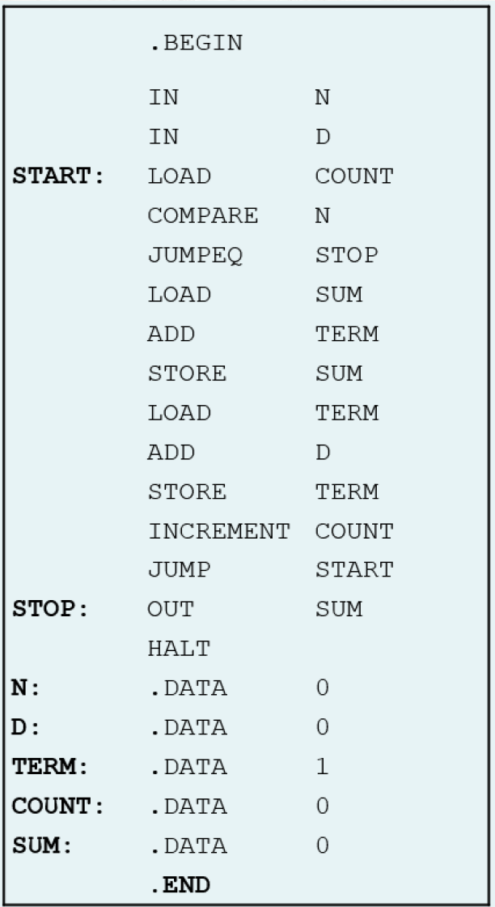

[1 mark] Which of the following statements are CORRECT?  
i. The address of label STOP is 001101 if MAR is of size 6 bits.  
ii. Total three different type of pseudo-ops are used in the code  
iii. If inputs are 3 and 5 in that order, the output will be 18.

i, ii and iii

ii only

iii only

ii and iii

i, and iii

[1 mark] Which of the following statements are CORRECT?  
  
i. The machine code in hexadecimal for the instruction at address 2 is D01016.  
ii. The machine code in hexadecimal for the instruction at address 14 is F00016.  
iii. .DATA pseudo-ops are stored as 16-bit 2’s complement value.

ii and iii

ii only

i, ii, and iii

i and iii

i only

[1 mark] Which of the following statements are CORRECT for the given object file?  
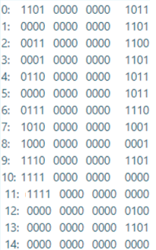  
i. The assembly language instruction for address 11 is HALT.  
ii. The code contains four .DATA pseudo-ops, with all different values stored.  
iii. With given above code, maximum number of labels can be 15

ii and iii

i and ii

ii only

iii only

i and iii

[1 mark] Which of the following statements are CORRECT given the pseudocode algorithm below?  
i. The output when this algorithm runs with input = 10 is 45  
ii. The output when this algorithm runs with input = 12 is 56  
iii. Pseudocode lies in between natural language and programming language  
iv. The given code uses all three basic pseudocode constructs (sequential, conditional, and loop constructs).

i and iii

ii and iii

i, ii and iv

i and iv

iii and iv

[2 mark] Which of the following statements are CORRECT?  
  
i. MAR is used to store address for both instructions and data as requested by and *PC* respectively  
ii. Binary opcode and are same thing.  
iii. Load is a destructive operation as it takes the value from memory to ALU  
iv. MAR and MDR are of same size as they deal with the same memory structure.  
v. If CPU frequency is 2 GHz, means each cycle duration is 0.5 ns  
vi. Modern day laptops use sequential access storage devices for primary data storage  
vii. AND and NOT together are functionally complete

Any three of the statements are CORRECT

Any two of the statements are CORRECT

Any four of the statements are CORRECT

Any five of the statements are CORRECT

Any six of the statements are CORRECT