MAROC3
Draft : 2014, January

MAROC project leaders:
Sylvie BLIN: sylvie.blin@in2p3.fr

Abstract:

A new generation of circuit in AMS SiGe 0.35 mm technology has been designed for reading data from photomultiplier. One of these ASICs called MAROC (standing for Multi Anode ReadOut Chip) is an evolution of the 32 channels OPERA_ROC ASIC developed and installed on the OPERA experiment to auto-trigger and readout 64 channels Hamamatsu multi anode PMTs. MAROC is expected to discriminate the 64 channels PMT signals and produce 64 corresponding trigger outputs. The charge measurement is also available.

The requirements of MAROC were defined by the ones given to the electronic chain of the ATLAS luminometer for which this chip was designed at first. In order to have the best detection efficiency a 100% trigger rate for signal greater than 1/3 photoelectron is required. This corresponds to a charge of 50fC for a PMT functioning at a gain of 106 (High Voltage = 900 V). The noise is expected to be less than 2fC. The crosstalk between neighboring channels should be better than 1%. Additionally the charge measurement should be feasible up to a signal of 30 photoelectrons with a linearity of 2%.

The third version of this chip is made of:

- 64 low impedance preamplifier with a variable 8 bit gain for each channel. This variable gain allows reaching one of the requirements by compensating the PM gain dispersion up to a factor 4.

- 64 trigger outputs coming from either a fast shaper and his low offset discriminator in order to have 100% trigger efficiency rate for input signal close to 10fC or a bipolar fast shaper with lower gain followed by his discriminator allowing to trig for higher input charge without saturation. There is a switch to select between the first and the second trigger as the trigger output. The thresholds are set by two internal 10 bit-DACs.

- 64 variable slow shaper (50-150ns) followed by 2 Track and Hold to provide a multiplexed analog charge output from baseline up to 15pC.

- A digital version of this measurement is also furnished by a 12 bit ADC Wilkinson

MAROC die snapshot

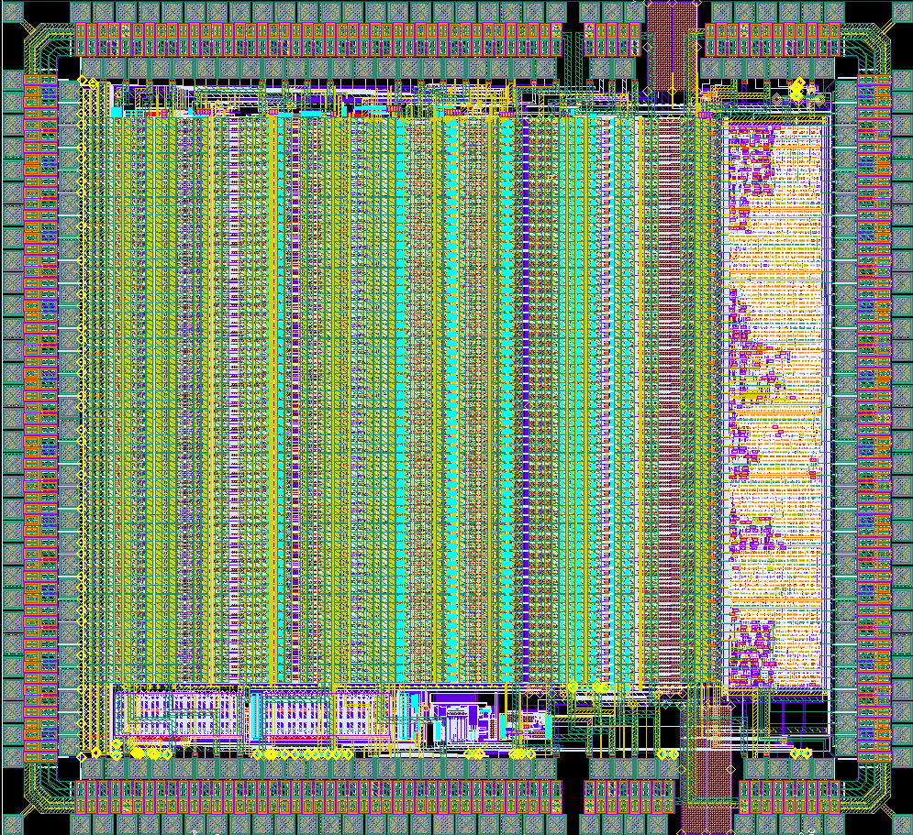

Chip characteristics:
Technology : AMS SiGe 0.35μm
Chip Area : 16mm² (4mm *3.9mm)
Package : CQFP240
Power consumption : 220mW ( ➔ 3.5mW/channel)
Power supply : 0-3.5 V

- Table of content
1. Table of content 3
2. Table of figures 4
3. MAROC3 chip Input/Output Pinout Table 5
4. General description 9
5. Preamplifier 10
5.1. Super Common Base 10
5.2. Sum outputs 10
5.2.1. Principe 10
5.2.2. Simulations 10
6. Slow Channel 11
6.1. Charge measurement description 11
6.1.1. RC buffer and Slow Shaper 11
6.1.2. Measurements results 12
6.2. Slow shaper linearity 12
6.3. Slow shaper linearity at different PA gain 13
6.4. Crosstalk 14
7. Wilkinson ADC 15
7.1. ADC description 15
7.2. Wilkinson calibration and pedestals measurements 17
8. Fast channel 20
8.1. DAC 20
8.1.1. Principle 20
8.1.2. DAC measurements 20
8.2. Variable Fast Shapers 21
8.3. Fast Shaper Measurements 21
8.3.1. DC measurements 21
9. Trigger outputs 22
9.1. S-curve vs injected charge 22
9.1.1. Bipolar Fast Shaper 22
9.1.2. Unipolar Fast Shaper 22
9.2. S-curve vs injected charge at different feedback resistors settings 23
9.2.1. Bipolar Fast Shaper 23
9.2.2. Gain adjustement 23
9.3. Cross talk 24
10. Result summary 25
11. TEST BOARD 26
11.1. ASIC Registers 26
11.1.1. D_SC, CK_SC and RST_SC (Static Register) 26
11.1.2. D_R, CK_R and RST_R* (Dynamic Register) 28

- Table of figures
Figure 1: Block schematic of MAROC3 chip architecture 9
Figure 2: Block schematic 10
Figure 3: Sum schematic 10
Figure 4: Sim: Waveform of the one sum output versus the number of fiber and linearity versus the number of fiber 11
Figure 5: Sim: The sum linearity versus input charge for 1 and 8 fibers 11
Figure 6: RC Buffer schematic and slow shaper schematic 11
Figure 7: Measurement Slow shaper waveform versus buffer capacitances and feedback SS capacitances for the same input charge (1pC) 12
Figure 8: Measurement Slow shaper waveform versus hold delay at different input charge and Slow shaper linearity at different shaping time 13
Figure 9: Charge Linearity at different gain 13
Figure 10: Slow shaper crosstalk 14
Figure 11: Wilkinson ADC 16
Figure 12: Wilkinson signal Zoom 16
Figure 13: Wilkinson ADC digital outputs 17
Figure 14: Delay between start_adc and transmitON 17
Figure 15: Ramp waveform for 12-bit conversions 18
Figure 16: Histogramme of 3 channel pedestals via the 12-bit Wilkinson ADC 18
Figure 17: Mean and rms of charge pedestal via the ADC 18
Figure 18: DAC schematic 20
Figure 19: DAC linearity : simulation and measurement 20
Figure 20: Fast Shapers schematics 21
Figure 21: Pedestal uniformity: Bipolar and Unipolar DC level vs channel number 21
Figure 22: Left: Scurve vs Injected charge at different threshold, Right: 50%trigger efficiency versus threshold 22
Figure 23: Left: FSB1 gain for all channels , Right: intercept of the fit 22
Figure 24: Left: Scurve vs injected charge at different threshold, Right: 50%trigger efficiency versus threshold 23
Figure 25: Left: FSU gain for all channels , Right: intercept of the fit 23
Figure 26: Preamplifier gain adjustement for the bipolar fast shaper 24
Figure 27: Preamplifier gain adjustement for the unipolar fast shaper 24

MAROC3 chip Input/Output Pinout Table

MAROC3 is pin-pin compatible with MAROC2.
GND is the ground layer (0V) and AVDD and DVDD are power layers (3.5V) for the Asic.
The last column gives a cabling proposition.

 | MAROC3
number | pin name | description | DC voltage | Bias (internal resistors and level value) | cabling
1 | in<3> | detector | 0.8V |  | Input
29 | in<31> | detector | 0.8V |  | Input
30 | gnd_pa | Analogue (PreAmplifier) Ground | GND |  | GND
31 | in<32> | detector | 0.8V |  | Input
60 | in<61> | detector | 0.8V |  | Input
61 | IN<62> | detector | 0.8V |  | Input
62 | IN<63> | detector | 0.8V |  | Input
63 | gnd_pa | Analogue (PreAmplifier) Ground | GND |  | GND
64 | D_SC | Slow Control Register Input |  | TTL 3.3 from FPGA | Input
65 | vssa | Inputs Bulk | GND |  | GND
66 | RSTn_SC | Selected Register Reset | 3.5V | TTL 3.3 from FPGA, Active Low | Input
67 | vdd_pa | Analogue (PreAmplifier) Power | AVDD |  | AVDD
68 | CK_SC | Slow Control Register Clock |  | TTL 3.3 from FPGA | Input
69 | vgain_pa | Pre Amps bias voltage | 2.5V | 150Ω vdd_PA | NC
70 | ibi_ss | Slow shaper input bias current | 0.8V | 125kΩ vdd_SS | NC
71 | vcasc_pmos | Pre Amps bias voltage | 1V | 2,5kΩ vdd_PA // 1kΩ gnd_PMOS | NC
72 | ibo_ss | Slow shaper output bias current | 0.8V | 125kΩ vdd_SS | NC
73 | gnd_nmos | Analogue (PreAmplifier) Ground | GND |  | GND
74 | ibi_buf | Buffer bias current | 0.8V | 80kΩ vdd_BUF2 | NC
75 | vref_ss | Slow shaper reference voltage | 1.1V | 14kΩ vdd_BG // 11kΩ gnd_SS | NC
76 | Qbuf_R | Multiplexeur Register Output |  | TTL 3.3 to FPGA | Output
77 | gnd_w | ADC Ground | GND |  | GND
78 | CK_R | Multiplexeur Register Clock |  | TTL 3.3 from FPGA | Input
79 | Hold1 | Hold Signal |  | default value=3,3V or 3.5V | Input
80 | RSTb_R | Multiplexeur Register Reset | 3.5V | TTL 3.3 from FPGA, Active Low | Input
81 | Hold2 |  |  | default value=3,3 or 3.5VV | Input
82 | D_R | Hold Signal |  | TTL 3.3 from FPGA | Input
83 | vdd_w | ADC power | AVDD |  | AVDD
84 | ibo_dac | 10-bit dual DAC output bias current | 0,6V | 100kΩ vdd_DAC | NC
85 | gnd_dac | 10-bit dual DAC ground | GND |  | GND
86 | iref_dac | 10-bit dual DAC bias current | 0,46V | 305kΩ vdd_DAC | Bias: Rx to avdd and Rx to gnd if needed or NC
87 | vdd_dac | 10-bit dual DAC power | AVDD |  | AVDD
ibi_dac |  |  |  | 15kΩ vdd_DAC
88 | vref_dac | 10-bit dual DAC reference voltage | 2V | 50kΩ vdd_BG //200kΩ gnd_DAC | NC
89 | vbi_tz | FSU input bias current | 2,6V | 170kΩ gnd_FSU | Bias: Rx to avdd and Rx to gnd if needed or NC
90 | vdd_fsu1 | FSU power | AVDD |  | AVDD
91 | G_diode | FSU bias voltage | 1V | 1kΩ gnd_FSU//2,5kW vdd_FSU1 | NC
92 | E_fsu | FSU ground | GND |  | GND
93 | vbo_tz | FSU output bias current | 0.96V | 40kΩ vdd_FSU2 | Bias: Rx to avdd and Rx to gnd if needed or NC
94 | vcasc_fsu | FSU bias voltage | 1V | 2,5kΩ vdd_FSU1 // 10kΩ gnd_FSU | NC
95 | vslope | ADC Ramp bias voltage | 800mV | 154kΩ vdd_BG // 46kΩ gnd_Wilk | Rx to avdd and Rx to gnd if needed or NC
96 | vref_fsu | FSU reference voltage | 1V | 1,5kΩ vdd_BG // 1kΩ gnd_FSU | NC
97 | ramp | Ramp output | test | Scope waveform | Output: Pin test
98 | gnd_wilk | ADC ground | GND |  | GND
99 | vref_ramp | ADC ramp reference voltage | 0.8V | 126kΩ vdd_BG // 74kΩ gnd_Wilk | Rx to avdd and Rx to gnd if needed or NC
100 | vdd_wilk | ADC power | AVDD |  | AVDD
101 | ib_integ | ADC bias current |  | 15kΩ gnd_Wilk | NC
102 | vssa | Inputs Bulk | GND |  | GND
103 | vssm | Inputs Bulk | GND |  | GND
104 | vbi_discri | Discriminator input stage bias current | 0.8V | 100kΩ vdd_discri | NC
105 | vdd_discri | Mixed (Discriminator) Power Supply | AVDD |  | AVDD
106 | vbm_discri | Discriminator middle stage bias current | 2.5V | 100kΩ gnd_discri | NC
107 | vdd_discriADC | ADC (Discriminator) Power Supply | AVDD |  | AVDD
108 | vbo_discri | Discriminator output stage bias current | 2.5V | 100kΩ gnd_discri | Bias: Rx to avdd and Rx to gnd if needed or NC
109 | gnd_discri | Analogue (Discriminator) Ground | GND |  | GND
110 | PWR_ON | should be set to vdd value (3.5V) |  |  | Input
111 | vssd | Digital part Bulk | GND |  | GND
112 | gndd | Digital (LVDS receivers & Digital ) Ground | GND |  | GND
113 | vddd2 | Digital (LVDS receivers & digita) Power | DVDD |  | DVDD
114 | TransmitOn | ADC Active data readout |  | VH-VL logic to FPGA | Output
115 | out_ADC | ADC serial data ouput |  | VH-VL logic to FPGA | Output
116 | start_ADC | ADC start input |  | TTL 3.3 from FPGA | Input
117 | vbi_discriADC | Rx to vdda and Rx to gnd if needed | 0,8V |  | Rx to vdda and Rx to gnd if needed or NC
118 | out<63> | Trigger output |  | VH-VL logic to FPGA | Output
119 | out<62> | Trigger output |  |  | Output
120 | out<61> | Trigger output |  |  | Output
121 | out<60> | Trigger output |  |  | Output
150 | vssd | Digital part Bulk | GND |  | GND
180 | out<2> | Trigger output |  |  | Output
181 | out<1> | Trigger output |  |  | Output
182 | out<0> | Trigger output |  |  | Output
183 | gndd | Digital (LVDS receivers & Digital ) Ground | GND |  | GND
184 | RST_ADC | ADC reset input |  | TLL 3.3 from FPGA | Input
185 | vddd | Digital (LVDS receivers & digital) Power | DVDD |  | DVDD
186 | CKb_40M | ADC: 40MHz Clock |  | LVDS from FPGA | Input
187 | VL | Low value of the trigger voltage and ADC outputs (700mV,100nF to gnd) | 700mV | analog input voltage: can be changed | Input: Low value of the trigger voltage (700mV,100nF to gnd) or the ground
188 | CK_40M | ADC : 40MHz Clock |  | LVDS from FPGA | Input
189 | vssd | Digital part Bulk | GND |  | GND
190 | VH | High value of the trigger voltage and ADC outputs(1.5V,100nF to gnd) | 1,5V | analog input voltage:can be changed | Input: High value of the trigger voltage (1.5V,100nF to gnd)
191 | OR_0 | OR of the first discriminators |  | TTL output | Pin test
192 | OR_1 | OR of the second discriminators |  | TTL output | Pin test
193 | vdd_discriADC | ADC (Discriminator) Power Supply | AVDD |  | AVDD
194 | vth1 | 10-bit dual DAC output 1 | 100nF to gnd | pin test: threshold second discri | Output: Pin test
195 | gnd_discri | The same signal, only the name is changed | GND |  | GND
196 | vth0 | 10-bit dual DAC output 0 | 100nF to gnd | pin test: threshold first discri | Output: Pin test
197 | vssm | Bulk inputs | GND |  | GND
198 | vss |  | GND |  | GND
199 | Qbuf_SC | Slow control register output |  | TTL 3,3 to FPGA | Output
200 | v_bg | internal bandgap (value 2,5V) ouput | 2.5V | modification between MAROC2 (external bandgap 3,3V) and MAROC3 (internal bandgap 2,5V) | internal bandgap (value 2,5V): only pin test
201 | out_fs | Fast Shapers Output | 1V // 2V | test output (1V for FSU or 2V for FSB1) | Output pin test: a buffer should be added
202 | gnd_fsu | FSU ground | GND |  | GND
203 | vb_otafsu | FSU bias voltage | 2.7V | 500kΩ gnd_FSU | NC
204 | vdd_fsu2 | FSu power | AVDD |  | AVDD
205 | vbo_fsb | FSB output bias current | 2,3V | 100kΩ gnd_FB1 | NC
206 | gnd_fsb1 | FSB ground | GND |  | GND
207 | vbi_fsb | FSB input bias current | 2.5V | 60kΩ gnd_FB1 | NC
208 | vref_fsb | FSB reference voltage | 2V | 500Ω vdd_BG // 2kΩ gnd_FB1 | NC
209 | ib_w | Track&Hold bias current | 0.8V | 250kΩ vdd_w | NC
210 | vdd_fsb | FSB power | AVDD |  | AVDD
ib_otaq |  |  |  | 15kΩ vdd_otaq
211 | gnd_fsb0 | FSB ground | GND |  | GND
212 | ib_sum | Preamplifier sum current bias | 1V | 5,6k vdd_ss | NC
213 | EN_otaq | Enable of the multiplexed analogue output | INPUT | TTL 3.3V from FPGA: default value should be 3.3V | Input
214 | sum8 | Sum ouput |  |  | NC
215 | out_q | Multiplexed analogue output | 1V | Charge ouput | Output pin test: a buffer should be added to see the waveform at scope
216 | sum7 | Sum output |  |  | NC
217 | gnd_capa | Track &Hold ground | GND |  | GND
218 | sum6 | Sum output |  |  | NC
219 | gnd_ss | Slow shaper ground | GND |  | GND
220 | sum5 | Sum output |  |  | NC
221 | vdd_ss | Slow Shaper power | AVDD |  | AVDD
222 | sum4 | Sum output |  |  | NC
223 | vdd_buf1 | Buffer power | AVDD |  | AVDD
224 | sum3 | Sum output |  |  | NC
225 | vdd_otaq |  | AVDD |  | AVDD
226 | sum2 | Sum output |  |  | NC
227 | gnd_otaq | Multiplexed analogue output driver OTA ground | GND |  | GND
228 | sum1 | Sum output |  |  | NC
229 | vcasc_nmos | Preamplifier voltage bias | 1.5V | 2kΩ vdd_NMOS //1,5kΩ gnd_NMOS | NC
230 | vbi_pa | Rx to vdda and Rx to gnd if needed | 0,65V | 500kΩ vdd_pa | Rx to vdda and Rx to gnd if needed or NC
231 | gnd_nmos | Preamplifier ground | GND |  | GND
232 | NC |  |  |  | NC
233 | vdd_pa | Preamplifier power | AVDD |  | AVDD
234 | Ctest | input signal for internal capacitors |  | Test input | input signal for internal capacitors
235 | vssi | Bulk inputs | GND |  | GND
236 | vdd_pad | Inputs Pads Protection | AVDD |  | AVDD
237 | gnd_pa | Analogue (PreAmplifier) Ground | GND |  | GND
238 | in<0> | detector | 0.8V |  | Input
239 | in<1> | detector | 0.8V |  | Input
240 | in<2> | detector | 0.8V |  | Input

power pin name | Pin number | current (mA) |  | power pin name | Pin number | current (mA)
vdd_w | 83 | 2.4 |  | vdd_FSU2 | 204 | 5.2
vdd_DAC | 87 | 0.65 (dac max) to 1.92 (dac min) |  | vdd_FSB | 210 | 8.3
vdd_FSU1 | 90 | 1,4 |  | vdd_SS | 221 | 8
vdd_wilk | 100 | 4.6 |  | vdd_buf1 | 223 | 0.6
vdd_discri | 105 | 3,6 |  | vdd_OTAQ | 225 | 5
vddd2 | 113 | 7.1 |  | vdd_pa | 233 | 5.4
vddd | 185 | 0,8 |  | vdd_pad | 236 | 0
vdd_discriADC | 193 | 7.6

Consumption Current ~ 62mA

- General description

The MAROC3 chip is a 64-channel input front end circuit to read out MAPMT outputs. It provides one shaped signal proportional to the input charge and 64 trigger outputs. Two outputs are implemented to make OR of the first and the second discriminator in order to perform a charge measurement with an auto trigger. Figure 1 gives a simplified schematic of the whole chip with its main features.
Each channel is made of a variable gain preamplifier (“Super Commun Base”) with low input tunable impedance (50-100Ω), a low offset and a low bias current (5μA) in order to minimize the cross talk. This variable gain allows adapting the gain depending on the detector choice, up to a factor 4 to an accuracy of 1% with 8 bits. This gain tuning is also convenient to switch off a noisy channel. The amplified current feeds then two paths:
- A slow shaper path which consists in a CRRC² shaper with switchable capacitances to allow tuning peaking time and gain and 2 Track and Hold Widlar differential buffer one to measure the baseline and other one to obtain charge measurement. These T&H blocks store the charge in a 2pF capacitor and deliver a multiplexed charge measurement with a 5 MHz readout speed.
- Two possible fast shapers selected with cmd_fsb_fsu switch are followed by a one discriminator to deliver trigger outputs. Another fast shaper with less gain is implemented to trig for higher threshold.
- CK_mux and d1_d2 commands allow selecting the wanted discriminator outputs as the trigger output.

The different blocks are described in the next section.

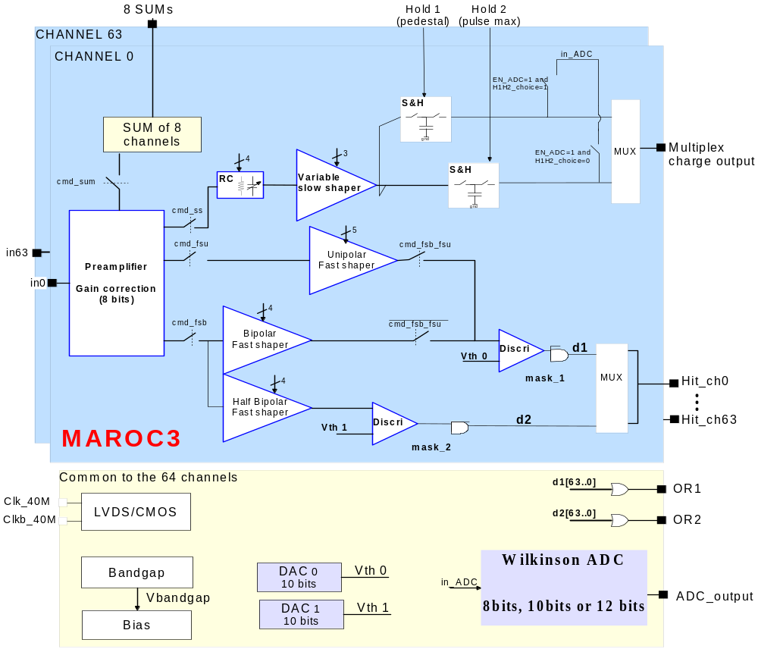
- Block schematic of MAROC3 chip architecture

All the biases of each stage are common for every channels and have an internal default value referenced at a 2.5V internal bandgap. Each threshold is loaded by a 10-bit DAC and all switch commands are programmed through the Slow Control register. There are 829 Slow Control (SC) parameters which are loaded serially to control the chip.
Few blocks are power pulsed to decrease the power consumption: Bandgap, DAC OTA, Slow Shaper
A Read register is used to readout the charge output and the outputs of the selected fast shaper (Unipolar Fast Shaper “FSU”, Bipolar Fast Shaper “FSB1”, Half Gain Bipolar Fast Shaper “FSB2”).
- Preamplifier

Super Common Base
The preamplifier (PA) is a super common base to minimise the input impedance following by scaled mirror to set the gain for each channel. There are 8bits/channel to command these switches. These 8 bits correspond to a binary Gain tuneable between 0 and 255 and to an analogue gain varying from 0 up to 3.984 (=1/64+ 1/32 …+1/2+1+2). The gain value 64 corresponds to the analogue unity gain and the gain of 0 allows inhibiting the signal at input.

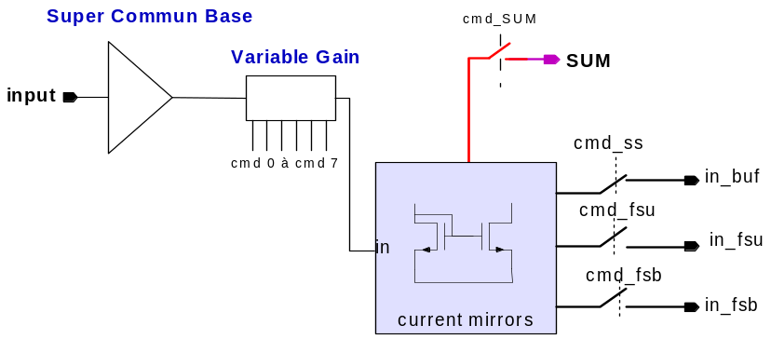

- Block schematic

After the variable gain block, the current is copied to provide the sum outputs and to send or not signal at the slow shaper and fast shapers inputs (figure 2).

Sum outputs

Principe
We added the possibility to perform a sum up to 8 successive channel preamplifier signals.

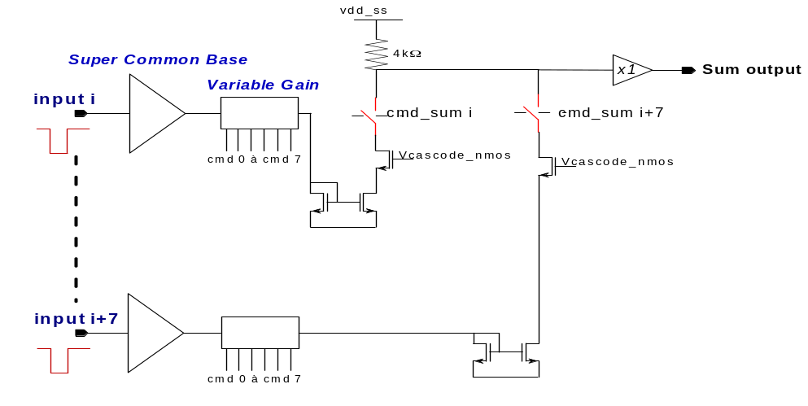
- Sum schematic

Simulations
In this simulation, a same charge (100fC ) is injected in all channels and the preamplifier gain is 1.

The DC voltage is proportional with the number of fibers used for the sum.
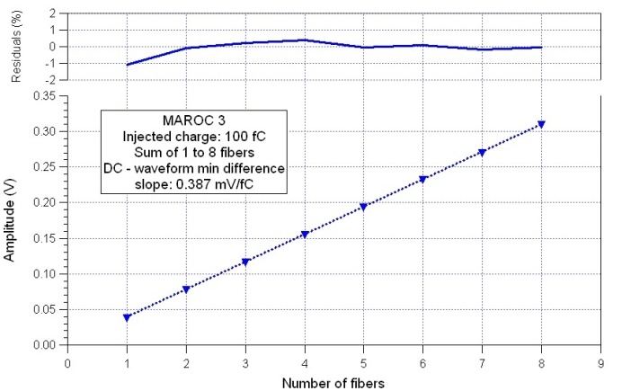

- Sim: Waveform of the one sum output versus the number of fiber and linearity versus the number of fiber
- Sim: The sum linearity versus input charge for 1 and 8 fibers

- Slow Channel

Charge measurement description

RC buffer and Slow Shaper

The preamplifier signal goes to the slow channel part thanks to a NMOS current mirror. The charge measurement will be performed through a RC buffer with variable capacitors to change the gain and a slow shaper to improve the signal/noise ratio at different rise time settings.
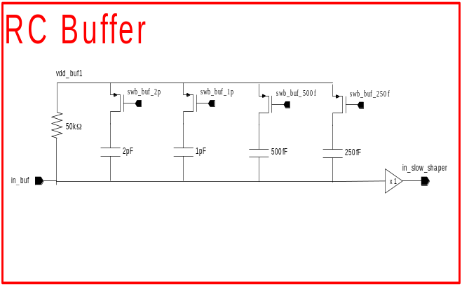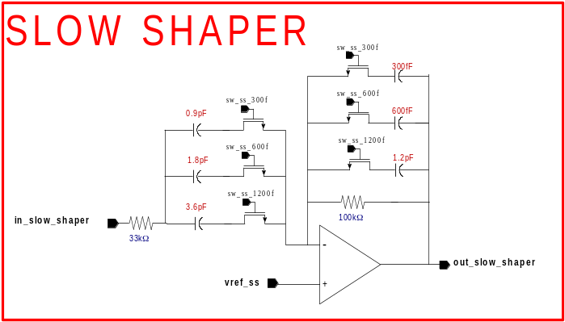

- RC Buffer schematic and slow shaper schematic

Its gain and speed can be tuned changing the RC buffer network and SS feedback capacitor (SC parameters). The peaking time (tp_{5-100%}) is expected to vary from 30 ns up to 150ns. (tp_{5-100%}=0.98τ).
The SS is followed by 2 Track and Hold to store the baseline and maximum charge in a 2pF capacitor. The output can be read by selecting the channel using the Read register.

Measurements results
The analogue output has been studied as a function of different tuneable capacitors. There are 3 feedback capacitors on the slow shaper (Css varies from 0.3pF to 2.1pF) and 4 buffer capacitors (Cbuf varies from 0pF to 3.75pF) common to all the channels, that can be switched on and off independently in order to vary the signal shape and its duration.
To reconstruct the waveform of the slow shaper, internal ADC conversions have been performed at different hold delays. This measure allows finding the best delay for the hold signal (hold value that corresponds to the signal maximum) for 8 capacitor configurations.
Converted data are plotted for different values of the hold (range 0-500, step 10n ns) in the following way: a pulse of 100 mV amplitude has been sent to a 10pF capacitor connected to channel 8.

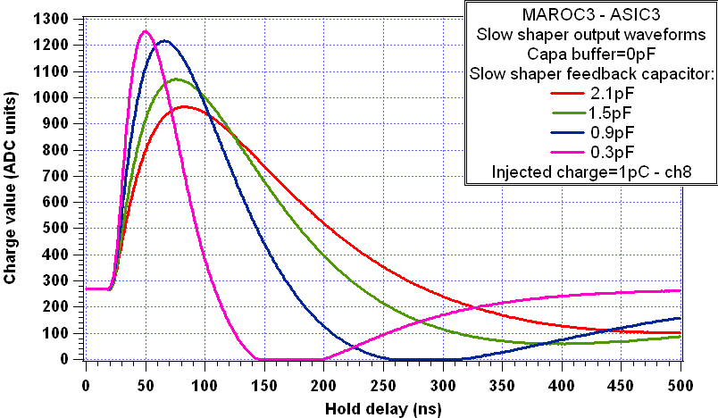 | 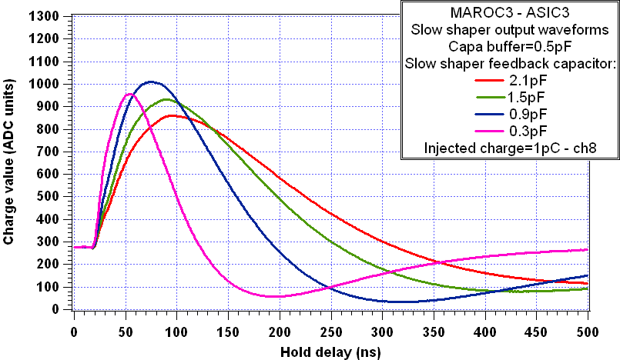
  SS capa | 0.3p | 0.9p | 1.5p | 2.1p
  DC level (V) | 269.6 | 270 | 269.6 | 269.3
  Tmax (ns) | 50 | 66 | 76 | 84
  Vmax V) | 1252.6 | 1216.8 | 1070.6 | 965.7
  SS capa | 0.3p | 0.9p | 1.5p | 2.1p
  DC level | 276.8 | 276.5 | 276.8 | 277.5
  Tmax | 54 | 76 | 89 | 95
  Vmax | 956.6 | 1009.4 | 932.1 | 859.2
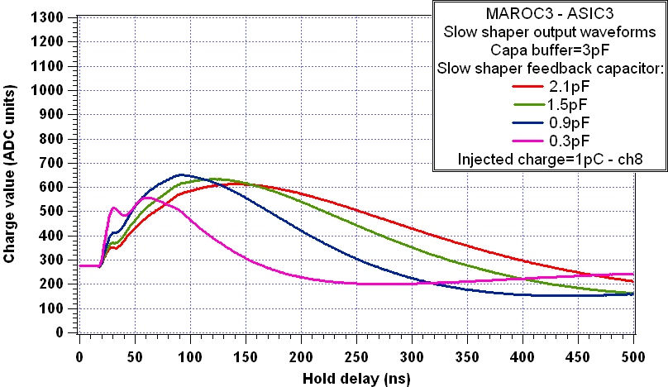 | 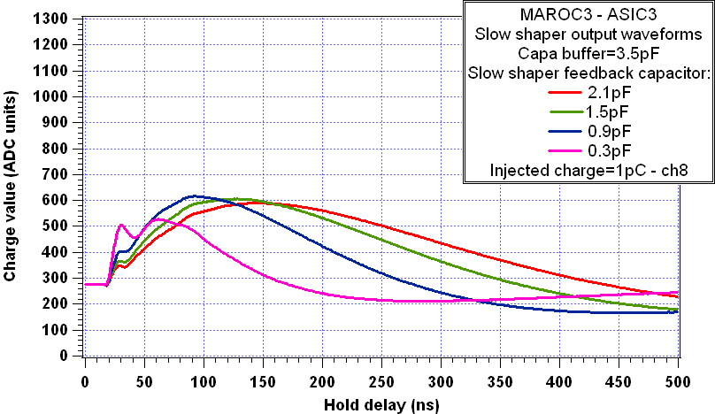
  SS capa | 0.3p | 0.9p | 1.5p | 2.1p
  DC level (V) | 276.8 | 276.8 | 276.6 | 276.8
  Tmax (ns) | 61 | 93 | 122 | 139
  Vmax V) | 557.6 | 650.5 | 633.6 | 613.6
  SS capa | 0.3p | 0.9p | 1.5p | 2.1p
  DC level (V) | 277.3 | 277 | 276.9 | 277.6
  Tmax (ns) | 62 | 92 | 126 | 142
  Vmax (V) | 527.6 | 616.3 | 606.1 | 589.9
- Measurement Slow shaper waveform versus buffer capacitances and feedback SS capacitances for the same input charge (1pC)
For few Cbuf and Css combinaisons, we can see a coupling with the FSB1. But this problem doesn’t disturb the hold position at the maximum.

Slow shaper linearity
A scan of the hold delay at few input voltage amplitude has been performed. The data converted as function of hold delay have been plotted for 3 shaping configurations.

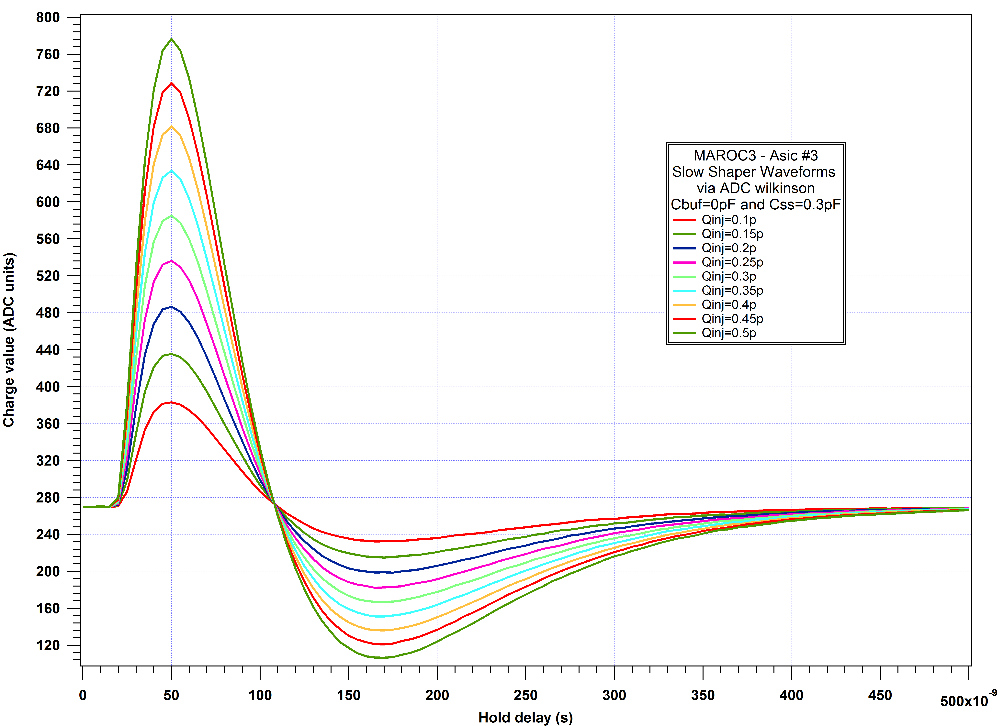 | 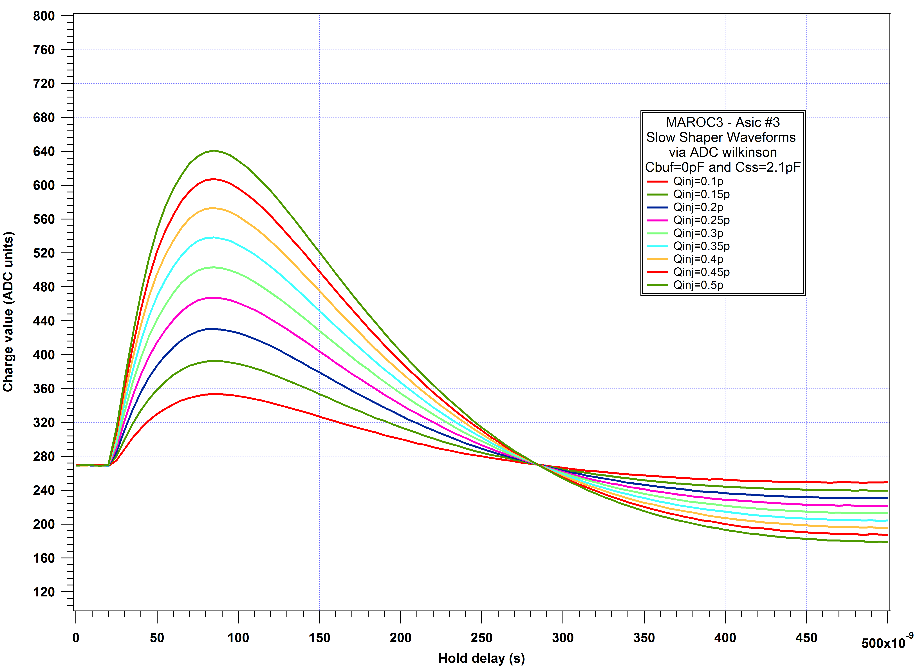
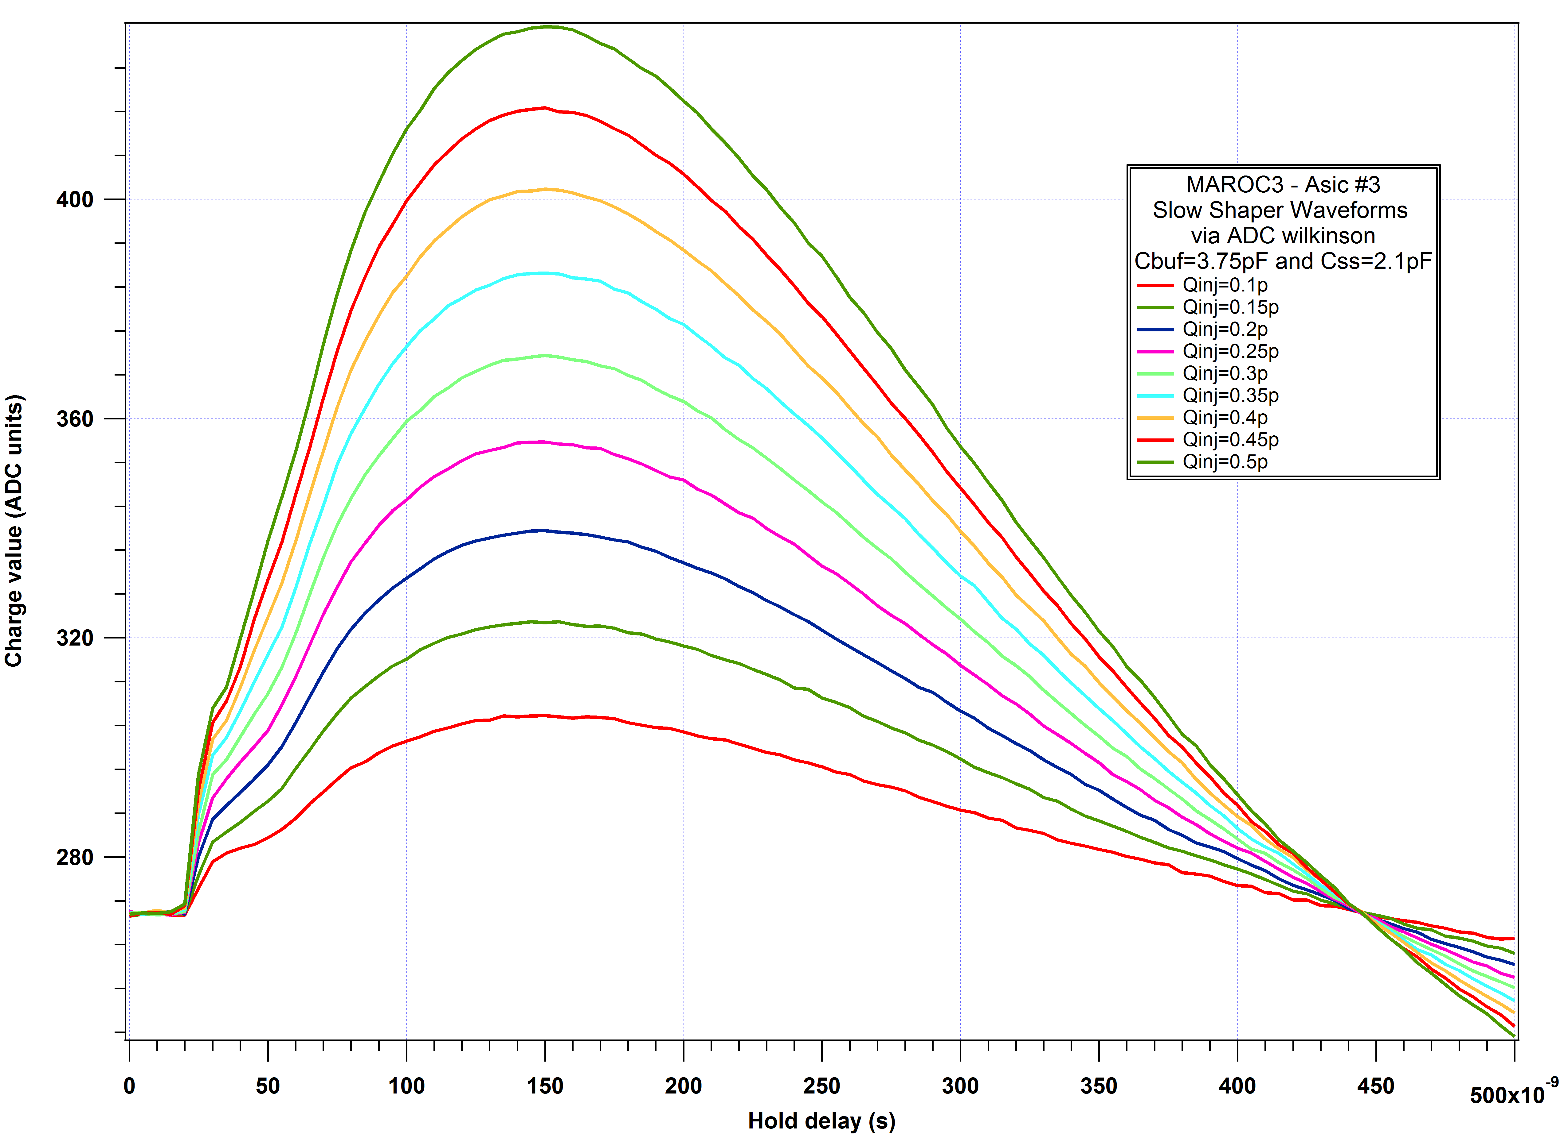 | 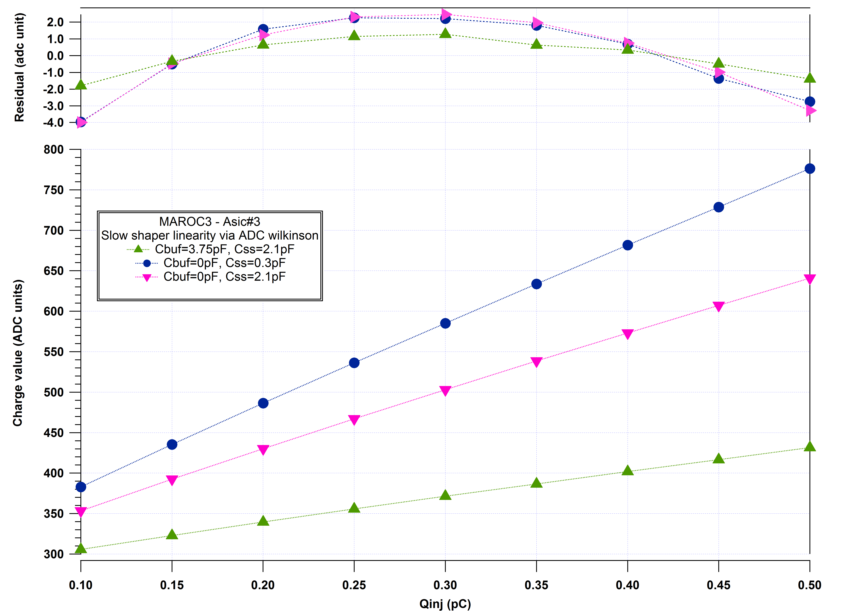
- Measurement Slow shaper waveform versus hold delay at different input charge and Slow shaper linearity at different shaping time
config | 0p+0.3p | 0p+2.1p | 3.75p+2.1p
Hold delay | 50ns | 85ns | 150ns
gain | 980.6 adc/pC | 717.2 adc/pC | 276.3 adc/pC
intercept | 288 adc | 286 adc | 313a dc

Slow shaper linearity at different PA gain
With a fixed hold value of 100n (that means at the signal peak) and Cbuf=0pF and Css=2.1pF, a scan on the input voltage amplitude has been performed to test the linearity of the ASIC. The input charge has been varied from 0 to 30pC while 4 values for the preamplifier gain have been chosen (4 - 8 - 16 – 32 – 40).
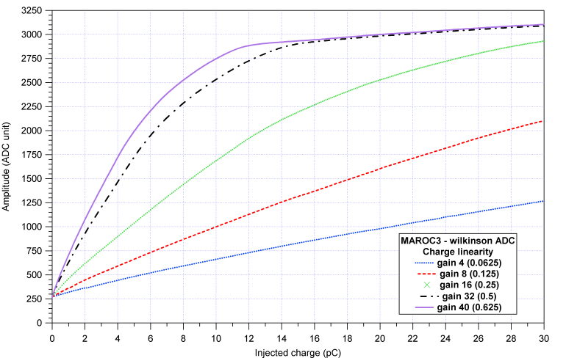
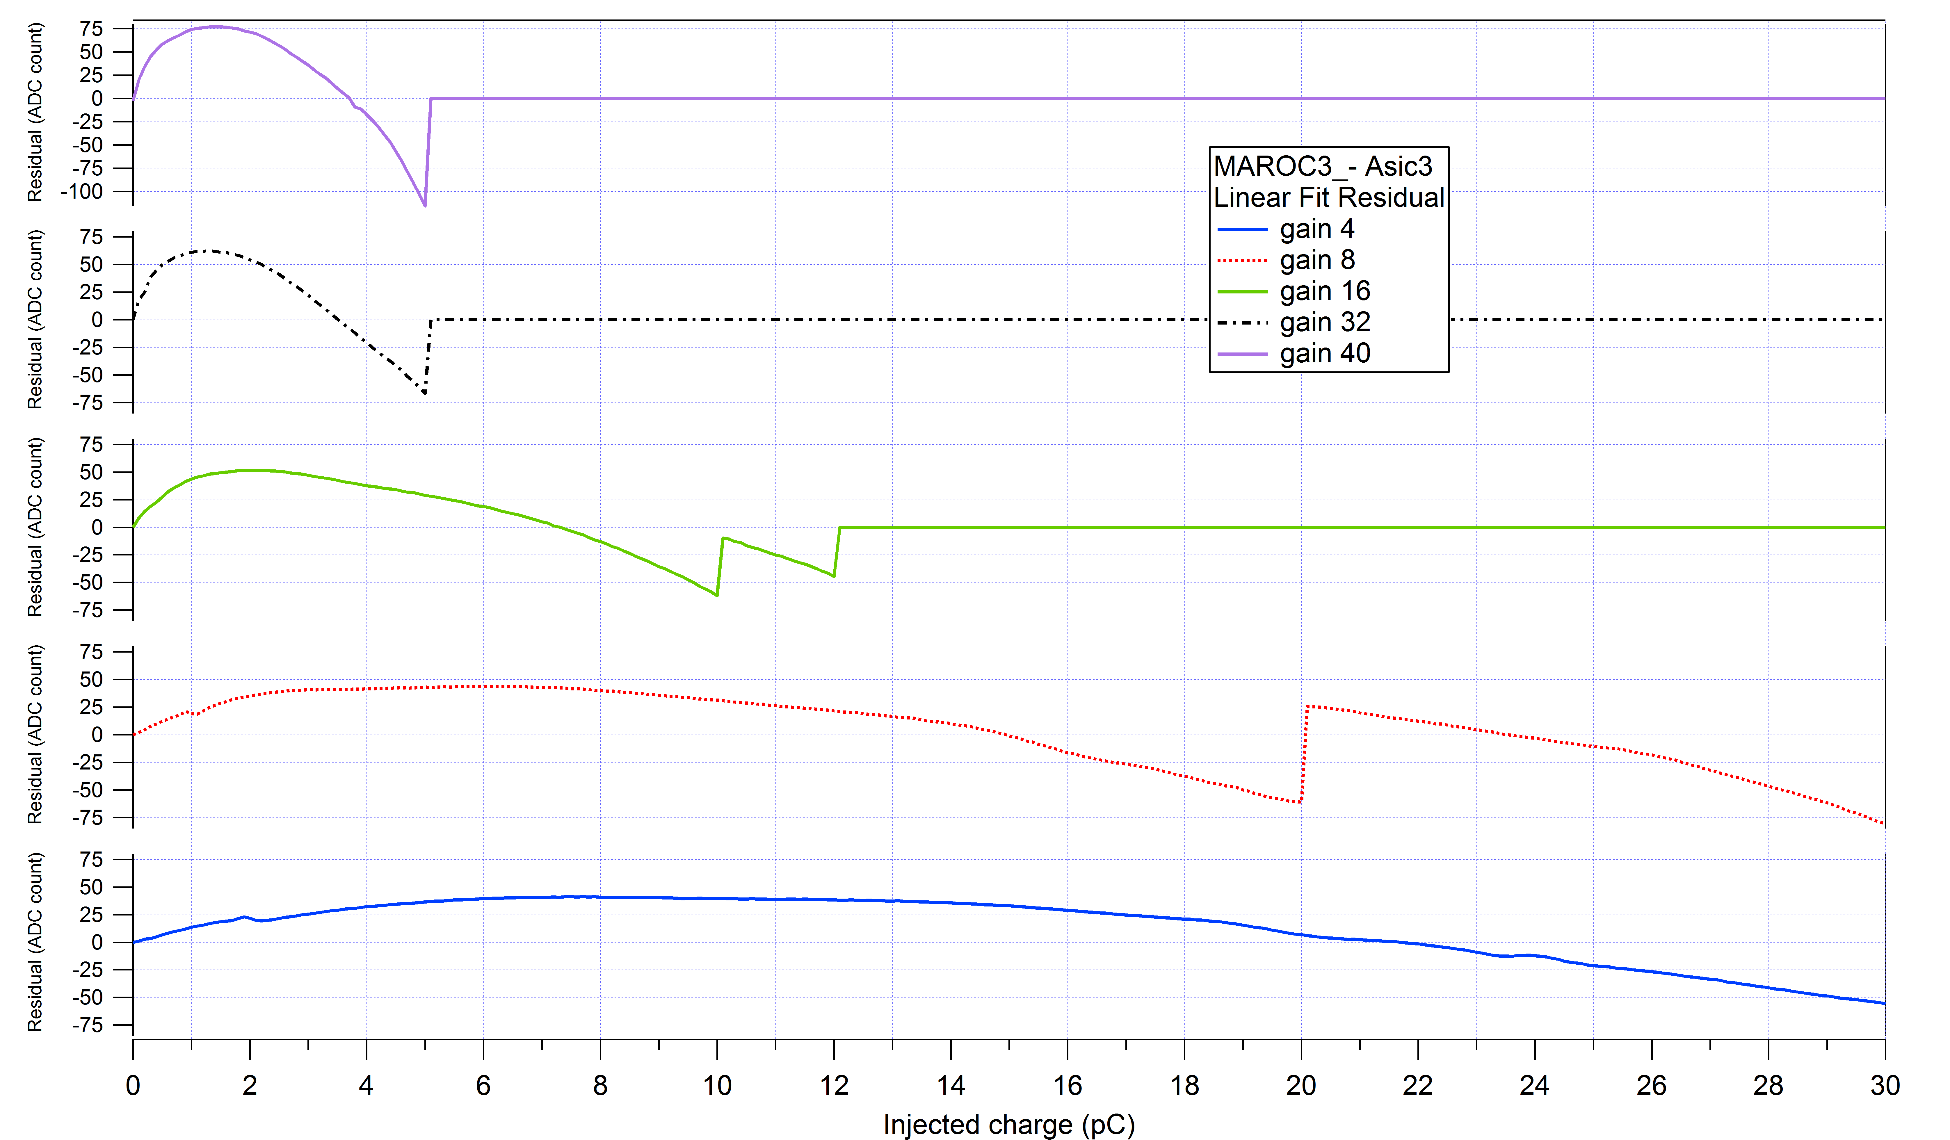

- Charge Linearity at different gain
The table shows the gain of slow shaper and the limit of the fit to obtain a non linearity of about 2%.

Gain | 4 | 8 | 16 | 32 | 40 | 64
Slope  (adc count/pC) | 35 | 70 | 148 | 305 | 383 | 636
Intercept (adc count) | 271 | 271 | 269 | 265 | 262 | 271
Fit limit (pC) | 30 | 20 | 10 | 5 | 4 | 3

The same measurement has been performed with the lowest shaping time: Cbuf=3.75pF and Css=2.1pF and hold delay=160ns.

The table shows the gain of slow shaper and the limit of the fit to obtain a non linearity of about 2%.

Gain | 4 | 8 | 12 | 16 | 24 | 32 | 40 | 64
Slope  (adc count/pC) | 13 | 26 | 9 | 52 | 79 | 107 | 138 | 225
Intercept (adc count) | 247 | 249 | 246 | 247 | 247 | 247 | 246 | 244
Fit limit (pC) | 85 | 85 | 75 | 75 | 51 | 39.1 | 30.6 | 18.9
Data at fit limit | 1292.5 | 2325.6 | 2991.7 | 3801.7 | 4026.7 | 4054.6 | 4073.5 | 4034.3

Crosstalk
To measure the crosstalk a large signal has been send in channel 8. The ratio between the adjacent channels and the channel 8 signal gives 0.25% crosstalk
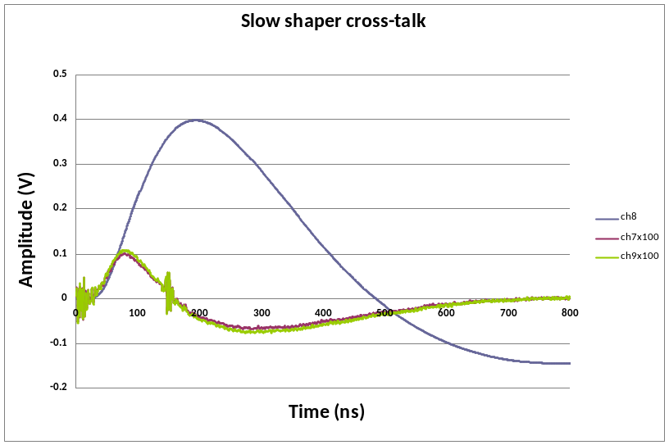

- Slow shaper crosstalk

Wilkinson ADC

ADC description

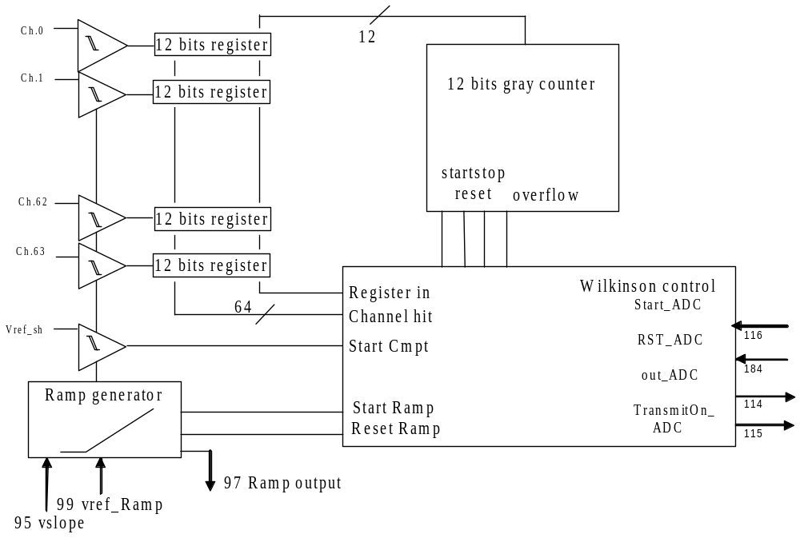

The Analog to Digital conversion chosen is a Ramp ADC working at 40MHz. The voltage to digital conversion is performed by measuring the time between the start of a voltage ramp (or another position) and its crossing, detected by the comparator, of the voltage to be converted. The time measurement is achieved by a gray counter not started simultaneously with the ramp. Indeed the launching of the ramp is ordered by the start_ADC falling edge signal. The crossing between the ramp and the reference voltage of the slow shaper generates a trigger pulse which becomes the start of the gray counter. When a comparator triggers, its output
is synchronized by the clock to memorize the state of the counter which will be the digital data.

The 12-bit gray counter and the ramp generator are shared between the channels. The ADC part replicated in each channel can be reduced to a discriminator and a memory used to copy and memorize the counter state when the discriminator triggers. So the power consumption and the area used can be very small even for high dynamic range.

The use of this kind of ADC is limited by its long conversion time. In fact, for an N bit conversion, it requires 2^{N}/Fck, where Fck is the clock period of the counter. So for a 12-bit conversion, making use of a 40 MHz clock, 102.4µs are required.

On the test board, the RST_ADC is synchronised by the Hold1 pulse falling edge and stays at 0 during 25ns. The Start_ADC is synchronised by the rising edge of the RST_ADC pulse and have to stay at zero during 3 clock ticks.
The ramp begins at the Start_ADC falling edge and the readout of the data starts automatically at the end of the conversion. Data are synchronised with the rising edge of the TransmitOn_ADC.

Be careful: The TransmitOn_ADC and the out_ADC signals are either on pin 114 or 115 depending of the chip production run. The swapping can be easily done in the FPGA.

- Wilkinson ADC

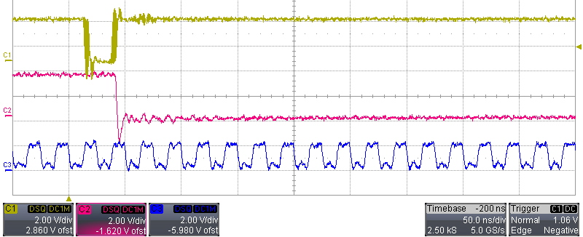
Rst_adc
start_adc
Ck_40M

- Wilkinson signal Zoom
Figure 11 shows that the ADC conversion only depends on RST_ADC, Start_ADC and 40Mhz clock. The first has to be low for one clock cycle (25 ns) and on its rising edge, Start_ADC goes low.
19.2µs=12bit*64channels*25ns
Data readout=40MHz
- Wilkinson ADC digital outputs

- Delay between start_adc and transmitON

Wilkinson calibration and pedestals measurements

With this ASIC we don’t have a dedicated input to calibrate the better reference and slope of the ramp. So we have to send a huge input charge to saturate the slow shaper and tune the ramp in order to have the highest data converted without to be at the over flow (means data equal 0). The saturation voltage of the slow shaper depends of the buffer capacitor and feedback capacitor settings.

The calibration has been performed with the highest shaping time: with Cbuf=3.75pF and Css=2.1pF and with 10 different charge inputs.
On the test board a 470kΩ resistor has been added at the pin 95 to change the slope of the ramp and to be able to convert the saturation voltage of the slow shaper. (V(pin 95=0.584V).

12 bits ramps
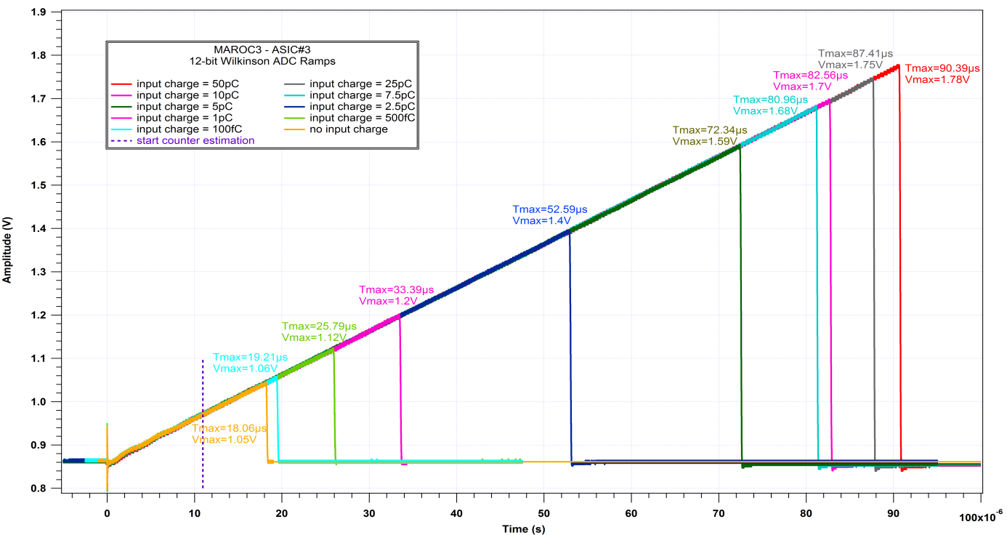
- Ramp waveform for 12-bit conversions
Input charge (pC) | Tmax (µs) | Vmax (V) | Data  (adc unit) | Rms  (adc unit) | Start_  Counter (µs) | Voltage at start counter (V) | LSB  (mV/adc unit) | slope  (mV/µs) | intercept  (V)
0 | 18.06 | 1.05 | 263 | 2 | 11.51 | 0.976 | 0.265 | 9.972 | 0.861
0.1 | 19.21 | 1.06 | 333.2 | 1.9 | 10.88 | 0.97 | 0.264 | 9.971 | 0.861
0.5 | 25.79 | 1.12 | 593.5 | 2.3 | 10.95 | 0.971 | 0.258 | 10.01 | 0.861
1 | 33.39 | 1.2 | 896.1 | 2.1 | 10.99 | 0.971 | 0.258 | 10.06 | 0.86
2.5 | 52.59 | 1.4 | 1674 | 2.2 | 10.75 | 0.969 | 0.255 | 10.08 | 0.86
5 | 72.34 | 1.59 | 2454 | 2 | 10.99 | 0.971 | 0.254 | 10.06 | 0.861
7.5 | 80.96 | 1.68 | 2803 | 2 | 10.88 | 0.97 | 0.254 | 10.09 | 0.86
10 | 82.56 | 1.7 | 2865 | 2.1 | 10.95 | 0.97 | 0.254 | 10.09 | 0.86
25 | 87.41 | 1.75 | 3063 | 1.8 | 10.83 | 0.969 | 0.254 | 10.09 | 0.859
50 | 90.39 | 1.78 | 3183 | 1.9 | 10.82 | 0.969 | 0.254 | 10.1 | 0.86
 |  | mean |  |  | 10.95 | 0.97 | 0.257 | 10.05 | 0.861
 |  | rms |  |  | 0.21 | 0.002 | 0.004 | 0.05 | 0.0007

Thanks to all ramp waveforms and the data converted the temporal position the start counter can be estimated at 10.95µs. The subtraction between the voltage max and the voltage at start counter divided by the data in time unit give us the value of the LSB.
In our case the LSB of the 12-bit ADC is 257µV.

Conversion formula:
Analog voltage [mV]=970[mV] +data*LSB[mV/adc]

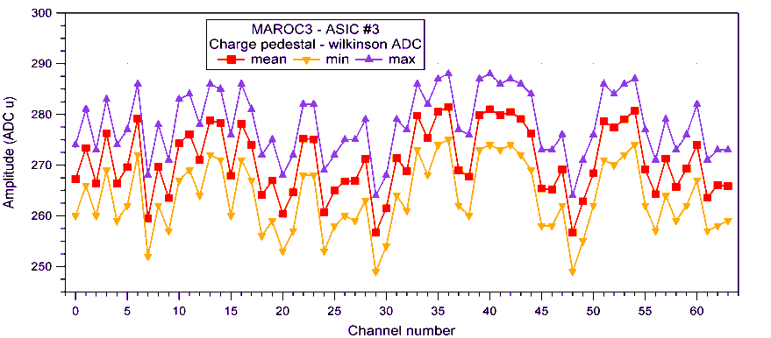
Pedestals 12-bit conversion
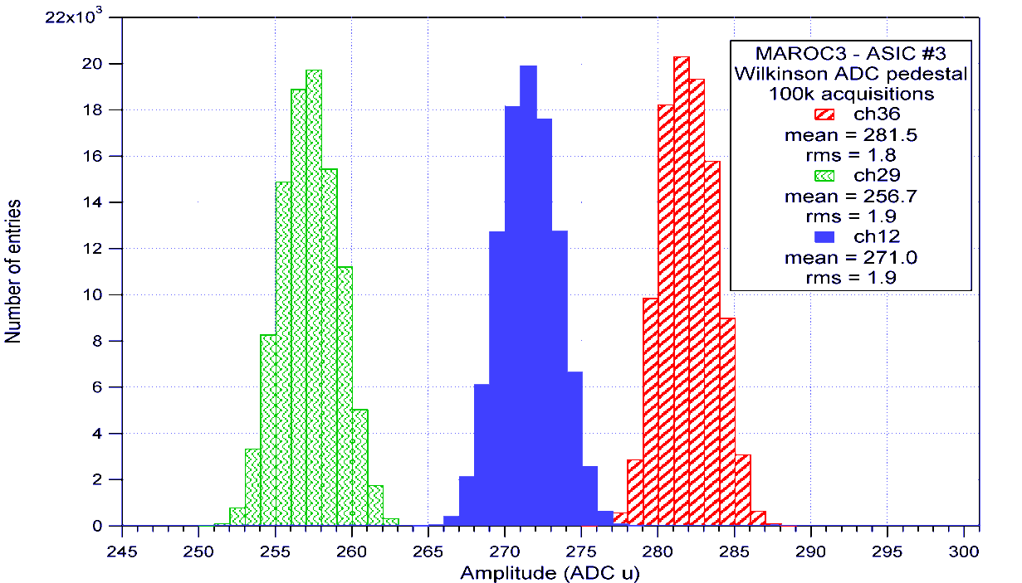
- Histogramme of 3 channel pedestals via the 12-bit Wilkinson ADC
- Mean and rms of charge pedestal via the ADC

The histogram rms corresponds of the noise of the slow shaper. In our case the slow shaper noise is 2 adc unit or about 514µV. The scope measurement gives about 580µV.

These graphs show a good uniformity for the pedestals and for the noise et the output of the slow shaper.
The mean of the charge pedestal id about 270 adc unit or 1.039V.

10 bits and 8 bits conversion
10 bits | Tmax (µs) | Vmax (V) | Data  (adc unit) | Rms  (adc unit)
0pC | 4.12 | 1.06 | 60.5 | 0.55
0.5pC | 6.11 | 1.15 | 143.4 | 0.56
1pC | 7.82 | 1.23 | 215.1 | 0.55
10pC | 19.12 | 1.75 | 662 | 0.52
50pC | 21.50 | 1.86 | 756.6 | 0.53
8 bits | Tmax (µs) | Vmax (V) | Data  (adc unit) | Rms  (adc unit)
0pC | 1.05 | 1.06 | 14 | 0
0.5pC | 1.54 | 1.16 | 33.5 | 0.5
1pC | 1.97 | 1.24 | 50.5 | 0.5
10pC | 4.64 | 1.76 | 157.6 | 0.48
50pC | 5.22 | 1.87 | 180 | 0.03
In our case the LSB of the 10-bit ADC is 1.24mV and the LSB of the 8-bit ADC is 5.13mV.

ADC conversion and readout Time

 | 12bits | 10bits | 8bits
conversion | 102µs | 25µs | 6µs
readout | 19.2µs | 16µs | 12.8µs
Total | 121.2µs | 41µs | 18.8µs
frequency | 8 kHz | 24kHz | 53kHz

Fast channel
To deliver the trigger information there are 3 variable fast shapers and two discriminators. Two fast shapers (one unipolar and another bipolar) followed by one discriminator are dedicated for the photon electron counting and one bipolar fast shaper with lower gain followed by its discriminator has been added to provide a trigger signal at higher input charge. The 2 discriminator outputs are multiplexed to provide only 64 trigger outputs. The thresholds are loaded by 2 internal 10-bit DACs common for the 64 channels.

DAC

Principle
The threshold of each discriminator is set by a 10 bit-DAC which is different that those integrated in MAROC1 or MAROC2. The 2 DACs are identical except that the reference current for DAC0 can be chosen using SC parameter (small dac) equal or half of the Iref. This is to allow finest tunings of the thresholds for small dynamic range charge inputs. Reference voltages are referred to an integrated band gap (v_bg=2.5V).

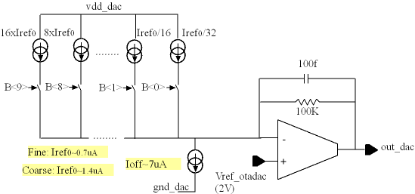
- DAC schematic

DAC measurements
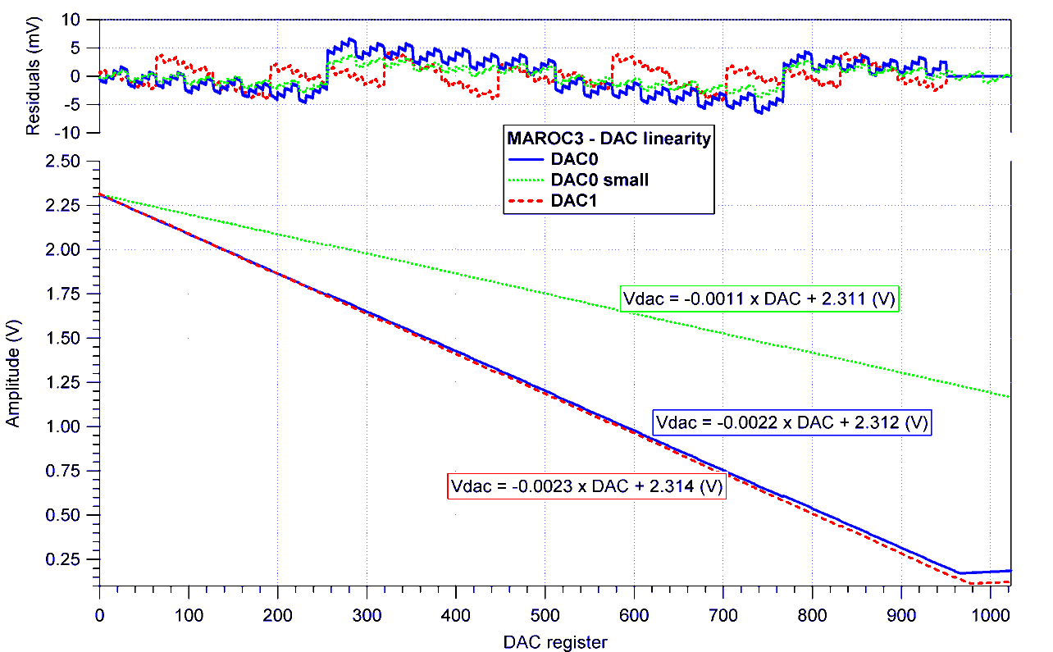
Linearity: ±0.2%

DC_FSB
DC_FSU
- DAC linearity : simulation and measurement

 | DAC0 | DAC0 small | DAC1
slope | 2.3mV/UDAC | 1.1mV/UDAC | 2.2mV/UDAC
DAC=0 | 2.3V | 2.3V | 2.3V

Variable Fast Shapers
There are 2 variable CRRC fast shapers. The network feedback of each amplifier can be changed independently thanks to the SC parameters. The peaking time is ≈ 20-25 ns.

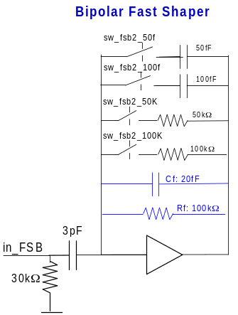 | 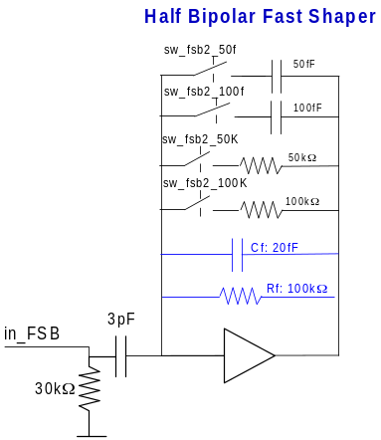 | 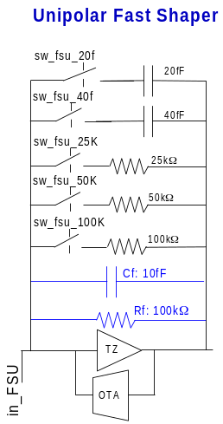
- Fast Shapers schematics

Fast Shaper Measurements

DC measurements
The DC levels, named also pedestals, of each fast shaper outputs for all channels are measured.
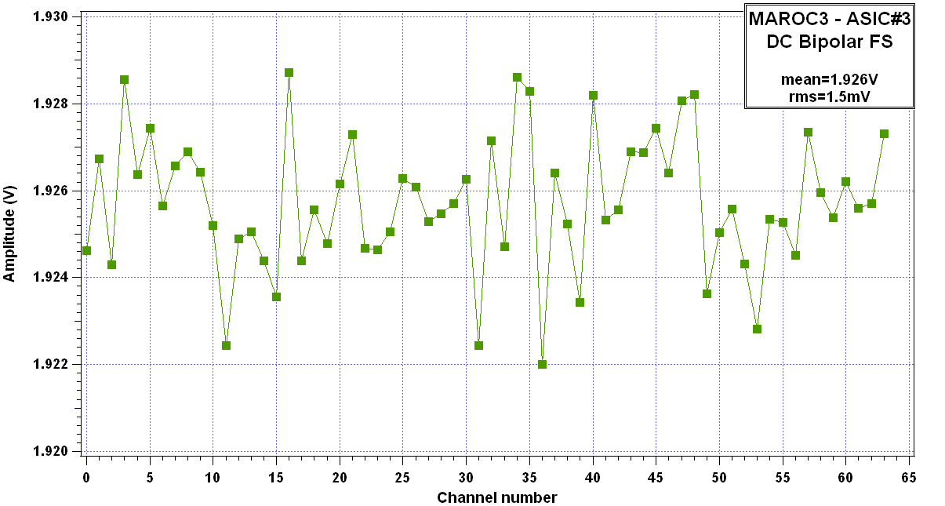
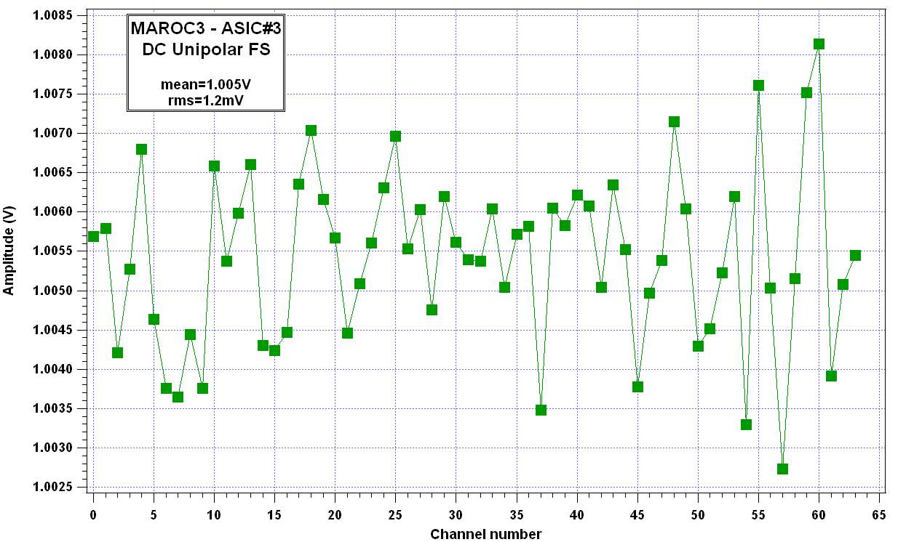

- Pedestal uniformity: Bipolar and Unipolar DC level vs channel number

 | Bipolar fast shaper n°1 | Bipolar fast shaper n°2 | Unipolar fast shaper
DC level | Mean=1.926V  Rms=1.5mV | Mean=1.926V  Rms=1.5mV | Mean=1.005V  Rms=1.2mV
Equivalent DAC value | 353 (small DAC) | 169 | 569

Trigger outputs

S-curve vs injected charge

Bipolar Fast Shaper
In order to characterize the FSB1, the Scurves versus injected charge has been performed at variable DAC values (Figure. 22 left). All scurves have been fitted and charges corresponding of 50%trigger efficiency have been extracted and plotted versus the threshold.

Slope inverse = 2.4V/pC
Intercept ~ 1.920V
- Left: Scurve vs Injected charge at different threshold, Right: 50%trigger efficiency versus threshold
The inverse slope is equivalent of the gain of the bipolar fast shaper: 2.4V/pC and the intercept is equivalent at the DC through the discriminator. This measure has been done for all channels to check the channel uniformity.
- Left: FSB1 gain for all channels , Right: intercept of the fit

Unipolar Fast Shaper
Same measurements have been performed with the unipolar fast shaper.
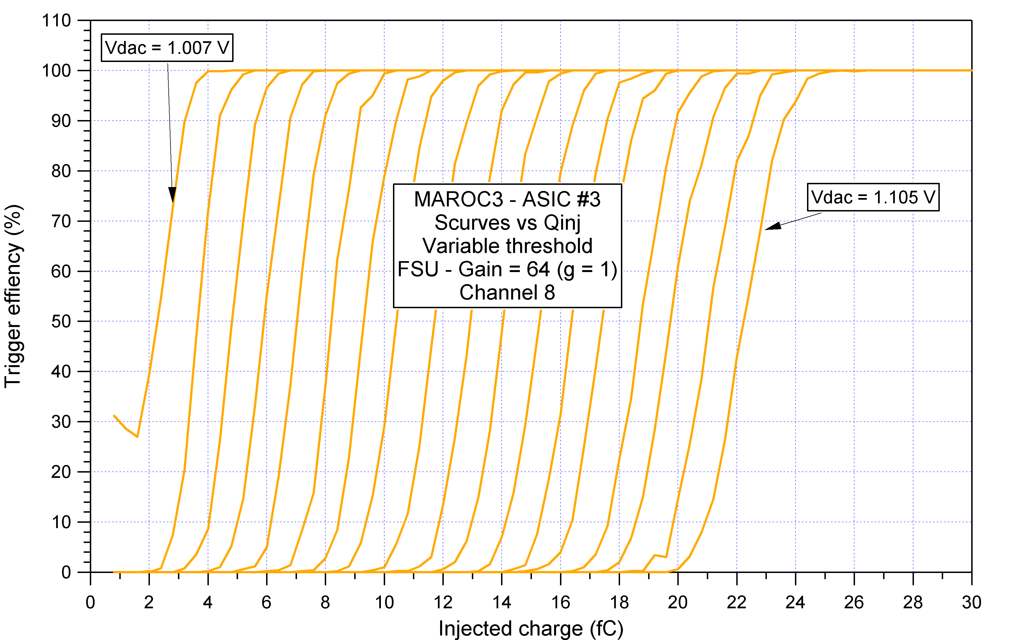
Slope inverse = 4.3V/pC
Intercept ~ 0.995V
- Left: Scurve vs injected charge at different threshold, Right: 50%trigger efficiency versus threshold

The inverse of the slope gives the Unipolar fast shaper gain: 4.4V/pC

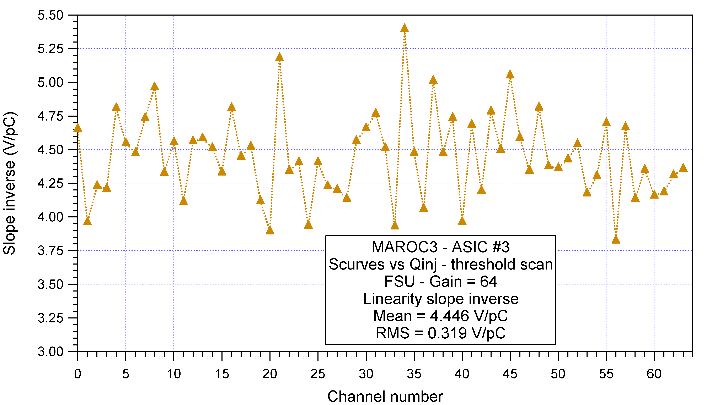
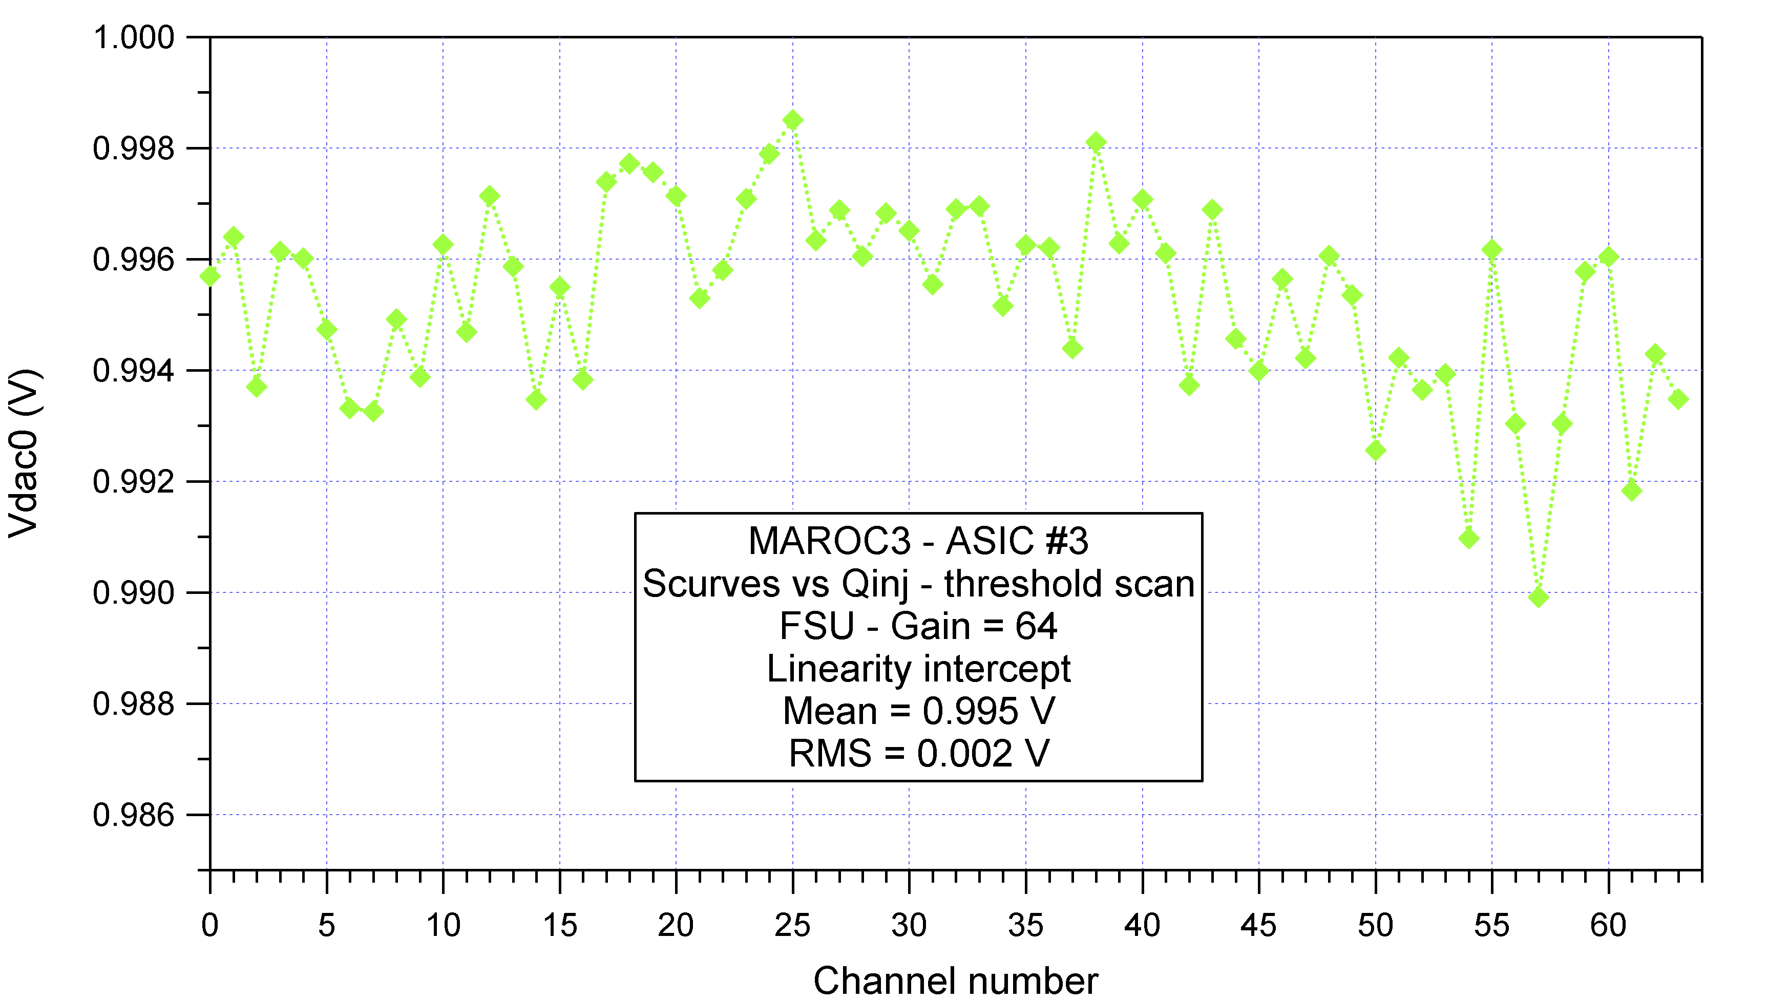

- Left: FSU gain for all channels , Right: intercept of the fit

Very good results in trigger measurements have been obtained. Thanks to the S-Curve tests with different injected charges, it has been demonstrated that the discriminator threshold can be set at lower than 1/3 of pe for the bipolar and the unipolar fast shaper.

S-curve vs injected charge at different feedback resistors settings

Bipolar Fast Shaper
The FS feedback resistor is made of one 100kΩ resistor and in parallel of two resistors (50kΩ and 100kΩ) can be added by slow control register. The feedback resistors chosen modify the fast shaper gain.

Rf settings | Equivalent resistor | Gain  (V/pC) | Minimum charge detected
0kΩ | 100kΩ | 2.32 | 4fC
100kΩ | 50kΩ | 1.89 | 7.5fC
50kΩ | 33kΩ | 1.56 | 10fC
150kΩ | 25kΩ | 1.32

Gain adjustement
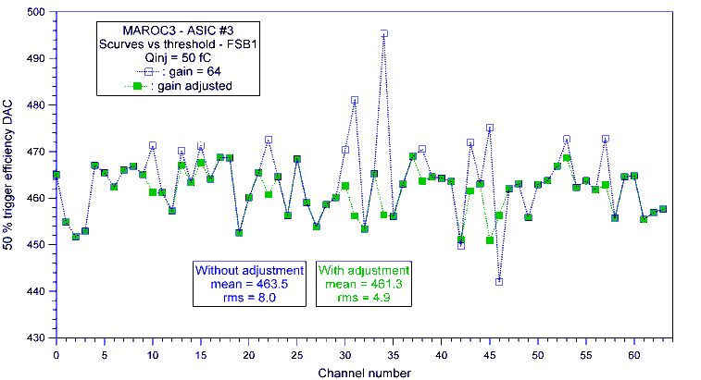

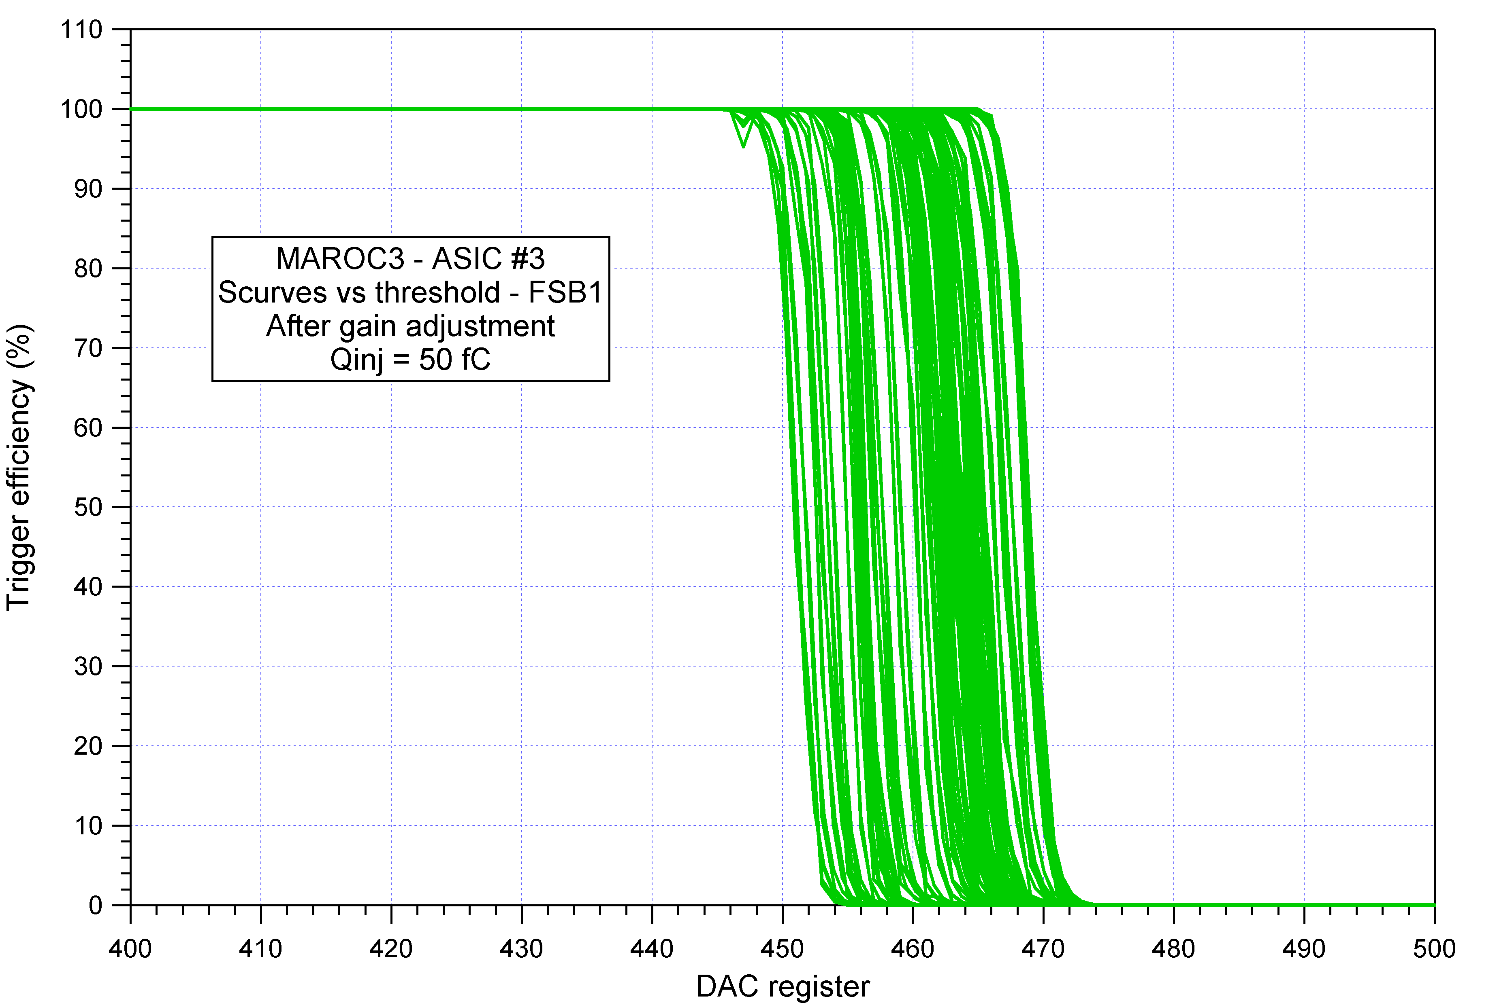
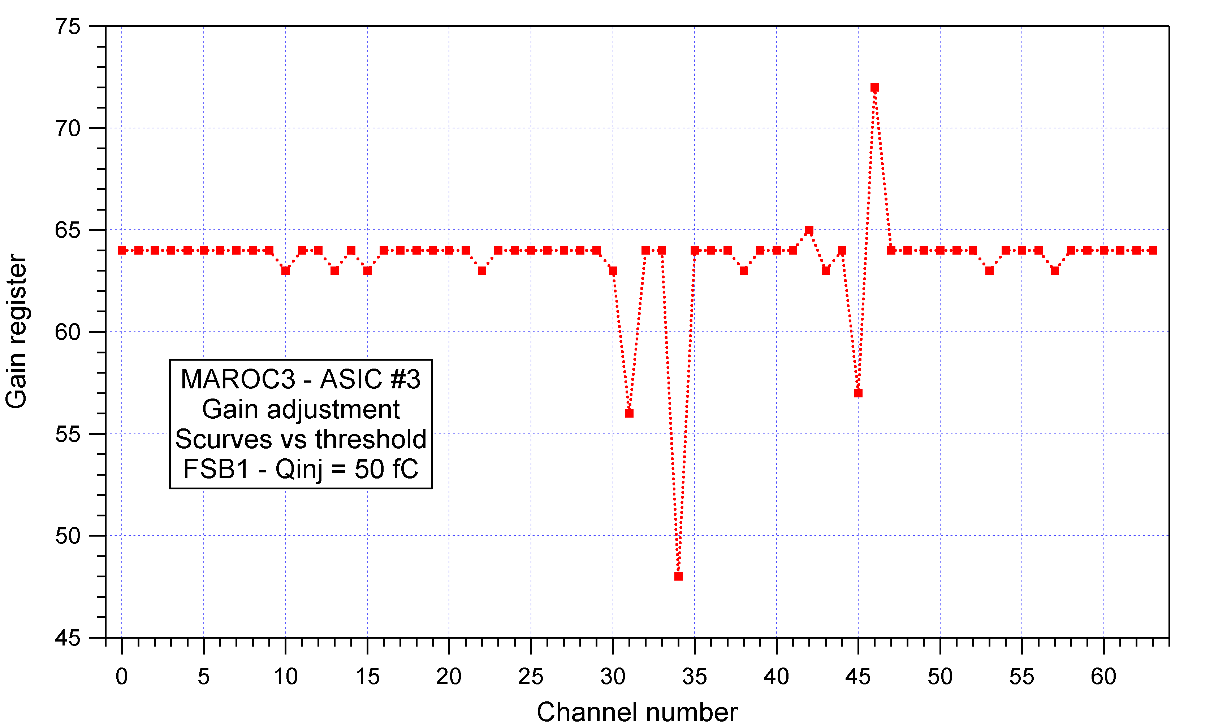

- Preamplifier gain adjustement for the bipolar fast shaper
The gain adjustement improve the trigger uniformity inside the asic.
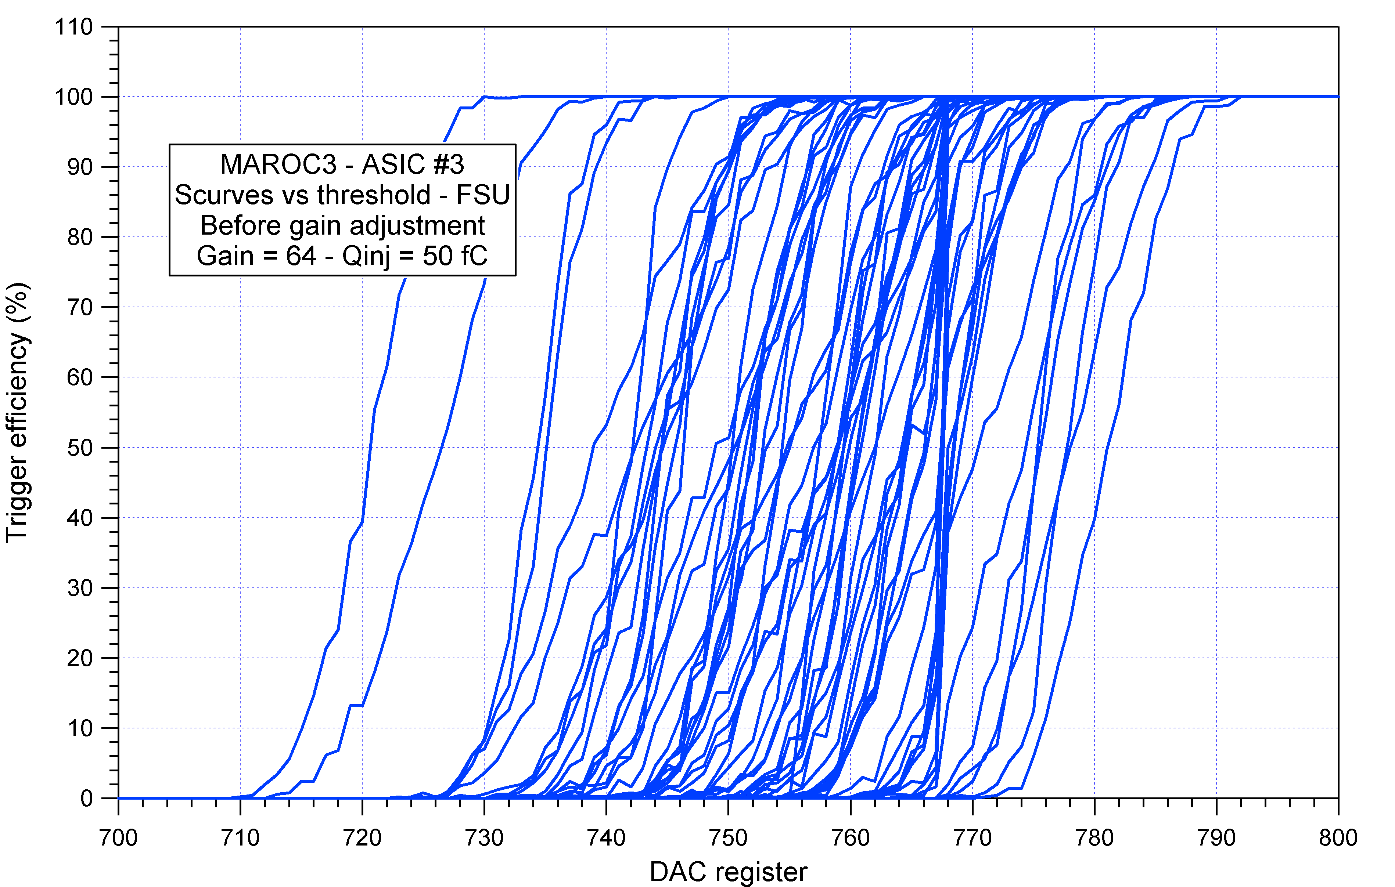
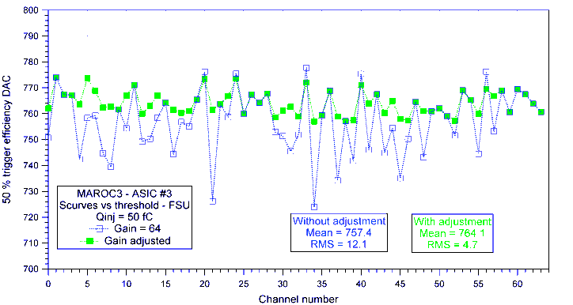

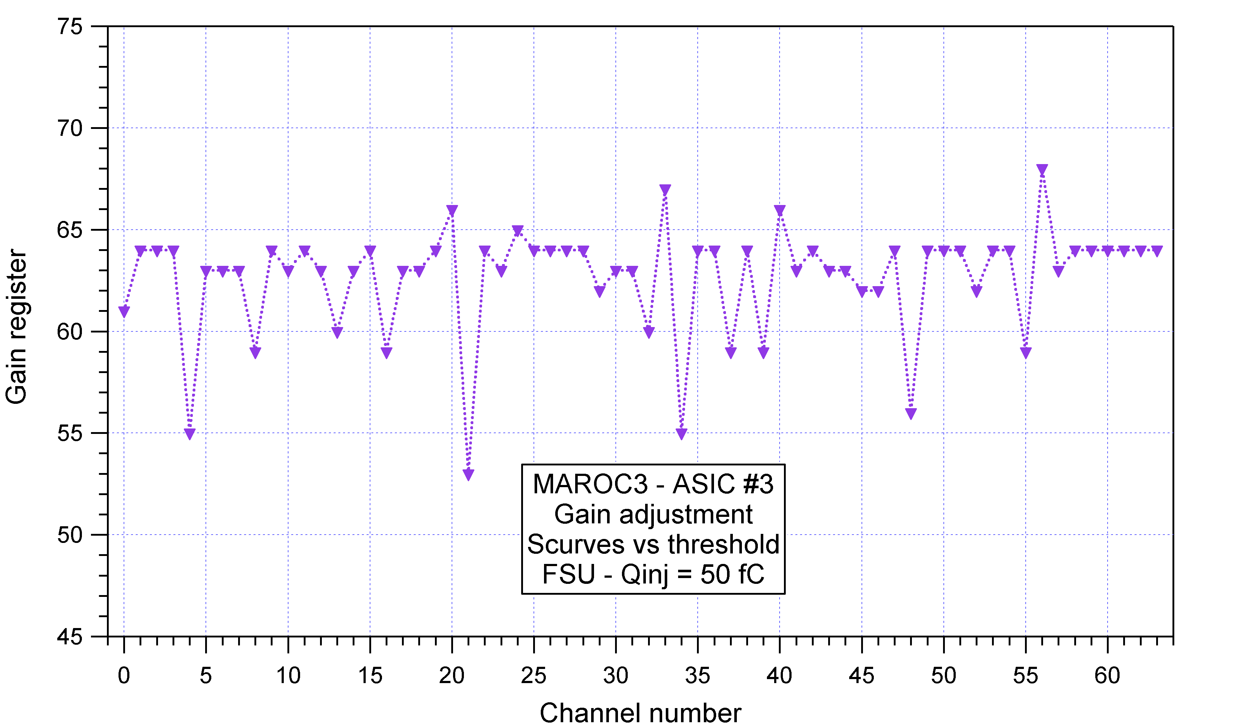
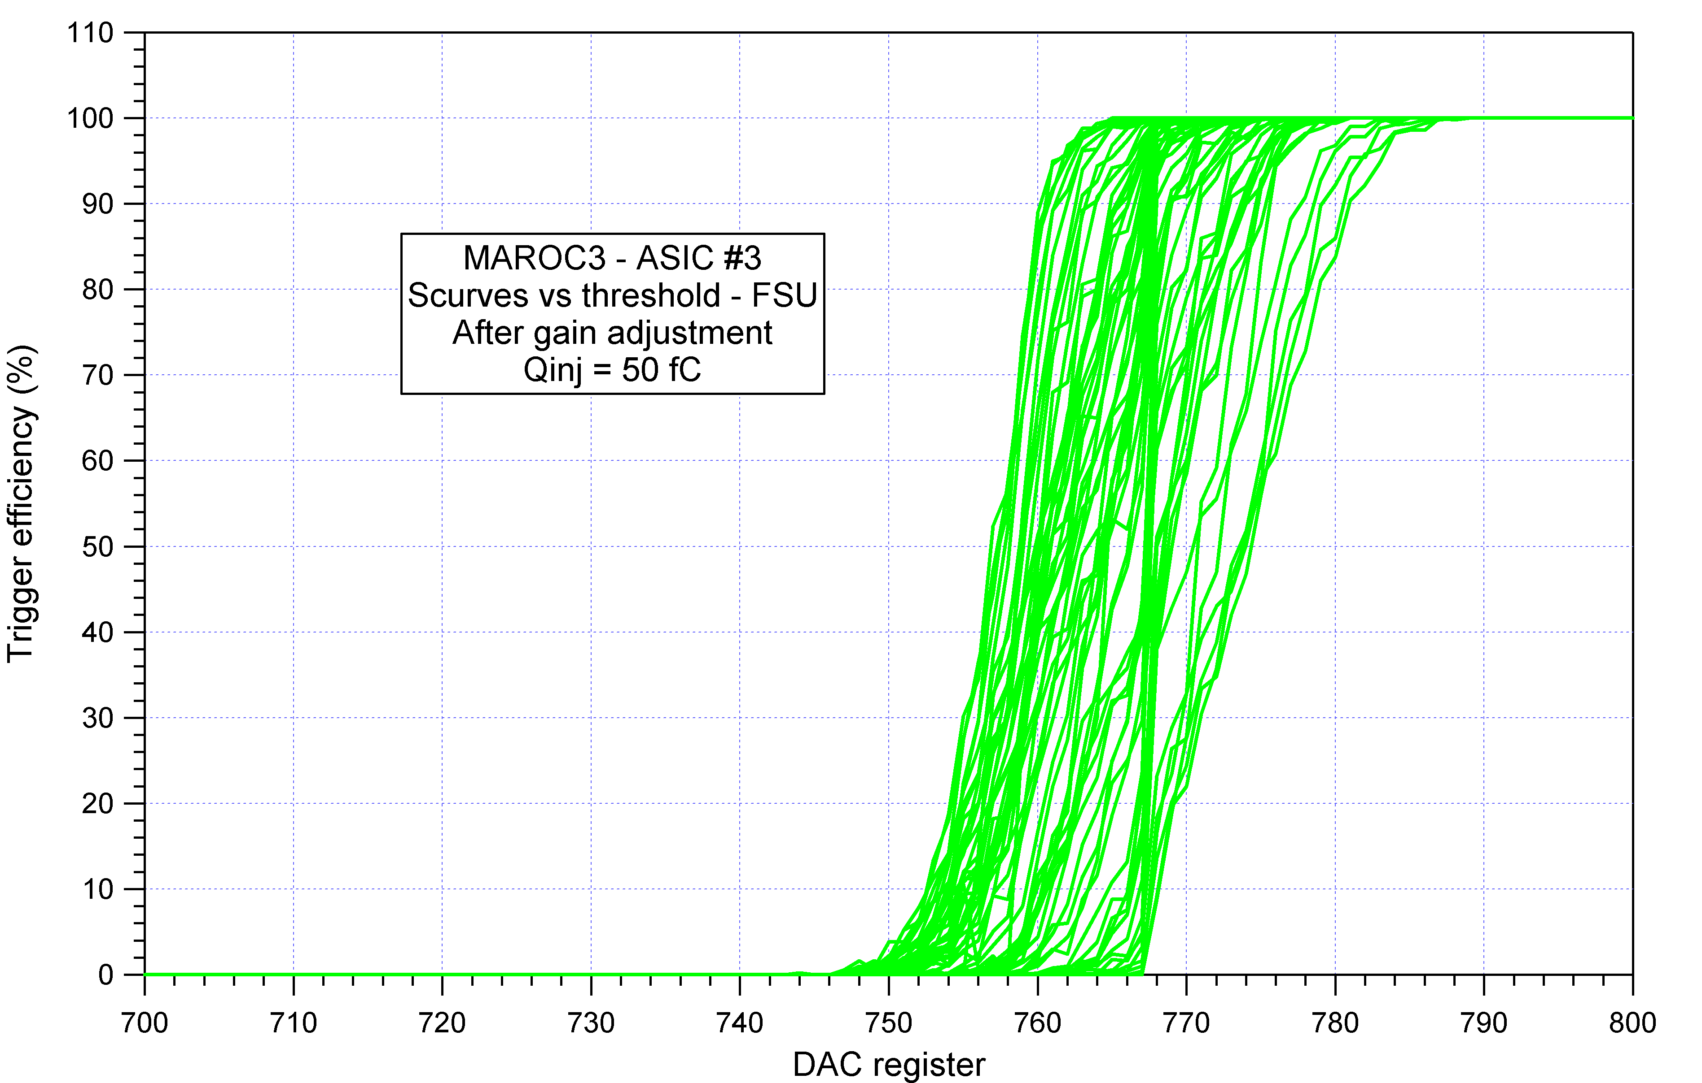

- Preamplifier gain adjustement for the unipolar fast shaper

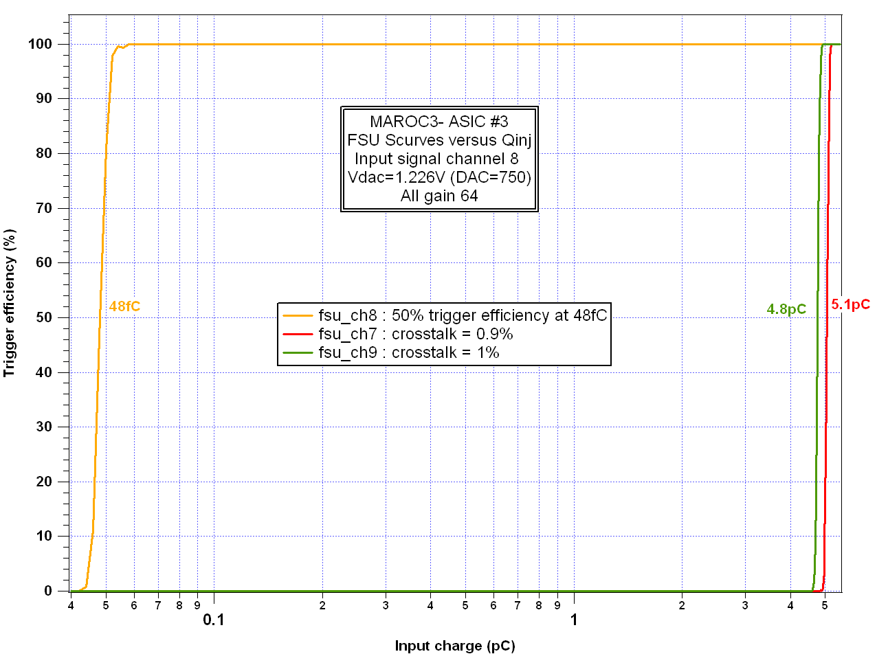
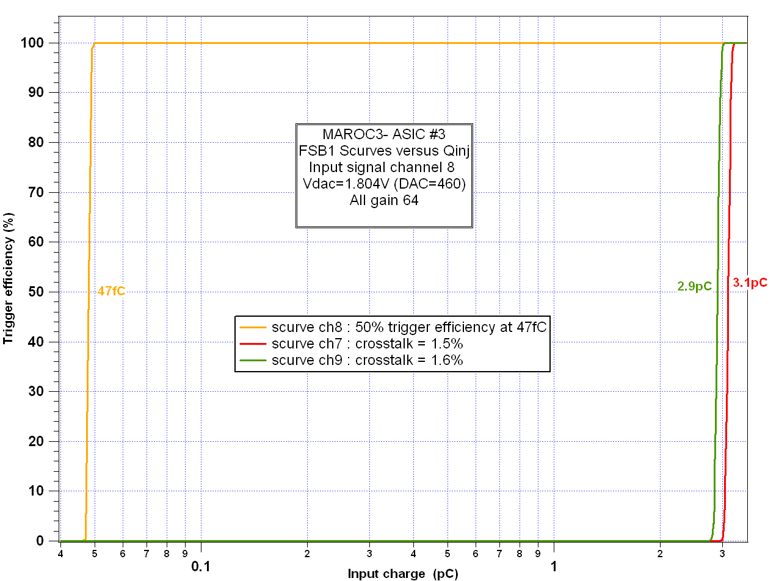
Cross talk

1.5%
3.1pC
ch7
1.6%
2.9pC
ch9
47fC
ch8
Cross talk
50% trigger efficiency
FSB
0.9%
5.1pC
ch7
1%
4.8pC
ch9
48fC
ch8
Cross talk
50% trigger efficiency
FSU

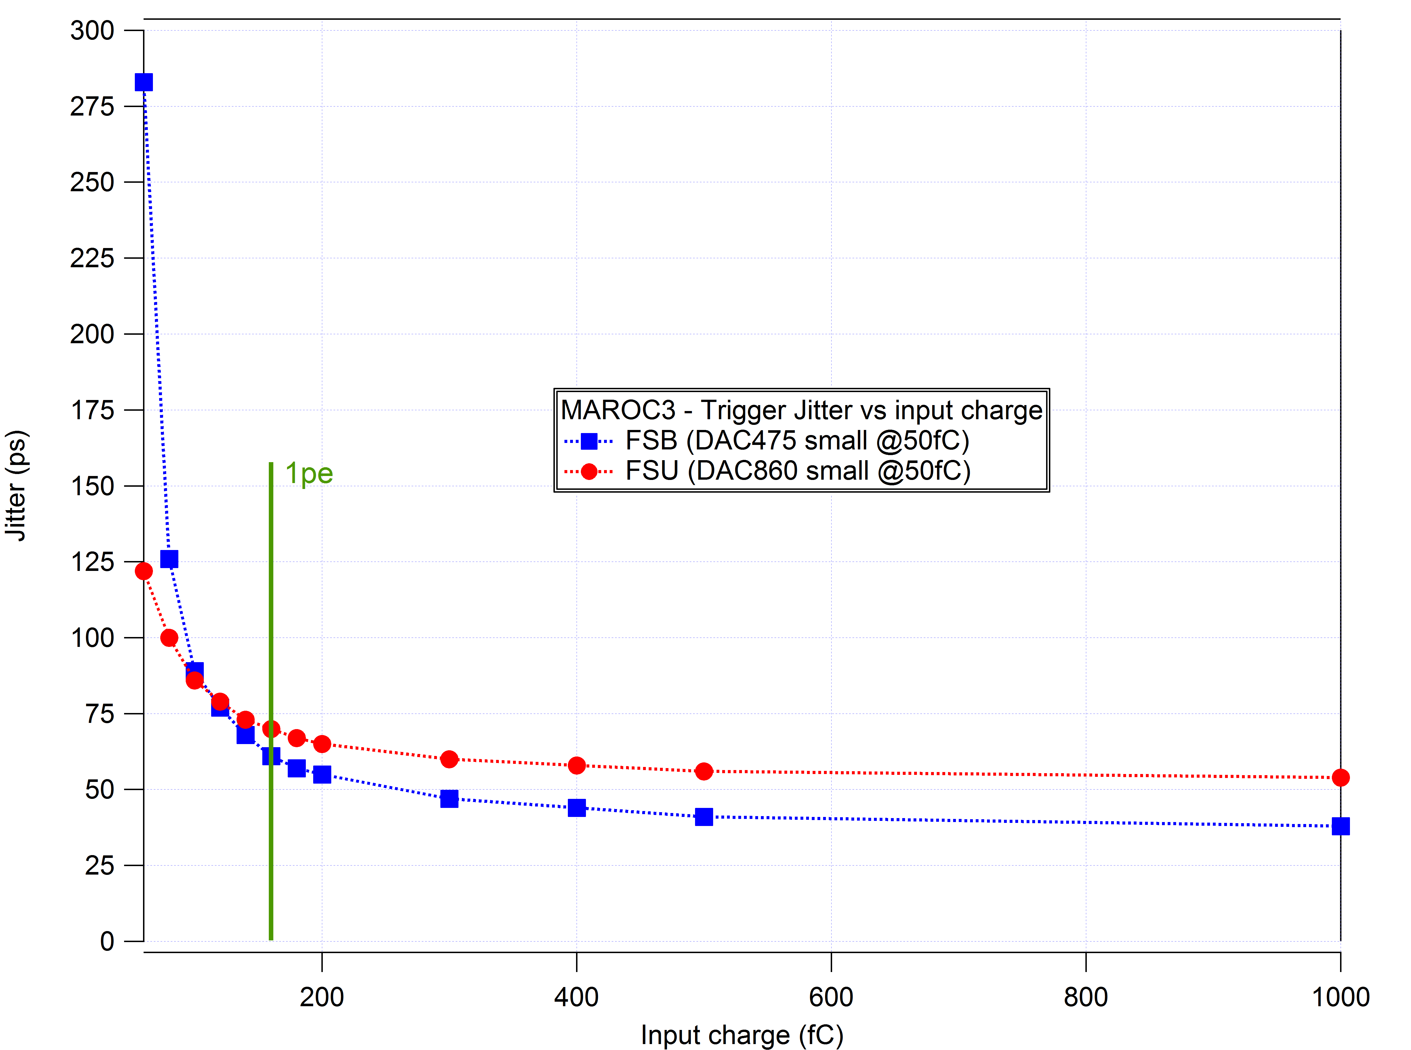
Jitter et Time walk measurements
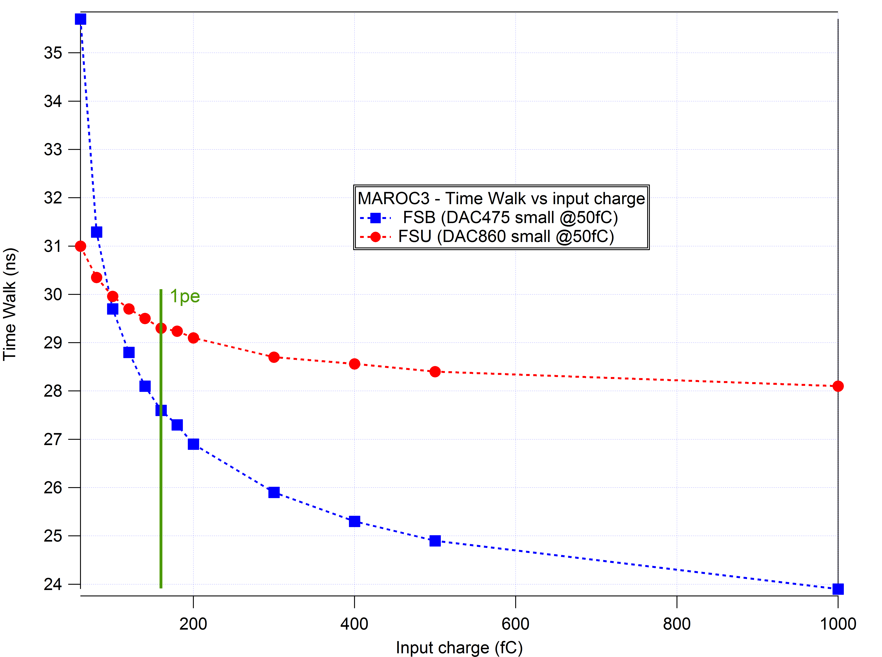

Result summary

 | MAROC3
 | consumption | 220mW ( ➔ 3.5mW/channel)
inputs | number | 64
inputs | polarity | negative
inputs | Input impedance | about 50-60 Ω
outputs | triggers | 64 triggers (Vhi=1.5V and Vlo=0V)
outputs | charge | 1 analog multiplex output  1 digital charge (12, 10 or 8 bits)
PA | Gain variable | 8 bits  (0 to ~4)
BFS | Gain | 4.5V/pC
BFS | Noise | 1.6mV
BFS | Min charge | 5fC
BFS | Jitter@160fC (for DAC@50fC) | 61ps
UFS | Gain | 2.3V/pC
UFS | Noise | 2.4mV
UFS | Min charge | 3fC
UFS | Jitter@160fC (for DAC@50fC) | 70ps
Slow shaper | Gain | 55mV/pC (gain64) – shaping=160ns
Slow shaper | Noise | 0.58mV

TEST BOARD

ASIC Registers

D_SC, CK_SC and RST_SC (Static Register)
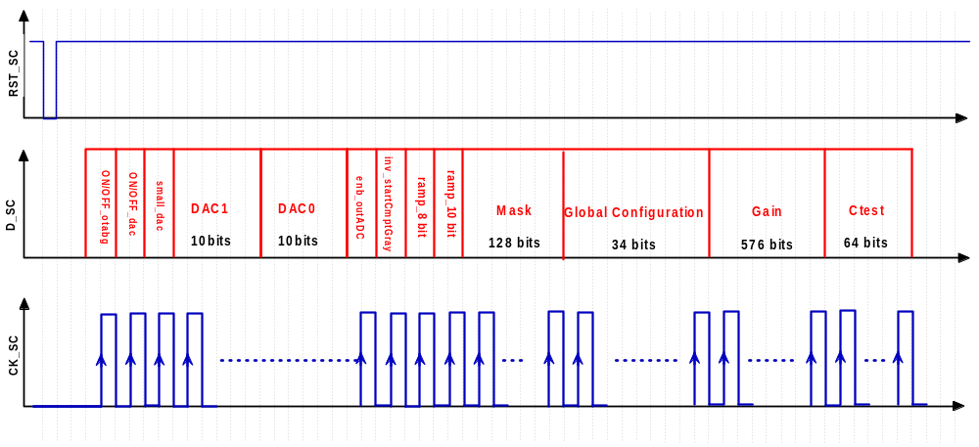
DACs bits

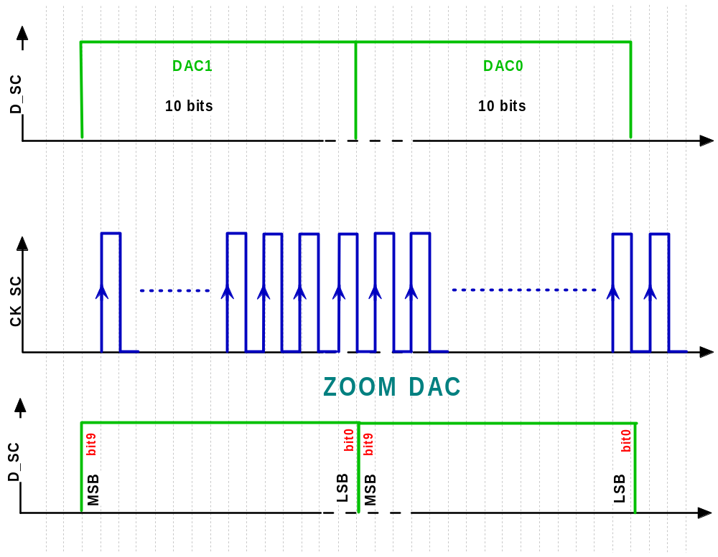

Mask bits

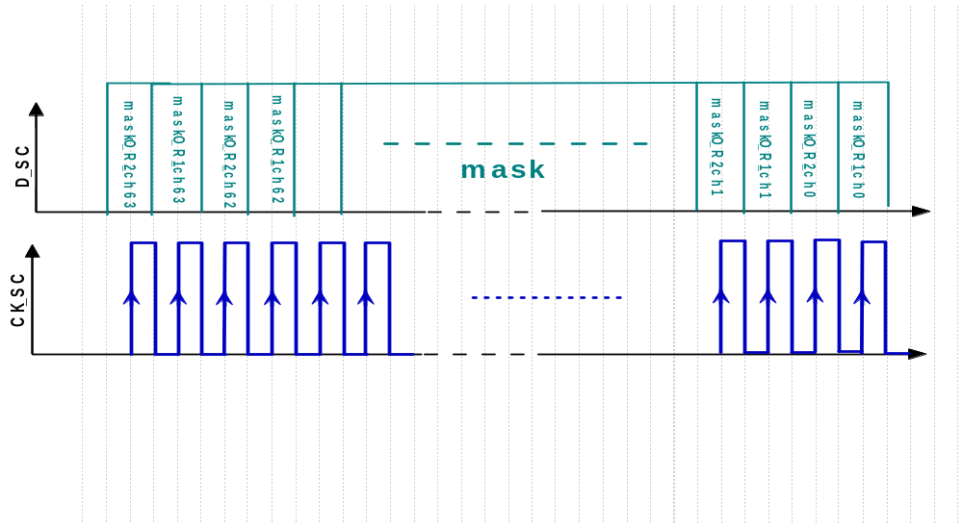

Global Config

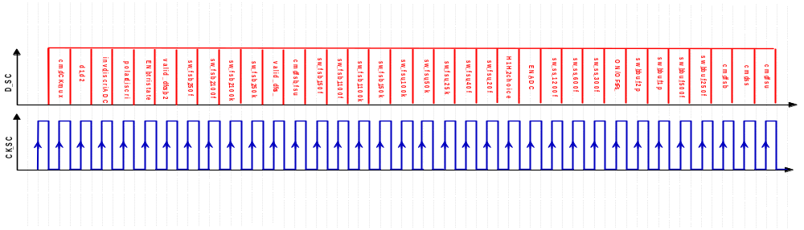
Gain, Sum and Ctest
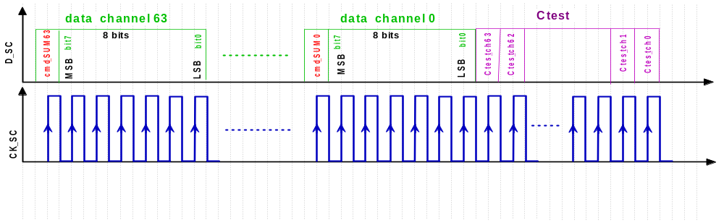

D_R, CK_R and RST_R* (Dynamic Register)

For multiplex charge output
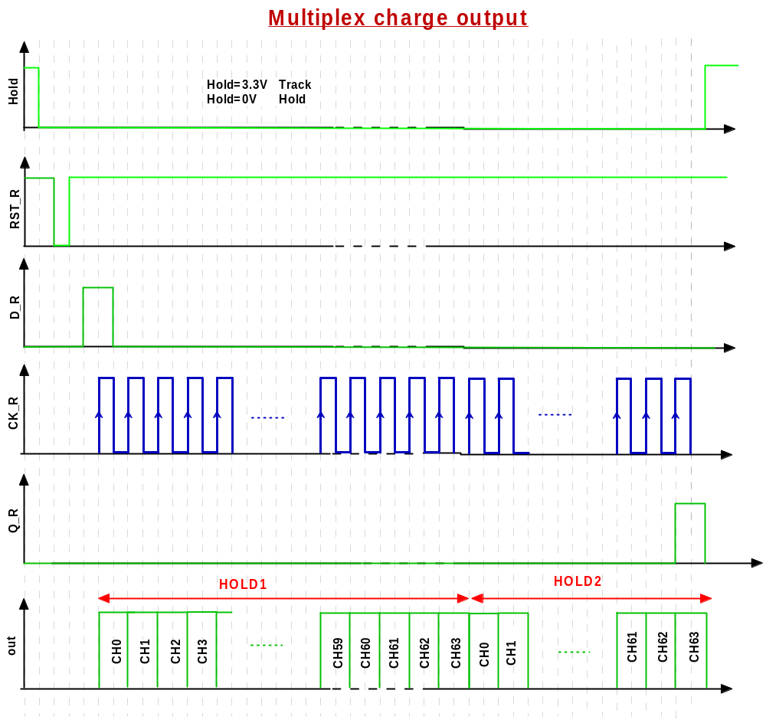

For DC_FS output (pin 201)

SC bits and name |  | description | observations
0 | ON/OFF_otabg | power pulsing bit for bandgap | not active on MAROC3 test board because power pulsing pin is connected to vdd
1 | ON/OFF_dac | power pulsing bit for all DACs | not active on MAROC3 test board because power pulsing pin is connected to vdd
2 | small_dac | to decrease the slope of DAC0 -> better accuracy | small dac OFF: threshold VTH0 min= and max= small dac ON: threshold VTH0 min= and max=
3 | DAC1[9] | DAC value for the second discri (with the fast shaper FSB2)
4 | DAC1[8] | DAC value for the second discri (with the fast shaper FSB2)
 | ,,, | DAC value for the second discri (with the fast shaper FSB2)
11 | DAC1[1] | DAC value for the second discri (with the fast shaper FSB2)
12 | DAC1[0] | DAC value for the second discri (with the fast shaper FSB2)
13 | DAC0[9] | DAC value for the first discri (with the fast shaper FSB1 or FSU)
14 | DAC0[8]
 | ,,,
21 | DAC0[1]
22 | DAC0[0]
23 | enb_outADC | wilkinson ADC parameter: enable data output | to use the wilkinson ADC should be OFF
24 | inv_startCmptGray | wilkinson ADC parameter: the start compteur polarity switching | to use the wilkinson ADC should be OFF
25 | ramp_8bit | wilkinson ADC parameter: ramp slope change to have quickly conversion on 8 bits
26 | ramp_10bit | wilkinson ADC parameter: ramp slope change to have quickly conversion on 10 bits
27 | mask _OR2_ch63 | mask the second discri output of ch63 (FSB2 to generate the trigger) | mask bit ON: no trigger output , mask bit OFF: trigger output visible
28 | mask_OR1_ch63 | mask the first discri output of ch63 (FSB1 or FSU to generate the trigger) | mask bit ON: no trigger output , mask bit OFF: trigger output visible
29 | mask _OR2_ch62 | mask the second discri output of ch62 (FSB2 to generate the trigger)
30 | mask_OR1_ch62 | mask the first discri output of ch62 (FSB1 or FSU to generate the trigger)
 | ,,,
151 | mask _OR2_ch1 | mask the second discri output of ch1 (FSB2 to generate the trigger)
152 | mask_OR1_ch1 | mask the first discri output of ch1 (FSB1 or FSU to generate the trigger)
153 | mask _OR2_ch0 | mask the second discri output of ch0 (FSB2 to generate the trigger)
154 | mask_OR1_ch0 | mask the first discri output of ch0 (FSB1 or FSU to generate the trigger)
155 | cmd_CK_mux |  | Should be OFF
156 | d1_d2 | trigger output choice | d1_d2='0' -> trigger from FSB1 and DAC0 ; d1_d2='1' -> trigger from FSB2 and DAC1
157 | inv_discriADC | ADC discri output could be inverted | Should be OFF
158 | polar_discri | polarity of trigger output | polar_discri='0' ->High polarity ; polar_discri='1' -> Low polarity
159 | Enb_tristate | enable all trigger outputs | Should be ON to see trigger outputs
160 | valid_dc_fsb2 | enable FSB2 DC measurements
161 | sw_fsb2_50f | Feedback capacitor for FSB2 | better if ON
162 | sw_fsb2_100f | Feedback resistor for FSB2
163 | sw_fsb2_100k | Feedback resistor for FSB2
164 | sw_fsb2_50k | Feedback resistor for FSB2
165 | valid_dc_fs | enable FSB and FSU DC measurements
166 | cmd_fsb_fsu | Choice between FSB1 or FSU for the first discri input (with DAC0) | cmd_fsb_fsu='1'-> FSU ; cmd_fsb_fsu='0'-> FSB
167 | sw_fsb1_50f | Feedback capacitor for FSB1 | better if ON
168 | sw_fsb1_100f | Feedback capacitor for FSB1 | better if ON
169 | sw_fsb1_100k | Feedback resistor for FSB1
170 | sw_fsb1_50k | Feedback resistor for FSB1
171 | sw_fsu_100k | Feedback resistor for FSU
172 | sw_fsu_50k | Feedback resistor for FSU
173 | sw_fsu_25k | Feedback resistor for FSU
174 | sw_fsu_40f | Feedback capacitor for FSU | better if ON
175 | sw_fsu_20f | Feedback capacitor for FSU | better if ON
176 | H1H2_choice | ADC wilkinson: choice between the first or the second track and hold for the input of the ADC
177 | EN_ADC | ADC wilkinson: enable ADC conversion inside the asic | Should be ON to make a conversion
178 | sw_ss_1200f | Feedback capacitor for Slow Shaper
179 | sw_ss_600f | Feedback capacitor for Slow Shaper
180 | sw_ss_300f | Feedback capacitor for Slow Shaper
181 | ON/OFF_ss | Power supply of Slow Shaper
182 | swb_buf_2p | capacitor for the buffer before the slow shaper
183 | swb_buf_1p | capacitor for the buffer before the slow shaper
184 | swb_buf_500f | capacitor for the buffer before the slow shaper
185 | swb_buf_250f | capacitor for the buffer before the slow shaper
186 | cmd_fsb | enable signal at the FSB inputs | Should be ON if we want to use FSB1 or FSB2
187 | cmd_ss | enable signal at the SS inputs | Should be ON if we want to do charge measurement
188 | cmd_fsu | enable signal at the FSU inputs | Should be ON if we want to use FSU
189 | cmd_SUM63 | enable signal to do sum
190 | GAIN63[7] | preamplifier gain value channel 63
191 | GAIN63[6] | preamplifier gain value channel 63
192 | GAIN63[5] | preamplifier gain value channel 63
193 | GAIN63[4] | preamplifier gain value channel 63
194 | GAIN63[3] | preamplifier gain value channel 63
195 | GAIN63[2] | preamplifier gain value channel 63
196 | GAIN63[1] | preamplifier gain value channel 63
197 | GAIN63[0] | preamplifier gain value channel 63
198 | cmd_SUM62 | enable signal to do sum
199 | GAIN62[7] | preamplifier gain value channel 63
200 | GAIN62[6] | preamplifier gain value channel 63
201 | GAIN62[5] | preamplifier gain value channel 63
202 | GAIN62[4] | preamplifier gain value channel 63
203 | GAIN62[3] | preamplifier gain value channel 63
204 | GAIN62[2] | preamplifier gain value channel 63
205 | GAIN62[1] | preamplifier gain value channel 63
206 | GAIN62[0] | preamplifier gain value channel 63
 | ,,,
759 | GAIN0[5] | preamplifier gain value channel 0
760 | GAIN0[4] | preamplifier gain value channel 0
761 | GAIN0[3] | preamplifier gain value channel 0
762 | GAIN0[2] | preamplifier gain value channel 0
763 | GAIN0[1] | preamplifier gain value channel 0
764 | GAIN0[0] | preamplifier gain value channel 0
765 | Ctest_ch63 | enable signal in Ctest input
766 | Ctest_ch62 | enable signal in Ctest input
767 | Ctest_ch61 | enable signal in Ctest input
 | ,,, | enable signal in Ctest input
826 | Ctest_ch2 | enable signal in Ctest input
827 | Ctest_ch1 | enable signal in Ctest input
828 | Ctest_ch0 | enable signal in Ctest input

