Bristol City Council Heat Pump Strategic Review:
Project Scope

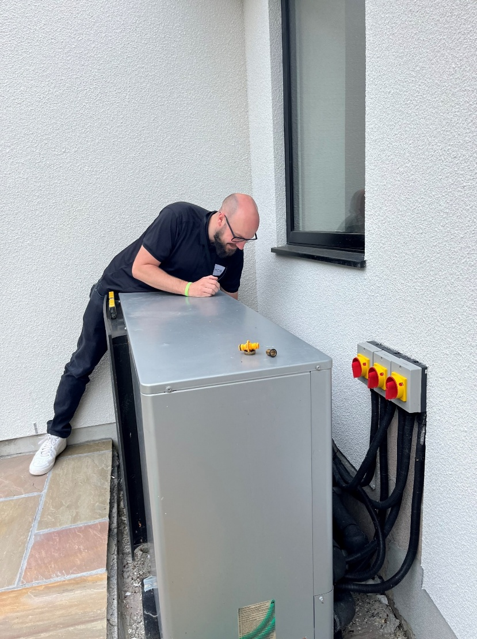

Background 4
Complementary projects 4
Approach to review 5
Stages of each cycle review: 5
Focus areas for cycles: 6
Overall scope of review 7
Areas of focus 8
Prioritisation approach 8
Summary of focus areas actions, outputs and outcomes 10
Procurement 10
Planning Permission 10
Specifications/ Employer requirements (including technology choices) 11
Installation 12
Handover 13
Quality assurance/ monitoring 13
Data Management Systems/ Existing stock review 14
Training/ Learning 15
Service and maintenance arrangements 16
Technology options 16
Non-Domestic 18
Stakeholder engagement 19
Timeline 19
Project sponsors 20
Task Group 20
Next steps 20

Background
The review is being coordinated by the Bristol City Council (BCC) Climate Change Team in collaboration with multiple areas of the council and partners. The review project was supported and resource agreed at the November 2025 HSLT meeting to proceed with a two-part approach to delivering the work.
- Creation of a project plan covering scope of work, timescales etc
- Delivery of strategic review with associated action plans and recommendations
This document outlines what should be included in the project plan by considering which aspects of our work are most essential to review. A full project plan would be required at the project initiation stage based on feedback from key stakeholders.
The review was identified as essential given the findings from audits of heat pumps installations highlighting that more work is required to ensure better outcomes from these.

Complementary projects
It is worth noting that there are several projects around heat pumps currently ongoing that will directly support the delivery of the strategic review.
Nesta Heat Pump Audits/ Fixes
- Auditing more social housing heat pump installs (39 complete to date)
- Learning and recording process
- Undertaking fixes to understand costs and impacts
Optiheat Phase 3 (Partners: University of Bristol, Vaillant, Havenwise, Carbon Trust)
- Trialling and setting up methodology for remote monitoring and support for heat pumps
- Updating resources and materials for heat pump delivery including specification
- Sharing learning with other social housing providers nationally
Heat Pump Learning Project (Partners: Green Register, Warmur Training Academy)
- Designing and delivering a non-technical heat pump learning programme (delivered autumn 2025)
- Technical training for BCC heating engineers and delivery partners
- Shaping next phase of training and potential to roll out further
- Investigating potential for ‘start at home’ training/ free heat pump for staff with Nesta
Collaborating better with local retrofit businesses to support their growth, diversification and access to resources
- Understanding how to better support local businesses including those in the heat pump space better engage with tender opportunities

Approach to review
To achieve the greatest impact the review will need to follow stages from definition through to deployment. It is suggested that there is a prioritisation of the focus areas. This will be followed by a staged review process. This document represents the definition phase.

Stages of each cycle review:
1. Define
2. Discover
4. Design
5. Deploy

Discover: Gathering data and defining what the future needs to look like
Design: Designing the change strategy by assessing the impact
Deploy: Engaging stakeholders to test and deploy solutions for BAU

Focus areas for cycles:
To keep the review achievable, it is recommended that once the priority areas are chosen, each one is looked at separately while still keeping in mind how they connect to each other.
This could operate on 6 week sprint cycles or a timescale proportionate to the scale of the review area. Critical to this approach would be to identify and implement quick wins to deploy immediately alongside medium and longer term recommended actions.
Focus area cycles
(order illustrative only)

Handover,
Data management

Non-Domestic, Procurement

Technology options, Specifications

Quality Assurance, Planning

ETC
Week 6 12 18 24

Overall scope of review
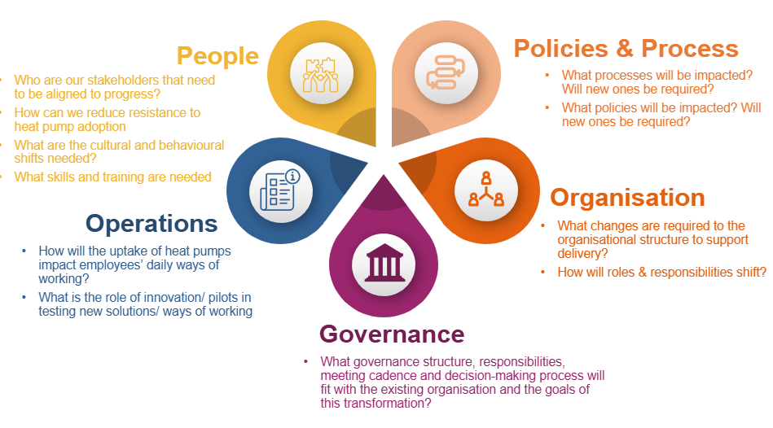

Areas of focus
Below are listed a range of focus areas the review could take. These will need to be prioritised and resourced within this project budget accordingly.
Focus Area installation journey: | Relevant housing type (scope TBC) and current status re work to date  (Red: no work undertaken or not recently updated/reviewed, Amber: work underway/ refresher may be required, Green: Complete and/or substantive work commenced) |  |  |  |  | Priority  TBC
 | New build | Social Retrofit | Non Domestic | Re-fits | Local Grant retrofit
Procurement | x | x | x | x | x
Planning department | x | x | x |  | x
Specifications/ Employer requirements | x | x | x | x | x
Installation | NA | NA | NA | x | NA
Handover | x | x | x | x | x
Quality assurance/ monitoring | x | x | x | x | x
Service and maintenance arrangements | x | x | x | x | x
Other
Technology options | x | x | x | x | x
Data Management Systems/ Existing stock review | x | x | x | x | x
Training/ learning | x | x | x | x | x
Non-domestic | x | x | x | x | x

Prioritisation approach
A prioritisation approach will be agreed with the project task group and ultimately by the project sponsors. Variables that could be factored in to the prioritisation matrix include:
- Urgency
- Risk to business
- Impact
- Capacity of consultees to support and implement
- Quick wins

Summary of focus areas actions, outputs and outcomes

Procurement
Procurement practices across programmes requires review. Audits have shown widespread poor quality installations therefore procurement practices are a first step to a good heat pump journey. We know that there are many barriers to engagement in procurement for particularly small businesses. We also know that some of the highest quality work is being done by smaller operations.
Procurement Review  Actions: | Outputs | Outcomes
- Work with Darren Perkins to support delivery of the business engagement project | Updated tender specification | Improved tender specification
- Assess current tender specification for heat pump re-fits, BCL delivery and non-domestic installers and recommend changes to encourage high quality installers | Support sessions to businesses (delivered through partner project) | Higher quality installations

Planning Permission
For heat pumps installed outside of our own social housing or grant programme, the planning process might be our only wider point of contact with installations. Nonetheless this is still an important area if we are to be able to influence wider city uptake of low carbon heating.
Planning review  Actions: | Outputs | Outcomes
- Workshop with planning officers to establish current practice and good practice from elsewhere | Collate relevant documents. | Increased knowledge of heat pumps amongst planning team
- Recommendations of where the planning process can influence the quality of outcomes for heat pump installs (sustainability statements, noise, heritage, discharge process) | Recommendation report/ presentation to planning team | Improved planning processes around heat pumps

Specifications/ Employer requirements (including technology choices)
Specifications are critical to ensuring a successful heat pump installation. BCC currently has a ASHP specification designed by the Climate Change Team but more work is required in this area.
Specifications/ Employer requirements  Actions: | Outputs | Outcomes
- Review specification for non-domestic installations | Recommendations for non-domestic specification | Improved specification for non-domestic installs
- Review employer requirements on new builds | Recommendations for new build employer requirements | Improved employer requirements
- Review specifications for GSHP/ other heat pump technologies. Consult and create where necessary | Specification creation for GSHP/ air to air heat pumps | New ASHP/ air to air heat pump specifications

Installation
It is understood that all heat pump installations are done by contractors at present. However given the likely numbers to be installed in social housing it is recommended that consideration should take place of upskilling our existing workforce to do this. In particular for older heat pump installations approaching end of life that may just need refitting with newer models could present an opportunity to do this is a more cost effective manner. Other areas of installation processes should be covered within the specification/ employer requirements elements of the review.

Installation  Actions: | Outputs | Outcomes
- Review extent to which BCC might undertake any installations ourselves | Skills map of current heating team to install | Understand possibility for long term cost savings on refitting old heat pumps

Handover
Resident handover is a critical step in ensuring a good experience of heat pumps for residents. There is currently a lack of any standardised handover and one doesn’t exist for re-tenanted properties of older heat pump systems.
Handover  Actions: | Outputs | Outcomes
- Collate and review existing handover documents | Folder with existing handovers collated | Better understanding of current handover practices
- Work with Nesta/ CSE and other relevant parties to create a new standard handover for ASHP/ GSHP | New handover created | Better handover process for tenants

Quality assurance/ monitoring
Given challenges of finding competent installers, quality assurance at each stage of a heat pump journey is vital. Below is an example of quality assurance processes that needs to be replicated for other delivery avenues.
Figure X: Stages of a heat pump journey example (Warms Homes grant delivery).
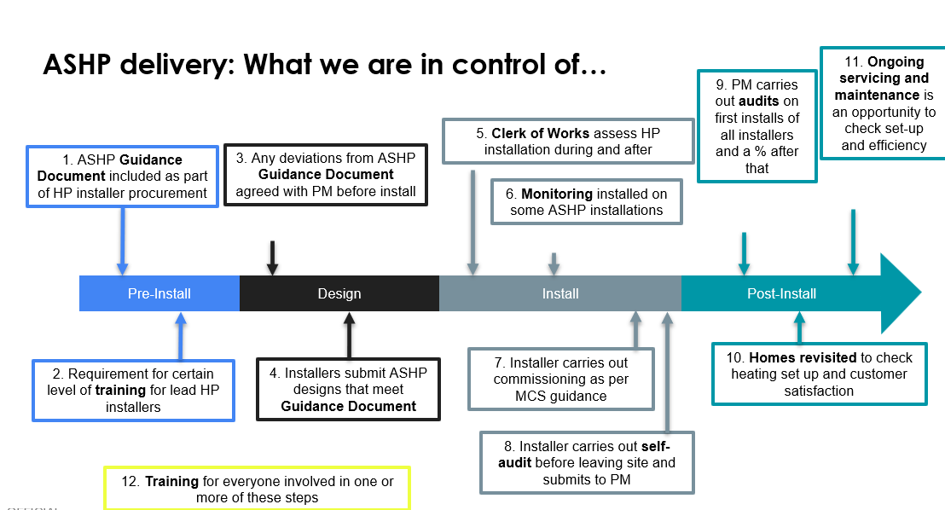

Quality Assurance  Actions: | Outputs | Outcomes
- Deliver a remote assistance trial at Romney Avenue | Method statement around remote assistance | BCC better able to manage assets and customers receive better service
- Learn from trial to update heat pump specifications | Updated specification document | Specification includes a position and method around r
- Map the quality assurance journeys for non-domestic, new build and refits | Quality assurance process maps | Enhanced quality assurance processes across installations
- Review options for tools to enhance quality assurance e.g. heat pump design tools (Spruce, Carno etc) | Recommendations for use of new tools | Better tools to help manage heat pump journeys

Data Management Systems/ Existing stock review
How we store information around heat pump installations is vital to enable
- Effective servicing schedules
- Timely issue resolution e.g. spare parts
- Oversight of warranty arrangements
- Capturing of commissioning settings
- Strategic financial planning
The review will assess data management systems and provide recommendations going forward.

Data management systems  Actions: | Outputs | Outcomes
- Assess data management systems across social housing heat pump stock and non-domestic buildings | Collation of what is held where. | Better understanding of data management systems and gaps to be plugged
- Assess existing stock data including warranty arrangements, likelihood of needing audit, | Recommendation document highlight properties to be audited/ assessed | Financial savings from data and audit leading to capturing faults before warranty periods expire.
- Review existing replacement cost estimates for existing stock | Costs of replacement units updated | More accurate data on replacement costs
- Review existing data on costs per install by house typology | Cost data for installs collated | Better understanding of current installation costs

Training/ Learning
For BCC and delivery partners it is essential that we are ‘intelligent clients’ of delivering heat pump projects. Both for non-technical and technical maintenance staff knowing what ‘good’ looks like in imperative to quality delivery.
There has been positive progress in this area with one round of training delivered however there are several areas of development still required.
Training/ Learning  Actions: | Outputs | Outcomes
- Deliver second round of heat pump training (subject to funding) for non-technical staff | Non-technical staff training course | Non-technical staff trained in delivering heat pump projects
- Support delivery of technical training with Warmur academy for heat maintenance team. | Training delivered | Technical teams better equipped to undertake their roles.
- Assess potential for technical teams to undertake heat pump design review quality assurance across all social housing projects. | Decision on role of heat maintenance team in wider QA role | Enhanced quality assurance processes.

Service and maintenance arrangements
Heat pumps are required to be serviced annually to keep their warranties and also to ensure effective operation. It is understood that the servicing regime may require assessment to understand what is done as part of normal servicing and what would be required to ensure warranties are valid and heat pumps work well. It is also possible that this would provide an excellent opportunity to reaffirm any handovers or do basic remedial work like re-do lagging.

Service/ maintenance arrangements  Actions: | Outputs | Outcomes
- Review service schedule and content | Comparison of actual vs needed maintenance | Equipment lasts longer and works better for tenants
- Review potential for low time high impact additional works to take place during service | Additional works list and timings | Heat pumps last longer and perform better

Technology options
Bristol City Council has a heat hierarchy which places heat pumps as second option. However, within this there is not a position on ASHP vs GSHP vs Air to Air heat pumps or other options. This requires a review and a position statement,
Technology options  Actions: | Outputs | Outcomes
- Review process for deciding on technology type in new build and retrofit including heat pumps, hot water delivery options and distribution systems | Summary of current methodology | Better understanding of current decision making approach
- Convene a workshop to discuss and decide a process for selecting technology tyres | Hierarchy of technology type options | Decision made around hierarchy of technology options

Non-Domestic
Work is required to understand the flow journey for non-domestic heat pumps. This area in general is one that has not had any scrutiny surrounding processes and outcomes to date. However, there is a pipeline of forthcoming planned installations that would benefit from a process review. A review in this area would…

Non-domestic  Actions: | Outputs | Outcomes
- Review of installs to date and asset management around these. Potentially including arrangement of audits. | Quantification of installs on our estate and key information | Better understanding of assets
- Support non-domestic team to implement QA processes on new builds | QA processes applied to newest installs | QA processes enhanced for new installations

Stakeholder engagement
The proposed approach to deliver the review will be to undertake the review in stages by focus area. It may be that there is an overlap between these and of course there are several interdependencies. The order of review will be decided in a first working group containing representatives from each of those areas to ensure this aligns with urgency and capacity of staff to engage with the process. It is suggested that New Builds and Non-domestic might be an urgent area of initial focus.
Approaches to the review will include:
- Setting up task group: key representatives from relevant departments to steer the project and priorities
- Data collection: gathering data/ gaining access from management systems or otherwise
- Interviews: 1:1 or group interviews with relevant colleagues
- Existing processes: gather and review existing process documents
- Shadowing: it may be beneficial to shadow colleagues to understand processes e.g. service visit
- Heat Pump Working Group: source of regular contact with departments and also discussion

Timeline
The strategic review process does not sit in isolation and for many of the focus areas identified there is already ongoing work.

Project sponsors
Martyn Pursey and Craig Cook are the primary project sponsors. Monthly review meetings will be scheduled to review progress to date and to shape the project going forward. Discuss implementation of urgent actions.
Working groups for each of the focus areas will be established to provide the technical input and discussion around each focus area.

Task Group
It is suggested that a task group is formed to help steer the project. This would included representatives from:
- Planning
- HRA including Housing Development
- Maintenance teams
- BCL
- ETC

Next steps
- Form task group in consultation with project sponsors
- Agree scope with newly formed task group based on areas of focus suggested here
- Finalise indicative budget based on scope

