Social Housing Heat Pump Strategic Review template

Version 0.1
Date: 25 March 20206

Background 4
Complementary projects 4
Approach to review 5
Stages of each cycle review: 5
Focus areas for cycles: 6
Overall scope of review 7
Areas of focus 8
Prioritisation approach 8
Summary of focus areas actions, outputs and outcomes 10
Procurement 10
Planning Permission 10
Specifications/ Employer requirements (including technology choices) 11
Installation 12
Handover 13
Quality assurance/ monitoring 13
Data Management Systems/ Existing stock review 14
Training/ Learning 15
Service and maintenance arrangements 16
Technology options 16
Non-Domestic 18
Stakeholder engagement 19
Timeline 19
Project sponsors 20
Task Group 20
Next steps 20

Disclaimer
This document has been produced by Bristol City Council who take no liability for it’s use. The purpose of the document is to provide a template that social housing provider officers might use to coordinate the review of activities within their organisations around heat pumps. This is essential to better coordinate organisational activities and deliver quality outcomes.

Background
The review is coordinated by X in collaboration with X.
Insert background to agreement of review
This document outlines what should be included in the project plan by considering which aspects of our work are most essential to review. A full project plan would be required at the project initiation stage based on feedback from key stakeholders.
Insert context why the review is needed, reference local audits ideally but you can reference national issues with heat pumps e.g. ECO4 .

Complementary projects
List any associated projects around heat pump that relate to this work for context.

Approach to review
To achieve the greatest impact the review will need to follow stages from definition through to deployment. It is suggested that there is a prioritisation of the focus areas. This will be followed by a staged review process. This document represents the definition phase.

Stages of each cycle review:
1. Define
2. Discover
4. Design
5. Deploy

Discover: Gathering data and defining what the future needs to look like
Design: Designing the change strategy by assessing the impact
Deploy: Engaging stakeholders to test and deploy solutions for BAU

Focus areas for cycles:
To keep the review achievable, it is recommended that once the priority areas are chosen, each one is looked at separately while still keeping in mind how they connect to each other.
This could operate on 6 week sprint cycles or a timescale proportionate to the scale of the review area. Critical to this approach would be to identify and implement quick wins to deploy immediately alongside medium and longer term recommended actions.

ETC

Handover,
Data management

Non-Domestic, Procurement

Technology options, Specifications

Quality Assurance, Planning

Focus area cycles
(order illustrative only)

Focus area cycles
(order illustrative only)

Week 6 12 18 24

Overall scope of review

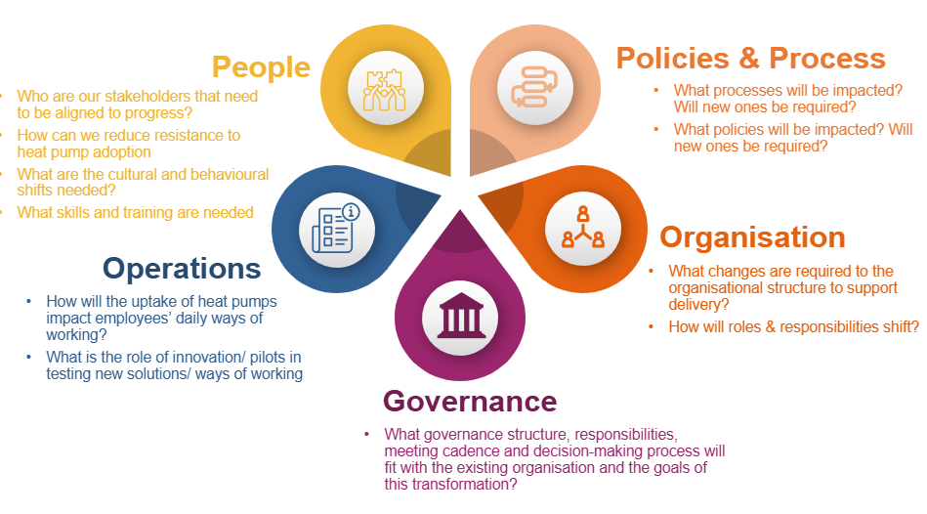

Areas of focus
Below are listed a range of focus areas the review could take. These will need to be prioritised and resourced within this project budget accordingly.
Focus Area installation journey: | Relevant housing type (scope TBC) and current status re work to date  (Red: no work undertaken or not recently updated/reviewed, Amber: work underway/ refresher may be required, Green: Complete and/or substantive work commenced) |  |  |  |  | Priority  TBC
 | New build | Social Retrofit | Non Domestic | Re-fits | Local Grant retrofit
Procurement
Planning department
Specifications/ Employer requirements
Installation
Handover
Quality assurance/ monitoring
Service and maintenance arrangements
Other
Technology options
Data Management Systems/ Existing stock review
Training/ learning
Non-domestic

Prioritisation approach
A prioritisation approach will be agreed with the project task group and ultimately by the project sponsors. Variables that could be factored in to the prioritisation matrix include:
- Urgency
- Risk to business
- Impact
- Capacity of consultees to support and implement
- Quick wins

Summary of focus areas actions, outputs and outcomes

Procurement
State why procurement practices need review

Procurement Review  Actions: | Outputs | Outcomes
- Assess current tender specification for heat pumps |  | Higher quality installations

Planning Permission
(for local authorities only)….For heat pumps installed outside of our own social housing or grant programme, the planning process might be our only wider point of contact with installations. Nonetheless this is still an important area if we are to be able to influence wider city uptake of low carbon heating.
Planning review  Actions: | Outputs | Outcomes
- Workshop with planning officers to establish current practice and good practice from elsewhere | Collate relevant documents. | Increased knowledge of heat pumps amongst planning team
- Recommendations of where the planning process can influence the quality of outcomes for heat pump installs (sustainability statements, noise, heritage, discharge process) | Recommendation report/ presentation to planning team | Improved planning processes around heat pumps

Specifications/ Employer requirements (including technology choices)
Specifications are critical to ensuring a successful heat pump installation.
Specifications/ Employer requirements  Actions: | Outputs | Outcomes
- Review specification for domestic and non-domestic installations | Recommendations for non-domestic specification | Improved specification for non-domestic installs
- Review employer requirements on new builds | Recommendations for new build employer requirements | Improved employer requirements
- Review specifications for GSHP/ other heat pump technologies. Consult and create where necessary | Specification creation for GSHP/ air to air heat pumps | New ASHP/ air to air heat pump specifications

Installation
Detail who currently installs, contractors or in house

Installation  Actions: | Outputs | Outcomes
- Review approach to installations in house or external

Handover
Resident handover is a critical step in ensuring a good experience of heat pumps for residents. Detail current handover materials available
Handover  Actions: | Outputs | Outcomes
- Collate and review existing handover documents | Folder with existing handovers collated | Better understanding of current handover practices
- Create standard handover for ASHP/ GSHP | New handover created | Better handover process for tenants

Quality assurance/ monitoring
Given challenges of finding competent installers, quality assurance at each stage of a heat pump journey is vital. Below is an example of quality assurance processes that needs to be replicated for other delivery avenues.
Figure X: Stages of a heat pump journey example (Warms Homes grant delivery example).
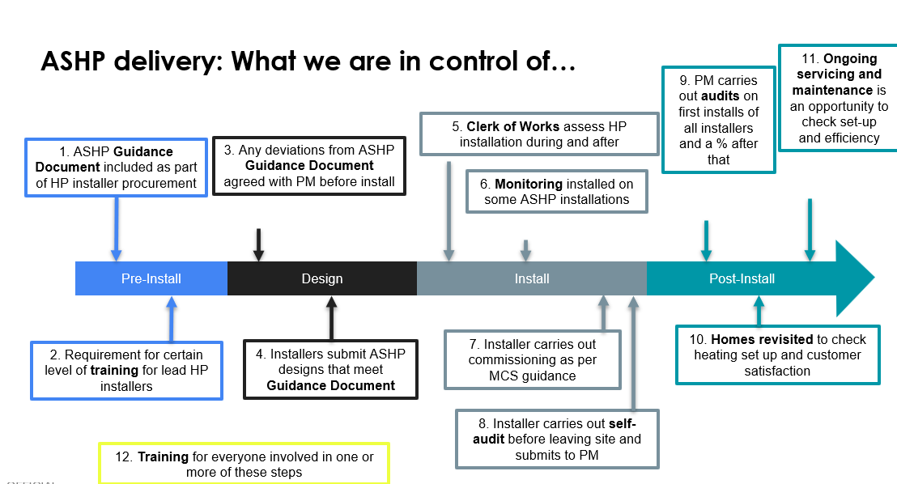

Quality Assurance  Actions: | Outputs | Outcomes
- Review remote monitoring possibilities for existing and new stock
- Map the quality assurance journeys for non-domestic, new build and refits | Quality assurance process maps | Enhanced quality assurance processes across installations
- Review options for tools to enhance quality assurance e.g. heat pump design tools (Spruce, Carno etc) | Recommendations for use of new tools | Better tools to help manage heat pump journeys

Data Management Systems/ Existing stock review
How we store information around heat pump installations is vital to enable
- Effective servicing schedules
- Timely issue resolution e.g. spare parts
- Oversight of warranty arrangements
- Capturing of commissioning settings
- Strategic financial planning
The review will assess data management systems and provide recommendations going forward.

Data management systems  Actions: | Outputs | Outcomes
- Assess data management systems across social housing heat pump stock and non-domestic buildings | Collation of what is held where. | Better understanding of data management systems and gaps to be plugged
- Assess existing stock data including warranty arrangements, likelihood of needing audit, | Recommendation document highlight properties to be audited/ assessed | Financial savings from data and audit leading to capturing faults before warranty periods expire.
- Review existing replacement cost estimates for existing stock | Costs of replacement units updated | More accurate data on replacement costs
- Review existing data on costs per install by house typology | Cost data for installs collated | Better understanding of current installation costs

Training/ Learning
It is essential that we are ‘intelligent clients’ of delivering heat pump projects. Both for non-technical and technical maintenance staff knowing what ‘good’ looks like in imperative to quality delivery.
Detail any work undertaken in this area to date
Training/ Learning  Actions: | Outputs | Outcomes
- Design and deliver heat pump training for staff | Non-technical/ technical staff training courses | Staff trained in delivering heat pump projects

Service and maintenance arrangements
Heat pumps are required to be serviced annually to keep their warranties and also to ensure effective operation. Detail current maintenance regime.

Service/ maintenance arrangements  Actions: | Outputs | Outcomes
- Review service schedule and content | Comparison of actual vs needed maintenance | Equipment lasts longer and works better for tenants
- Review potential for low time high impact additional works to take place during service e.g. recommissioning | Additional works list and timings | Heat pumps last longer and perform better

Technology options
Detail existing approach to selecting low carbon heating option at properties
Technology options  Actions: | Outputs | Outcomes
- Review process for deciding on technology type in new build and retrofit including heat pumps, hot water delivery options and distribution systems | Summary of current methodology | Better understanding of current decision making approach
- Convene a workshop to discuss and decide a process for selecting technology types | Hierarchy of technology type options | Decision made around hierarchy of technology options

Non-Domestic
Detail approach to non-domestic heat pump installations

Non-domestic  Actions: | Outputs | Outcomes
- Review of installs to date and asset management around these. Potentially including arrangement of audits. | Quantification of installs on estate and key information | Better understanding of assets
- Implement QA processes on new builds | QA processes applied to newest installs | QA processes enhanced for new installations

Stakeholder engagement
The proposed approach to deliver the review will be to undertake the review in stages by focus area. It may be that there is an overlap between these and of course there are several interdependencies. The order of review will be decided in a first working group containing representatives from each of those areas to ensure this aligns with urgency and capacity of staff to engage with the process. It is suggested that New Builds and Non-domestic might be an urgent area of initial focus.
Approaches to the review will include:
- Setting up task group: key representatives from relevant departments to steer the project and priorities
- Data collection: gathering data/ gaining access from management systems or otherwise
- Interviews: 1:1 or group interviews with relevant colleagues
- Existing processes: gather and review existing process documents
- Shadowing: it may be beneficial to shadow colleagues to understand processes e.g. service visit
- Heat Pump Working Group: source of regular contact with departments and also discussion

Timeline
The strategic review process does not sit in isolation and for many of the focus areas identified there is already ongoing work.

Project sponsors
Detail who are the project sponsors and budget arrangements

Task Group
It is suggested that a task group is formed to help steer the project. This would include representatives from:
List

Next steps

