Bristol City Council Air Source Heat Pump Guidance
For Officers and installers
Matt jones & Emily White, Sustainable city and climate change service; with input from Harry Payne, Housing and landlord services; and Martin Brookes, Ameresco
2025
Contents
Version and review 3
Overview of guidance 4
Introduction 7
Aims and Outcomes 7
Installing heat pumps in homes: the whole journey 7
Before heat pump installation 8
Engaging with residents 8
Surveying home 8
Solutions 8
Fabric upgrades for retrofit 9
Understanding heat pump running costs 9
Heat pump installation 11
Necessary pre-requisites 11
Installer accreditations 11
Workmanship guarantees and product warranties 12
Planning permissions and permitted development 12
Notification to the Distribution Network Operator 13
Design of a heat pump system 13
Design temperature 13
Heat Loss Calculation 14
System performance 14
Heat emitters 14
Pipe work and sizing 14
Buffer tanks 16
Equipment specification 16
Heat pumps 16
Monitoring/controls 16
Water tanks 17
Installation 17
Lagging 17
Pipework 18
Electrical work 18
System conversion 18
Making good 19
Commissioning of system and handover 19
Default settings 19
Handover to resident 19
Integration with other renewable technologies 19
Registration of install with MCS or relevant institution 20
Completion paperwork 20
After heat pump installation 21
Ensuring residents understand their heat pump 21
Energy tariffs 21
Maintenance 21
Annual servicing 21

Version and review

Date | Version | Authors | Reviewers
16/01/2025 | 1 | Simon Poskett (formerly of C Brookes Plumbing and Heating), Matt Jones (BCC), Emily White (BCC) | Harry Payne (BCC), Martin Brookes (Ameresco)

Overview of guidance

Theme | Essential | Desirable | Notes
Installer Accreditations | MCS accreditation (for retrofit and new build)  BPEC level 3 ASHP (or equivalent)  Low temperature design e.g. Heat Geek Mastery, Northampton Heating academy  References from two past customers | Ability to demonstrate performance of previous installs
Guarantees/ Warranties | 2 Year minimum workmanship  5 years+ product warranties  Product based warranties should include both equipment and labour required to undertaken remedial action
Design Temperature | 45°C max for heating unless specific justification provided to delivery team.  55°C for hot water.
Heat Loss Calculation | MCS heat loss calculation | Measured heat loss calculation e.g. Build Test Solutions approach
System Performance | Minimum 350% (combined heat and hot water) efficiency design for retrofit. Minimum 400% efficiency for new build. Anything lower should be flagged to project team.  System design performance guarantee based on design specification | 400% efficiency
Emitters | Radiators preferred solution sized to dT22.5°C (log mean temperature difference) at a 5°CΔT (for max flow temperature 45°C ) (Essential for new build; desirable for retrofit considering limitations of existing system) | Consider Top Bottom Opposite End for radiator pipework connections, to maximise thermal output of radiators at lower temperature.
Pipework and sizing |  | Open system design without TRVs (however TRVs may be a more intuitive way to adjust heating for many tenants)
Buffer tanks | Not to be used unless needed , if additional system volume is needed put additional volumiser in return, not in parallel, or maximise volume in the design e.g. larger radiators.
Heat Pump equipment | Unit with a low GWP refrigerant e.g. equal to or less than that of R32 (GWP of 675)  Remote monitoring inbuilt alongside in situ monitoring | Vaillant is preferred manufacturer, Daikin is secondary choice
Water tank equipment | Heat pump specific and suitable for low flow temperatures. | Consider more innovative solutions where required e.g. Sunamp, Heat Geek mini etc but only as last resort and note limitations
Heat Pump controller | Must be easy for customers to use  Must show performance data at user level  Remote monitoring functionality  Set to enable weather compensation as per MCS standard  Set to run hot water from the heat pump not the immersion backup  No on/off thermostats to be used. | Advanced weather compensation controller to be used where heat pumps are compatible e.g. Homely, Passiv , havenwise etc smart thermostat.  Preferential for controller to be connected to wifi where possible for monitoring/ maintenance.
Lagging | As per MCS standards | External trunking | Often a fail issue on MCS audits
Commissioning | Weather compensation should always be set  Hot water set to run off heat pump not immersion  Flushing/cleaning/dosing of new/existing system should be reviewed. Especially if existing radiators are retained
Handover | Record video of handover with resident in situ  Self audit following form provided | A % of installs to be audited by BCC post installation
Ongoing monitoring and support | Revisit home either remotely or on site 1 month in to first winter heating season to check system settings and ensure customer
Energy tariffs |  | Check household energy tariff is most suitable for heat pump e.g. single rate
Maintenance | Annual service offer available | Annual service for first year included for private dwellings

Introduction
This document is intended as a guide to heat pump installation. It makes reference to but is not a substitution for industry standards set by bodies including MCS and the certification bodies, planning regulations and DNO procedures. It goes beyond some of the requirements of these regulations to ensure quality installations in Bristol.
Bristol City Council commissioned installation advice from Simon Poskett (formerly of C. Brookes Plumbing and Heating). This document also draws on the specification for heating installations from the Bristol City Council Housing Service Mechanical, Electrical and Heating team.
This guidance should be followed unless the reasons for not doing so are provided and agreed on with the project manager.

Aims and Outcomes
- Residents are satisfied with the full heat pump installation process
- Residents understand how to use their heat pump
- Residents are happy with how much it is costing them to run their heat pump
- Installations are good value for money and good quality

Installing heat pumps in homes: the whole journey

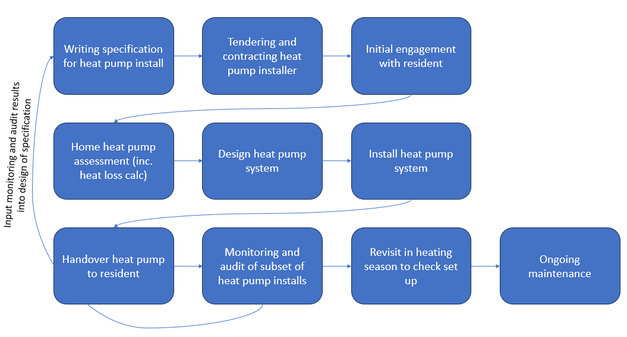

Before heat pump installation

Engaging with residents
Due to the relative low numbers of households who have a heat pump in the UK, the technology is often unfamiliar to most. Unlike a replacing an existing gas boiler there is a significantly higher level of engagement and onboarding required to ensure the system is operated effectively as a result.
Residents should be empowered to have a basic understanding of the system that is going to be installed including clear expectations of any behaviour change they might need to make. Furthermore, residents should be provided information to make informed decisions about whether or not to go forward with an installation. Critical within this is to understand how to interrogate the expected performance of the system and ensure they agree to this. For example, if a system design states the performance will be less than 350% efficient then at present, moving away from a gas boiler is likely to cost them more money to run. Equally it is important to empower residents to understand how to check performance once installed and be able to refer back to the design that was provided.

Surveying home
A full heat loss calculation should be done to correctly size the system and inform the system design. For an MCS approved installation the heat loss calculation should conform with the MCS standards. It should be noted that there is a significant and growing body of research that shows traditional tools for calculating heat loss are often inaccurate ( see MEASURED (google.com)). There can be significant impacts of inaccurate heat loss calculations. Oversizing will result in more capital outlay for the heat pump unit (this can be significant if a three phase upgrade is required) whilst the heat pump itself will not function optimally as it will cycle on and off more and will ultimately shorten the lifespan of the heat pump itself. Heat Pumps are often oversized to reduce the risk of under sizing which would mean the heat pump cannot meet the heat demand of the building. Benchmarking against customer half hour Smart Meter data for their existing gas boilers on the coldest days and then adjusting for boiler efficiency and occupants may be beneficial to enhance the accuracy of calculation.
Heat loss calculations are often wrong as they rely on assumptions of building fabric that are often inaccurate. For example, one could assume a cavity wall is filled and functioning correctly however without inspection this is impossible to know therefore the assumed u-value for a cavity wall in a building might be incorrect. Relatively small inaccuracies across a building can add up to a substantial variation.

Solutions
There are options to more accurately size heat pumps. These are through using measurements rather than estimates. There are a few options around how to do this but the most common is to place sensors in a home over 3 weeks during the heating season, measure the heat input (smart meter or bills) then this produces a figure that can be used for size a heat pump. Hot water demand is not factored into this and will need to be separately calculated.
The cost can vary but factors to be considered are:
- Risk to household of wrongly sizing a heat pump
- Time to arrange sensor deployment and collection
- Cost of buying enough sensors to deploy simultaneously
There is currently no established solution for measuring heat loss in oil and biomass fuelled properties although this is under further investigation. There are other measured heat loss tools in development through the SMETER project where the lead time might reduce to capture an accurate measurement.
Although the outlay increases the upfront cost the ongoing running costs and likely equipment savings should make for a relatively quick payback period.
The design and sizing of the HP should also consider defrosts and hot water usage (i.e allow for around 25%/30% reduction in output when doing HW or a defrost)
Helpful learning:
Heat Loss Calculation: Heat Pump & Boiler Sizing Guide (heatgeek.com)
Accurate Heat Loss Measurement is Vital to Heat Pump Sizing (buildtestsolutions.com)
Improving Heat Pump Sizing with SMETER Technology – City Science

Fabric upgrades for retrofit
The retrofit strategy for a property needs to consider the upfront costs, running costs, carbon reduction and impact of any measures to improve other issues such as comfort and damp and mould, as well as who is responsible for the different costs and benefits.
Fabric First is a term that is commonly used to describe the guidance that a home should prioritise thermal efficiency over other retrofit measures. This has merits where the priority is to reduce ongoing running costs and improve the comfort of a home regardless of whether the heating system is being used.
However, beyond the ‘easy wins’ such as cavity and loft insulation, measures become very expensive and disruptive. Where the priority is to reduce upfront costs, accelerate decarbonisation and minimise disruption it may be better to install low carbon heating rather than carry out a deep retrofit of a property. Studies have shown that so long as the easy wins are complete, including draught proofing, then good system design and installation represents significantly better value than deep retrofit Retrofit: is Fabric First Really the Best Strategy? - Sero
A well-designed heating system will account for meeting the heat requirement irrespective of the heat loss through the building. For example, larger pipe sizing and larger emitters help to overcome such challenges. Coupled with a measured heat loss approach this could represent better value for money for the household and the largest carbon saving vs elongating the life of a gas boiler.

Understanding heat pump running costs
Heat pump running costs are related to the efficiency of the heat pump system. A heat pump that is 350% efficient will use 1 unit of electricity to deliver 3.5 units of heat. By comparison, a modern gas boiler advertises itself as 92% efficient, using 1 unit of gas to deliver 0.92 units of heat. In November 2024, the price cap for a unit of electricity is 24.5p per kWh and the price cap for a unit of gas is 6.24 p per kWh. This means that for both systems to have the same running costs, the heat pump needs to be 3.9 times more efficient than a gas boiler, or 360% efficient.
The standing charge also needs to be considered. If a heat pump is replacing a gas boiler and there is no longer any gas use in the property (e.g. cooking is via an induction hob rather than a gas hob), the gas can be disconnected and the resident no longer has to pay the gas standing charge (31.66 p per day, £115.56 for a year).

Heat pump installation

Necessary pre-requisites
The Heat Pump Ready project worked with the Green Register to define pre-requisites to installer onboarding including training and other competency based criteria.
• Work under MCS certification (own accreditation or umbrella scheme)
• Provide performance figures (SCOPs) for installations over past two years, if available.
• 2 x customer references (including name, phone number and email address) from heat pump
installations over the past two years
• Ability to generate high quality designs, install to design and commission system along with
monitoring equipment

Installer accreditations
Installation companies may list the qualifications their staff hold but is unlikely that this will be consistent across staff particularly for larger installers. Ideally individual CVs of installers working on the commission should be provided ahead of time.
Industry standard accreditations:
BPEC Level 3
- Installation and Maintenance of Air Source Heat Pumps (essential)
Evidence of additional training such as Heat Geek Mastery or equivalent around low temperature system design should be looked on favourably. Evidence from open energy monitor shows the correlation to those installers who have done ‘heat geek’ or equivalent level training and the system performances achieved.
Details of manufacturer specific training undertaken should also be provided.
Some installers may have done on the job training so the opportunity to highlight this would be beneficial when putting out a tender.

Heat pump installation
All air to water heat pump systems to be installed and commissioned in accordance with Microgeneration Installation Standard MIS 3005. Hot and cold water services pipework shall be installed in accordance with Water Regulations Advisory Scheme (WRAS). Engineers carrying out installation to have valid WRAS approved Water Regulations Qualification, G3 Unvented Hot Water Qualification and the installation must be installed or commissioned by a MCS certified installer.

Refrigerant installation
If carrying out the installation of the refrigerant part of the system, the engineer must hold the required F-Gas Certification (e.g. City & Guilds 2079 certificate). This will also be required for decommissioning of existing heat pump systems.
F-Gas certification is not necessary for the installation of monobloc systems as the refrigeration side of the unit is a sealed system. However, F-Gas certification is essential for any future maintenance of the refrigeration circuit.

Unvented installation
If carrying out installation of an unvented cylinder the engineer must hold the required G3 qualification and certificates and be registered with a relevant competent person’s scheme to ensure unvented work is registered with Building Regulations. The installation and commissioning shall be in accordance with manufactures instructions and Part G Building Regulations.

Electrical installation
Installation of electrical parts of the system to be carried out by an NICEIC or equivalent approved contractor, to the current IET Wiring Regulations.

Workmanship guarantees and product warranties
Workmanship guarantees are typically for 2 years. A good length of warranty on installed product is least 5 years. Warranties on hot water cylinders are typically 25 years if all installation requirements are met.

Planning permissions and permitted development
Air source heat pumps can be installed under permitted development providing the following limits are met:
- Development is permitted only if the air source heat pump installation complies with the Microgeneration Certification Scheme Planning Standards (MCS 020) or equivalent standards. This includes passing a sound pressure test to ensure that the noise from the Heat pump doesn’t exceed 42dBA. Read more about the scheme.
- The volume of the air source heat pump’s outdoor compressor unit (including housing) must not exceed 0.6 cubic metres
- Only the first installation of an air source heat pump would be permitted development, and only if there is no existing wind turbine on a building or within the curtilage of that property. Additional wind turbines or air source heat pumps at the same property requires an application for planning permission
- All parts of the air source heat pump must be at least one metre from the property boundary
- Installations on pitched roofs are not permitted development. If installed on a flat roof all parts of the air source heat pump must be at least one metre from the external edge of that roof
- Permitted development rights do not apply for installations within the curtilage of a Listed Building or within a site designated as a Scheduled Monument
- On land within a Conservation Area or World Heritage Site the air source heat pump must not be installed on a wall or roof which fronts a highway or be nearer to any highway which bounds the property than any part of the building
- On land that is not within a Conservation Area or World Heritage Site, the air source heat pump must not be installed on any part of a wall above the level of the ground floor storey if that wall fronts a highway.
In addition, the following conditions must also be met. The air source heat pump must be:
- Used solely for heating purposes
- Removed as soon as reasonably practicable when it is no longer needed for microgeneration
- Sited, so far as is practicable, to minimise its effect on the external appearance of the building and its effect on the amenity of the area.
If these limits are not met, planning permission may be required. See Planning Portal for more details.

Notification to the Distribution Network Operator
The DNO must be notified, either before installation (apply to connect), or after installation within 28 days (connect and notify) by completing the Electricity Networks Association application form. The ENA flow chart must be followed to ascertain which category the installation is in. As a rule of thumb any installation below 8kW will be ‘connect and notify’ and any above this figure would be ‘apply to connect’
The low carbon technologies database shows a list of most of the heat pumps currently on the market and columns AC and AD indicate if the HP is ‘apply to connect’ or ‘connect and notify’.
The ENA application form must be completed and signed off by the DNO before any work is undertaken on the property if the installation is ‘apply to connect’, allow 28 days for this approval. The form can be completed within 28 days if ‘connect and notify’.

Design of a heat pump system
The design of a heat pump system must follow the general guidelines found in MIS3005-D. The premise of the design is to create a simple installation which is an ‘easy to repeat’ system across many house types.

Design temperature
To ensure good efficiency and therefore Seasonal Coefficient of Performance (SCOP) with a radiator system then a maximum design flow temperature of 45°C should be considered. This will enable the lowest possible running costs. Raising the design temperature higher will have the detrimental effect on the running costs for the occupier, however may result in a cheaper installation cost. Any installation that has a system design above 45°C should seek special approval to be installed.
Systems shall be designed by the contractor in accordance with the parameters given in BS5449, Part 1, 1977, assuming an outside air temperature of – 3 and continuous operation of the systems to maintain the following design temperature:
Living Rooms 21C
Dining Rooms 21C
Kitchens 18C
Bedrooms 18C
Bathrooms 22C
Cloakrooms 18C
Halls and Landings 18C

A recommended design temperature for hot water is 55°C, noting anti-pasteurisation for legionella. 55°C should be suitable for most domestic settings.

Heat Loss Calculation
A full room by room heat loss calculation will need to be carried out in accordance with CIBSE heating design guidelines. This will ascertain the total heating and hot water load for the house and provide the heat loss for each room to enable a suitably sized radiator to be chosen. There is no short cut here, some estimations can be made but a full HLC will need to be carried out as per MCS guidelines.
See previous information re measured heat loss calculation as another superior option.

System performance
A recommended target SCOP/SPF for air source heat pump installations would be 3.5 (350% efficiency). Correct design and installation practices should achieve this. Heat meters may be used on installations to ascertain effectiveness of the design but are relatively costly vs the alternative of viewing system performance via the control unit. Any system design resulting in a lower predicted SCOP should be flagged immediately before continuing with the council project management. Anything below this efficiency may represent higher running costs compared to a gas boiler so should be agreed with the householder in advance to ensure acceptability. Solar PV alongside heat pumps can help reduce running costs so may be a factor when understanding the additional cost of achieving higher performance vs offsetting the cost through onsite generation.

Heat emitters
Radiators are likely to be the preferred solution for heat pump installations carried out by Bristol City Council, this is mainly driven by cost. Overlay Under Floor Heating is more expensive although it brings an energy saving due to the lower running temperatures.
Radiators sized ideally to dT22.5°C (log mean temperature difference) at a 5°CΔT (for max flow temperature 45°C ) but consideration of existing pipework and removing the need for buffer vessels and secondary pumping may change this. This will provide occupier comfort with low flow temperatures whilst achieving a good overall annual efficiency.
Consider radiator pipework connections to be Top Bottom Opposite End to maximise thermal output of radiators at lower temperature.
Radiator positions should be agreed with the Householder.

Pipe work and sizing
Pipework should match existing.
In an ideal scenario, re-piping the heating circuit with new MLCP pipework guarantees quality, speed, clean pipework and ensures the correct energy delivery throughout the house which is imperative for good running efficiency with the increased flow rates of a heat pump system.
As per CIBSE heating design guide it is recommended to maintain the velocity (the speed at which the water flows) in pipework to around 1m/s (or ideally below, max 1.2m/s), due to heat pumps needing approximately 4 times the flow rate compared to boilers. This means larger pipes are required to carry the heat throughout the house. The velocity limits set by CIBSE (0.5m/s to 1.5m/s) are there to:
- ensure low noise from the flow of water in the pipework (high velocity water increases the noise in the pipework and increases the pump energy required to create adequate flow throughout the system).
- ensure good longevity of pipework by preventing erosion corrosion to pipes subject to high velocity.
It is imperative that correct pipe sizing is calculated for each property to ensure good flow from the Heat pump and efficient delivery into the heating system. Consideration must be given to the entire system ensuring at every ‘Tee’ junction the pipe is sized to carry the reduction in kWs along it. A simple heat pump system comprises of open circuits to provide adequate volume for the heat pump to load into, and well sized pipes to carry the load at a delta temperature across the system of 5°C.P system
A chart below shows pipe sizing for typical loads throughout a domestic heating system.
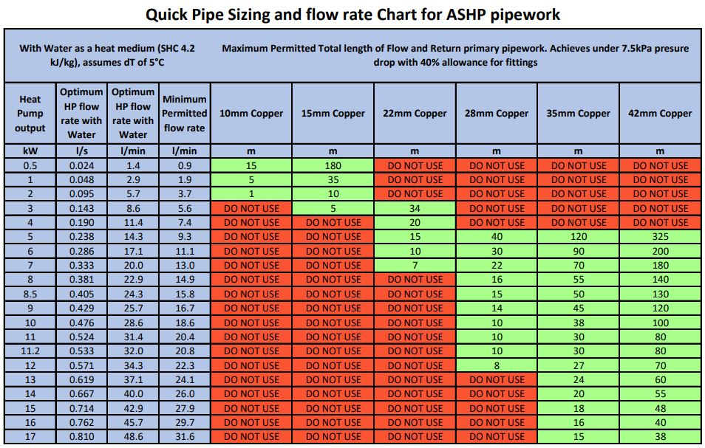

Installation Pipework for Heat Pump systems will be either copper tube or MLCP to allow for adequate flow rates for heat pump operation.
As a rule of thumb, MLCP pipe sizes are one up from copper sizes due to the wall thickness of the Multilayer pipe: 28mm copper will equate to 32mm MLCP, 22mm equals 25mm etc.

Buffer tanks

Buffer tanks should not be used unless needed. If additional system volume is needed, this can be achieved by putting an additional volumiser in return, not in parallel, or maximising volume in the design e.g. larger radiators.
A buffer tank should always be a last resort to a HP system, for example should it prove impossible to upgrade the existing pipework. Buffer tanks provide a route to flow for the HP but this functionality can be designed in elsewhere. They add volume to the system which will also need extra energy to heat up, although the overall SCOP will be similar the extra volume still needs energy to heat it.

Equipment specification

Heat pumps
Heat pumps to be installed should aim to use a refrigerant with a global warming potential (GWP) as low as possible (e.g. equal to or less than that of R32 (GWP of 675)).
Consideration should be made to the noise output of air-source heat pumps. There are units badged as ‘low-noise’ on the market.
Heat pumps should have the functionality to enable the home user to see performance data of the heat pump and ideally have an option for third party settings control to enable the installer to tweak settings remotely thus reduce the need for return visits.

Monitoring/controls
Occupiers benefit from a simple to use programmer for heating and hot water, however this isn’t always the case with some heat pump systems, so some further work will be needed to source the correct equipment here.
The occupier needs simple control of heating comfort to include set back temperature programming and control over hot water reheat and the legionella cycle.
A well commissioned heat pump interface can automate most of the requirements for a homeowner so in-depth knowledge is not necessarily needed for the resident. However, some training and instruction on the new concepts of heating a house with a heat pump will be needed (see “Commissioning of system and handover” and “Ensuring residents understand their heat pump”).
It is important that heat pump controls are:
- Easy to use by the resident
- Able to show heat pump performance data (energy in/out and SCOP) easily without having to go in to an installer specific area
- Set to enable weather compensation as per MCS standard (Microgeneration Installation Standard (mcscertified.com))
- Set to run hot water from the heat pump not the immersion backup
Due to the complexities in explaining concepts such as weather compensation it should be considered that controllers such as the Passiv Smart Thermostat or Homely are used where possible to enable advanced automatic weather compensation optimisation and also easy access to performance monitoring data for both the household and commissioners.

Water tanks
All HP water cylinders must heat pump specific and suitable for a low temperature HP with a heat exchanger coil suitably sized for the HP maximum output. This can be above the badged output at higher ambient temperatures. A rule of thumb for this is 0.25m2 x kW. So an 8kW HP would require a minimum surface area of the coil to be 2m2, to reheat the tank in an acceptable time frame. Most HP cylinders are 3m2 coils.
Hot water cylinders should always be powered by the heat pump and not the immersion controller for maximum efficiency.

Installation
The installation will consist of fitting an air source heat pump, hot water cylinder, pipework, radiators, radiator valves and associated wiring centre and controls.

Lagging
External pipework should be insulated, as well as areas where excessive heat gain might become a problem (such as airing cupboards) but generally internal pipework should be left unlagged as this adds additional heating surface area. This includes leaving pipework unlagged in areas such as floor voids. Care must be taken to ensure good mitre joints are made to minimise heat loss from lagged pipework. Cable ties and purpose made tapes can be used.
Use 13mm minimum thickness Climaflex lagging (grey foam lagging to British Standard BS5422:2009) internally and 19mm minimum in loft spaces and externally. Any exposed lagging must be weatherproof Armaflex HT grade. Ideally external trunking should be used to further protect pipework from the elements.
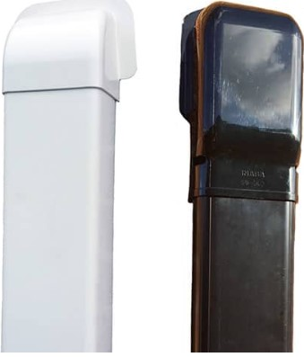External Trunking

All pipework through the building fabric must be sleeved, sealed and fully lagged throughout its length as per Part L of Building Regulations. See drawing below as a guide.
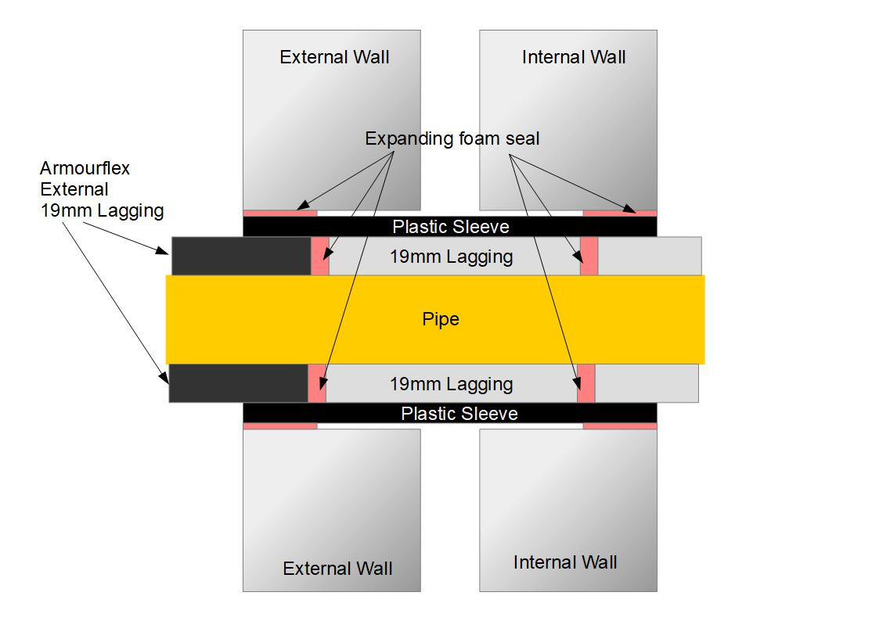

Pipework
Heating circuits should not be installed in the roof spaces of any property, if this is not possible the location of pipe work should be kept to a minimum and suitably insulated.
Heating pipes should not be installed in solid floors. If this is unavoidable preformed ducts should be used and the location agreed with the Resident.
All pipework runs shall be laid in such a manner that it is possible to vent and drain the entire system.
Any holes formed in Pre-cast Reinforced Concrete (PRC) structures must be carried out with extreme care, core drills must be diamond tipped and used with no hammer action. Where concrete and steel joists are found, they should not be damaged and an alternative route for pipework agreed with the Resident.

Electrical work
All surface wiring must be encased in trunking; all wiring that may contact heating pipes must be protected.

System conversion
System conversion shall consist of Draining down existing system, remove existing appliance (including storage heaters, multi-point water heaters, back boilers, solid fuel appliances, gas wall heaters and any associated pipe work) and all redundant equipment making good upon removal, upgrade system to suit new appliance in accordance with Surveyors Specification.
Gas, hot and cold water and heating pipework dead legs to be removed as far as reasonably practical.
Where old appliances, have been removed including electric storage heaters the old fixings holes must be filled.
All waste materials and packaging derived as a result of the Works shall be disposed of responsibly, ethically and in accordance with the relevant law and/or legislation in effect at that time, including compliance with the Waste electrical and electronic equipment regulation, 2014.

Making good
Any holes drilled must be filled using appropriate filler/plaster, larger holes must be filled using plaster internally and sand cement for external.
Where loft insulation has been disturbed it must be correctly re-laid.
On Completion of work all rubbish must be removed from site.

Commissioning of system and handover

Default settings
Optimum settings of the system will depend on the design of the heating circuits. Discussions with the residents are vital at this point to fine tune the system for them. Heating Setback temperatures of 3°C max from comfort should be adhered to. So with a Comfort setting of 21°C max setback would equal 18°C.
Correct setting of the weather compensation curve will come from the actual design but will be around -3°C = 45°C flow temp and 15°C = 25°C flow temp. Fine tuning will come from discussions with the residents.
Hot Water settings will be set 55°C with a weekly legionella cycle raising the water temperature in the HW cylinder to 60°C. Consideration should be given to timing of legionella cycle and heating hot water tank so that it occurs outside of peak electricity demand (4-7pm), especially if the resident is on a time of use electricity tariff. If the resident has solar PV this could be set to coincide with maximum electricity generation.

Handover to resident
Resident handover will be system specific but some clear usage documents will be necessary including relevant manuals and quick start guides. Handover packs should specify arrangements to contact the installer in case of repair or breakdown and the service level agreement being offered as part of this in terms of response times.
The contractor carrying out the install should allocate at least one hour to go through any questions with the resident on handover.
If the resident has a smart phone then the handover talk through could be recorded as a record for them to refer back to.
The weather compensation curve should be set then further tuning with homeowner post installation is beneficial to enhance performance and comfort

Integration with other renewable technologies
Adding EV charging will require DNO approval but doesn’t in anyway interact with a HP system.
A PV system can help offset the running cost of heat pumps. It is usually good practice to install a ‘pv diverter’ to heat the hot water tank when there is excess solar but when there is a heat pump present it always is more efficient to use the 300%+ efficiency of a heat pump vs the 100% efficiency of an electric emersion to heat hot water.

Registration of install with MCS or relevant institution
Once installation is complete, it is the installers responsibility to complete MCS registration and gather all information required.

Completion paperwork
Certification required:
- MCS Certification (compliance certificate and installation certificate)
- DNO Certification
- Resident sign-off form
- Warranties for workmanship and product
- Unvented Benchmark?
- Heat Pump Benchmark?
- Building Regulations Compliance Certificate?
- Any Asbestos Removal document must also be supplied with Invoicing and paperwork if asbestos removal work has been carried out.
- Hand over audit complete showing work completed to required standard

After heat pump installation

Ensuring residents understand their heat pump
A return visit or phone call should be scheduled with the homeowner once the property has started using the heating system for space heating for no more than 1 month. During this call or visit the installer should check the settings (remotely where possible) and adapt accordingly such as tweaking the weather compensation curve if required.

Energy tariffs
There are increasing numbers of heat pump specific tariffs. These usually require the changing of heat pump run times to maximise one or more cheaper windows of electricity. Although householders are free to choose tariffs we should urge caution to ensure that if any smart tariff is used they should contact the installer to change the run times for the heat pump to maximise savings whilst not affecting thermal comfort.

Maintenance

Annual servicing
Annual servicing can be undertaken by any competent heating engineer, however a G3 hot water cylinder competency will be required to service the Hot water cylinder and F-Gas certification is essential for any maintenance of the refrigeration circuit.
Every manufacturer will have their own recommendations on checks to carry out but the usual things to check are as follows.
- Check and charge expansion vessels on the heating and HW cylinder.
- Check and clean system filters and strainers
- Check integrity of pipework and lagging
- Visually check for signs of refrigerant leaks
- Inspect and clean heat exchanger/evaporator fins
- Check all electrical connections including mains isolator.
- Check the antifreeze and if necessary top up concentration
- Check/reset system pressure
- If < 2 to 5 miles from coast, check for salt anti-corrosion
Normal Hot water cylinder service by G3 Certified engineer
- Record HP settings
- Energy readings from meters
- HW setpoints and flow rates
- No of starts and compressor hours
- Heat curve settings and any offset applied
- System flow rate if flow meter fitted

