A dictionary in Python is an unordered collection of items, each consisting of a key and a value. Dictionaries are also known as associative arrays or hash maps. They are enclosed in curly braces {} and values can be accessed using keys.
Here is an example of a simple dictionary:
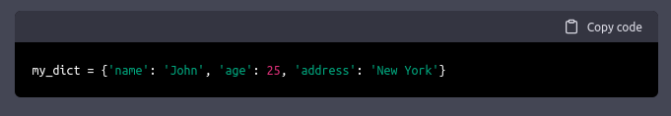
déclaration

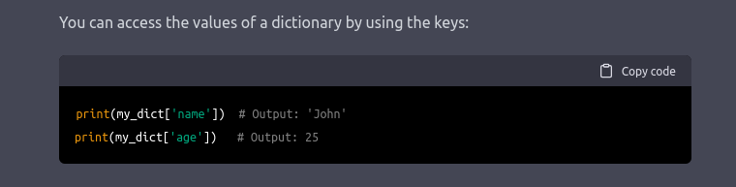
h
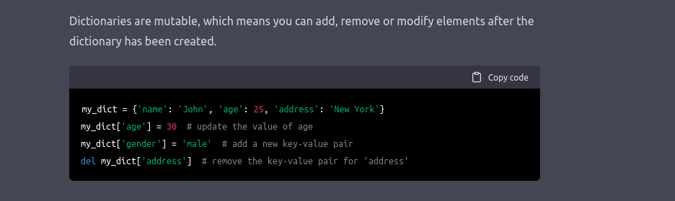
j

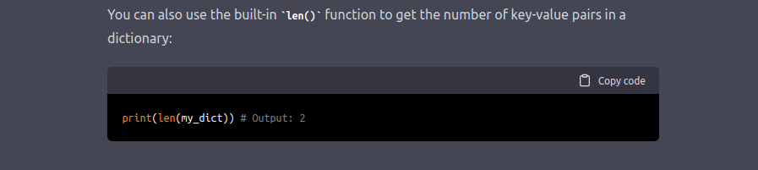
h

here are many built-in methods that you can use on dictionaries, such as:
- clear(): Removes all items from the dictionary.
- copy(): Returns a shallow copy of the dictionary.
- items(): Returns a view object that displays a list of dictionary's (key, value) tuple pairs.
- keys(): Returns a view object that displays a list of all the keys in the dictionary.
- values(): Returns a view object that displays a list of all the values in the dictionary.
You can use the in keyword to check if a key exists in a dictionary:
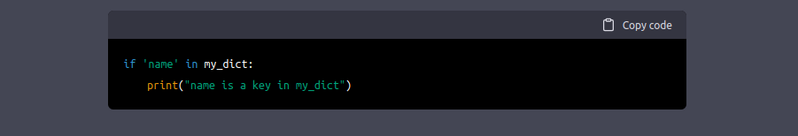
j
You can also use the get() method to access the value of a key if it exists, or a default value if it does not exist:

y
Dictionaries are very useful in Python and can be used in many different ways, such as storing configuration settings, counting occurrences of elements in a list, and representing graph data structures.
Keep in mind that dictionaries are unordered collections, so the order of items may not be the same as the order in which they were added.

