CPSC583

Assignment 2

UK Food Trends

Brian Nguyen

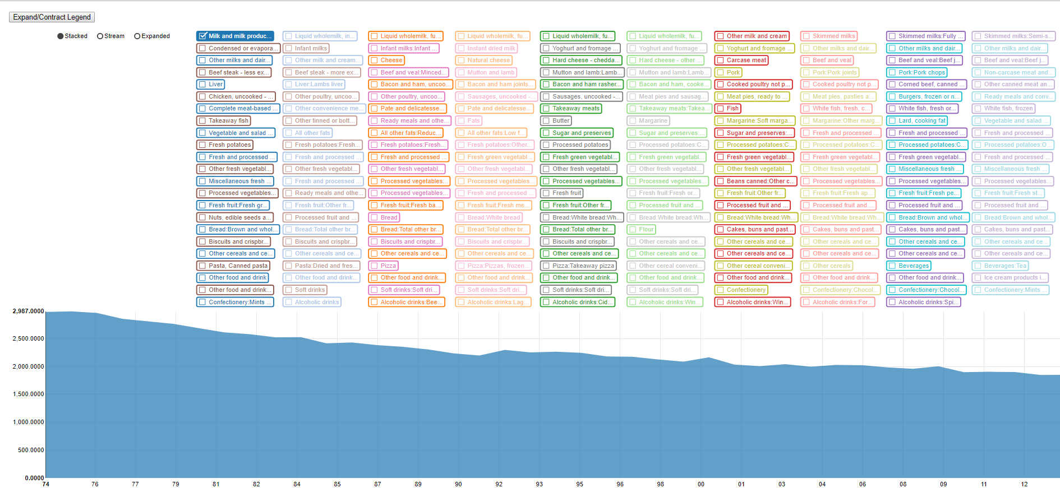

Data Summary

Sketches

* explain why you chose the stacked area chart

# Preface

The data given is the average quantity of food and drink purchased per UK consumer per week for each food and drink category. The volume of this information is high so it is impossible to process all of it intuitively by purely observing the numerical values. By visualizing this data set, it allows us to predict the UK food market and profile the diet of an average UK consumer. With this information, public health campaigns can be launched to direct UK consumers in the right direction at the right time if need be.

# Directions and Change

I discovered a D3 library that fit my requirements for a stacked area graph, however the input data had to be in JSON format. There was no quick and easy way to convert the data into the format that was required because additional information had to be appended to the given data set.

To elaborate, each data value had to be appended to a Unix time stamp for the library to generate the correct year for the axes. I had to calculate the initial year (1974) as a Unix time stamp and add the number of seconds in a year to the initial time to get each consecutive year. Next, I had to append the appropriate time stamp to the given data value for each year.

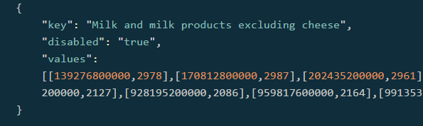I manually created a JSON entry which was extremely tedious so I wrote a parser in java that read each .csv line and appended the correct Unix time stamp to each data value. It also generated the rest of the JSON entry for me as well by some string operations.

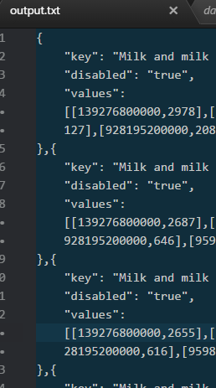I finally had an output file of the data values in JSON format and simply had to copy paste them into the .html file for the library to do its work. After observing the first iteration of the visualization. I realized that the legend was extremely difficult to read. I simply appended all of the descriptions together

-explain java file that helped parse the data into json format

-explain that year is difficult to calculate

# Representation

-todo

* explain the mapping from data to
* representation of change over time
* depict time-series relationship
* can also represent volume
* information is graphed on two axes using data point connected by line segments
* area between the axis and line is emphasized with color or shading for legibility
* often area charts compare two or more categories

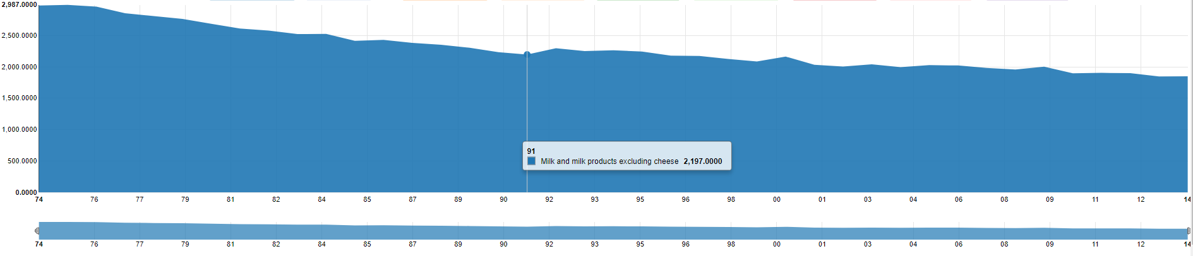



# Presentation

todo

* explain how you organized your information spatially

Interaction

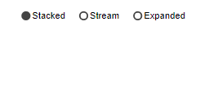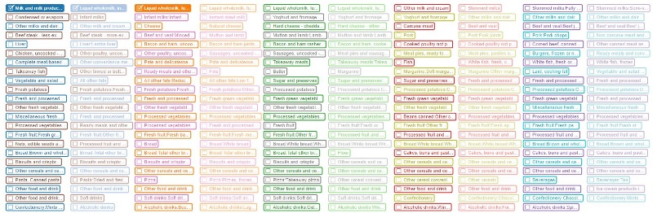

-todo

* explain each food item can be selected/unselected
* 3 different types of streams
* explain each stream
* explain ability to narrow focus of years

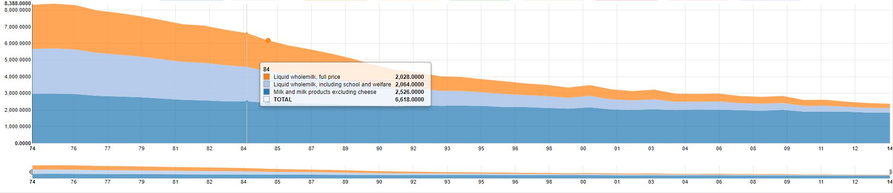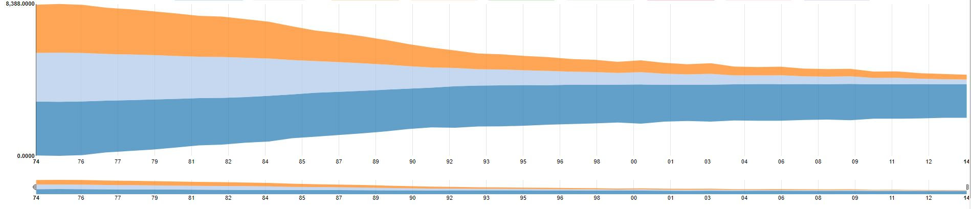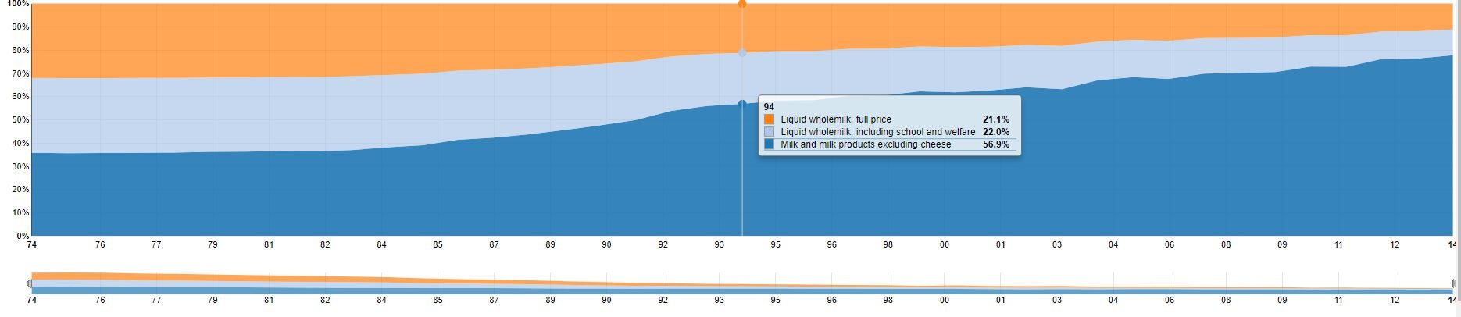

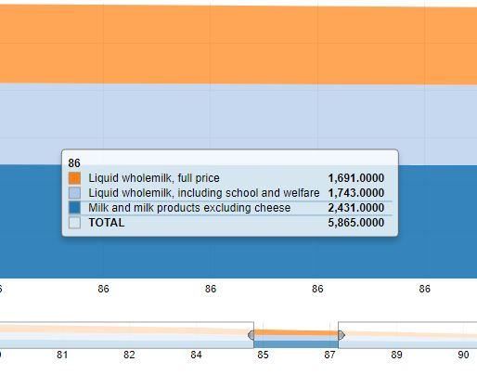 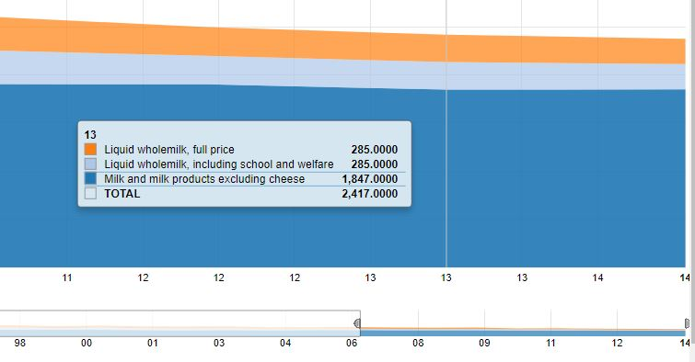

# Positive Features

* ability to isolate the data that you want
* ability to compare and contrast the isolated data
* ability to make meaningful insights based on selection and stream chosen
* area charts are perfect when communicating the overall trend as opposed to individual values
* use stacked are chart for multiple data series with part-to-whole relationships or for cumulative series of values

**standard chart**

* best used to show or compare quantitative progression over time

**100% stacked**

* best used to show distribution of categories as parts o a whole where cumulative total is unimportant
* best used to visualize part to whole relationships

**stream graph**

* variation of a stacked area graph but instead of plotting values against a fixed, straight axis, a stream graph has values displaced around a varying central baseline
* stream graph display the changes in data over time of different categories through the use of flowing organic shapes
* the size of each individual stream shape is proportional to the values in each category.
* the axis that a stream graph flows parallel to, is used for the time scale
* stream graphs are ideal for displaying high-volume data sets in order to discover trends and patterns over time across a wide range of categories
* for example, seasonal peaks and troughs in the stream shape can suggest a periodic pattern