Formal Review Request Template

Requester: Sri Aashrith Vithana
Reviewer: Javier Nieves
Date: 29 October, 2026
Approx. review duration: 1 hour

Choose one primary review method:

Code / Software Review
- Code Quality Review
Inspect the code for issues such as readability, modularity, maintainability, efficiency, and appropriate programming practices.
- White-Box / Edge-Case Testing
Inspect the internal logic and systematically test branches, boundary conditions, exceptions, or adversarial inputs.
- Black-Box / Functional Testing
Develop test cases from the expected requirements or behavior and determine whether the software produces the expected results.
- Performance / Runtime Testing
Systematically evaluate whether the software meets relevant runtime or performance expectations.

Usability Review
- Task-Based Usability Testing
Give the reviewer/user specific tasks to complete while you observe what they do, where they succeed, and where they encounter problems. A think-aloud protocol may be used.

- Heuristic / Guidelines Evaluation
Systematically inspect the interface using identified usability principles, heuristics, or design guidelines.
- Prototype Usability Testing
Have users complete defined tasks using a wireframe, prototype, or partially implemented interface.

Design Review
- Architecture / Conceptual Design Review
Evaluate whether architecture and major design decisions align with project requirements and constraints.
- Preliminary Design / UML Review
Evaluate proposed system structure, diagrams, component relationships, interfaces, or other design artifacts.
- Security Design Review
Evaluate relevant authentication flows, trust boundaries, data protection, error handling, or other security-related design decisions.

Other
- Other review method: ________________________________________________________________
Explain what the reviewer will evaluate and why this method is appropriate for your work:
The reviewer will evaluate the new MCG Opportunity Signals, Key Takeaways and Conversation Starter panels on the Snapshot homepage. I chose Heuristic / Guidelines Evaluation because this review is about design and visuals: whether the panels are clear, consistent and easy to understand. The reviewer can check them against basic usability guidelines without needing to know the finance formulas behind the numbers.

Review Request Details
- What specifically should the reviewer examine or interact with?
The reviewer is expected to view the MCG opportunity signals, key takeaways and Conversation Starter panel in the Snapshot homepage and examine if the presented panels have clear and ‘easy to understand’ information.

- What question do you want this review to help answer?
Are there any typing mistakes in any of the panels?
Do the descriptions match the numbers and statuses shown in the panels? Is it clear why each signal has its status (High, Moderate, Review, Low)?
Examples:
- Does this implementation correctly handle boundary and error cases?
- Can a new user complete the checkout task without assistance?
- Does this architecture satisfy our project's stated requirements?

- What should the reviewer focus on?
The reviewer should focus on whether the three new panels are easy to read and understand. That includes the labels, the status colors and legend, and the short descriptions under each signal, and whether the panels look consistent with the rest of the homepage. The reviewer can also try the thresholds panel at the bottom of the page (change a number and press Apply) and say whether it is clear what changed.

- What should the reviewer not evaluate during this review?
The reviewer should not evaluate the accuracy of the financial numbers, because the page currently uses a sample bank and is not yet connected to the real data. The reviewer should also not evaluate the other panels and pages built by my teammates, or how the page looks on mobile.
Examples:
- Do not evaluate visual polish or mobile responsiveness (for a usability test evaluating navigation and task completion)
- Do not evaluate the database layer or unfinished API integration (for a code review focusing on the authentication module)

- What should the reviewer use to judge the work?
I expect the reviewer to use basic usability heuristics, such as clear and consistent labels, easy-to-understand status colors, readable text, and whether the descriptions match what the panel shows.
Examples include expected software behavior, project requirements, coding best practices, usability heuristics, or design constraints.

Reviewer Section
1) Briefly describe what you actually did during the review.
Examples include executing defined test cases, inspecting particular code paths, observing a user completing defined tasks, or systematically examining a design against specified criteria.

I specifically looked at the overview page but I also clicked on every button to see if they worked compared to last time, in the overview page I read over the data to see if it was clearly formatted, and easy to read.

2) What portions of the artifact did you evaluate?
The overview page I looked at what each value meant and with the arrows going up, down, or still. But specifically looked at the signal thresholds part and read over the signal, the status, and the why.

3) Provide or link to relevant evidence such as test cases, screenshots, notes, annotated code, observations, or other review artifacts.
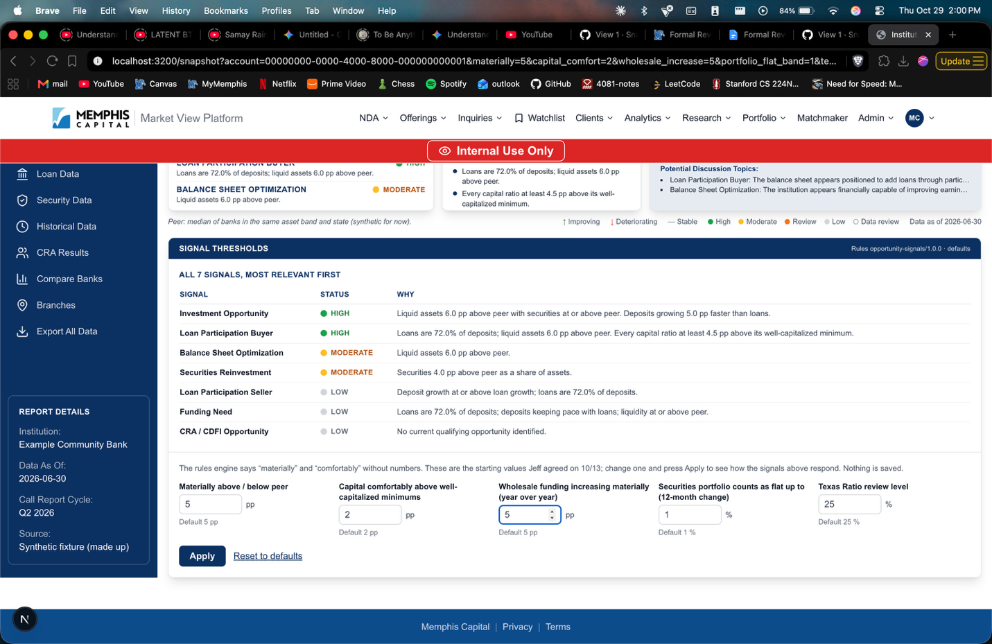

Findings
Strengths:
- Easy to read, if I would be an actual stakeholder for this application, the information seems relevant to what I would want to see
- Status and why are easy to follow and clearly reflect quickly what I am looking for
Issues / Defects:
Description of Issue | Severity (Low/Med/High) | Evidence / Example | Suggestions
Text may be too small | low | All the text in Overview page | Maybe try splitting into two different pages
Functional Buttons | Med | On the nav bar the buttons show other options now, but does options don’t take you any where | Probably teammates working on this feature, but would be interesting to see those pages working
Values to change signal | med | The sponsor gave initial values but when changing them no signal actually changes | Since you are not working with actual data, create two separate test cases for comparing the difference when different values are placed

Requester Follow-Up
- How will you address the feedback? If you decide not to, briefly explain why.

Text may be too small: I won’t split the Overview into two pages, because the client asked for the whole homepage to fit on one screen so it can be read at a glance. Instead, I will increase the smallest text in the new panels where it still fits, and confirm the text size with the client.

Functional buttons: I will not address this one myself, because the pages in the side bar (Loan Data, Security Data, Historical Data, Compare Banks, CRA Results and Branches) are being built by my teammates this sprint. I will pass the feedback on to them.

Values to change signals: The thresholds panel does work, but the sample bank’s numbers are far from most thresholds, so small changes don’t change any signal. For example, setting “Capital comfortably above minimums” to 5 changes Loan Participation Buyer from High to Low, but changing “Materially” from 5 to 4 changes nothing. I will add test cases with a second sample bank whose numbers sit close to the thresholds, and show which signals changed after Apply, so the effect is easy to see. Once the signals are connected to real data in the next task, the changes will also reflect each actual institution.

The second sample bank already exists in the tests, so I can add it to the page as a switch next to the thresholds panel when you’re ready.

