Formal Review Request Template

Requester: Javier Nieves
Reviewer: Sri Aashrith Vithana
Date: 10/29/26
Approx. review duration: 1 hour

Choose one primary review method:

Code / Software Review
- Code Quality Review
Inspect the code for issues such as readability, modularity, maintainability, efficiency, and appropriate programming practices.
- White-Box / Edge-Case Testing
Inspect the internal logic and systematically test branches, boundary conditions, exceptions, or adversarial inputs.
- Black-Box / Functional Testing
Develop test cases from the expected requirements or behavior and determine whether the software produces the expected results.
- Performance / Runtime Testing
Systematically evaluate whether the software meets relevant runtime or performance expectations.

Usability Review
- Task-Based Usability Testing
Give the reviewer/user specific tasks to complete while you observe what they do, where they succeed, and where they encounter problems. A think-aloud protocol may be used.

- Heuristic / Guidelines Evaluation
Systematically inspect the interface using identified usability principles, heuristics, or design guidelines.
- Prototype Usability Testing
Have users complete defined tasks using a wireframe, prototype, or partially implemented interface.

Design Review
- Architecture / Conceptual Design Review
Evaluate whether architecture and major design decisions align with project requirements and constraints.
- Preliminary Design / UML Review
Evaluate proposed system structure, diagrams, component relationships, interfaces, or other design artifacts.
- Security Design Review
Evaluate relevant authentication flows, trust boundaries, data protection, error handling, or other security-related design decisions.

Other
- Other review method: ________________________________________________________________
Explain what the review er will evaluate and why this method is appropriate for your work:

The reviewer will evaluate TAG'em Up's usability by completing tasks such as navigating the dashboard, finding teams, and viewing sprint information. This method is appropriate because it helps identify navigation issues and areas for improvement from a new user's perspective.

Review Request Details
1) What specifically should the reviewer examine or interact with?
The reviewer should interact with TAG'em Up's dashboard, navigation menus, team and student pages, sprint information, and timesheet button to evaluate how easily users can find information and navigate the website

2) What question do you want this review to help answer?
Examples:
- Does this implementation correctly handle boundary and error cases?
- Can a new user complete the checkout task without assistance?
- Does this architecture satisfy our project's stated requirements?
Can a new user navigate TAG'em Up, find important information, and complete basic tasks without assistance or confusion?

3) What should the reviewer focus on?
The reviewer should focus on how easy the website is to navigate, whether buttons and features are clearly labeled, and whether tasks can be completed without confusion or assistance.

4) What should the reviewer not evaluate during this review?
Examples:
- Do not evaluate visual polish or mobile responsiveness (for a usability test evaluating navigation and task completion)
- Do not evaluate the database layer or unfinished API integration (for a code review focusing on the authentication module)
The reviewer should not evaluate the website's code, database functionality, or backend implementation. The review should focus only on navigation, ease of use, and task completion.

5) What should the reviewer use to judge the work?
Examples include expected software behavior, project requirements, coding best practices, usability heuristics, or design constraints.
The reviewer should use basic usability principles, such as ease of navigation, clear instructions, and intuitive design, to determine whether a new user can complete tasks efficiently without assistance.

Reviewer Section
- Briefly describe what you actually did during the review.
Selected the fall 2026 semester and tested the buttons on the ‘Teams’ page. Tried to edit the links, student’s names. Tried to add students to the team and navigated between ‘teams’, ‘students’, and ‘status’ pages to understand the information presented.
Examples include executing defined test cases, inspecting particular code paths, observing a user completing defined tasks, or systematically examining a design against specified criteria.

- What portions of the artifact did you evaluate?
I evaluated the ‘teams’, ‘students’, and ‘status’ pages and checked if the added team had the required information attached to it.

- Provide or link to relevant evidence such as test cases, screenshots, notes, annotated code, observations, or other review artifacts.
Asked the requester for the CSV files and added the team members/team roaster to the page.
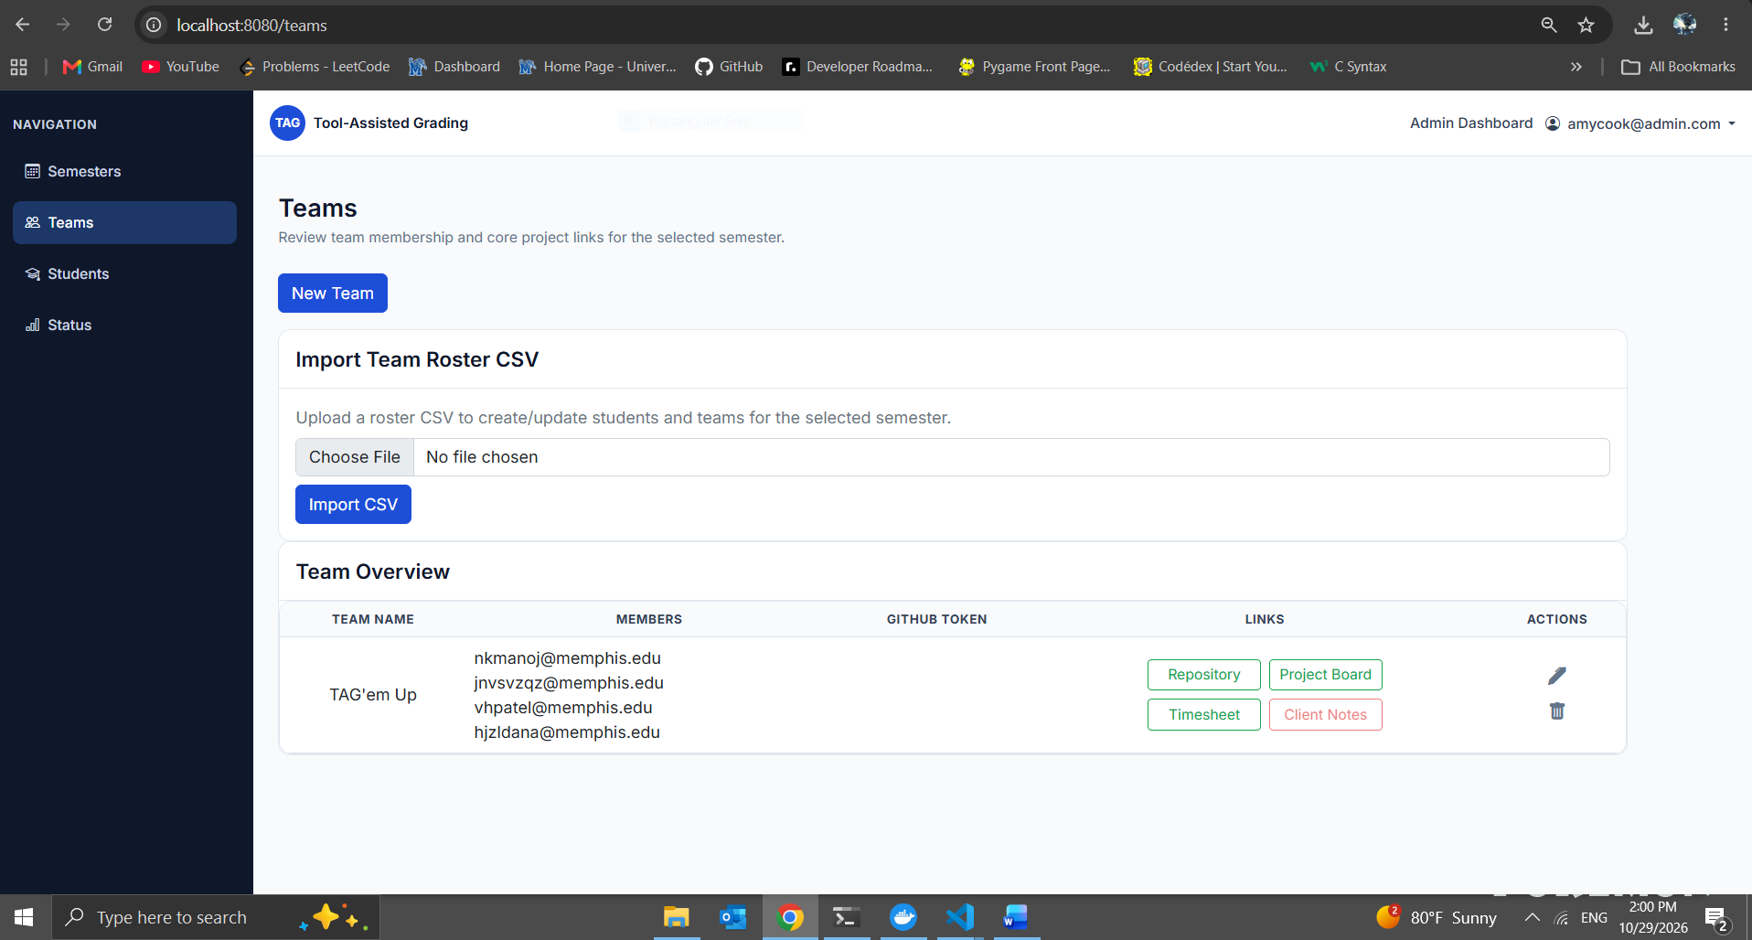

Findings
Strengths:
- The application has a clean UI and is easy to navigate with clear distinction with the pages.
- All the links, buttons work well without any issues. The links are also editable. The applications passes different test cases such as the application doesn’t allow different format files apart from .csv which allows the application to work smoothly.
Issues / Defects:
Description of Issue | Severity (Low/Med/High) | Evidence / Example | Suggestions
Not enough necessary data to test | Low | In the status page, there is no data on different sprints to check if the application picks up the information from the .csv file | Add data related to different sprints so it can be tested.
A student cannot be in multiple teams | Low | After a student is selected in a team, the student is still being able to be added to a different team | Lock-in a student to a certain team and not allow the student be in more than one team at once.

Requester Follow-Up
- How will you address the feedback? If you decide not to, briefly explain why.
I will address the feedback by adding more sprint data to properly test the Status page and verify that the information displays correctly. I will also review the team assignment functionality to determine whether students should be restricted to one team and make changes if necessary.

