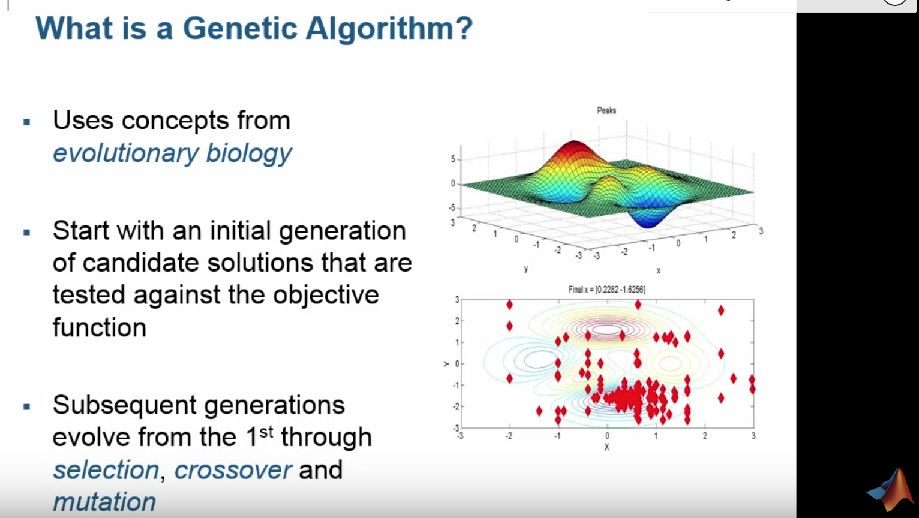

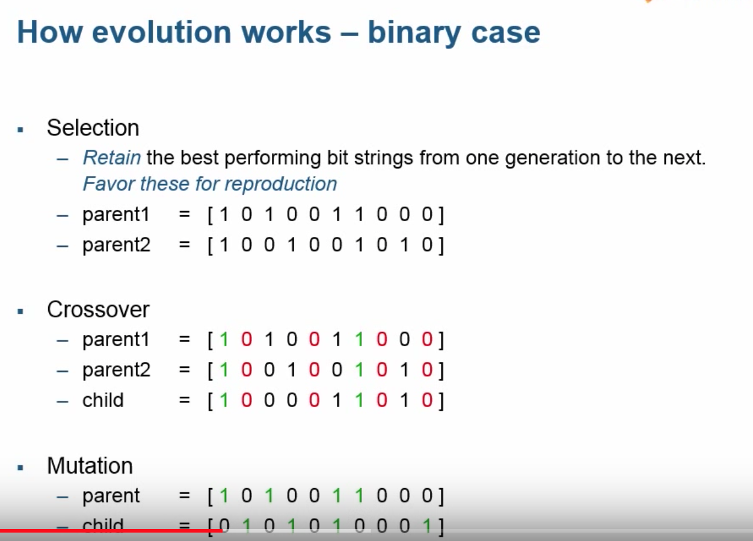

CrossOver is select common similarities between different parent variables and keep those the same to create children

Mutation: take a parent and mutate certain variables to take on random values and create a child based on mutation….avoid falling into local minima

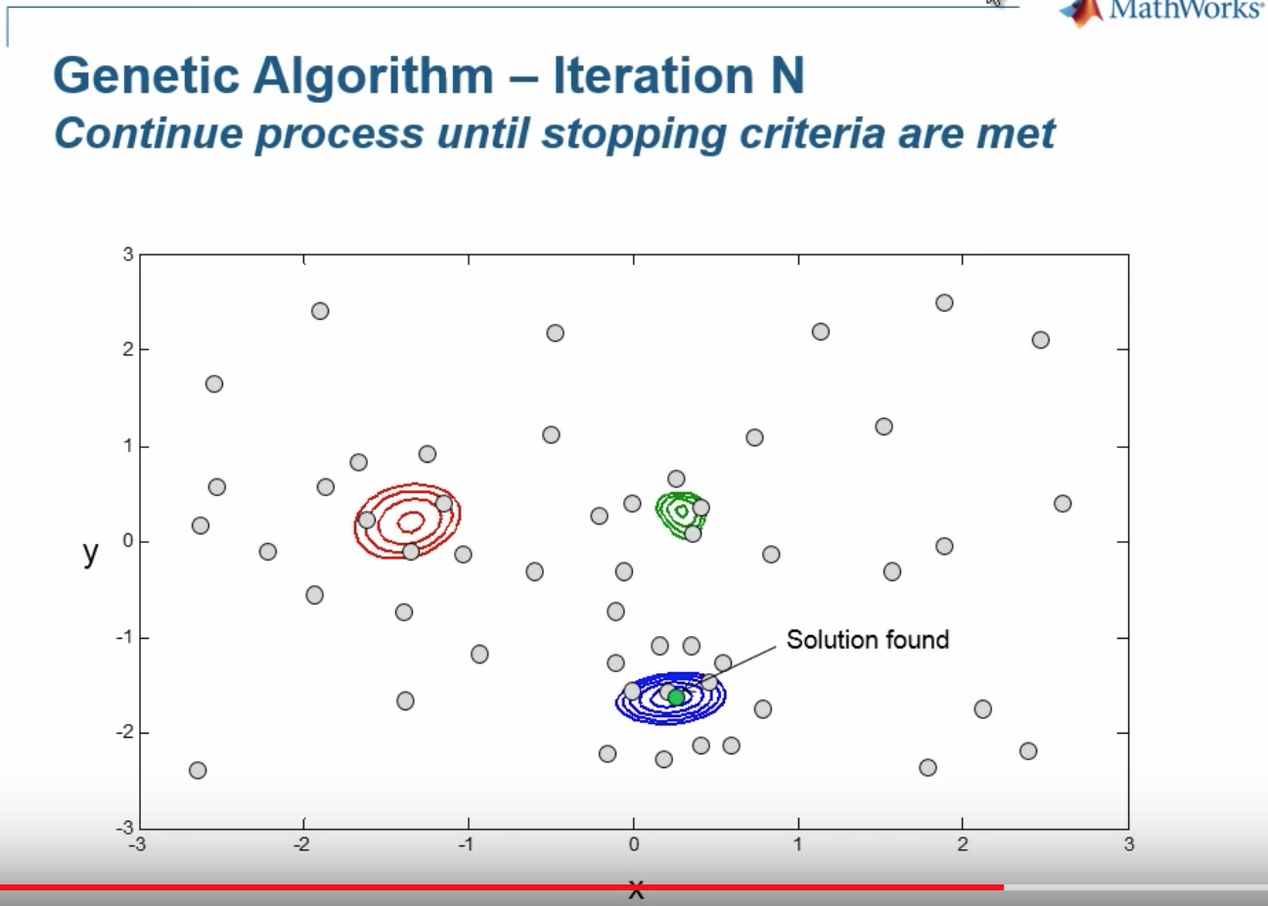

GA will run until it’s hit a certain number of generation or it converge when the best objective function or best fitness function value is no longer changing or it’s changing by a really small amount.

https://www.youtube.com/watch?v=1i8muvzZkPw