University of Hull: Archivematica, City of Culture, Untold Stories

University of Hull + Cottage Labs
08-06-2016

Objective of project

Archiving and dissemination of research data, images and other content (for example data from untold stories and current Hydra deposit interface) using Archivematica for the archiving process and Hydra for the dissemination of content. This is done as part of the Jisc project finishing in mid-September.

The purpose of being able to archive the content in this way is primarily to meet research council mandate requirements. The exact way in which compliance will be evaluated is currently unknown. The secondary purpose is for general discoverability of research produced by the university.

In addition, this Archivematica process will be used to support the City of Culture work, which consists of:

- City of Culture Company records (the business archive)
- Records from companies putting on events (creative archive)
- Input from those attending the events (the participation archive)

General Process workflow
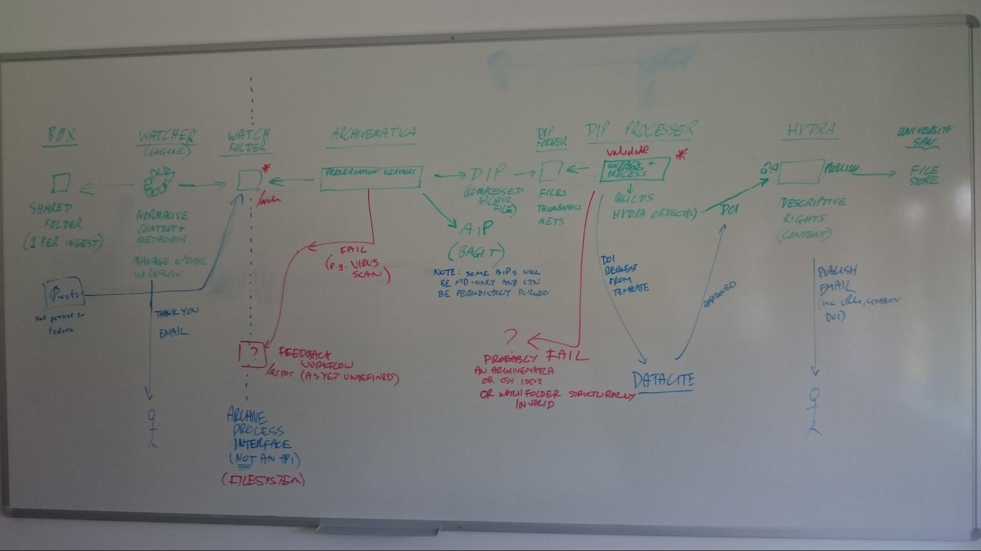

Files to be deposited will enter the process in a shared Box folder.

Question: How will users share folders with the deposit process?
Option 1: Hull creates folders and shares them with users to populate
Option 2: Users are asked to share folders with a Hull account when they wish to deposit

The preference is for option 2. Decision pending based on BOX API capability. With option 2 we ask the user to share the folder when they are ready and so we know what to watch.
- What information can we get about a shared folder (i.e. who shared it and when)
- What information can we get about files placed in a shared folder (e.g. last updated times, file created date)

The shared folders will be observed by a “Watcher” process which determines when a new directory has been created and populated (most likely via integration with the Box API). (Note, this is specific to the Jisc Archivematica project, but the pattern may well be re-used in other projects)

Note: there is an outstanding question over how update workflows are handled. What happens if the shared folder later changes, or is removed by the user?

The “Watcher” will be responsible for creating a BagIt file which conforms to the Watch Folder specification, defined in the next section.

This Watch Folder provides an effective “interface” to the archiving process - all deposit services will be integrated at this point, by requiring them all to produce a BagIt in a Watch Folder which meets the requirements. On the diagram the existing deposit interface (Proto-queue) is shown as an example.

The Watch Folder is in turn monitored by Archivematica which will produce an AIP and a DIP. Note that both metadata-only and full content items will be processed in the same way; although this will result in the creation of a lot of small, potentially unnecessary, AIPs, this is simpler than alternatives we explored which look at applying different workflows in different cases.

Question: how do we handle errors at the Archivematica stage? The need for this has been articulated in the diagram, but no solution has yet been specified.

The DIP output by Archivematica is picked up by a “DIP Processor” which will convert the DIP into a Hydra Object (see below for specification), register a DOI with DataCite (in the case of a research data object), and push the data into Hydra via the Hydra API.

Data for archiving and dissemination

The data for archival will be available in one of the following locations
Box
Local storage directory
Web form (Hydra / Fedora - proto queue in current Hydra workflow)
Users will need to follow the following structure when providing data through Box or local folder
Metadata to be added in a file called DESCRIPTION.txt written if the format
Title:
Authors: (separated by a semicolon)
Description:
Citation to papers:
Visible files: list all filenames whose surrogates will be made available in Hydra. Semicolon separated. If all files need to be made available, use the word all.
We could create description.txt keeping in mind that we support all of the dublin core fields.
If there are multiple files and the user would like each of these files to appear on its own, then they can provide the metadata for each object in a comma separated value file (csv) named DESCRIPTION.csv containing the following columns
Filename
Title
Authors (separated by a semicolon)
Description
Citation to papers:
Visible files:
Pid label: T
If the user would like to share further information (for example regarding rights / licences or have additional descriptive information), this can be added to file named README.txt. The information in this file will be read by the ‘qa person’ who will act accordingly or get back to you if needed.
If you do have citations of the papers related to the data available in other formats like bibtex (expand on this) this can be provided in a file named CITATIONS.bib / CITATIONS.---
All other files in the folder will be assumed to be content files.

DIP Processor and Hydra Objects
There are two possible processing models, depending on the settings in the incoming DIP:

- The DIP maps to a single Hydra Object with the following datastreams
  - DESC_METADATA created from the description.txt, the provenance data, the DOI and any citation files in formats that we understand
  - RIGHTS_METADATA created from the rights information (route into the system TBD)
  - PROPERTIES created from user data (id, email) and ingest route (box, proto, etc)
  - RELS_EXT populated with the content model
  - ADMIN_INFO populated with the readme.txt and any citations that are not in a format that we recognise (could be part of PROPERTIES)
  - Files are provided in a flat structure (see below for further notes)
- The DIP maps to multiple Hydra Objects (e.g. an image collection) (when the “admin info” says that the object structure is “multiple”)
  - For each row in description.csv, do the following
  - Create a description.txt by taking any existing top-level description.txt and overlaying metadata fields taken from the csv where present. Also fold in any provenance information, citation information, and mint a DOI (where necessary).
  - Treat the sub-object as per (1), but only incorporate the single file referenced by the row in description.csv. This means that for each hydra object, information such as the user info, the readme, citations, rights, etc are duplicated.

A note on flattening files; the user may provide us with:
- A directory with one or more files in a flat structure
  - This will be presented as single object with multiple content datastreams or as multiple objects with a single file each (depending on presence of description.csv/appropriate admin info)
  - Note: zip files will be kept as zip files, and not unpacked at any point in the process
  - Advice users to not provide zip, but if they do we will not unzip it
  - If there are zip files with a description.csv which seem to describe the files in the csv, raise an error
- A directory with a hierarchical file structure
  - This will be zipped and added into hydra as a single object, unless there also exists a DESCRIPTION.csv. In which case we raise an error.
- If the csv does not match up with the content for a multi object
  - Create the metadata for filenames where possible.
  - Deal with this use case as best as possible

Metadata to be extracted from the Premis
- The AIP pid needs to be added as an alternated identifier to the MODS
- Location data from the metadata premis exif

Note: DIP processor will need to pre-validate DIPs against the rules for interpretation of the ingest package (e.g. description.csv + multiple zips == error). These rules need to be properly defined as part of the spec work.

Jisc Archivematica Project

The Watcher

The watcher will produce a Bag (conforming to the Bagit spec) as in the attached image and add it to a watch folder.
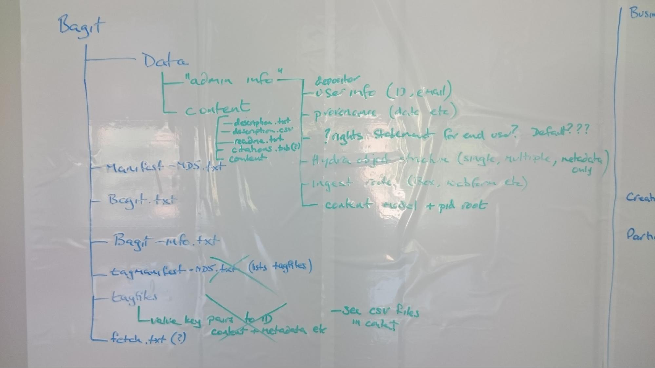

The bagit data folder contains the user content in a folder called content along with administrative information required by the system in a folder called admin_info containing a file with the information as laid out in the diagram above along with the pid label to be used for the Fedora objects. The content model will be one of a set of dictionary of terms describing the model

When the user provides no descriptive metadata i.e. the folder contains no files named ‘description.txt’ or ‘description.csv’, the watcher will produce a file called description.txt containing the information
Title: authorName_date (author info obtained from the single sign on credentials)
Authors: author name
Note: We could extract the file creation date from the file if not given (note: this is likely the deposit date and not the file creation date)
If the user provides a csv file with just the filename but with no other info in the other columns, we will populate the title column as authorName_date and author columns with the author name.
By default no surrogates will be added to Hydra and a metadata only record will be created unless the information was provided by the user.

Bagit-info.txt is envisaged to be used in the future to add metadata that archivematica can consume and include in the METS file produced by it.

Similarly, the fetch.txt file is also envisaged to be used in the future, providing URLs of the content files which will then be fetched by Archivematica.

When the watcher has been successfully processed and moved into the watch folder, it will email the user acknowledging receipt of content.

The data in the watch folder will be consumed by Archivematica which will produce an AIP and DIP.

Question: How does the watcher monitor files added / updated in the Box folder or local storage and decide to act on it. (30 minutes after last modified date it is processed by the watcher?)

Enhancements to the Hydra Interface for dissemination
- Create a landing page for images. This will need to include a download of image from store.
- Create a landing page for the display of research data
- If the Hydra Object contains a single zip file, provide a view of the ToC of that zip and ability to download a single file from the zip

City of Culture unzip
- Capture for City of Culture is out-of-scope - it is anticipated that this will be done by the council, and that we should only aim to provide them a well-documented interface to the Watch Folder to enable integration
  - Alternate is to provide them a web form where they can add the location of the folder and enter in the required metadata
- Dissemination and discovery for City of Culture is not well defined - it would be useful to see what their requirements are
  - We may need to deal with differential permissions - i.e. the user can see an image of this resolution but not the higher resolutions (capture in description.txt and process in DIP processor)
  - They would like both image and video to be displayed
  - Consider installing Avalon to surface the video and audio files, use an external play site or do format conversion to a specific format which we support and play
- There is a hole in the Hydra gems space for an “intellectual arrangement” tool to enable the construction of collections, etc, during curation by archivists
- City of Culture may be trying to archive more complex data forms such as video (e.g. from YouTube), images, twitter streams, etc. Capture of such data may be an issue for the council, but display of such data could be an issue, so we should engage with them to find out their requirements.
- Some content from City of Culture may be by-reference (e.g. blog posts, youtube videos) - we should find out what their requirements here are.
- The content from city of Culture may need to be reviewed before getting to the Box / local storage

Types of Content from City of Culture

Business Archive
Documents (reports on progress, papers, proposals for projects, progress updates, consultancy reports, plans, strategy documents, accounts)
- Are these all public records. Are some restricted?
- Software needs to preserve file structure
  - has to be zipped and added into Hydra if file structure needs to be preserved - need to implode it for archivematica and zip-it up in the dip processor before adding to Hydra (single object in admin)
  - In hydra we need to create the functionality to view the zip file and extract just a single file
  - Provide a webform to upload file location and add metadata including rights
- Files will be picked up from a shared file system (not the Box)
- The rights statement may be different for each content file

Deposit implementation options:
Option 1: Web-form which allows the archivist to specify a file-system node and some metadata
Option 2: Have the archivist provide a well defined directory/file structure containing description.txt, etc

Creative archive
Same as Business Archive but with more file formats (technically same as above including web form and processing)
The rights statement may be different for each content file
Will get a curated set

Participant archive
Same as Business Archive but with more file formats (technically same as above including web form and processing)
- Data submitted to the watcher through an app specifically via Box (so also similar to the Research Data deposit)
- The rights statement is a default which all others agree too in the app
- Content provided by app which will work to our bagit data spec
- Could the app support fetch.txt - the app should provide the url of the content to download - NOT US if we / archivematica were to download)
- Highlight to City of Culture that URLs can be dereferenced during deposit, but this should trigger a conversation with them about what this actually means (i.e. we are not going to archive twitter streams from a hashtag URL, we want to download a well-defined resource)

Untold Stories
Due 2018, expect around 4000 audio recordings
Expect to use the same infrastructure as City of Culture
Considered the possibility of using 3rd party content delivery services such as Vimeo, Soundcloud, etc...

What Next

- How to get the rights statement for the research data archive
- Make the case for model of sharing Box folders
- Write a definitive specification (first draft) of the Watch Folder BagIt
- Write the processing description for the DIP Processor
- Box API investigation
- Archivematica investigation (around success/error handling)
- Hydra Object specification
- What is the error handling approach for the overall process?
- Consider the update workflow process (when files change or are deleted), or develop a mitigation (e.g. explicitly don’t support)
- Technical design documentation for the overall archive and dissemination process (taking into account the above)
- CL to estimate for minimum viable amount of work to deliver for Jisc Archivematica work
- Consider how test version of the infrastructure can be provided both for the Hull-based project team (inc CL) and any 3rd parties (such as City of Culture app developers)

