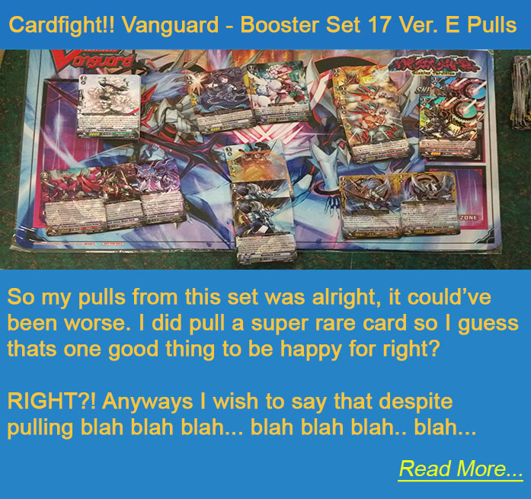**Blog**

This is a blog that will be generated by the xml database.  
  
The expected data fields are :  
<blogTitle></blogTitle>

<blogDesc></blogDesc>

<blogImg></blogImg>

<blogComments></blogComments>

<blogKeywords></blogKeywords>  
  
These blogs will be generated on the homepage, of course if the blog is very descriptive then only a small portion of the blog will be shown and there is a Read More… link that will take the user to the blog page to read more.

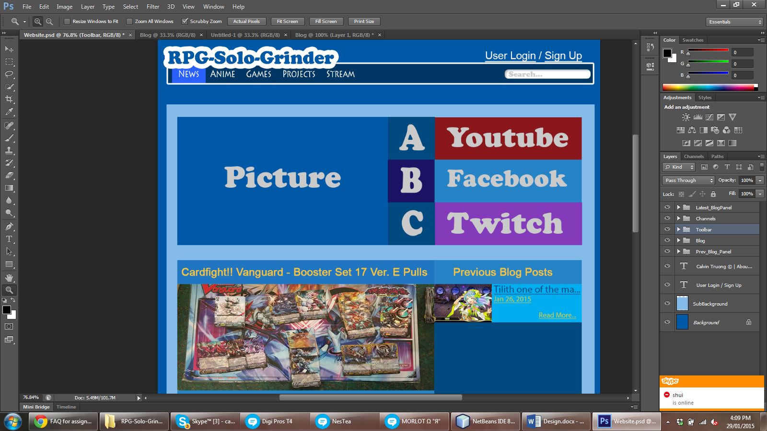

**User Login**

There will be a database that the user will use to login and out of the website.

The admins will be able to modify the contents of the blogs, while the users can only view it and comment.

The database will hold for the user:

Username, Password, Email, Avatar, and status

Username is the name to be used to login.

Password is the access key required to login.

Email is a way to contact the user.

Avatar is the user’s personal image to represent himself when he/she comments

Status indicates if the user is an admin or user.

**Picture Panel**

At the start of the website, the picture and A, B, C will be populated with what the admin wants to display. This could be either advertisement, hottest blogs, or favorite blogs. The darker background for B means that it is selected and that is the current Picture for B. Clicking on the picture will direct the user to the blog or destination of what the picture was intended for.

**Media Buttons**

Buttons that will direct you to the blog owner’s official media website which may be youtube, facebook, and twitch.



**Search Bar**

The search bar will allow the user to search for blogs based on what the user inputs. The search will be based on the title of the blogs and not on the content of the blogs. The user can also type in keywords and it will bring out blogs with the related keywords.

**Toolbar**

The toolbar is the main component of the website for the user to navigate.

* Logo: Will redirect the user to the homepage
* Anime: Will redirect the user to the anime page.
* Games: Will redirect the user to the game page.
* Projects: Will redirect the user to the Projects page.
* Stream: Will redirect the user to the stream page.



**Previous Blog Posts**

The previous blog posts will populate with previous blogs. Clicking on them will redirect the user to the respective blog page.

**Footer**

The footer is one of the main component of the website. Clicking on the links will redirect you to the respective pages:

* About: Will redirect the user to the about page.
* Contact Us: Will redirect the user to the contact page
* Terms of Service: Will redirect the user to the service page
* Privacy Policy: Will redirect the user to the privacy page