|  |
| --- |
|  |
|  |
| CO4015 Computer Science ProjectAn Android Application of a Canteen Ordering System **Interim Report**  University of Leicester  School of Informatics  Joshua D. Brookes  Submitted: November 2020 |

**DECLARATION**

All sentences or passages quoted in this report, or computer code of any form whatsoever used and/or submitted at any stages, which are taken from other people’s work have been specifically acknowledged by clear citation of the source, specifying author, work, date and page(s).

Any part of my own written work, or software coding, which is substantially based upon other people’s work, is duly accompanied by clear citation of the source, specifying author, work, date and page(s).

I understand that failure to do this amounts to plagiarism and will be considered grounds for failure in this module and the degree examination as a whole.

Name: Joshua Brookes

Date: 24th November 2020

**Table of Contents**

1 Aims and Objectives 3

2 Literature Survey 4

3 Requirements 4

3.1 Administrator Application 4

3.2 Android Application 5

3.3 Summary of Challenges 5

4 Outline of Specification and Design 6

5 Planning and Timescales 8

6 Bibliography and Citations 9

**1 Aims and Objectives**

This project aims to develop an Android app that allows users to order products in advance, and allows them to be able to collect the order safely and on demand. This is paired with an administration side program that can recreate the brick-and-mortar location’s product selection easily on the system, manage orders and serve customers. The end product is targeted towards universities and other educational institutions, and is especially designed for campuses with multiple outlets for patrons to visit.

The proposed benefit of the app from the patron’s point of view is the ability to plan meals in advance, as the app will provide menus for every location up to the end of the next full week that users can order from. This will be enabled by having the administration side of the system set menus for each day at each location. To make this as user-friendly as possible, the administrator will be able to reuse previous menus from that location, and in the case of creating a new menu, be able to toggle the availability of products from the list that would then be hidden to the patron ordering from that menu. In addition, it will be possible for the user to filter out allergens they may have, and add this to their order to ensure their order is safely prepared; as such it will also be possible for the administrator to set the allergens and other dietary necessities for every item. As a result, it will be possible for patrons to filter items in a menu by dietary restrictions and cost, as well as simply searching by an item’s name.

The main objectives of this project are as follows:

* Develop a database that can store the information for locations, users and orders.
* Develop a desktop application that can manage the administration of the ordering system.
* Develop an Android app from which users can order items in advance for collection on demand.

**2 Literature Survey**

In this section, I will outline what laws are currently in place for providing nutritional and allergen information, and the steps required to collect it for display in the system. I will then discuss how feasible it will be for these steps to be taken, and what information will be included in the final system. Firstly, it should be stated outright that the information that follows will apply specifically to the United Kingdom. The UK government provides regulations on food packaging and what nutritional information must be displayed, and this is defined in the Technical Guidance on Nutrition Labelling [1]. In this guidance, it states that “back of pack” nutrition labelling must declare energy in kilojoules (kJ) and kilocalories (kcal), as well as the amount of “fat, saturates, carbohydrate, sugars, protein and salt” in the product.

However, this is not mandatory for “food offered for sale to the final consumer […] without pre-packaging” or “foods prepacked for direct sale” [1], but options are given that reduce the amount of information displayed; this can be as little as only the energy values, if one wishes to include any information in the first place. As such, for a university to provide any amount of information as described above, they would likely need to send samples of all of their products to a private company for nutritional testing. This added expense is naturally not one a university’s catering department would wish to have if at all possible. As a result, it wouldn’t make sense for this system to require caterers to provide nutritional information when they don’t legally have to, and in many cases don’t anyway. It should still be that the administrator is able to enter the energy value of the products, but this should not be required for any items.

On the other hand, allergens must be declared on all prepacked and non-prepacked food and drink, as explained by the Food Standards Agency [2]. These 14 allergens are: celery, cereals containing gluten, crustaceans, eggs, fish, lupin, milk, molluscs, mustard, nuts, peanuts, sesame seeds, soya and sulphur dioxide [2]. As this information is already gathered by university catering departments, this information should be included in the system. However, it could also be said that a patron’s allergens should also be included when placing an order, to ensure that their order is prepared safely. Similarly, there are other dietary restrictions that are not included in the allergen list that could be described as self-imposed, such as vegetarianism and veganism, that should also be included in the system as an allergen. This is predominantly because other than the consequences of ingestion, these self-imposed allergens and the 14 medically imposed allergens are the same, especially from a food preparation perspective.

**3 Requirements**

*3.1 Administrator Application*

* Locations can be setup with a calendar view which can have each day selected.
* Each day selected opens a menu with further options.
* If a menu has not been set with a month until the date in question and the location is set to open, a small warning is displayed on that date on the calendar view.
* A day’s menu contains options to create a menu.
* A day’s menu contains an option to load a previously used menu.
* A location can be set to be open or closed on a selected day.
* A menu consists of categories of items, and a section for deals which is always at the top of the menu.
* Each item can be set on each day to be available or not.
* Unavailable items will be hidden to the customers ordering.
* Each item can have the following attributes set: name, price, photo, allergens, calories.
* The allergens that can be selected are the 14 main allergens as defined by the Food Information Legislation.
* Each item can be selected from the prospective menu to be promoted or have a reduced price set (special offer).
* A promotion can be set so that an item or deal can be highlighted to customers on their home page.
* A promotion consists of a picture advert that is placed in the top banner of the customer’s app.
* A special offer can be set that reduces an item’s price between two set dates.
* A deal can be set by grouping together items of a similar type into multiple groups, connected by either an ‘and’ connection or an ‘or’ connection.
* A deal can have its price set with mark-ups for certain items in groups.
* A deal can be set to run between two dates or set indefinitely.
* Upcoming remote orders can be summarised to allow for stock control.
* Upcoming remote orders can be viewed by day for the upcoming week or by the week itself.
* Each location’s orders can be viewed to allow its compilation by staff.
* Each location can reject orders as necessary, which alerts the customer.
* Available payment methods can be enabled or disabled.

*3.2 Android Application*

* New locations can be added by searching for the campus by name and selecting it from the list of results.
* The top of the main screen should show a rolling view of promotions.
* Clicking a promotion takes the user to the promoted item in the menu.
* Clicking a location starts an order for a selected day.
* Categories on a menu can be expanded to view that category’s items.
* Orders can be started for the remainder of the current week, plus the next week.
* Items in a menu can be filtered by the 14 main allergens as defined by the Food Information Legislation, and their price.
* Items in a menu can be searched for by name.
* Items in a menu can be filtered by cost and dietary restrictions.
* Orders are collected by scanning a QR code upon entry to the pickup location.
* Orders can be paid for upon checking in at the location.
* Orders can be updated or deleted at any time by the customer until they check in at the location.
* Meals can be recommended to the customer when they select the recommend button on the toolbar at the bottom of the screen.
* Recommendations will be based on similar items that the user has purchased recently.
* An order should list any allergies a customer has.

*3.3 Summary of Challenges*

This section will briefly outline the most difficult sections of this project. There are two significant challenges to this project, namely QR code creation and reading, and handling payments. This is predominantly because both may require external APIs to be added to the project that could cause compatibility problems or added expense, especially in the case of handling payments. Also, many universities or colleges will have multiple different and unique payment systems, so the main challenge there would be finding a way to incorporate all of them, or as many of them as possible.

**4 Outline of Specification and Design**

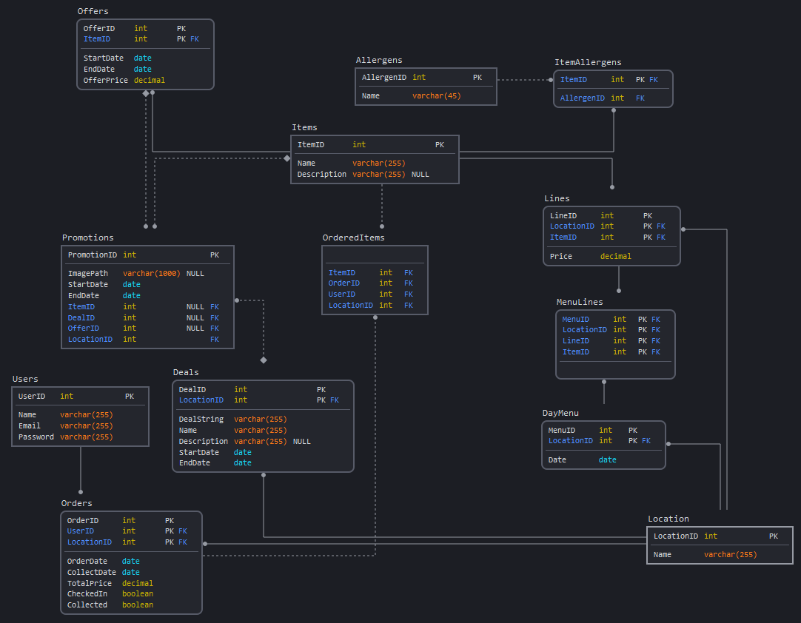As mentioned earlier, there are three main aspects to this system: the administration program, the Android app, and the database that links the two together. This section will outline this database, its structure, how concurrency issues are to be dealt with, how information will flow between the database and the two subsystems. Finally, this section will show how deals will be stored in the database.

Figure 1: Planned structure of the database

The diagram in Figure 1 shows the planned structure of the database system. Relationships between tables are identifying if the line between them is solid, and by contrast the relationship is non-identifying if the line is dashed. If the end of a line is circular, this represents ‘many’, while a diamond represents ‘zero or more’, and no shape on the end of a line means ‘one’. For example, the relationship between the tables ‘Offers’ and ‘Promotions’ is one offer to many promotions, but not every promotion has to have a deal as an attribute; the ‘DealID’ attribute can remain null.

The system will allow for menus to vary between days and locations, using the ‘DayMenu’ table. This covers a typical occurrence in campus eating establishments that makes it slightly different to standard restaurants in that the menu often changes on a daily basis. To improve user friendliness, it will also be possible to search through past menus for reuse, saving the administrator of the system a significant amount of time by not having to manually recreate menus for every day. A similar case is present for items and lines. Items can be searched for across all locations for reuse, then used to create a line, which makes that item specific to a location with a certain price. An item can naturally be present in multiple lines as it may appear in multiple locations.

With a database on this size, it is important to consider concurrency issues. There are likely two common ways where concurrency could occur, one where an administrator and a patron make changes to the database simultaneously (in the patron’s case by placing an order in all likelihood), and one where two or more patrons place orders simultaneously. The former is likely to be less of an issue because of the design of the database, the only tables where the patron can make edits are the Orders, Users and OrderedItems tables, all of whom being tables the administrator would never edit (although the Orders table could theoretically be edited by the administrator in an emergency). However, the latter offers more of a problem. Multiple users making an order could cause a clash in the Orders table if not dealt with appropriately. However, modern database management systems are able to deal with concurrent insert queries, for example MySQL will perform the concurrent queries in sequence without data clashes provided the “concurrent_insert” setting is set to 1 (Auto) or 2 (Always) [3].

Finally, there are three extra tables included in the database system that represent temporary changes to a location’s pricing structure or visibility. The first of these tables is the Promotions table; this gives the administrator the ability to promote an item, a deal or a special offer for a set time period by displaying an image as a banner at the top of a patron’s app’s home page. Pressing on this image would then redirect the patron to the promoted item or deal. Special offers are stored in the Offers table; special offers allow the administrator to reduce the price of an item for a set period of time. On the patron’s app, both the usual price and the reduced price would be displayed, as well as the end date of the special offer.

The final table stores deals in its namesake table in the database. Deals give the administrator the ability to group items together into groups, and link that group with others using combination commands (“and” and “or”), and set that combination to an overall price. This structure is most commonly seen in “meal deals” wherein you would typically be able to buy a sandwich, a packet of crisps and a drink for example for a certain price. The structure that such a deal could be defined is stored in the “DealString” attribute, and is outlined below:

Syntax:

* Use ItemID rather than the Item’s name (to ensure the deal string is concise)
* ( ) – Statement Group
* { } – Item Group (commas used to separate items in the item group)
* [ ] – Item Surcharge
* * – And
* / – Or
* = End of statement (this is followed by the standard deal price before any item surcharges)
* Whitespace is ignored

Example:

({3, 6, 17 [0.3], 27} * {14, 2, 28}) / ({71, 66, 112 [0.5]} * {229, 236}) = 4.5

In the example, firstly selecting items with the ID 17 or 112 incur a 30p and 50p surcharge respectively. The patron can then select an item from either the first and second groups, or from the third and fourth groups. Finally, the final price of the deal is £4.50, excluding any surcharge from premium items (items 17 or 112 in this example).

**5 Planning and Timescales**

**6 Bibliography and Citations**

[1] Department of Health. (2016, September). *Technical guidance on nutrition labelling* [Online] Available: https://assets.publishing.service.gov.uk/government/uploads/system/uploads/attachment_data/file/595961/Nutrition_Technical_Guidance.pdf

[2] Food Standards Agency. (2020, April 2). *Allergen guidance for food businesses* [Online] Available: https://www.food.gov.uk/business-guidance/allergen-guidance-for-food-businesses

[3] MySQL. (Unknown). *MySQL 8.0 Reference Manual 8.11.3 Concurrent Inserts* [Online] Available: https://dev.mysql.com/doc/refman/8.0/en/concurrent-inserts.html