**NATIONAL INSTITUTE ON AGING ALZHEIMER DISEASE FAMILY BASED STUDY**

**PROCEDURES MANUAL**

**June 2023**

**TABLE OF CONTENTS**

1.0 Abbreviations 4

2.0 Purpose 5

* 1. NIAADFBS Information 6
  2. Participating Sites
  3. NIAAD-FBS Contacts
  4. Family Recruitment and Evaluation 7
  5. Recruitment Inclusion/Exclusion Criteria
  6. Recruitment Procedures
  7. Clinical Evaluation on New and Follow up Individuals
  8. Minimum Data Set
  9. Globally Unique Identifier (GUID)
  10. **Biofluid Collection** **8**
  11. Biospecimen Collection
  12. Biospecimen Collection Kit Contents
  13. Kit Requests
  14. Blood collection and Processing Procedures

5.4a Site Coordinator Instructions for contracted Mobile Phlebotomy services 5.4b Biological Sample and Shipment Notification Forms (Page 13)

* 1. c. Participant Instructions for contracted Mobile Phlebotomy appointments
  2. Labeling Samples
  3. Instructions for Plasma/Buffy Coat/PBMC Kits
  4. Instructions for PBMC/DNA Combo Kits
  5. Instructions for Genetic Testing Kits
  6. Instructions for Saliva Kits
  7. Sample Redraws
  8. **Data Collection** **37**
  9. Data Collection Schedule
  10. Data Cleaning
  11. **Brain Autopsy** **37**
  12. Deceased family member with previous autopsy
  13. Current Participants and Family Members Program Enrollment
  14. Autopsy results
  15. Brain shipment and coordinator contacts

#### Informed Consent 38

* 1. Consent Procedures

#### 9.0 Trainings and Certifications 39

#### Appendices List 40

* 1. Appendix A: Minimum Data Set
  2. Appendix B: Dementia Questionnaire 10.3 Appendix C: Sample Consent Form
  3. Appendix D: Sample Collection Form
  4. Appendix E: Queries/Discrepancies Dictionary 10.6 Appendix F: GUID Demographics form
  5. Appendix G: NYBB Fresh Tissue shipping instructions
  6. Appendix H: Sample Form for Frozen and Fixed Brain Tissue

#### Abbreviations

|  |  |
| --- | --- |
| AD | Alzheimer’s Disease |
| ADRC | Alzheimer Disease Research Center |
| CT | Computer assisted Tomography |
| CUMC | Columbia University Medical Center |
| DNA | Deoxyribonucleic Acid |
| DQ | Dementia Questionnaire |
| EDTA | Ethylene Diamine Tetra-acetic Acid |
| FBS | Family Based Study |
| FTD GUID | Frontotemporal Dementia Globally Unique Identifier |
| IATA | International Air Transport Association |
| IRB | Internal Review Board |
| LBD | Lewy Body Dementia |
| LOAD | Late Onset Alzheimer’s Disease |
| EOAD | Early Onset Alzheimer’s Disease |
| MDS | Minimum Data Set |
| MRI | Magnetic Resonance Imaging |
| NaHep | Sodium Heparin (Green-Top) Blood Collection Tube (10 mL) |
| NCRAD | National Centralized Repository for Alzheimer’s Disease and Related Dementias |
| NYBB | New York Brain Bank |
| NIA | National Institute on Aging |
| NINCDS-ADRDA | National Institute of Neurological and Communicative Diseases and Stroke/Alzheimer’s Disease Related Disorders Association |
| NPIQ-CBRS | Integrated Neuropsychiatric Inventory questionnaire and the Behavior Rating Scale for dementia |
| PBMC | Peripheral Blood Mononuclear Cell |
| PCS | Personal, Cultural and Structural analysis |

#### Purpose

The purpose of this manual is to provide NIA AD-FBS staff (PIs and study coordinators) at the various study sites with instructions for family recruitment, sample collection and data submission. The following may be collected at each study visit:

* + - Medical History
    - Family History
    - Risk factors
    - Dementia Questionnaire (optional- for deceased individuals)
    - Psychometrics
    - NPIQ-CBRS
    - Whole Blood (for DNA and plasma extraction)
    - PBMC (for extraction of white blood cells)

These procedures are relevant to all study personnel responsible for data and biological specimen collection*.*

#### NIAAD-FBS Information

The National Institute on Aging -Alzheimer’s Disease Family Based Study (NIAAD-FBS) is a U24 proposal in which the main purpose is to develop or maintain unique resources to be shared with the scientific community. Dr. Richard Mayeux at Columbia University, Dr. Tatiana Foroud at Indiana University, and Dr. Alison Goate at the Icahn School of Medicine at Mount Sinai, are the co-principal investigators for this study.

#### Participating Sites

|  |  |
| --- | --- |
| **Site #** | **Site Name** |
| **4** | **Columbia University (coordinating center)** |
| **8** | **Indiana University** |
| **15** | **Rush University** |
| **22** | **University of Pittsburgh** |
| **25** | **University of Texas Southwestern** |
| **26** | **University of Washington** |
| **27** | **Washington University** |
| **61** | **University of Miami** |
| **62** | **North Carolina A & T** |
| **63** | **Case Western University** |
| **10R** | **Mayo Clinic Rochester** |
| **ISMMS** | **Icahn School of Medicine at Mount Sinai** |
| **64** | **University of California, Los Angeles** |
| **65** | **Rutgers University** |

#### NIAAD- FBS Contacts

|  |  |  |  |  |
| --- | --- | --- | --- | --- |
| **Site Name** | **PI** | **PI Email** | **Site Coordinator** | **Coordinator Email** |
| Case Western | Jonathan Haines | [Jonathan.haines@case.edu](mailto:Jonathan.haines@case.edu) | Renee Laux | [Ral119@case.edu](mailto:Ral119@case.edu) |
| Columbia | Richard Mayeux | [rpm2@columbia.edu](mailto:rpm2@columbia.edu) | Dolly Reyes- Dumeyer | [dr22100@cumc.columbia.edu](mailto:dr22100@cumc.columbia.edu) |
| Indiana | Jared Brosch | [jbrosch@iupui.edu](mailto:jbrosch@iupui.edu) | Kelly Horner | [kjhorner@iu.edu](mailto:kjhorner@iu.edu) |
| ISMMS | Alison Goate | [alison.goate@mssm.edu](mailto:alison.goate@mssm.edu) |  |  |
| Mayo Rochester | Brad Boeve | [bboeve@mayo.edu](mailto:bboeve@mayo.edu) | Amber O’Reilly | [oreilly.amber@mayo.edu](mailto:oreilly.amber@mayo.edu) |
| Miami | Margaret Pericak- Vance | [MPericak@med.miami.edu](mailto:MPericak@med.miami.edu) |  |  |
| NCRAD | Tatiana Foroud | [tforoud@iu.edu](mailto:tforoud@iu.edu) | Kelley Faber (manager)  Abigail Erickson (coordinator) | [kelfaber@iu.edu](mailto:kelfaber@iu.edu)  agericks@iu.edu |
| NCAT | Goldie S Byrd | [gsbyrd@ncat.edu](mailto:gsbyrd@ncat.edu) | Takiyah D. Starks | [tdstarks@ncat.edu](mailto:tdstarks@ncat.edu) |
| Rush | David Bennett | [dbennett@rush.edu](mailto:dbennett@rush.edu) | Celina Pavon | [CELINA_PAVON@rush.edu](mailto:CELINA_PAVON@rush.edu) |
| UPitt | Robert Sweet | [SweetRA@upmc.edu](mailto:SweetRA@upmc.edu) | Elise Weamer | [weamerea@upmc.edu](mailto:weamerea@upmc.edu) |
| UTSW | Roger Rosenberg | [Roger.Rosenberg@UTSouthwestern.edu](mailto:Roger.Rosenberg@UTSouthwestern.edu) | Amy Browning | [Amy.Browning@UTSouthwestern.edu](mailto:Amy.Browning@UTSouthwestern.edu) |
| UWash | Debby Tsuang | [dwt1@uw.edu](mailto:dwt1@uw.edu) | Sarah Peterson | [sk.peterson1@outlook.com](mailto:sk.peterson1@outlook.com) |
| WashU | Carlos Cruchaga | [cruchagc@psychiatry.wustl.edu](mailto:cruchagc@psychiatry.wustl.edu) | Joanne Norton | [nortonj@psychiatry.wustl.edu](mailto:nortonj@psychiatry.wustl.edu) |
| UCLA | Keith Vossel | [kvossel@mednet.ucla.edu](mailto:kvossel@mednet.ucla.edu) | Aisha Mohammed | [amohammed@mednet.ucla.edu](mailto:amohammed@mednet.ucla.edu) |
| Rutgers | Mark Gluck | [Gluck@Newark.rutgers.edu](mailto:Gluck@Newark.rutgers.edu) | Genesis Tan | [gt308@sph.rutgers.edu](mailto:gt308@sph.rutgers.edu) |

#### Family Recruitment and Evaluation

Sites will typically recruit individuals from their memory clinics, referrals from other sites, NCRAD or the Alzheimer’s Association, as well as previously unidentified members of existing families. We might also use advertisements such as radio, television and newspapers. We will recruit participants who meet the criteria as described in section 4.1.

#### Recruitment Inclusion/Exclusion Criteria

#### Inclusion criteria

|  |  |
| --- | --- |
| **INCLUSION CRITERION** | **METHOD OF ASCERTAINMENT** |
| **3 living relatives willing to participate.**   * **2 of them should be siblings** * **The 3rd could be any other family member (e.g. cousin, aunt/uncle, etc)** | Documented by history, medical records and/or examination |
| * First sibling with established diagnosis of definite AD (autopsy/tissue as described on the brain donation section 7.0**), probable AD OR a diagnosis of a related neurodegenerative disorder such as FTD or LBD. * Second sibling with established diagnosis of definite AD (autopsy/tissue as described on the brain donation section 7.0**), probable AD, or possible AD OR a diagnosis of a related neurodegenerative disorder such as FTD or LBD. 3rd family member with established diagnosis of definite AD (autopsy/tissue as described on the brain donation section 7.0**), probable AD, or possible AD OR a diagnosis of a related neurodegenerative disorder such as FTD or LBD. | Documented by history, medical records and/or examination |
| Identified companion to serve as an informant for all participants in the proband’s generation; | Self-report or report of family members |
| Participants who have capacity to consent or participants lacking capacity to consent with a surrogate/proxy in place to provide consent. | Research proxy/surrogate identified and documented in the research chart or next of kin (parent, spouse, adult child) identified and available |

**The inclusion of families with only two individuals affected will be permitted with the coordinating site’s approval, especially for non-Caucasian families.

Note: To allow flexibility on new recruitments, families will be divided into two tiers:

Tier 1 Families: All the criteria stated above must be met.

Tier 2 Families: Families where the original criteria are not met but there is at least one affected and another family member (cousin, aunt/uncle, parent) is affected, only one affected is alive and willing to participate or a family history of a deceased first degree relative with dementia.

* + 1. **Exclusion criteria**

|  |  |
| --- | --- |
| **EXCLUSION CRITERION** | **METHOD OF ASCERTAINMENT** |
| Failure to identify an appropriate informant; | Research staff will document surrogate and/or identify  next of kin |
| Uncertainty of the clinical diagnosis of Alzheimer's disease  or other related disorder; | Documented by history, medical records and/or  examination |
| Discovery of additional diagnosis that could account for the clinical manifestations; | Documented by history, medical records and/or examination |
| Unwillingness to participate; | As indicated verbally or if a participant is not able to speak by a physical sign or refusing blood draw |
| Failure to identify a living relative with AD or other related disorder; | Family history |
| Participant lacking the capacity to consent and does not have a surrogate or proxy or next of kin to provide consent. | Research staff must identify proxy or next of kin |

* 1. **Recruitment Procedures**
     1. **New Families Recruitment**

For new families, the research site physicians or NCRAD may refer individuals (probands) who report a known family history of dementia to the research study. Once individuals have been referred to the study, and the family is approved by Columbia University, the coordinator or research staff who are designated to obtain consent will explain study participation and enroll individuals in the study.

#### New Individuals within Existing Families

For new participants from existing families, the proband and/or informant will facilitate participation of other family members by contacting family members about the study. Family members who wish to participate may contact the study coordinator directly or may give permission for the study coordinator or research staff to contact them. Through advertisements and community talks, individuals may directly contact the study staff regarding research participation.

Families meeting the inclusion criteria will be enrolled.

#### Clinical Evaluation of New and Follow Up Individuals

Evaluations of participants will be the same across all sites. The diagnosis of AD is mainly clinical and rests on the physician, review of medical records and neuropsychological assessment. Computer assisted tomography (CT) of the brain, MRI or other laboratory studies are recommended to ensure full implementation of the NINCDS-ADRDA criteria, but for epidemiological studies this is not always feasible. Participants may also choose to go to their personal physician. We will establish and maintain contact with this individual in order to achieve the goals of confirming diagnoses. Participants may also choose to have imaging studies, laboratory investigations and neuropsychological studies as outpatients with their personal physician. Brain imaging results and laboratory results that are part of the participant’s clinical chart may be made available to the research study with consent of release of medical information from the participant or surrogate.

These records will be obtained for the purpose of confirming the dementia diagnoses.

Throughout the course of this study, participants who are unaffected or have questionable dementia will have a follow-up study visit every 18 months. At every visit, participants will get repeat neurological and medical examination, and neuropsychological testing in order to detect any change in the individual’s cognitive status. Individuals are selected for interviews based on several factors: willingness to continue participation, availability, and if they are still living. Eligible participants will be consented again using verbal consent via telephone (this might be different at every site depending on their IRB mandate). Participants could be given the option to be interviewed via skype.

#### For deceased participants at follow up, a DQ (Appendix B) or MDS should be completed with the informant or next of kin.

* 1. **Minimum Data Set**

We established a standardized minimum dataset (MDS – Appendix A) for the study that includes demographic, medical and risk factor information. This process ensured that uniform data is collected across this multi-site study. In many situations, the proband has already been enrolled in other studies and the MDS can be extracted from the study database. De-identified data is transferred electronically to Columbia University on a quarterly basis (section 6.0) and if problems are encountered with the data, Columbia University staff work with the site to resolve the issue. Each site assigns and codes disease status in a standardized way as defined in the MDS data dictionary. The data set is designed to accurately capture not only a subject’s diagnosis, but also how the diagnosis was made.

Some fields are designated as “required for all” or “required for sampled”. The variables are ordered so that required fields are at the beginning of the data set. Variables designated as “required for all” must be properly coded for every essential subject in a family regardless of whether he/she was sampled ensuring that family structure can be ascertained. “Required for all” fields cannot be left blank or coded as Missing/Unknown for any subject. Variables designated as “required for sampled” are data that are critical for genetic analysis and must be properly coded for sampled subjects as well as for subjects not sampled if the data are available. Columbia University will follow up with sites regarding required fields that are not properly coded. Each site is responsible for providing most recent information for subjects and will maintain one family data file to which new family members are added. When a site has questions regarding the data set, they contact the staff at Columbia.

#### Globally Unique Identifier - GUID

The GUID is a subject ID that allows researchers to share data specific to a study participant, without exposing personally identifiable information. A GUID is made up of random alpha-numeric characters and does not include any PHI in the identifier. By using GUIDs in your research data, the system can associate a single research participant’s genetic, imaging, clinical assessment data even if the data was collected at different locations or through different studies.

To create a GUID follow these steps:

1. Create an account: https://bricsguid.nia.nih.gov/portal/jsp/login.jsp
2. Once you have an account, go to the GUID Tool – Create GUID
3. To open the ‘Launch GUID Tool’ you will need to have Java installed on your device
4. In order to generate a GUID, the following PHI is required (Appendix F):
   * Complete legal given (first) name of subject at birth
   * If the subject has a middle name
   * Complete legal family (last) name of subject at birth
   * Day of birth
   * Month of birth
   * Year of birth
   * Name of city/municipality in which subject was born
   * Country of birthcoordinators will be able to create GUID retrospectively on anyone seen before the generator is up and running. The PHI data collected will be kept at the site and will not be shared with Columbia or NCRAD.

#### *Note: Please use the GUID Demographics Form in the Appendix of the manual to collect the necessary information. Details about the GUID generator site will be provided when available by NIA.

* 1. **Blood Collection**

Research specimen collection kits as well as shipping materials will be provided by NCRAD. These materials include blood tubes, packaging for shipping the blood tubes, as well as partially completed shipping labels to send materials to NCRAD.

Collection tube labels will be pre-printed with study information specific to the type of sample being drawn. Ensure that all tubes are properly labeled during processing and at the time of shipment according to section 5.3.

#### Biospecimen Collection

|  |  |  |  |  |
| --- | --- | --- | --- | --- |
| Visit*** | # of Collection Tubes | Sample Type | Collection Tube Type | Shipment |
| Initial Visit and at Follow Up | 2 | Whole blood for PBMC isolation | Sodium Heparin (NaHep Green-Top) Blood Collection Tube (10mL) | Room Temperature. Needs to be at NCRAD within 24 hours of collection. Cannot be shipped on Thursday or Fridays |
| Initial Visit and at Follow Up | 2 | Whole blood for plasma & buffy coat isolation | EDTA (Lavender-Top) Blood Collection Tube (10mL) | Dry Ice |
| Initial Visit (or at follow up if needed*) | 1 | Whole blood for genetic testing | EDTA (Lavender-Top) Blood Collection Tube (3mL) | Dry Ice |

*See section 5.8 for sample redraw guidelines. **Visits listed in order of blood draw per industry standards.

#### Biospecimen Collection Kit Contents

Collection kits are provided by NCRAD for each subject. Each collection kit provides the necessary supplies to collect samples from a given subject. Do not replace or supplement any of the tubes or kit components provided with your own supplies unless you have received approval from the NCRAD Study team to do so. *Please store all kits at room temperature until use.*

**Plasma / Buffy Coat / PBMC Kit**

|  |  |
| --- | --- |
| **Quantity** | **Plasma / Buffy Coat / PBMC Kit Components** |
| *Plasma/Buffy Coat Components:* | |
| 2 | EDTA (Purple-Top) Blood Collection Tube (10ml) |
| 1 | 15mL Conical Tube |
| 20 | Micronic tubes - 2mL PURPLE cap |
| 2 | Micronic tubes - 2mL GREY cap |
| 1 | Micronic tube - 2mL BLUE cap |
| 2 | Disposable transfer pipette (1mL) |
| 23 | Micronic Tube Labels |
| 6 | Kit Number Labels |
| 3 | Site and ID Labels |
| 1 | Cryobox 48-Slot Rack |
| 1 | Biohazard Bag w/ absorbent sheet |
| 1 | Large resealable bag |
| 1 | small label bag 4"x6" |
| 1 | Processing Schematic |
| *PBMC Components:* | |
| 2 | PBMC (Green-Top) Blood Collection Tube (10mL) |
| 3 | Site and ID labels |
| 2 | Collection Tube Labels |
| 6 | Kit number labels |
| 1 | FedEx Airbill/UPS Return Label (depending on the site) |
| 1 | FedEx ClinPak/UPS Laboratory Pak (depending on site) |
| 1 | Processing Schematic |
| *Ambient Mailer Kit:* | |
| 1 | Biohazard bag w/absorbent sheet |
| 1 | Refrigerant Pack |
| 1 | Ambient Shipper w/Insulated Cooler |
| 1 | UN3373 Category B Label |
| 1 | List of Contents Card |

**DNA/PBMC Kit (for offsite collection only)**

|  |  |
| --- | --- |
| **Quantity** | **DNA/PBMC Kit Components** |
| 2 | EDTA (Purple-Top) Blood Collection Tube (10mL) |
| 2 | PBMC (Green-Top) Blood Collection Tube (10mL) |
| 5 | Labels for handwritten Site ID, Family ID, and Individual ID |
| 4 | Pre-Printed labels for blood collection tubes |
| 2 | Kit number labels |
| 1 | Resealable bag |
| 1 | FedEx Airbill/UPS Return Label (depending on the site) |
| 1 | FedEx Clinical Pack/UPS Laboratory Pak (depending on the site) |
| 1 | Biohazard bag w/absorbent tube sleeves |
| 1 | Refrigerant Pack |
| 1 | Small IATA shipping box |
| 1 | UN3373 Category B Label |
| 1 | List of Contents Card |

**Mobile Phlebotomy Kits (only to be ordered and used by Mobile Phlebotomy company)**

|  |  |
| --- | --- |
| **Quantity** | **Mobile Phlebotomy Kits Components** |
| *Plasma/Buffy Coat Components:* | |
| 2 | EDTA (Purple-Top) Blood Collection Tube (10mL) |
| 1 | 15mL Conical Tube |
| 20 | Micronic tubes - 2mL PURPLE cap |
| 2 | Micronic tubes - 2mL GREY cap |
| 1 | Micronic tube - 2mL BLUE cap |
| 2 | Disposable transfer pipette (1mL) |
| 23 | Micronic Tube Labels |
| 6 | Kit Number Labels |
| 3 | Site and ID Labels |
| 1 | Cryobox 48-Slot Rack |
| 1 | Biohazard Bag w/ absorbent sheet |
| 1 | Large resealable bag |
| 1 | small label bag 4"x6" |
| 1 | Processing Schematic |
| *Frozen Shipping Components:* | |
| 1 | X-Small Insulated Frozen Shipper |
| 1 | Dry Ice Label |
| 1 | UN3373 Label |
| 1 | UPS Return Label w/Waybill (provided to RN by PCM management) |
| *PBMC Components:* | |
| 2 | PBMC (Green-Top) Blood Collection Tube (10mL) |
| 3 | Site and ID labels |
| 2 | Collection Tube Labels |
| 6 | Kit number labels |
| 1 | UPS Return Label (provided to RN by PCM management) |
| 1 | UPS Laboratory Pak |
| 1 | Processing Schematic |
| *Ambient Mailer Kit:* | |
| 1 | Biohazard bag w/absorbent sheet |
| 1 | Refrigerant Pack |
| 1 | Ambient Shipper w/Insulated Cooler |
| 1 | UN3373 Category B Label |
| 1 | List of Contents Card |

**Whole Blood Collection Kit for Genetic Testing**

|  |  |
| --- | --- |
| **Quantity** | **Whole Blood Collection Kit for Genetic Testing Components** |
| 1 | EDTA (Lavender-Top) Blood Collection Tube (3 mL) |
| 1 | Pre-printed Collection Tube label for whole blood |
| 1 | Label for handwritten Site ID, Family ID, and Individual ID |
| 2 | Pre-printed labels with kit number |
| 1 | Bubble wrap tube sleeve |

**Frozen Shipping Supply Kit**

|  |  |
| --- | --- |
| **Quantity** | **Frozen Shipping Supply Kit Components** |
| 1 | Frozen Shipper (Small frozen shipper/Sm brain box) |
| 1 | Dry Ice Label |
| 1 | UN3373 Label |
| 1 | FedEx Airbill/UPS Return Label (depending on site) w/Waybill |

**Saliva Collection Kit**

|  |  |
| --- | --- |
| **Quantity** | **Saliva Collection and Shipping Kit Components** |
| 1 | Oragene Saliva Collection Kit |
| 2 | Kit number labels |
| 1 | Label for handwritten Site ID, Family ID, and Individual ID |
| 1 | Small Saliva Biohazard Bag with Absorbent Sheet |
| 1 | Resealable Bag |
| 1 | Exempt Human Specimen Label |
| 1 | Shipping Envelope |
| 1 | UPS Return Label w/Waybill |

* 1. **Kit Requests**

Each individual site will be responsible for ordering and maintaining a steady supply of kits from NCRAD. Be sure to check your supplies and order additional materials before you run out so you are prepared for study visits. Please go to:

<https://redcap.link/FBS>request additional kits. Enter your site name from the drop down menu and follow the prompts to request the desired supplies.

When making your order please note:

* + - If the kit is for a follow up visit the visit number will be needed in the order. At the bottom of the kit request survey there is a place to indicate which visit you will be using the kits for. The kit will be assigned to the specific visit number for which it will be used. Please only use the kit for the specific visit for which it has been assigned.
    - There are 5 types of kits available for the FBS study:
      * Plasma/BC/PBMC, which will be used onsite and shipped back to NCRAD frozen (plasma, buffy coat) and ambient (PBMC).
      * Mobile phlebotomy collection Plasma/BC/PBMC kit, which will be used by the mobile phlebotomy RN and shipped back to NCRAD frozen (plasma, buffy coat) and ambient (PBMC).
      * PBMC/DNA kit which is the kit that you will send out to participants to have collected at the location of their choosing and shipped back to NCRAD ambient.
      * Whole Blood for Genetic Testing kit that will also be collected and shipped frozen from your site
      * Saliva kit
      * Frozen Shipping Supply kit that will be used by the site to send plasma, buffy coat, and whole blood (for genetic testing) back to NCRAD.

Please allow **3 weeks** for kit orders to be processed and delivered.

#### Blood Collection and Processing Procedures

**EDTA tubes:**

* Two 10mL EDTA solution (lavender-top) tubes should be drawn from all participants at the initial visit and follow up visits.
  + If collected via Plasma/Buffy Coat/PBMC kit (on site or by mobile phlebotomist), the 10mL EDTA tubes should be processed into Plasma and Buffy Coat samples. These samples need to be spun, aliquoted, and placed on dry ice within 2 hours, preferably within 30 minutes, from the time of collection. Overnight shipment is expected with cryovial on dry ice. Do not draw or ship samples on Thursday or Fridays.
  + If collected via PBMC/DNA kit, the 10mL EDTA tubes should be shipped to NCRAD ambient and unprocessed on the same day as collection.
* One 3mL EDTA solution (lavender-top) tube should be drawn from all participants at the initial visit. If not collected at the initial visit, this should be collected at a follow up visit.

**PBMC tubes:** At initial visit and follow up visits**,** two 10mL PBMC (NaHep green-top) tubes will be collected from all participants.

* For the NaHep tubes to yield the maximum number of viable white blood cells, it is recommended that these **tubes are processed within 24 hours after blood is drawn.** Samples should be sent ambient, immediately and by overnight courier to NCRAD. PBMC samples should not be drawn/shipped on Thursday or Fridays.

#### Important note:

In order to ensure that the highest quality samples are collected, processed, and stored, it is essential to follow the specific collection, processing, and shipment procedures detailed in the following pages. Please read the following instructions first before collecting any specimens. Have all your supplies and equipment out and prepared prior to drawing blood.

#### SPECIFIC INSTRUCTIONS FOR COLLECTION AND PROCESSING OF EACH SAMPLE ARE DETAILED ON THE FOLLOWING PAGES.

* + 1. **Site Coordinator instructions for collection utilizing contracted Mobile Phlebotomy services**

Site coordinators will be tasked to prepare and mail collection kits to the participant for the contracted Mobile Phlebotomy blood collection and schedule appointments for participants. The following instructions will detail this process.

#### Preparing mailing and kits for remote collection

1. Label all cryovials and collection tubes according to the instructions in this manual. (Section 5.5).
2. Personalize and print Participant Instructions document (Section 5.4c.)
3. Complete Site Coordinator contact information on Mobile Phlebotomy Procedures manual, located inside the Phlebotomist envelope.
4. Prepare Biological Samples and Shipment Notification forms
   1. Print a copy of the appropriate Biological Sample and Shipment Notification Form for each sample type that will be collected.
   2. Complete all areas of form EXCEPT sample specific information to be completed at the time of sample collection.
   3. Affix corresponding Kit labels to forms.
   4. Include UPS tracking number on each Biological Sample and Shipment Notification form from the prepared UPS return mailing stickers included with the kit to ensure the samples are tracked after being shipped by contracted phlebotomist to NCRAD.
   5. Place prepared Biological Sample and Shipment Notification forms inside Phlebotomist envelope.
5. Assemble mailing labels
   1. Affix UPS return mailing label to Ambient shipping box.
   2. Place UPS return mailing label for Frozen shipping box inside Phlebotomist envelope.
6. Assemble mailing to participant. Pack all materials inside of the dry ice shipping box with the Participant Instruction letter on top. Mailing will include:
   1. Collection kit materials with all cryovials labeled per instructions
   2. Participant Instructions letter- with Participant name
   3. Phlebotomist Instruction envelope.
      1. Mobile Phlebotomy Procedures manual- Collection, Processing and Shipping instructions
      2. Prepared Biological Samples and Shipment Notification Forms
      3. Preprinted UPS shipping label with each kit (frozen) that will be used to ship the samples to NCRAD after collection and processing.
7. Remove previous UPS shipping label from Dry Ice shipper. Affix FedEx mailing label. Seal box and ship via FedEx to the study participant.

#### Scheduling Mobile Phlebotomist Blood Collection Appointments:

The participant is instructed to contact the site coordinator if they would like blood collection via mobile phlebotomy. The site will then reach out to the mobile phlebotomist with subject information. The mobile phlebotomist will then contact the subject to schedule their blood collection appointment. Kits for mobile visits will be sent to the mobile phlebotomist.

Scheduling appointments with the mobile phlebotomist for blood collections should ONLY be scheduled **Monday through Wednesday**. Please notify the participants of this important scheduling information

**Critical note: When scheduling with the mobile phlebotomist, include “Special Instructions” that 10lbs Dry Ice and Centrifuge are needed for this appointment.**

#### Biological Sample and Shipment Notification Form

#### Biological Sample and Shipment Notification Form – PBMC and DNA

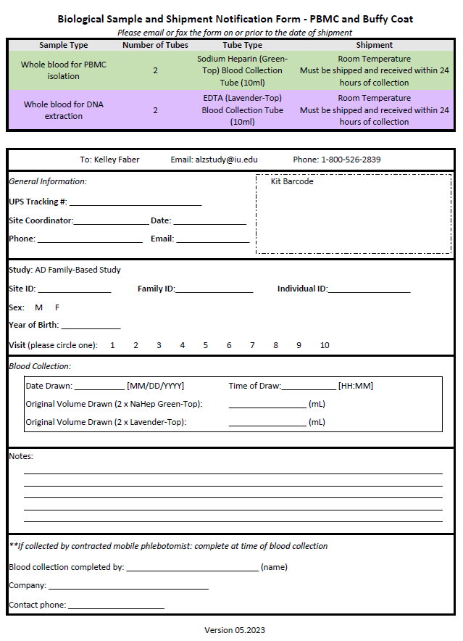

#### Biological Sample and Shipment Notification Form – Plasma/Buffy Coat/PBMC

#### 

1. **Biological Sample and Shipment Notification Form – Saliva**

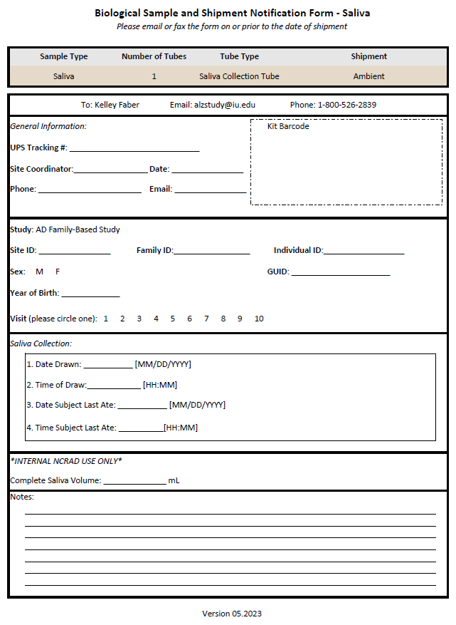

1. **Biological Sample and Shipment Notification Form – Whole Blood for Genetic Testing**

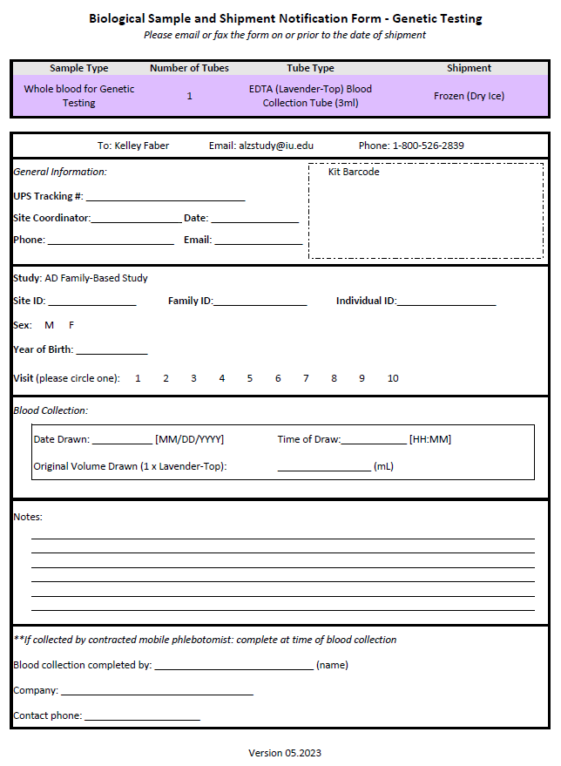

#### Participant Instructions for Contracted Mobile Phlebotomy Appointments

If the subject would like to set up a mobile phlebotomy appointment, they should contact the site coordinator. The site coordinator will then reach out to the mobile phlebotomist to relay the subject’s information. The mobile phlebotomist will then reach out to the subject to schedule their visit.

Appointments can ONLY be scheduled for Monday – Wednesday.

Kits for mobile visits will be sent to the mobile phlebotomist, who will then bring the kit(s) to the subject visit.

#### Labeling Samples

**Label Type Summary**

1. Kit Number Label
2. Site ID, Family ID, Individual ID Label
3. Collection Tube Label

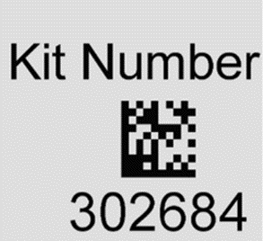

The **Kit Number Labels** do not indicate a specimen type. They are affixed to the Biological Sample and Shipment Notification Forms and on specific packing materials.

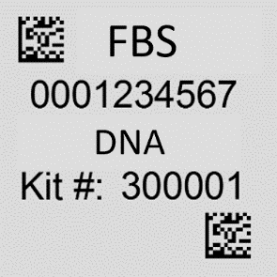

The **Collection Tube Labels** for blood are placed on all collection tubes.

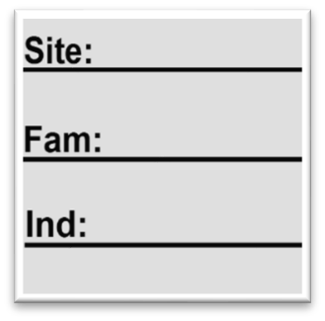

The **Site ID, Family ID, and Individual ID** labels are placed on all collection tubes.

Each kit is supplied with labels for the specimens to be shipped to NCRAD. Place one Kit Number Label within the designated location on the “Biological Sample and Shipment Notification Form”. Place the other Kit Number Label on the lid of the shipping canister.

**Important Note**

**Each collection tube will contain two labels**: the Collection Tube Label and the Site ID, Family ID, and Individual ID Label. Be sure to place labels in the same configuration consistently among tubes, with the barcoded label near the top of the tube with the handwritten Site ID, Family ID, and Individual ID label below.

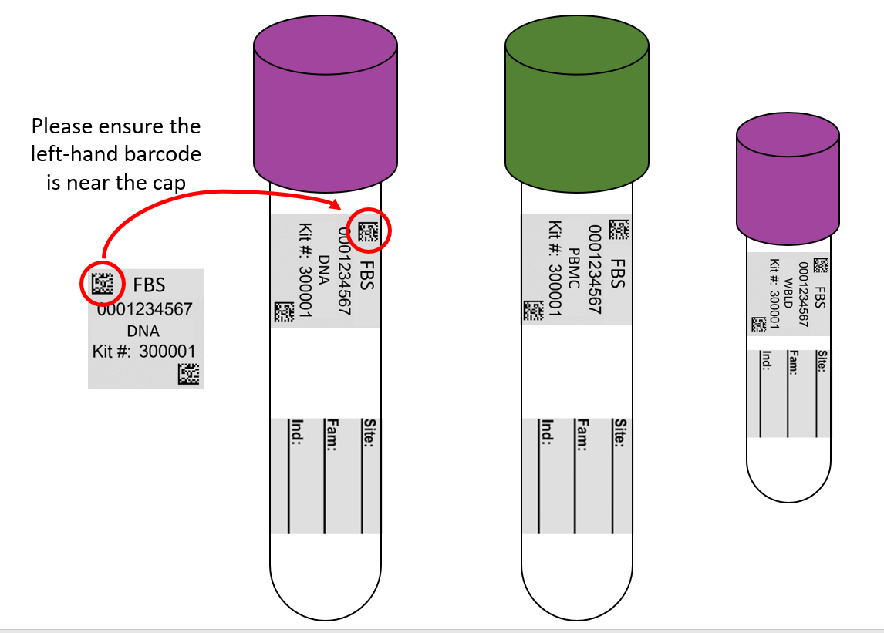

EDTA Tube NaHep Tube Genetic Testing Tube

In order to ensure the label adheres properly and remains on the tube, please follow these instructions:

* Place blood collection and aliquot labels on **ALL** collection and aliquot tubes **BEFORE** sample collection, sample processing, or freezing. This should help to ensure the label properly adheres to the tube before exposure to moisture or different temperatures.
* Using a fine point permanent marker, fill-in and place the Site, Family and Ind. ID Labels on the collection tubes only (RNA, Serum, NaHep, EDTA) **BEFORE** sample collection, processing, or freezing. These labels are in addition to the Collection and Aliquot Tube Labels. **DO NOT** place Site, Family, and Individual ID labels on any cryovials.
* When applying labels to the NaHep tube, ensure that a clear window is left unobstructed along the entire length of the tube.

This is an example of good label placement.

Correct label placement allows a clear view of the sample from the bottom of the tube all the way up to the cap.

* Place cryovials in numerical order based on the specimen number, located at the top of the label. This ensures that no aliquot is misplaced or lost during the shipment process.

Specimen Number

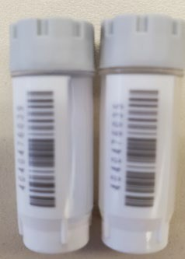

* 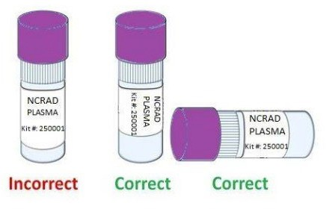The Collection and Aliquot Tube Labels contain a 2D barcode on the left hand side of the label. Place this barcode toward the tube cap.
* Place label **horizontally** on the tube (wrapped around sideways if the tube is upright) and **just below the ridges** of the aliquot tubes (see labeling diagram below).
* Take a moment to ensure the label is **completely adhered** to each tube. It may be helpful to roll the tube between your fingers after applying the label.

#### Instructions for Plasma/Buffy Coat/PBMC Kits (collection by mobile phlebotomist or on site by study coordinator)

#### Sample Collection & Processing: Plasma/Buffy Coat/PBMC Kits

#### Draw order:

1. Whole Blood for isolation of Peripheral Blood Mononuclear Cells (PBMC) - Sodium Heparin (NaHep) Green-Top Blood Collection Tube (10mL) x 2

#### Whole Blood for isolation of Plasma and Buffy Coat - EDTA (Lavender- Top) Blood Collection Tube (10mL) x 2

#### Collection & Processing: Whole Blood for isolation of Peripheral Blood Mononuclear Cells (PBMC) - Sodium Heparin (NaHep) Green-Top Blood Collection Tube (10mL) x 2

|  |  |  |  |
| --- | --- | --- | --- |
| **Sample Type** | **Number of tubes** | **Tube Type** | **Shipment** |
| Whole blood for PBMC isolation | 2 | Sodium Heparin(Green-Top) Blood Collection Tube (10 mL) | Room Temperature  Must be shipped and received within 24 hours of collection |

**\*\*\*Important Visit Scheduling Note\*\*\***

**Once drawn, Sodium Heparin tubes MUST be shipped to NCRAD on the day of collection via UPS Priority Overnight.**

**These samples should only be collected Monday-Wednesday.**

**\*\*NOTE** DO NOT collect these samples on Thursday or Friday.**

**Step 1.** Preparing for sample draw

#### CRITICAL STEP: Store empty Sodium Heparin tubes at room temperature, 64°F - 77°F (18°C to 25°C) before use.

Obtain blood collection kit from the participant. This kit was prepared to include all collection and shipping supplies needed for this collection. Confirm all collection tubes and aliquot tubes are labeled. Confirm Kit # and ADFBS ID # on collection tubes match the Biological Sample and Shipment notification form included in the envelope. Note any missing labels on the Biological Sample and Shipment form prior to the collection.

**Step 2.** Collecting Sample

* 1. Using a blood collection set, collect blood into the 10mL Sodium Heparin tubes using your institution’s recommended procedure for standard venipuncture technique.
  2. The following techniques shall be used to prevent possible backflow: 2.2a Place participant’s arm in downward position.

2.2b Hold tube in vertical position, below the participant’s arm during blood collection.

2.2c Release tourniquet as soon as blood starts to flow into tube.

* 1. d Make sure tube additives do not touch stopper or end of the needle during venipuncture.
  2. Document collection on the Biological Sample and Shipment Notification Form - PBMC

**Step 3**. Immediately after blood collection, **gently** invert the tubes 8-10 times to mix sample.

**Step 4**. Seal the Sodium Heparin tubes in the ambient shipment kit. See Shipping instructions for complete packaging and shipping information. Ship the unprocessed tubes ambient to NCRAD.

**Samples must be shipped the same day as collection. Samples must be received the following day after collection.**

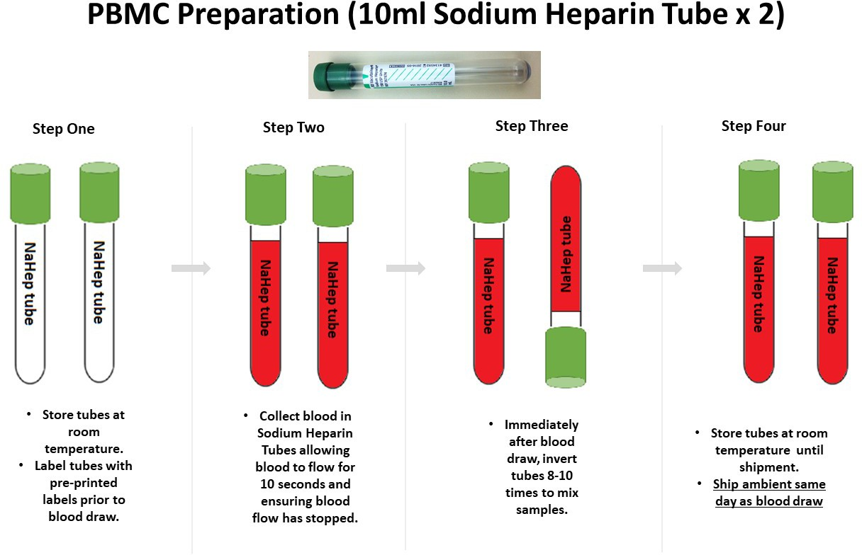

***Please be sure to compare the labels on each tube and cryovial to the Biological Sample Form included with each kit***

**Important Note:** Ensure all tubes are not expired prior to collection and processing of samples.

#### Collection & Processing: Whole Blood for isolation of Plasma and Buffy Coat - EDTA (Lavender- Top) Blood Collection Tube (10mL) x 2

|  |  |  |  |  |
| --- | --- | --- | --- | --- |
| **Sample Type** | **Number of Collection Tubes** | **Collection Tube Type** | **Tubes to Send to NCRAD** | **Shipment** |
| Whole blood for isolation of plasma & buffy coat (for DNA extraction) | 2 | EDTA (Lavender-Top) Blood CollectionTube (10 mL) | Up to 20 x 2mL purple top cryovials with plasma  Up to 2 x 2mL grey top cryovials with buffy coat | Dry Ice |

**Step 1.** Preparing for sample draw

Set centrifuge to 4°C to pre-chill before use.

Obtain blood collection kit from the participant. This kit was prepared to include all collection and shipping supplies needed for this collection. Confirm all collection tubes and aliquot tubes are labeled. Confirm Kit # and ADFBS ID # on collection tubes match the Biological Sample and Shipment notification form included in the envelope. Note any missing labels on the Biological Sample and Shipment form prior to the collection.

Keep labels in numerical order (by specimen number) throughout the aliquoting and shipping process.

**Step 2.** Collecting Whole Blood sample

* 1. Using a blood collection set, collect blood into the **EDTA (Lavender-top) Blood Collection Tube (10mL)** using your institution’s recommended procedure for standard venipuncture techniques.
  2. The following techniques shall be used to prevent possible backflow: 2.2a Place donor’s arm in downward position.

2.2b Hold tube in vertical position, below the donor’s arm during blood collection. 2.2c Release tourniquet as soon as blood starts to flow into tube.

2.2d Make sure tube additives do not touch stopper or end of the needle during venipuncture.

* 1. Allow at least 10 seconds for a complete blood draw to take place in each tube. Ensure that the blood has stopped flowing into the tube before removing the tube from the holder. The tube with its vacuum is designed to draw 10 mL of blood into the tube.
  2. Document collection on the Biological Sample and Shipment Notification Form- Plasma/ Buffy Coat

**If complications arise during the blood draw, please note the difficulties on the **Biological Sample and Shipment Notification Form**. Do not attempt to draw an additional EDTA tube at this time. Process blood obtained in existing EDTA tube.

**Step 3.** Processing sample following draw

#### CRITICAL STEP: Immediately after blood collection, gently invert/mix (180 degree turns) the EDTA tube 8-10 times.

**Step 4. CRITICAL STEP: Immediately after inverting the EDTA tube, place it on wet ice until centrifugation begins.**

Plasma samples need to be spun, aliquoted, and placed on dry ice **within 2 hours**, from the time of collection.

#### Step 5. CRITICAL: Tubes must be centrifuged at the appropriate speed and temperature to ensure plasma separation.

* 1. Centrifuge balanced tubes for 10 minutes at 2000 x g at 4 C. **It is critical that the tubes be centrifuged at the appropriate speed and temperature to ensure proper plasma separation (see worksheet in Appendix C to calculate RPM.)**
  2. While centrifuging, record all times, temperatures and spin rates on the Biological Sample and Shipment Notification Form.

#### Spin, aliquot and freeze all plasma and buffy coat aliquots within 2 hours of collection. Step 6: Pooling Plasma

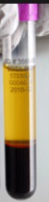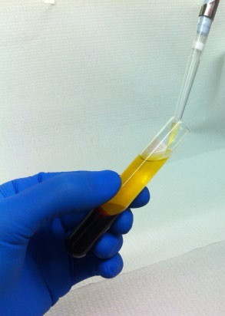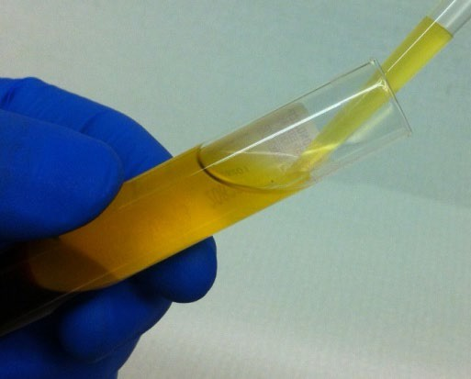

**Instruction Illustration**

Remove the plasma, being careful not to agitate the packed red blood cells at the bottom of the collection tube.

Plasma

Buffy Coat

Red Blood Cells

Tilt the tube and place the disposable pipette tip along the lower side of the wall without touching the pellet (buffy coat) so that plasma is not contaminated

## NOTE: When pipetting plasma from the plasma tube into the conical, be very careful to pipette the plasma top layer only, leaving the buffy coat and the red blood cell layers untouched.

|  |  |  |
| --- | --- | --- |
| Transfer plasma from both EDTA tubes into the blue topped 15 mL conical tubes and gently invert 3 times.  NOTE:15 mL blue top conical will not have a label. |  | |
| **Step 7: Aliquot plasma** | | |
| Aliquot plasma into the pre-labeled cryovials.  Aliquot 0.5 mL per cryovial (up to 20 vials with  0.5 mL each).  Be sure to only place **plasma** in cryovials labeled with “PLASMA” labels.  *If there is extra plasma left, use 1 extra cryovial with blue cap provided for another <0.5 mL aliquot of plasma.  **If residual aliquot (<0.5 mL) is created, document the sample number and volume on the Biological Sample and Shipment Notification  Form.  Store plasma aliquots upright at -80°C until shipment to NCRAD. |  | |
| After plasma has been removed from the EDTA (Lavender-Top) Blood Collection Tube (10 mL), the top layer of cells is the buffy coat mixed with RBCs.  Carefully remove the Buffy coat layer along with a small amount of the underlying RBCs with a disposable bulb pipette. Transfer the buffy coat to the grey cryovial. Repeat for the second buffy coat. Use one cryovial per EDTA tube. |  | |
| Buffy Coat layer (mixed with RBCs) |  |

|  |  |
| --- | --- |
| **Step 8: Aliquot Buffy Coat** | |
| Aliquot buffy coat layer from each collection tube into separate cryovials with gray cap using a disposable graduated micropipette.  The buffy coat aliquot is expected to have a reddish color from the RBCs.  Place Buffy Coat cryovials into the same cryovial box with the plasma samples on Dry Ice  Store buﬀy coat aliquots upright at -80°C until shipment to NCRAD.  Spin, aliquot, and freeze all plasma and buﬀy coat aliquots within 2 hours of collection. | Buffy Coat Aliquot  use GRAY cap cryovial “BUFFY COAT” label |
| Dispose of collection tubes with red blood cell pellet according to your site’s guidelines for disposing of biomedical waste. |  |

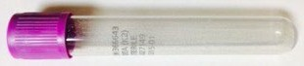**Plasma & Buﬀy Coat Preparation (10mL EDTA Tube x 2)**

**Step One Step Two Step Three Step Four Step Five Step Six**

**Step Seven**

* + - **Label purple-capped cryovials with “PLASMA” labels .**

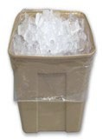

* + - **Aliquot 0.5 mL plasma into each**

**cryovial.**

* + - **If residual aliquot is created, document specimen number and volume on Sample Form.**
    - **Store plasma aliquots upright at**

**-80°C until shipment to NCRAD.**

* **Store tubes at room**

**temp.**

* **Each tube should be labeled with Collection Tube and Site and PTID Labels.**

***Please be sure to compare the labels on each tube and cryovial to the Biological Sample Form included with each kit***

**Important Note:** Ensure all tubes are not expired prior to collection and processing of samples.

* **Collect blood into each EDTA Tube, allowing blood to ﬂow for 10 seconds and ensuring blood ﬂow has stopped.**
* **Immediately after blood draw, invert tubes 8-10 times to mix samples.**
* **Place thoroughly mixed tube on wet ice until centrifugation begins.**
* **Centrifuge samples at 2000 x g for 10 minutes at 4C.**

* + **Pool all plasma from the 2 EDTA tubes into a 15 mL conical tube and invert gently 3 times to mix the plasma.**

**Step Eight**

* + **Label gray -capped cryovials with “BUFFY COAT” labels.**
  + **Using a clean transfer pipette, collect the buﬀy coat (may have residual plasma and some RBCs included).**
  + **Transfer the buﬀy coat from each EDTA tube into its own cryovial.**

**Store buﬀy coat aliquots upright at -80°C until shipment to NCRAD.**

* + **Spin, aliquot, and freeze all plasma and buﬀy coat aliquots within 2 hours of collection.**

#### Shipment: Plasma/Buffy Coat/PBMC Kits

#### Ambient PBMC Shipping Instructions

|  |  |  |  |
| --- | --- | --- | --- |
| **Sample Type** | **Number of tubes** | **Tube Type** | **Shipment** |
| Whole blood for PBMC isolation | 2 | Sodium Heparin(Green-Top) Blood Collection Tube (10 mL) | Room Temperature  Must be shipped and received within 24 hours of collection |

**\*\*\* Packing and Labeling Guidelines \*\*\***

* + - The primary receptacle (collection tube) must be leak proof and must not contain more than 10 mL total.
    - The secondary packaging (foam box) must be leak proof.
    - Absorbent material must be placed between the primary receptacle (collection tube) and the secondary packaging (foam box). The absorbent material should be of sufficient quantity in order to absorb the entire contents of the specimens being shipped. Examples of absorbent material are paper towels, absorbent pads, cotton balls, or cellulose wadding.
    - A copy of the Biological Sample and Shipment Notification Form must be included between the secondary and outer packaging.
    - The outer shipping container must display the following labels:
      * Sender’s name and address
      * Recipient’s name and address
      * Responsible Person
      * The words “Biological Substance, Category B”
      * UN3373

PMBC Blood Collection Tube (10 mL) shipments should be considered as Category B UN3373 and as such must be tripled packaged and compliant with the IATA Packing Instructions 650. *See the Latest Edition of the IATA Regulations for complete documentation.*

Triple packaging consists of a primary receptacle(s), a secondary packaging, and a rigid outer packaging. The primary receptacles must be packed in secondary packaging in such a way that, under normal conditions of transport, they cannot break, be punctured or leak their contents into the secondary packaging. Secondary packaging must be secured in outer packaging with suitable cushioning material. Any leakage of the contents must not compromise the integrity of the cushioning material or of the outer packaging.

|  |
| --- |
| **IMPORTANT!** |
| **AMBIENT SAMPLES MUST BE SHIPPED MONDAY-WEDNESDAY ONLY!**  **Do NOT draw blood for ambient shipments on Thursday or Friday** |

|  |  |
| --- | --- |
| Contact UPS 1-800-742-5877 to locate the closest UPS store location to drop off the package for same day shipping.  **Do NOT** ship from UPS drop box location. |  |
| Scan or take a picture with a cell phone of completed Biological Sample and Shipment notification form. |  |
| Notify NCRAD of shipment by emailing [alzstudy@iu.edu.](mailto:alzstudy@iu.edu)  If email is unavailable, please call NCRAD **1-800-526- 2839**  Do not ship until you have notified NCRAD coordinators of the shipment in advance. | **Content of email:**   1. **Completed Biological Sample and Shpment notification form- PBMC (scanned)** 2. **UPS Shipment tracking number**   Email to [alzstudy@iu.edu](mailto:alzstudy@iu.edu) |

|  |  |
| --- | --- |
| Place filled and labeled sodium heparin (green-top) tubes within the slots in the absorbent pad provided, and place into the plastic biohazard bag with absorbent sheet.  Remove as much air as possible from the plastic biohazard bag and seal the bag according to the directions printed on the bag. | **Blood Samples**  **Absorbent Pad/Sleeve**  **Biohazard Bag** |
| Place the refrigerant pack into the cooler on top of the filled biohazard bag.  *Note: the refrigerant pack should have been in a freezer for at least 24 hours prior to sample packing.  Place the Styrofoam lid onto the cooler inside the shipping box. |  |
| Place the Biological Sample and Shipment Notification Form within the shipping box and list of contents form in the shipping box before closing and securing box top.  Secure box with packing tape.  Confirm UN3373 (Biological Substance Category B) label is on outside of the cardboard box |  |
| Place shipping box inside UPS Next Day mailing envelope with the pre-printed return address label |  |
| Specimens should be sent via UPS Next Day Air. Samples must be sent next day and on **Monday through Wednesday** to avoid any potential shipping delays. | **NCRAD**  **IU School of Medicine 351 W. 10th Street, TK 217**  **Indianapolis, IN 46202**  **Phone: 1-800-526-2839** |

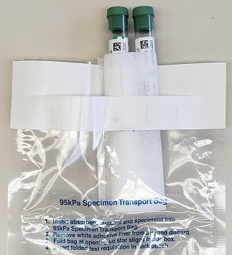

In addition to tracking and reconciliation of samples, the condition and number of samples received are tracked by NCRAD for each sample type. Investigators and clinical coordinators for each project are responsible to ensure the requested amounts of each fluid are collected to the best of their ability.

**Remember to complete the Biological Sample and Shipment Notification (****A****), include a copy in your shipment AND include a scanned copy in the email notification to** [**alzstudy@iu.edu**](mailto:alzstudy@iu.edu) **IN ADVANCE to confirm the shipment.**

#### Frozen Plasma & Buffy Coat Shipping Instructions

|  |  |  |  |  |
| --- | --- | --- | --- | --- |
| **Sample Type** | **Number of Collection Tubes** | **Collection Tube Type** | **Tubes to Send to NCRAD** | **Shipment** |
| Whole blood for isolation of plasma & buffy coat (for DNA extraction) | 2 | EDTA (Lavender-Top) Blood Collection Tube (10 mL) | Up to 20 x 2mL purple top cryovials with plasma  Up to 2 x 2mL grey top cryovials with buffy coat | Frozen - Dry Ice |

|  |
| --- |
| **IMPORTANT!** |
| **FROZEN SAMPLES MUST BE SHIPPED MONDAY-WEDNESDAY ONLY!**  **Do NOT draw blood on Thursday or Friday** |

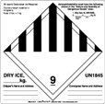

## *** Packing and Labeling Guidelines ***

* + - The primary receptacle (frozen cryovials) must be leak proof and must not contain more than 1L total.
    - The secondary packaging (biohazard bag) must be leak proof and if multiple blood tubes are placed in a single secondary packaging, they must be either individually wrapped or separated to prevent direct contact with adjacent blood tubes.
    - Absorbent material must be placed between the primary receptacle (within the cryovial box containing the frozen cryovials) and the secondary packaging. The absorbent material should be of sufficient quantity in order to absorb the entire contents of the specimens being shipped. Examples of absorbent material are paper towels, absorbent pads, cotton balls, or cellulose wadding.
    - A copy of the Biological Sample and Shipment Notification Form must be included between the secondary and outer packaging.
    - The outer shipping container must display the
    - following labels:
      * Sender’s name and address
      * Recipient’s name and address
      * Responsible Person
      * The words “Biological Substance, Category B”
      * UN3373
      * Class 9 label including UN 1845, and net weight of dry ice contained

#### Steps for completing Shipping process for FROZEN Plasma and Buffy Coat Samples

|  |  |
| --- | --- |
| Contact UPS 1-800-742-5877 to locate the closest UPS store location to drop off the package for same day shipping.  **Do NOT** ship from UPS drop box location. |  |
| Scan or take a picture with a cell phone of completed Biological Sample and Shipment notification form-  Plasma/ Buffy Coat |  |
| Email NCRAD notification of shipment [alzstudy@iu.edu.](mailto:alzstudy@iu.edu)  If email is unavailable, please call NCRAD **1-800-526- 2839**  **Do** not ship until you have notified NCRAD coordinators of the shipment in advance. | **Content of email:**   1. **Completed Biological Sample and Shipment Notification Form- Plasma/ Buffy Coat (scanned)** 2. **UPS Shipment tracking number**   Email to [alzstudy@iu.edu](mailto:alzstudy@iu.edu) |
| Place all labeled and frozen plasma and buffy coat aliquots in a cryovial box. Ensure that the outside of the cryovial box is labeled with a kit number label. The kit number on the outside of the cryovial box should match the kit number on the cryovial labels. |  |
| If collected, place the 3mL EDTA tube in a bubble wrap tube sleeve. |  |
| Place cryovial box (and bubble-wrapped 3mL EDTA tube when applicable) in a clear large biohazard bag. Do **not** remove absorbent material found in the bag and seal according to the instructions on the bag. |  |
| Place approximately 2-3 inches of dry ice in the bottom of the Styrofoam shipping container.  Place the biohazard bag with cryovial box (and bubble-wrapped 3mL EDTA tube when applicable) into the Styrofoam-lined shipping container on top of the dry ice.  Ensure cryovial box is placed so the cryovials are upright in the shipping container. |  |
| The dry ice should entirely fill the inner box and be placed on top of the biohazard bags to ensure the frozen state of the specimens. The inner Styrofoam shipping container must contain approximately 10 lbs. (or 4.5kg) of dry ice. | C:\Users\drcmitch\AppData\Local\Temp\image6.jpeg |
| Replace the lid of the Styrofoam container.  Place the completed Biological Sample and Shipment Notification Form(s) in the package on top of the Styrofoam lid.  Please note, you will have two Biological Sample and Shipment Notification Forms if you also collected blood for genetic testing.  Close and seal the outer cardboard shipping carton with package tape.  **DO NOT** completely seal the outer cardboard box with tape, as the dry ice needs to vent. |  |
| Apply the provided, pre-printed UPS shipping label to the outside of the box.  **Important:** Remove any previous shipping labels prior to shipping |  |
| Specimens should be sent via UPS Next Day Air. Frozen specimens should be sent **Monday through Wednesday** to avoid any potential shipping delays. | **NCRAD**  **IU School of Medicine 351 W. 10th Street, TK 217**  **Indianapolis, IN 46202**  **Phone: 1-800-526-2839** |

**DRAW AND SHIP ALL FROZEN SAMPLES MONDAY - WEDNESDAY ONLY!**

**BE AWARE OF INCIPIENT INCLEMENT WEATHER THAT MAY DELAY SHIPMENT/DELIVERY OF SAMPLES!**

**Remember to complete the Biological Sample and Shipment Notification (****A****), include a copy in your shipment AND include a scanned copy in the email notification to** [**alzstudy@iu.edu**](mailto:alzstudy@iu.edu) **IN ADVANCE to confirm the shipment.**

In addition to tracking and reconciliation of samples, the condition and number of samples received are tracked by NCRAD for each sample type. Investigators and clinical coordinators for each project are responsible to ensure the requested amounts of each fluid are collected to the best of their ability and that samples are packed with sufficient amounts of dry ice to avoid thawing in the shipment process.

#### Instructions for PBMC/DNA Combo Kits (collection by subject-selected location)

**Sample Collection & Processing: PBMC/DNA Combo Kit**

**Draw order:**

1. Whole Blood for isolation of Peripheral Blood Mononuclear Cells (PBMC) - Sodium Heparin (NaHep) Green-Top Blood Collection Tube (10mL) x 2
2. Whole Blood for isolation of Plasma and Buffy Coat - EDTA (Lavender- Top) Blood Collection Tube (10mL) x 2

**Collection & Processing: Whole Blood for isolation of Peripheral Blood Mononuclear Cells (PBMC) - Sodium Heparin (NaHep) Green-Top Blood Collection Tube (10mL) x 2**

|  |  |  |  |
| --- | --- | --- | --- |
| **Sample Type** | **Number of tubes** | **Tube Type** | **Shipment** |
| Whole blood for PBMC isolation | 2 | Sodium Heparin(Green-Top) Blood Collection Tube (10 mL) | Room Temperature  Must be shipped and received within 24 hours of collection |

**\*\*\*Important Visit Scheduling Note\*\*\***

**Once drawn, Sodium Heparin tubes MUST be shipped to NCRAD on the day of collection via UPS Priority Overnight.**

**These samples should only be collected Monday-Wednesday.**

**\*\*NOTE** DO NOT collect these samples on Thursday or Friday.**

**Step 1.** Preparing for sample draw

#### CRITICAL STEP: Store empty Sodium Heparin tubes at room temperature, 64°F - 77°F (18°C to 25°C) before use.

Obtain blood collection kit from the participant. This kit was prepared to include all collection and shipping supplies needed for this collection. Confirm all collection tubes and aliquot tubes are labeled. Confirm Kit # and ADFBS ID # on collection tubes match the Biological Sample and Shipment notification form included in the envelope. Note any missing labels on the Biological Sample and Shipment form prior to the collection.

**Step 2.** Collecting Sample

* 1. Using a blood collection set, collect blood into the 10mL Sodium Heparin tubes using your institution’s recommended procedure for standard venipuncture technique.
  2. The following techniques shall be used to prevent possible backflow: 2.2a Place participant’s arm in downward position.

2.2b Hold tube in vertical position, below the participant’s arm during blood collection.

2.2c Release tourniquet as soon as blood starts to flow into tube.

* 1. d Make sure tube additives do not touch stopper or end of the needle during venipuncture.
  2. Document collection on the Biological Sample and Shipment Notification Form - PBMC

**Step 3**. Immediately after blood collection, **gently** invert the tubes 8-10 times to mix sample.

**Step 4**. Seal the Sodium Heparin tubes in the ambient shipment kit. See Shipping instructions for complete packaging and shipping information. Ship the unprocessed tubes ambient to NCRAD.

**Samples must be shipped the same day as collection. Samples must be received the following day after collection.**



#### 

***Please be sure to compare the labels on each tube and cryovial to the Biological Sample Form included with each kit***

**Important Note:** Ensure all tubes are not expired prior to collection and processing of samples.

**Collection & Processing: Whole Blood for isolation DNA - EDTA (Lavender- Top) Blood Collection Tube (10mL) x 2**

|  |  |  |  |
| --- | --- | --- | --- |
| **Sample Type** | **Number of tubes** | **Tube Type** | **Shipment** |
| Whole blood for DNA extraction | 2 | EDTA (Lavender-Top) Blood CollectionTube (10 mL) | Room Temperature  Must be shipped and received within 24 hours of collection |

**Step 1.** Preparing for sample draw

Obtain blood collection kit from the participant. This kit was prepared to include all collection and shipping supplies needed for this collection. Confirm that the 10mL EDTA collection tubes are labeled. Confirm Kit # and ADFBS ID # on collection tubes match the Biological Sample and Shipment notification form included in the envelope. Note any missing labels on the Biological Sample and Shipment form prior to the collection.

Keep labels in numerical order (by specimen number) throughout the aliquoting and shipping process.

**Step 2.** Collecting Whole Blood sample

* 1. Using a blood collection set, collect blood into the **EDTA (Lavender-top) Blood Collection Tubes (10mL)** using your institution’s recommended procedure for standard venipuncture techniques.
  2. The following techniques shall be used to prevent possible backflow:

- Place donor’s arm in downward position.

- Hold tube in vertical position, below the donor’s arm during blood collection.

- Release tourniquet as soon as blood starts to flow into tube.

- Make sure tube additives do not touch stopper or end of the needle during venipuncture.

* 1. Allow at least 10 seconds for a complete blood draw to take place in each tube. Ensure that the blood has stopped flowing into the tube before removing the tube from the holder. The tube with its vacuum is designed to draw 3mL of blood into the tube.
  2. Document collection on the Biological Sample and Shipment Notification Form- Plasma/ Buffy Coat

**If complications arise during the blood draw, please note the difficulties on the **Biological Sample and Shipment Notification Form**. Do not attempt to draw an additional EDTA tube at this time. Process blood obtained in existing EDTA tube.

**Step 3.** Processing sample following draw

#### CRITICAL STEP: Immediately after blood collection, gently invert/mix (180 degree turns) the EDTA tube 8-10 times.

#### Step 4: Ship ambient same day as collection.

#### 

***Please be sure to compare the labels on each tube and cryovial to the Biological Sample Form included with each kit***

**Important Note:** Ensure all tubes are not expired prior to collection and processing of samples.

#### Shipment: PBMC/DNA Combo Kit

#### Ambient PBMC & EDTA Shipping Instructions

|  |  |  |  |  |
| --- | --- | --- | --- | --- |
| **Sample Type** | **Number of Collection Tubes** | **Collection Tube Type** | **Tubes to Send to NCRAD** | **Shipment** |
| Whole blood for isolation of PBMC | 2 | Sodium Heparin (Green-Top) Blood Collection Tube (10 mL) | 2 x Sodium Heparin (Green-Top) Blood Collection Tube (10 mL) | Room Temperature  Must be shipped and received within 24 hours of collection |
| Whole blood for DNA extraction | 2 | EDTA (Lavender-Top) Blood Collection Tube (10 mL) | 2 x EDTA (Lavender-Top) Blood Collection Tube (10 mL) | Room Temperature  Must be shipped and received within 24 hours of collection |

**\*\*\* Packing and Labeling Guidelines \*\*\***

* + - The primary receptacle (collection tube) must be leak proof and must not contain more than 10 mL total.
    - The secondary packaging (foam box) must be leak proof.
    - Absorbent material must be placed between the primary receptacle (collection tube) and the secondary packaging (foam box). The absorbent material should be of sufficient quantity in order to absorb the entire contents of the specimens being shipped. Examples of absorbent material are paper towels, absorbent pads, cotton balls, or cellulose wadding.
    - A copy of the Biological Sample and Shipment Notification Form must be included between the secondary and outer packaging.
    - The outer shipping container must display the following labels:
      * Sender’s name and address
      * Recipient’s name and address
      * Responsible Person
      * The words “Biological Substance, Category B”
      * UN3373

PMBC Blood Collection Tube (10 mL) shipments should be considered as Category B UN3373 and as such must be tripled packaged and compliant with the IATA Packing Instructions 650. *See the Latest Edition of the IATA Regulations for complete documentation.*

Triple packaging consists of a primary receptacle(s), a secondary packaging, and a rigid outer packaging. The primary receptacles must be packed in secondary packaging in such a way that, under normal conditions of transport, they cannot break, be punctured or leak their contents into the secondary packaging. Secondary packaging must be secured in outer packaging with suitable cushioning material. Any leakage of the contents must not compromise the integrity of the cushioning material or of the outer packaging.

|  |
| --- |
| **IMPORTANT!** |
| **AMBIENT SAMPLES MUST BE SHIPPED MONDAY-WEDNESDAY ONLY!**  **Do NOT draw blood for ambient shipments on Thursday or Friday** |

|  |  |
| --- | --- |
| Contact UPS 1-800-742-5877 to locate the closest UPS store location to drop off the package for same day shipping.  **Do NOT** ship from UPS drop box location. |  |
| Scan or take a picture with a cell phone of completed Biological Sample and Shipment notification form. |  |
| Notify NCRAD of shipment by emailing [alzstudy@iu.edu.](mailto:alzstudy@iu.edu)  If email is unavailable, please call NCRAD **1-800-526- 2839**  Do not ship until you have notified NCRAD coordinators of the shipment in advance. | **Content of email:**   1. **Completed Biological Sample and Shpment notification form- PBMC (scanned)** 2. **UPS Shipment tracking number**   Email to [alzstudy@iu.edu](mailto:alzstudy@iu.edu) |

|  |  |
| --- | --- |
| Place filled and labeled sodium heparin (green-top) tubes within the slots in the absorbent pad provided, and place into the plastic biohazard bag with absorbent sheet. Do the same with the EDTA (lavender-top) tubes.  Remove as much air as possible from the plastic biohazard bag and seal the bag according to the directions printed on the bag. | **Blood Samples**  **Absorbent Pad/Sleeve**  **Biohazard Bag** |
| Place the refrigerant pack into the cooler on top of the filled biohazard bag.  *Note: the refrigerant pack should have been in a freezer for at least 24 hours prior to sample packing.  Place the Styrofoam lid onto the cooler inside the shipping box. |  |
| Place the Biological Sample and Shipment Notification Form within the shipping box and list of contents form in the shipping box before closing and securing box top.  Secure box with packing tape.  Confirm UN3373 (Biological Substance Category B) label is on outside of the cardboard box |  |
| Place shipping box inside UPS Next Day mailing envelope with the pre-printed return address label |  |
| Specimens should be sent via UPS Next Day Air. Samples must be sent next day and on **Monday through Wednesday** to avoid any potential shipping delays. | **NCRAD**  **IU School of Medicine 351 W. 10th Street, TK 217**  **Indianapolis, IN 46202**  **Phone: 1-800-526-2839** |



In addition to tracking and reconciliation of samples, the condition and number of samples received are tracked by NCRAD for each sample type. Investigators and clinical coordinators for each project are responsible to ensure the requested amounts of each fluid are collected to the best of their ability.

**Remember to complete the Biological Sample and Shipment Notification (****A****), include a copy in your shipment AND include a scanned copy in the email notification to** [**alzstudy@iu.edu**](mailto:alzstudy@iu.edu) **IN ADVANCE to confirm the shipment.**

#### Instructions for Genetic Testing Kit (collection by mobile phlebotomist or on site by study coordinator)

#### Collection & Processing: Whole Blood Collection for Genetic Testing: EDTA (Lavender- Top) Blood Collection Tube (3mL) x 1

|  |  |  |  |
| --- | --- | --- | --- |
| **Sample Type** | **Number of tubes** | **Tube Type** | **Shipment** |
| Whole blood for genetic testing | 1 | EDTA (Lavender-Top) Blood Collection Tube (3mL) | Frozen - Dry Ice |

**Step 1.** Preparing for sample draw

Obtain blood collection kit from the participant. This kit was prepared to include all collection and shipping supplies needed for this collection. Confirm that the 3mL EDTA collection tube is labeled. Confirm Kit # and ADFBS ID # on collection tubes match the Biological Sample and Shipment notification form included in the envelope. Note any missing labels on the Biological Sample and Shipment form prior to the collection.

Keep labels in numerical order (by specimen number) throughout the aliquoting and shipping process.

**Step 2.** Collecting Whole Blood sample

* 1. Using a blood collection set, collect blood into the **EDTA (Lavender-top) Blood Collection Tube (3mL)** using your institution’s recommended procedure for standard venipuncture techniques.
  2. The following techniques shall be used to prevent possible backflow: 2.2a Place donor’s arm in downward position.

2.2b Hold tube in vertical position, below the donor’s arm during blood collection. 2.2c Release tourniquet as soon as blood starts to flow into tube.

2.2d Make sure tube additives do not touch stopper or end of the needle during venipuncture.

* 1. Allow at least 10 seconds for a complete blood draw to take place in each tube. Ensure that the blood has stopped flowing into the tube before removing the tube from the holder. The tube with its vacuum is designed to draw 3mL of blood into the tube.
  2. Document collection on the Biological Sample and Shipment Notification Form- Plasma/ Buffy Coat

**If complications arise during the blood draw, please note the difficulties on the **Biological Sample and Shipment Notification Form**. Do not attempt to draw an additional EDTA tube at this time. Process blood obtained in existing EDTA tube.

**Step 3.** Processing sample following draw

#### CRITICAL STEP: Immediately after blood collection, gently invert/mix (180 degree turns) the EDTA tube 8-10 times.

#### Step 4: Place the sample in -80°C freezer until shipment

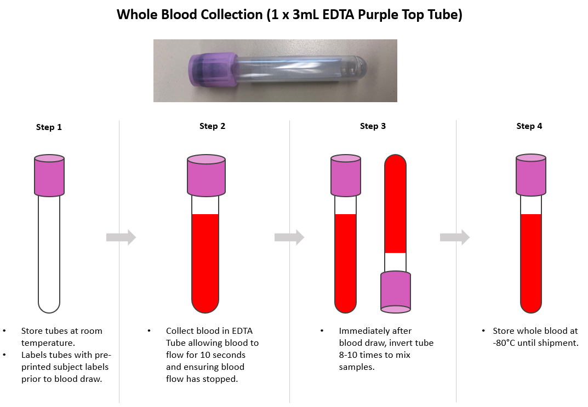

***Please be sure to compare the labels on each tube and cryovial to the Biological Sample Form included with each kit***

**Important Note:** Ensure all tubes are not expired prior to collection and processing of samples.

#### Shipment: Whole Blood Collection for Genetic Testing: EDTA (Lavender- Top) Blood Collection Tube (3mL)

|  |
| --- |
| **IMPORTANT!** |
| **FROZEN SAMPLES MUST BE SHIPPED MONDAY-WEDNESDAY ONLY!**  **Do NOT draw blood on Thursday or Friday** |



## *** Packing and Labeling Guidelines ***

* + - The primary receptacle (frozen cryovials) must be leak proof and must not contain more than 1L total.
    - The secondary packaging (biohazard bag) must be leak proof and if multiple blood tubes are placed in a single secondary packaging, they must be either individually wrapped or separated to prevent direct contact with adjacent blood tubes.
    - Absorbent material must be placed between the primary receptacle (within the cryovial box containing the frozen cryovials) and the secondary packaging. The absorbent material should be of sufficient quantity in order to absorb the entire contents of the specimens being shipped. Examples of absorbent material are paper towels, absorbent pads, cotton balls, or cellulose wadding.
    - A copy of the Biological Sample and Shipment Notification Form must be included between the secondary and outer packaging.
    - The outer shipping container must display the
    - following labels:
      * Sender’s name and address
      * Recipient’s name and address
      * Responsible Person
      * The words “Biological Substance, Category B”
      * UN3373
      * Class 9 label including UN 1845, and net weight of dry ice contained

#### Steps for completing Shipping process for Whole Blood for Genetic Testing

|  |  |
| --- | --- |
| Contact UPS 1-800-742-5877 to locate the closest UPS store location to drop off the package for same day shipping.  **Do NOT** ship from UPS drop box location. |  |
| Scan or take a picture with a cell phone of completed Biological Sample and Shipment notification form-  Plasma/ Buffy Coat |  |
| Email NCRAD notification of shipment [alzstudy@iu.edu.](mailto:alzstudy@iu.edu)  If email is unavailable, please call NCRAD **1-800-526- 2839**  **Do** not ship until you have notified NCRAD coordinators of the shipment in advance. | **Content of email:**   1. **Completed Biological Sample and Shipment Notification Form- Plasma/ Buffy Coat (scanned)** 2. **UPS Shipment tracking number**   Email to [alzstudy@iu.edu](mailto:alzstudy@iu.edu) |
| The 3mL EDTA tube for Genetic Testing will be collected at a regularly scheduled visit alongside samples collected for the Plasma/Buffy Coat/PBMC kit.  The 3mL EDTA tube should be shipped frozen along with the plasma and buffy coat samples (pictured here). |  |
| Place the 3mL EDTA tube in a bubble wrap tube sleeve. |  |
| Place cryovial box and bubble-wrapped 3mL EDTA tube in a clear large biohazard bag. Do **not** remove absorbent material found in the bag and seal according to the instructions on the bag. |  |
| Place approximately 2-3 inches of dry ice in the bottom of the Styrofoam shipping container.  Place the biohazard bag with cryovial box (and bubble-wrapped 3mL EDTA tube when applicable) into the Styrofoam-lined shipping container on top of the dry ice.  Ensure cryovial box is placed so the cryovials are upright in the shipping container. |  |
| The dry ice should entirely fill the inner box and be placed on top of the biohazard bags to ensure the frozen state of the specimens. The inner Styrofoam shipping container must contain approximately 10 lbs. (or 4.5kg) of dry ice. | C:\Users\drcmitch\AppData\Local\Temp\image6.jpeg |
| Replace the lid of the Styrofoam container.  Place the completed Biological Sample and Shipment Notification Form(s) in the package on top of the Styrofoam lid.  Please note, you will have two Biological Sample and Shipment Notification Forms if you also collected blood for genetic testing.  Close and seal the outer cardboard shipping carton with package tape.  **DO NOT** completely seal the outer cardboard box with tape, as the dry ice needs to vent. |  |
| Apply the provided, pre-printed UPS shipping label to the outside of the box.  **Important:** Remove any previous shipping labels prior to shipping |  |
| Specimens should be sent via UPS Next Day Air. Frozen specimens should be sent **Monday through Wednesday** to avoid any potential shipping delays. | **NCRAD**  **IU School of Medicine 351 W. 10th Street, TK 217**  **Indianapolis, IN 46202**  **Phone: 1-800-526-2839** |

**DRAW AND SHIP ALL FROZEN SAMPLES MONDAY - WEDNESDAY ONLY!**

**BE AWARE OF INCIPIENT INCLEMENT WEATHER THAT MAY DELAY SHIPMENT/DELIVERY OF SAMPLES!**

**Remember to complete the Biological Sample and Shipment Notification (****A****), include a copy in your shipment AND include a scanned copy in the email notification to** [**alzstudy@iu.edu**](mailto:alzstudy@iu.edu) **IN ADVANCE to confirm the shipment.**

In addition to tracking and reconciliation of samples, the condition and number of samples received are tracked by NCRAD for each sample type. Investigators and clinical coordinators for each project are responsible to ensure the requested amounts of each fluid are collected to the best of their ability and that samples are packed with sufficient amounts of dry ice to avoid thawing in the shipment process.

**5.9 Instructions for Saliva Kit: Collection and Shipment**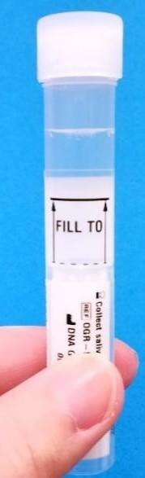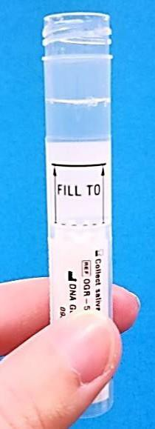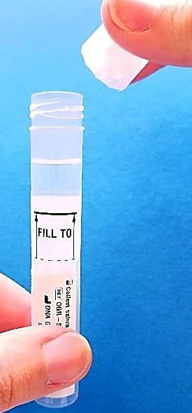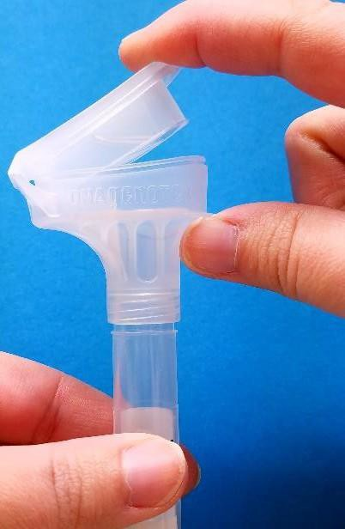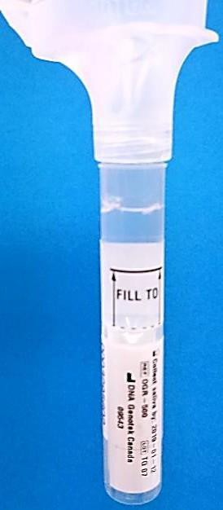

**Do not eat, drink, smoke, or chew gum for 30 minutes prior to giving your sample.**

Note: Do not rinse your mouth prior to giving your sample. Most people take between 2 and 5 minutes to deliver a saliva sample following steps 1 through 7 below. Before spitting, relax and rub your cheeks gently for 30 seconds to create saliva.

## To review a video of the saliva collection procedure, please visit:

[http://www.dnagenotek.com/ROW/support/ciOG500.htmL](http://www.dnagenotek.com/ROW/support/ciOG500.html)

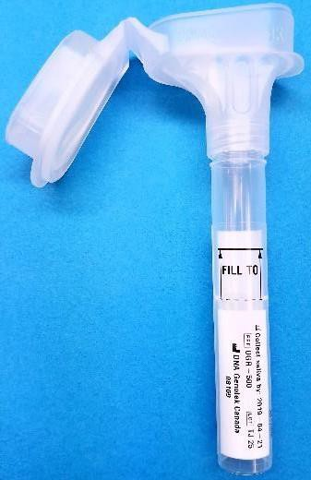

|  |
| --- |
| **STEP 1 Funnel**   * Do NOT remove the plastic film from the lid of the container. * Spit directly into the funnel at the top of the tube until the amount of liquid saliva (not including   bubbles) reaches the fill line shown in picture #1. **Fill Line**   * **The saliva tube has a false bottom, so you will only need to provide 2 milliliters (less than ½ teaspoon) of saliva to reach the fill line.** * Do NOT fill above the line. |
| **STEP 2**   * Once the saliva level reaches the fill line, hold the tube upright with one hand. * Close the lid with the other hand (as shown) by firmly pushing the lid until you hear a loud click. * The liquid in the lid will be released into the tube to mix with the saliva. Make sure that the lid is closed tightly. |
| **STEP 3**   * Hold the tube upright. * Unscrew the funnel from the tube. * Pick up the small cap for the tube. * Use the small cap to close the tube tightly. |

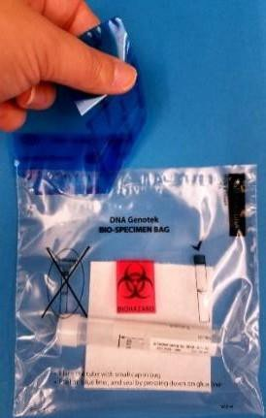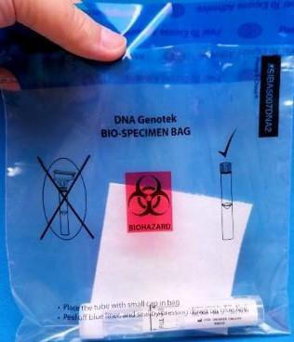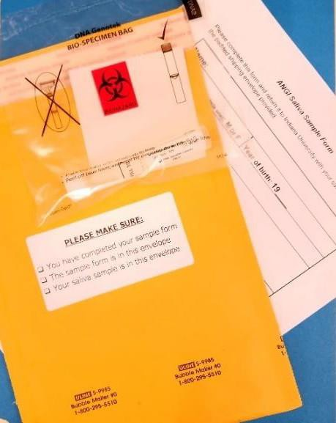

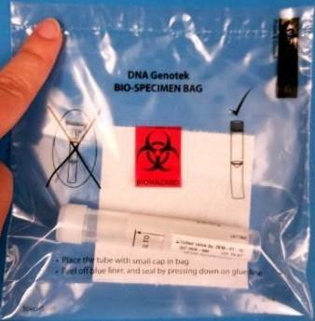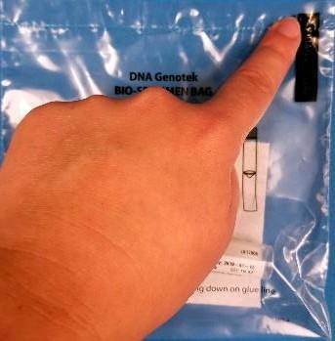

|  |
| --- |
| **STEP 4**   * Shake the capped tube for 5 seconds. * Discard or recycle the funnel. * Place sample in provided specimen bag for shipment to Indiana University (IU). |
| **STEP 5**   * Peel off blue plastic liner at the top of the specimen bag to expose the adhesive. * Seal bag by pressing down across the top of the bag. |
| **STEP 6**   * Fill out sample form with Sex, Year of Birth, Date Collected, Time of Collection, Last date subject ate, Last time subject ate * Fold sample form and place into prepaid shipping envelope. * Also put your specimen (in the provided specimen bag) into this shipping envelope. |
| **STEP 7**   * Peel off the white paper at the top of the envelope to expose the adhesive, fold this flap down, and press firmly to seal envelope. * Send the envelope via U.S. Mail as soon as possible after sample collection. The envelope may be placed in your mailbox with any outgoing mail or mailed through any USPS drop box or post office location. |

## Questions? Please contact a study coordinator at 1-800-526-2839 or email [alzstudy@iupui.edu](mailto:alzstudy@iupui.edu)

**Intended Use: This product is designed for the safe collection of human saliva samples. Contents:** The funnel lid contains 2 mL of liquid. The solution should be clear and colorless.

**Warnings:** Do not ingest this liquid. Wash with water if the saliva container liquid comes in contact with eyes or skin. Small Cap, choking hazard.

**Storage:** Store at room temperature 15-30˚C (59-86˚F).

#### 5.9 Sample Redraws

There may be situations that arise that **require** a patient sample to be redrawn. At those times, NCRAD study staff will alert site coordinators via email that a participant sample has failed and should be redrawn. This can happen for several reasons, including insufficient blood at the time the sample was drawn, temperature storage extremes, or even shipping errors.

Redraw kits may vary depending upon the sample that failed and must be redrawn. Tubes that may be redrawn using the redraw kit include the EDTA (Lavender-Top) Blood Collection Tube (10 mL) and the Sodium Heparin (Green-Top) Blood Collection Tube (10 mL). Both of these tubes should be sent back to NCRAD ambient and unprocessed.

#### Data Collection

* 1. **Data Collection Schedule**

Each site is responsible for providing the NIA-AD FBS with the most recent information for participants. All data should be sent to the coordinating site (CUMC) every quarter. The project manager will send a reminder to all coordinators and provide a template for the data submission. Data calls are scheduled to happen in January, April, July and October.

Identity of participants will not be shared with Columbia, NCRAD or with any investigators.

#### Data Cleaning

The MDS must be completed on each participant as accurately as possible. Every effort is made to ensure that required fields are not left blank or coded as Missing/Unknown; Columbia will follow-up for required fields not properly coded.

Information that appears incorrect in the NIA-AD FBS database, will be queried through the standard system. Queries (if any) will be sent to the sites after each data call. Additional discrepancies that may be unrelated to data entry will be resolved with the Principal Investigator in a separate follow up communication. The data queries dictionary and guide can be found on Appendix E.

#### Brain Autopsy

Brain donation is useful to confirm the clinical diagnosis of AD or the absence of AD pathology and the tissue is useful for genetic research studies.

#### Deceased Family Member with a Previous Autopsy:

For deceased individuals who have previously participated in brain donation/autopsy, their brain tissue and neuropathological diagnosis may be used in the study. If an individual is deceased, DNA can be extracted from an autopsy specimen. 2-3 grams of frozen tissue is required. Families may have obtained an autopsy through their own healthcare provider. The research staff will assist the family in obtaining autopsy tissue to send to NCRAD. Family members must obtain copies of medical records for deceased individuals including records that confirm a clinical diagnosis of Alzheimer’s disease or other related neurodegenerative disorder.

#### Current Participants and Family Members Program Enrollment:

Participating (living) individuals and/or their next of kin/surrogate in these families, will be informed of the brain donation program through the Columbia ADRC and/or the Rush University ADRC. Families who wish to plan for brain donation may call their site coordinator who will put them in touch with one of the brain donation sites. Brain donation flyers may be given to participants in the study. All study staff should be able to answer initial questions about the role of brain donation in the study of Alzheimer’s disease and related neurological disorders. The autopsy consent and intent forms are approved by the IRB under Columbia’s and Rush’s Alzheimer’s Diseases Resource Center and ADFBS can cross- reference those forms.

After autopsy is completed, ~20 grams of frozen dorsal lateral/pre-frontal cortex and/or ~20 grams of fixed dorsal lateral/pre-frontal cortex tissue will be sent to NCRAD for sharing with the scientific community. We will request the same amount of tissue from autopsies done at other institutions. See Appendix H for sample form.

#### Autopsy Results:

Once autopsy and the pathology report is completed (usually takes 3-4 months), CU/Rush personnel will return the report to the site where the participant was originally enrolled. The site PI or an appropriate staff member will contact the next of kin or surrogate to explain the autopsy results. A copy of the pathology report may be sent to the family.

#### Brain shipment and Coordinator Contacts:

For fresh brain shipment instructions, please refer to Appendix G. For any inquiries about brain donation and autopsy, please contact:

#### Scott M. Reid, MA

**Clinical Research Coordinator Phone**: (212) 305-10086

**Fax:** (212) 342-5323

**Email:** [SMR2212@COLUMBIA.EDU](mailto:SMR2212@COLUMBIA.EDU)

Rush Contact: TBA

#### Informed Consent

**Address:**

The Taub Institute for Research on Alzheimer’s Disease and the Aging Brain Columbia University Medical Center

630 West 168th Street, P&S Box 16 New York, NY 10032-37105

Each site will need to obtain an approved consent form from their institution to conduct this study (see appendix C for sample language). Written informed consent should be obtained from the participant and informant prior to any study related procedures. Capacity of assent should be evaluated throughout the study (based on each site’s IRB requirements). Trained research staff will be responsible for leading the potential participant through the entire consent process.

#### Consent Procedures

**The following is just general guidelines for consenting participants. Each site’s procedures may vary as required by local IRBs.**

1. Capacity to consent will be determined and documented by trained and experienced research staff.
2. All aspects of the study, as described in the consent form, are first discussed with the potential subject.
3. The consent form is thoroughly reviewed with the potential subject and answers to the potential subject's questions are provided.
4. While reviewing the consent form, the person obtaining consent (reviewer) asks questions designed to assess the potential subject's understanding of the material. The reviewer will specifically state this intent to the potential subject. Responses to these questions are the basis of the assessment of capacity to consent. The consent issues can be repeated and explained in more detail by the research staff during the determination of capacity to consent.
5. The potential subject is given ample opportunity to decide, without coercion or undue influence, whether or not to participate in the study.
6. The potential subject’s capacity to understand, appreciate, reason with, and express a choice about this specific protocol will be documented in our progress note. Specifically, we will make a note of the potential subject’s knowledge of critical elements in the informed consent form: nature of the illness being studied, voluntary nature of participation, ability to withdraw at any time, consequences of withdrawing, possible risks and benefits of participating, procedures involved, time required, confidentiality, and whom to call with any questions.

All participants who have capacity to consent to research participation will be asked to decide and document whether or not they will appoint a research health care proxy should they lose decision making capacity by the time of follow up. If appointed, the research health care proxy would make decisions regarding enrollment in this study once capacity is lost.

At follow up, the appointed proxy may provide consent on subject’s behalf.

When no proxy is assigned in advance and the subject has not previously indicated that he/she would like to terminate participation in case of incapacity, consent may be provided by next of kin (parent, spouse, adult child). If next of kin is not available, and participant is determined to retain capacity to appoint a surrogate, then research staff will use the PCS model to appoint any trusted individual.

Although many subjects will have capacity to consent to research participation at the onset, it is likely that many will have diminished capacity over time. Capacity and loss of capacity will be determined and documented by trained research staff. Cognitive functioning and capacity to consent to research participation will be reassessed at follow-up research visits.

A waiver of consent for information obtained for family members without their consent is justified under the 45CFR46.116 (d). Consent, assent and research participation will be conducted in the presence of the surrogate (or surrogate choice). Research health care proxy will be identified if possible.

**Documentation of assent**. If the research participant lacks capacity to give consent, assent will be documented on the consent form. The designated individual will provide consent.

For follow-up participants, since they have previously consented to be part of the study and to participate in follow-up evaluations, site’s IRB may or may not ask for verbal consent to be obtained from the participant and noted in chart. In case of incapacity, verbal consent will be obtained from surrogate/proxy and noted in chart Informed Consent.

For participants living out of the research site area, both initial and follow-up assessments will be done remotely by email, phone or via skype.

#### 9.0 Trainings and Certifications

All study coordinators are required to complete training on the neuropsychological battery, the NPIQ-CBRS and the Dementia Questionnaire.

|  |  |  |  |
| --- | --- | --- | --- |
| **Training** | **Site** | **Contact** | **Recurrence** |
| **Neuropsychological Battery** | **Rush University** | **Celina Pavon** [**CELINA_PAVON@rush.edu**](mailto:CELINA_PAVON@rush.edu) | **Once a year** |
| **NPIQ-CBRS** | **University of Pittsburgh** | **Elise Weamer** [**weamerea@upmc.edu**](mailto:weamerea@upmc.edu) | **One time only** |
| **Dementia Questionnaire** | **Columbia University** | **Dolly Reyes-Dumeyer**  [**Dr22100@cumc.columbia.edu**](mailto:Dr2290@cumc.columbia.edu) | **One time only** |

#### Appendices

* 1. **Appendix A: ADFBS Minimum Data set**

|  |  |
| --- | --- |
| **VARIABLE** | **QUESTION** |
| **ADCID**  Required for all  **Overwrite** | 1. Site ID  __ |
| **FAMID**  Required for all  **Overwrite** | 2. Family ID  **__** |
| **INDID**  Required for all  **Overwrite** | 3. Individual ID  **__** |
| **FATHID**  Required for all  **Overwrite** | 4. Father ID  __  **“Founders” are 0** |
| **MOTHID**  Required for all  **Overwrite** | 5. Mother ID  __  **“Founders” are 0** |
| **CONTROL**  Required for all  **Overwrite** | 1. Is the subject a control?    1. Yes    2. No |
| **CONTYPE**  Required for control  **Overwrite** | 6a. Type of control   1. Unaffected spouse 2. Population control 3. Convenience control |
| **RELDEM**  Required for control  **Overwrite** | 6b. How many first degree relatives (parents, siblings, or children of subject) were reported to have had dementia (by symptoms, history, or diagnosis)?  99 Missing/Unknown |
| **8PROBAND**  Required for all  **Overwrite** | 1. Is the subject the proband?    1. Yes    2. No |
| **TWIN**  Required for all  **Overwrite** | 7a. Is this person a twin?   1. Yes 2. No |

|  |  |
| --- | --- |
| **TWINTYPE**  Required for all  **Overwrite** | 7b. If yes, indicate twin type:   1. Monozygotic (Identical) 2. Dizygotic (Fraternal)   9 Unknown |
| **TWINID**  Required for all  **Overwrite** | 7c. If yes, indicate twin individual ID (INDID): |
| **SEX**  Required for all  **Overwrite** | 1. Subject’s sex:    1. Male    2. Female |
| **INF**  **Longitudinal** | 1. Relation of Informant to Subject (primary informant)    1. Spouse    2. Child    3. Sibling    4. Other Family    5. Friend    6. Professional    7. Other   Note: 6 and 7 require specific informant information in 9a. |
| **INFCOM** | 9a. |
| **INFID** | 9b. Individual ID of primary informant (if known):  _ |
| **INF2**  **Longitudinal** | 9c. Relation of Informant to Subject (second informant)   1. Spouse 2. Child 3. Sibling 4. Other Family 5. Friend 6. Professional 7. Other   Note: 6 and 7 require specific informant information in 9d. |
| **INF2COM**  **Longitudinal** | 9d. |
| **INF2ID** | 9e. Individual ID of secondary informant (if known): |
| **INF3**  **Longitudinal** | 9f. Relation of Informant to Subject (third informant)   1. Spouse 2. Child 3. Sibling 4. Other Family 5. Friend 6. Professional 7. Other   Note: 6 and 7 require specific informant information in 9g. |

|  |  |
| --- | --- |
| **INF3COM**  **Longitudinal** | 9g. |
| **INF3ID** | 9h. Individual ID of tertiary informant (if known): |
| **INFA**  **Longitudinal** | 9i. At Least One Informant Lives with Subject   1. No 2. Yes |
| **INFB**  **Longitudinal** | 9j. Total Contact of All Informant(s) with Subject (Combined)   1. < 2 days a week 2. 2 days/week 3. 3-4 days/week 4. 5 or more days/week |
| **SAMPLED**  Required for all  **Overwrite** | 1. Is the subject sampled or will the subject be sampled (blood, cell lines, brain tissue)?    1. Yes    2. No   If **Yes**, please continue.  If **No**, please code any of the following variables for which you have data (specifically 12- 29); if you have no data for the variable(s), please leave blank OR fill in with the appropriate code for missing values. |
| **LTF**  **Overwrite** | 10b. Lost to follow-up   1. Yes 2. No |
| **COMREQ**  Required for all  **Overwrite** | 1. Does the subject consent to for-profit organizations (pharmaceutical and biotechnology companies) having access to his/her clinical data and DNA?    1. Yes    2. No    3. Subject was not specifically asked/consented   9 Missing/Unknown |
| **GENRSCH**  Required for all  **Overwrite** | 11b. Does the subject consent to researchers studying the genetics of any human disease having access to his/her clinical data and DNA?   1. Yes 2. No 3. Subject was not specifically asked/consented   9 Missing/Unknown |
| **BIRTHYR**  Required for all  **Overwrite** | 12. Subject’s year of birth  __  9999 Missing/Unknown  *If exact date is not known, please approximate to nearest decade.* |
| **VITALST**  Required for all  **Overwrite** | 1. The subject’s last known vital status was:    1. Alive    2. Dead   9 Missing/Unknown |

|  |  |
| --- | --- |
|  | ***SKIP?*** If 1 or 9, skip to #14 RACE  If 2, continue with next item, #13a AGEDEATH |
| **AGEDEATH**  Required for sampled if subject is dead (VITALST  = 2)  **Overwrite** | 13a. At what age did the subject die?  __  999 Missing/Unknown  *If exact age is not known, please approximate to nearest decade.* |
| **AUTOPSY**  Required for sampled if subject is dead (VITALST  = 2)  **Overwrite** | 13b. Has an autopsy been performed that resulted in data or a report that is available or will be available at your Center?   1. Yes 2. No   9 Missing/Unknown  ***SKIP?*** If 2 or 9, skip to #14 RACE  If 1, continue with next item, #13c CERAD |
| **CERAD**  Required for sampled if autopsy report available (AUTOPSY = 1)  **Overwrite** | 13c. Was CERAD criteria used?   1. Yes 2. No   9 Missing/Unknown  ***SKIP?*** If 2 or 9, skip to #13e REAGAN  If 1, continue with next item, #13d CERADCT |
| **CERADCT**  Required for sampled if CERAD criteria used (CERAD = 1)  **Overwrite** | 13d. If CERAD was used, what category was assigned?   1. Definite 2. Probable 3. Possible 4. Normal   9 Missing/Unknown |
| **REAGAN**  Required for sampled if autopsy report available (AUTOPSY = 1)  **Overwrite** | 13e. Was NIA-Reagan criteria used?   1. Yes 2. No   9 Missing/Unknown  ***SKIP?*** If 2 or 9, skip to #13g BRAAK  If 1, continue with next item, #13f REAGANCT |
| **REAGANCT**  Required for sampled if REAGAN criteria used (REAGAN = 1)  **Overwrite** | 13f. If NIA-Reagan criteria was used, what category was assigned?   1. High 2. Intermediate 3. Low   9 Missing/Unknown |
| **BRAAK**  Required for sampled if autopsy report available (AUTOPSY = 1)  **Overwrite** | 13g. Was Braak and Braak criteria used?   1. Yes 2. No   9 Missing/Unknown  ***SKIP?*** If 2 or 9, skip to #13i OTHCRI  If 1, continue with next item, #13h BRAAKCT |
| **BRAAKCT**  Required for sampled if | 13h. If Braak and Braak was used, what category was assigned? |

|  |  |
| --- | --- |
| BRAAK criteria used (BRAAK = 1)  **Overwrite** | 1. Stage I 2. Stage II 3. Stage III 4. Stage IV 5. Stage V 6. Stage VI   9 Missing/Unknown |
| **OTHCRI**  Required for sampled if autopsy report available (AUTOPSY = 1)  **Overwrite** | 13i. Was another neuropathological criteria used?   1. Yes 2. No   9 Missing/Unknown  ***SKIP?*** If 2 or 9, skip to #13k LEWYBODY If 1, continue with next item, #13j TYPECRI |
| **TYPECRI**  Required for sampled if other criteria used (OTHCRI = 1)  **Overwrite** | 13j. Describe the type of neuropathological criteria and the assigned category. |
| **LEWYBODY**  Required for sampled if autopsy report available (AUTOPSY = 1)  **Overwrite** | 13k. If Lewy bodies were present, in what part of the brain were they found?   1. Substantia nigra/brain stem 2. Limbic/amygdala 3. Neocortex 4. Substantia nigra/brain stem and limbic/amygdala 5. Substantia nigra/brain stem and neocortex 6. Limbic/amygdala and neocortex 7. Substantia nigra/brain stem, limbic/amygdala and neocortex 8. Lewy bodies present but location not specified 9. Missing/Unknown/Lewy bodies not present |
| **LEWYSTAIN**  Required for sampled if autopsy report available (AUTOPSY = 1)  **Overwrite** | 13l. What stain was used to look for Lewy bodies?   1. Hematoxylin and eosin (H&E) alone 2. alpha-synuclein and H&E 3. Ubiquitin and H&E 4. Ubiquitin, alpha-synuclein and H&E 5. Other   9 Missing/Unknown  ***SKIP?*** If 1-4 or 9, skip to #14 RACE  If 5, continue with next item, #13m LSTAINTY |
| **LSTAINTY**  Required for sampled if other stain used (LEWYSTAIN = 5)  **Overwrite** | 13m. Describe the type of stain used to look for Lewy bodies. |
| **RACE**  Required for sampled  **Overwrite** | 1. Subject’s race/ethnic group:    1. White    2. Black    3. American Indian or Alaskan Native    4. Asian or Pacific Islander 54 Other   99 Missing/Unknown |

|  |  |
| --- | --- |
| **HISPANIC**  Required for sampled  **Overwrite** | 1. Is the subject Spanish/Hispanic/Latino?    1. Yes    2. No   9 Missing/Unknown |
| **EDUC**  **Overwrite** | 16. Subject’s education: Highest grade or number of years of school completed.  __  99 = Missing/Unknown |
| **VISIT**  Required for ALL  **Longitudinal** | 17. What is the visit number?  98 = Not applicable  *Baseline/initial visit = 1, 2nd visit (follow-up) = 2, etc. If a diagnosis changes, you must change the VISIT number, e.g., if a subject goes to autopsy and is diagnosed with Definite AD.*  *For individuals that will never be sampled/evaluated and are included for pedigree structure, code as 98* |
| **EVALMETH**  Required for sampled  **Longitudinal** | 1. How was disease status assigned?    1. Autopsy    2. Examination (in-person at your ADC/institution or by your genetics staff)    3. Medical record review from formal dementia evaluation with or without a telephone interview    4. Review of general medical records AND informant and/or subject telephone interview    5. Review of general medical records *only*    6. Subject and/or informant telephone interview    7. Family report   9 Missing/Unknown |
| **EVALYR**  Required for sampled  **Longitudinal** | 19. When was the last assessment by examination, medical record review, or telephone interview?  Year  Missing/Unknown = 9999  NOTE: If EVALMETH = Family report, record as Missing/Unknown. |
| **EVALTEST**  Required for sampled  **Longitudinal** | 1. Was cognitive testing administered to the subject?    1. Yes    2. No   9 Missing/Unknown |
| **NEUROIM**  Required for sampled  **Longitudinal** | 1. Has brain imaging been performed?    1. Yes    2. No   9 Missing/Unknown |
| **CLINDEM**  Required for sampled  **Longitudinal** | 1. Is the subject demented?    1. Yes    2. No (includes questionable dementia or diagnosis not completed)   9 Missing/Unknown  ***SKIP?*** If 1, skip to #23 DEMDX  If 2, continue with next item, #22a NOTDEMCI  If 9, please code any of the following variables for which you have data; if you have no data |

|  |  |
| --- | --- |
|  | for the variable(s), please leave blank OR fill in with the appropriate code for missing values. |
| **NOTDEMCI**  Required for sampled if subject is not demented (CLINDEM = 2)  **Longitudinal** | 22a. If the subject does not meet criteria for dementia, what is the diagnosis?   1. Not demented, no neurological disorder 2. Not demented, but has other neurological disorder (such as Parkinson’s, MS, etc.) 3. Questionable dementia (e.g., CDR=0.5) or cognitive impairment (MCI, AAMI) 4. Down syndrome, but not demented 5. Other 6. No diagnosis made   9 Missing/Unknown  ***SKIP?*** Skip to #31 CDR |
| **DEMDX**  Required for sampled if subject is demented (CLINDEM = 1)  **Longitudinal** | 1. Is the primary clinical dementia diagnosis Alzheimer’s disease?    1. Definite AD (autopsy confirmed)    2. Probable AD    3. Possible AD    4. Dementia, unspecified    5. Non-Alzheimer’s dementia    6. Dementia by family report   9 Missing/Unknown  ***SKIP?*** If 1 through 3 continue with next item, #24 CLDEMLEW If 4, 6 or 9, skip to #25 COMDXAD  If 5, skip to #26 NONADDEM |
| **CLDEMLEW**  **Longitudinal** | 1. If the primary clinical dementia diagnosis is Alzheimer’s disease (CLDEMX = 1 through 3), does the subject also meet clinical criteria for dementia with Lewy bodies, Lewy body variant Alzheimer’s disease, or diffuse Lewy body disease?    1. Yes    2. No   9 Missing/Unknown |
| **COMDXAD**  **Longitudinal** | 25. Please note any comments for DEMDX and/or CLDEMLEW or any comments regarding diagnosis, e.g., interesting neuropathological data.  ***SKIP?*** Skip to #28 AGEDEM |
| **NONADDEM**  Required for sampled if subject has non-AD dementia  (DEMDX = 5)  **Longitudinal** | 1. If the primary clinical dementia diagnosis is non-Alzheimer’s dementia, what is the suspected etiology?    1. Frontal lobe dementia (e.g., Pick’s, FTD)    2. Parkinson’s disease dementia    3. Huntington’s disease (HD)    4. Progressive supranuclear palsy (PSP)    5. Alcohol related dementias    6. Corticobasal degeneration    7. Communicating, obstructive, or normal pressure hydrocephalus    8. Vascular dementia (e.g., dementia due to stroke)    9. Dementia with Lewy bodies (not Parkinson’s dementia)    10. Prion-associated dementia (e.g., Creutzfeldt-Jakob)    11. Human immunodeficiency virus (HIV) encephalopathy    12. Primary progressive aphasia    13. Posterior cortical dysfunction    14. Down syndrome    15. Dementia due to multiple non-Alzheimer’s etiologies    16. Dementia due to other general medical conditions    17. Other (dementia not otherwise specified)   99 Missing/Unknown |

|  |  |
| --- | --- |
| **COMDXNAD**  **Longitudinal** | 27. Please note any comments for **NONADDEM** |
| **AGEDEM**  Required for sampled if subject is demented (CLINDEM = 1)  **Overwrite** | 28. At what age did the subject *develop* dementia symptoms (AAO)?  __  999 Missing/Unknown  *If exact age is not known, please approximate to nearest five year period.* |
| **AAOSYMP**  **Overwrite** | 1. What presented as the first dementia symptom?    1. Memory change    2. Performance change (in daily activities)    3. Language change    4. Disorientation    5. Personality change (e.g. outgoing to withdrawn)    6. Depressed mood    7. Behavior change (e.g. dropped hobbies)    8. Psychosis (includes paranoia, hallucinations, etc.)    9. Missing/Unknown |
| **AGEDXDEM**  **Overwrite** | 30. At what age was the subject *diagnosed* with Alzheimer’s disease or other non- Alzheimer’s dementia?  __  999 Missing/Unknown  *If exact age is not known, please approximate to nearest five year period.* |
| **CDR**  **Longitudinal** | 31. What is the most recent CDR score?  __  99 Missing/Unknown |
| **CDRYR**  **Longitudinal** | 31a. What YEAR was the most recent CDR Scale administered?  __ __  9999 Missing/Unknown |
| **CDRVER**  **Longitudinal** | 31b. What version of the CDR was used?   1. Short Form 2. Long Form   9 Missing/Unknown |
| **STROKE**  **Overwrite** | 1. Does the subject have a history of stroke(s)?    1. Yes    2. No   9 Missing/Unknown  ***SKIP?*** If 1, continue with next item, #32a STROKETY If 2 or 9, skip to #33 HYPERTEN |
| **STROKETY**  **Overwrite** | 32a. What type of stroke did the subject have?   1. Ischemic 2. Hemorrhagic   9 Missing/Unknown  *If multiple strokes, record type of first stroke.* |
| **STROKEAGE**  **Overwrite** | 32b. At what age did the subject have a stroke? |

|  |  |
| --- | --- |
|  | __  999 Missing/Unknown  *If multiple strokes, record age at first stroke.*  *If exact age is not known, please approximate to nearest decade.* |
| **HYPERTEN**  **Overwrite** | 1. Does the subject have a history of hypertension?    1. Yes    2. No   9 Missing/Unknown  ***SKIP?*** If 1, continue with next item, #33a HYPERAGE If 2 or 9, skip to #34 HEART |
| **HYPERAGE**  **Overwrite** | 33a. At what age was the subject diagnosed with hypertension?  __  999 Missing/Unknown  *If exact age is not known, please approximate to nearest decade.* |
| **HEART**  **Overwrite** | 1. Does the subject have a history of heart disease?    1. Yes    2. No   9 Missing/Unknown  ***SKIP?*** If 1, continue with next item, #34a HEARTAGE If 2 or 9, skip to #35 DIABETES |
| **HEARTAGE**  **Overwrite** | 34a. At what age was the subject diagnosed with heart disease?  __  999 Missing/Unknown  *If exact age is not known, please approximate to nearest decade.* |
| **DIABETES**  **Overwrite** | 1. Does the subject have a history of diabetes?    1. Yes    2. No   9 Missing/Unknown  ***SKIP?*** If 1, continue with next item, #35a DIABETAG If 2 or 9, skip to #36 PDNODEM |
| **DIABETAG**  **Overwrite** | 35a. At what age was the subject diagnosed with diabetes?  999 Missing  *If exact age is not known, please approximate to nearest decade.* |
| **DIABETX**  **Overwrite** | 35b. Has the subject undergone treatment for diabetes?   1. Yes, diet alone 2. Yes, hypoglycemics 3. Yes, insulin 4. Yes, both hypoglycemics and insulin 5. No   9 Missing/Unknown |
| **PDNODEM**  **Overwrite** | 36. Does the subject have a history of Parkinson’s disease? |

|  |  |
| --- | --- |
|  | 1. Yes 2. No   9 Missing/Unknown  ***SKIP?*** If 1, continue with next item, #36a PDCLINDX If 2 or 9, skip to #37 DEPR |
| **PDCLINDX**  **Overwrite** | 36a. What category of Parkinson’s disease was the subject diagnosed with?   1. Definite PD (autopsy confirmed) 2. Probable PD 3. Possible PD   9 Missing/Unknown |
| **PDAGE**  **Overwrite** | 36b. At what age was the subject diagnosed with Parkinson’s disease?  __  999 Missing/Unknown  *If exact age is not known, please approximate to nearest decade.* |
| **DEPR**  **Overwrite** | 1. Does the subject have a history of depression?    1. Yes    2. No   9 Missing/Unknown  ***SKIP?*** If 1, continue with next item, #37a DEPRTX If 2 or 9, skip to #38 HEADINJ |
| **DEPRTX**  **Overwrite** | 37a. Has the subject undergone treatment for depression?   1. Yes, therapy alone 2. Yes, antidepressants with or without therapy 3. Yes, electroconvulsive therapy with or without antidepressants/therapy 4. No   9 Missing/Unknown |
| **DEPRAGE**  **Overwrite** | 37b. At what age was the subject diagnosed with depression?  __ 999 Missing  *If subject has multiple depressive episodes, record age at first episode. If exact age is not known, please approximate to nearest decade.* |
| **HEADINJ**  **Overwrite** | 1. Does the subject have a history of head injury?    1. Yes    2. No   9 Missing/Unknown  ***SKIP?*** If 1, continue to next item, #38a HEADAGE If 2 or 9, skip to #39 ALCDRUG |
| **HEADAGE**  **Overwrite** | 38a. At what age did the subject have the head injury?  __  999 Missing/Unknown  *If multiple head injuries, record age at first head injury.*  *If exact age is not known, please approximate to nearest decade.* |
| **ALCDRUG**  **Overwrite** | 39. Does the subject have a history of alcohol or drug abuse? |

|  |  |
| --- | --- |
|  | 1. Yes 2. No   9 Missing/Unknown  ***SKIP?*** If 1, continue to next item, #39a ABUSEAGE If 2 or 9, skip to #40 COM28_36 |
| **ABUSEAGE**  **Overwrite** | 39a. At what age was the subject initially diagnosed with alcohol or drug abuse?  __  999 Missing/Unknown  *If exact age is not known, please approximate to nearest decade.* |
| **COM28_36**  **Overwrite** | 40. Please note any comments for fields #31 through #39a |
| **SMOKE**  **Longitudinal** | 1. Have you ever smoked one or more cigarettes, cigars, or pipes a day for at least a year?    1. Yes    2. No   9 Missing/Unknown  ***SKIP?*** If 1, continue to next item, #41a SMOKEAGE If 2 or 9, skip to #46 PHYSACT |
| **SMOKEAGE**  **Longitudinal** | 41a. How old were you when you started smoking?  __  999 Missing/Unknown  *If exact age is not known, please approximate to nearest decade.* |
| **SMOKENOW**  **Longitudinal** | 41b. Do you still smoke?   1. Yes 2. No   ***SKIP?*** If 2, continue to next item, #41c SMOKESTOP If 1, skip to #46 PHYSACT |
| **SMOKESTOP**  **Longitudinal** | 41c. How old were you when you stopped smoking?  __  999 Missing/Unknown  *If exact age is not known, please approximate to nearest decade.* |
| **PREG**  **Overwrite** | 42. How many pregnancies did you have?  __  99 Missing/Unknown  *If exact age is not known, please approximate to nearest decade.* |
| **PREGLIVE**  **Overwrite** | 42a. How many live born children did you have?  __  99 Missing/Unknown  *If exact age is not known, please approximate to nearest decade.* |

|  |  |
| --- | --- |
| **HRT**  **Overwrite** | 1. Have you ever taken any form of hormone replacement therapy (HRT) or medication for menopause?    1. Yes    2. No   9 Missing/Unknown  ***SKIP?*** If 1, continue to next item, #43a HRTAGEA If 2 or 9, skip to #44 HYST |
| **HRTAGEA**  **Overwrite** | 43a. How old were you when you started taking HRT?  __  99 Missing/Unknown  *If exact age is not known, please approximate to nearest decade.* |
| **HRTAGEB**  **Overwrite** | 43b. How old were you when you last took HRT?  __  99 Missing/Unknown  *If exact age is not known, please approximate to nearest decade.* |
| **HRTYRS**  **Overwrite** | 43c. For how many years total did you take any form of HRT?  __  99 Missing/Unknown  *If exact time is not known, please approximate to nearest 5 yr period.* |
| **HYST**  **Overwrite** | 1. Have you had a hysterectomy?    1. Yes    2. No   9 Missing/Unknown  ***SKIP?*** If 1, continue to next item, #44a HYSTAGE If 2 or 9, skip to #45 OVAR |
| **HYSTAGE**  **Overwrite** | 44a. At what age did you have a hysterectomy?  __  99 Missing/Unknown  *If exact age is not known, please approximate to nearest decade.* |
| **OVAR**  **Overwrite** | 1. Have any of your ovaries been removed?    1. Yes    2. No   9 Missing/Unknown  ***SKIP?*** If 1, continue to next item, #45a OVARAGE If 2 or 9, skip to #46 PHYSACT |
| **OVARAGE**  **Overwrite** | 45a. At what age were your ovaries removed?  __  99 Missing/Unknown  *If exact age is not known, please approximate to nearest decade.* |
| **OVARBOTH** | 45b. Were both ovaries removed? |

|  |  |
| --- | --- |
| **Overwrite** | 1. Yes 2. No   9 Missing/Unknown |
| **OVARHRT**  **Overwrite** | 45c. Was hormone replacement therapy given at the time your ovaries were removed?   1. Yes 2. No   9 Missing/Unknown |
| **PHYSACT**  **Longitudinal** | 1. In the past 14 days, have you participated in your typical number of recreational or leisure-time activities?    1. Yes    2. No   9 Missing/Unknown  ***SKIP?*** If 2, continue to next item, #46aPHYSACTNO If 1, skip to #47a. VIGACTA1 |
| **PHYSACTNO**  **Longitudinal** | 46a. What prevented you from engaging in your usual number of recreational or leisure- time activities during the past 14 days?   1. Poor Health 2. No desire 3. Other responsibilities 4. Weather 5. Vacation/Holiday 6. Other |
| **VIGACTA1**  **Longitudinal** | 47a. In the past 2 weeks, did you take part in any vigorous activities (aerobic dancing, playing handball) more than 10 times?   1. Yes 2. No   ***SKIP?*** If 1, continue to next item, #47b.VIGACTA2 If 2, skip to #47d. VIGACTB1 |
| **VIGACTA2**  **Longitudinal** | 47b. How many times in the past 2 weeks did you take part in any vigorous activities?  __  999 Missing/Unknown |
| **VIGACTA3**  **Longitudinal** | 47c. For how many minutes did you participate in vigorous activities each time?  __  999 Missing/Unknown |
| **VIGACTB1**  **Longitudinal** | 47d. From ages 12-25, did you take part in any vigorous activities more than 10 times?   1. Yes 2. No   ***SKIP?*** If 1, continue to next item, #47e.VIGACTB2 If 2, skip to #47f. VIGACTC1 |
| **VIGACTB2**  **Longitudinal** | 47e. How would you describe your level of vigorous activity from ages 12-25?   1. Almost all the time 2. Very frequently 3. Frequently |

|  |  |
| --- | --- |
|  | 4 Rarely |
| **VIGACTC1**  **Longitudinal** | 47f. From ages 26-50, did you take part in any vigorous activities more than 10 times?   1. Yes 2. No   ***SKIP?*** If 1, continue to next item, #47g.VIGACTC2 If 2, skip to #47h. VIGACTD1 |
| **VIGACTC2**  **Longitudinal** | 47g. How would you describe your level of vigorous activity from ages 26-50?   1. Almost all the time 2. Very frequently 3. Frequently 4. Rarely |
| **VIGACTD1**  **Longitudinal** | 47h. From ages 50 and up, did you take part in any vigorous activities more than 10 times?   1. Yes 2. No   ***SKIP?*** If 1, continue to next item, #47i. VIGACTD2 If 2, skip to #48a. MODACTA1 |
| **VIGACTD2**  **Longitudinal** | 47i. How would you describe your level of vigorous activity from ages 50 and up?   1. Almost all the time 2. Very frequently 3. Frequently 4. Rarely |
| **MODACTA1**  **Longitudinal** | 48a. In the past 2 weeks, did you take part in any moderate activities (bicycling, swimming, hiking, playing tennis) more than 10 times?   1. Yes 2. No   ***SKIP?*** If 1, continue to next item, #48b.MODACTA2 If 2, skip to #48d. MODACTB1 |
| **MODACTA2**  **Longitudinal** | 48b. How many times in the past 2 weeks did you take part in any moderate activities?  __  999 Missing/Unknown |
| **MODACTA3**  **Longitudinal** | 48c. For how many minutes did you participate in moderate activities each time?  __  999 Missing/Unknown |
| **MODACTB1**  **Longitudinal** | 48d. From ages 12-25, did you take part in any moderate activities more than 10 times?   1. Yes 2. No   ***SKIP?*** If 1, continue to next item, #48e.MODACTB2 If 2, skip to #48f. MODACTC1 |
| **MODACTB2 Longitudinal** | 48e. How would you describe your level of moderate activity from ages 26-50? |

|  |  |
| --- | --- |
|  | 1. Almost all the time 2. Very frequently 3. Frequently 4. Rarely |
| **MODACTC1**  **Longitudinal** | 48f. From ages 26-50, did you take part in any moderate activities more than 10 times?   1. Yes 2. No   ***SKIP?*** If 1, continue to next item, #48g.MODACTC2 If 2, skip to #48h. MODACTD1 |
| **MODACTC2**  **Longitudinal** | 48g. How would you describe your level of moderate activity from ages 26-50?   1. Almost all the time 2. Very frequently 3. Frequently 4. Rarely |
| **MODACTD1**  **Longitudinal** | 48h. From ages 50 and up, did you take part in any moderate activities more than 10 times?   1. Yes 2. No   ***SKIP?*** If 1, continue to next item, #48i MODACTD2 If 2, skip to #49a. LITEACTA1 |
| **MODACTD2**  **Longitudinal** | 48i. How would you describe your level of moderate activity from ages 50 and up?   1. Almost all the time 2. Very frequently 3. Frequently 4. Rarely |
| **LITEACTA1**  **Longitudinal** | 49a. In the past 2 weeks, did you take part in any light activities (walking, dancing, calisthenics, bowling, gardening, horseback riding) more than 10 times?   1. Yes 2. No   ***SKIP?*** If 1, continue to next item, #49b. LITEACTA2 If 2, skip to #49d. LITEACTB1 |
| **LITEACTA2**  **Longitudinal** | 49b. How many times in the past 2 weeks did you take part in any light activities?  __  999 Missing/Unknown |
| **LITEACTA3**  **Longitudinal** | 49c. For how many minutes did you participate in light activities each time?  __  999 Missing/Unknown |
| **LITEACTB1**  **Longitudinal** | 49d. From ages 12-25, did you take part in any light activities more than 10 times?   1. Yes 2. No   ***SKIP?*** If 1, continue to next item, #49e. LITEACTB2 If 2, skip to #49f. LITEACTC1 |

|  |  |
| --- | --- |
| **LITEACTB2**  **Longitudinal** | 49e. How would you describe your level of light activity from ages 12-25?   1. Almost all the time 2. Very frequently 3. Frequently 4. Rarely |
| **LITEACTC1**  **Longitudinal** | 49f. From ages 26-50, did you take part in any light activities more than 10 times?   1. Yes 2. No   ***SKIP?*** If 1, continue to next item, #49g.LITEACTC2 If 2, skip to #49h. LITEACTD1 |
| **LITEACTC2**  **Longitudinal** | 49g. How would you describe your level of light activity from ages 26-50?   1. Almost all the time 2. Very frequently 3. Frequently 4. Rarely |
| **LITEACTD1**  **Longitudinal** | 49h. From ages 50 and up, did you take part in any light activities more than 10 times?   1. Yes 2. No   ***SKIP?*** If 1, continue to next item, #49i. LITEACTD2 If 2, skip to #50 VERSION |
| **LITEACTD2**  **Longitudinal** | 49i. How would you describe your level of light activity from ages 50 and up?   1. Almost all the time 2. Very frequently 3. Frequently 4. Rarely |
| **VERSION**  **Longitudinal** | 50. What version of the cognitive measures was given?  LC01 Load Cognitive version 1  LC02 Load Cognitive version 2 (vegetables)  9999 Missing/Unknown |
| **INTID**  **Longitudinal** | 51. What is the interviewer ID?  NOTE: This is an open text field. You may use any scheme for assigning Interviewer ID, such as initials. |
| **DATEINT**  **Longitudinal** | 52. What is the month and year of the cognitive testing interview?  __ / __ __ __ |
| **PHONE**  **Longitudinal** | 1. Was the interview in person or via telephone?    1. In person    2. Phone 2. Refusal 3. Missing/Unknown |

|  |  |
| --- | --- |
| **STORY**  **Longitudinal** | 1. Logical Memory IA-- Story Score   0-25  __   * 1. Physical problem   2. Cognitive/behavioral problem   3. Other problem   4. Verbal refusal |
| **DIGFOR**  **Longitudinal** | 1. Digit Span Forward Score 0-12    1. Physical problem    2. Cognitive/behavioral problem    3. Other problem    4. Verbal refusal |
| **DIGBAK**  **Longitudinal** | 1. Digit Span Backward Score   0-12  __   * 1. Physical problem   2. Cognitive/behavioral problem   3. Other problem   4. Verbal refusal |
| **ANIMALS**  **Longitudinal** | 1. Category Fluency-- Animals Score 0-79   __   * 1. Physical problem   2. Cognitive/behavioral problem   3. Other problem   4. Verbal refusal |
| **FRUITS**  **Longitudinal** | 1. Category Fluency-- Fruits and Vegetables Score   0-79  __   * 1. Physical problem   2. Cognitive/behavioral problem   3. Other problem   4. Verbal refusal |
| **DIGORD**  **Longitudinal** | 1. Digit Ordering Score   0-16  __   * 1. Physical problem   2. Cognitive/behavioral problem |

|  |  |
| --- | --- |
|  | 1. Other problem 2. Verbal refusal |
| **DELAY**  **Longitudinal** | 1. Logical Memory IIA-- Story Score 0-25   __   * 1. Physical problem   2. Cognitive/behavioral problem   3. Other problem   4. Verbal refusal |
| **HOWWELL**  **Longitudinal** | 1. How well do you think the subject understood the questions?    1. Quite well    2. Fairly well    3. Somewhat    4. Very little    5. Not at all 2. Refusal 3. Missing/Unknown |
| **HEARIMP**  **Longitudinal** | 1. Does the participant have substantial hearing impairment?    1. Yes    2. No |
| **CSTATUS**  **Longitudinal** | 1. What is the cognitive testing status of the subject?    1. Complete    2. Incomplete, refused    3. Incomplete, too impaired    4. Incomplete- interim, complete later 2. Not tested, out of town 3. Not tested, moved 4. Not tested, refused 5. Not tested, hospitalized 6. Not tested, other 7. Deceased 8. Withdrawn |

|  |  |
| --- | --- |
| **COMM**  **Longitudinal** | 64. Please note any comments for fields #41 - #60 |
| **VEG**  **Longitudinal** | 1. Category Fluency-- Vegetable Score 0-79   __   * 1. Physical problem   2. Cognitive/behavioral problem   3. Other problem   4. Verbal refusal |
| **COM_ANY**  **Longitudinal** | 66. Please note any comments for any field |

|  |  |  |  |
| --- | --- | --- | --- |
| **LOAD MDS Part 2** | Added in 2007 | |  |
| **VARIABLE** | | **QUESTION** | |
| **NPIQDATE**  **Longitudinal** | | 67. What is the month and year of the interview?  _ _ / _ _ _ _  NOTE: Please format as MM/YYYY | |
| **INITIALS**  Required  **Longitudinal** | | 68. Psychiatric Rater Initials | |
| **NPIQNA**  **Longitudinal** | | 68a. Assessment Was Not Administered due to (Circle one):   1. No Informant 2. Subject Refused 3. Other   NOTE: 3 requires specific information. | |
| **NPIQNACOM**  **Longitudinal** | | 68b. If 68a = 3 (other), please provide specific information. | |
| **NPIQTYPE**  **Longitudinal** | | 1. Interview Type    1. Visit    2. Telephone | |
| **NPIQSOURCE**  **Longitudinal** | | 69a. What is source of the data submitted?   1. LOAD Integrated Interview 2. UDS 3. Other   NOTE: See Data Element Dictionary for more information | |

|  |  |
| --- | --- |
| **NPIQSOURCECOM**  **Longitudinal** | 69b. Document comments about the source of NPIQ data if NPIQSOURCE = 3 (other) |
| **NPIQVITAL**  **Longitudinal** | 69c. Was NPIQ data collected on a living or deceased individual?   1. Living Individual 2. Deceased Individual   NOTE: See Data Element Dictionary for more information |
| **AGIT**  **Longitudinal** | 1. Is the patient stubborn and resistive to help from others?    1. No    2. Yes   ***SKIP:*** if 1, continue with next item (#12a AGITSEV) if 0, skip to #71 DEPD. |
| **AGITSEV**  **Longitudinal** | 70a. Severity of agitation or aggression.  1-3 Scale. |
| **DEPD**  **Longitudinal** | 1. Does the patient act as if he or she is sad or in low spirits? Does he or she cry?    1. No    2. Yes   ***SKIP:*** if 1, continue with next item (#71a DEPDSEV) if 0, skip to #67 ANX. |
| **DEPDSEV**  **Longitudinal** | 71a. Severity of depression or dysphoria.  1-3 Scale |
| **ANX**  **Longitudinal** | 1. Does the patient become upset when separated from you? Does he or she have any other signs of nervousness, such as shortness of breath, sighing, being unable to relax, or feeling excessively tense?    1. No    2. Yes   ***SKIP:*** if 1, continue with next item (#72a ANXSEV) if 0, skip to #73 ELAT. |
| **ANXSEV**  **Longitudinal** | 72a. Severity of anxiety.  1-3 Scale |
| **ELAT**  **Longitudinal** | 1. Does the patient appear to feel too good or act excessively happy?    1. No    2. Yes   ***SKIP:*** if 1, continue with next item (#73a ELATSEV) if 0, skip to #74 APA. |
| **ELATSEV**  **Longitudinal** | 73a. Severity of elation or euphoria.  1-3 Scale |
| **APA**  **Longitudinal** | 1. Does the patient seem less interested in his or her usual activities and in the activities and plans of others?    1. No    2. Yes   ***SKIP:*** if 1, continue with next item (#74a APASEV) if 0, skip to #70 DISN. |

|  |  |
| --- | --- |
| **APASEV**  **Longitudinal** | 74a. Severity of Apathy or Indifference.  1-3 Scale |
| **DISN**  **Longitudinal** | 1. Does the patient seem to act impulsively? For example, does the patient talk to strangers as if he or she knows them, or does the patient say things that may hurt people’s feelings?    1. No    2. Yes   ***SKIP:*** if 1, continue with next item (#75a DISNSEV) if 0, skip to #76 IRR. |
| **DISNSEV**  **Longitudinal** | 75a. Severity of disinhibition.  1-3 Scale |
| **IRR**  **Longitudinal** | 1. Is the patient impatient or cranky? Does he or she have difficulty coping with delays or waiting for planned activities?    1. No    2. Yes   ***SKIP:*** if 1, continue with next item (#76a IRRSEV) if 0, skip to #77 MOT. |
| **IRRSEV**  **Longitudinal** | 76a. Severity of irritability or lability.  1-3 Scale |
| **MOT**  **Longitudinal** | 1. Does the patient engage in repetitive activities, such as pacing around the house, handling buttons, wrapping string, or doing other things repeatedly?    1. No    2. Yes   ***SKIP:*** if 1, continue with next item (#77a MOTSEV) if 0, skip to #78 NITE. |
| **MOTSEV**  **Longitudinal** | 77a. Severity of motor disturbance.  1-3 Scale |
| **NITE**  **Longitudinal** | 1. Does the patient awaken you during the night, rise too early in the morning, or take excessive naps during the day?    1. No    2. Yes   ***SKIP:*** if 1, continue with next item (#78a NITESEV) if 0, skip to #79 APP. |
| **NITESEV**  **Longitudinal** | 78a. Severity of nighttime behaviors.  1-3 Scale |
| **APP**  **Longitudinal** | 1. Has the patient lost or gained weight, or had a change in the food he or she likes?    1. No    2. Yes   ***SKIP:*** if 1, continue with next item (#79a APPSEV) if 0, skip to #80 DEL. |
| **APPSEV**  **Longitudinal** | 79a. Severity of appetite and eating.  1-3 Scale |
| **DEL**  **Longitudinal** | 1. Does the patient believe that others are stealing from him or her, or planning to harm him or her in some way?    1. No    2. YES   ***SKIP:*** if 1, continue with next item (#80a DELSEV) if 0, skip to #80b PARA. |
| **DELSEV**  **Longitudinal** | 80a. Severity of Delusions.  1-3 Scale |
| **Paranoid (PARA) Longitudinal** | 80b. How often has that happened this past month?   1. Has not occurred since illness began 2. 1-2 days in past month 3. 3-8 days in past month (up to twice per week) 4. 9-15 days in past month (up to half the days in past month) 5. 16 days or more in past month 6. Occurred since illness began, but not in past month 7. Unable to rate   **SKIP:** If 1-8, continue with next item (#80c PARAB). If 0 or 9, skip to #81 (HALL).  **Note:** If '8' was circled, please also complete #80d (PARAC) and #80e (PARAD). |
| **ParanoidB (PARAB) Longitudinal** | 80c. If you try to correct {S}, will {S} accept the truth?   1. No 2. Yes   9 NA |
| **ParanoidC (PARAC) Longitudinal** | 80d. In the month when this symptom was most persistent, how often has {S} done or said anything that suggests {S} believes people are harming, threatening or taking advantage of {S} in some way?   1. 1-2 days in past month 2. 3-8 days in past month (up to twice per week) 3. 9-15 days in past month (up to half the days in past month) |

|  |  |
| --- | --- |
|  | 4 16 days or more in past month  9 Unable to rate  **Note:** To be completed if the answer to #80b. Paranoid (PARA) was '8'. |
| **ParanoidD (PARAD) Longitudinal** | 80e. Was this symptom ever a focus of medication treatment?   1. No 2. Yes   9 Unknown  **Note:** To be completed if the answer to #80b (PARA) is '8'. |
| **HALL**  **Longitudinal** | 1. Does the patient act as if he or she hears voices? Does he or she talk to people who are not there?    1. No    2. Yes   ***SKIP:*** If 1, continue with next item #81a (HALLSEV). If 0, skip to #82 (VISHALL). |
| **HALLSEV**  **Longitudinal** | 81a. Severity of Hallucinations.  1-3 Scale |
| **AuditoryHallucinations (AUDHALL)**  **Longitudinal** | 81b. How often has that happened this past month?   1. Has not occurred since illness began 2. 1-2 days in past month 3. 3-8 days in past month (up to twice per week) 4. 9-15 days in past month (up to half the days in past month) 5. 16 days or more in past month 6. Occurred since illness began, but not in past month 7. Unable to rate   ***SKIP:*** If 1-8, continue with next item #81c (AUDHALLB). If 0 or 9, skip to #82 (VISHALL).  **Note:** If 8 was circled, please also complete #81c (PARAC) and #81e (PARAD). |
| **AuditoryHallucinationsB (AUDHALLB)**  **Longitudinal** | 81c. Rate for clarity.   1. Vauge 2. Clear |
| **AuditoryHallucinationsC (AUDHALLC)**  **Longitudinal** | 81d. In the month when this symptom was most persistent, how often has {S} done or said anything that suggests {S} believes people are harming, threatening or taking advantage of {S} in some way?   1. 1-2 days in past month 2. 3-8 days in past month (up to twice per week) 3. 9-15 days in past month (up to half the days in past month) 4. 16 days or more in past month   9 Unable to rate  **Note:** To be completed if the answer to #81b (AUDHALL) is '8'. |
| **AuditoryHallucinationsD (AUDHALLD)**  **Longitudinal** | 81e. Was this symptom ever a focus of medication treatment?   1. No 2. Yes   9 Unknown  **Note:** To be completed if the answer to #81b (AUDHALL) is '8'. |
| **VisualHallucinations (VISHALL)**  **Longitudinal** | 1. Has {S} seen things or people that were not there? *If yes, describe.*    1. Has not occurred since illness began    2. 1-2 days in past month    3. 3-8 days in past month (up to twice per week)    4. 9-15 days in past month (up to half the days in past month)    5. 16 days or more in past month 2. Occurred since illness began, but not in past month 3. Unable to rate   ***SKIP:*** I f 1-8, continue with next item #82a (VISHALLB). If 0 or 9, skip to #83 (MISIDP).  **Note:** If '8' was circled, please also complete #82b (VISHALLC) and #82c (VISHALLD). |
| **VisualHallucinationsB (VISHALLB)**  **Longitudinal** | 82a. Rate for clarity.   1. Vague 2. Clear |
| **VisualHallucinationsC (VISHALLC)**  **Longitudinal** | 82b. In the month when this symptom was most persistent, how often has {S} seen things or people that were not there?   1. 1-2 days in past month 2. 3-8 days in past month (up to twice per week) 3. 9-15 days in past month (up to half the days in past month) |

|  |  |
| --- | --- |
|  | 4 16 days or more in past month  9 Unable to rate  **Note:** To be completed if the answer to #82 (VISHALL) is '8'. |
| **VisualHallucinationsD (VISHALLD)**  **Longitudinal** | 82c. Was this symptom ever a focus of medication treatment?   1. No 2. Yes   9 Unknown  **Note:** To be completed if the answer to #82 (VISHALL) is '8'. |
| **MisidentifyPeople (MISIDP) Longitudinal** | 1. Has {S} misidentified people? (For example, has {S} confused one familiar person with another, or has {S} thought that a familiar person was a stranger?)   ***NOTE:*** *‘Misidentification’ means an actual belief that one person was another, not simply a misnaming or failure to remember who someone is, and it refers to someone actually seen by {S}.*   * 1. Has not occurred since illness began   2. 1-2 days in past month   3. 3-8 days in past month (up to twice per week)   4. 9-15 days in past month (up to half the days in past month)   5. 16 days or more in past month  1. Occurred since illness began, but not in past month 2. Unable to rate   ***SKIP:*** If 1-8, continue with next item #83a (MISIDPB). If 0 or 9, skip to #84 (MISIDSEL).  **Note:** If '8' was circled, please also complete #83b (MISIDPC) and #83c (MISIDPD). |
| **MisidentifyPeopleB (MISIDPB)**  **Longitudinal** | 83a. If you try to correct {S}, will {S} accept the truth?   1. No 2. Yes   9 N/A |
| **MisidentifyPeopleC (MISIDPC)**  **Longitudinal** | 83b. In the month when this symptom was most persistent, how often has {S} misidentified people? (For example, has {S} confused one person with another, or has {S} thought that a familiar person was a stranger?)   1. 1-2 days in past month 2. 3-8 days in past month (up to twice per week) 3. 9-15 days in past month (up to half the days in past month) 4. 16 days or more in past month   9 Unable to rate  **Note:** To be completed if the answer to #83. MisidentifyPeople (MISIDP) was '8'. |
| **MisidentifyPeopleD (MISIDPD)**  **Longitudinal** | 83c. Was this symptom ever a focus of medication treatment?   1. No 2. Yes   9 Unknown  **Note:** To be completed if the answer to #83. MisidentifyPeople (MISIDP) was '8'. |
| **MisidentifySelf (MISIDSEL) Longitudinal**\ | 1. Has {S} looked at {S's} self in a mirror and not recognized {S's} self?    1. Has not occurred since illness began    2. 1-2 days in past month    3. 3-8 days in past month (up to twice per week)    4. 9-15 days in past month (up to half the days in past month)    5. 16 days or more in past month 2. Occurred since illness began, but not in past month 3. Unable to rate   ***SKIP:*** If 1-8 , continue with next item #84a (MISIDSB). If 0 or 9, skip to #85 (MISIDT).  **Note:** If '8' was circled, please also complete #84b (MISIDSC) and #84c (MISIDSD). |
| **MisidentifySelfB (MISIDSB) Longitudinal** | 84a. If you try to correct {S}, will {S} accept the truth?   1. No 2. Yes   9 NA |
| **MisidentifySelf C (MISIDSC)**  **Longitudinal** | 84b. In the month when this symptom was most persistent, how often has {S} looked at  {Ss} self in a mirror and not recognized {Ss} self?   1. 1-2 days in past month 2. 3-8 days in past month (up to twice per week) 3. 9-15 days in past month (up to half the days in past month) 4. 16 days or more in past month   9 Unable to rate  **Note:** To be completed if the answer to #84. MisidentifySelf (MISIDSEL) was '8'. |

|  |  |
| --- | --- |
| **MisidentifySelfD (MISIDSD) Longitudinal** | 84c. Was this symptom ever a focus of medication treatment?   1. No 2. Yes   9 Unknown  **Note:** To be completed if the answer to #84. MisidentifySelf (MISIDSEL) was '8'. |
| **MisidentifyThings (MISIDT)**  **Longitudinal** | 1. Has {S} misidentified things? Has {S} thought common things were something else? (For example, has {S} said that a pillow was a person or that a light bulb was a fire?) *If yes, describe.*    1. Has not occurred since illness began    2. 1-2 days in past month    3. 3-8 days in past month (up to twice per week)    4. 9-15 days in past month (up to half the days in past month)    5. 16 days or more in past month 2. Occurred since illness began, but not in past month 3. Unable to rate   ***SKIP:*** If 1-8, continue with next item #85a (MISIDTB). If 0 or 9, skip to #86 (INFID).  **Note:** If '8' was circled, please also complete #85b (MISIDTC) and #85c (MISIDTD). |
| **MisidentifyThingsB (MISIDTB)**  **Longitudinal** | 85a. If you try to correct {S}, will {S} accept the truth?   1. No 2. Yes   9 NA |
| **MisidentifyThingsC (MISIDTC)**  **Longitudinal** | 85b. In the month when this symptom was most persistent, how often has (S} misidentified things? Has {S} thought common things were something else?   1. 1-2 days in past month 2. 3-8 days in past month (up to twice per week) 3. 9-15 days in past month (up to half the days in past month) 4. 16 days or more in past month   9 Unable to rate  **Note:** To be completed if the answer to #85. MisidentifyThings (MISIDT) was '8'. |
| **MisidentifyThingsD (MISIDTD)**  **Longitudinal** | 85c. Was this symptom ever a focus of medication treatment?   1. No 2. Yes   9 Unknown  **Note:** To be completed if the answer to #85. MisidentifyThings (MISIDT) was '8'. |

|  |  |
| --- | --- |
| **Infidelity (INFID) Longitudinal** | 1. Has {S} done or said anything that suggests {S} thinks {S's} spouse is unfaithful?    1. Has not occurred since illness began    2. 1-2 days in past month    3. 3-8 days in past month (up to twice per week)    4. 9-15 days in past month (up to half the days in past month)    5. 16 days or more in past month 2. Occurred since illness began, but not in past month 3. Unable to rate   ***SKIP:*** If 1-8, continue with next item #86a.(INFIDB). If 0 or 9, skip to #87 (ABND).  **Note:** If '8' was circled, please also complete #86b (INFIDC) and #86c (INFIDD). |
| **InfidelityB (INFIDB) Longitudinal** | 86a. If you try to correct {S}, will {S} accept the truth?   1. No 2. Yes   9 N/A |
| **InfidelityC (INFIDC) Longitudinal** | 86b. In the month when this symptom was most persistent, how often has {S} done or said anything that suggests {S} thinks {Ss} spouse is unfaithful?   1. 1-2 days in past month 2. 3-8 days in past month (up to twice per week) 3. 9-15 days in past month (up to half the days in past month) 4. 16 days or more in past month   9 Unable to rate  **Note:** To be completed if the answer to |
| **InfidelityD (INFIDD) Longitudinal** | 86c. Was this symptom ever a focus of medication treatment?   1. No 2. Yes   9 Unknown  **Note:** To be completed if the answer to #86. Infidelity (INFID) was '8'. |

|  |  |
| --- | --- |
|  |  |
| **Abandonment (ABND) Longitudinal** | 1. Has {S} done or said anything that suggests {S} thinks {S's} spouse or caregiver is plotting to abandon {S}?    1. Has not occurred since illness began    2. 1-2 days in past month    3. 3-8 days in past month (up to twice per week)    4. 9-15 days in past month (up to half the days in past month)    5. 16 days or more in past month 2. Occurred since illness began, but not in past month 3. Unable to rate   ***SKIP:*** If 1-8, continue with next item #87a (ABNDB). If 0 or 9, skip to #88 (IMP)  **Note:** If '8' was circled, please also complete #87b (ABNDC) and #87c (ABNDC). |
| **AbandonmentB (ABNDB) Longitudinal** | 87a. If you try to correct {S}, will {S} accept the truth?   1. No 2. Yes   9 N/A |
| **AbandonmentC (ABNDC) Longitudinal** | 87b. In the month when this symptom was most persistent, how often has {S}done or said anything that suggests {S} thinks {Ss} spouse or caregiver is plotting to abandon {S}?   1. 1-2 days in past month 2. 3-8 days in past month (up to twice per week) 3. 9-15 days in past month (up to half the days in past month) 4. 16 days or more in past month   9 Unable to rate  **Note:** To be completed if the answer to #87. Abandonment(ABND) was '8'. |
| **AbandonmentD (ABNDD) Longitudinal** | 87c. Was this symptom ever a focus of medication treatment?   1. No 2. Yes   9 Unknown  **Note:** To be completed if the answer to #87. Abandonment(ABND) was '8'. |
| **Imposter (IMP) Longitudinal** | 1. Has {S} done or said anything that suggests {S} thinks {S's} spouse or caregiver is an imposter?    1. Has not occurred since illness began    2. 1-2 days in past month    3. 3-8 days in past month (up to twice per week)    4. 9-15 days in past month (up to half the days in past month)    5. 16 days or more in past month 2. Occurred since illness began, but not in past month 3. Unable to rate   ***SKIP:*** if 1-8, continue with next item #88a (IMPB). If 0 or 9, skip to #89 (TVR) .  **Note:** If '8' was circled, please also complete #88b. (IMPC) and #88c (IMPD). |
| **ImposterB (IMPB) Longitudinal** | 88a. If you try to correct {S}, will {S} accept the truth?   1. No 2. Yes   9 N/A |
| **ImposterC (IMPC) Longitudinal** | 88b. In the month when this symptom was most persistent, how often has {S} done or said anything that suggests {S} thinks {S’s} spouse or caregiver is an imposter?   1. 1-2 days in past month 2. 3-8 days in past month (up to twice per week) 3. 9-15 days in past month (up to half the days in past month) 4. 16 days or more in past month   9 Unable to rate  **Note:** To be completed if the answer to #88. Imposter (IMP) was '8'. |
| **ImposterD (IMPD) Longitudinal** | 88c. Was this symptom ever a focus of medication treatment?   1. No 2. Yes   9 Unknown  **Note:** To be completed if the answer to #88. Imposter (IMP) was '8'. |
| **TelevisionIsReal (TVR) Longitudinal** | 1. Has {S} done or said anything that suggests {S} thinks that characters on television are real? (For example, has {S} talked to them, acted as if they could hear or see {S}, or said that they were friends or neighbors?)    1. Has not occurred since illness began    2. 1-2 days in past month    3. 3-8 days in past month (up to twice per week)    4. 9-15 days in past month (up to half the days in past month) |

|  |  |
| --- | --- |
|  | 4 16 days or more in past month   1. Occurred since illness began, but not in past month 2. Unable to rate   ***SKIP:*** if 1-8, continue with next item (#89a. TVRB if 0 or 9, skip to #90 OPI) .  **Note:** If '8' was circled, please also complete #89b. TVRC and #89c. TVRD. |
| **TelevisionIsRealB (TVRB) Longitudinal** | 89a. If you try to correct {S}, will {S} accept the truth?   1. No 2. Yes   9 NA |
| **TelevisionIsRealC (TVRC) Longitudinal** | 89b. In the month when this symptom was most persistent, how often has {S} done or said anything that suggests {S} thinks that characters on television are real?   1. 1-2 days in past month 2. 3-8 days in past month (up to twice per week) 3. 9-15 days in past month (up to half the days in past month) 4. 16 days or more in past month   9 Unable to rate  **Note:** To be completed if the answer to #89. TVR was '8'. |
| **TelevisionIsRealD (TVRD) Longitudinal** | 89c. Was this symptom ever a focus of medication treatment?   1. No 2. Yes   9 Unknown  **Note:** To be completed if the answer to #89. TVR was '8'. |
| **OtherPeopleInHouse (OPIH)**  **Longitudinal** | 1. Has {S} done or said anything that suggests {S} believes that there are people in or around the house beyond those who are actually there?    1. Has not occurred since illness began    2. 1-2 days in past month    3. 3-8 days in past month (up to twice per week)    4. 9-15 days in past month (up to half the days in past month)    5. 16 days or more in past month 2. Occurred since illness began, but not in past month 3. Unable to rate   ***SKIP:*** if 1-8, continue with next item #90a. OPIHB. If 0 or 9, skip to #91 DPSA .  **Note:** If '8' was circled, please also complete #90b. OPIHC and #90c. OPIHD. |
| **OtherPeopleInHouseB (OPIHB)**  **Longitudinal** | 90a. If you try to correct {S}, will {S} accept the truth?   1. No 2. Yes   9 NA |
| **OtherPeopleInHouseC (OPIHC)**  **Longitudinal** | 90b. In the month when this symptom was most persistent, how often has {S} done or said anything that suggests {S} believes that there are people in or around the house beyond those who are actually there?   1. 1-2 days in past month 2. 3-8 days in past month (up to twice per week) 3. 9-15 days in past month (up to half the days in past month) 4. 16 days or more in past month   9 Unable to rate  **Note:** To be completed if the answer to #90. OtherPeopleInHouse (OPIH) was '8'. |
| **OtherPeopleInHouseD (OPIHD)**  **Longitudinal** | 90c. Was this symptom ever a focus of medication treatment?   1. No 2. Yes   9 Unknown  **Note:** To be completed if the answer to #90. OtherPeopleInHouse (OPIH) was '8'. |
| **DeadPersonStillAlive (DPSA)**  **Longitudinal** | 1. Has {S} done or said anything that suggests {S} believes that a dead person is still alive, even though {S} used to know they were dead?   *Do not rate memory problems. If {S} simply cannot remember whether a particular person has died, it should not be rated as a mistaken belief.*   * 1. Has not occurred since illness began   2. 1-2 days in past month   3. 3-8 days in past month (up to twice per week)   4. 9-15 days in past month (up to half the days in past month) |

|  |  |
| --- | --- |
|  | 4 16 days or more in past month   1. Occurred since illness began, but not in past month 2. Unable to rate   ***SKIP:*** if 1-8, continue with next item (#91a. DeadPersonStillAliveB (DPSAB). If 0 or 9, skip to #92 HouseNotHome (HNH)) .  **Note:** If '8' was circled, please also complete #91b. DPSAC and #91c. DPSAD. |
| **DeadPersonStillAliveB (DPSAB)**  **Longitudinal** | 91a. If you try to correct {S}, will {S} accept the truth?   1. No 2. Yes   9 NA |
| **DeadPersonStillAliveC (DPSAC)**  **Longitudinal** | 91b. In the month when this symptom was most persistent, how often has {S} done or said anything that suggests a dead person is still alive even though {S} used to know they were dead?   1. 1-2 days in past month 2. 3-8 days in past month (up to twice per week) 3. 9-15 days in past month (up to half the days in past month) 4. 16 days or more in past month   9 Unable to rate  **Note:** To be completed if the answer to #91. DeadPersonStillAlive (DPSA) was '8'. |
| **DeadPersonStillAliveD (DPSAD)**  **Longitudinal** | 91c. Was this symptom ever a focus of medication treatment?   1. No 2. Yes   9 Unknown  **Note:** To be completed if the answer to #91. DeadPersonStillAlive (DPSA) was '8'. |
| **HouseNotHome (HNH) Longitudinal** | 1. Has {S} done or said anything that suggests {S} thinks where {S} lives is not really   {S's} home, even though {S} used to consider it home?   * 1. Has not occurred since illness began   2. 1-2 days in past month   3. 3-8 days in past month (up to twice per week)   4. 9-15 days in past month (up to half the days in past month)   5. 16 days or more in past month  1. Occurred since illness began, but not in past month 2. Unable to rate   ***SKIP:*** if 1-8, continue with next item #87a. HouseNotHomeB (HNHB). If 0 or 9, skip to #93 INTQUAL .  **Note:** If '8' was circled, please also complete #92b.HNHC and #92c. HNHD. |
| **HouseNotHomeB (HNHB) Longitudinal** | 92a. If you try to correct {S}, will {S} accept the truth?   1. No 2. Yes   9 NA |

|  |  |
| --- | --- |
| **HouseNotHomeC (HNHC) Longitudinal** | 92b. In the month when this symptom was most persistent, how often has {S} done or said anything that suggests {S} thinks where {S}lives is not really {S's}home, even though  {S} used to consider it home?   1. 1-2 days in past month 2. 3-8 days in past month (up to twice per week) 3. 9-15 days in past month (up to half the days in past month) 4. 16 days or more in past month   9 Unable to rate  **Note:** To be completed if the answer to #92. HouseNotHome (HNH) was '8'. |
| **HouseNotHomeD (HNHD) Longitudinal** | 92c. Was this symptom ever a focus of medication treatment?   1. No 2. Yes   9 Unknown  **Note:** To be completed if the answer to #92. HouseNotHome (HNH) was '8'. |
| **INTQUAL**  **Longitudinal** | 1. Quality of interview (Rater’s judgment)   *Rater should record the basis for judging the interview of questionable or doubtful validity.*   * 1. Interview appeared valid.   2. Some question about interview, but interview is probably acceptable.   3. Information from interview is of doubtful validity. |
| **MEDS**  **Longitudinal** | 94. Please list medications subject is currently taking: |

* 1. **Appendix B: Dementia** Memory:

Does the subject have any problems with:

* + 1. Memory
    2. Remembering people's names
    3. Recognizing familiar faces
    4. Finding way about indoors
    5. Finding way on familiar streets
    6. Remembering a short list of items
    7. Did trouble with memory begin:

Suddenly or slowly

* + 1. Has the course of memory problems been :

a steady downhill progression or have there been abrupt declines

* + 1. Ever see a doctor for memory problems
    2. If yes, what was the cause given:

Yes No Don't know Date

|  |  |  |  |  |  |  |  |  |
| --- | --- | --- | --- | --- | --- | --- | --- | --- |
| Expression   1. Ever have trouble finding the right word or 2. Talking less over time 3. Tendency to dwell in the past | expressing self |  |  |  |  |  |  |  |
| Daily Functioning |  |  |  |  |  |  |  |  |
| 14. Trouble with household tasks |  |  |  |  |  |  |  |  |
| 15. Handling money |  |  |  |  |  |  |  |  |
| 16. Grasping situations or explanations |  |  |  |  |  |  |  |  |
| 17. Difficulty at work | (Check if N/A) |  |  |  |  |  |  |  |
| Age Retired | Date Retired |  |  |  |  |  |  |  |
| Date significant change in work status | | | | | | | | |
| 18. Trouble dressing or caring for self | |  |  |  |  |  |  |  |  |  |
| 19. Trouble feeding self | |  |  |  |  |  |  |  |  |  |
| 20. Controlling bladder and bowels | |  |  |  |  |  |  |  |  |  |
| 21. Agitation and nervousness | |  |  |  |  |  |  |  |  |  |
| Other Problems | |  |  |  |  |  |  |  |  |  |
| 22. High blood pressure | |  |  |  |  |  |  |  |  |  |
| 23. Stroke | |  |  |  |  |  |  |  |  |  |
| 24. More that one (1) stroke | |  |  |  |  |  |  |  |  |  |
| 25. Is one side of the body weaker than the other | |  |  |  |  |  |  |  |  |  |
| 26. Parkinson's Disease (tremors, shuffling gait, rigidity of limbs) | |  |  |  |  |  |  |  |  |  |
| 27. Injury to head resulting in loss of consciousness for more than a  second or two | |  |  |  |  |  |  |  |  |  |
| 28. Seizure or fits | |  |  |  |  |  |  |  |  |  |
| 29. Syphilis | |  |  |  |  |  |  |  |  |  |
| 30. Diabetes | |  |  |  |  |  |  |  |  |  |
| 31. Drinking problem (If alcoholism suspected, explore further SADS Sxs) | |  |  |  |  |  |  |  |  |  |
| 32. Did memory problems coincide with drinking | |  |  |  |  |  |  |  |  |  |
| 33. Ever depressed or sad for 2 weeks or more | |  |  |  |  |  |  |  |  |  |
| 34. If yes, ever seek treatment | |  |  |  |  |  |  |  |  |  |
| 35. Ever very high, euphoric, top of the world | |  |  |  |  |  |  |  |  |  |
| 36. If yes, ever seek treatment | |  |  |  |  |  |  |  |  |  |

1. Ever seek psychiatric or psychological help for any reason
2. If yes, ever hospitalized for psychiatric illness Where?
3. Down's Syndrome

1. Other medical problems we have not talked about

|  |
| --- |
| Medical Contacts |
| 41. Name and address of first doctor seen for problems: |
|  |
|  |
| 42. Ever receive medications |
| 43. A neurological or psychiatric examination |
| 44. CAT scan of head |
| 45. Ever in an institution (Nursing home) |
| Where? |
| 46. What was diagnosis given for problems _ |
| Recognition of Problem |
| 47. Who was first person to notice something wrong? |
| 48. What was noticed? _ |
| 49. When was the last time (the subject) seemed to be really well or his/her  olf self? |

* 1. **Appendix C: Sample Consent form**

#### Site Name

**Consent to Participate in A Research Study (Study Participant)**

Research studies only include people who choose to be involved in the study. Please read this consent form carefully and take your time making your decision. This consent form may contain words that are hard to understand. Please ask the study doctor or the study staff to explain any words or information that you do not clearly understand.

Study title: Late Onset Alzheimer’s Disease Study - LOAD study IRB study number:

Contact information: , Principal Investigator

_ _Address

(name/phone #), Site coordinator 1

(name/phone #), Site coordinator 2 (if needed)

#### Study Purpose

You are invited to participate in a research study funded by the National Institutes of Health (NIH). The purpose of this study is to identify risk factors, which might be associated with the development of diseases of the nervous system associated with late-onset Alzheimer’s disease (AD) (late onset is defined as symptoms of AD beginning at age 60 or older), aging and other related disorders. Other related disorders may include early-onset Alzheimer’s disease, frontotemporal degeneration (FTD), lewy body dementia, corticobasal degeneration and progressive supranuclear palsy. **[SITE PI]** and his associates hope to learn about factors that might increase the risk of developing late-onset Alzheimer's disease or other related disorders and study genes that are associated with late-onset Alzheimer’s disease, aging and other related disorders in extended families or in the general population.

Should you choose to participate in this study, you will be asked to provide a biological sample, medical records, and family history information. You may also receive a clinical examination by a neurologist and complete neuropsychological testing to fully evaluate your memory and thinking skills.

This research study examines the genetic code to help understand why some people develop Alzheimer’s disease or other related disorders and others do not. The cells of your body contain the genetic code or DNA. DNA is passed down from your parents, in the form of genes, which determines your physical characteristics, such as the color of your hair and eyes; and risk for some diseases. Just as differences in our genetic code help explain why we all look different, these differences can also help to explain why some people develop certain diseases and others do not.

Our study seeks to identify, evaluate, and follow individuals with AD and individuals without AD. Specifically, we are seeking families who have at least 2 members with late onset (signs and symptoms of dementia started at 60 years of age or older) AD who have been diagnosed by a neurologist, gerontologist or other specialist in the diseases of the elderly. In addition, we are seeking healthy, unrelated individuals over the age of 60 who do not have a family history of AD. Information gathered from the individuals and families that participate in this research study will be used by researchers to identify genetic factors that contribute to this disease. Families will be seen at various sites throughout the United States.

#### Alternative to study participation

This is not a treatment study. Information being collected is for research purposes only and will not provide information that will be medically useful for you. The alternative to participating would be simply not to participate.

#### Study Procedures

If you decide to participate, you may receive a neurological examination from a physician and you may also be asked to take a pencil and paper test, to assess memory and other cognitive functions including reasoning, attention and language (neuropsychological testing). Additionally, you will be asked to complete an interview of risk factors and family history.

This interview may take 30-40 minutes and consists of questions regarding habits and behavior such as smoking, alcohol intake, physical activities and your past medical history. We will ask you about the state of health of many of your close relatives (mother, father, brother, sister and children). We will ask you about a number of conditions in those individuals such as whether or not they had Alzheimer's disease or other related disorders. Since we wish to study the relationship between heart disease and these neurological disorders, we will ask you about previous heart attacks and related disorders. You may also be asked to provide medical records. You will be also asked to give a blood sample (3 tablespoons)**.**

The complete evaluation including the neurological examination, memory testing (neuropsychological testing), family history and risk factor interview and blood draw, should take approximately 2-3 hours to complete.

You may be invited to participate in this study on a yearly basis, during which you may be asked to complete all or some of the interview, clinical exam or memory testing. This is done in order to detect any change in the individual’s cognitive status. In addition, you may be asked to give another blood sample. If you are asked to give another blood sample, the appropriate consent will be obtained from you. The total amount of time required for each yearly visit will be approximately two to three hours.

Your blood samples will be sent to the National Centralized Repository for Alzheimer’s Disease and Related Dementias (NCRAD) at Indiana University and will be stored indefinitely. Your blood will be used to examine some of your genetic material (DNA), extract white blood cells, and grow cell lines that will be invaluable to researchers who are interested in studying AD and other diseases. We will also freeze these cells in a special way so that we can re-examine other genes that may cause or increase the risk of AD or other related disorders later. Your biological sample may undergo genetic analysis and genomic sequencing which involves determining the arrangement and sequence of all the genes in your DNA. As this is done for research purposes, you will not be given the results of this genetic analysis.

A unique subject identifier will be used to link your blood sample and clinical information. Only de-identified (coded) data will be kept on a secure computer at the data-coordinating center at Columbia University and the biological specimen repository at NCRAD. These data can be accessed only by authorized investigators. De-identified (all identifying information has been removed) clinical, biological sample and genetic data may be provided to qualified researchers at academic institutions, hospitals, and biotechnology/pharmaceutical companies. Results of analyses performed using the biological samples collected as part of this study may be submitted, along with de-identified clinical data, to a government health research database that will assist other researchers investigating various diseases, including AD and dementia.

This government health research database will have access limited to approved researchers. Your data may be withdrawn at any time, upon your request. However, data that has already been distributed for approved research will not be retrieved.

Taking part in this study is voluntary. You may choose to take part or may refuse to participate in the study at any time. Leaving the study will not result in any penalty or loss of benefits to which you are otherwise entitled. You will continue to have access to health care at **[SITE NAME]** Medical Center. If you do withdraw from the study, then you may request that your demographic and clinical data and any unused samples be destroyed. However, data and samples that have already been distributed to approved researchers will not be retrieved. If you do decide to withdraw, we ask that you contact **[SITE PI NAME]** in writing to let him know that you are withdrawing from the study.

#### Voluntary Autopsy Program and Specimen

The only means to definitively diagnose AD is through examination of the brain at the time of death (termed autopsy). For this reason, many families choose to have an autopsy performed when a family member with Alzheimer’s disease or memory loss dies. In addition, autopsy can also be informative when completed for individuals without memory loss. If you are interested in learning more about autopsy, our study staff will provide additional information and can also assist in autopsy planning. If you choose to plan an autopsy for yourself or a family member, you will be asked to sign a separate

consent form. The Late Onset Alzheimer Disease study will pay for costs associated with an autopsy. An autopsy report will be provided to the subject’s legal next-of-kin, guardian or representative.

Some families will meet criteria for this study due to the availability of an autopsy specimen from a family member. If we find that this autopsy sample has been stored under conditions that will allow it to still be used for genetic research, we may request that you sign a separate consent form allowing us to obtain a piece of the autopsy specimen. Just like a blood sample, DNA can be extracted from an autopsy specimen that has been stored under the proper conditions. A cell line cannot be grown from an autopsy specimen. The autopsy specimen will be assigned a unique subject identifier and will never be identified using the name of the individual.

#### Study Risks

A possible risk from your participation in the Late Onset Alzheimer Disease study involves loss of privacy as a result of providing biological samples for research. Although your genetic information is unique to you, you do share some genetic information with your children, parents, brothers, sisters, other blood relatives, and other members of your ethnic group. Consequently, it may be possible that genetic information from them could be used to help identify you. Similarly, it may be possible that genetic information from you could be used to help identify them. While information traditionally used to identify you will not be released (i.e. name, date of birth, address, telephone number), people may develop ways in the future that would allow someone to link your genetic or medical information back to you.

Similarly, when information about you and your family are sent to the National Centralized Repository for Alzheimer’s Disease and Related Dementias and Columbia University, a unique subject identifier is assigned to this information. A unique subject identifier is a combination of numbers and/or letters that do not correspond to any information you have provided to us (i.e. birth date, age, name) and which is different for each person who participates in this study. The National Centralized Repository for Alzheimer’s Disease and Related Dementias and Columbia University use a secure computer system. There is a slight risk that there could be a breach of the security of these computer systems resulting in the access of information about family or medical history. Safeguards are in place to minimize this risk.

Some de-identified data may be provided to a government health research database for broad sharing to approved investigators. This information will be de-identified and will not contain any traditional identifiers (i.e. name, date of birth, address, telephone number). There is a slight risk that there could be a breach in the security of this database system resulting in the access of information. Safeguards are in place to minimize this risk.

Your participation in this study might be associated with slight pain due to the blood test. For most people, drawing blood does not cause any serious problems. However, there is a risk of bruising, discomfort, dizziness, infection, and pain at the needle site. To reduce any risk, we will take every precaution using skilled individuals to obtain blood from you. If there is any difficulty in obtaining the blood or if there is some medical reason you cannot allow us to perform the blood draw, we will omit this part of the study.

You may also be slightly embarrassed, tired, or anxious about the memory testing or answering questions about your habits such as smoking and alcohol use, but we assure you that you can choose not to answer a specific question or we can stop at any time. There may be other privacy risks that we have not foreseen.

#### Study Benefits

You are not expected to benefit personally from this study. However, the greatest benefit will be to society where you will assist us in identifying important risk factors for the cause of diseases of the nervous system in the elderly.

If you have concerns about memory problems or other health related questions, the research team will refer you to appropriate medical resources (i.e. your primary care physician, a memory disorders specialist).

#### Costs/Compensation

There will be no costs to you for participating in this study**. [Insert language regarding payment if applicable]** Samples and data sent to the National Centralized Repository for Alzheimer’s Disease and Related Dementias may be shared with companies and there is the possibility that the research done may be used to develop new products. You will receive no financial compensation for the development of new products that result from the use of your biological sample (blood, cell line, autopsy tissue), clinical and demographic data, and/or genetic data.

In the event of physical injury resulting from your participation in this research, necessary medical treatment will be provided to you and billed as part of your medical expenses. Costs not covered by your health care insurer will be your responsibility. Also, it is your responsibility to determine the extent of your health care coverage. There is no program in place for other monetary compensation for such injuries. However, you are not giving up any legal rights or benefits to which you are otherwise entitled.

#### Confidentiality

Confidentiality is a central concern of this study of Alzheimer’s disease and other related disorders. Every possible effort will be made to maintain the research information in the strictest confidence. We cannot absolutely guarantee that disclosure might not occur unintentionally. We remind all persons participating in this research that maintaining complete confidentiality is a responsibility of both the investigator and his/her staff (US), and the participant (YOU). If you are concerned about these issues, you should consider them carefully before telling anyone that you are participating in a genetic study of Alzheimer’s disease.

Any information and blood samples obtained during this study and identified with you will remain confidential. To protect your identity, we have assigned you a unique code number. This means that we will not send the participant’s name, address, phone number or other identifying information to Columbia University or the National Centralized Repository for Alzheimer’s Disease and Related Dementias. Coded data linked to the sample will be kept on a secure computer that can only be accessed by authorized individuals. Research records are maintained in locked paper files and secured computer files, available only to research staff and institutional personnel as part of routine audits.

In addition to the confidentiality protections described in this consent form, a Federal law called the Genetic Information Nondiscrimination Act (GINA) generally makes it illegal for health insurance companies, group health plans, and most employers to discriminate against you based on your genetic information. **[Sites insert their own GINA language here]** GINA does not protect you against genetic discrimination by companies that sell life insurance, disability insurance, or long-term care insurance or by adoption agencies. GINA also does not protect you against discrimination based on an already diagnosed genetic condition or disease. If you would like to know more about it you can discuss this with the principal investigator of this study or you can go to the following website [www.genome.gov/10002328.](http://www.genome.gov/10002328)

The researchers for this study have obtained a Certificate of Confidentiality issued by the Department of Health and Human Services (DHHS) that will help them protect your privacy during this study. With this certificate, the research staff cannot be forced (for example by court subpoena) to disclose research information that may identify you as a research participant, without your written consent. However, if the researchers learn that you are in real danger of physical or serious mental harm (example, suspected or known sexual or physical abuse of a child or threatened violence to self or others) they will release study related information to protect you and the other persons. Such information must be reported to the appropriate authorities. You should also understand that this Certificate of Confidentiality does not prevent you or a member of your family from voluntarily releasing information about you or your participation in this research. If an insurance company asks you to release information and you choose to do so, the Certificate of Confidentiality will not protect your privacy. The **[SITE NAME]** Human Research Protection Office and the Office of Human Research Protection (OHRP) are entities that may have access to the data collected as part of this research.

#### Research Standards and Rights of Participants

Participation in this research study is voluntary. If you decide not to participate, or if you later decide to stop participating, you will not lose any benefits to which you are otherwise entitled. You can contact **[STUDY COORDINATOR NAME & PHONE #]** to stop participating. If you agree to be in this study, you are free to change your mind. Participants will be

notified of significant new findings that may relate to their willingness to continue to participate. Signing this form does not waive any of your legal rights.

#### Questions

You can reach the investigator, **[SITE PI, PHONE NUMBER]**. He will answer to the best of his ability any questions that the participant may have now or in the future about the research procedures, or about the subject's response to the procedures.

If you have any questions about your rights as a research subject, you should contact the Institutional Review Board by phone at **[SITE IRB Phone #]** or by email at **[SITE IRB EMAIL]**

More information about taking part in a research study can be found on the IRB website at **[SITE IRB’S WEBSITE]**

Taking part in this research study may result in injury or harm to you. In the event of an injury resulting from your participation in this study, you should seek appropriate medical care and inform the study doctor. In the event of an emergency you should go to an emergency room.

If you are injured or harmed as a result of participating in the study and receive medical care through the **[SITE]**, or any other health provider, you will be sent a bill for whatever medical care you receive. All or part of your bill may be paid by your health insurance.

**Consent by participant:** I have had the opportunity to review the information and ask questions regarding this consent form. I voluntarily consent to participate in this research study. I may drop out of or be withdrawn from this study at any time without fear of changing the investigator’s interest or the quality of medical care that I may seek or receive in the future from the doctor’s participating in this study. I have received (or will receive) a copy of this form for my records and future reference. In consideration of all of the above, I give my consent to participate in a Study Visit.

_ _ _

*Signature of participant Date*

_ _ _

*Name of participant (printed)*

I have discussed the proposed research with this participant, and, in my opinion, this participant understands the benefits, risks and alternatives (including non-participation) and is capable of freely consenting to participate in research.

_ _ _ *Signature of person obtaining consent Printed name Date* Documentation of Assent

To be completed by research staff if participant is not able to provide consent and consent provided by surrogate. Assent by participant:

I voluntarily agree to participate in the research study described above.

I understand that _ will provide consent for my research participation. (name of surrogate)

_ _ _

*Signature of participant Date*

_ _ _

*Printed name of participant*

Consent by surrogate: I was present when the proposed research study was described to the above patient and in my opinion, she or he agrees to participate, or does not object to participation.

_ _ _

*Signature of Surrogate Date*

_ _ _

*Name of Surrogate (printed) Relationship to participant*

I have discussed the proposed research with this participant and the participant’s surrogate, and, in my opinion, the surrogate understands the benefits, risks and alternatives (including non-participation) for this participant.

_ _ _ *Signature of person obtaining consent Printed name Date* Assessment of capacity by research staff

I assessed (Name of subject) on (Date), for the purpose of determining whether he/she is capable of understanding the purpose, nature, risks, benefits and alternatives (including non- participation) of the research, making a decisions about participation, and understanding that the decision about participation in the research will involve no penalty or loss of benefits to which the patient is otherwise entitled, for [SITE PI] research project of Late onset Alzheimer’s disease and related disorders. On the basis of this assessment I have arrived at the conclusion that:

A. This patient has this capacity at this time.

B. There is a question about this patient’s capacity at this time.

C. This patient clearly lacks this capacity. Print Name _ _

Signature _ _ Date

#### For telephone assessments and remote annual follow up visits:

Has verbal consent from the participant been obtained?

Yes, participant has consented to the telephone assessment. No, participant does not wish to continue participation.

Participant’s Name (Printed) Date

I have discussed the proposed research with this participant, and, in my opinion, this participant understands the benefits, risks and alternatives (including non-participation) and is capable of freely consenting to participate in research.

* 1. **Appendix E: MDS/Queries/Discrepancies Guide**

#### Minimum Data Set Query Guide

There are many queries in place to insure the validity of data sets submitted by all participating centers. Quarterly, reports will be generated from these queries and distributed to the appropriate centers by NCRAD or Columbia.

All data errors or missing entries MUST BE CORRECTED before the next data submission. It is imperative that data is valid at the source, as this data overwrites the information housed at Columbia each time it is imported.

Columbia will pool all reports together when notifying centers in hopes that this will be more

**Required Variables**

The following variables are required in order for the data to import. Please complete these variables before first data submission.

**ADCID** Center ID

**FAMID** Family ID

**INDID** Individual ID

**FATHID** Father ID

**MOTHID** Mother ID

**CONTROL** Is the subject a control?

**PROBAND** Is the subject the proband?

**SEX** Subject’s gender

**SAMPLED** Is the subject sampled or will be sampled?

**VISIT** What is the visit number?

**Reporting Queries- Dataclean file 1**

**File I (name of site_dataclean file_month_year)** contains the following variables. These data errors need to corrected and updated in the center’s database/file before the next datacall; the file *does not* have to be sent back to Columbia. A detailed explanation of each query can be found below.

* + 1. Qualifying families (lists all families that meet qualifying family criteria-nothing needs to be done excepted checked over to be sure you agree with total list)
    2. Nearly Qualifying families
    3. Dead end families (lists all families that have been noted to be dead end-nothing needs to be done except checked over to be sure you agree with total list)
    4. Qualifying families-Non Qualifying (summarizes families not meeting the qualifying family criteria and shows key variables that can indicate why the family does not qualify)
    5. Overwrite, but no Long data
    6. Long data, but no Overwrite
    7. Samples without data
    8. Samples without data-Controls
    9. Autopsy, only 1 visit
    10. All autopsy info null
    11. All autopsy info 9
    12. All autopsy info, no sample
    13. Sampled=Yes, no sample at NCRAD
    14. Sampled=No, sample at NCRAD
        1. **Qualifying Families**

This program screens for families with at least **three sampled** individuals that meet the following conditions:

1. At least 1 individual diagnosed with Definite (Def) and/or Probable AD (PRAD) with AAO of 60 or older.
2. At least 1 individual diagnosed with Def, PRAD, Possible AD with AAO of 60 or older.
3. At least 1 individual diagnosed with Def, PRAD, Possible AD with AAO of 50 or older; OR at least 1 individual diagnosed with MCI or normal that is 60 or older.
4. The two affected, sampled individuals must be full-siblings.

The logic/fields we consider in the query that checks for qualifying families are:

* 1. Moth and Fath ID to be sure there are at least 2 full sibs
  2. AgeDem OR AgeDxDem >=60 AND diagnosis of confirmed or probable AD (DemDx=1 or 2) in the first full sib
  3. AgeDem OR AgeDxDem >=60 AND diagnosis of confirmed, probable, possible AD (DemDx=1 or 2 or 3) in the second full sib
  4. AgeDem OR AgeDxDem >=50 AND diagnosis of confirmed, probable or possible AD (DemDx=1 or 2 or 3) in the 3rd family member OR is Not demented (Clindem=2) and over age 60.

**2.Nearly Qualifying Families**

We now have a spreadsheet that searches all data sets for families that almost meet the minimum LOAD criteria. This program screens for families with at least **two sampled** individuals that meet the following conditions:

1. At least 1 individual diagnosed with Definite (Def) and/or Probable AD (PRAD) with AAO of 60 or older.
2. At least 1 individual diagnosed with Def, PRAD, or Possible AD with AAO of 60 or older.
3. The two affected, sampled individuals must be full-siblings.

**this query NO LONGER CONTAINS families that meet the “Qualifying Family” criteria.

* 1. **Dead End Families**

We now have a spreadsheet that searches all data sets for families that have been deemed to be dead end by the site. This means that this family will never make “Qualifying Family” status.

* 1. **Qualifying Fams-NonQualifying**

This query lists individuals in families not meeting the qualifying family criteria and shows key variables that can indicate why the family does not qualify.

#### Overwrite, No Long

Overwrite data has been submitted but no longitudinal data. All individuals need to have a record in both datasets. If the individual will never be seen, please use a visit=98. Please check that there are no typos in ADCID, FAMID or INDID fields.

#### Long, No Over

Longitudinal data has been submitted but no corresponding overwrite data. Please check that there are no typos in site, fam or ind fields.

#### Samples without Data

Compares samples submitted by ADCs to data sets submitted for all subjects. All samples submitted by an ADC should also have a corresponding data set. Records will appear when data is not submitted for a particular sampled individual.

**Queries Important for Autopsy Data**

#### Autopsy only 1 visit

Individuals will be listed if EvalMeth is autopsy on visit 1. There should be medical records available to indicate status prior to autopsy. It is important to document the clinical vs. pathological diagnoses.

#### All Autopsy Info is Null

Individual is listed as “yes” for autopsy but all of the autopsy variables are null. This report serves as a reminder of autopsy data that needs to be submitted. Please fill in as soon as possible. We realize that there is often a significant lag between the time of death and the time the autopsy report is available.

#### All Autopsy Info is 9

Individual is listed as “yes” for autopsy but all of the autopsy variables are 9. Please fill in as much data as possible.

#### All Autopsy info, No Sample

Individuals will be listed if autopsy is “yes” but there is no sample available at NCRAD. Please try to obtain brain tissue if possible.

#### 12.Sampled = Yes, No Sample at NCRAD

Compares information from the data set to sample information at NCRAD. Indicates individuals coded as sampled (SAMPLED = 1), with no corresponding sample in the repository. Many of you will code an individual as sampled before you send the sample in to NCRAD. This is fine, however be sure to update the record to SAMPLED = 2 if you are not able to obtain a sample. This information needs to be accurate in the data set.

#### 13.Sampled = No, Sample at NCRAD

Compares information from the data set to sample information at NCRAD. Indicates individuals coded as not sampled (SAMPLED = 2), who do have a sample present in the repository. Results of this query need to be updated and changed to SAMPLED = 1.

**Cleaning Queries- Dataclean file 2**

File II contains data errors that need to be corrected and sent back to Columbia ASAP. The following variables should be included in **File II (name of site_dataclean File II_month_year)**. A detailed explanation of each query can be found below.

* + 1. Required for sampled
    2. Required for sampled-controls
    3. Autopsy Status
    4. ClinDem and AgeDem
    5. ClinDem and NotDemCi
    6. Deceased, no AgeDeath
    7. DemDx and ClinDem
    8. DemDx and NonADDem
    9. Sampled=1, Visit=98
    10. Visit=98 with other visits
    11. AgeDeath >100
    12. AgeDeath<20
    13. Birth Yr vs. AgeDeath
    14. AgeDem or AgeDxDem <50
    15. AgeDem or AgeDxDem = 99
    16. AgeDxDem or AgeDem vs. YOB
    17. AgeDem>AgeDxDem
    18. Alive but has AgeDeath
    19. Child vs. Parent YOB
    20. No Proband in Family
    21. More Than One Proband
    22. Proband Not Affected
    23. Sex and YOB don’t match sample
    24. Sampled under 20
    25. Control is 1, sample not control
    26. Control is 2, control sample
    27. AgeDxDem Clean
    28. CDR Clean
    29. Educ clean
    30. Co-morbidity Age
    31. CogDateIntCheck
    32. CogVersion
    33. LC02 Update
    34. CStatusNull
    35. NPIQ
    36. Fath ID= Moth ID
    37. Ind ID= Mother or Fath ID
    38. Missing one parent ID
    39. Missing all data

1. **Required for Sampled Variables**

The following variables are required if the individual is sampled. In most cases, missing/unknown values will not be accepted.

**COMREQ** Does subject consent to for-profit organizations (pharmaceutical and biotechnology companies) having

access to his/her clinical data and DNA? Record will be listed if 9 or null.

**GENRSCH** Does subject consent to researchers studying the genetics of any human disease having

access to his/her clinical data and DNA? Record will be listed if 9 or null.

**BIRTHYR** Subject’s year of birth. Record will be listed if 9999 or null.

**VITALST** Subject’s last known vital status. Record will be listed if 9 or null.

**AGEDEATH** At what age did subject die?

**RACE** Subject’s race/ethnic group Record will be listed if 99 or null.

**HISPANIC** ------ Is the subject Spanish/Hispanic/Latino? Record will be listed if 9 or null. **VISIT**----------What is the visit number? Null is not accepted. Data will not be imported if null. **EVALMETH** ---- How was the disease status assigned? Record will be listed if 9 or null.

**EVALYR** When was the last assessment by examination, medical record review, telephone interview, or family

report? Record will be listed if 9999 or null.

**EVALTEST** Was cognitive testing administered to the subject? Record will be listed if 9 or null.

**NEUROIM** ------ Has brain imaging been performed? Record will be listed if 9 or null.

**CLINDEM** ------- Is the subject demented? Record will be listed if 9 or null.

1. **Required for Sampled Controls Variables**

The following variables are required if the individual is sampled control. Columbia will run queries periodically to determine if these variables contain valid information. In most cases, missing/unknown values will not be accepted.

**RELDEM** How many first degree relatives (parents, siblings or children of subject) were reported to have had dementia

(by symptoms, history, or diagnosis)? Record will be listed if anything other than 0 for control.

**BIRTHYR** Subject’s year of birth. Record will be listed if subject’s age <60 for a control.

**EVALTEST** Was cognitive testing administered to the subject? Record will be listed if anything but “yes” for a control.

**PDNoDem** Does the subject have a history of Parkinson’s disease? Record will be listed if anything but “no” for a control.

**DEPR** Does the subject have a history of *major* depression? Record will be listed if anything but “no” for a control.

**STROKE----**Does the subject have a history of stroke? Record will be listed if anything but “no” for a control. **Will not disqualify control. Included to be sure that subject really had a stroke and not a TIA. Stroke is not desirable in a control. **HEADINJ---**Does the subject have a history of head injury? Record will be listed if anything but “no” for a control. **Will not disqualify control. Head injury is not desirable in a control.

**CLINDEM** s the subject demented? Record will appear if anything but “no” listed for a control at visit=1.

**NOTDEMCI-**If the subject does not meet the criteria for dementia, what is the diagnosis? Record will be listed if anything but “not demented, no neurological disorder.”is listed for a control.

**Conditional Requirements**

Certain variables in the data set are required pending the entry of a specific value in another variable. Columbia will run the following queries to look for these conditional requirements. Missing or unknown (999) variables will not be accepted, and these requirements only apply to **sampled** subjects.

1. **Autopsy Status** alue in AUTOPSY required if subject is deceased, VITALST = 2
2. **ClinDem and AgeDem** alue in AGEDEM required if subject is demented, CLINDEM = 1
3. **ClinDem and NotDemCi** alue in NOTDEMCI required if subject is not demented, CLINDEM = 2

And NOTDEMCI should be Null if CLINDEM=1

1. **Deceased, no AgeDeath** alue in AGEDEATH required if subject is deceased, VITALST = 2
2. **DemDx and ClinDem** alue in DEMDX required if subject is demented, CLINDEM = 1
3. **DemDx and NonADDem** ------Value in NONADDEM required if subject has non-AD dementia, DEMDX = 5

**Logic Queries**

The following queries were designed to find common errors in the data sets. Most of these errors result from data entry mistakes, but need to be corrected for data validity.

#### Sampled=1 Visit=98

Compares visit number to sampled status. Visit 98 should only be used if subject will never ever have a visit or sample. Therefore record will be listed if a sampled individual has a visit number 98. This will be checked before the data is imported into the database!

#### Visit=98 with other Visits

Compares visit numbers. Visit 98 should only be used if a subject will never ever have a visit or sample. Therefore record will be listed if an individual has multiple visit entries, one of which is number 98. This will be checked before the data is imported into the database!

#### AgeDeath > 100

Looks for any individual with an age of death (AGEDEATH) greater than 100 in order to be sure this information is valid. We realize that it will be valid in some cases.

#### AgeDeath < 20

Looks for any individual with an age of death (AGEDEATH) less than 20 in order to be sure this information is valid. We realize that it will be valid in some cases.

#### BirthYr vs AgeDeath

Looks for any individual with an age of death (AGEDEATH) greater than the value produced by this formula, Current Year – Year of Birth = ?.

#### AgeDem or AgeDxDem <50

Indicates subjects with a reported age at onset or age of diagnosis less than 50. Only looks at sampled subjects (Sampled

= 1).

#### AgeDem or AgeDxDem =99

Indicates subjects with a reported age at onset or age of diagnosis equal to 99. This may be a valid response but is a very late onset age and is close to the missing/unknown value of 999. This query checks to make sure the age is really 99 and not 999 mistyped.

#### AgeDxDem or AgeDem vs YOB

Compares subject’s YOB to age at onset or age of diagnosis.

#### AgeDem > AgeDxDem

Looks for individuals with an age of onset after age of diagnosis.

#### Alive but has AgeDeath

Looks for individuals who are coded as alive (VITALST = 1), but have a value other than 999 listed in the AGEDEATH field. AGEDEATH needs to be corrected, or VITALST updated to deceased.

#### Child vs. Parent YOB

Compares year of birth between parents and child. Will pull the record if the age difference is less than 12 or greater than

60. We realize this may be valid in some cases.

#### No Proband in Family

Checks Proband variable within all non-control families to make sure family contains a proband. Lists all members of the family who are not controls. PROBAND variable needs to be changed to 1 for the individual in the family who is the proband.

#### More Than 1 Proband

Checks families for number of probands and lists all individuals within a family where PROBAND=1. Families must have only one proband.

#### Proband Not Affected

Checks Clindem for all individuals with PROBAND=1. Probands must be affected.

#### Sex and YOB Don't Match Sample

Compares gender and year of birth provided when the sample is sent to NCRAD (listed on sample tubes and LOAD Study Sample Form), to the gender and year of birth listed in the corresponding data set for an individual. Will list the record if either the gender or the year of birth on the sample do not match the gender or year of birth in the data set.

#### Sampled under 20

Compares year of birth to date when sample is drawn (listed on sample tubes and LOAD Study Sample Form). Will list the record if the age of the individual sampled is less than 20 years old.

#### Control=1 not Control Sample

Compares information provided when the sample is sent to NCRAD (listed on sample tubes or LOAD Study Sample Form) to the corresponding data set submitted for an individual. Will list the record if data set submitted indicates sample is a control but control was not noted at time of sample submission.

#### Control=2 Control Sample

Compares information provided when the sample is sent to NCRAD (listed on the sample tubes or LOAD Study Sample Form) to the corresponding data set submitted for an individual. Will list the record if the data set submitted indicates the sample is NOT a control but the sample was noted to be a control at time of sample submission.

#### AgeDxDem Clean

Compares NotDemCi to AgeDxDem. If NotDemCi is anything but 9 or 3 (questionable dementia or cognitive impairment) indicating that the individual is not demented, then there should not be an age of diagnosis. Record will be listed if not demented and age of onset is anything but null or 999.

#### CDR Clean

Looks for individuals with a CDR Score other than null, 0, 0.5, 1, 2 or 3. While other CDR scales are often used, for the LOAD study we want the scale certified by Washington University School of Medicine in St. Louis. CDR Scores of 4 or 5 should be recoded as a 3 for the LOAD MDS.

#### EDUC Clean

Checks for valid years of education. Record will be shown if education years are null, less than or equal to 8 or greater than

20. Data should be categorical if possible. If an attempted level is not completed, enter the number of years completed.

12 = High School/GED

16 = College /Bachelor degree

18 = Master degree

20 = Doctorate

99 = Missing/Unknown

#### Co-morbidity Age

Looks for individuals with an age less than 20 for the co-morbidities such as stroke, hypertension, heart disease, and head injury etc. We realize that these may be valid responses in some cases.

**Queries Important for Cognitive Data**

#### CogDateIntCheck

Looks at the format of the date. DateInt is required to be in **mm/yyyy** format. It is not possible to query for a particular format, therefore, all individuals with cognitive data are listed. Please check that the date is listed in the correct format.

#### CogVersion

Looks to see if the year of evaluation (EvalYr) is greater than or equal to 2004 that the cognitive battery used is LC01 or LC02.

#### LC02Update

Looks to see if the vegetables field is not null then the cognitive battery version should be LC02.

#### CStatusNull

Looks to see if the status field is null when the cognitive battery was administered.

**Queries Important for Behavioral Data**

#### NPIQ

Uses the logic in the NPIQ and CBRS to check for errors. Looks for errors in logic or missing data. The “check” fields will indicate which data field having missing or erroneous data. Commonly, errors in logic occur for the questions that merge the NPIQ and CBRS fields (DEL/PARA and HALL/AUDHALL). If the NPIQ rating =1 (yes, occurred in the past month), the CBRS field should never = 8 (occurred since the illness began but not in the past month). Similarly, if the NPIQ rating=2 (no, did not occur in the past month), the CBRS field should never= 1, 2, 3, or 4.

**Queries Important for Pedigree Linkage**

The following queries were designed to validate information that is critical for pedigree analysis of the data sets. If any of these queries return results, this indicates that the pedigree will not plot accurately based on the minimum data sets for that family.

#### 36.FathID = MothID

Looks for individuals in the data set who have the same ID listed for both MothID and FathID.

#### 37.IndID = MothID or FathID

Looks for individuals in the data set who have the same ID as their mother or father, indicating that they are their own parent.

#### Missing one ParentID

Looks for individuals in the data set who have a MothID or FathID listed, but the other parent ID is 0. Both MothID and FathID must be filled in with an actual ID, or both must be 0 if founder.

#### Missing all Data (formerly Fathers Missing Data & Mothers Missing data)

Finds individuals listed in the data set as a father for another subject, but has no data set submitted for themselves. The following variables will need to be completed to correct this problem.

|  |
| --- |
| **THESE INDIVIDUALS NEED TO BE ADDED TO THE DATAFILE.** |
| **THE FOLLOWING VARIABLES MUST BE CODED FOR THE HIGHLIGHTED**  **INDIVIDUALS:** |
| **ADCID** |
| **FAMID** |
| **INDID** |
| **FATHID** (0 IF THE FATHER IS A FOUNDER) |
| **MOTHID** (0 IF THE MOTHER IS A FOUNDER) |
| **CONTROL** |
| **PROBAND** |
| **SEX** |
| **SAMPLED** |
| **VISIT** (98 IF THE SUBJECT WILL NOT EVER BE  SAMPLED/EVALUATED) |

*We recommend that you keep a print out of your previous data cleaning queries and changes made. Some instances where incorrect data is not fixable, it will continue to appear on all discrepancy reports. We recommend that you refer to previous print outs so you do not have to look this data up in the chart each time.

**If you have any suggestions for additional queries or logic checks, feel free to email Dolly Reyes-Dumeyer at [dr2290@cumc.columbia.edu](mailto:dr2290@cumc.columbia.edu)

#### Appendix F: GUID Demographics Form

LOAD-FBS Additional Demographics

Please be certain to collect the following demographic information to generate a Global Unique Identifier:

* + 1. Compete legal given (first) name of subject at birth: _
    2. Complete additional (middle) name or names at birth: _ _
    3. Complete legal family (last) name of subject at birth: _ _ _
    4. Suffix: _
    5. Date of Birth: _
    6. Name of city/municipality in which subject was born: _ _ _
    7. Country of birth: _
  1. **Appendix G: NYBB Fresh Tissue shipping instructions**

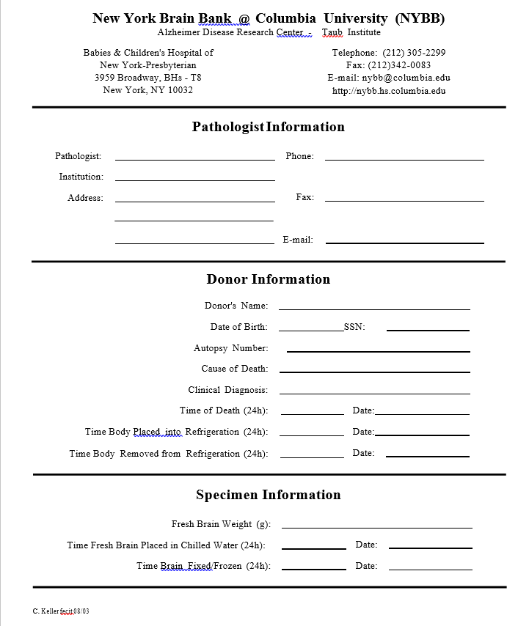

#### Instructions for Shipping Fresh Brains to the NYBB – Taub

[**http://nybb.hs.columbia.edu**](http://nybb.hs.columbia.edu/) **–** [**nyb**](mailto:nybb@columbia.edu)[**b@columbia.edu**](mailto:b@columbia.edu)

These instructions outline the procedures of packing a fresh brain for shipment to the NYBB. Upon request, we provide packing material. For further assistance call 212-305-2299.

* + 1. Recommended items to pack a fresh brain:

|  |  |
| --- | --- |
| Two clean, dry ziploc plastic bags (about 22.0 x 30.0 cm) | Plastic bucket with a tightly fitting lid  (about 4.0 liters) |
| Large plastic  bag (about 40.0 x 50.0 cm) | Envelope for documents |
| Thermosafe polyfoam container (about 38.0 x 33.0 x 31.0 cm) | Two refrigerant packs about (17.0 x 10.0 cm) |
| Wet ice (about 1.0 kg) | |

* + 1. Packing procedure:

|  |  |
| --- | --- |
| Put the fresh brain in the first ziploc bag (A). | Ziploc first bag (B). |
| Place bag (B) in second bag and ziploc it (C). | Place 0.5 kg of wet ice into the bucket and transfer the double-bagged brain onto the ice (D). |
| Cover double-bagged brain with wet ice (E) and tightly fit the lid on the bucket. | Put big plastic bag into the polyfoam container and place wet ice (about 0.3 kg) into the bag (F). |
| Transfer sealed bucket into plastic bag of the container, onto the ice and add refrigerant packs (G). | Close plastic bag (H), put polyfoam lid in place, add documents and close cardboard box. |
| Please provide information pertaining to the donor of the specimen and the time intervals between the steps of obtaining and packing the brain. Please refer to the information sheet,  which may be downloaded from our Internet site. (http://www.nybb.hs.columbia.edu) | |
| We use *"Sterling Courier Systems"* as they are familiar with our operations. For pickup call:  **1-888-633-6666** and indicate that you would like to send tissue samples to: **"NYBB - Taub"**. | |

* 1. **Appendix H: Sample form for frozen and fixed brain tissue**

**AD FBS Brain Tissue Specimens**

Please complete this form when sending brain tissue to NCRAD. The contact information for emailing the form is in the box below. **Please email the form as soon as possible after tissue is extracted**. NCRAD would like to receive this form BEFORE tissue arrives.

**To: Kelley Faber**

**Fax: 317-321-2003 Email:** [**alzstudy@iu.edu**](mailto:alzstudy@iu.edu)

**Phone: 1-800-526-2839 Phone: 317-274-7360**

|  |  |  |  |  |  |  |  |  |
| --- | --- | --- | --- | --- | --- | --- | --- | --- |
| From: Site ID: Phone: Fax:  Email: Date: | | | | | | | | |
| **Site ID** | **Family ID** | **Individual ID** | **GUID** | **Tissue Removal Date** | **Section of Brain** | **Gender** | **Year of Birth** | **Fixed or Frozen Tissue** |
|  |  |  |  |  |  |  |  |  |
|  |  |  |  |  |  |  |  |  |
|  |  |  |  |  |  |  |  |  |
|  |  |  |  |  |  |  |  |  |
|  |  |  |  |  |  |  |  |  |
|  |  |  |  |  |  |  |  |  |
|  |  |  |  |  |  |  |  |  |
|  |  |  |  |  |  |  |  |  |
|  |  |  |  |  |  |  |  |  |
|  |  |  |  |  |  |  |  |  |
|  |  |  |  |  |  |  |  |  |
|  |  |  |  |  |  |  |  |  |
|  |  |  |  |  |  |  |  |  |
|  |  |  |  |  |  |  |  |  |
|  |  |  |  |  |  |  |  |  |