Year 12 physics extended experimental Investigation

An experimental analysis of Dreamworld’s “Tower of Terror 2”.

Contents

**No table of contents entries found.**

# Abstract

# Introduction

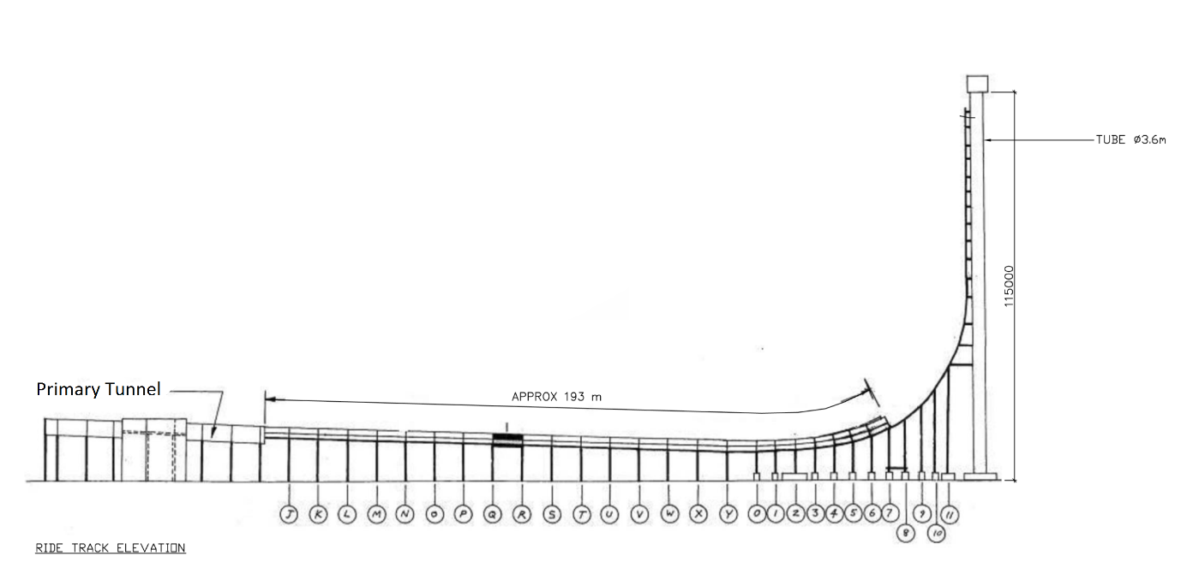

Figure : Tower of Terror 2 Schematics

The *Tower of Terror II* is a reverse free-fall ride, residing in the Dreamworld Theme park in the Gold Coast, Australia. Although there are a number of physics concepts that can be examined on this ride, the focus of the following investigation will be drag and energy. The investigation will focus on the kinetic and gravitational potential energy of the ride’s cart at various points, but will further evaluate the kinetic energy of the cart when it leaves and re-enters the primary tunnel (See Figure 1).