  - REVIEW DRAFT - NOT FOR SUBMISSION. Generated 2026-10-06 from manuscripts/benchmark/manuscript.md and manuscripts/benchmark/supplementary.md.
  - Highlighted fields are outstanding author input; see AUTHOR_FIELDS_TO_COMPLETE.md.
  - FIMM governance and secure source-provenance fields remain submission blockers; see COAUTHOR_REVIEW_CHECKLIST.md.
  - Scientific results are retrospective development evidence; no external validation is claimed.
  - Inline provenance citations are stripped from this rendering; they remain in the markdown source.

PanelHLA: an auditable benchmark and plurality baseline for short-read classical HLA class I (HLA-A, -B and -C) genotyping
Running title: PanelHLA short-read HLA class I benchmark

Authors and submission metadata
PROVISIONAL AUTHOR METADATA — confirmation required: Umut Onur Özcan¹, Nemo Ikonen¹, Philipp Sergeev¹, Ella Sinervuori¹, Khalid Saeed², Ziaurrehman Tanoli^{1,3}, Markus Vähä-Koskela^{1,3}
¹ Institute for Molecular Medicine Finland (FIMM), HiLIFE, University of Helsinki, Helsinki, Finland
² King Abdullah International Medical Research Center, Riyadh; King Saud bin Abdulaziz University for Health Sciences, Riyadh; Ministry of National Guard Health Affairs, Riyadh, Saudi Arabia
³ iCAN Digital Precision Cancer Medicine Flagship, University of Helsinki and Helsinki University Hospital, Helsinki, Finland
Provisional corresponding authors: Ziaurrehman Tanoli and Markus Vähä-Koskela. Postal addresses and email addresses remain to be supplied.
TO CONFIRM BEFORE SUBMISSION: author names, order and affiliations; ORCIDs; corresponding-author details; CRediT roles; public-data ethics determination; FIMM governance and ethics wording; funding; competing interests; acknowledgements; repository release tag and final commit; archival DOI; and externally controlled container digests. The author, affiliation, funding, competing-interest and acknowledgement text below is provisional and was carried forward from the superseded CHAMPHLA draft, not independently inferred.

Keywords
HLA typing; caller integration; benchmark resource; immunogenomics; whole-exome sequencing; RNA sequencing; reproducibility

Abstract
HLA typing performance depends on assay, reference database and caller (the computational tool that infers HLA genotypes from sequencing reads). Combining callers may reduce dependence on individual tool selection, but incomplete outputs, unresolved reference-genotype ambiguity and inappropriate denominators can overstate consensus performance. We evaluated PanelHLA-Consensus, an equal-weight plurality baseline for HLA-A, HLA-B and HLA-C, using recovered outputs from six callers across two panels (five for whole-exome sequencing [WES] and four for RNA-seq). “Recovered” denotes preserved outputs whose upstream workflow cannot be rerun here. Fixed-denominator concordance scored every truth locus and treated no-calls as incorrect. Reference genotypes were parsed from a checksum-pinned 2014 1000 Genomes table. A fail-closed audit retained 153/390 WES loci from 63 subjects and 120/321 RNA-seq loci from 52 subjects for exact unordered two-field scoring. PanelHLA-Consensus was concordant at 143/153 WES loci (93.5%) and 110/120 RNA-seq loci (91.7%); it tied POLYSOLVER in WES and exceeded OptiType by one RNA-seq locus. Compatibility with any allowed ambiguous genotype increased the evaluable sets to 335 WES and 266 RNA-seq loci, with concordance of 95.5% and 95.1%, respectively. Paired cluster-t inference used separate descriptive and fitted comparison families. A fitted policy that selects the single best caller by nested cross-validation (nested-CV) did not improve on the plurality vote: on RNA-seq it was 9.17 percentage points worse (Holm p=0.044), and that difference did not survive an exact sign-flip sensitivity test (Holm p=0.078). Errors made by different callers were correlated rather than independent (pairwise φ 0.09 to 0.77 in WES and 0.41 to 0.86 in RNA-seq), which bounds how much any vote over them can correct.
Contents
Use the document outline to navigate.

Introduction
Accurate HLA typing informs drug-hypersensitivity prevention — including pre-prescription screening for HLA-B\15:02 before carbamazepine and for HLA-B\57:01 before abacavir — donor matching in haematopoietic cell transplantation, disease-association research — in which HLA alleles are tested for statistical association with susceptibility to autoimmune and infectious disease — and neoantigen prediction in cancer immunotherapy (Chung et al., 2004; Petersdorf et al., 2007; Mallal et al., 2008; Schumacher and Schreiber, 2015; Matzaraki et al., 2017). The classical class I genes HLA-A, HLA-B and HLA-C encode cell-surface molecules that present intracellular peptides to CD8-positive T cells, linking genotype to immune recognition in infection, malignancy and transplantation (Trowsdale and Knight, 2013). These genes are exceptionally polymorphic — the IPD-IMGT/HLA database catalogues more than 45,000 named alleles — and difficult to type from short reads because homologous loci, reference bias, multi-mapping and uneven assay coverage interact with rapidly evolving nomenclature and reference databases (Trowsdale and Knight, 2013; Robinson et al., 2020). RNA-seq adds an assay-specific constraint: it samples expressed alleles rather than genomic copies, and HLA expression estimation itself is sensitive to polymorphism-aware mapping (Aguiar et al., 2019).
Different HLA callers use materially different evidence and inference procedures. For instance, OptiType uses integer programming (Szolek et al., 2014), HLA-HD scores alignments to an allele dictionary (Kawaguchi et al., 2017), arcasHLA uses transcript abundance (Orenbuch et al., 2019), POLYSOLVER combines alignment and population information (Shukla et al., 2015), T1K estimates allele abundance by expectation maximization (Song et al., 2023), and SpecHLA combines alignment and local assembly (Wang et al., 2023). Graph-based systems such as HLALA and HISAT-genotype form another important caller class: rather than aligning reads to one linear reference sequence, they align to a graph in which known alleles are represented as alternative paths, so reads from alleles that diverge strongly from the reference can still be placed correctly (Dilthey et al., 2019; Kim et al.*, 2019). Callers within the same algorithmic family share mapping assumptions and tend to produce correlated errors on difficult allele configurations, limiting the error-correction benefit of combining them in a vote.
Benchmarks show assay-, gene- and dataset-dependent rankings (Kiyotani et al., 2017; Claeys et al., 2023). Consensus is consequently attractive, but not new. Lee et al. (2021) combined existing HLA tools and related confidence to the number of concordant calls. The consHLA workflow combined HLA-HD results across germline WGS, tumour WGS and tumour RNA-seq from the same patient (Bowen-James et al., 2025). PanelHLA-Consensus addresses a narrower question: within one assay and a named panel of callers. The study aim was to quantify exact two-field concordance, callability, paired differences, ambiguity-aware sensitivity and correlated errors for a deterministic equal-weight genotype vote, while preserving failed calls and unavailable provenance.
This development-stage reanalysis was prompted by two integrity findings. First, the earlier parser converted a singleton allele into a homozygous pair, although a missing second allele is not evidence of homozygosity. Second, the result tables produced by that earlier analysis selected a single allele from ambiguous laboratory-typing strings in the public truth source, rather than treating the ambiguity as unresolved. We correct both defects, retain invalid historical values only as provenance, and distinguish development performance from external validation.

Methods

Study design and reproducibility boundary
This retrospective benchmark evaluated recovered normalized outputs already produced for 1000 Genomes WES and Geuvadis RNA-seq (1000 Genomes Project Consortium, 2015; Lappalainen et al., 2013). Here, “recovered” means that the caller outputs were produced by an earlier processing run and kept as files. The workflow that produced them is not part of this repository and cannot be re-run from it, so the benchmark begins from those stored outputs rather than from raw sequencing reads. The paper repository verifies the path from truth-free outputs through normalization, truth selection, joining, statistics, tables, figures and manuscript generation. Raw-read acquisition, alignment and execution of the historical caller workflow cannot be reproduced from this repository and are outside that boundary. The benchmark is therefore not a clean rerun of each caller or a prospective validation study.
The primary reporting rule was selected after inspection of the development-stage evidence. It uses no truth labels during prediction, but its development performance is post hoc and cannot estimate prospective generalization. A second, separately pre-registered protocol — referred to here as version 2 — locks a subject-disjoint public-data extension before any truth labels are joined, so that its evaluation is prospective with respect to the rule reported here. That extension contains 89 WES and 99 RNA-seq subjects with zero development/evaluation overlap; it is within the same 1000 Genomes/Geuvadis ecosystem and is not independent clinical validation. No extension performance is reported until all caller containers, native databases and truth-free outputs pass the release gates.
Capture kit, read length, sequencing depth and historical preprocessing metadata were not recoverable for either assay. The requested inputs contained 130 WES subjects (390 subject-gene loci) and 107 RNA-seq subjects (321 loci); 106 subjects occurred in both requested assay sets. The same individual can contribute to both assay analyses, which are reported separately and are not treated as independent replications. After exact-truth filtering, the analyses contained 63 WES subjects and 52 RNA-seq subjects, 51 of whom occurred in both sets; these are also the subject clusters used for inference.

Reference HLA typing and denominator construction
Reference genotypes were acquired from the International Genome Sample Resource (IGSR) copy of the 2014 1000 Genomes HLA diversity table (Gourraud et al., 2014). Acquisition is pinned to a SHA-256 checksum — a cryptographic digest of the file contents, which changes if any byte of the file changes — 0455d0302ac12a29ab87091cab5e3e557416f6301e89fb122eef8d49cd5644ec; a mismatch stops regeneration.
Throughout, a subject is one individual in the public 1000 Genomes and Geuvadis collections. These are consented population-genomics donors, not patients, and no clinical samples are involved; a locus is one subject–gene pair within one assay.
The source includes allele ambiguity strings and duplicate subject records. For each subject and gene, every source row was parsed before an exact label was accepted. A locus was excluded from the exact endpoint if any row was ambiguous, invalid or conflicting; thus a resolved duplicate could not conceal an ambiguous duplicate. No first-listed or frequency-preferred allele was selected. This yielded 153 WES loci from 63 subjects and 120 RNA-seq loci from 52 subjects, with 51 subjects in both filtered sets. The audit excluded 237/390 requested WES loci and 201/321 RNA-seq loci. Predictions for all 711 requested loci were generated and checksummed before truth selection.
Secondary analyses represented truth as every valid unordered two-field candidate pair. A prediction was compatible when it matched any allowed pair; this retained 335 WES and 266 RNA-seq loci. A further sensitivity mapped each two-field designation to all compatible official IPD-IMGT/HLA 3.65.0 G groups; it tests compatibility and does not infer an exact G-group call. Exclusion was described by gene, source population, source presence, ambiguity width and candidate-pair count. Candidate-occurrence bounds were treated as internal benchmark counts, not population allele frequencies.

Callers and assay-specific panels
The WES panel comprised five callers: HLA-HD, OptiType, POLYSOLVER, SpecHLA and T1K. The RNA-seq panel comprised four: arcasHLA, HLA-HD, OptiType and T1K. Kourami, seq2HLA, HLALA and HISAT-genotype were not present in the recovered row-level inputs (Boegel et al., 2012; Lee and Kingsford, 2018; Dilthey et al., 2019; Kim et al.*, 2019). Because no outputs from these callers survive in the recovered data, they could not be scored here, and no claim is made about how they would compare with the panel callers in either direction. The panel reflects historical assay deployment rather than an exhaustive modern benchmark.
Recovered inputs carried metadata referring to IPD-IMGT/HLA 3.59.0, but the historical normalization implementation only checked allele syntax and reduced identifiers to two numeric fields; it did not verify release membership or map renamed/deleted alleles. The development results are therefore syntax-normalized, not database-harmonized. A release-3.65 audit records the membership state of every truth and predicted allele at every discordant locus, but exact historical search databases were unavailable, so native truth representability and the fraction of errors caused by database vintage remain unknown. Algorithm, database and deployment effects are not separated. The locked extension uses archived official IPD-IMGT/HLA 3.65.0 allele, deletion, P-group and G-group files with SHA-256 identities. Historical execution did not preserve executable versions or container digests. An independent content audit assigned retained caller resources as HLA-HD 3.15.0, OptiType 3.13.1, POLYSOLVER 3.11.0, SpecHLA with heterogeneous 3.38.0/3.51.0 components, T1K 3.63.0, and arcasHLA 3.40.0 from a historical bundled version report. These are caller resources, not the later normalization release. Historical WES inputs were aligned to GRCh38DH and RNA-seq inputs to GRCh37. Missing executable and container provenance is reported rather than inferred.

Allele normalization and call states
For recovered development inputs, alleles required a valid HLA gene and at least two numeric fields. Gene mismatches, malformed alleles and unresolved slash-delimited ambiguities were rejected. Higher fields and expression suffixes (N, L, S, Q, C and A) were retained as metadata; P and G denote allele groups and are not expression suffixes (Marsh et al., 2010). The primary endpoint used the first two numeric fields. Extension calls additionally require membership in the pinned IPD release; renamed and deleted identifiers, group-level calls and release-incompatible identifiers receive explicit mapping states. Diploid pairs were sorted before comparison.
Each caller row has one explicit state: complete, partial, missing, ambiguous, invalid or failed. Centralized placeholders include empty strings, -, ., NA and NOTTYPED. A row with one resolved allele and no second allele is partial and abstains. Duplication is allowed only when a caller-native format explicitly declares homozygosity. POLYSOLVER and OptiType consistently emitted complete diploid pairs in both assays and had no partial rows; HLA-HD, T1K and arcasHLA returned single-allele partial rows when a second allele was absent, so those rows abstain rather than fabricate a homozygous call. Missing, partial and invalid rows do not vote.

Primary and secondary consensus rules
At each subject-gene locus, each callable intended-use caller casts one vote for its unordered two-field genotype. PanelHLA-Consensus selects the genotype with the most votes. Equal maxima are resolved by lexicographic allele-pair order and flagged. If no caller is callable, the method abstains. The rule uses no truth labels, allele frequencies or fitted weights.
Two additional descriptive rules used the same votes: strict majority emitted the leading pair only with more than half of callable votes, and two-thirds consensus required at least two thirds. Individual caller outputs were also evaluated. Six fitted policies were exploratory: nested-CV best single caller; champion–challenger; two-thirds-guarded champion–challenger; vote-stratum-gated champion–challenger; L2-regularized logistic meta-consensus; and a champion–challenger rule requiring support from at least two algorithm families. Supplementary S7 defines their gates and fallbacks. Their development scores cannot establish generalization because construction or selection and evaluation share the development resource.

Endpoints and statistical analysis
The primary descriptive endpoint was exact unordered diploid concordance at two-field resolution: a locus counted as concordant only when both predicted alleles matched both reference alleles to the first two fields, in either order (unordered), with no credit for matching one allele of the pair. Every evaluable truth locus remained in the denominator; an absent or non-callable prediction scored incorrect. Callability was reported separately. Allele concordance counted the multiset intersection between predicted and truth alleles over twice the genotype denominator.
Fixed-denominator concordance includes every evaluable truth locus and scores a missing or non-callable prediction as incorrect. Called-only concordance uses only loci with a complete diploid prediction and is always reported with callability. Subject-cluster percentile bootstrap intervals describe fixed-denominator genotype concordance, allele concordance, callability and called-only concordance. Each interval used 100,000 subject resamples with base seed 20260831 and a deterministic SHA-256-derived method seed. Resampling retains every evaluable locus and both alleles from each sampled subject, so the estimand remains locus weighted.
For each comparator, the paired effect is PanelHLA-Consensus − comparator in percentage points. The locus-weighted mean difference used a CR1 (bias-reduced cluster-robust) subject-clustered standard error and Student t reference distribution with G−1 degrees of freedom. Holm correction was applied separately within each assay's descriptive-comparator and exploratory-fitted families; comparisons with zero discordance were displayed but excluded from multiplicity. Bonferroni-adjusted cluster-t intervals used the identical active family and therefore are dual to the primary tests. Exact two-sided sign-flip tests were enumerated for at most 20 nonzero subject aggregates; larger sets used 1,000,000 seeded assignments with a plus-one correction. These sign-flip results and their discrete detectability limits are sensitivity analyses. A post hoc two-percentage-point non-inferiority calculation is exploratory sensitivity analysis and is not used to claim equivalence. Support-stratified results are descriptive proportions, not probability calibration. No external validation test was performed.

Software and audit trail
The release environment — the pinned software stack in which the reported results were regenerated — is Python 3.11.15 with NumPy 1.26.4, SciPy 1.14.1 and Matplotlib 3.9.2. Workflow metadata declare Nextflow 25.10.2 for workflow execution and Apptainer for containerisation, with caller containers taken from the curated bioinformatics software collection of the national computing centre used for this work (CSC — IT Center for Science, Finland; collection bio-apps, release v202603) (Harris et al., 2020; Virtanen et al., 2020; Hunter, 2007; Di Tommaso et al., 2017). Inputs, truth, predictions and outputs carry SHA-256 identities. Prediction generation enforces the truth firewall in code: the step that produces caller predictions refuses to run if any input table carries a reference-genotype column, so truth cannot reach a prediction. Figures read versioned tab-separated value (TSV) artifacts and are emitted as PDF, SVG, 600-dpi PNG and TIFF. A superseding decision record preserves rather than rewrites historical decisions. Invalid historical WGS results are quarantined and no quantitative WGS performance is reported.
Current raw-workflow provenance is limited to two successful single-sample HG00096 smoke runs on Roihu. The DNA route used a WGS-derived mate-aware HLA BAM and is not presented as a WES runtime estimate; the RNA-seq route used paired FASTQ. Nextflow and Slurm task measurements, container hashes, commands and workflow revisions are reported separately in Supplementary S9. They do not recover historical development-cohort resource use or support cost or scaling claims.
Official IPD-IMGT/HLA 3.65.0 resources are pinned to their upstream release tag and locally checksummed. The extension readiness gate fails closed until every voting caller and contemporary comparator has an immutable container digest, exact native allele database and validated output parser. At this manuscript build, that gate remains closed and no extension result is available for interpretation.

Results

Cohort flow and truth-source audit
Only 153/390 requested WES loci and 120/321 requested RNA-seq loci had a fail-closed unique two-field genotype in the checksum-pinned source. The WES flow comprised 153 resolved, 182 ambiguous, one invalid and 54 source-absent loci; RNA-seq comprised 120, 146, one and 54, respectively. The retained WES set contained 50 HLA-A, 52 HLA-B and 51 HLA-C loci; RNA-seq contained 39, 41 and 40. Ten assay-loci accepted by the previous parser were removed because a resolved duplicate record had concealed an ambiguous duplicate. The prior 390/321 denominators and their concordance estimates are invalid for an exact two-field endpoint because they selected representatives from ambiguous truth strings. Exact-truth retention was also strongly population-dependent: after pooling genes, 84.7% of CEPH and 92.8% of YRI WES source-present loci were retained, compared with 3.9% of FIN, 3.9% of GBR and 8.3% of PUR loci. This confirms rather than merely hypothesizes selection in the exact endpoint; Supplementary Table S1 reports the assay-, gene- and population-level flow (Figure 1).
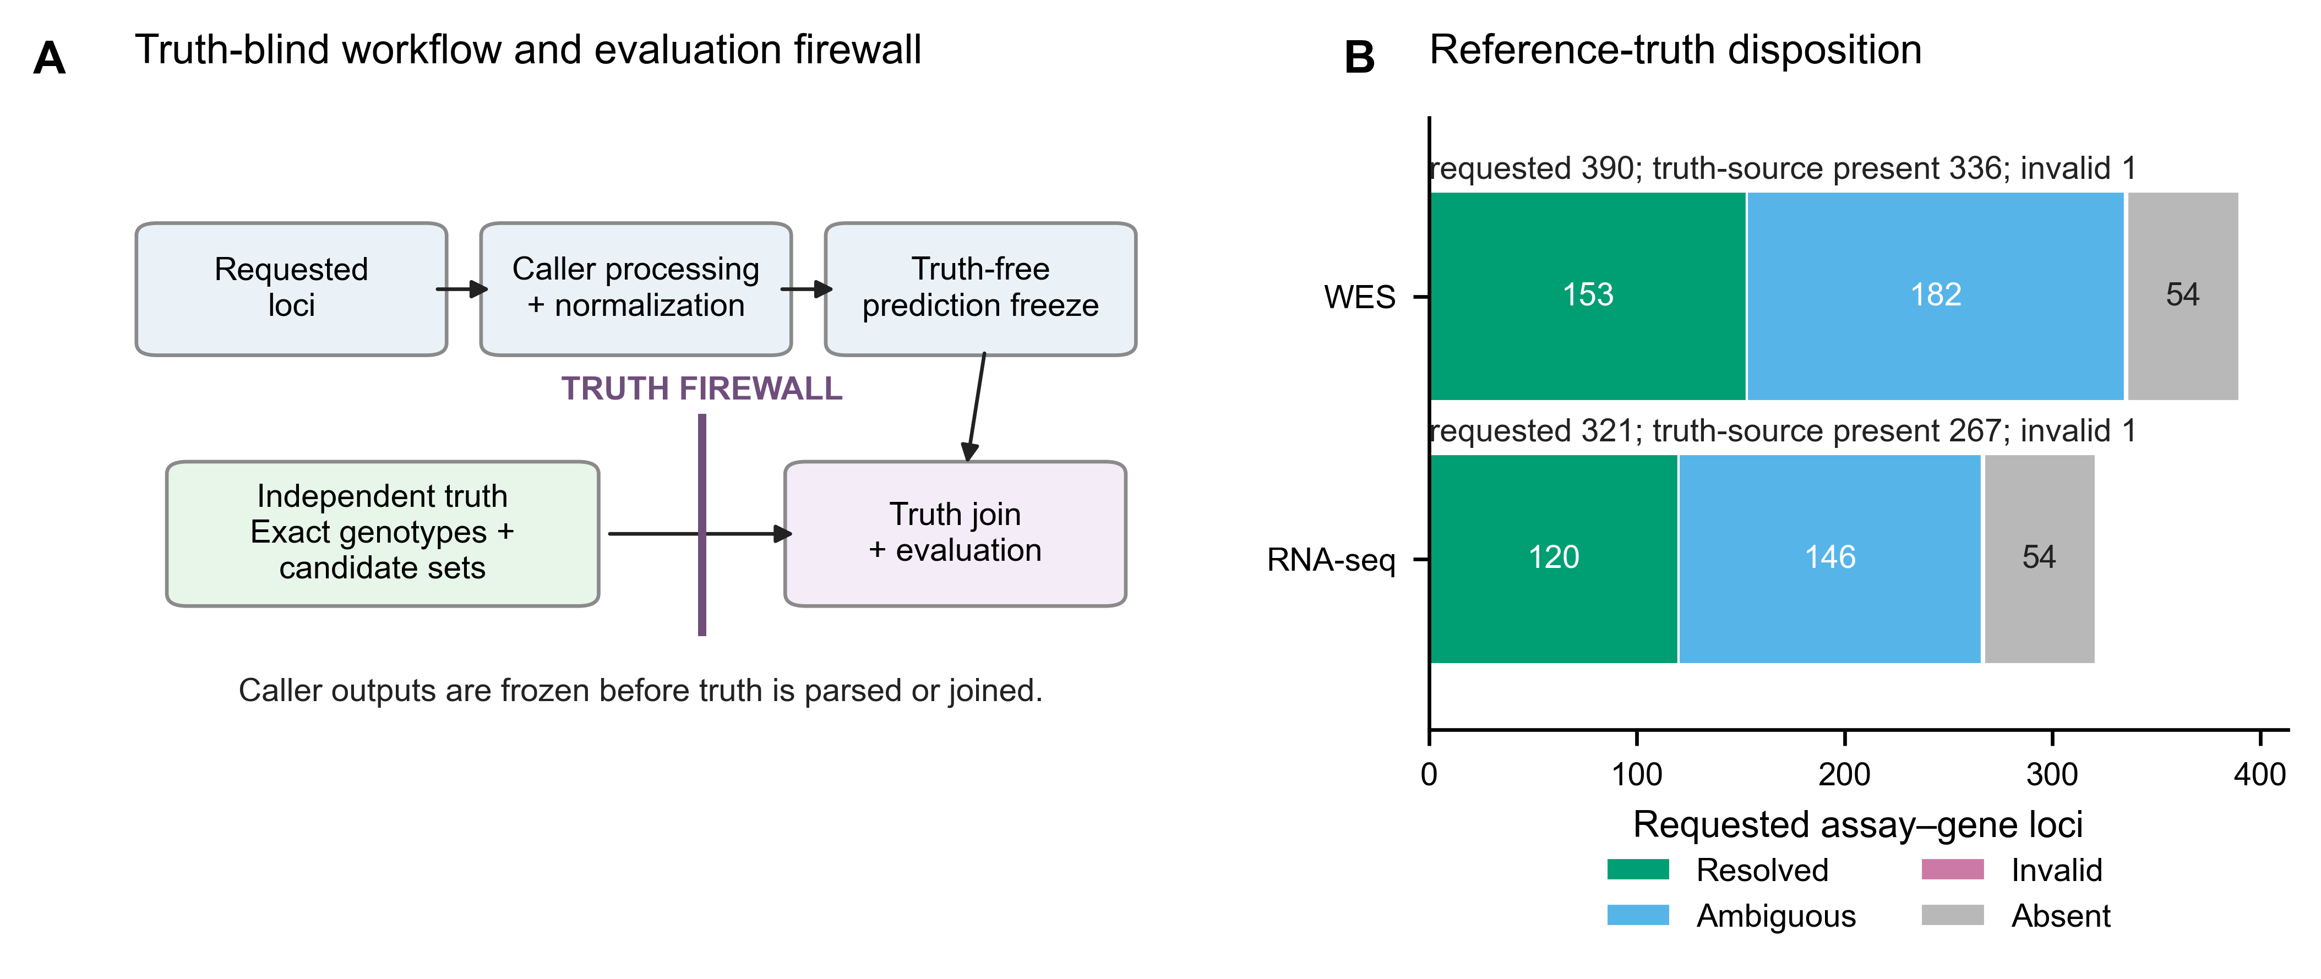
Figure 1. Study design, truth firewall and cohort flow. (A) Caller processing and normalization are completed and frozen before the independently parsed truth is joined, preventing caller output from influencing truth resolution. (B) Requested assay–gene loci are partitioned into resolved, ambiguous, invalid and source-absent truth states. Source absence is a truth-record state, not a caller no-call. Counts are generated from the truth-flow artifact.

Status of the locked extension
The version-2 protocol audit confirmed the frozen 89-subject WES and 99-subject RNA-seq rosters and found no overlap with any development or prior evaluation subject. Extension execution nevertheless remained prohibited: all ten required caller resources lacked at least one release-critical item, including an immutable container digest, exact native allele database or completed licence/resource audit. No truth join was performed, no subject was replaced and no extension performance estimate is reported. The extension is therefore a locked future analysis, not evidence supporting the conclusions of this development report.

Exact development-set concordance and paired comparisons
PanelHLA-Consensus called 153/153 WES loci and 119/120 RNA-seq loci. Exact genotype concordance was 143/153 (93.5%; subject-clustered 95% CI 89.7–96.8%) for WES and 110/120 (91.7%; 86.3–96.5%) for RNA-seq (Figure 2). Allele concordance was 296/306 (96.7%; 94.9–98.4%) and 228/240 (95.0%; 91.4–98.0%), respectively.
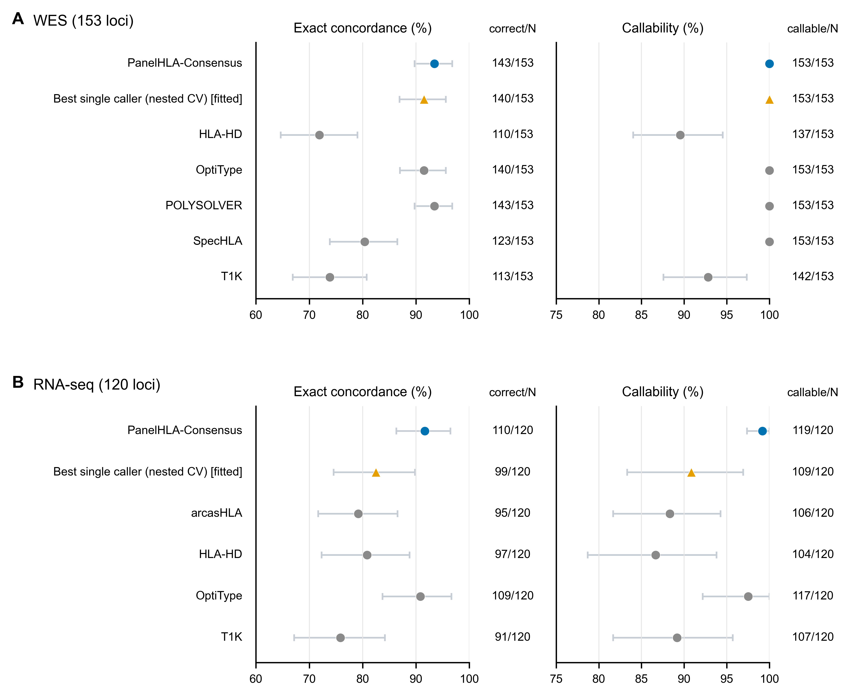
Figure 2. Fixed-denominator exact genotype concordance and callability. WES (A) and RNA-seq (B) show exact unordered two-field genotype concordance and callability over the same fixed denominator. Bars are 95% subject-cluster percentile bootstrap intervals; adjacent columns report correct/N and callable/N. Blue denotes PanelHLA-Consensus, the orange triangle denotes the exploratory fitted nested-CV best-caller policy and grey circles denote individual callers. Methods follow a fixed role-based order rather than observed performance. Both percentage axes are truncated below 100% to show the observed range and never extend above 100%.
PanelHLA-Consensus and POLYSOLVER each had 143/153 correct WES genotypes; their paired difference was 0.00 points (Bonferroni-adjusted cluster-t 95% CI −2.59 to 2.59; Holm p=1). In RNA-seq, PanelHLA-Consensus had 110/120 correct calls and OptiType 109/120, a difference of 0.83 points (−4.32 to 5.98; Holm p=0.659). These intervals permit benefit or harm and do not establish equivalence or non-inferiority (Figure 3).
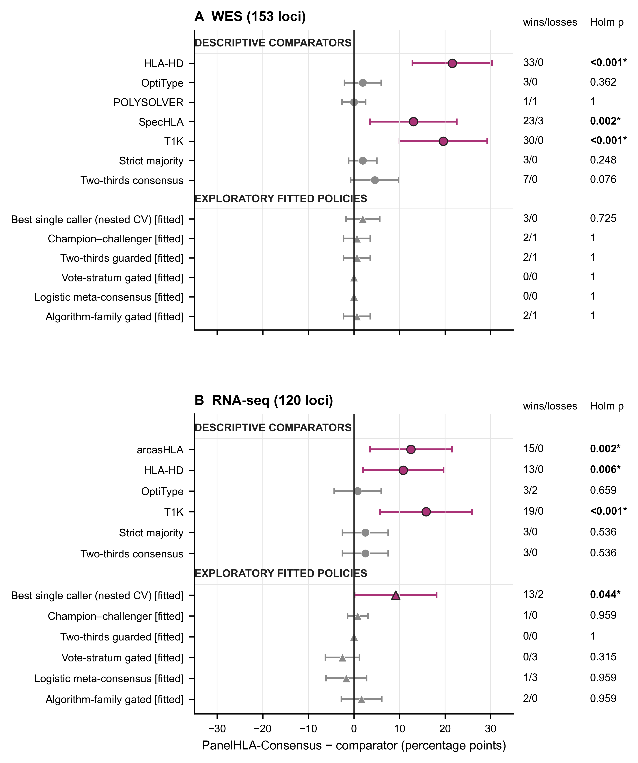
Figure 3. Paired cluster-robust differences from PanelHLA-Consensus. Every delta is PanelHLA-Consensus minus comparator. Bars are Bonferroni-adjusted cluster-t intervals over the same family used for Holm testing. Circles denote descriptive comparators and triangles exploratory fitted policies. Magenta and an asterisk identify Holm-adjusted p<0.05; grey is nonsignificant. Right-hand columns give locus wins/losses and Holm-adjusted p values. Zero-discordance comparisons are displayed at 0 with interval [0,0], wins/losses 0/0 and p=1. Exact sign-flip sensitivity results are in Supplementary Section S3. Non-significance is not equivalence.
Table 1. Primary and descriptive comparator performance. Concordance uses the fixed denominator; intervals are 95% subject-cluster percentile bootstrap intervals.
Assay | Method | Scope | Callable | Correct | Fixed-denominator concordance, % (95% CI) | Called-only concordance, % (95% CI)
WES | PanelHLA-Consensus | primary | 153/153 | 143/153 | 93.5 (89.7–96.8) | 93.5 (89.7–96.8)
WES | Strict majority | descriptive comparator | 150/153 | 140/153 | 91.5 (87.4–95.4) | 93.3 (89.5–96.8)
WES | Two-thirds consensus | descriptive comparator | 144/153 | 136/153 | 88.9 (84.0–93.4) | 94.4 (90.8–97.8)
WES | POLYSOLVER | individual caller | 153/153 | 143/153 | 93.5 (89.7–96.8) | 93.5 (89.7–96.8)
WES | OptiType | individual caller | 153/153 | 140/153 | 91.5 (87.0–95.6) | 91.5 (87.0–95.6)
WES | SpecHLA | individual caller | 153/153 | 123/153 | 80.4 (73.9–86.5) | 80.4 (73.9–86.4)
WES | T1K | individual caller | 142/153 | 113/153 | 73.9 (66.9–80.8) | 79.6 (73.2–85.7)
WES | HLA-HD | individual caller | 137/153 | 110/153 | 71.9 (64.6–79.0) | 80.3 (73.0–87.1)
WES | Best single caller (nested CV) | exploratory fitted; nested CV | 153/153 | 140/153 | 91.5 (86.9–95.6) | 91.5 (86.9–95.6)
RNA-seq | PanelHLA-Consensus | primary | 119/120 | 110/120 | 91.7 (86.3–96.5) | 92.4 (87.2–96.9)
RNA-seq | Strict majority | descriptive comparator | 114/120 | 107/120 | 89.2 (83.1–94.7) | 93.9 (88.7–98.2)
RNA-seq | Two-thirds consensus | descriptive comparator | 114/120 | 107/120 | 89.2 (83.1–94.7) | 93.9 (88.7–98.2)
RNA-seq | OptiType | individual caller | 117/120 | 109/120 | 90.8 (83.7–96.6) | 93.2 (87.8–97.5)
RNA-seq | T1K | individual caller | 107/120 | 91/120 | 75.8 (67.2–84.2) | 85.0 (77.9–91.6)
RNA-seq | HLA-HD | individual caller | 104/120 | 97/120 | 80.8 (72.3–88.8) | 93.3 (87.5–98.0)
RNA-seq | arcasHLA | individual caller | 106/120 | 95/120 | 79.2 (71.7–86.6) | 89.6 (83.5–95.1)
RNA-seq | Best single caller (nested CV) | exploratory fitted; nested CV | 109/120 | 99/120 | 82.5 (74.6–89.8) | 90.8 (85.1–96.0)
After Holm correction within the descriptive comparison family, PanelHLA-Consensus had greater concordance than HLA-HD, SpecHLA and T1K in WES, and than arcasHLA, HLA-HD and T1K in RNA-seq. Within the fitted family, it exceeded the nested-CV best-caller policy on RNA-seq by 9.17 points (Bonferroni-adjusted cluster-t 95% CI 0.18–18.16; Holm p=0.044). The exact sign-flip sensitivity was not significant (Holm p=0.078), so this result is inference-method sensitive as well as fitted.

Ambiguity-compatible sensitivity analyses
Set-valued scoring recovered 335 WES and 266 RNA-seq loci with parseable source truth. PanelHLA-Consensus was compatible with 320/335 WES candidate sets (95.5%; subject-clustered 95% CI 93.4–97.6%) and 253/266 RNA-seq candidate sets (95.1%; 91.7–97.8%). Mapping two-field designations to all compatible official IPD-IMGT/HLA 3.65.0 G groups yielded 322/333 (96.7%; 94.6–98.5%) and 252/264 (95.5%; 92.1–98.1%), respectively; two truth loci per assay were unresolved for that endpoint. These are more permissive compatibility analyses, not replacements for the exact primary endpoint. Supplementary Figure S4 compares the endpoint-specific estimates without connecting results that use different denominators.
All truth alleles in the 20 PanelHLA-Consensus error loci, and all predicted alleles in the 19 callable discordances, were current IPD-IMGT/HLA 3.65.0 designations; the remaining RNA-seq error was a no-call. Thus no primary error was attributable solely to a current-release rename, deletion or membership failure. Exact historical caller search spaces were unavailable, so this audit does not isolate database-vintage effects from algorithm or deployment effects.

Caller missingness after singleton abstention
The corrected parser classified 16 HLA-HD and 11 T1K WES rows as partial. In RNA-seq, arcasHLA had 14 partial rows, HLA-HD 13 and T1K 10; three rows were absent for each of HLA-HD, OptiType and T1K. These rows no longer contribute fabricated homozygous votes (Supplementary Figure S1). Stricter vote thresholds reduced both callability and fixed-denominator concordance; the coincident RNA-seq strict-majority and two-thirds point estimates are displayed explicitly rather than overplotted (Supplementary Figure S2).

Vote-support profiles
Full-panel unanimity was concordant at 82/85 WES 5/5 loci (96.5%) and 88/92 RNA-seq 4/4 loci (95.7%). Single-voter 1/1 loci were kept separate and were 12/12 concordant in RNA-seq; this is not equivalent evidence to 4/4 unanimity. Among strata with at least five observations, support remained nonmonotonic, including 4/6 concordant WES 3/5 loci. Point estimates and intervals for strata with fewer than five loci are suppressed while their profiles and denominators remain listed (Supplementary Figure S3). There was one WES tie and four RNA-seq ties; the lexicographic winner was correct in one and two, respectively. These are not held-out calibration curves.

Caller error dependence and oracle headroom
Pairwise caller-error φ ranged from 0.09 to 0.77 in WES (median 0.39) and 0.41 to 0.86 in RNA-seq (median 0.70). Restriction to mutually callable loci did not remove the dependence: corresponding ranges were 0.19–0.77 and 0.58–0.93. The strongest RNA-seq association was between HLA-HD and T1K (φ=0.86 on the fixed denominator). These descriptive correlations plausibly explain limited plurality gains but do not identify a causal failure mechanism. This interpretation is descriptive rather than causal (Figure 4).
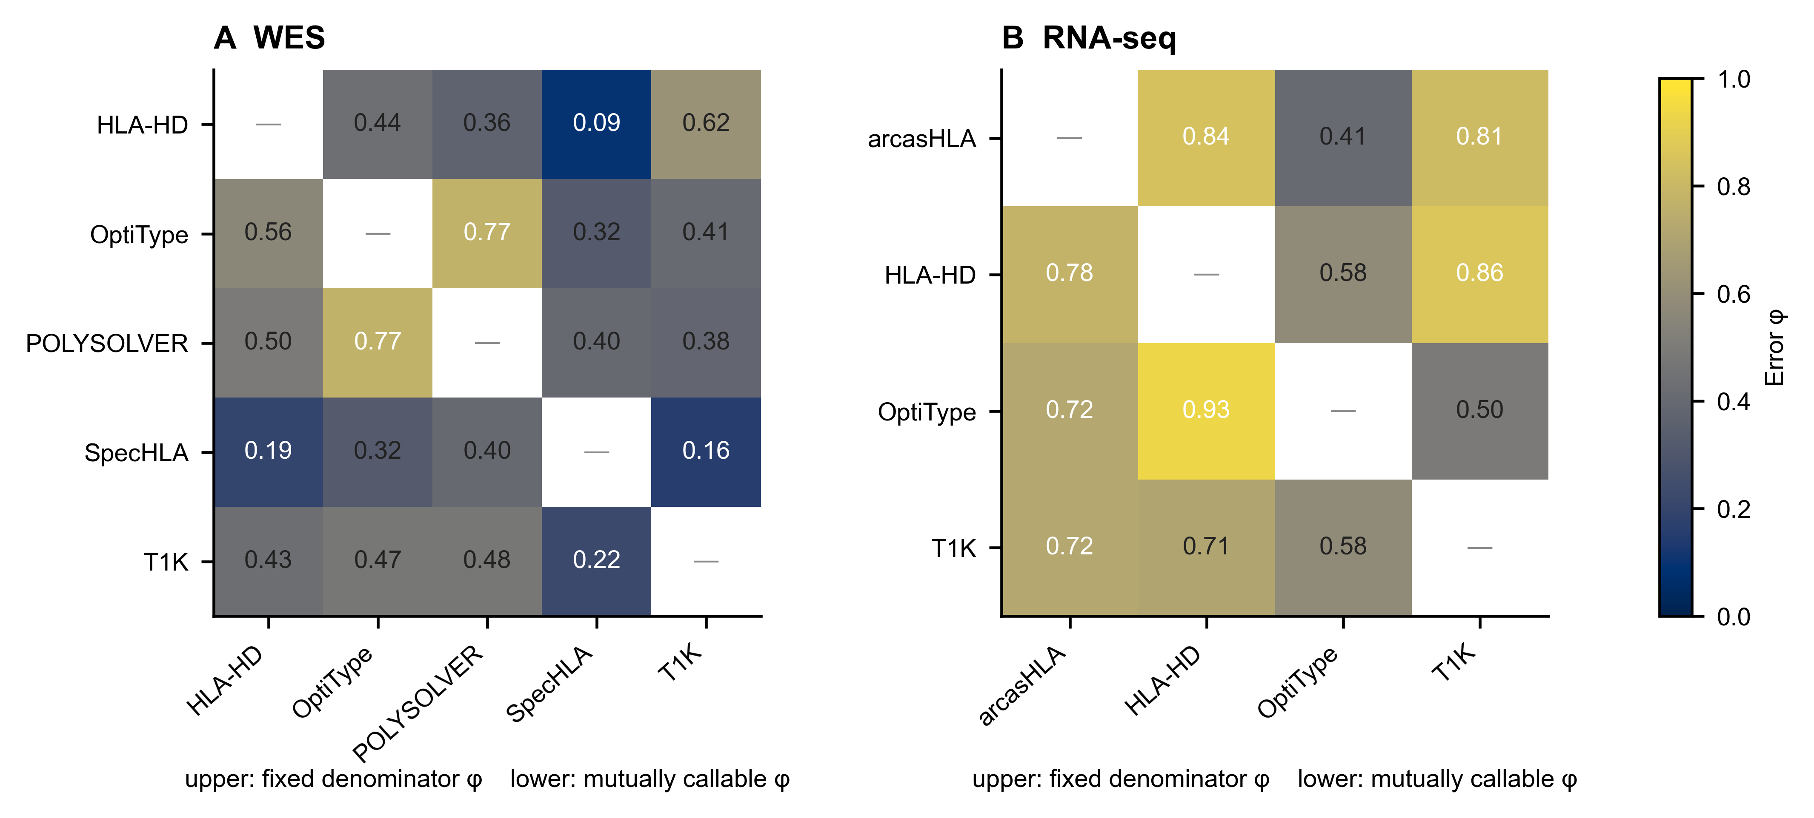
Figure 4. Pairwise caller-error dependence. WES (A) and RNA-seq (B) matrices show fixed-denominator error φ above the diagonal and error φ restricted to mutually callable loci below the diagonal, using one 0–1 colour scale. The cells are annotated to two decimals. The mutually callable analysis reduces correlation induced by shared no-calls. The matrices are descriptive and do not identify a causal error mechanism.
PanelHLA-Consensus made 10 errors in each assay. An oracle allowed to choose any evaluated caller output could recover three WES errors and two RNA-seq errors; seven and eight errors were not solved by any panel caller. Thus a selector restricted to existing outputs had ceilings of 146/153 (95.4%) for WES and 112/120 (93.3%) for RNA-seq. This is an oracle bound, not achievable performance.
The vote-stratum-gated fitted policy scored 143/153 in WES and 113/120 in RNA-seq; the logistic meta-consensus scored 143/153 and 112/120. Those RNA-seq values exceed the primary method descriptively, but the policies share the development resource and lack unseen validation. Supplementary Table S2 gives all results.

Descriptive subgroup results
WES concordance by gene was 48/50 HLA-A, 50/52 HLA-B and 45/51 HLA-C; RNA-seq was 37/39, 37/41 and 36/40. Results where the rarer truth allele occurred once within the benchmark were 21/23 in WES and 21/24 in RNA-seq. Population strata other than CEU and YRI were very small; percentages were suppressed below five loci. Homozygous strata contained only 18 WES and 15 RNA-seq loci. All subgroup analyses are descriptive.

Exploratory application to the FIMM AML/MDS cohort
The identity-linked reanalysis of the FIMM acute myeloid leukaemia (AML) and myelodysplastic syndrome (MDS) cohort imported 2,610 of 2,642 workbook rows and retained 7,179 locus rows after conservative replicate collapse; conflicting replicates abstained rather than being resolved by selecting a genotype.
Two coequal specimen-level eligibility definitions were reported. Across all complete callable pairs, exploratory exact-pair agreement was 854/958 for bulk RNA–WES (89.1%; Wilson 95% CI 87.0–91.0%), 85/93 for scRNA-seq–WES (91.4%; 83.9–95.6%) and 84/93 for bulk RNA–scRNA-seq (90.3%; 82.6–94.8%). When both assays were additionally required to have at least two valid callers, the corresponding results were 62/70 (88.6%; 79.0–94.1%), 21/24 (87.5%; 69.0–95.7%) and 18/21 (85.7%; 65.4–95.0%) (Supplementary Figure S5). The denominator difference reflects caller availability, not selection of a different biological cohort. No independent HLA truth exists for FIMM, so these are cross-modality agreement estimates, not accuracy or external-validation results. Every assay pair shares callers; the caller-disjoint sensitivity consequently had zero overlap and was non-estimable rather than omitted.

Discussion
Equal-weight plurality was competitive within these named historical panels and provided traceability from individual votes to output. Its selection for primary reporting was post hoc. PanelHLA-Consensus tied POLYSOLVER on the WES total and was one locus above OptiType in RNA-seq, but the paired intervals were wider than a two-point margin and do not establish equivalence. The nested-CV comparison also changed significance across defensible cluster-t and exact sign-flip analyses, illustrating why the fitted result should not be promoted as external evidence.
The remediation itself is a central result. Treating a singleton allele as a homozygous genotype conflates missingness with biological evidence. Selecting the first allele from an ambiguous reference string similarly turns uncertain truth into an exact label. Both can inflate sample size and alter consensus. Explicit call states, abstention and a truth parser that respects every source record are prerequisites for credible HLA benchmarking. The larger ambiguity-compatible denominators show the value of reporting exact and set-valued endpoints rather than discarding or arbitrarily resolving ambiguous typing.
This work differs from prior ensembles in its unit of integration. Lee et al. (2021) related confidence to agreement among callers; consHLA combines HLA-HD outputs across multiple specimens from a patient (Bowen-James et al., 2025). Here, distinct callers are combined within one assay and missing calls remain in a fixed denominator. The panel nevertheless spans only a few related algorithmic families, the setting in which correlated errors are expected and were observed. Modern graph, pangenome and assembly approaches were not evaluated. PanelHLA-Consensus is therefore a baseline and audit framework for a future prospective benchmark, not a comprehensive comparison of HLA callers.
Limited oracle headroom shows that selecting among the same outputs cannot fix loci where every caller is wrong. Future work should add methodologically distinct graph/pangenome callers, harmonize databases prospectively, preserve read-level evidence and test a locked policy on unseen subjects with orthogonal laboratory typing.
For current research use, these results do not justify running a multi-caller panel solely to improve concordance when a suitable assay-specific caller has already been validated. The plurality baseline is instead useful when caller choice is uncertain and an auditable robustness check is desired. Where WES and RNA-seq are both available from the same subjects, cross-modality agreement provides an inexpensive consistency check complementary to within-assay plurality; the FIMM bulk RNA–WES results here illustrate this pattern, though shared callers mean that such agreement is not methodologically independent truth. That recommendation does not extend to clinical HLA typing — including transplant donor–recipient matching and pharmacogenomics pre-prescription screening — where accredited laboratory methods and regulatory-grade validation are required.
The exploratory FIMM and VenEx applications reinforce the distinction between agreement and truth. Shared callers can induce correlated cross-modality agreement, and donor collapse can inflate apparent concordance by excluding longitudinal conflicts. BB7.2 contributes serogroup-level evidence only. VenEx describes caller availability and within-panel dissent; it is not a FIMM validation set. Neither cohort measures HLA accuracy or supports clinical utility. An exploratory application of the frozen plurality policy to 42 NCI-60 cancer cell lines (Reinhold et al., 2019) yielded concordance of 84.1% on WES and 81.7% on RNA-seq (Supplementary S9.6), broadly consistent with the development results; lower HLA-C RNA-seq concordance in cell lines is consistent with known HLA-C expression variability. These figures are descriptive and do not constitute external validation.

Limitations
This is a retrospective development study without independent external validation. WES and RNA-seq subjects overlap, and the filtered sets are small. Exact-endpoint ambiguity exclusion was strongly population-dependent, although set-valued and G-group compatibility sensitivities recover many excluded loci. The reference is the 2014 public table rather than newly generated clinical typing, and only HLA-A, HLA-B and HLA-C at two-field resolution were evaluated.
The caller panel is historical and incomplete. HLA*LA, HISAT-genotype, Kourami, seq2HLA and other graph/pangenome approaches were not compared. Callers used different database vintages and reference builds, and exact historical executable versions, native searchable databases and historical container digests were not recoverable. Current smoke-workflow artifacts do not establish what executed in the development analysis. Differences combine algorithm, deployment and reference-resource effects; the nomenclature audit cannot assign an error to one component. Capture kit, read length, sequencing depth and historical preprocessing metadata were also unavailable.
Lexicographic tie-breaking is deterministic but not biologically informed and requires prospective replacement or review routing. Support strata were not externally calibrated. Rare alleles, homozygotes and most population strata had insufficient sample sizes. Post hoc non-inferiority and power analyses are sensitivity analyses only.
Historical WGS processing failed input-validity checks involving HLA alternate contigs and read extraction. All quantitative WGS results were removed; the failure remains only as provenance. Finally, the verified development analysis starts from normalized caller outputs. The current single-sample workflow smoke runs establish only operational executability of their recorded routes; they neither reproduce the historical development execution nor establish cohort-scale raw-read-to-call reproducibility.
The FIMM analysis is post hoc and exploratory. Its three-caller panel is an approved cohort-specific deviation. All-callable agreement and agreement where both assays had at least two valid callers are coequal views, while single-caller and missing-call strata remain visible. Because the same callers recur across assays, agreement is not methodologically independent. Donor-level estimates are sensitivity analyses because the collapse excludes conflicting longitudinal calls. BB7.2 is a serogroup assay, not allele-level truth. The withdrawn circular legacy concordance, empty WES imbalance screen, HLA evolutionary divergence (HED), survival and clinical-utility analyses remain outside the evidence base. Submission remains blocked pending verified ethics and cohort-governance identifiers, collection period, demographics, inclusion and exclusion rules, consent or biobank basis, and the secure source-level manifest and specimen–donor crosswalk checksum.

Conclusions
After correcting singleton handling, duplicate source records and ambiguous truth labels, PanelHLA-Consensus achieved 93.5% exact two-field concordance on 153 WES loci and 91.7% on 120 RNA-seq loci. PanelHLA is a transparent development baseline within the evaluated panels: an auditable research benchmark and robustness baseline, not a novel inference algorithm, a clinical typing system or an external validation. The study does not establish non-inferiority, state-of-the-art performance, probability calibration or external validity. The transferable contribution is a fail-closed, artifact-traceable evaluation that keeps missing calls, truth ambiguity, fitted analyses and unavailable provenance visible.

Data and software availability
The paper repository is intended for archival release at https://github.com/uoozcan/PanelHLA-paper under the MIT licence. Its verified post-normalization boundary contains truth-free normalized outputs, checksum-pinned truth acquisition, deterministic truth selection, analysis code, tests, artifacts, all figure formats, manuscript sources and a release manifest. The historical raw-read-to-caller workflow at https://github.com/uoozcan/panelhla is an external dependency and is not claimed as reproduced. Callers retain their own licences and some caller distributions restrict commercial use; see THIRD_PARTY_NOTICES.md.
AUTHOR INPUT REQUIRED: immutable release tag, final commit, archival DOI and externally controlled container identifiers. Public human data remain subject to source-project terms. FIMM source workbooks, specimen–donor mappings and row-level calls remain in controlled storage and are not part of the public release; only privacy-reviewed aggregate artifacts are included. Submission of the FIMM material remains blocked pending the ethics/FHRB identifier, collection period, demographics, inclusion and exclusion rules, consent or biobank basis, and checksum-frozen secure source manifest and specimen–donor crosswalk.

Author contributions
AUTHOR INPUT REQUIRED — CRediT roles for every author.

Ethics
The analysis uses public 1000 Genomes and Geuvadis data and published HLA typing; no new samples were collected. AUTHOR INPUT REQUIRED — host-institution determination and any required approval/exemption identifier.
The exploratory FIMM AML/MDS analysis uses controlled cohort data and is not covered by the public-data statement above. AUTHOR INPUT REQUIRED — approved ethics/FHRB wording and identifier, collection period, cohort demographics, inclusion and exclusion rules, and the consent or biobank basis permitting publication of aggregate HLA and BB7.2 serogroup results. The FIMM material must not be submitted until those governance fields and the secure provenance manifest are confirmed.

Funding
PROVISIONAL — author confirmation required: Research Council of Finland, grant 351507 to Ziaurrehman Tanoli. Confirm the funder name, recipient, grant number and any additional support before submission.

Competing interests
PROVISIONAL — confirmation required from every author: the authors declare no competing interests.

Acknowledgements
PROVISIONAL — author confirmation required: the authors acknowledge CSC — IT Center for Science, Finland, for computing resources. Confirm the relevant systems and all non-author contributions before submission.

References
1000 Genomes Project Consortium (2015). A global reference for human genetic variation. Nature, 526, 68–74.
Aguiar, V.R.C. et al. (2019). Expression estimation and eQTL mapping for HLA genes with a personalized pipeline. PLoS Genetics, 15, e1008091.
Boegel, S. et al. (2012). HLA typing from RNA-Seq sequence reads. Genome Medicine, 4, 102.
Chung, W.H. et al. (2004). Medical genetics: a marker for Stevens-Johnson syndrome. Nature, 428, 486.
Bowen-James, R. et al. (2025). consHLA: a next generation sequencing consensus-based HLA typing workflow. BMC Bioinformatics, 26, 215.
Claeys, A. et al. (2023). Benchmark of tools for in silico prediction of HLA genotypes from NGS data. BMC Genomics, 24, 292.
Dilthey, A.T. et al. (2019). HLALA—HLA typing from linearly projected graph alignments. Bioinformatics*, 35, 4394–4396.
Di Tommaso, P. et al. (2017). Nextflow enables reproducible computational workflows. Nature Biotechnology, 35, 316–319.
Gourraud, P.A. et al. (2014). HLA diversity in the 1000 Genomes dataset. PLoS ONE, 9, e97282.
Holm, S. (1979). A simple sequentially rejective multiple test procedure. Scandinavian Journal of Statistics, 6, 65–70.
Harris, C.R. et al. (2020). Array programming with NumPy. Nature, 585, 357–362.
Hunter, J.D. (2007). Matplotlib: a 2D graphics environment. Computing in Science & Engineering, 9, 90–95.
Kawaguchi, S. et al. (2017). HLA-HD: an accurate HLA typing algorithm for next-generation sequencing data. Human Mutation, 38, 788–797.
Kim, D. et al. (2019). Graph-based genome alignment and genotyping with HISAT2 and HISAT-genotype. Nature Biotechnology, 37, 907–915.
Kiyotani, K., Mai, T.H. and Nakamura, Y. (2017). Comparison of exome-based HLA class I genotyping tools: identification of platform-specific genotyping errors. Journal of Human Genetics, 62, 397–405.
Lappalainen, T. et al. (2013). Transcriptome and genome sequencing uncovers functional variation in humans. Nature, 501, 506–511.
Lee, H. and Kingsford, C. (2018). Kourami: graph-guided assembly for novel human leukocyte antigen allele discovery. Genome Biology, 19, 16.
Lee, H. et al. (2021). A new human leukocyte antigen typing algorithm combined with currently available genotyping tools based on next-generation sequencing data and guidelines to select the most likely human leukocyte antigen genotype. Frontiers in Immunology, 12, 688183.
Mallal, S. et al. (2008). HLA-B5701 screening for hypersensitivity to abacavir. New England Journal of Medicine*, 358, 568–579.
Marsh, S.G.E. et al. (2010). Nomenclature for factors of the HLA system, 2010. Tissue Antigens, 75, 291–455.
Matzaraki, V. et al. (2017). The MHC locus and genetic susceptibility to autoimmune and infectious diseases. Genome Biology, 18, 76.
Orenbuch, R. et al. (2020). arcasHLA: high-resolution HLA typing from RNA-seq. Bioinformatics, 36, 33–40.
Parham, P. and Brodsky, F.M. (1981). Partial purification and some properties of BB7.2, a cytotoxic monoclonal antibody with specificity for HLA-A2 and a variant of HLA-A28. Human Immunology, 3, 277–299.
Petersdorf, E.W. et al. (2007). Major histocompatibility complex variation and outcomes in hematopoietic cell transplantation. Immunological Reviews, 214, 229–244.
Reinhold, W.C. et al. (2019). A Land of Diversity and Heterogeneity: The NCI-60 in Light of Recent Re-Annotations and Current Genomic Data. Cancer Research, 79, 3519–3531.
Robinson, J. et al. (2020). IPD-IMGT/HLA database. Nucleic Acids Research, 48, D948–D955.
Schumacher, T.N. and Schreiber, R.D. (2015). Neoantigens in cancer immunotherapy. Science, 348, 69–74.
Shukla, S.A. et al. (2015). Comprehensive analysis of cancer-associated somatic mutations in class I HLA genes. Nature Biotechnology, 33, 1152–1158.
Song, L. et al. (2023). Efficient and accurate KIR and HLA genotyping with massively parallel sequencing data. Genome Research, 33, 923–931.
Szolek, A. et al. (2014). OptiType: precision HLA typing from next-generation sequencing data. Bioinformatics, 30, 3310–3316.
Trowsdale, J. and Knight, J.C. (2013). Major histocompatibility complex genomics and human disease. Annual Review of Genomics and Human Genetics, 14, 301–323.
Virtanen, P. et al. (2020). SciPy 1.0: fundamental algorithms for scientific computing in Python. Nature Methods, 17, 261–272.
Wang, S. et al. (2023). SpecHLA enables full-resolution HLA typing from sequencing data. Cell Reports Methods, 3, 100589.

Appendix: Supplementary material
Supporting methods and complete development results for PanelHLA: an auditable benchmark and plurality baseline for short-read classical HLA class I (HLA-A, -B and -C) genotyping. All scientific tables below are regenerated from versioned TSV artifacts; values must not be edited in this document.

S1. Cohort and truth-source audit
The requested benchmark had 390 WES loci from 130 subjects and 321 RNA-seq loci from 107 subjects. The public truth parser retained a locus only when all reported ambiguity alternatives collapsed to one unordered two-field genotype. The fail-closed duplicate-record rule produced an exact endpoint containing 153 WES loci from 63 subjects and 120 RNA-seq loci from 52 subjects; 51 filtered subjects occurred in both assays. The set-valued secondary endpoint retained 335 WES and 266 RNA-seq loci with at least one parseable candidate genotype.
Assay | Requested subjects | Requested loci | Retained subjects | Retained loci | Excluded loci | Retained cross-assay overlap
WES | 130 | 390 | 63 | 153 | 237 | 51
RNA-seq | 107 | 321 | 52 | 120 | 201 | 51
Assay | Source-truth state | Loci | Requested loci
WES | resolved | 153 | 390
WES | ambiguous | 182 | 390
WES | invalid | 1 | 390
WES | absent | 54 | 390
RNA-seq | resolved | 120 | 321
RNA-seq | ambiguous | 146 | 321
RNA-seq | invalid | 1 | 321
RNA-seq | absent | 54 | 321
Assay | Gene | Source population | Resolved | Ambiguous | Invalid | Absent | Total | Exact retention, %
RNA-seq | HLA-A | CEPH | 24 | 0 | 0 | 0 | 24 | 100.0
RNA-seq | HLA-A | FIN | 0 | 17 | 0 | 0 | 17 | 0.0
RNA-seq | HLA-A | GBR | 0 | 18 | 0 | 0 | 18 | 0.0
RNA-seq | HLA-A | TSI | 0 | 13 | 0 | 0 | 13 | 0.0
RNA-seq | HLA-A | YRI | 15 | 2 | 0 | 0 | 17 | 88.2
RNA-seq | HLA-A | unknown | 0 | 0 | 0 | 18 | 18 | 0.0
RNA-seq | HLA-B | CEPH | 20 | 4 | 0 | 0 | 24 | 83.3
RNA-seq | HLA-B | FIN | 0 | 17 | 0 | 0 | 17 | 0.0
RNA-seq | HLA-B | GBR | 1 | 17 | 0 | 0 | 18 | 5.6
RNA-seq | HLA-B | TSI | 5 | 8 | 0 | 0 | 13 | 38.5
RNA-seq | HLA-B | YRI | 15 | 2 | 0 | 0 | 17 | 88.2
RNA-seq | HLA-B | unknown | 0 | 0 | 0 | 18 | 18 | 0.0
RNA-seq | HLA-C | CEPH | 17 | 6 | 1 | 0 | 24 | 70.8
RNA-seq | HLA-C | FIN | 2 | 15 | 0 | 0 | 17 | 11.8
RNA-seq | HLA-C | GBR | 3 | 15 | 0 | 0 | 18 | 16.7
RNA-seq | HLA-C | TSI | 2 | 11 | 0 | 0 | 13 | 15.4
RNA-seq | HLA-C | YRI | 16 | 1 | 0 | 0 | 17 | 94.1
RNA-seq | HLA-C | unknown | 0 | 0 | 0 | 18 | 18 | 0.0
WES | HLA-A | CEPH | 24 | 0 | 0 | 0 | 24 | 100.0
WES | HLA-A | CHB+JPT | 5 | 5 | 0 | 0 | 10 | 50.0
WES | HLA-A | FIN | 0 | 17 | 0 | 0 | 17 | 0.0
WES | HLA-A | GBR | 0 | 17 | 0 | 0 | 17 | 0.0
WES | HLA-A | PUR | 0 | 8 | 0 | 0 | 8 | 0.0
WES | HLA-A | TSI | 0 | 13 | 0 | 0 | 13 | 0.0
WES | HLA-A | YRI | 21 | 2 | 0 | 0 | 23 | 91.3
WES | HLA-A | unknown | 0 | 0 | 0 | 18 | 18 | 0.0
WES | HLA-B | CEPH | 20 | 4 | 0 | 0 | 24 | 83.3
WES | HLA-B | CHB+JPT | 5 | 5 | 0 | 0 | 10 | 50.0
WES | HLA-B | FIN | 0 | 17 | 0 | 0 | 17 | 0.0
WES | HLA-B | GBR | 0 | 17 | 0 | 0 | 17 | 0.0
WES | HLA-B | PUR | 1 | 7 | 0 | 0 | 8 | 12.5
WES | HLA-B | TSI | 5 | 8 | 0 | 0 | 13 | 38.5
WES | HLA-B | YRI | 21 | 2 | 0 | 0 | 23 | 91.3
WES | HLA-B | unknown | 0 | 0 | 0 | 18 | 18 | 0.0
WES | HLA-C | CEPH | 17 | 6 | 1 | 0 | 24 | 70.8
WES | HLA-C | CHB+JPT | 5 | 5 | 0 | 0 | 10 | 50.0
WES | HLA-C | FIN | 2 | 15 | 0 | 0 | 17 | 11.8
WES | HLA-C | GBR | 2 | 15 | 0 | 0 | 17 | 11.8
WES | HLA-C | PUR | 1 | 7 | 0 | 0 | 8 | 12.5
WES | HLA-C | TSI | 2 | 11 | 0 | 0 | 13 | 15.4
WES | HLA-C | YRI | 22 | 1 | 0 | 0 | 23 | 95.7
WES | HLA-C | unknown | 0 | 0 | 0 | 18 | 18 | 0.0
The public source is 20140702_hla_diversity.txt, obtained from the IGSR 2014 HLA technical directory. Its required SHA-256 is 0455d0302ac12a29ab87091cab5e3e557416f6301e89fb122eef8d49cd5644ec. The selection manifest records all excluded subject-modality-gene keys. The large exclusion fraction means the exact results apply only to uniquely resolved truth loci. Retained-versus-excluded comparisons use gene, population, source availability, ambiguity width and candidate-pair count. Candidate occurrence bounds are benchmark-set counts, not population allele frequencies. Retention was strongly population-dependent: after pooling genes, exact truth was retained for 84.7% of CEPH and 92.8% of YRI WES source-present loci, but only 3.9% of FIN, 3.9% of GBR and 8.3% of PUR loci. The corresponding RNA-seq rates were 84.7%, 90.2%, 3.9% and 7.4% for CEPH, YRI, FIN and GBR. These are properties of the historical truth representation, not biological population accuracy estimates.
Assay | Method | Compatibility endpoint | Compatible | Concordance, % (95% CI)
RNA-seq | Best single caller (nested CV) | Allowed two-field candidate | 226/266 | 85.0 (79.3–90.2)
RNA-seq | PanelHLA-Consensus | Allowed two-field candidate | 253/266 | 95.1 (91.7–97.8)
WES | Best single caller (nested CV) | Allowed two-field candidate | 315/335 | 94.0 (91.3–96.4)
WES | PanelHLA-Consensus | Allowed two-field candidate | 320/335 | 95.5 (93.4–97.6)
RNA-seq | Best single caller (nested CV) | Compatible IPD 3.65 G group | 229/264 | 86.7 (81.1–91.8)
RNA-seq | PanelHLA-Consensus | Compatible IPD 3.65 G group | 252/264 | 95.5 (92.1–98.1)
WES | Best single caller (nested CV) | Compatible IPD 3.65 G group | 317/333 | 95.2 (92.8–97.3)
WES | PanelHLA-Consensus | Compatible IPD 3.65 G group | 322/333 | 96.7 (94.6–98.5)
Two-field compatibility counts a call when it equals any allowed unordered candidate genotype. G-group compatibility maps each two-field designation to all compatible official IPD-IMGT/HLA 3.65.0 G groups and tests set intersection; it is not an exact G-group call. Two loci per assay could not be mapped for this sensitivity endpoint and remain explicit.

S2. Complete method performance
Scope is one of primary, descriptive_comparator, or exploratory_fitted. Individual callers are descriptive comparisons. Callability and concordance use the same fixed truth denominator. Genotype and allele intervals are 95% subject-cluster percentile bootstrap intervals.
Assay | Method | Scope | Callable (95% CI) | Genotypes correct | Fixed-denominator genotype %, 95% CI | Called-only genotype %, 95% CI | Alleles correct | Allele %, 95% CI
RNA-seq | Best single caller (nested CV) | exploratory fitted | 109/120 (83.3–96.9) | 99/120 | 82.5 (74.6–89.8) | 90.8 (85.1–96.0) | 207/240 | 86.2 (78.7–92.7)
RNA-seq | arcasHLA | descriptive comparator | 106/120 (81.7–94.3) | 95/120 | 79.2 (71.7–86.6) | 89.6 (83.5–95.1) | 200/240 | 83.3 (76.5–89.7)
RNA-seq | HLA-HD | descriptive comparator | 104/120 (78.7–93.8) | 97/120 | 80.8 (72.3–88.8) | 93.3 (87.5–98.0) | 200/240 | 83.3 (75.4–90.6)
RNA-seq | OptiType | descriptive comparator | 117/120 (92.2–100.0) | 109/120 | 90.8 (83.7–96.6) | 93.2 (87.8–97.5) | 225/240 | 93.8 (87.5–98.3)
RNA-seq | T1K | descriptive comparator | 107/120 (81.7–95.7) | 91/120 | 75.8 (67.2–84.2) | 85.0 (77.9–91.6) | 198/240 | 82.5 (75.0–89.3)
RNA-seq | Champion–challenger | exploratory fitted | 116/120 (93.4–99.2) | 109/120 | 90.8 (85.4–95.7) | 94.0 (88.8–98.2) | 224/240 | 93.3 (89.1–97.1)
RNA-seq | Algorithm-family-gated champion–challenger | exploratory fitted | 116/120 (93.3–99.2) | 108/120 | 90.0 (83.9–95.4) | 93.1 (87.8–97.5) | 223/240 | 92.9 (88.4–96.9)
RNA-seq | Vote-stratum-gated champion–challenger | exploratory fitted | 120/120 (100.0–100.0) | 113/120 | 94.2 (89.2–98.3) | 94.2 (89.2–98.3) | 232/240 | 96.7 (93.4–99.2)
RNA-seq | Logistic meta-consensus | exploratory fitted | 120/120 (100.0–100.0) | 112/120 | 93.3 (88.2–97.5) | 93.3 (88.2–97.5) | 231/240 | 96.2 (92.9–98.8)
RNA-seq | PanelHLA-Consensus | primary | 119/120 (97.4–100.0) | 110/120 | 91.7 (86.3–96.5) | 92.4 (87.2–96.9) | 228/240 | 95.0 (91.4–98.0)
RNA-seq | Strict majority | descriptive comparator | 114/120 (90.2–99.1) | 107/120 | 89.2 (83.1–94.7) | 93.9 (88.7–98.2) | 220/240 | 91.7 (86.5–96.2)
RNA-seq | Two-thirds consensus | descriptive comparator | 114/120 (90.3–99.1) | 107/120 | 89.2 (83.1–94.7) | 93.9 (88.7–98.2) | 220/240 | 91.7 (86.5–96.2)
RNA-seq | Two-thirds-guarded champion–challenger | exploratory fitted | 119/120 (97.4–100.0) | 110/120 | 91.7 (86.3–96.4) | 92.4 (87.1–96.9) | 228/240 | 95.0 (91.4–98.0)
WES | Best single caller (nested CV) | exploratory fitted | 153/153 (100.0–100.0) | 140/153 | 91.5 (86.9–95.6) | 91.5 (86.9–95.6) | 293/306 | 95.8 (93.5–97.8)
WES | HLA-HD | descriptive comparator | 137/153 (84.0–94.5) | 110/153 | 71.9 (64.6–79.0) | 80.3 (73.0–87.1) | 244/306 | 79.7 (73.9–85.3)
WES | OptiType | descriptive comparator | 153/153 (100.0–100.0) | 140/153 | 91.5 (87.0–95.6) | 91.5 (87.0–95.6) | 293/306 | 95.8 (93.5–97.8)
WES | POLYSOLVER | descriptive comparator | 153/153 (100.0–100.0) | 143/153 | 93.5 (89.7–96.8) | 93.5 (89.7–96.8) | 296/306 | 96.7 (94.9–98.4)
WES | SpecHLA | descriptive comparator | 153/153 (100.0–100.0) | 123/153 | 80.4 (73.9–86.5) | 80.4 (73.9–86.4) | 275/306 | 89.9 (86.5–93.0)
WES | T1K | descriptive comparator | 142/153 (87.6–97.3) | 113/153 | 73.9 (66.9–80.8) | 79.6 (73.2–85.7) | 254/306 | 83.0 (77.5–88.2)
WES | Champion–challenger | exploratory fitted | 153/153 (100.0–100.0) | 142/153 | 92.8 (89.0–96.4) | 92.8 (89.0–96.4) | 295/306 | 96.4 (94.5–98.2)
WES | Algorithm-family-gated champion–challenger | exploratory fitted | 153/153 (100.0–100.0) | 142/153 | 92.8 (89.0–96.4) | 92.8 (89.0–96.4) | 295/306 | 96.4 (94.5–98.2)
WES | Vote-stratum-gated champion–challenger | exploratory fitted | 153/153 (100.0–100.0) | 143/153 | 93.5 (89.7–96.8) | 93.5 (89.8–96.8) | 296/306 | 96.7 (94.9–98.4)
WES | Logistic meta-consensus | exploratory fitted | 153/153 (100.0–100.0) | 143/153 | 93.5 (89.7–96.8) | 93.5 (89.7–96.8) | 296/306 | 96.7 (94.9–98.4)
WES | PanelHLA-Consensus | primary | 153/153 (100.0–100.0) | 143/153 | 93.5 (89.7–96.8) | 93.5 (89.7–96.8) | 296/306 | 96.7 (94.9–98.4)
WES | Strict majority | descriptive comparator | 150/153 (95.6–100.0) | 140/153 | 91.5 (87.4–95.4) | 93.3 (89.5–96.8) | 290/306 | 94.8 (92.0–97.3)
WES | Two-thirds consensus | descriptive comparator | 144/153 (89.8–97.9) | 136/153 | 88.9 (84.0–93.4) | 94.4 (90.8–97.8) | 280/306 | 91.5 (87.2–95.3)
WES | Two-thirds-guarded champion–challenger | exploratory fitted | 153/153 (100.0–100.0) | 142/153 | 92.8 (89.0–96.4) | 92.8 (89.0–96.4) | 295/306 | 96.4 (94.5–98.2)

S3. Paired comparisons
Every delta is PanelHLA-Consensus − comparator. Missing or non-callable comparator predictions score incorrect. The primary paired analysis estimates the locus-weighted difference and uses a CR1 subject-clustered standard error with a Student t reference distribution and G−1 degrees of freedom. Holm correction and Bonferroni-adjusted cluster-t intervals use the same active family. Descriptive comparators and exploratory fitted policies form separate families; zero-discordance rows are displayed but excluded from multiplicity. Exact or Monte Carlo sign-flip tests are sensitivity analyses. The two-percentage-point non-inferiority analysis is post hoc, not confirmatory. The sign-flip seed for each row is a deterministic SHA-256 derivation from base seed 20260831 and is recorded with the assignment count in the source TSV. Exact rows enumerate all 2^{d} assignments for d nonzero subject aggregates; rows with d>20 use 1,000,000 assignments and the plus-one correction.
Assay | Comparator | Comparator correct | Delta, points | Family | m | Pointwise cluster-t 95% CI | Bonferroni-adjusted cluster-t 95% CI | Wins/losses | Raw p | Holm p | Sign-flip Holm p | Significant
RNA-seq | arcasHLA | 95/120 | 12.50 | descriptive comparator | 6 | 5.93 to 19.07 | 3.52 to 21.48 | 15/0 | 3.64e-04 | 0.002 | 0.002 | yes
RNA-seq | HLA-HD | 97/120 | 10.83 | descriptive comparator | 6 | 4.37 to 17.30 | 1.99 to 19.67 | 13/0 | 0.001 | 0.006 | 0.008 | yes
RNA-seq | OptiType | 109/120 | 0.83 | descriptive comparator | 6 | -2.93 to 4.60 | -4.32 to 5.98 | 3/2 | 0.659 | 0.659 | 1 | no
RNA-seq | T1K | 91/120 | 15.83 | descriptive comparator | 6 | 8.47 to 23.19 | 5.77 to 25.90 | 19/0 | 7.26e-05 | 4.36e-04 | 3.66e-04 | yes
RNA-seq | Strict majority | 107/120 | 2.50 | descriptive comparator | 6 | -1.18 to 6.18 | -2.53 to 7.53 | 3/0 | 0.179 | 0.536 | 1 | no
RNA-seq | Two-thirds consensus | 107/120 | 2.50 | descriptive comparator | 6 | -1.18 to 6.18 | -2.53 to 7.53 | 3/0 | 0.179 | 0.536 | 1 | no
RNA-seq | Best single caller (nested CV) | 99/120 | 9.17 | exploratory fitted | 5 | 2.42 to 15.91 | 0.18 to 18.16 | 13/2 | 0.009 | 0.044 | 0.078 | yes
RNA-seq | Champion–challenger | 109/120 | 0.83 | exploratory fitted | 5 | -0.83 to 2.50 | -1.39 to 3.05 | 1/0 | 0.32 | 0.959 | 1 | no
RNA-seq | Algorithm-family-gated champion–challenger | 108/120 | 1.67 | exploratory fitted | 5 | -1.66 to 5.00 | -2.77 to 6.11 | 2/0 | 0.32 | 0.959 | 1 | no
RNA-seq | Vote-stratum-gated champion–challenger | 113/120 | -2.50 | exploratory fitted | 5 | -5.30 to 0.30 | -6.23 to 1.23 | 0/3 | 0.079 | 0.315 | 1 | no
RNA-seq | Logistic meta-consensus | 112/120 | -1.67 | exploratory fitted | 5 | -5.00 to 1.66 | -6.11 to 2.77 | 1/3 | 0.32 | 0.959 | 1 | no
RNA-seq | Two-thirds-guarded champion–challenger | 110/120 | 0.00 | exploratory fitted | 5 | 0.00 to 0.00 | 0.00 to 0.00 | 0/0 | 1 | 1 | 1 | no
WES | HLA-HD | 110/153 | 21.57 | descriptive comparator | 7 | 15.27 to 27.87 | 12.80 to 30.33 | 33/0 | 3.97e-09 | 2.78e-08 | 7.00e-06 | yes
WES | OptiType | 140/153 | 1.96 | descriptive comparator | 7 | -0.94 to 4.86 | -2.07 to 6.00 | 3/0 | 0.181 | 0.362 | 1 | no
WES | POLYSOLVER | 143/153 | 0.00 | descriptive comparator | 7 | -1.86 to 1.86 | -2.59 to 2.59 | 1/1 | 1 | 1 | 1 | no
WES | SpecHLA | 123/153 | 13.07 | descriptive comparator | 7 | 6.23 to 19.91 | 3.55 to 22.60 | 23/3 | 3.13e-04 | 0.002 | 0.002 | yes
WES | T1K | 113/153 | 19.61 | descriptive comparator | 7 | 12.68 to 26.53 | 9.97 to 29.25 | 30/0 | 4.14e-07 | 2.48e-06 | 7.00e-06 | yes
WES | Strict majority | 140/153 | 1.96 | descriptive comparator | 7 | -0.26 to 4.18 | -1.13 to 5.05 | 3/0 | 0.083 | 0.248 | 0.75 | no
WES | Two-thirds consensus | 136/153 | 4.58 | descriptive comparator | 7 | 0.78 to 8.37 | -0.71 to 9.86 | 7/0 | 0.019 | 0.076 | 0.125 | no
WES | Best single caller (nested CV) | 140/153 | 1.96 | exploratory fitted | 4 | -0.94 to 4.86 | -1.77 to 5.69 | 3/0 | 0.181 | 0.725 | 1 | no
WES | Champion–challenger | 142/153 | 0.65 | exploratory fitted | 4 | -1.62 to 2.93 | -2.27 to 3.58 | 2/1 | 0.567 | 1 | 1 | no
WES | Algorithm-family-gated champion–challenger | 142/153 | 0.65 | exploratory fitted | 4 | -1.62 to 2.93 | -2.27 to 3.58 | 2/1 | 0.567 | 1 | 1 | no
WES | Vote-stratum-gated champion–challenger | 143/153 | 0.00 | exploratory fitted | 4 | 0.00 to 0.00 | 0.00 to 0.00 | 0/0 | 1 | 1 | 1 | no
WES | Logistic meta-consensus | 143/153 | 0.00 | exploratory fitted | 4 | 0.00 to 0.00 | 0.00 to 0.00 | 0/0 | 1 | 1 | 1 | no
WES | Two-thirds-guarded champion–challenger | 142/153 | 0.65 | exploratory fitted | 4 | -1.62 to 2.93 | -2.27 to 3.58 | 2/1 | 0.567 | 1 | 1 | no
Assay | Comparator | Sign-flip sensitivity family | m | Nonzero subject aggregates | Minimum attainable raw p | Holm significance reachable in worst rank
RNA-seq | arcasHLA | descriptive comparator | 6 | 12 | 4.88e-04 | yes
RNA-seq | HLA-HD | descriptive comparator | 6 | 10 | 0.002 | yes
RNA-seq | OptiType | descriptive comparator | 6 | 2 | 0.5 | no
RNA-seq | T1K | descriptive comparator | 6 | 15 | 6.10e-05 | yes
RNA-seq | Strict majority | descriptive comparator | 6 | 2 | 0.5 | no
RNA-seq | Two-thirds consensus | descriptive comparator | 6 | 2 | 0.5 | no
RNA-seq | Best single caller (nested CV) | exploratory fitted | 5 | 10 | 0.002 | yes
RNA-seq | Champion–challenger | exploratory fitted | 5 | 1 | 1 | no
RNA-seq | Algorithm-family-gated champion–challenger | exploratory fitted | 5 | 1 | 1 | no
RNA-seq | Vote-stratum-gated champion–challenger | exploratory fitted | 5 | 3 | 0.25 | no
RNA-seq | Logistic meta-consensus | exploratory fitted | 5 | 4 | 0.125 | no
RNA-seq | Two-thirds-guarded champion–challenger | exploratory fitted | 5 | 0 | 1 | no
WES | HLA-HD | descriptive comparator | 7 | 28 | 7.45e-09 | yes
WES | OptiType | descriptive comparator | 7 | 2 | 0.5 | no
WES | POLYSOLVER | descriptive comparator | 7 | 2 | 0.5 | no
WES | SpecHLA | descriptive comparator | 7 | 23 | 2.38e-07 | yes
WES | T1K | descriptive comparator | 7 | 23 | 2.38e-07 | yes
WES | Strict majority | descriptive comparator | 7 | 3 | 0.25 | no
WES | Two-thirds consensus | descriptive comparator | 7 | 6 | 0.031 | no
WES | Best single caller (nested CV) | exploratory fitted | 4 | 2 | 0.5 | no
WES | Champion–challenger | exploratory fitted | 4 | 3 | 0.25 | no
WES | Algorithm-family-gated champion–challenger | exploratory fitted | 4 | 3 | 0.25 | no
WES | Vote-stratum-gated champion–challenger | exploratory fitted | 4 | 0 | 1 | no
WES | Logistic meta-consensus | exploratory fitted | 4 | 0 | 1 | no
WES | Two-thirds-guarded champion–challenger | exploratory fitted | 4 | 3 | 0.25 | no
Detectability refers specifically to the discrete sign-flip sensitivity test; it does not imply that every valid clustered analysis is incapable of detecting a difference. Non-significance is not interpreted as equivalence.

S4. Stratified primary results
Strata were not used to fit or select the primary method. Population labels are the source population codes, not broad continental superpopulations. The minimum_within_benchmark_truth_allele_count is the smaller empirical count of the two truth alleles within the filtered assay denominator and is not an external population frequency. Intervals are exact and unadjusted; all strata are descriptive.
Assay | Stratum type | Stratum | Correct | Concordance, % (95% CI)
RNA-seq | gene | A | 37/39 | 94.9 (82.7–99.4)
RNA-seq | gene | B | 37/41 | 90.2 (76.9–97.3)
RNA-seq | gene | C | 36/40 | 90.0 (76.3–97.2)
RNA-seq | rarer truth allele: within-benchmark count | 1 | 21/24 | 87.5 (67.6–97.3)
RNA-seq | rarer truth allele: within-benchmark count | 2-4 | 52/55 | 94.5 (84.9–98.9)
RNA-seq | rarer truth allele: within-benchmark count | >=5 | 37/41 | 90.2 (76.9–97.3)
RNA-seq | population | CEU | 55/61 | 90.2 (79.8–96.3)
RNA-seq | population | FIN | 2/2 | suppressed (n<5)
RNA-seq | population | GBR | 4/4 | suppressed (n<5)
RNA-seq | population | TSI | 7/7 | 100.0 (59.0–100.0)
RNA-seq | population | YRI | 42/46 | 91.3 (79.2–97.6)
RNA-seq | truth zygosity | heterozygous | 98/105 | 93.3 (86.7–97.3)
RNA-seq | truth zygosity | homozygous | 12/15 | 80.0 (51.9–95.7)
WES | gene | A | 48/50 | 96.0 (86.3–99.5)
WES | gene | B | 50/52 | 96.2 (86.8–99.5)
WES | gene | C | 45/51 | 88.2 (76.1–95.6)
WES | rarer truth allele: within-benchmark count | 1 | 21/23 | 91.3 (72.0–98.9)
WES | rarer truth allele: within-benchmark count | 2-4 | 59/63 | 93.7 (84.5–98.2)
WES | rarer truth allele: within-benchmark count | >=5 | 63/67 | 94.0 (85.4–98.3)
WES | population | CEU | 58/61 | 95.1 (86.3–99.0)
WES | population | CHB | 14/15 | 93.3 (68.1–99.8)
WES | population | FIN | 2/2 | suppressed (n<5)
WES | population | GBR | 2/2 | suppressed (n<5)
WES | population | PUR | 2/2 | suppressed (n<5)
WES | population | TSI | 7/7 | 100.0 (59.0–100.0)
WES | population | YRI | 58/64 | 90.6 (80.7–96.5)
WES | truth zygosity | heterozygous | 126/135 | 93.3 (87.7–96.9)
WES | truth zygosity | homozygous | 17/18 | 94.4 (72.7–99.9)

S5. Missingness, support and ties
A partial row contains one valid allele and an undetermined second allele. Such rows abstain. An absent row was not present in the recovered caller table.
Caller disagreements in this benchmark fall into conceptually distinct categories. A technical conflict occurs when two callable callers both return different complete diploid pairs. A low-evidence conflict involves at least one caller returning a partial or minimal-support call alongside a different complete call. Possible expression bias describes RNA-seq loci where two callers agree on a diploid pair but it differs from the WES consensus, consistent with differential allele expression rather than typing error. No-evidence disagreement occurs when most or all callers abstain, leaving the consensus based on a single vote or a tie. These categories are not mutually exclusive and are provided for interpretive context; the support profiles and error-correlation tables in S7 give quantitative summaries.
Assay | Caller | Loci | Rows | Callable | Partial | Missing | Absent | Invalid
WES | HLA-HD | 153 | 153 | 137 | 16 | 0 | 0 | 0
WES | OptiType | 153 | 153 | 153 | 0 | 0 | 0 | 0
WES | POLYSOLVER | 153 | 153 | 153 | 0 | 0 | 0 | 0
WES | SpecHLA | 153 | 153 | 153 | 0 | 0 | 0 | 0
WES | T1K | 153 | 153 | 142 | 11 | 0 | 0 | 0
RNA-seq | arcasHLA | 120 | 120 | 106 | 14 | 0 | 0 | 0
RNA-seq | HLA-HD | 120 | 117 | 104 | 13 | 0 | 3 | 0
RNA-seq | OptiType | 120 | 117 | 117 | 0 | 0 | 3 | 0
RNA-seq | T1K | 120 | 117 | 107 | 10 | 0 | 3 | 0
Support is recorded as the unreduced number of callable callers selecting the emitted pair (k) and the number of callable panel callers (n). Distinct profiles such as 1/1 and 4/4 are never pooled, even though both reduce to one. These are descriptive concordance strata, not calibrated probabilities.
Assay | Support profile (supporting/callable) | Tied loci | Correct | Concordance, % (95% CI)
RNA-seq | 0/0 | 0 | 0/1 | 0.0 (0.0–97.5)
RNA-seq | 1/1 | 0 | 12/12 | 100.0 (73.5–100.0)
RNA-seq | 1/2 | 3 | 1/3 | 33.3 (0.8–90.6)
RNA-seq | 2/4 | 1 | 2/2 | 100.0 (15.8–100.0)
RNA-seq | 3/4 | 0 | 7/10 | 70.0 (34.8–93.3)
RNA-seq | 4/4 | 0 | 88/92 | 95.7 (89.2–98.8)
WES | 2/3 | 0 | 2/2 | 100.0 (15.8–100.0)
WES | 2/5 | 1 | 3/3 | 100.0 (29.2–100.0)
WES | 3/3 | 0 | 8/8 | 100.0 (63.1–100.0)
WES | 3/4 | 0 | 7/7 | 100.0 (59.0–100.0)
WES | 3/5 | 0 | 4/6 | 66.7 (22.3–95.7)
WES | 4/5 | 0 | 37/42 | 88.1 (74.4–96.0)
WES | 5/5 | 0 | 82/85 | 96.5 (90.0–99.3)
There was one tied WES locus and four tied RNA-seq loci. Lexicographic tie-breaking selected the truth genotype at one WES and two RNA-seq ties. A production implementation should route ties to review or validate a locked biologically informed rule on independent data.

S6. Caller-resource provenance
Caller | Assay role | Algorithm family | Audited IPD-IMGT/HLA resource | Evidence | Executable/container provenance
arcasHLA | RNA-seq | transcript abundance/EM | 3.40.0 | historical bundled report; original report not preserved here | unavailable
HLA-HD | WES, RNA-seq | alignment/dictionary scoring | 3.15.0 | content-derived lower bound | unavailable
OptiType | WES, RNA-seq | integer programming | 3.13.1 | content-derived lower bound | unavailable
POLYSOLVER | WES | alignment/population model | 3.11.0 | content-derived lower bound; filtered database | unavailable
SpecHLA | WES | alignment/local assembly | 3.38.0 + 3.51.0 | heterogeneous bundled components | unavailable
T1K | WES, RNA-seq | alignment/expectation maximization | 3.63.0 | deployment declaration plus content audit | unavailable
Callers absent from the recovered development inputs — Kourami, seq2HLA, HLA\LA and HISAT-genotype — were not present in the normalized row-level outputs and are excluded from benchmark comparisons. seq2HLA was present in the current smoke workflow (S10) but produced output under different conditions from the historical development run. Kourami, HLA\LA and HISAT-genotype have no recovered development outputs; no comparative claim about their performance is made here.
The recovered calls carried IPD-IMGT/HLA 3.59.0 metadata, but normalization was syntactic two-field reduction and did not verify release membership. The pinned 3.65.0 resources support the present G-group compatibility and nomenclature-audit sensitivity analyses, and are also locked for the future extension. They do not reconstruct the historical caller databases. A normalization label does not replace or homogenize the allele search spaces used by the callers. A definitive allele-representability analysis would require the exact historical database artifacts for every caller, which are not all part of the reproducibility bundle; no representability-adjusted concordance claim is made. Among the 20 PanelHLA-Consensus errors, all 40 truth alleles and all alleles in the 19 callable discordant predictions were current release-3.65 designations; one RNA-seq locus was non-callable. The audit therefore found no error explained solely by a current-release rename, deletion or membership failure, but cannot exclude differences in caller-native search spaces.

S7. Oracle headroom and exploratory fitted policies
Assay | Caller 1 | Caller 2 | Fixed-denominator loci | Error φ | Mutually callable loci | Mutually callable error φ
WES | HLA-HD | OptiType | 153 | 0.44 | 137 | 0.56
WES | HLA-HD | POLYSOLVER | 153 | 0.36 | 137 | 0.50
WES | HLA-HD | SpecHLA | 153 | 0.09 | 137 | 0.19
WES | HLA-HD | T1K | 153 | 0.62 | 136 | 0.43
WES | OptiType | POLYSOLVER | 153 | 0.77 | 153 | 0.77
WES | OptiType | SpecHLA | 153 | 0.32 | 153 | 0.32
WES | OptiType | T1K | 153 | 0.41 | 142 | 0.47
WES | POLYSOLVER | SpecHLA | 153 | 0.40 | 153 | 0.40
WES | POLYSOLVER | T1K | 153 | 0.38 | 142 | 0.48
WES | SpecHLA | T1K | 153 | 0.16 | 142 | 0.22
RNA-seq | arcasHLA | HLA-HD | 120 | 0.84 | 104 | 0.78
RNA-seq | arcasHLA | OptiType | 120 | 0.41 | 104 | 0.72
RNA-seq | arcasHLA | T1K | 120 | 0.81 | 104 | 0.72
RNA-seq | HLA-HD | OptiType | 120 | 0.58 | 104 | 0.93
RNA-seq | HLA-HD | T1K | 120 | 0.86 | 104 | 0.71
RNA-seq | OptiType | T1K | 120 | 0.50 | 107 | 0.58
The first φ coefficient treats every no-call as an error, matching the fixed denominator. The mutually-callable sensitivity excludes loci at which either caller abstained. Positive dependence remains common, so a vote over this narrow caller panel should be understood primarily as a robustness baseline, not a source of independent error correction.
The oracle marks a locus correct if any intended-use caller produced the truth genotype. It is an upper bound for methods that only select among caller outputs, not an implementable method.
Assay | Loci | Consensus correct | Oracle correct | Consensus errors | Recoverable | No caller correct
WES | 153 | 143 | 146 | 10 | 3 | 7
RNA-seq | 120 | 110 | 112 | 10 | 2 | 8
Previously fitted policies are retained for transparency and labelled exploratory_fitted because development labels or performance informed their construction. Their results were not used to reselect the primary rule:
- Best single caller (nested CV) chooses the best caller within each training
fold and applies that choice to its held-out fold.
- Champion–challenger uses a gene/assay champion and permits a
reliability-weighted challenger only when support and margin gates pass.
- Two-thirds-guarded champion–challenger preserves a two-thirds vote when one
exists, otherwise uses champion–challenger and then plurality as fallback.
- Vote-stratum-gated champion–challenger permits overrides only in vote strata
supported during development; otherwise it returns plurality.
- Logistic meta-consensus is an L2-regularized candidate scorer using vote,
caller, assay, gene and confidence features.
- Algorithm-family-gated champion–challenger requires support from at least two
caller families before an override.
Best single caller scored 140/153 on WES and 99/120 on RNA-seq, compared with 143/153 and 110/120 for PanelHLA-Consensus. On RNA-seq the primary cluster-t analysis supported a difference (+9.17 points; Holm p=0.044), whereas the exact sign-flip sensitivity did not (Holm p=0.078). This inference-method sensitivity and the policy's fitted status preclude a general superiority claim.
The power projection resamples subjects jointly across every comparator and applies the actual Holm step-down procedure in each replicate. It uses a normal approximation to the subject sign-flip statistic inside simulation, whereas observed tests are exact. It is a conditional sensitivity analysis, not a sample-size guarantee.

S8. Historical analyses excluded from evidence
Earlier files reported different WES and RNA-seq headline values under an invalid truth collapse and generic singleton completion. Those numbers remain only in historical decision records and quarantined artifacts; they are not active results. A signed superseding decision adopts singleton abstention and the audited public-truth denominator.
Historical WGS inputs failed validity review because extraction did not preserve all HLA-relevant alternate-contig and mate evidence. No WGS concordance, ranking, accuracy or denominator is reproduced in this submission. The WGS material is provenance only.
The superseded CHAMPHLA draft also combined several distinct study aims. Their disposition in the active PanelHLA route is recorded below so that historical material cannot be mistaken for current evidence.
Historical component | Active disposition | Reason
WGS performance and rankings | Excluded; provenance only | HLA-relevant alternate-contig and mate evidence was not preserved.
Champion–challenger and MV-floor headline claims | Historical exploratory methods; limited definitions and development results retained in S7 | The policies were fitted or selected using the development resource and have no unseen validation.
Locityper/Immuannot pangenome “silver truth” | Excluded from evidence | The components act on the same selected haplotypes and do not provide independent biological truth; required databases and complete call-level provenance are unavailable.
NCI-60, GIAB and IHWG “external validation” | Excluded from active validation claims | The arms are small, mixed-resolution, partly summary-only and lack a consistent call-level provenance chain.
Legacy FIMM cross-modality concordance | Withdrawn and replaced by the identity-linked analysis in S9 | The legacy workbook lacked specimen identifiers and paired records by HLA allele fingerprint, making the endpoint circular.
FIMM WES LOH, HED and survival analyses | Excluded | The imbalance input was non-informative, and the clinical endpoints lack the evidence and governance required for this benchmark paper.
HPC/local installation tutorials and cohort-scale resource claims | Kept in versioned software documentation, not as manuscript evidence | Current smoke runs do not reconstruct historical execution or establish cohort-scale cost, runtime or reproducibility.

S9. Exploratory FIMM and VenEx applications

S9.1 Scope, governance and source provenance
FIMM_AML_MDS and VENEX_WES are separate exploratory datasets. Both are ineligible for accuracy, external-validation and abstract claims. The FIMM three-caller deviation is approved only for this cohort and non-accuracy reporting; the frozen 1000 Genomes panels are unchanged. The source workbook, specimen–donor mapping and row-level consensus calls remain in controlled storage. Only aggregate TSVs, their SHA-256 manifest and figures are included in the release. The corresponding VenEx manifest likewise covers aggregates only.
FIMM submission remains blocked pending a verified ethics or FHRB identifier, collection period, demographics, inclusion and exclusion rules, consent or biobank basis, and a checksum-frozen secure source manifest and specimen–donor crosswalk. The aggregate denominators and manuscript claims are reconciled. The remaining block does not invalidate the reproducible exploratory analysis; it prevents submission of the cohort material until controlled-source provenance and governance metadata are complete.
AUTHOR INPUT REQUIRED BEFORE FIMM SUBMISSION: the FIMM data custodian must verify the ethics/FHRB identifier, collection period, demographics, inclusion/exclusion rules, consent or biobank basis, and secure source-manifest checksums listed in COAUTHOR_REVIEW_CHECKLIST.md.

S9.2 Legacy withdrawal and corrected FIMM rules
The legacy FIMM concordance is withdrawn because a stripped workbook had no specimen identifier and specimens were paired by HLA allele fingerprint before HLA concordance was calculated. Its figures and numbers are not evidence. The empty WES allele-imbalance screen is also withdrawn; no LOH claim is made. HED, survival and clinical-utility analyses remain out of scope.
The corrected importer requires an explicit specimen identifier. Repeated rows for one specimen, assay and caller are collapsed only when their genotypes agree; a disagreement becomes a caller no-call. Singleton alleles are partial calls, bare integers are invalid, and missing tokens are no-calls. Of 2,642 source rows, 2,610 were imported; 7,179 locus rows remained after replicate collapse. There were 81 replicate conflicts and 89 numeric-allele artefacts.
The cross-modality unit is the specimen. Two eligibility definitions are coequal: all_callable requires a complete unordered two-field plurality pair in both assays, whereas contested_both additionally requires at least two valid callers in each assay. The denominator difference therefore reflects caller availability rather than selection of different specimens. Donor collapse is sensitivity-only: all complete longitudinal calls must agree, otherwise the donor–modality locus is longitudinal_conflict and excluded. A collapsed donor call meets contested_both only when every contributing callable longitudinal specimen had at least two valid callers.
Assay | 0 valid callers | 1 valid caller | 2 valid callers | 3 valid callers
WES | 344 (FIMM_PANEL_WES_CALLABLE_CALLERS_0) | 2,211 (FIMM_PANEL_WES_CALLABLE_CALLERS_1) | 466 (FIMM_PANEL_WES_CALLABLE_CALLERS_2) | 21 (FIMM_PANEL_WES_CALLABLE_CALLERS_3)
Bulk RNA | 207 (FIMM_PANEL_BULKRNA_CALLABLE_CALLERS_0) | 696 (FIMM_PANEL_BULKRNA_CALLABLE_CALLERS_1) | 330 (FIMM_PANEL_BULKRNA_CALLABLE_CALLERS_2) | 48 (FIMM_PANEL_BULKRNA_CALLABLE_CALLERS_3)
scRNA-seq | 0 | 18 (FIMM_PANEL_SCRNA_CALLABLE_CALLERS_1) | 75 (FIMM_PANEL_SCRNA_CALLABLE_CALLERS_2) | 0
The zero cells in the scRNA-seq row are structural absences from the frozen aggregate rather than suppressed observations. Supplementary Figure S5 shows the panel composition next to the specimen-level endpoint.

S9.3 FIMM cross-modality results
Pairing | Eligibility | Assay pair | Agreement/overlap | Estimate, % (Wilson 95% CI) | Registry ID
Specimen, coequal | All callable | Bulk RNA–WES | 854/958 | 89.1 (87.0–91.0) | FIMM_PANEL_SPECIMEN_BULKRNA_WES_EXACT_PAIR
Specimen, coequal | All callable | scRNA-seq–WES | 85/93 | 91.4 (83.9–95.6) | FIMM_PANEL_SPECIMEN_SCRNA_WES_EXACT_PAIR
Specimen, coequal | All callable | Bulk RNA–scRNA-seq | 84/93 | 90.3 (82.6–94.8) | FIMM_PANEL_SPECIMEN_BULKRNA_SCRNA_EXACT_PAIR
Specimen, coequal | Contested in both | Bulk RNA–WES | 62/70 | 88.6 (79.0–94.1) | FIMM_PANEL_SPECIMEN_CONTESTED_BULKRNA_WES_EXACT_PAIR
Specimen, coequal | Contested in both | scRNA-seq–WES | 21/24 | 87.5 (69.0–95.7) | FIMM_PANEL_SPECIMEN_CONTESTED_SCRNA_WES_EXACT_PAIR
Specimen, coequal | Contested in both | Bulk RNA–scRNA-seq | 18/21 | 85.7 (65.4–95.0) | FIMM_PANEL_SPECIMEN_CONTESTED_BULKRNA_SCRNA_EXACT_PAIR
Donor, sensitivity | All callable | Bulk RNA–WES | 340/350 | 97.1 (94.8–98.4) | FIMM_PANEL_DONOR_BULKRNA_WES_EXACT_PAIR_SENSITIVITY
Donor, sensitivity | All callable | scRNA-seq–WES | 58/63 | 92.1 (82.7–96.6) | FIMM_PANEL_DONOR_SCRNA_WES_EXACT_PAIR_SENSITIVITY
Donor, sensitivity | All callable | Bulk RNA–scRNA-seq | 72/80 | 90.0 (81.5–94.8) | FIMM_PANEL_DONOR_BULKRNA_SCRNA_EXACT_PAIR_SENSITIVITY
Donor, sensitivity | Contested in both | Bulk RNA–WES | 2/2 | 100.0 (34.2–100.0) | FIMM_PANEL_DONOR_CONTESTED_BULKRNA_WES_EXACT_PAIR_SENSITIVITY
Donor, sensitivity | Contested in both | scRNA-seq–WES | 0/0 | non-estimable | FIMM_PANEL_DONOR_CONTESTED_SCRNA_WES_EXACT_PAIR_SENSITIVITY
Donor, sensitivity | Contested in both | Bulk RNA–scRNA-seq | 0/0 | non-estimable | FIMM_PANEL_DONOR_CONTESTED_BULKRNA_SCRNA_EXACT_PAIR_SENSITIVITY
The donor collapse removed 233 WES and 28 bulk-RNA donor–loci with conflicting longitudinal calls, so the donor estimates are not promoted over the specimen analysis. All assay pairs use overlapping caller sets. Removing shared callers leaves zero overlap for each pair; the caller-disjoint sensitivity is explicitly non-estimable.
These estimates measure reproducibility of related caller panels on different assay inputs. They do not measure accuracy, and shared callers can increase agreement through correlated decisions.

S9.4 FIMM BB7.2 serogroup agreement
BB7.2 flow status was joined by donor identity. The antibody was originally characterized as an HLA-A2 typing reagent with recognition of an HLA-A28 variant (Parham and Brodsky, 1981). A02 is the primary mapping; A02/A68/A69 is a cross-reactivity sensitivity. The table reports every confusion matrix and interval estimate. Only 16 of 53 flow records linked to the sequenced subset; informative denominators differ by modality and all unlinked records remain in the source aggregate. These are serogroup agreement metrics, not allele-level accuracy.
Modality | Mapping | TP/TN/FP/FN | Sensitivity | Specificity | PPV | NPV | Agreement | Registry IDs
scRNA-seq | A*02 | 4/3/0/1 | 0.800 (0.376–0.964) | 1.000 (0.439–1.000) | 1.000 (0.510–1.000) | 0.750 (0.301–0.954) | 0.875 (0.529–0.978) | FIMM_BB72_SCRNA_A02_{SENSITIVITY,SPECIFICITY,PPV,NPV,AGREEMENT}
scRNA-seq | A02/A68/A*69 | 5/2/1/0 | 1.000 (0.566–1.000) | 0.667 (0.208–0.939) | 0.833 (0.436–0.970) | 1.000 (0.342–1.000) | 0.875 (0.529–0.978) | FIMM_BB72_SCRNA_A02_A68_A69_{SENSITIVITY,SPECIFICITY,PPV,NPV,AGREEMENT}
Bulk RNA | A*02 | 7/7/0/0 | 1.000 (0.646–1.000) | 1.000 (0.646–1.000) | 1.000 (0.646–1.000) | 1.000 (0.646–1.000) | 1.000 (0.785–1.000) | FIMM_BB72_BULK_RNA_A02_{SENSITIVITY,SPECIFICITY,PPV,NPV,AGREEMENT}
Bulk RNA | A02/A68/A*69 | 7/6/1/0 | 1.000 (0.646–1.000) | 0.857 (0.487–0.974) | 0.875 (0.529–0.978) | 1.000 (0.610–1.000) | 0.929 (0.685–0.987) | FIMM_BB72_BULK_RNA_A02_A68_A69_{SENSITIVITY,SPECIFICITY,PPV,NPV,AGREEMENT}
WES | A*02 | 7/4/2/0 | 1.000 (0.646–1.000) | 0.667 (0.300–0.903) | 0.778 (0.453–0.937) | 1.000 (0.510–1.000) | 0.846 (0.578–0.957) | FIMM_BB72_WES_A02_{SENSITIVITY,SPECIFICITY,PPV,NPV,AGREEMENT}
WES | A02/A68/A*69 | 7/3/3/0 | 1.000 (0.646–1.000) | 0.500 (0.188–0.812) | 0.700 (0.397–0.892) | 1.000 (0.439–1.000) | 0.769 (0.497–0.918) | FIMM_BB72_WES_A02_A68_A69_{SENSITIVITY,SPECIFICITY,PPV,NPV,AGREEMENT}
The brace notation in the final column denotes the five separately registered metric rows sharing that prefix. Supplementary Figure S6 shows the primary confusion matrices and Wilson intervals for the primary and cross-reactivity mappings.
The WES row shows two false positives under the strict A\02 mapping (specificity 0.667), meaning two donors without an A\02 allele were assigned one by the WES plurality. Caller-level inspection attributed both false positives to OptiType, which returned A\02 calls at these loci while HLA-HD and T1K did not; POLYSOLVER was not callable at those loci. This is not generalizable beyond this small linked subset, but illustrates why per-assay calibration of A\02 assignments may be warranted. The bulk-RNA modality had no false positives (specificity 1.000) under the primary mapping.

S9.5 Separate VenEx WES diagnostic cohort
VenEx contains 86 WES samples and 258 class-I sample–gene loci. POLYSOLVER had no usable output: 64 samples had no file and 22 had an empty output. It therefore had zero mutually callable loci and its dissent rate is non-estimable.
Caller | Contested loci | Dissents | Dissent, % (Wilson 95% CI) | Registry ID
HLA-HD | 230 | 0 | 0.0 (0.0–1.6) | VENEX_WES_HLA_HD_CONTESTED_DISSENT
OptiType | 256 | 2 | 0.8 (0.2–2.8) | VENEX_WES_OPTITYPE_CONTESTED_DISSENT
SpecHLA | 231 | 26 | 11.3 (7.8–16.0) | VENEX_WES_SPECHLA_CONTESTED_DISSENT
T1K | 230 | 1 | 0.4 (0.1–2.4) | VENEX_WES_T1K_CONTESTED_DISSENT
POLYSOLVER | 0 | 0 | non-estimable | VENEX_WES_POLYSOLVER_CONTESTED_DISSENT
The plurality includes the caller being compared, so dissent is not error against truth. SpecHLA's 11.3% result is within-panel dissent, and neither it nor any other VenEx diagnostic establishes HLA accuracy. Supplementary Figure S7 presents caller availability and contested-locus dissent together.

S9.6 Exploratory application to NCI-60 cancer cell lines
This section describes an exploratory descriptive external application only. It is not external validation. NCI-60 concordance figures do not appear in the abstract, conclusions or primary accuracy claims.
The NCI-60 cell-line panel (National Cancer Institute) comprises 60 human cancer cell lines derived from nine tissue types. HLA class-I genotypes are publicly available from Reinhold et al. (2019), who performed sequence-based typing (SBT) on the panel. A frozen subset of 42 cell lines for which both WES and RNA-seq read data were available was run through the PanelHLA caller workflow on the Roihu HPC cluster using the same caller versions and normalization pipeline as the development cohort. The frozen 1000G plurality policy (PanelHLA-Consensus, equal weight over the available panel) was applied without any retraining on NCI-60 data. One cell line was excluded per modality due to missing data, leaving 42 per modality (82 HLA class-I loci each).
Modality | Callers | Samples | Class-I loci | Plurality concordance, % (n)
WES | HLA-HD, OptiType, SpecHLA, T1K | 42 | 82 | 84.1 (69/82)
RNA-seq | arcasHLA, HLA-HD, OptiType, seq2HLA, SpecHLA, T1K | 42 | 82 | 81.7 (67/82)
Per-gene breakdown under the WES panel: HLA-A 84.2% (32/38), HLA-B 88.5% (23/26), HLA-C 77.8% (14/18). Per-gene breakdown under the RNA-seq panel: HLA-A 81.6% (31/38), HLA-B 92.3% (24/26), HLA-C 66.7% (12/18).
The concordance estimates are broadly consistent with those of the development cohort (93.5% WES, 91.7% RNA-seq), though a direct comparison is not appropriate: NCI-60 cell lines are not primary tissue samples, the truth panel is SBT from a single publication, and the denominator was not pre-registered. The lower RNA-seq HLA-C concordance (66.7%) is consistent with known low-expression variability at HLA-C in cancer cell lines. No caller-level error attribution is possible from these aggregate figures.
Neither modality establishes external validation, benchmark accuracy, or clinical utility. The cell-line context, small denominator, and single-source truth do not satisfy the criteria of the planned external gate (89 WES and 99 RNA-seq subjects from subject-disjoint cohorts with orthogonal truth).

Supplementary figure legends
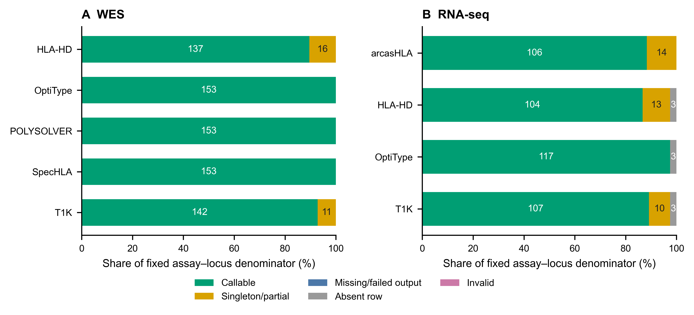
Supplementary Figure S1. Caller call-state composition. WES (A) and RNA-seq (B) bars partition each fixed assay–locus denominator into callable, singleton/partial, missing/failed-output, absent-row and invalid states; segment labels are counts. Historical normalized development artifacts do not separate runtime failure from an empty or missing output, so no independent runtime-failure rate is inferred.
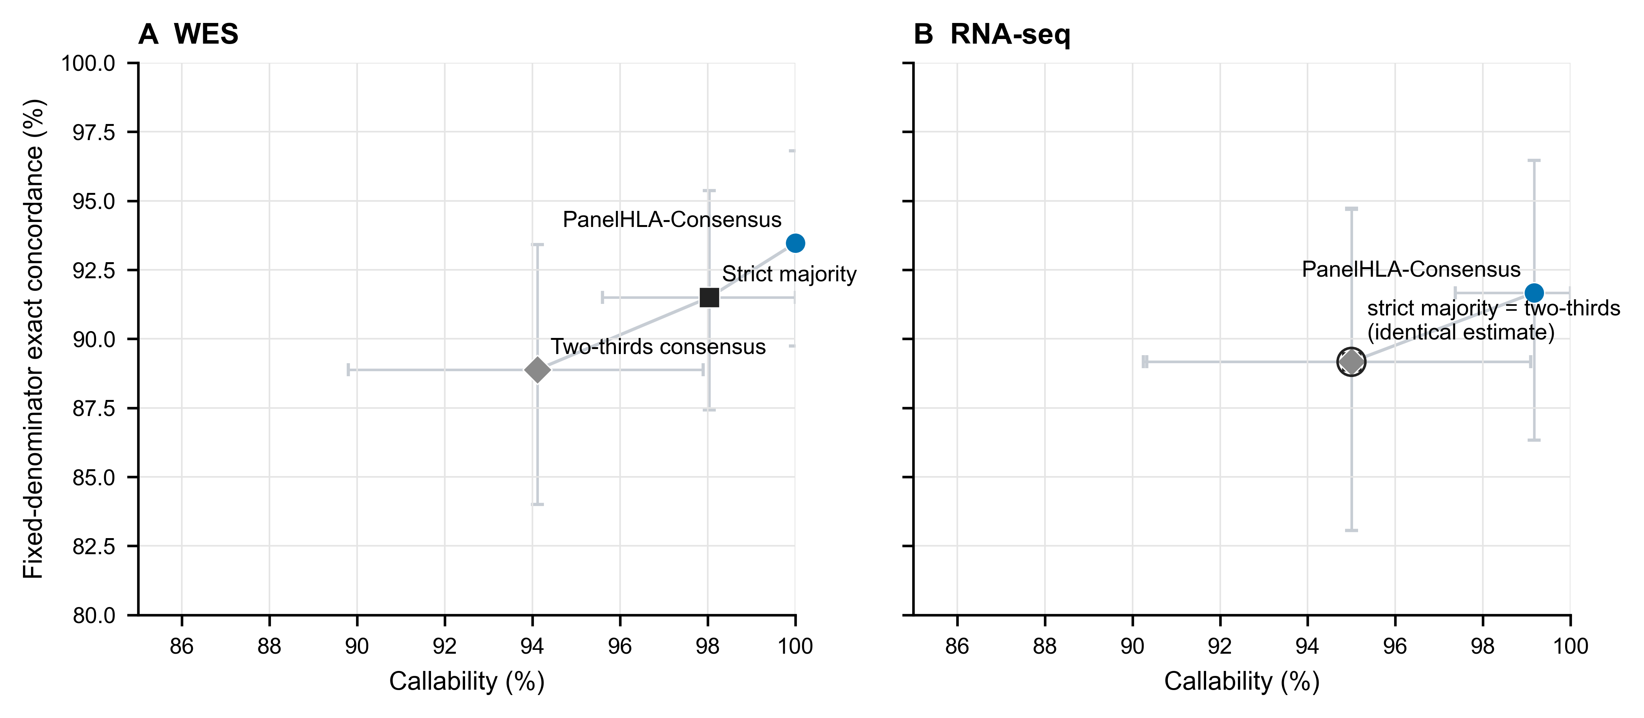
Supplementary Figure S2. Vote-threshold callability–concordance trade-off. WES (A) and RNA-seq (B) show PanelHLA-Consensus, strict majority and two-thirds consensus in threshold order. Horizontal and vertical bars are marginal 95% subject-cluster percentile bootstrap intervals for callability and fixed-denominator concordance. Both axes are truncated to the observed range. The blue circle denotes PanelHLA-Consensus, the dark square strict majority and the grey diamond two-thirds consensus. The identical RNA-seq strict-majority and two-thirds point estimates use a composite marker and shared label; no jitter is applied.
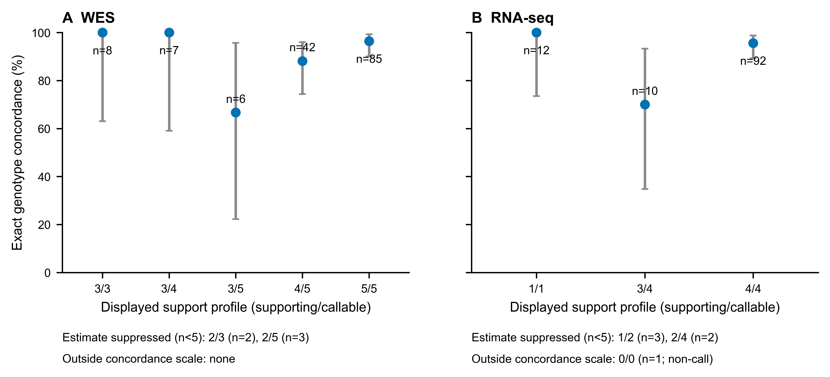
Supplementary Figure S3. Support-profile concordance. WES (A) and RNA-seq (B) use unreduced k-of-n profiles. Points and exact 95% binomial intervals are shown only for strata with at least five loci. Profiles with fewer than five loci remain listed with their denominators but their percentages and intervals are suppressed. The 0/0 profile is a non-call state outside the concordance scale. These strata are descriptive, not calibrated probabilities.
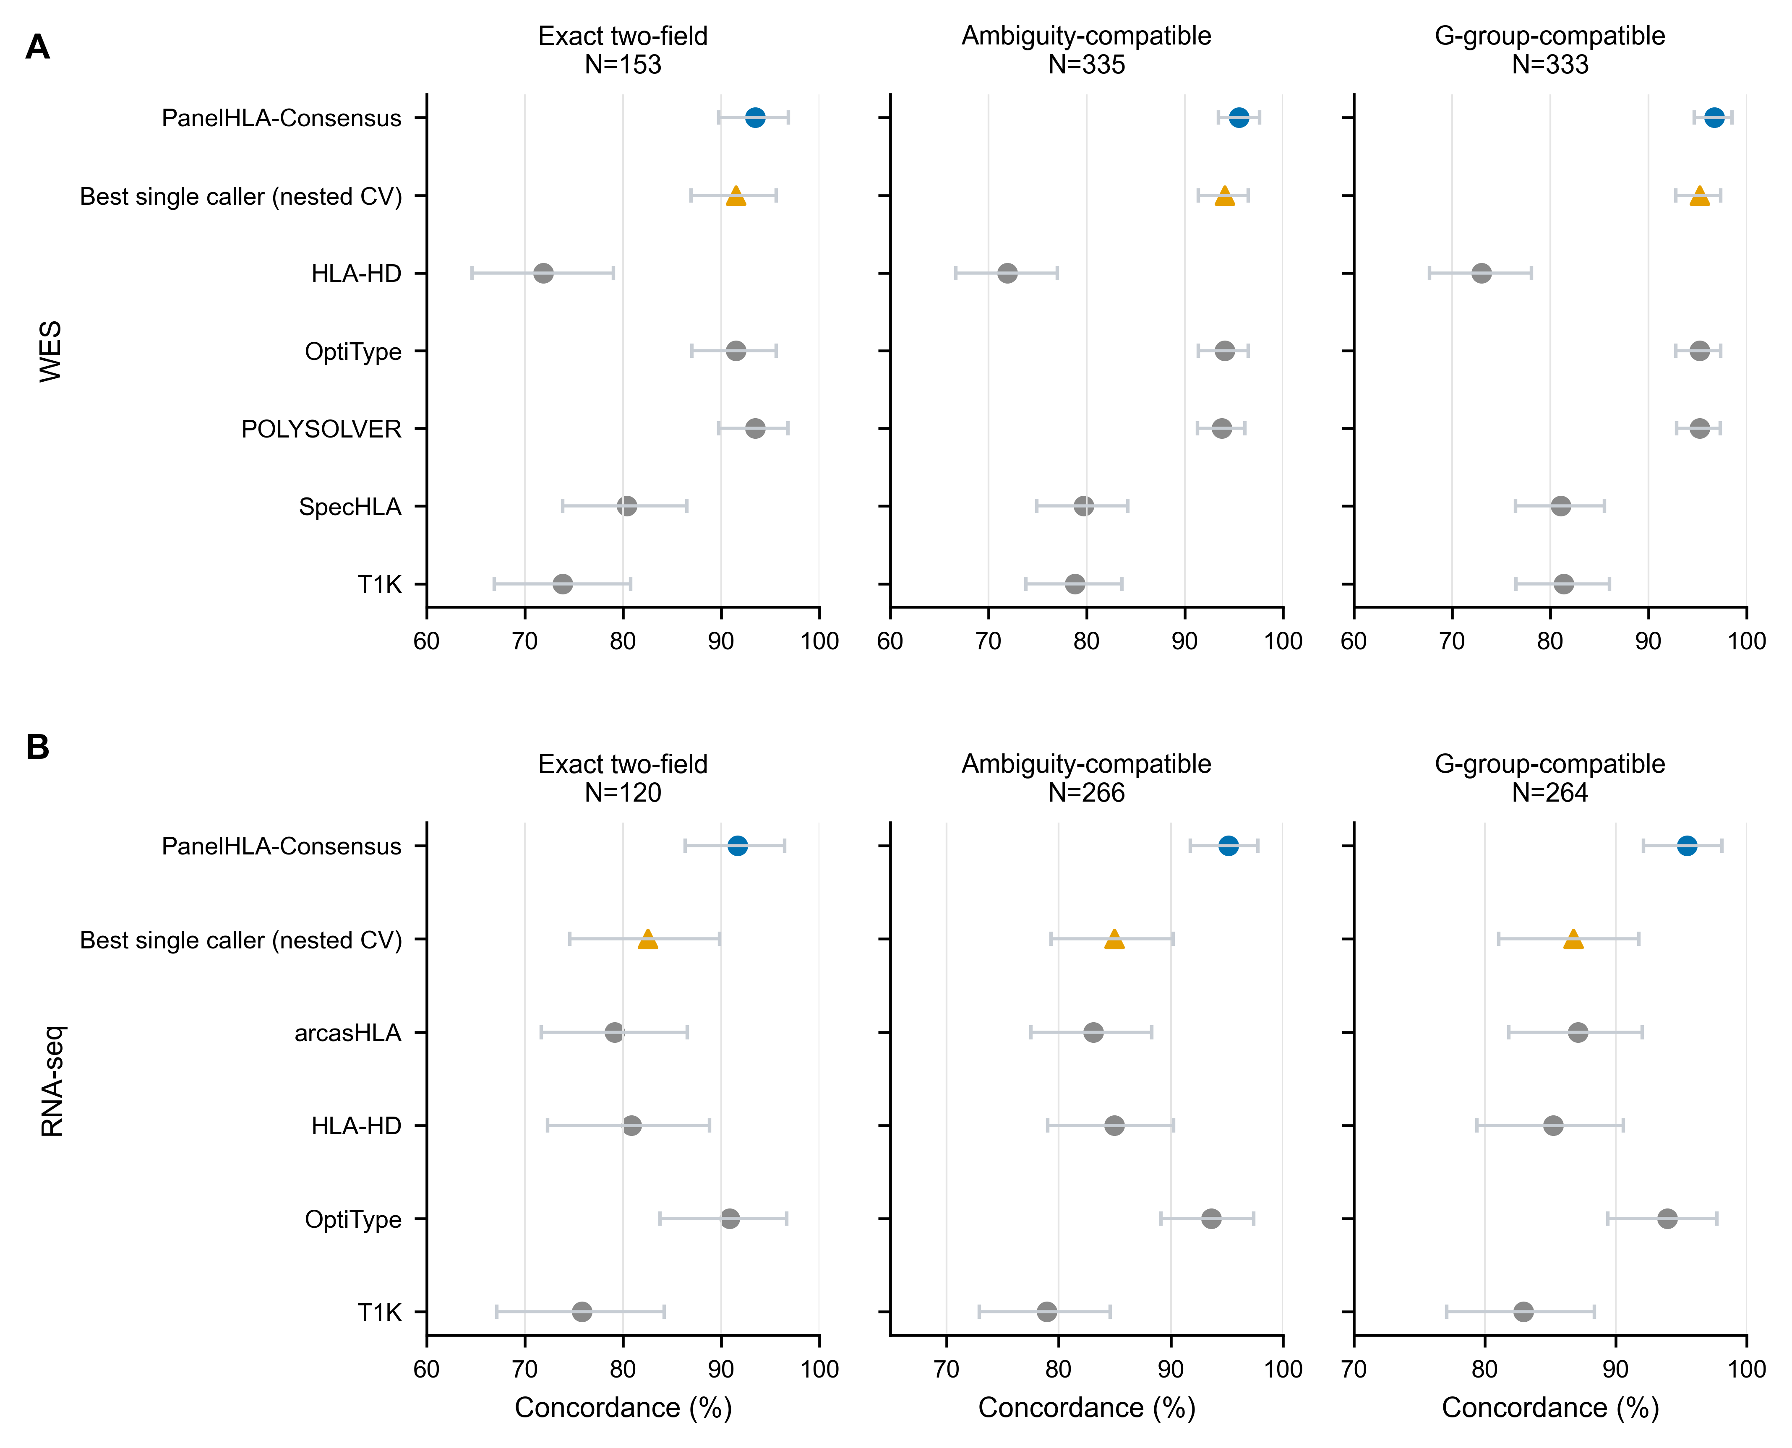
Supplementary Figure S4. Truth-definition sensitivity. WES (A) and RNA-seq (B) compare exact two-field, ambiguity-compatible and official IPD-IMGT/HLA 3.65.0 G-group-compatible endpoints. Points and bars are estimates and 95% subject-cluster percentile bootstrap intervals. Each facet states its own denominator; estimates across different truth definitions are not connected or treated as paired. Each percentage axis is truncated below 100% to the observed range and stops at 100%. Colours and shapes follow Figure 2.
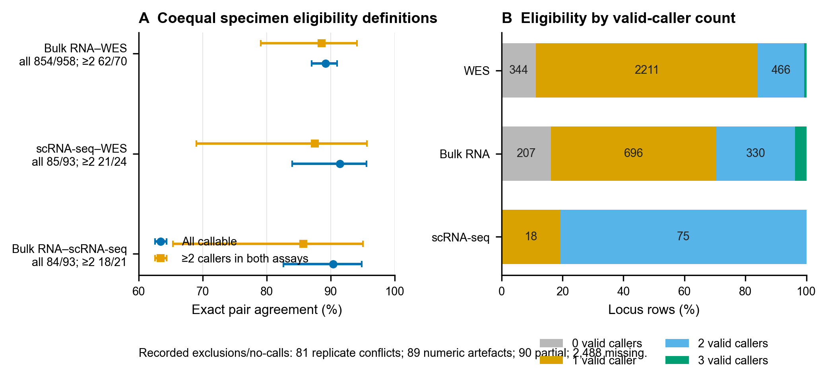
Supplementary Figure S5. Exploratory FIMM cross-modality agreement and eligibility. (A) Specimen-level exact unordered two-field agreement with Wilson 95% intervals for two coequal definitions: all complete callable pairs and pairs with at least two valid callers in both assays. Counts are agreement/overlap; their denominator difference reflects caller availability, not biological sample selection. (B) Locus-row composition by the number of valid callers. Zero valid callers are missing consensus evidence and one valid caller is not a vote. Shared callers mean that panel agreement is not independent HLA truth. Recorded replicate-conflict, numeric-artefact, partial and missing counts are printed below the endpoint panel.
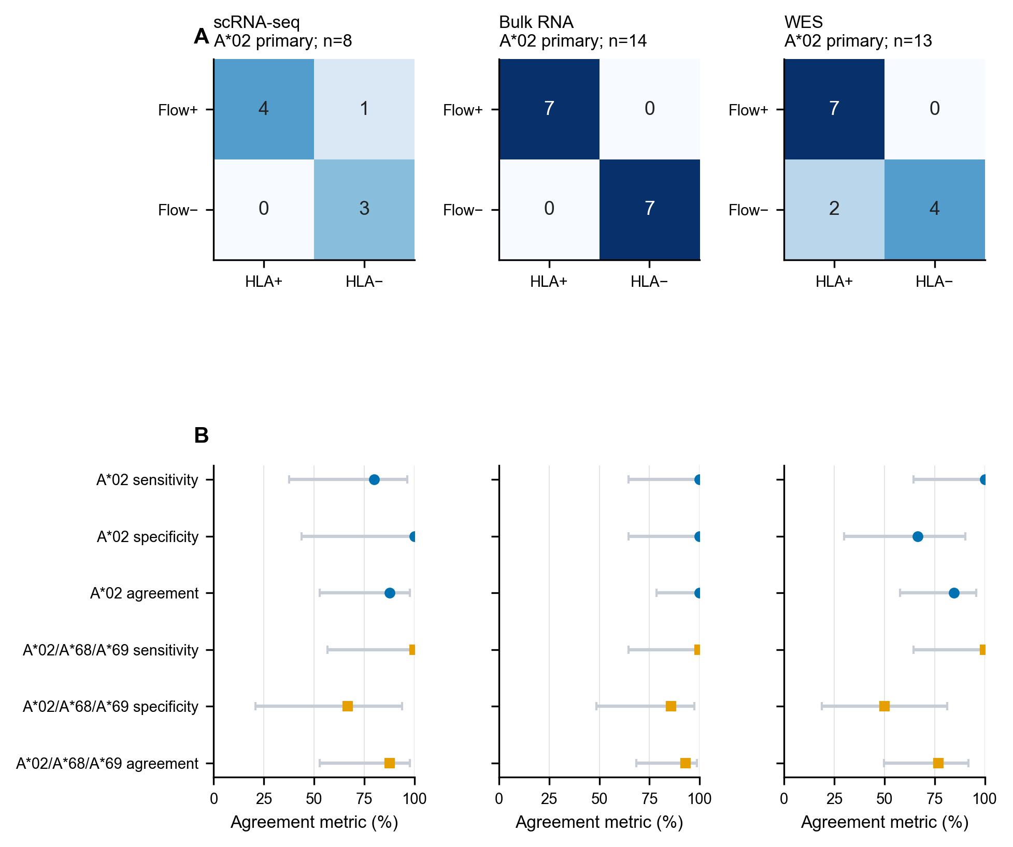
Supplementary Figure S6. Exploratory FIMM BB7.2 serogroup agreement. (A) Primary A02 confusion matrices for scRNA-seq, bulk RNA and WES. (B) Sensitivity, specificity and overall agreement with Wilson 95% intervals under the A02 primary mapping and A02/A68/A*69 cross-reactivity sensitivity. BB7.2 supplies serogroup-level evidence only; linkage is incomplete and the endpoint is not allele-level accuracy.
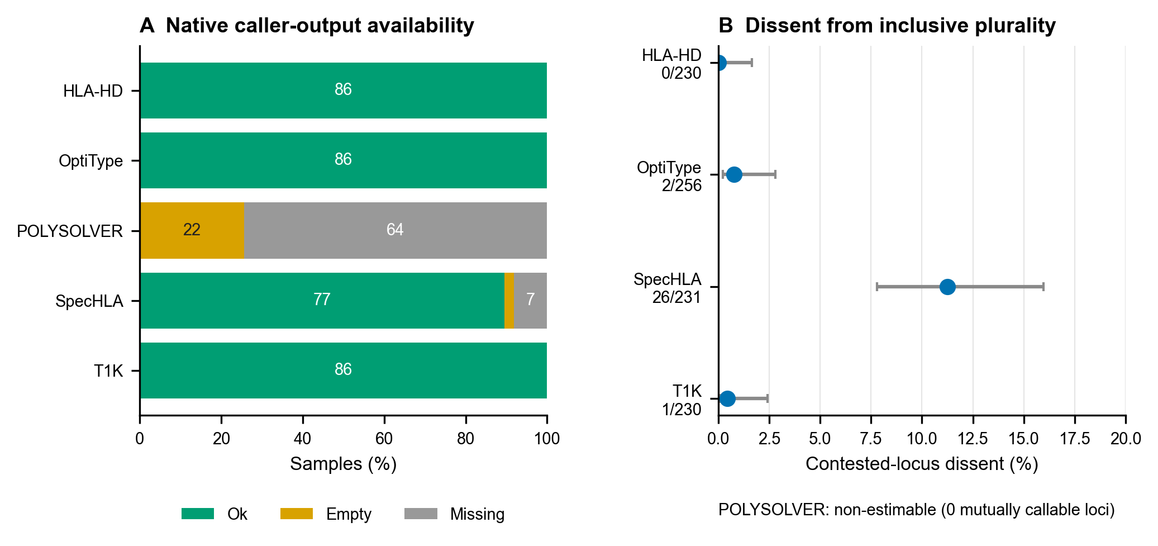
Supplementary Figure S7. Exploratory VenEx WES diagnostics. (A) Native caller-output availability across 86 samples. (B) Contested-locus dissent from the inclusive PanelHLA plurality with Wilson 95% intervals. POLYSOLVER is shown as non-estimable at zero mutually callable loci. Dissent is not error against truth.

S10. Reproducibility contract
The release boundary starts at:
- data/development/normalized_caller_calls.tsv, which is truth-free;
- data/development/normalized_secondary_calls.tsv, for frozen exploratory
predictions; and
- a downloaded public truth file whose checksum must match the pinned value.
One top-level command regenerates the selected truth, primary and secondary predictions, truth join, statistical outputs, tables, figures, claim audit and DOCX. Release mode must fail if any scientific stage is skipped, if generated artifacts are stale, if truth columns appear in prediction inputs, if active artifacts contain WGS results, or if unresolved scientific placeholders remain. The only permitted pre-submission gate is the consolidated author/archive input block listed in the manuscript.
The raw-read-to-caller Nextflow workflow is an external dependency and is not inside this verified boundary. Exact historical caller executable versions, container digests, scheduler job identifiers, and measured historical caller resource use remain unavailable; historical costs were neither reconstructed nor estimated. A later HG00096 smoke exercise recovered current workflow, container and scheduler evidence. These operational measurements cannot be attributed retrospectively to the development cohort or extrapolated to cohort requirements. The analysis environment is pinned to Python 3.11.15, NumPy 1.26.4, SciPy 1.14.1, Matplotlib 3.9.2 and python-docx 1.2.0. This remains a reproducible analysis release from normalized outputs, not an independently reproduced rerun of the historical caller execution.

Current single-sample workflow smoke measurements
Two successful HG00096 runs were recovered from Roihu. The DNA caller route used a WGS-derived mate-aware HLA BAM, not WES reads; it therefore does not estimate WES runtime. The RNA-seq route used paired FASTQ. Nextflow realtime and peak_rss are task-level trace fields. Slurm Elapsed, TotalCPU and batch-step MaxRSS are reported separately because their definitions and instrumentation differ. Disagreement between the two sources is retained, rather than resolved by selecting the smaller or larger value. Versions are reported exactly as emitted: OptiType produced usage text, and T1K and arcasHLA produced empty version fields, so those versions remain unresolved. SpecHLA ran from a native local installation; the other caller rows used the named SIF.
Route and actual input | Caller | Version output | Execution artifact | Slurm job | Nextflow realtime | Nextflow peak RSS, GB | Slurm elapsed | Slurm TotalCPU | Slurm MaxRSS, GB
DNA route (WGS-derived HLA BAM) | POLYSOLVER | v4 | polysolver | 1427634 | 4 min 39 s | 1.40 | 4 min 41 s | 20 min 30 s | 3.82
DNA route (WGS-derived HLA BAM) | HLA-HD | HLA-HD version 1.4.0 | hlahd | 1427636 | 1 min 3 s | 0.93 | 1 min 6 s | 4 min 42 s | 7.12
DNA route (WGS-derived HLA BAM) | SpecHLA | 1.0.7 | /projappl/project_2008084/SpecHLAx | 1427637 | 6 h 13 min 26 s | 1.00 | 6 h 14 min 34 s | 31 min 45 s | 2.42
DNA route (WGS-derived HLA BAM) | Kourami | 0.9.6 | kourami | 1427638 | 2 min 0 s | 5.90 | 2 min 2 s | 22 min 17 s | 7.55
DNA route (WGS-derived HLA BAM) | OptiType | unresolved (usage output) | optitype | 1427643 | 25.8 s | 0.51 | 28 s | 32.331 s | 1.55
DNA route (WGS-derived HLA BAM) | T1K | unresolved (empty output) | t1k | 1427644 | 1 min 26 s | 3.00 | 1 min 29 s | 7 min 47 s | 3.51
RNA-seq route (paired FASTQ) | OptiType | unresolved (usage output) | optitype | 1410979 | 9 min 29 s | 8.50 | 9 min 33 s | 9 min 50 s | 21.03
RNA-seq route (paired FASTQ) | T1K | unresolved (empty output) | t1k | 1410980 | 14 min 8 s | 11.30 | 14 min 12 s | 1 h 3 min 3 s | 12.60
RNA-seq route (paired FASTQ) | seq2HLA | 2.3 | seq2hla | 1410981 | 12 min 12 s | 0.11 | 12 min 15 s | 1 h 31 min 1 s | 2.39
RNA-seq route (paired FASTQ) | HLA-HD | HLA-HD version 1.4.0 | hlahd | 1410983 | 19 min 12 s | 5.40 | 19 min 18 s | 2 h 51 min 52 s | 10.40
RNA-seq route (paired FASTQ) | arcasHLA | unresolved (empty output) | arcashla | 1410984 | 5 min 58 s | 10.80 | 6 min 3 s | 9 min 8 s | 11.34
All rows describe one sample and successful tasks only. They are not monetary costs, historical development-cohort measurements, scaling estimates or accuracy evidence. Raw traces, task commands, launch wrappers, workflow source, version files, container inspection output and scheduler records are preserved under provenance/compute_smoke/raw; their hashes and row-level provenance are recorded in artifacts/compute_smoke_benchmark.tsv.

