Presubmission review update
This review copy incorporates the existing T1K quality rule explicitly in Methods. The manuscript title, concluding paragraph, scientific results, figures, tables and reference entries are unchanged.
The associated tracking documents now distinguish completed work from author inputs, pending analyses and release decisions. D2 transfer classification is complete; the extension will not be relaunched by the agent. NCI-60 remains under way.
The citation record distinguishes supported full-text checks from sources still marked unverified because full text was unavailable. The release audit identifies mixed cohort material, internal documents and reference-resource permissions requiring author review.
This is a review draft, not a submission package. Author declarations, controlled-cohort governance, pending analyses and final release/archive metadata remain outstanding. No email, deposit, release or push has been performed.

Benchmarking consensus HLA class I genotyping from exome and RNA sequencing with ChampHLA
Running title: Consensus HLA genotyping benchmark

Abstract
Short-read HLA genotyping depends on the caller, sequencing assay and reference database. Voting combines callers when the best caller for a dataset is unknown. Evaluation choices can inflate a vote's apparent performance. We evaluated ChampHLA-Consensus, an equal-weight plurality vote without fitted parameters, at HLA-A, -B and -C in 1000 Genomes whole-exome and Geuvadis RNA sequencing data. We re-ran every caller with one specified workflow version. We excluded ambiguous, invalid or conflicting reference typing from the exact-genotype endpoint and counted no-calls as errors. In both assays the vote could not be distinguished from the strongest single caller, although so few subjects differed that only large effects were detectable. No fitted or threshold rule improved on the vote, and scoring ambiguous typing did not change the conclusions. Most shared caller errors coincided with loci where a published re-typing had corrected the reference. This post hoc interpretation is not independent of the exome data. Exact-endpoint retention depended on population. ChampHLA-Consensus is therefore an auditable development baseline rather than evidence of equivalence or clinical validity; a pre-registered test on unseen subjects is under way.

Keywords
HLA typing; consensus genotyping; benchmarking; immunogenomics; whole-exome sequencing; RNA sequencing
Contents
Use the document outline to navigate.

Introduction
The human leukocyte antigen (HLA) genes of the major histocompatibility complex (MHC) on chromosome 6p21.3 form one of the most polymorphic regions of the human genome [1]. The classical class I genes studied here, HLA-A, HLA-B and HLA-C, present intracellular peptides to CD8-positive cytotoxic T cells. These genes are the main route by which adaptive immunity surveys cells for infection, malignant transformation and, after transplantation, non-self antigens.
HLA typing errors have consequences. In unrelated-donor haematopoietic cell transplantation, a single allele mismatch at HLA-A, -B, -C or -DRB1 is associated with higher mortality [2]. Matching lowers the risks of graft failure and graft-versus-host disease [3]. HLA-B*57:01 predicts abacavir hypersensitivity [4], and HLA-B*15:02 is associated with carbamazepine-induced Stevens–Johnson syndrome in Han Chinese patients [5]. HLA genotype determines which tumour neoantigens can be presented, so typing errors propagate into vaccine and T-cell receptor therapy design [6]. The region also carries many of the strongest known associations with autoimmune disease [7].
Typing these genes from short whole-exome sequencing (WES), whole-genome sequencing (WGS) or RNA sequencing (RNA-seq) reads is difficult. The genes are highly diverse. We used release 3.65.0 of the IPD-IMGT/HLA database (Immuno Polymorphism Database–ImMunoGeneTics HLA) [8]. It contains 45,421 HLA allele designations in the allele list (46,652 entries when MICA, MICB, TAP1, TAP2 and HFE are included). Homologous loci make reads map to more than one place, and alignment to a single linear reference loses or misplaces reads from strongly divergent alleles before any caller sees them [9]. RNA-seq samples expressed rather than genomic copies, so a weakly expressed allele can be missed. Expression estimation is itself sensitive to polymorphism-aware mapping [10].
HLA callers use different evidence. OptiType chooses the allele pair that best explains read support by integer linear programming [11]; HLA-HD scores alignments against an allele dictionary [12]. arcasHLA uses transcript abundance in RNA-seq [13], POLYSOLVER adds population allele frequencies as a prior [14], and T1K uses expectation maximization over allele abundance [15]. SpecHLA combines alignment with local assembly and phasing [16], and Kourami assembles alleles by graph-guided alignment [17]. seq2HLA types class I alleles directly from RNA-seq [18]; HLA*LA and HISAT-genotype align reads to graphs of known alleles [9, 19]. Callers that share mapping assumptions may make correlated errors, limiting what a vote can correct. We measured that dependence directly. Running several callers requires different dependencies, databases and inputs: FASTQ reads or alignments in BAM or its compressed form, CRAM. Their allele formats also differ. Outside a few public resources such as the 1000 Genomes Project [20, 21], sequencing data with reference HLA typing are rare, so accuracy on a new cohort usually cannot be measured. ChampHLA runs the callers for each assay in one Nextflow workflow [22], converts their outputs to a common two-field representation and applies a declared consensus rule (Methods).
Benchmarks show that caller rankings depend on the assay, gene and dataset [23] and reveal typing-tool-specific errors [24]. The best caller for a new dataset is therefore unknown. Several studies have evaluated consensus. Larjo et al. [25] found that ensemble prediction could improve accuracy. Combining the three best tools outperformed any single tool on The Cancer Genome Atlas data [26], although the labels there came from agreement among the evaluated tools. Lee et al. [27] accepted a 1000 Genomes genotype when at least six of eight tools agreed. Claeys et al. [23] applied a majority vote, with ties broken toward the best tool, to 1000 Genomes exome and Geuvadis RNA-seq data. Their four-tool WES class I vote reached 99.0% against 98.0% for OptiType alone, with little gain in RNA-seq. Among workflows, consHLA combines HLA-HD results across germline and tumour sequencing of one patient [28], and nf-hlamajority implements majority class I typing from DNA in Nextflow [29]. SweHLA combined computational typings with targeted validation to build a population resource [30].
Evaluation choices have received less attention. Two common choices can inflate a vote's apparent performance. The first completes every single reported allele into a homozygous pair, although for some callers a missing second allele marks a failed call. The second selects one allele from an ambiguous laboratory-typing string, which turns unresolved truth into an exact label. An earlier analysis of these data made both choices. We completed a single allele only where the caller's output format declared homozygosity. We excluded ambiguous reference typing from the exact endpoint, scored it separately and retained earlier values only as provenance.
We asked how ChampHLA-Consensus, a deterministic equal-weight genotype vote, performs within one assay and a named caller panel when failed calls, reference ambiguity and unavailable provenance remain visible. We deliberately made the vote without fitted parameters primary. An earlier version used a champion–challenger design: a benchmark-selected caller supplies each gene's default call, which a weighted ensemble may override. The project retains the name ChampHLA from that design. With a single labelled development resource, apparent gains of fitted policies cannot be separated from fitting to that resource. We retained them only as exploratory comparators (Supplementary S13). A rule without fitted parameters can instead be stated completely, audited from each vote to the reported genotype and applied unchanged to new data. Every caller was re-run for this evaluation with one specified workflow version, and a separate cohort with no overlapping subjects is being processed for a confirmatory test under a previously specified analysis plan.

Methods

Study design and data
We ran callers on 1000 Genomes WES and Geuvadis RNA-seq data [20, 31] with ChampHLA workflow release 3.5.0 in October 2026. This retrospective benchmark evaluates the caller outputs produced by that run. The prediction tables contain no reference genotypes; reference typing is used only for evaluation. A subject is one individual in these public collections of consented population-genomics donors; the development set contains no clinical samples. A locus is one subject–gene pair within one assay. The workflow version, input files, software images and outputs are recorded with file checksums so that the analysis can be reproduced (Supplementary S10). Historical stored outputs came from an April and May 2026 caller run with an unarchived pre-release deployment. Its executables, container images and launch parameters were not preserved. Those outputs enter only the stored-to-rerun comparison (Supplementary S10) and restored analyses (Supplementary S12). The reproducible analysis covers allele normalization, reference-genotype selection, prediction scoring, statistical comparisons, and preparation of tables and figures. We call these data the development set because we selected the primary reporting rule after inspecting their results. Development performance is post hoc, not prospective validation.
The analysed sample list contained 130 WES subjects (390 subject–gene loci) and 106 RNA-seq subjects (318 loci), 105 of whom also occurred in the WES roster. Capture kit, read length, sequencing depth and original preprocessing metadata were unavailable. We analysed the assays separately; they are not independent replications. Exact-truth filtering left 63 WES subjects and 51 RNA-seq subjects, 50 present in both sets. Subjects were the clusters used for inference.
We checked sample identity without reference to truth. Every input had to appear in the official 1000 Genomes and Geuvadis assay manifest, and no rerun input was absent from it. For the 105 subjects in both assays, we compared WES and RNA-seq consensus genotypes at every gene called in both: 101 subjects shared all six alleles and four shared five. We added this check after the development results were known and first applied it to historical stored outputs. The stored NA07000 RNA-seq input shared one of six alleles with its WES input and was absent from the manifest. We withheld it as a provenance failure; the analysed sample list excludes it. Its WES input was in the manifest and retained. In the stored outputs that input's two exact-endpoint RNA-seq loci were both consensus errors, and including them gave 113/120 (Supplementary S7, analysis-choice summary).
Three exploratory applications lie outside the primary analysis and support no accuracy, external-validation or abstract claim (Supplementary S9). The FIMM AML/MDS and VenEx WES cohorts contribute aggregate cross-assay agreement and within-panel dissent only. In a flow-linked FIMM subset, BB7.2 antibody status gives serogroup-level agreement; BB7.2 was characterized as an HLA-A2 reagent [32], and single-antigen beads show specificity for HLA-A*02 and A*69 with cross-reactivity at high concentration [33]. The NCI-60 cancer cell lines have published sequence-based class I typing [34]; an earlier NCI-60 analysis is withdrawn because its estimates cannot be traced to registered results, and the application is being regenerated with release 3.5.0, the development panels and a parser that retains only unambiguous reference genotypes (Supplementary S9.6).

The ChampHLA workflow
ChampHLA runs each caller in an assay's panel (Table 1) as an independent containerized Nextflow process [22]. It parses outputs into unordered two-field genotypes and combines callers at each sample and gene (Figure 1A). For BAM or CRAM input, reads in the chromosome 6 MHC window and on HLA-allele and alternate-haplotype contigs are first realigned to chromosome 6 with BWA-MEM [35], so that every caller sees both haplotypes (Supplementary S11.1). Under -profile paper, the consensus step implements ChampHLA-Consensus. A workflow test requires the same call at all 708 development loci (Supplementary S11.2). The default calibrated weighting was not evaluated. We computed all development results by applying the paper-repository rule to normalized caller tables from the release 3.5.0 run.
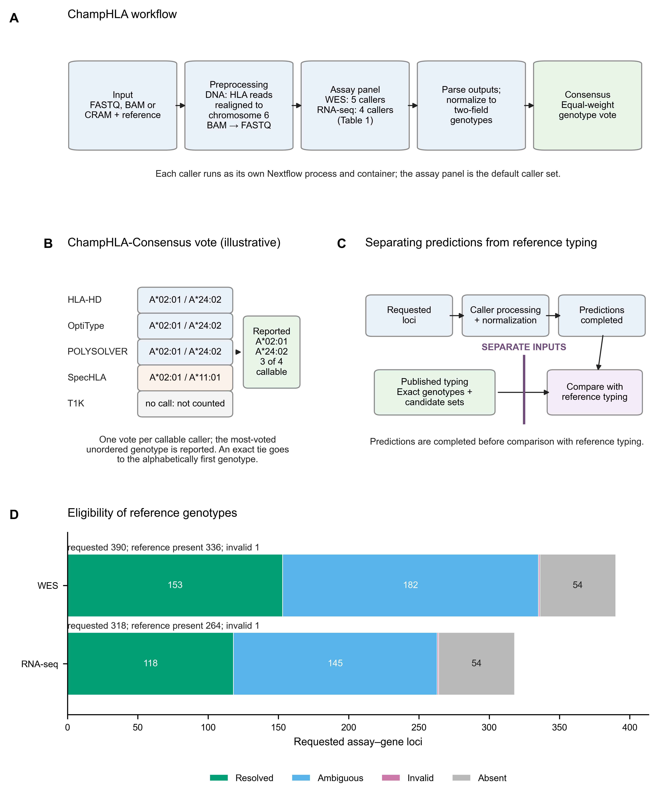
Figure 1. ChampHLA workflow, consensus rule, study design and cohort flow. (A) The workflow routes FASTQ, BAM or CRAM input to the assay's caller panel (Table 1), parses and normalizes outputs to two-field genotypes, then applies consensus. (B) Example ChampHLA-Consensus vote at a WES locus: each callable caller casts one vote; callers without calls do not vote. The most-voted unordered genotype is reported, with exact ties going to the alphabetically first genotype. The alleles shown are an example, not data. (C) Caller processing and normalization are completed before comparison with separately parsed reference typing. Caller output cannot influence reference resolution. (D) Requested assay–gene loci partitioned into resolved, ambiguous, invalid and source-absent reference states. Source absence is a state of the reference record, not a caller no-call. Counts are generated from the truth-flow artifact.
Table 1. Callers wrapped by the ChampHLA workflow and the assay panels evaluated.
Caller | Evidence and inference | WES panel | RNA-seq panel | Earliest consistent IPD-IMGT/HLA release (lower bound)
HLA-HD | Alignment scored against an allele dictionary | Yes | Yes | 3.15.0
OptiType | Integer linear programming over allele-pair read support | Yes | Yes | 3.13.1
POLYSOLVER | Alignment likelihood with population allele frequencies | Yes | No | 3.11.0
SpecHLA | Alignment, local assembly and haplotype phasing | Yes | No | 3.38.0 and 3.51.0 components
T1K | Allele abundance by expectation maximization | Yes | Yes | 3.63.0
arcasHLA | Allele reconstruction from transcript abundance | No | Yes | 3.40.0 (bundled report, not preserved)
Kourami | Graph-guided allele assembly (WGS) | No | No | 3.24.0 (not scored)
seq2HLA | Read assignment to an allele index (RNA-seq) | No | No | Not audited (not scored)

The last column gives the earliest IPD-IMGT/HLA release consistent with each caller's bundled database, a content-derived lower bound (Supplementary S6) that is not necessarily the release used to build the caller. For example, the POLYSOLVER publication reports IMGT/HLA 3.10, whereas 3.11.0 is the lower bound for the preserved allele list [14]. The arcasHLA value comes from a bundled version report that was not preserved. The reference typing was interpreted against IMGT/HLA 2.26.0 [21]. Kourami and seq2HLA are wrapped by the workflow but lie outside the evaluated panels, and their incomplete historical outputs are not scored.

Reference HLA typing and denominator construction
We obtained reference genotypes from the International Genome Sample Resource (IGSR) copy of the 2014 1000 Genomes HLA diversity table [21]. A SHA-256 file checksum verifies that the reference file is identical to the version used for this analysis (Data availability).
This table is laboratory typing, not error-free truth. Class I loci were typed by locus-specific polymerase chain reaction (PCR) and Sanger sequencing of exons 2 and 3 and interpreted against IMGT/HLA 2.26.0 (July 2009); allele ambiguities were retained, and confirmatory typing was performed for 12 samples [21]. Such typing cannot separate alleles that differ only outside exons 2 and 3, and a 2009 release cannot name alleles described later. Independent typings of the same samples do not always agree: of 263 1000 Genomes samples typed in more than one study, 221 (84%) had concordant typings [36]. When 992 of the typed individuals were retyped from exome data, read inspection and new laboratory typing of 21 individuals led the authors to retain 105 results that disagreed with the published types [37]. Agreement with this reference therefore combines caller error with reference error, and the exact endpoint measures agreement with the reference rather than accuracy against the true genotype.
We used that in silico re-typing by Abi-Rached et al. [37], obtained from IGSR with a verified checksum, to adjudicate consensus errors. In it, an asterisk marks a result that disagreed with the previously published type and that its authors kept after verification [37]. Thuesen et al. later used these corrections to update the 2014 types in an exome benchmark [38], and Buchkovich et al. replaced 38 discordant and two low-resolution Geuvadis allele calls after targeted typing of 34 samples [39]. Because the re-typing derives from the same exome data, and T1K and SpecHLA were evaluated against it in their original publications [15, 16], it can adjudicate a discordance but never replaces the reference. Its parsing rule, adjudication classes and a sensitivity analysis restricted to loci where both typings agree were fixed in a documented analysis plan before any comparison was made. That rule treats an asterisked value as unavailable, so the comparison with the corrected values (Results) is post hoc.
Exact scoring requires an exact reference genotype, but the source includes allele-ambiguity strings and duplicate subject records. We retained a locus for exact scoring only when its reference genotype could be resolved without ambiguity. We parsed every source row for each subject and gene, excluding a locus from the exact endpoint if any row was ambiguous, invalid or conflicting. A resolved duplicate could not conceal an ambiguous one. No first-listed or frequency-preferred allele was ever selected. The audit excluded 237/390 requested WES loci and 200/318 RNA-seq loci, leaving 153 WES loci from 63 subjects and 118 RNA-seq loci from 51 subjects. We generated and checksummed predictions for all 708 requested loci before selecting any truth (Figure 1C).
To retain information from ambiguous typing, secondary analyses represented the reference as every valid unordered two-field candidate pair. A prediction was compatible if it matched any allowed pair, making 335 WES and 263 RNA-seq loci evaluable. Further sensitivities mapped each two-field designation to every compatible official IPD-IMGT/HLA 3.65.0 G group and P group. They test compatibility under a two-field mapping and do not infer exact P- or G-group calls. Supplementary S1 describes the exclusions by gene, source population, reference-typing state and candidate-pair count. Populations use the 1000 Genomes codes, among them CEU (Utah residents with Northern and Western European ancestry) and YRI (Yoruba in Ibadan, Nigeria); the others are defined in Supplementary S1.

Callers and assay-specific panels
We used a separate intended-use panel for each assay (Table 1): HLA-HD, OptiType, POLYSOLVER, SpecHLA and T1K for WES; arcasHLA, HLA-HD, OptiType and T1K for RNA-seq. The assay-specific panels were chosen from the callers available in the original deployment; the same panels were used throughout the comparisons. They reflect the callers deployed in that run rather than an exhaustive modern benchmark. HLA*LA and HISAT-genotype were not run [9, 19], and the historical outputs of Kourami and seq2HLA [17, 18], like those of off-panel caller–assay combinations, are partly incomplete and are not scored (Supplementary S6).
This benchmark is not independent of the callers' own development. Five of the six panel callers were evaluated in their original publications against reference typings of 1000 Genomes samples, using exome or Geuvadis RNA-seq data from the collections used here [11, 13, 14, 15, 16]. They are OptiType, whose β parameter was chosen by cross-validation on 253 1000 Genomes exome runs, POLYSOLVER, arcasHLA, T1K and SpecHLA. We could not find in an open-access source which data were used to evaluate HLA-HD [12]. The development subjects may include samples used to develop or evaluate these callers; we could not check this subject by subject. Such overlap can inflate absolute concordance for callers and votes built from them.
The rerun records what each caller received. WES inputs are GRCh38DH exome alignments (the GRCh38 reference with decoy and HLA allele sequences). Release 3.5.0 realigns reads on HLA-allele and alternate-haplotype contigs to primary chromosome 6 before DNA callers run. RNA-seq inputs are GRCh37 Geuvadis alignments. Each sample's input checksums, container digests, workflow files and results are recorded (Supplementary S10). Normalization checks allele syntax and reduces identifiers to two numeric fields. The collector records whether an allele is a current IPD-IMGT/HLA 3.65.0 designation, a group designation, or deleted or renamed. It never renames calls: results are syntax-normalized, not database-harmonized. Native search databases differ in vintage (Table 1; Supplementary S6), so algorithm, database and deployment effects remain inseparable. Even the read route was unrecorded for historical stored outputs.

Allele normalization and call states
We assigned every output row a call state before counting votes because callers report incomplete or uncertain results differently. Alleles required a valid HLA gene and at least two numeric fields. We rejected gene mismatches, malformed alleles and unresolved slash-delimited ambiguities, retaining higher fields and suffix tokens as metadata. N, L, S and Q expression suffixes and P/G group terminology follow HLA nomenclature [40]; C and A were retained as opaque suffix metadata rather than interpreted by this analysis. The primary endpoint used the first two numeric fields, and diploid pairs were sorted before comparison.
Each requested caller cell has exactly one state: complete, partial, missing, ambiguous, invalid, failed or absent. Absent means the collected table has no row for that sample, gene and caller, distinct from an executed caller returning a missing or failed result. Empty strings, -, ., NA and NOTTYPED are recognized centrally as placeholders. A caller is callable at a locus when its row is complete and reports an unordered two-field genotype. Missing, partial and invalid rows do not vote.
A row with one resolved allele and no second, a singleton call, is partial and abstains unless the caller's own output format declares homozygosity. HLA-HD writes a hyphen for the second allele of a homozygous call and "Not typed" for a failed call [41]. arcasHLA releases before 0.4.0 report homozygotes as a single allele [42]. These rows are completed into homozygous pairs. The historical arcasHLA executable was not preserved, so the stored-output convention rested on its representation. The v3.5.0 rerun container holds arcasHLA 0.2.0, which reports homozygotes this way. The rerun T1K parser records num_diff_alleles and quality fields distinguishing native homozygotes from missing alleles. It ignores alleles with non-positive quality and does not promote secondary alleles into the genotype. We complete T1K's declared homozygotes; other single-allele rows abstain. At exact-endpoint loci, 27 of 30 single-allele WES rows and 30 of 34 RNA-seq rows lay at homozygous reference genotypes. Exceptions were three T1K WES rows (one declaration, two partial) and four arcasHLA RNA-seq declarations. We finalized this handling after inspecting development results and report abstain-all singleton scoring alongside it (Supplementary S2).

Primary and secondary consensus rules
At each locus, every callable intended-use caller casts one vote for its unordered two-field genotype, and ChampHLA-Consensus reports the genotype with the most votes (Figure 1B). The rule is a plurality, not a majority: the selected genotype need not receive more than half of the votes. Ties go to the first-sorting pair when sorted allele names are compared as character strings (A*02:101 precedes A*02:11). We flag tied loci. If no caller is callable, the method abstains. The rule uses no truth labels, allele frequencies or fitted weights.
Let x denote one subject–gene locus within an assay, Cₓ the callers with a complete two-field genotype at that locus, and G₍c,x₎ the unordered genotype reported by caller c. For each candidate genotype g, the vote count is
$V_{x}(g)=\sum_{c∈C_{x}}{1[G_{c,x}=g]}$
Here, the indicator is one when the caller reports g and zero otherwise. The reported genotype is the alphabetically first genotype among those with the largest vote count:
${\hat{G}}_{x}=lexmin\{g:V_{x}(g)=\max_{h∈G_{x}}V_{x}(h)\}$
The candidate set contains the genotypes reported by the callable callers. Alleles within each pair are sorted before voting. If no caller has a complete genotype, the method returns no call. Alphabetic ordering is a deterministic tie-break; it does not use allele frequencies or biological evidence.
Algorithm 1. Equal-weight consensus for one subject–gene locus.
Input: caller outputs for one locus and its assay-specific panel
votes = empty genotype-to-count map
for each caller in the panel:
normalize the reported allele pair to two fields
if the pair is complete and valid:
sort the two alleles to form an unordered genotype
add one vote to that genotype
if votes is empty:
return NO CALL
largest_count = the largest count in votes
winners = all genotypes with count equal to largest_count
report the alphabetically first genotype in winners
flag the result if more than one genotype is in winners
The normalization step applies the caller-specific homozygote rules described above; it does not complete an otherwise partial call.
Two descriptive rules use the same votes. Strict majority requires more than half of callable votes for the leading pair; two-thirds consensus requires at least two thirds. Each caller was also evaluated on its own. Six fitted policies were exploratory: the best single caller chosen by nested cross-validation (CV), four champion–challenger variants and an L2-regularized logistic meta-consensus (Supplementary S7.1). Their development scores cannot establish generalization, because construction or selection and evaluation share the development resource.

Endpoints and statistical analysis
The primary endpoint was exact unordered diploid concordance at two-field resolution. Both predicted alleles had to match both reference alleles to the first two fields, in either order; matching one allele earned no credit. The denominator is fixed, so an absent or non-callable prediction counts as incorrect and a method cannot improve its score by declining difficult loci. We reported callability separately and always alongside called-only concordance, computed over loci with a complete diploid prediction.
For N loci with eligible reference genotypes, callability and exact genotype concordance are
$Callability=\frac{1}{N}\sum_{x=1}^{N}{1[{\hat{G}}_{x}≠∅]}$
$Concordance=\frac{1}{N}\sum_{x=1}^{N}{1[{\hat{G}}_{x}=G_{x}^{∗}]}$
An asterisk denotes the reference genotype. A no-call contributes zero to concordance and remains in the denominator. Called-only concordance uses only loci with a complete prediction and is reported as a secondary descriptive measure.
Allele concordance counted the multiset intersection between predicted and reference alleles over twice the genotype denominator.
We described concordance, allele concordance, callability and called-only concordance with subject-cluster percentile bootstrap intervals from 100,000 subject resamples, base seed 20260831 and a deterministic SHA-256-derived seed per method. Each resample retained every evaluable locus and both alleles of each sampled subject, keeping the estimand locus-weighted. Estimates of 0% or 100%, where a percentile bootstrap collapses to a point, use the exact Clopper–Pearson interval [43]. Stratified results use exact Clopper–Pearson intervals, and the exploratory Institute for Molecular Medicine Finland (FIMM) and VenEx results use Wilson intervals [44], as stated with each table.
For each comparator, the paired effect is ChampHLA-Consensus minus the comparator, in percentage points. We determined significance with an exact two-sided subject sign-flip test of the locus-weighted difference. We enumerated all sign assignments for at most 20 subjects with nonzero aggregates, otherwise using 1,000,000 seeded assignments and a plus-one correction. We applied Holm correction [45] separately within each assay's descriptive-comparator and exploratory fitted-policy families. Zero-discordance comparisons were displayed but excluded from multiplicity. A comparison is called significant when its sign-flip Holm-adjusted p<0.05. Because the test is discrete, a comparison in which few subjects differ cannot reach p<0.05 at any effect size (Supplementary S3).
Intervals for the paired differences are descriptive. They use a CR1 (finite-cluster-corrected cluster-robust) subject-clustered standard error, a Student t reference distribution with G−1 degrees of freedom and Bonferroni adjustment over the same family. Cluster-robust inference is unreliable with few clusters [46]. Only discordant subjects contribute to a paired contrast, so intervals may be too narrow when few subjects differ. A post hoc two-percentage-point non-inferiority calculation is an exploratory sensitivity analysis and is not used to claim equivalence. Results stratified by vote support are descriptive proportions, not probability calibration, and no external validation test was performed.

Retrospective design and sensitivity analyses
The primary reporting rule and several analysis choices were selected after examining development results. The comparisons are therefore retrospective and exploratory, even though reference genotypes were excluded when generating the predictions used for evaluation. These procedures do not make the development results confirmatory. Supplementary S14 explains how changes to reference handling, missing calls and inference affect interpretation.
The confirmatory extension uses a separate cohort with no overlapping subjects and an analysis plan specified before predictions are compared with reference genotypes. Processing is under way; its results are not reported here. The separate NCI-60 application is described in Supplementary S9.6.

Software and reproducibility
We regenerated results in a specified software environment: Python 3.11.15, NumPy 1.26.4, SciPy 1.14.1 and Matplotlib 3.9.2 [47, 48, 49]. The historical caller-run software environment was unrecorded. Release 3.5.0 of the workflow, used for the development rerun, runs on the Roihu cluster of CSC – IT Center for Science (CSC) with Nextflow 25.10.2 [22], Apptainer (formerly Singularity) [50], SAMtools 1.21 [51] and BWA 0.7.19 [35]. Its caller images are specified by SHA-256 in configs/caller_resources_v2.json, and the workflow stops before any task runs if an image differs from its specified checksum (Supplementary S10). Inputs, truth, predictions and outputs carry SHA-256 identities. Prediction generation rejects any input table containing reference-genotype columns, keeping prediction and evaluation data separate. Figures read versioned tab-separated value (TSV) artifacts. Earlier analysis versions are retained with their documentation. WGS outputs from the same caller run failed input-validity checks (Limitations); they are quarantined, and no quantitative WGS performance is reported.

Ethics and data reuse
The primary benchmark uses public 1000 Genomes and Geuvadis sequencing data and published HLA typing. No new participants were recruited and no new samples were collected. The development subjects were consented population-genomics donors rather than clinical patients.
The supplementary FIMM and VenEx applications use controlled patient data and are separate from the public-data benchmark. Only aggregate agreement and within-panel dissent are reported; source workbooks, specimen–donor mappings and individual calls remain in controlled storage.

Results

Exact reference genotypes were available for a selected subset of loci
Only 153/390 requested WES loci and 118/318 requested RNA-seq loci had a unique two-field genotype after resolving the checksum-verified reference typing without selecting an allele from an ambiguous result. The remaining WES loci were ambiguous (182), invalid (one) or absent from the source (54); for RNA-seq the corresponding counts were 145, one and 54. The retained WES set contained 50 HLA-A, 52 HLA-B and 51 HLA-C loci, and the RNA-seq set 38, 40 and 40. Checking every duplicate source record removed ten assay-loci accepted earlier because a resolved duplicate had concealed an ambiguous one. The earlier 390- and 321-locus denominators, which selected representatives from ambiguous typing strings, are therefore invalid for an exact two-field endpoint.
Retention depended strongly on population. After pooling genes, 84.7% of CEU (CEPH) and 92.8% of YRI WES source-present loci were retained, compared with 3.9% of FIN, 3.9% of GBR and 8.3% of PUR loci. The exact endpoint therefore represents a selected subset of the data (Figure 1D; Supplementary S1).

The vote could not be distinguished from the strongest caller in small comparisons
ChampHLA-Consensus called every retained locus (153/153 WES, 118/118 RNA-seq). Its exact genotype concordance was 143/153 (93.5%; subject-clustered 95% confidence interval [CI] 89.7–96.8%) for WES and 113/118 (95.8%; 92.1–99.1%) for RNA-seq. Allele concordance was 296/306 (96.7%; 94.9–98.4%) and 231/236 (97.9%; 96.1–99.6%), respectively (Figure 2; Table 2).
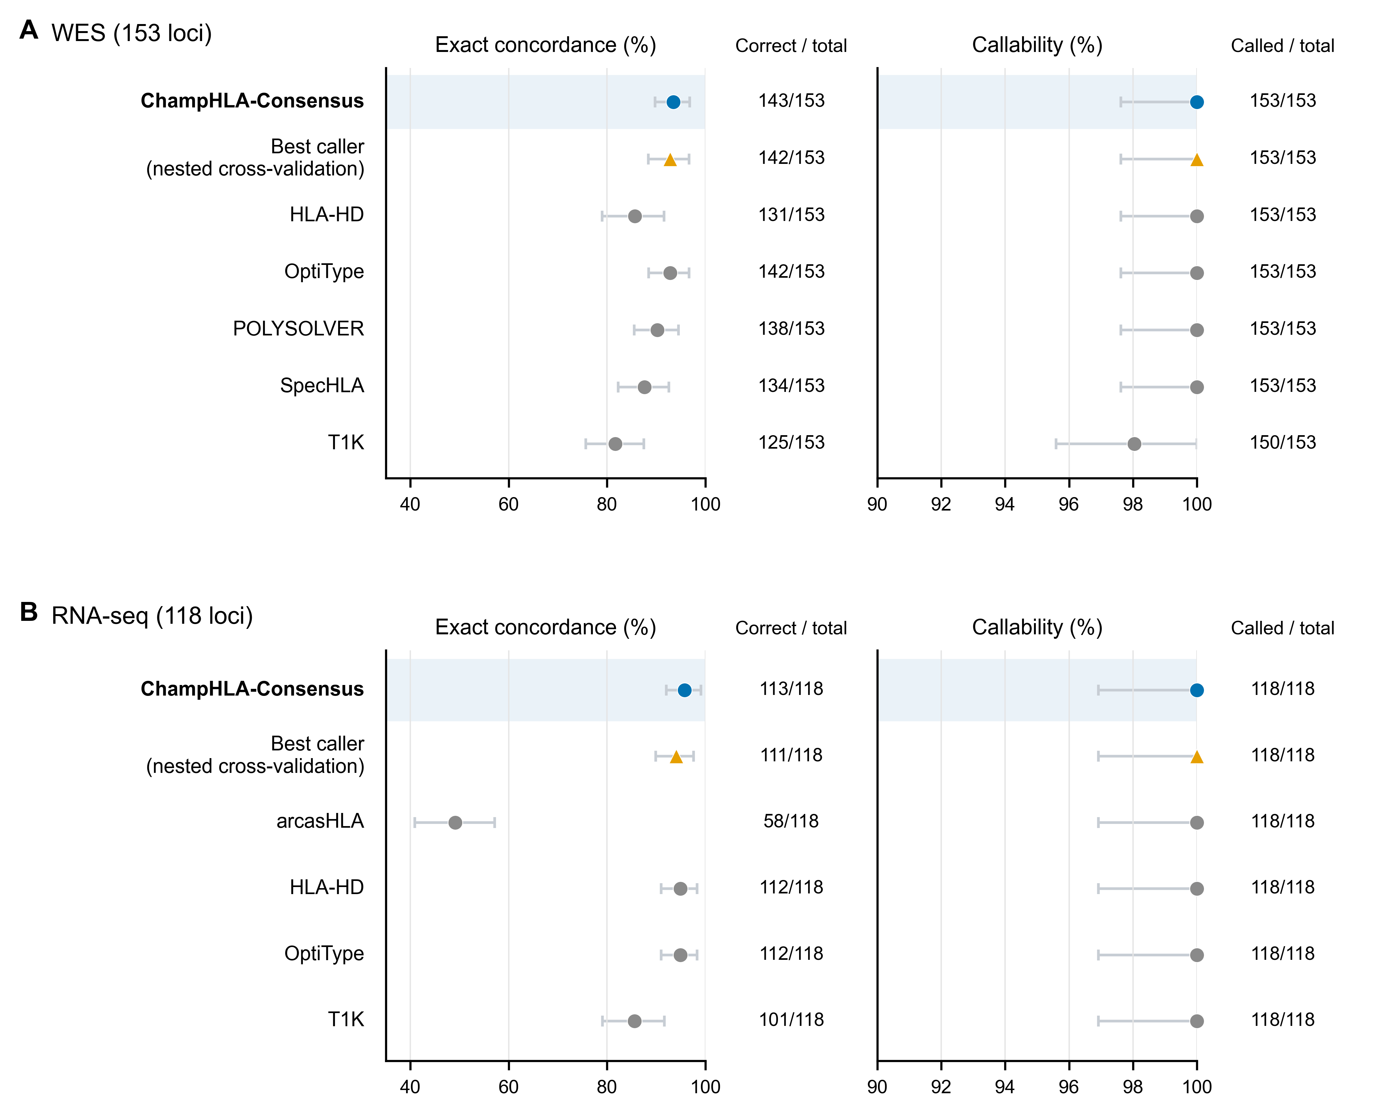
Figure 2. Fixed-denominator exact genotype concordance and callability. Exact unordered two-field genotype concordance and callability of each method in WES (A) and RNA-seq (B), over the same fixed denominator. Bars are 95% subject-cluster percentile bootstrap intervals, and the adjacent columns give correct/N and callable/N. Blue denotes ChampHLA-Consensus, the orange triangle the exploratory fitted nested-CV best-caller policy, and grey circles individual callers. Methods follow a fixed role-based order rather than observed performance. Both percentage axes are truncated below 100% to show the observed range and never extend above 100%.
The strongest single caller in each assay scored slightly lower. OptiType was the strongest WES caller, with 142/153 correct genotypes, a paired difference of 0.65 points (Bonferroni-adjusted cluster-t 95% CI −3.44 to 4.74; sign-flip Holm p=1). In RNA-seq HLA-HD and OptiType tied as the strongest callers with 112/118 each, one locus below the vote (0.85 points; −1.47 to 3.16; sign-flip Holm p=1 for both). These intervals permit benefit or harm and do not establish equivalence or non-inferiority (Figure 3).
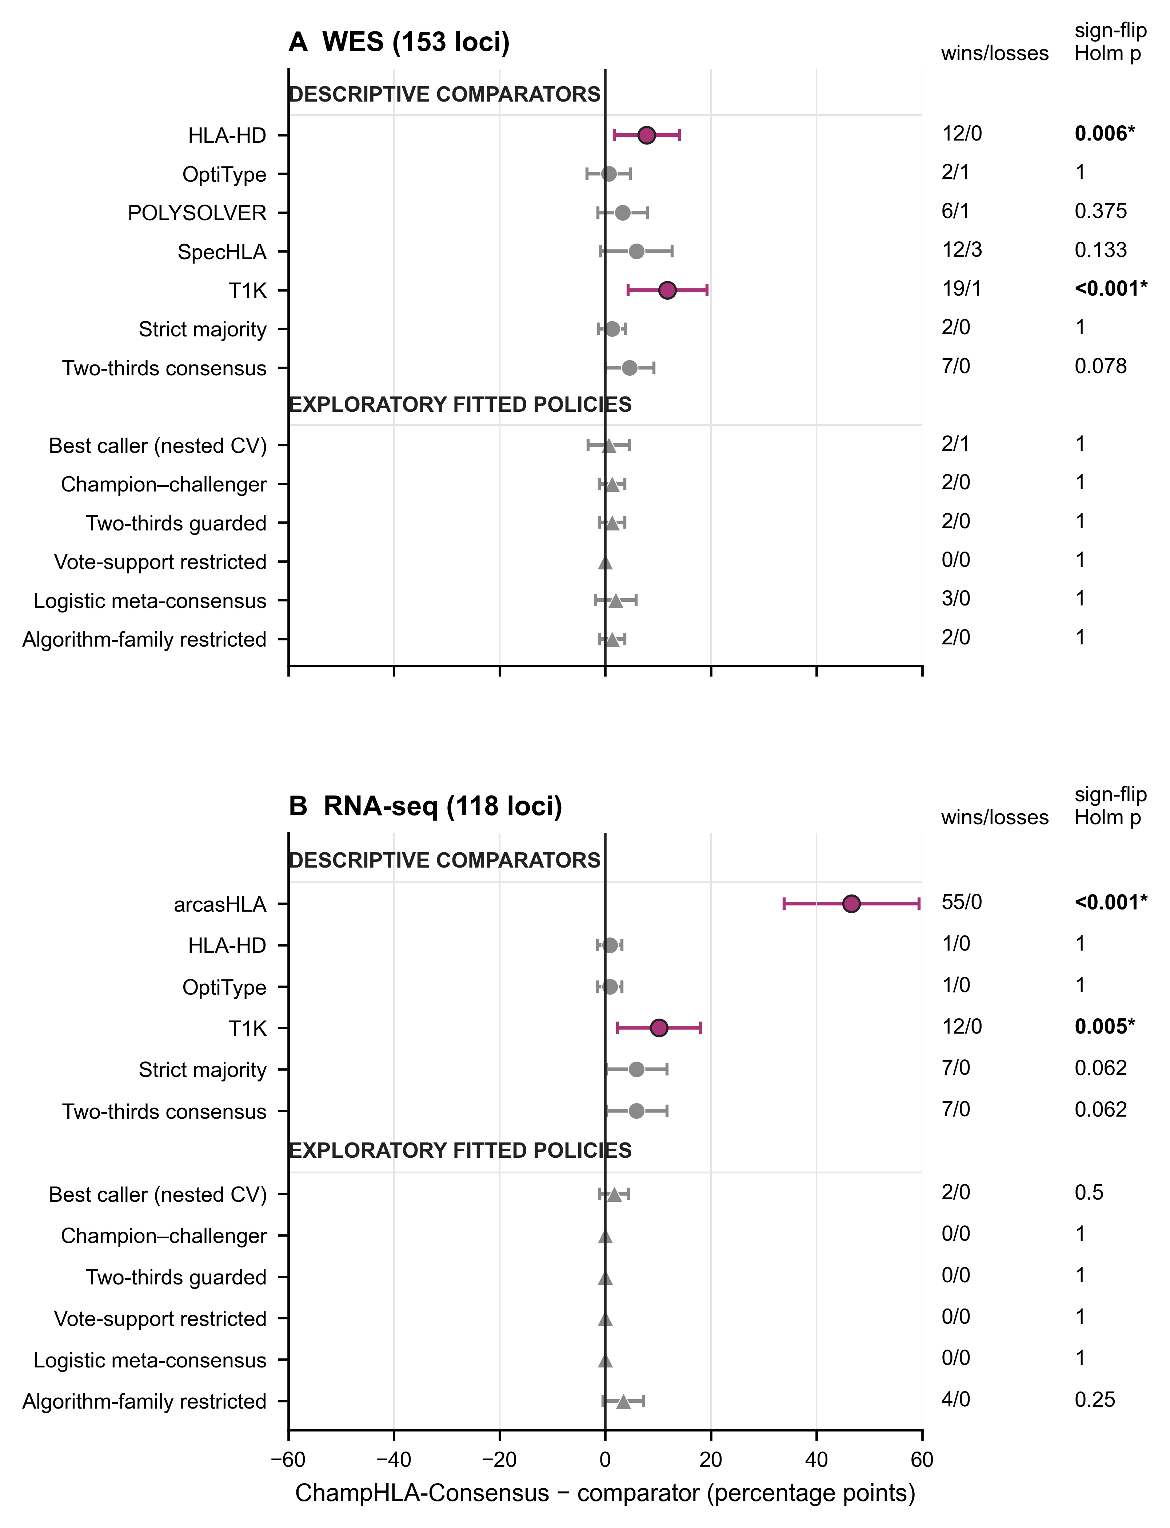
Figure 3. Paired differences from ChampHLA-Consensus. Each point is ChampHLA-Consensus minus one comparator, in percentage points, so positive values favour the vote. Bars are descriptive Bonferroni-adjusted cluster-t intervals over the same family used for Holm testing. Circles denote descriptive comparators and triangles exploratory fitted policies. Magenta with an asterisk marks an exact subject sign-flip Holm-adjusted p<0.05; grey is nonsignificant. Significance follows the governing sign-flip test. In RNA-seq the strict-majority and two-thirds consensus intervals exclude zero, but their sign-flip Holm-adjusted p values are not below 0.05; both are grey (Supplementary S3). The right-hand columns give locus wins/losses and sign-flip Holm-adjusted p values. Comparisons with zero discordance are displayed at 0 with interval 0 to 0, wins/losses 0/0 and p=1. Cluster-t Holm-adjusted p values are in Supplementary S3. Non-significance is not equivalence.
Neither exact sign-flip comparison could have detected a difference. Only two WES subjects differed in correctness between ChampHLA-Consensus and OptiType, and only one RNA-seq subject differed between the vote and either strongest caller. The exact sign-flip test therefore could not reach p<0.05 at any effect size. In these comparison families, a significant difference with no losses would have required at least nine WES subjects (5.88 points) or eight RNA-seq subjects (6.78 points) to favour one method (Supplementary S3). A two-point non-inferiority margin was not met in WES (lower adjusted limit −3.44 points), and the RNA-seq lower limit (−1.47 points) rests on a single discordant subject.
In the v3.5.0 rerun every panel caller returned a row for every retained locus. The stored historical outputs lacked three callers' rows for one RNA-seq subject, a gap that decided the earlier comparison with HLA-HD. Supplementary S10 compares stored and rerun calls for each caller.

Table 2. Primary and descriptive comparator performance.
Assay | Method | Scope | Callable | Exact-reference correct | Corrected-reference sensitivity, correct | Fixed-denominator concordance, % (95% CI) | Called-only concordance, % (95% CI)
WES | ChampHLA-Consensus | primary | 153/153 | 143/153 | 143/143 | 93.5 (89.7–96.8) | 93.5 (89.7–96.8)
WES | Strict majority | descriptive comparator | 150/153 | 141/153 | 141/143 | 92.2 (88.2–95.9) | 94.0 (90.3–97.3)
WES | Two-thirds consensus | descriptive comparator | 144/153 | 136/153 | 136/143 | 88.9 (84.0–93.4) | 94.4 (90.8–97.8)
WES | POLYSOLVER | individual caller | 153/153 | 138/153 | 137/143 | 90.2 (85.5–94.6) | 90.2 (85.5–94.6)
WES | OptiType | individual caller | 153/153 | 142/153 | 141/143 | 92.8 (88.5–96.7) | 92.8 (88.5–96.7)
WES | SpecHLA | individual caller | 153/153 | 134/153 | 131/143 | 87.6 (82.3–92.6) | 87.6 (82.3–92.6)
WES | T1K | individual caller | 150/153 | 125/153 | 124/143 | 81.7 (75.6–87.5) | 83.3 (77.7–88.7)
WES | HLA-HD | individual caller | 153/153 | 131/153 | 131/143 | 85.6 (79.0–91.6) | 85.6 (79.0–91.6)
WES | Best single caller (nested CV) | exploratory fitted; nested CV | 153/153 | 142/153 | 141/143 | 92.8 (88.4–96.7) | 92.8 (88.4–96.7)
RNA-seq | ChampHLA-Consensus | primary | 118/118 | 113/118 | 112/112 | 95.8 (92.1–99.1) | 95.8 (92.1–99.1)
RNA-seq | Strict majority | descriptive comparator | 110/118 | 106/118 | 106/112 | 89.8 (84.2–94.9) | 96.4 (92.7–99.1)
RNA-seq | OptiType | individual caller | 118/118 | 112/118 | 111/112 | 94.9 (91.0–98.3) | 94.9 (91.0–98.3)
RNA-seq | T1K | individual caller | 118/118 | 101/118 | 100/112 | 85.6 (79.0–91.7) | 85.6 (79.0–91.7)
RNA-seq | HLA-HD | individual caller | 118/118 | 112/118 | 112/112 | 94.9 (91.0–98.3) | 94.9 (91.0–98.3)
RNA-seq | arcasHLA | individual caller | 118/118 | 58/118 | 58/112 | 49.2 (40.9–57.1) | 49.2 (40.9–57.1)
RNA-seq | Best single caller (nested CV) | exploratory fitted; nested CV | 118/118 | 111/118 | 111/112 | 94.1 (89.9–97.6) | 94.1 (89.9–97.6)

Concordance uses the fixed denominator; intervals are 95% subject-cluster percentile bootstrap intervals, or exact Clopper–Pearson intervals for estimates of 0% or 100%. In the four-caller RNA-seq panel, strict majority and two-thirds consensus are mathematically identical and therefore appear once.

No threshold or fitted rule improved on the vote
After Holm correction within the descriptive comparison family, ChampHLA-Consensus had greater concordance than HLA-HD and T1K in WES, and than arcasHLA and T1K in RNA-seq. Its WES advantage over SpecHLA, 5.88 points (Bonferroni-adjusted cluster-t 95% CI −0.91 to 12.67), did not survive correction (sign-flip Holm p=0.133). Stricter vote thresholds reduced both callability and fixed-denominator concordance (Table 2; Supplementary Figure S2).
The exploratory nested-CV best-caller policy was refitted on the recovered subject folds under the current rules. It scored 142/153 in WES (0.65 points below the vote; −3.25 to 4.56) and 111/118 in RNA-seq (1.69 points below; −1.02 to 4.41; sign-flip Holm p=1 and 0.5). We replaced the earlier previous predictions, fitted under superseded labels and call states, which had scored 99/118 and appeared significantly worse (Supplementary S7). No fitted policy exceeded the primary method in either assay. All share the development resource and lack validation on unseen subjects (Supplementary S2 and S7).

Scoring ambiguous typing kept the conclusions, but rankings depended on which loci were scored
We next scored ambiguous reference typing instead of excluding it. Set-valued scoring admitted 335 WES and 263 RNA-seq loci with parseable reference typing. ChampHLA-Consensus was compatible with 321/335 WES candidate sets (95.8%; subject-clustered 95% CI 93.7–97.6%) and 257/263 RNA-seq candidate sets (97.7%; 95.8–99.2%). Mapping two-field designations to all compatible official IPD-IMGT/HLA 3.65.0 groups gave 324/333 (97.3%; 95.5–98.8%) for WES and 256/261 (98.1%; 96.2–99.6%) for RNA-seq under both the G- and P-group mappings, with two reference loci per assay unresolved for each endpoint. These compatibility analyses are more permissive than the exact primary endpoint and do not replace it (Supplementary Figure S4).
Exact-reference filtering changed which loci were scored. Of the retained loci, 125/153 WES and 105/118 RNA-seq came from the CEU (CEPH) and YRI HapMap samples, against 15/182 and 14/145 of the excluded loci that could be scored for compatibility (Supplementary S1). On excluded loci ChampHLA-Consensus was compatible with 178/182 WES and 144/145 RNA-seq candidate sets. OptiType led individual callers in both assays (176/182 and 143/145), ahead of POLYSOLVER in WES (168/182) and HLA-HD in RNA-seq (142/145). Exact-endpoint rankings therefore describe the retained, predominantly CEU and YRI loci. Compatibility on excluded loci is lenient because any of several candidate genotypes counts.
No consensus error was attributable to nomenclature alone. All 15 ChampHLA-Consensus error loci (10 WES and 5 RNA-seq) were callable discordances. Every reference and predicted allele at those loci was a current IPD-IMGT/HLA 3.65.0 designation.

Shared caller errors were mostly disagreements with the 2014 reference
A vote can correct one caller's error only when the other callers err differently. Pairwise caller-error φ, the phi coefficient between two callers' per-locus error indicators, ranged from 0.28 to 0.59 in WES (median 0.41) and from 0.11 to 0.82 in RNA-seq (median 0.34). Dependence remained after restricting analysis to mutually callable loci: the corresponding ranges were 0.24–0.59 and 0.11–0.82. HLA-HD and OptiType had the strongest RNA-seq association (φ=0.82 on the fixed denominator). Intervals were wide, and the arcasHLA–OptiType interval included zero (Figure 4; Supplementary S7).
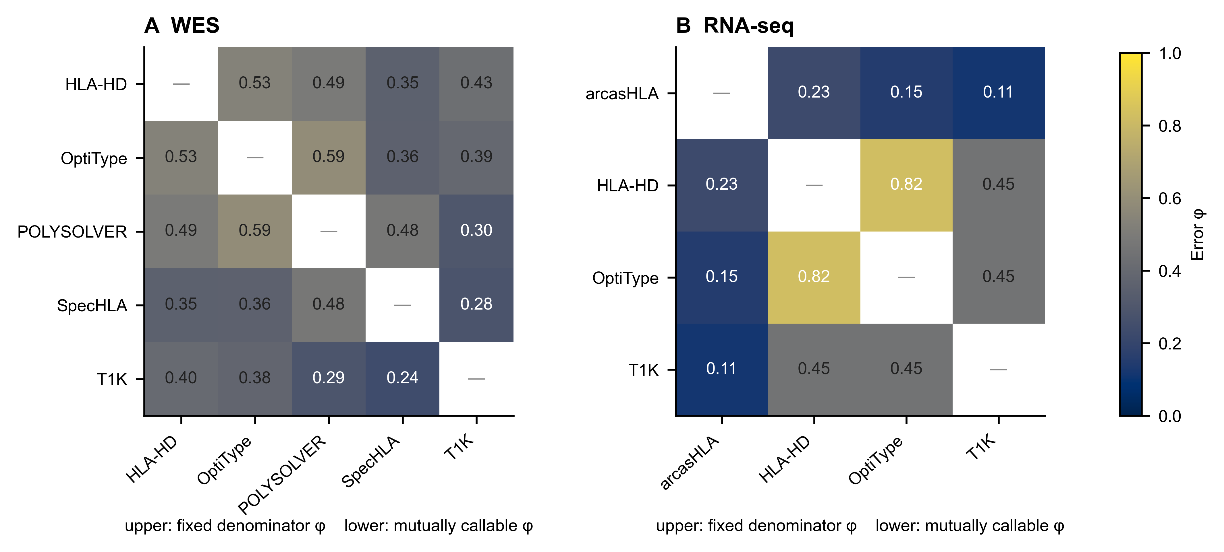
Figure 4. Pairwise caller-error dependence. Error φ between each pair of callers in WES (A) and RNA-seq (B), on one 0–1 colour scale and annotated to two decimals. Both triangles use exact-endpoint loci. Above the diagonal, φ uses the fixed denominator; below it, φ uses mutually callable loci, excluding any locus where either caller made no call. Most joint errors occur where second typing disagrees with the reference. Where the typings agree, dependence largely disappears (Supplementary S7). The matrices are descriptive and do not identify a causal error mechanism.
The same dependence bounds what any rule that selects among these outputs could achieve. Of the vote's 10 WES and 5 RNA-seq errors, an oracle choosing any evaluated caller output could have corrected six WES errors and no RNA-seq error. No panel caller solved four WES and five RNA-seq errors. A selector restricted to existing outputs therefore had ceilings of 149/153 (97.4%) for WES and 113/118 (95.8%) for RNA-seq; this is an oracle bound, not achievable performance.
A published re-typing of the same exomes explains most of this apparent shared error. Under the pre-specified parsing rule, which treats asterisked values as unavailable, the second typing was unavailable at all 15 consensus errors. Wherever it was available it agreed with the reference (143/143 WES and 112/112 RNA-seq loci), as the rule entails. Read post hoc with the asterisk removed, the second typing equals the consensus call at all 15 error loci (10 WES, 5 RNA-seq). Only one other exact-endpoint locus carries an asterisk. At each of the 15, the source reports the 2014 type as incorrect. It records confirmation by targeted sequencing for some allele corrections and by inspection of exome reads for the others [37]. The five RNA-seq errors are the same subject–gene loci as five of the WES errors, with the same consensus genotype, although the two assays use different reads and partly different callers (Supplementary S7).
Where the two typings agree, the vote and the strongest caller were almost always correct. On these loci ChampHLA-Consensus was correct at all 143 WES and all 112 RNA-seq loci. OptiType was correct at 141/143 WES and 111/112 RNA-seq loci, and HLA-HD at all 112 RNA-seq loci. WES caller errors were nearly uncorrelated on this subset (φ −0.08 to 0.31, median 0.02). The vote was correct at all 12 of HLA-HD's errors, all 12 of SpecHLA's and all 19 of T1K's. In RNA-seq, HLA-HD made no error on this subset, and OptiType's single error was not shared with HLA-HD or T1K. Most consensus errors therefore probably reflect errors in the 2014 reference typing rather than in the callers. On this subset, the strongest caller makes almost no errors; shared caller errors do not explain the vote's result. This exploratory interpretation was made after the data had been seen and rests on few errors. The second typing derives from the same exomes, so the analysis does not estimate independence (Supplementary S7).

Call states, singletons, ties and vote support
In the rerun every panel caller had a row at every exact-endpoint locus; two T1K WES rows were partial and one was missing (Supplementary S5). The singleton rows of HLA-HD (16 WES, 14 RNA-seq) and arcasHLA (9 RNA-seq), and T1K's declared homozygotes (12 WES, 11 RNA-seq), were completed as caller-declared homozygotes. Of the 64 single-allele rows at exact-endpoint loci, 57 lay at homozygous reference loci. The other seven—four arcasHLA RNA-seq declarations, one T1K WES declaration and the two partial T1K WES rows—lay at heterozygous reference loci (Supplementary Figure S1).
No locus was tied in either assay, so the tie-break did not affect either result (143/153 and 113/118 with ties sent to the last-sorting pair). Concordance did not rise steadily with vote support, the number of callers supporting the reported genotype out of the number callable (Supplementary Figure S3). Full-panel unanimity was concordant at 103/104 WES 5/5 loci (99.0%) and 51/53 RNA-seq 4/4 loci (96.2%): unanimous calls were usually, but not always, correct. Among RNA-seq strata with at least five loci, support was nonmonotonic. These are descriptive proportions, not held-out calibration. Results by gene, rare allele, population and zygosity are descriptive, with small strata outside CEU and YRI (Supplementary S4). Restored analyses describe historical stored outputs and are reported as provenance (Supplementary S12).

Exploratory cohorts show that agreement is not accuracy
Two aggregate-only exploratory patient cohorts illustrate the distinction between agreement and accuracy (Supplementary S9). In FIMM, bulk RNA-seq–WES exact-pair agreement was 62/70 (88.6%; Wilson 95% CI 79.0–94.1%) [44] when both assays had at least two valid callers. Every assay pair shared callers; the caller-disjoint sensitivity analysis had no evaluable pairs. In VenEx WES, dissent from the inclusive plurality ranged from 0/230 for HLA-HD to 26/231 for SpecHLA, while POLYSOLVER had no mutually callable loci. These estimates are neither comparisons with independent truth nor evidence of clinical utility. An earlier NCI-60 cell-line analysis is being regenerated with the evaluated workflow release under a previously specified analysis plan and is not reported here (Supplementary S9.6).

Discussion
Within these named panels, the equal-weight plurality vote could not be distinguished from each assay's strongest caller, without choosing that caller in advance. The vote was one locus above OptiType in WES and one above both HLA-HD and OptiType in RNA-seq. Every reported genotype can be traced to its supporting votes. No fitted policy did better. The refitted nested-CV best-caller policy fell one locus short in WES and two in RNA-seq without a significant difference (Supplementary S7). These data give no reason to prefer a trained rule. The comparisons were small, and we made the vote primary after seeing the results. They establish neither equivalence nor superiority.
The vote's small gain appears to reflect the reference typing rather than the callers. On all exact loci, correlated caller errors and small oracle headroom would ordinarily point to errors shared by the callers. Most loci behind that pattern had already been corrected from the 2014 reference to the callers' genotype by a published re-typing [37]. Where the two typings agreed, caller errors were nearly uncorrelated and the vote corrected almost all of them. The strongest caller also made almost no errors. A vote cannot improve on a caller at the ceiling allowed by the reference. An uncorrected reference can make agreement among callers look like shared error. This account is exploratory and should be tested against orthogonal laboratory typing.
How the benchmark was scored mattered as much as the voting rule. Treating every single allele as homozygous conflates missingness with biological evidence. Reading caller-native declarations changed the scores of HLA-HD, arcasHLA, T1K and the RNA-seq vote; we report both scorings (Supplementary S2). Credible HLA benchmarks should record call states and abstentions, parse every reference record and report exact and set-valued endpoints together. Re-running callers from recorded inputs also matters: here it exposed a deployment defect that stored outputs would have hidden.
Earlier studies also combined HLA callers by voting. Claeys et al. [23] evaluated a majority vote on the same public 1000 Genomes and Geuvadis data, keeping failed predictions in an allele-level denominator. Lee et al. [27] combined callers within an assay and restricted genotype-level analysis to loci with one resolved reference genotype. This evaluation adds caller-native call states, a tie-break independent of performance, a specified caller run that can be repeated, and traceability from every reported number to its source. Claeys et al. reported allele-level accuracy; our primary endpoint is unordered-genotype concordance, so the values are not directly comparable. In both studies the vote's gain over the best single caller was small. Our panel covers only a few related algorithmic families. ChampHLA-Consensus therefore provides a baseline and a framework for checking results, rather than a comprehensive comparison of HLA callers.
For research use, these results do not justify running a multi-caller panel solely to improve concordance when a suitable assay-specific caller has already been validated. The plurality baseline is useful when caller choice is uncertain and users want an auditable rule without fitted parameters. These results do not extend to clinical HLA typing, including donor–recipient matching or pharmacogenomic screening, which requires accredited laboratory methods and regulatory-grade validation. Users of the workflow should run it with -profile paper, which applies the evaluated rule rather than the unevaluated calibrated default. They should treat a single reported allele as homozygous only where the caller's format declares it, review tied loci and loci supported by only one caller, and report exact and ambiguity-compatible concordance together.
The specified rule is now being tested on unseen subjects: the separate extension cohort is being processed with the same workflow version, under an analysis plan that will be publicly deposited before predictions are compared with reference typing. The NCI-60 cell-line application is being regenerated under a documented exploratory protocol. Evaluating graph and pangenome callers, harmonized databases, class II genes HLA-DRB1 and HLA-DQB1, three-field reference typing, re-extracted WGS inputs and long-read modes would widen the study. Larger cohorts would allow population-stratified analysis and help separate algorithm from deployment effects.
Design. This is a retrospective development study without independent external validation. We set or changed the primary rule, multiplicity scheme, primary paired test and single-allele handling after seeing development results (Methods; Supplementary S14). Every development result is therefore exploratory. A subject-disjoint extension cohort of 89 WES and 99 RNA-seq subjects was specified before any comparison with reference genotypes; its pre-specified confirmatory analysis is running and is not reported here. WES and RNA-seq subjects overlap, and the filtered sets are small. The same five subject–gene loci account for all RNA-seq vote errors and five WES errors, so cross-assay agreement is not independent replication.
Reference typing. The reference is the fallible 2014 exon 2–3 table interpreted against a 2009 allele release, and only HLA-A, HLA-B and HLA-C were evaluated, at two-field resolution. Several callers were developed or evaluated against typings of these same samples (Methods). Neither the primary nor the corrected-reference comparison is independent of every caller, and absolute concordance may be optimistic. Exclusion of ambiguous typing was strongly population-dependent. Retention reflects how each contributing laboratory encoded ambiguity as well as typing resolution or quality, so it must not be read as a population accuracy estimate.
Samples, callers and provenance. Both assays were generated from lymphoblastoid cell lines, whose high HLA expression and cell-state composition limit transfer of the RNA-seq result to primary or tumour tissue. The caller panel reflects the original deployment and used different database vintages and reference builds. Historical executables, native search databases and container digests were not recorded. The v3.5.0 rerun uses one workflow release and records each sample's container digests. Caller differences still combine algorithm, deployment and reference-resource effects; rankings describe deployed tools rather than algorithms (Supplementary S13). The rerun exposed a defect in the specified software version: its arcasHLA module extracts paired-end Geuvadis reads as single-end. The arcasHLA 0.2.0 container then genotypes them without pair information. In a comparison that did not use reference genotypes, rerun arcasHLA calls differed from stored calls at 176 of 318 RNA-seq caller–gene cells and included many rarely observed allele designations (Supplementary Table S10.2). Exact concordance was 58/118; we diagnosed the deployment only after seeing that score. We report the result as the specified deployment produced it and did not change the module, so the arcasHLA estimate describes that deployment rather than the caller. WGS outputs from the original caller run failed input-validity checks involving HLA alternate contigs and read extraction, and all quantitative WGS results were removed.
Statistics. Single-allele handling changes individual callers' scores (Supplementary S2). Lexicographic tie-breaking is deterministic but not biologically informed, and it needs prospective replacement or review routing. Support strata were not externally calibrated. Rare alleles, homozygotes and most population strata were too few to analyse. The post hoc non-inferiority and power analyses are sensitivities only.
ChampHLA-Consensus is an auditable development baseline. With unambiguous reference typing, fixed denominators, explicit call states and a re-executed caller run, it could not be distinguished from the best single caller in WES or RNA-seq. It provides neither a new inference algorithm nor a clinical typing system. Its value is operational: users need not choose a caller in advance, and every reported genotype remains traceable to the calls that support it. The pre-registered extension will test the specified rule on unseen subjects; claims of equivalence, generalization or clinical use require independent laboratory typing beyond it.

Data availability
The primary input data are public. The WES data are the 1000 Genomes Project GRCh38DH exome alignments distributed by the International Genome Sample Resource [52]. The RNA-seq data are from the Geuvadis project (ENA study PRJEB3366 [53]; ArrayExpress E-GEUV-1 [54]). cohorts/official_1000g_assay_manifest.tsv lists each subject–assay input, its URL and the source checksum where available. The reference typing is the 2014 1000 Genomes HLA table [55] (SHA-256 0455d0302ac12a29ab87091cab5e3e557416f6301e89fb122eef8d49cd5644ec). artifacts/development_corrected/per_locus_results.tsv releases every method's call, reference genotype and agreement at each exact-endpoint locus. scripts/run_local_verification.sh regenerates these results from public inputs. The caller outputs from the release 3.5.0 rerun, without reference genotypes, their per-sample provenance and the stored-to-rerun comparison are released in provenance/development_rerun_v350/truth_free_collection/. The public inputs of the planned extension are listed in cohorts/extension_v350_manifest.tsv, and those of the NCI-60 application in cohorts/nci60_v350_manifest.tsv, with the ENA file reports and the published NCI-60 typing in resources/nci60/.
Public human data remain subject to source-project terms. FIMM source workbooks, specimen–donor mappings and row-level calls remain in controlled storage and are not part of the public release; only privacy-reviewed aggregate artifacts are included.

Code availability
The paper repository is intended for archival release on GitHub [56] under the MIT licence. The reproducible analysis starts from normalized caller outputs that contain no reference genotypes and covers checksum-verified reference acquisition, reference selection, code, tests, artifacts, figure formats, manuscript sources and a release manifest. The raw-read-to-caller workflow is maintained separately on GitHub [57]. Evaluated outputs came from release 3.5.0 (tag v3.5.0, commit 66d949d), the release to cite; it was distributed under the workflow's interim name, PanelHLA, which denotes the same software. It implements the rule under -profile paper, verifies caller images against specified SHA-256 checksums, rescues HLA-allele and alternate-contig reads (introduced in release 3.4.0) and corrects the T1K parser. The historical stored outputs came from an unarchived pre-release deployment; the whole run cannot be assigned to the 7 April 2026 revision retained in the repository history. Callers retain their own licences, and some distributions restrict commercial use; see THIRD_PARTY_NOTICES.md.

References
1. Trowsdale J, Knight JC. Major Histocompatibility Complex Genomics and Human Disease. Annu Rev Genomics Hum Genet. 2013;14:301–323. doi:10.1146/annurev-genom-091212-153455.
2. Lee SJ, Klein J, Haagenson M, Baxter-Lowe LA, Confer DL, Eapen M, et al. High-resolution donor-recipient HLA matching contributes to the success of unrelated donor marrow transplantation. Blood. 2007;110:4576–4583. doi:10.1182/blood-2007-06-097386.
3. Petersdorf EW. Risk assessment in haematopoietic stem cell transplantation: Histocompatibility. Best Pract Res Clin Haematol. 2007;20:155–170. doi:10.1016/j.beha.2006.09.001.
4. Mallal S, Phillips E, Carosi G, Molina JM, Workman C, Tomažič J, et al. HLA-B*5701 Screening for Hypersensitivity to Abacavir. N Engl J Med. 2008;358:568–579. doi:10.1056/NEJMoa0706135.
5. Chung WH, Hung SI, Hong HS, Hsih MS, Yang LC, Ho HC, et al. A marker for Stevens–Johnson syndrome. Nature. 2004;428:486. doi:10.1038/428486a.
6. Schumacher TN, Schreiber RD. Neoantigens in cancer immunotherapy. Science. 2015;348:69–74. doi:10.1126/science.aaa4971.
7. Matzaraki V, Kumar V, Wijmenga C, Zhernakova A. The MHC locus and genetic susceptibility to autoimmune and infectious diseases. Genome Biol. 2017;18:76. doi:10.1186/s13059-017-1207-1.
8. Robinson J, Barker DJ, Georgiou X, Cooper MA, Flicek P, Marsh SGE. IPD-IMGT/HLA Database. Nucleic Acids Res. 2020;48:D948–D955. doi:10.1093/nar/gkz950.
9. Dilthey AT, Mentzer AJ, Carapito R, Cutland C, Cereb N, Madhi SA, et al. HLA*LA—HLA typing from linearly projected graph alignments. Bioinformatics. 2019;35:4394–4396. doi:10.1093/bioinformatics/btz235.
10. Aguiar VRC, César J, Delaneau O, Dermitzakis ET, Meyer D. Expression estimation and eQTL mapping for HLA genes with a personalized pipeline. PLoS Genet. 2019;15:e1008091. doi:10.1371/journal.pgen.1008091.
11. Szolek A, Schubert B, Mohr C, Sturm M, Feldhahn M, Kohlbacher O. OptiType: precision HLA typing from next-generation sequencing data. Bioinformatics. 2014;30:3310–3316. doi:10.1093/bioinformatics/btu548.
12. Kawaguchi S, Higasa K, Shimizu M, Yamada R, Matsuda F. HLA-HD: An accurate HLA typing algorithm for next-generation sequencing data. Hum Mutat. 2017;38:788–797. doi:10.1002/humu.23230.
13. Orenbuch R, Filip I, Comito D, Shaman J, Pe’er I, Rabadan R. arcasHLA: high-resolution HLA typing from RNAseq. Bioinformatics. 2020;36:33–40. doi:10.1093/bioinformatics/btz474.
14. Shukla SA, Rooney MS, Rajasagi M, Tiao G, Dixon PM, Lawrence MS, et al. Comprehensive analysis of cancer-associated somatic mutations in class I HLA genes. Nat Biotechnol. 2015;33:1152–1158. doi:10.1038/nbt.3344.
15. Song L, Bai G, Liu XS, Li B, Li H. Efficient and accurate KIR and HLA genotyping with massively parallel sequencing data. Genome Res. 2023;33:923–931. doi:10.1101/gr.277585.122.
16. Wang S, Wang M, Chen L, Pan G, Wang Y, Li SC. SpecHLA enables full-resolution HLA typing from sequencing data. Cell Rep Methods. 2023;3:100589. doi:10.1016/j.crmeth.2023.100589.
17. Lee H, Kingsford C. Kourami: graph-guided assembly for novel human leukocyte antigen allele discovery. Genome Biol. 2018;19:16. doi:10.1186/s13059-018-1388-2.
18. Boegel S, Löwer M, Schäfer M, Bukur T, de Graaf J, Boisguérin V, et al. HLA typing from RNA-Seq sequence reads. Genome Med. 2012;4:102. doi:10.1186/gm403.
19. Kim D, Paggi JM, Park C, Bennett C, Salzberg SL. Graph-based genome alignment and genotyping with HISAT2 and HISAT-genotype. Nat Biotechnol. 2019;37:907–915. doi:10.1038/s41587-019-0201-4.
20. 1000 Genomes Project Consortium. A global reference for human genetic variation. Nature. 2015;526:68–74. doi:10.1038/nature15393.
21. Gourraud PA, Khankhanian P, Cereb N, Yang SY, Feolo M, Maiers M, et al. HLA Diversity in the 1000 Genomes Dataset. PLoS One. 2014;9:e97282. doi:10.1371/journal.pone.0097282.
22. Di Tommaso P, Chatzou M, Floden EW, Barja PP, Palumbo E, Notredame C. Nextflow enables reproducible computational workflows. Nat Biotechnol. 2017;35:316–319. doi:10.1038/nbt.3820.
23. Claeys A, Merseburger P, Staut J, Marchal K, Van den Eynden J. Benchmark of tools for in silico prediction of MHC class I and class II genotypes from NGS data. BMC Genomics. 2023;24:247. doi:10.1186/s12864-023-09351-z.
24. Kiyotani K, Mai TH, Nakamura Y. Comparison of exome-based HLA class I genotyping tools: identification of platform-specific genotyping errors. J Hum Genet. 2017;62:397–405. doi:10.1038/jhg.2016.141.
25. Larjo A, Eveleigh R, Kilpeläinen E, Kwan T, Pastinen T, Koskela S, et al. Accuracy of Programs for the Determination of Human Leukocyte Antigen Alleles from Next-Generation Sequencing Data. Front Immunol. 2017;8:1815. doi:10.3389/fimmu.2017.01815.
26. Li X, Zhou C, Chen K, Huang B, Liu Q, Ye H. Benchmarking HLA genotyping and clarifying HLA impact on survival in tumor immunotherapy. Mol Oncol. 2021;15:1764–1782. doi:10.1002/1878-0261.12895.
27. Lee M, Seo JH, Song S, Song IH, Kim SY, Kim YA, et al. A New Human Leukocyte Antigen Typing Algorithm Combined With Currently Available Genotyping Tools Based on Next-Generation Sequencing Data and Guidelines to Select the Most Likely Human Leukocyte Antigen Genotype. Front Immunol. 2021;12:688183. doi:10.3389/fimmu.2021.688183.
28. Bowen-James R, Wu W, Wong-Erasmus M, Quinn JMW, Mayoh C, Cowley MJ. consHLA: a next generation sequencing consensus-based HLA typing workflow. BMC Bioinformatics. 2025;26:215. doi:10.1186/s12859-025-06223-z.
29. Ryan KM, O’Connor D, Digby B, Barkley LR, Ó Broin P. Abstract P2-06-26: nf-hlamajority: a Nextflow pipeline for consensus MHC class I typing and its application to neoantigen identification in breast cancer stromal cells. Clin Cancer Res. 2025;31 Suppl 12:P2-06-26. doi:10.1158/1557-3265.SABCS24-P2-06-26.
30. Nordin J, Ameur A, Lindblad-Toh K, Gyllensten U, Meadows JRS. SweHLA: the high confidence HLA typing bio-resource drawn from 1000 Swedish genomes. Eur J Hum Genet. 2020;28:627–635. doi:10.1038/s41431-019-0559-2.
31. Lappalainen T, Sammeth M, Friedländer MR, ‘t Hoen PAC, Monlong J, Rivas MA, et al. Transcriptome and genome sequencing uncovers functional variation in humans. Nature. 2013;501:506–511. doi:10.1038/nature12531.
32. Parham P, Brodsky FM. Partial purification and some properties of BB7.2 a cytotoxic monoclonal antibody with specificity for HLA-A2 and a variant of HLA-A28. Hum Immunol. 1981;3:277–299. doi:10.1016/0198-8859(81)90065-3.
33. Hilton HG, Parham P. Direct binding to antigen-coated beads refines the specificity and cross-reactivity of four monoclonal antibodies that recognize polymorphic epitopes of HLA class I molecules. Tissue Antigens. 2013;81:212–220. doi:10.1111/tan.12095.
34. Adams S, Robbins FM, Chen D, Wagage D, Holbeck SL, Morse HC, et al. HLA class I and II genotype of the NCI-60 cell lines. J Transl Med. 2005;3:11. doi:10.1186/1479-5876-3-11.
35. Li H. Aligning sequence reads, clone sequences and assembly contigs with BWA-MEM. arXiv. 2013;1303.3997. doi:10.48550/arXiv.1303.3997.
36. Bauer DC, Zadoorian A, Wilson LOW, Melbourne Genomics Health Alliance, Thorne NP. Evaluation of computational programs to predict HLA genotypes from genomic sequencing data. Brief Bioinform. 2018;19:179–187. doi:10.1093/bib/bbw097.
37. Abi-Rached L, Gouret P, Yeh JH, Di Cristofaro J, Pontarotti P, Picard C, et al. Immune diversity sheds light on missing variation in worldwide genetic diversity panels. PLoS One. 2018;13:e0206512. doi:10.1371/journal.pone.0206512.
38. Thuesen NH, Klausen MS, Gopalakrishnan S, Trolle T, Renaud G. Benchmarking freely available HLA typing algorithms across varying genes, coverages and typing resolutions. Front Immunol. 2022;13:987655. doi:10.3389/fimmu.2022.987655.
39. Buchkovich ML, Brown CC, Robasky K, Chai S, Westfall S, Vincent BG, et al. HLAProfiler utilizes k-mer profiles to improve HLA calling accuracy for rare and common alleles in RNA-seq data. Genome Med. 2017;9:86. doi:10.1186/s13073-017-0473-6.
40. Marsh SGE, Albert ED, Bodmer WF, Bontrop RE, Dupont B, Erlich HA, et al. Nomenclature for factors of the HLA system, 2010. Tissue Antigens. 2010;75:291–455. doi:10.1111/j.1399-0039.2010.01466.x.
41. HLA-HD demo manual, version 1.7.0. Kyoto University. https://w3.genome.med.kyoto-u.ac.jp/HLA-HD/demo/hlahd-demo.v1.pdf. Accessed 13 Oct 2026.
42. arcasHLA, release v0.2.0 (source code). GitHub. https://github.com/RabadanLab/arcasHLA/tree/v0.2.0. Accessed 10 Oct 2026.
43. Clopper CJ, Pearson ES. The use of confidence or fiducial limits illustrated in the case of the binomial. Biometrika. 1934;26:404–413. doi:10.2307/2331986.
44. Wilson EB. Probable Inference, the Law of Succession, and Statistical Inference. J Am Stat Assoc. 1927;22:209–212. doi:10.1080/01621459.1927.10502953.
45. Holm S. A simple sequentially rejective multiple test procedure. Scand J Stat. 1979;6:65–70. doi:10.2307/4615733.
46. Cameron AC, Miller DL. A Practitioner’s Guide to Cluster-Robust Inference. J Hum Resour. 2015;50:317–372. doi:10.3368/jhr.50.2.317.
47. Harris CR, Millman KJ, van der Walt SJ, Gommers R, Virtanen P, Cournapeau D, et al. Array programming with NumPy. Nature. 2020;585:357–362. doi:10.1038/s41586-020-2649-2.
48. Virtanen P, Gommers R, Oliphant TE, Haberland M, Reddy T, Cournapeau D, et al. SciPy 1.0: fundamental algorithms for scientific computing in Python. Nat Methods. 2020;17:261–272. doi:10.1038/s41592-019-0686-2.
49. Hunter JD. Matplotlib: A 2D Graphics Environment. Comput Sci Eng. 2007;9:90–95. doi:10.1109/MCSE.2007.55.
50. Kurtzer GM, Sochat V, Bauer MW. Singularity: Scientific containers for mobility of compute. PLoS One. 2017;12:e0177459. doi:10.1371/journal.pone.0177459.
51. Li H, Handsaker B, Wysoker A, Fennell T, Ruan J, Homer N, et al. The Sequence Alignment/Map format and SAMtools. Bioinformatics. 2009;25:2078–2079. doi:10.1093/bioinformatics/btp352.
52. International Genome Sample Resource. 1000 Genomes Project data collection. https://ftp.1000genomes.ebi.ac.uk/vol1/ftp/data_collections/1000_genomes_project/. Accessed 10 Oct 2026.
53. European Nucleotide Archive. Study PRJEB3366 (Geuvadis RNA sequencing). https://www.ebi.ac.uk/ena/browser/view/PRJEB3366. Accessed 10 Oct 2026.
54. ArrayExpress. E-GEUV-1: RNA-sequencing of 465 lymphoblastoid cell lines from the 1000 Genomes. https://www.ebi.ac.uk/biostudies/arrayexpress/studies/E-GEUV-1. Accessed 10 Oct 2026.
55. International Genome Sample Resource. 1000 Genomes HLA diversity genotypes (20140702_hla_diversity.txt). https://ftp.1000genomes.ebi.ac.uk/vol1/ftp/technical/working/20140725_hla_genotypes/20140702_hla_diversity.txt. Accessed 10 Oct 2026.
56. ChampHLA paper repository. GitHub. https://github.com/uoozcan/ChampHLA-paper.
57. ChampHLA Nextflow workflow (release v3.5.0, distributed as PanelHLA). GitHub. https://github.com/uoozcan/ChampHLA.

Supplementary information
Supplementary methods, results, tables and figures are supplied as a separate document. They cover the cohort and reference-source audit, complete method performance, paired comparisons, stratified results, call states and ties, caller-resource provenance, oracle headroom and fitted policies, excluded earlier analyses, aggregate-only exploratory FIMM, VenEx and NCI-60 analyses, the reproducibility details, workflow execution, disagreement classes, and background and design rationale.

Appendix: Supplementary material
Supporting methods and complete development results for Benchmarking consensus HLA class I genotyping from exome and RNA sequencing with ChampHLA. Tables report results from the accompanying versioned data files. Numerical citations continue the reference numbering of the main manuscript.

S1. Cohort and reference-source audit
The documented v3.5.0 rerun roster had 390 WES loci from 130 subjects and 318 RNA-seq loci from 106 subjects. The roster excludes NA07000 RNA-seq because the historical input was absent from the official assay manifest and failed cross-assay identity checks (Methods; decisions/20261008_identity_check_na07000.json). Every rerun input is in the manifest. artifacts/development_characterisation/identity_check.tsv contains identity evidence for every rerun subject. provenance/development_rerun_v350/historical_artifacts/ retains the withheld input's historical evidence. The public reference-genotype parser retained a locus only when all reported ambiguity alternatives collapsed to one unordered two-field genotype. Excluding loci with any ambiguous, invalid or conflicting reference record retained 153 WES loci from 63 subjects and 118 RNA-seq loci from 51 subjects. The filtered sets shared 50 subjects. The set-valued secondary endpoint retained 335 WES and 263 RNA-seq loci with at least one parseable candidate genotype.
Populations use the 1000 Genomes codes: CEU (Utah residents with Northern and Western European ancestry), YRI (Yoruba in Ibadan, Nigeria), CHB (Han Chinese in Beijing), JPT (Japanese in Tokyo), FIN (Finnish), GBR (British), TSI (Toscani in Italy) and PUR (Puerto Rican). The 2014 reference table labels the CEU samples "CEPH" and pools CHB and JPT as "CHB+JPT"; tables derived from it keep those labels. Candidate-occurrence bounds are internal benchmark counts, not population allele frequencies.
Assay | Requested subjects | Requested loci | Retained subjects | Retained loci | Excluded loci | Retained cross-assay overlap
WES | 130 | 390 | 63 | 153 | 237 | 50
RNA-seq | 106 | 318 | 51 | 118 | 200 | 50

Assay | Source-truth state | Loci | Requested loci
WES | resolved | 153 | 390
WES | ambiguous | 182 | 390
WES | invalid | 1 | 390
WES | absent | 54 | 390
RNA-seq | resolved | 118 | 318
RNA-seq | ambiguous | 145 | 318
RNA-seq | invalid | 1 | 318
RNA-seq | absent | 54 | 318

Assay | Gene | Source population | Resolved | Ambiguous | Invalid | Absent | Total | Exact retention, %
RNA-seq | HLA-A | CEPH | 23 | 0 | 0 | 0 | 23 | 100.0
RNA-seq | HLA-A | FIN | 0 | 17 | 0 | 0 | 17 | 0.0
RNA-seq | HLA-A | GBR | 0 | 18 | 0 | 0 | 18 | 0.0
RNA-seq | HLA-A | TSI | 0 | 13 | 0 | 0 | 13 | 0.0
RNA-seq | HLA-A | YRI | 15 | 2 | 0 | 0 | 17 | 88.2
RNA-seq | HLA-A | unknown | 0 | 0 | 0 | 18 | 18 | 0.0
RNA-seq | HLA-B | CEPH | 19 | 4 | 0 | 0 | 23 | 82.6
RNA-seq | HLA-B | FIN | 0 | 17 | 0 | 0 | 17 | 0.0
RNA-seq | HLA-B | GBR | 1 | 17 | 0 | 0 | 18 | 5.6
RNA-seq | HLA-B | TSI | 5 | 8 | 0 | 0 | 13 | 38.5
RNA-seq | HLA-B | YRI | 15 | 2 | 0 | 0 | 17 | 88.2
RNA-seq | HLA-B | unknown | 0 | 0 | 0 | 18 | 18 | 0.0
RNA-seq | HLA-C | CEPH | 17 | 5 | 1 | 0 | 23 | 73.9
RNA-seq | HLA-C | FIN | 2 | 15 | 0 | 0 | 17 | 11.8
RNA-seq | HLA-C | GBR | 3 | 15 | 0 | 0 | 18 | 16.7
RNA-seq | HLA-C | TSI | 2 | 11 | 0 | 0 | 13 | 15.4
RNA-seq | HLA-C | YRI | 16 | 1 | 0 | 0 | 17 | 94.1
RNA-seq | HLA-C | unknown | 0 | 0 | 0 | 18 | 18 | 0.0
WES | HLA-A | CEPH | 24 | 0 | 0 | 0 | 24 | 100.0
WES | HLA-A | CHB+JPT | 5 | 5 | 0 | 0 | 10 | 50.0
WES | HLA-A | FIN | 0 | 17 | 0 | 0 | 17 | 0.0
WES | HLA-A | GBR | 0 | 17 | 0 | 0 | 17 | 0.0
WES | HLA-A | PUR | 0 | 8 | 0 | 0 | 8 | 0.0
WES | HLA-A | TSI | 0 | 13 | 0 | 0 | 13 | 0.0
WES | HLA-A | YRI | 21 | 2 | 0 | 0 | 23 | 91.3
WES | HLA-A | unknown | 0 | 0 | 0 | 18 | 18 | 0.0
WES | HLA-B | CEPH | 20 | 4 | 0 | 0 | 24 | 83.3
WES | HLA-B | CHB+JPT | 5 | 5 | 0 | 0 | 10 | 50.0
WES | HLA-B | FIN | 0 | 17 | 0 | 0 | 17 | 0.0
WES | HLA-B | GBR | 0 | 17 | 0 | 0 | 17 | 0.0
WES | HLA-B | PUR | 1 | 7 | 0 | 0 | 8 | 12.5
WES | HLA-B | TSI | 5 | 8 | 0 | 0 | 13 | 38.5
WES | HLA-B | YRI | 21 | 2 | 0 | 0 | 23 | 91.3
WES | HLA-B | unknown | 0 | 0 | 0 | 18 | 18 | 0.0
WES | HLA-C | CEPH | 17 | 6 | 1 | 0 | 24 | 70.8
WES | HLA-C | CHB+JPT | 5 | 5 | 0 | 0 | 10 | 50.0
WES | HLA-C | FIN | 2 | 15 | 0 | 0 | 17 | 11.8
WES | HLA-C | GBR | 2 | 15 | 0 | 0 | 17 | 11.8
WES | HLA-C | PUR | 1 | 7 | 0 | 0 | 8 | 12.5
WES | HLA-C | TSI | 2 | 11 | 0 | 0 | 13 | 15.4
WES | HLA-C | YRI | 22 | 1 | 0 | 0 | 23 | 95.7
WES | HLA-C | unknown | 0 | 0 | 0 | 18 | 18 | 0.0

The public source is 20140702_hla_diversity.txt, obtained from the IGSR 2014 HLA technical directory. Its required SHA-256 is 0455d0302ac12a29ab87091cab5e3e557416f6301e89fb122eef8d49cd5644ec. The selection manifest records each excluded subject–assay–gene key. Because many loci were excluded, exact results apply only to uniquely resolved reference loci. Retained-versus-excluded comparisons use gene, population, reference-typing state and candidate-pair count. Candidate-occurrence bounds are benchmark counts, not population allele frequencies. Retention was strongly population-dependent: after pooling genes, exact truth was retained for 84.7% of CEU (CEPH) and 92.8% of YRI WES source-present loci, but only 3.9% of FIN, 3.9% of GBR and 8.3% of PUR loci. The corresponding RNA-seq rates were 85.5%, 90.2%, 3.9% and 7.4% for CEU, YRI, FIN and GBR. These are properties of the 2014 truth representation, not biological population accuracy estimates.
Assay | Method | Compatibility endpoint | Compatible | Concordance, % (95% CI)
RNA-seq | Algorithm-family-restricted champion–challenger | Allowed two-field candidate | 248/263 | 94.3 (91.2–97.0)
RNA-seq | Best single caller (nested CV) | Allowed two-field candidate | 253/263 | 96.2 (93.9–98.1)
RNA-seq | ChampHLA-Consensus | Allowed two-field candidate | 257/263 | 97.7 (95.8–99.2)
RNA-seq | Champion–challenger | Allowed two-field candidate | 256/263 | 97.3 (95.4–99.2)
RNA-seq | HLA-HD | Allowed two-field candidate | 254/263 | 96.6 (94.3–98.5)
RNA-seq | Logistic meta-consensus | Allowed two-field candidate | 256/263 | 97.3 (95.4–99.2)
RNA-seq | OptiType | Allowed two-field candidate | 255/263 | 97.0 (94.7–98.9)
RNA-seq | Strict majority | Allowed two-field candidate | 235/263 | 89.4 (85.5–92.8)
RNA-seq | T1K | Allowed two-field candidate | 230/263 | 87.5 (83.3–91.3)
RNA-seq | Two-thirds consensus | Allowed two-field candidate | 235/263 | 89.4 (85.5–92.8)
RNA-seq | Two-thirds-guarded champion–challenger | Allowed two-field candidate | 256/263 | 97.3 (95.4–99.2)
RNA-seq | Vote-support-restricted champion–challenger | Allowed two-field candidate | 257/263 | 97.7 (95.8–99.2)
RNA-seq | arcasHLA | Allowed two-field candidate | 114/263 | 43.3 (37.6–48.9)
WES | Algorithm-family-restricted champion–challenger | Allowed two-field candidate | 320/335 | 95.5 (93.4–97.6)
WES | Best single caller (nested CV) | Allowed two-field candidate | 318/335 | 94.9 (92.5–97.0)
WES | ChampHLA-Consensus | Allowed two-field candidate | 321/335 | 95.8 (93.7–97.6)
WES | Champion–challenger | Allowed two-field candidate | 320/335 | 95.5 (93.4–97.6)
WES | HLA-HD | Allowed two-field candidate | 282/335 | 84.2 (79.4–88.7)
WES | Logistic meta-consensus | Allowed two-field candidate | 319/335 | 95.2 (92.8–97.3)
WES | OptiType | Allowed two-field candidate | 318/335 | 94.9 (92.5–97.0)
WES | POLYSOLVER | Allowed two-field candidate | 306/335 | 91.3 (88.4–94.0)
WES | SpecHLA | Allowed two-field candidate | 291/335 | 86.9 (82.7–90.7)
WES | Strict majority | Allowed two-field candidate | 312/335 | 93.1 (90.2–95.8)
WES | T1K | Allowed two-field candidate | 285/335 | 85.1 (81.1–88.9)
WES | Two-thirds consensus | Allowed two-field candidate | 293/335 | 87.5 (83.5–91.3)
WES | Two-thirds-guarded champion–challenger | Allowed two-field candidate | 320/335 | 95.5 (93.4–97.6)
WES | Vote-support-restricted champion–challenger | Allowed two-field candidate | 321/335 | 95.8 (93.7–97.6)
RNA-seq | Algorithm-family-restricted champion–challenger | G-compatible under a two-field mapping | 247/261 | 94.6 (91.5–97.3)
RNA-seq | Best single caller (nested CV) | G-compatible under a two-field mapping | 253/261 | 96.9 (94.7–98.9)
RNA-seq | ChampHLA-Consensus | G-compatible under a two-field mapping | 256/261 | 98.1 (96.2–99.6)
RNA-seq | Champion–challenger | G-compatible under a two-field mapping | 255/261 | 97.7 (95.8–99.2)
RNA-seq | HLA-HD | G-compatible under a two-field mapping | 254/261 | 97.3 (95.4–99.2)
RNA-seq | Logistic meta-consensus | G-compatible under a two-field mapping | 255/261 | 97.7 (95.8–99.2)
RNA-seq | OptiType | G-compatible under a two-field mapping | 254/261 | 97.3 (95.4–99.2)
RNA-seq | Strict majority | G-compatible under a two-field mapping | 234/261 | 89.7 (85.8–93.2)
RNA-seq | T1K | G-compatible under a two-field mapping | 239/261 | 91.6 (87.8–95.0)
RNA-seq | Two-thirds consensus | G-compatible under a two-field mapping | 234/261 | 89.7 (85.8–93.2)
RNA-seq | Two-thirds-guarded champion–challenger | G-compatible under a two-field mapping | 255/261 | 97.7 (95.8–99.2)
RNA-seq | Vote-support-restricted champion–challenger | G-compatible under a two-field mapping | 256/261 | 98.1 (96.2–99.6)
RNA-seq | arcasHLA | G-compatible under a two-field mapping | 172/261 | 65.9 (60.7–71.0)
WES | Algorithm-family-restricted champion–challenger | G-compatible under a two-field mapping | 324/333 | 97.3 (95.5–98.8)
WES | Best single caller (nested CV) | G-compatible under a two-field mapping | 320/333 | 96.1 (93.7–98.2)
WES | ChampHLA-Consensus | G-compatible under a two-field mapping | 324/333 | 97.3 (95.5–98.8)
WES | Champion–challenger | G-compatible under a two-field mapping | 324/333 | 97.3 (95.5–98.8)
WES | HLA-HD | G-compatible under a two-field mapping | 284/333 | 85.3 (80.6–89.6)
WES | Logistic meta-consensus | G-compatible under a two-field mapping | 323/333 | 97.0 (94.9–98.8)
WES | OptiType | G-compatible under a two-field mapping | 320/333 | 96.1 (93.7–98.2)
WES | POLYSOLVER | G-compatible under a two-field mapping | 310/333 | 93.1 (90.4–95.5)
WES | SpecHLA | G-compatible under a two-field mapping | 293/333 | 88.0 (83.8–91.8)
WES | Strict majority | G-compatible under a two-field mapping | 314/333 | 94.3 (91.5–96.7)
WES | T1K | G-compatible under a two-field mapping | 293/333 | 88.0 (84.2–91.6)
WES | Two-thirds consensus | G-compatible under a two-field mapping | 295/333 | 88.6 (84.6–92.2)
WES | Two-thirds-guarded champion–challenger | G-compatible under a two-field mapping | 324/333 | 97.3 (95.5–98.8)
WES | Vote-support-restricted champion–challenger | G-compatible under a two-field mapping | 324/333 | 97.3 (95.5–98.8)
RNA-seq | Algorithm-family-restricted champion–challenger | P-group-compatible under a two-field mapping | 247/261 | 94.6 (91.5–97.3)
RNA-seq | Best single caller (nested CV) | P-group-compatible under a two-field mapping | 253/261 | 96.9 (94.7–98.9)
RNA-seq | ChampHLA-Consensus | P-group-compatible under a two-field mapping | 256/261 | 98.1 (96.2–99.6)
RNA-seq | Champion–challenger | P-group-compatible under a two-field mapping | 255/261 | 97.7 (95.8–99.2)
RNA-seq | HLA-HD | P-group-compatible under a two-field mapping | 254/261 | 97.3 (95.4–99.2)
RNA-seq | Logistic meta-consensus | P-group-compatible under a two-field mapping | 255/261 | 97.7 (95.8–99.2)
RNA-seq | OptiType | P-group-compatible under a two-field mapping | 254/261 | 97.3 (95.4–99.2)
RNA-seq | Strict majority | P-group-compatible under a two-field mapping | 234/261 | 89.7 (85.8–93.2)
RNA-seq | T1K | P-group-compatible under a two-field mapping | 230/261 | 88.1 (84.0–92.0)
RNA-seq | Two-thirds consensus | P-group-compatible under a two-field mapping | 234/261 | 89.7 (85.8–93.2)
RNA-seq | Two-thirds-guarded champion–challenger | P-group-compatible under a two-field mapping | 255/261 | 97.7 (95.8–99.2)
RNA-seq | Vote-support-restricted champion–challenger | P-group-compatible under a two-field mapping | 256/261 | 98.1 (96.2–99.6)
RNA-seq | arcasHLA | P-group-compatible under a two-field mapping | 165/261 | 63.2 (57.6–68.7)
WES | Algorithm-family-restricted champion–challenger | P-group-compatible under a two-field mapping | 324/333 | 97.3 (95.5–98.8)
WES | Best single caller (nested CV) | P-group-compatible under a two-field mapping | 320/333 | 96.1 (93.8–98.2)
WES | ChampHLA-Consensus | P-group-compatible under a two-field mapping | 324/333 | 97.3 (95.5–98.8)
WES | Champion–challenger | P-group-compatible under a two-field mapping | 324/333 | 97.3 (95.5–98.8)
WES | HLA-HD | P-group-compatible under a two-field mapping | 284/333 | 85.3 (80.6–89.6)
WES | Logistic meta-consensus | P-group-compatible under a two-field mapping | 323/333 | 97.0 (94.9–98.8)
WES | OptiType | P-group-compatible under a two-field mapping | 320/333 | 96.1 (93.7–98.2)
WES | POLYSOLVER | P-group-compatible under a two-field mapping | 310/333 | 93.1 (90.4–95.5)
WES | SpecHLA | P-group-compatible under a two-field mapping | 293/333 | 88.0 (83.8–91.8)
WES | Strict majority | P-group-compatible under a two-field mapping | 314/333 | 94.3 (91.5–96.7)
WES | T1K | P-group-compatible under a two-field mapping | 290/333 | 87.1 (83.2–90.7)
WES | Two-thirds consensus | P-group-compatible under a two-field mapping | 295/333 | 88.6 (84.5–92.2)
WES | Two-thirds-guarded champion–challenger | P-group-compatible under a two-field mapping | 324/333 | 97.3 (95.5–98.8)
WES | Vote-support-restricted champion–challenger | P-group-compatible under a two-field mapping | 324/333 | 97.3 (95.5–98.8)

Two-field compatibility counts a call when it equals any allowed unordered candidate genotype. The P- and G-group sensitivities map each two-field designation to all compatible official IPD-IMGT/HLA 3.65.0 groups of that kind. They test a bijective set intersection across the two alleles. They are compatibility analyses under a two-field mapping, not exact P- or G-group calls. Two reference loci per assay could not be mapped for either endpoint; these exclusions remain explicit. Every method is reported for all three set-valued endpoints.

Subject-level paired inference for the set-valued two-field endpoint used the same fixed locus denominator as the compatibility estimates. Positive differences favour ChampHLA-Consensus. We enumerated two-sided sign assignments exactly through 25 nonzero subjects, otherwise sampling 1,000,000 plus-one-corrected assignments. We applied Holm adjustment within each assay and predeclared descriptive or fitted comparator family.
Assay | Comparator | Family | ChampHLA compatible | Comparator compatible | Difference, points | Wins/losses | Raw sign-flip p | Holm p | Test
WES | HLA-HD | descriptive comparator | 321/335 | 282/335 | 11.64 | 39/0 | 1.00e-06 | 6.00e-06 | monte carlo plus one
WES | OptiType | descriptive comparator | 321/335 | 318/335 | 0.90 | 4/1 | 0.5 | 0.5 | exact enumeration
WES | POLYSOLVER | descriptive comparator | 321/335 | 306/335 | 4.48 | 18/3 | 0.001 | 0.004 | exact enumeration
WES | SpecHLA | descriptive comparator | 321/335 | 291/335 | 8.96 | 33/3 | 2.00e-06 | 8.00e-06 | monte carlo plus one
WES | Strict majority | descriptive comparator | 321/335 | 312/335 | 2.69 | 9/0 | 0.004 | 0.008 | exact enumeration
WES | T1K | descriptive comparator | 321/335 | 285/335 | 10.75 | 39/3 | 1.00e-06 | 6.00e-06 | monte carlo plus one
WES | Two-thirds consensus | descriptive comparator | 321/335 | 293/335 | 8.36 | 28/0 | 1.19e-07 | 8.34e-07 | exact enumeration
WES | Algorithm-family-restricted champion–challenger | exploratory fitted | 321/335 | 320/335 | 0.30 | 2/1 | 1 | 1 | exact enumeration
WES | Best single caller (nested CV) | exploratory fitted | 321/335 | 318/335 | 0.90 | 4/1 | 0.5 | 1 | exact enumeration
WES | Champion–challenger | exploratory fitted | 321/335 | 320/335 | 0.30 | 2/1 | 1 | 1 | exact enumeration
WES | Logistic meta-consensus | exploratory fitted | 321/335 | 319/335 | 0.60 | 3/1 | 0.75 | 1 | exact enumeration
WES | Two-thirds-guarded champion–challenger | exploratory fitted | 321/335 | 320/335 | 0.30 | 2/1 | 1 | 1 | exact enumeration
WES | Vote-support-restricted champion–challenger | exploratory fitted | 321/335 | 321/335 | 0.00 | 0/0 | 1 | 1 | exact enumeration
RNA-seq | HLA-HD | descriptive comparator | 257/263 | 254/263 | 1.14 | 3/0 | 0.25 | 0.5 | exact enumeration
RNA-seq | OptiType | descriptive comparator | 257/263 | 255/263 | 0.76 | 2/0 | 0.5 | 0.5 | exact enumeration
RNA-seq | Strict majority | descriptive comparator | 257/263 | 235/263 | 8.37 | 22/0 | 1.91e-06 | 7.63e-06 | exact enumeration
RNA-seq | T1K | descriptive comparator | 257/263 | 230/263 | 10.27 | 27/0 | 1.19e-07 | 7.15e-07 | exact enumeration
RNA-seq | Two-thirds consensus | descriptive comparator | 257/263 | 235/263 | 8.37 | 22/0 | 1.91e-06 | 7.63e-06 | exact enumeration
RNA-seq | arcasHLA | descriptive comparator | 257/263 | 114/263 | 54.37 | 143/0 | 1.00e-06 | 5.00e-06 | monte carlo plus one
RNA-seq | Algorithm-family-restricted champion–challenger | exploratory fitted | 257/263 | 248/263 | 3.42 | 9/0 | 0.008 | 0.039 | exact enumeration
RNA-seq | Best single caller (nested CV) | exploratory fitted | 257/263 | 253/263 | 1.52 | 4/0 | 0.125 | 0.5 | exact enumeration
RNA-seq | Champion–challenger | exploratory fitted | 257/263 | 256/263 | 0.38 | 1/0 | 1 | 1 | exact enumeration
RNA-seq | Logistic meta-consensus | exploratory fitted | 257/263 | 256/263 | 0.38 | 1/0 | 1 | 1 | exact enumeration
RNA-seq | Two-thirds-guarded champion–challenger | exploratory fitted | 257/263 | 256/263 | 0.38 | 1/0 | 1 | 1 | exact enumeration
RNA-seq | Vote-support-restricted champion–challenger | exploratory fitted | 257/263 | 257/263 | 0.00 | 0/0 | 1 | 1 | exact enumeration

By retaining only uniquely resolved reference typings, the exact endpoint also selects which subjects and populations are scored. The next table reports two-field compatibility separately for retained loci, where it equals exact concordance, and excluded loci with scoreable ambiguous typing. The profile table compares population composition, panel-caller agreement and the number of candidate genotypes per excluded locus without using truth labels. Compatibility on excluded loci is lenient, because any allowed candidate counts.
Assay | Method | Retained exact loci, correct (%) | Excluded ambiguous loci, compatible (%)
WES | ChampHLA-Consensus | 143/153 (93.5) | 178/182 (97.8)
WES | Algorithm-family-restricted champion–challenger | 141/153 (92.2) | 179/182 (98.4)
WES | Best single caller (nested CV) | 142/153 (92.8) | 176/182 (96.7)
WES | Champion–challenger | 141/153 (92.2) | 179/182 (98.4)
WES | Logistic meta-consensus | 140/153 (91.5) | 179/182 (98.4)
WES | Strict majority | 141/153 (92.2) | 171/182 (94.0)
WES | Two-thirds consensus | 136/153 (88.9) | 157/182 (86.3)
WES | Two-thirds-guarded champion–challenger | 141/153 (92.2) | 179/182 (98.4)
WES | Vote-support-restricted champion–challenger | 143/153 (93.5) | 178/182 (97.8)
WES | HLA-HD | 131/153 (85.6) | 151/182 (83.0)
WES | OptiType | 142/153 (92.8) | 176/182 (96.7)
WES | POLYSOLVER | 138/153 (90.2) | 168/182 (92.3)
WES | SpecHLA | 134/153 (87.6) | 157/182 (86.3)
WES | T1K | 125/153 (81.7) | 160/182 (87.9)
RNA-seq | ChampHLA-Consensus | 113/118 (95.8) | 144/145 (99.3)
RNA-seq | Algorithm-family-restricted champion–challenger | 109/118 (92.4) | 139/145 (95.9)
RNA-seq | Best single caller (nested CV) | 111/118 (94.1) | 142/145 (97.9)
RNA-seq | Champion–challenger | 113/118 (95.8) | 143/145 (98.6)
RNA-seq | Logistic meta-consensus | 113/118 (95.8) | 143/145 (98.6)
RNA-seq | Strict majority | 106/118 (89.8) | 129/145 (89.0)
RNA-seq | Two-thirds consensus | 106/118 (89.8) | 129/145 (89.0)
RNA-seq | Two-thirds-guarded champion–challenger | 113/118 (95.8) | 143/145 (98.6)
RNA-seq | Vote-support-restricted champion–challenger | 113/118 (95.8) | 144/145 (99.3)
RNA-seq | HLA-HD | 112/118 (94.9) | 142/145 (97.9)
RNA-seq | OptiType | 112/118 (94.9) | 143/145 (98.6)
RNA-seq | T1K | 101/118 (85.6) | 129/145 (89.0)
RNA-seq | arcasHLA | 58/118 (49.2) | 56/145 (38.6)

Assay | Reference loci | Loci | Subjects | CEU or YRI loci (%) | Caller-unanimous loci (%) | Median candidate pairs
WES | retained (resolved) | 153 | 63 | 125 (81.7) | 104 (68.0) | 1.0
WES | excluded (ambiguous) | 182 | 72 | 15 (8.2) | 111 (61.0) | 7.5
RNA-seq | retained (resolved) | 118 | 51 | 105 (89.0) | 53 (44.9) | 1.0
RNA-seq | excluded (ambiguous) | 145 | 59 | 14 (9.7) | 49 (33.8) | 8.0

S2. Complete method performance

Scope is one of primary, descriptive_comparator, or exploratory_fitted. Individual callers are descriptive comparisons. Callability and concordance use the same fixed truth denominator. Intervals are 95% subject-cluster percentile bootstrap intervals. Estimates of 0% or 100% use exact Clopper–Pearson intervals because a bootstrap would collapse to a point.
Assay | Method | Scope | Callable (95% CI) | Genotypes correct | Fixed-denominator genotype %, 95% CI | Called-only genotype %, 95% CI | Alleles correct | Allele %, 95% CI
RNA-seq | Best single caller (nested CV) | exploratory fitted | 118/118 (96.9–100.0) | 111/118 | 94.1 (89.9–97.6) | 94.1 (89.9–97.6) | 229/236 | 97.0 (95.0–98.8)
RNA-seq | arcasHLA | descriptive comparator | 118/118 (96.9–100.0) | 58/118 | 49.2 (40.9–57.1) | 49.2 (40.9–57.1) | 148/236 | 62.7 (55.8–69.2)
RNA-seq | HLA-HD | descriptive comparator | 118/118 (96.9–100.0) | 112/118 | 94.9 (91.0–98.3) | 94.9 (91.0–98.3) | 230/236 | 97.5 (95.5–99.2)
RNA-seq | OptiType | descriptive comparator | 118/118 (96.9–100.0) | 112/118 | 94.9 (91.0–98.3) | 94.9 (91.0–98.3) | 230/236 | 97.5 (95.5–99.2)
RNA-seq | T1K | descriptive comparator | 118/118 (96.9–100.0) | 101/118 | 85.6 (79.0–91.7) | 85.6 (79.0–91.7) | 219/236 | 92.8 (89.5–95.8)
RNA-seq | Champion–challenger | exploratory fitted | 118/118 (96.9–100.0) | 113/118 | 95.8 (92.1–99.1) | 95.8 (92.1–99.1) | 231/236 | 97.9 (96.1–99.6)
RNA-seq | Algorithm-family-restricted champion–challenger | exploratory fitted | 118/118 (96.9–100.0) | 109/118 | 92.4 (87.1–96.8) | 92.4 (87.1–96.8) | 225/236 | 95.3 (92.0–98.2)
RNA-seq | Vote-support-restricted champion–challenger | exploratory fitted | 118/118 (96.9–100.0) | 113/118 | 95.8 (92.1–99.1) | 95.8 (92.1–99.1) | 231/236 | 97.9 (96.1–99.6)
RNA-seq | Logistic meta-consensus | exploratory fitted | 118/118 (96.9–100.0) | 113/118 | 95.8 (92.1–99.1) | 95.8 (92.1–99.1) | 231/236 | 97.9 (96.1–99.6)
RNA-seq | ChampHLA-Consensus | primary | 118/118 (96.9–100.0) | 113/118 | 95.8 (92.1–99.1) | 95.8 (92.1–99.1) | 231/236 | 97.9 (96.1–99.6)
RNA-seq | Strict majority | descriptive comparator | 110/118 (88.7–97.3) | 106/118 | 89.8 (84.2–94.9) | 96.4 (92.7–99.1) | 216/236 | 91.5 (86.7–95.9)
RNA-seq | Two-thirds consensus | descriptive comparator | 110/118 (88.7–97.3) | 106/118 | 89.8 (84.2–94.9) | 96.4 (92.7–99.1) | 216/236 | 91.5 (86.7–95.8)
RNA-seq | Two-thirds-guarded champion–challenger | exploratory fitted | 118/118 (96.9–100.0) | 113/118 | 95.8 (92.1–99.1) | 95.8 (92.1–99.1) | 231/236 | 97.9 (96.0–99.6)
WES | Best single caller (nested CV) | exploratory fitted | 153/153 (97.6–100.0) | 142/153 | 92.8 (88.4–96.7) | 92.8 (88.4–96.7) | 295/306 | 96.4 (94.2–98.3)
WES | HLA-HD | descriptive comparator | 153/153 (97.6–100.0) | 131/153 | 85.6 (79.0–91.6) | 85.6 (79.0–91.6) | 281/306 | 91.8 (88.2–95.2)
WES | OptiType | descriptive comparator | 153/153 (97.6–100.0) | 142/153 | 92.8 (88.5–96.7) | 92.8 (88.5–96.7) | 295/306 | 96.4 (94.2–98.3)
WES | POLYSOLVER | descriptive comparator | 153/153 (97.6–100.0) | 138/153 | 90.2 (85.5–94.6) | 90.2 (85.5–94.6) | 291/306 | 95.1 (92.8–97.3)
WES | SpecHLA | descriptive comparator | 153/153 (97.6–100.0) | 134/153 | 87.6 (82.3–92.6) | 87.6 (82.3–92.6) | 284/306 | 92.8 (89.5–95.8)
WES | T1K | descriptive comparator | 150/153 (95.6–100.0) | 125/153 | 81.7 (75.6–87.5) | 83.3 (77.7–88.7) | 273/306 | 89.2 (85.2–92.9)
WES | Champion–challenger | exploratory fitted | 153/153 (97.6–100.0) | 141/153 | 92.2 (88.2–95.9) | 92.2 (88.2–95.9) | 294/306 | 96.1 (94.1–97.9)
WES | Algorithm-family-restricted champion–challenger | exploratory fitted | 153/153 (97.6–100.0) | 141/153 | 92.2 (88.2–95.9) | 92.2 (88.2–95.9) | 294/306 | 96.1 (94.1–97.9)
WES | Vote-support-restricted champion–challenger | exploratory fitted | 153/153 (97.6–100.0) | 143/153 | 93.5 (89.8–96.8) | 93.5 (89.8–96.8) | 296/306 | 96.7 (94.9–98.4)
WES | Logistic meta-consensus | exploratory fitted | 153/153 (97.6–100.0) | 140/153 | 91.5 (87.0–95.6) | 91.5 (87.0–95.6) | 293/306 | 95.8 (93.5–97.8)
WES | ChampHLA-Consensus | primary | 153/153 (97.6–100.0) | 143/153 | 93.5 (89.7–96.8) | 93.5 (89.7–96.8) | 296/306 | 96.7 (94.9–98.4)
WES | Strict majority | descriptive comparator | 150/153 (95.6–100.0) | 141/153 | 92.2 (88.2–95.9) | 94.0 (90.3–97.3) | 291/306 | 95.1 (92.3–97.6)
WES | Two-thirds consensus | descriptive comparator | 144/153 (90.3–97.4) | 136/153 | 88.9 (84.0–93.4) | 94.4 (90.8–97.8) | 280/306 | 91.5 (87.5–95.2)
WES | Two-thirds-guarded champion–challenger | exploratory fitted | 153/153 (97.6–100.0) | 141/153 | 92.2 (88.3–95.9) | 92.2 (88.3–95.9) | 294/306 | 96.1 (94.1–97.9)

Singleton sensitivity. The table repeats the analysis with every single-allele output abstaining, including HLA-HD, arcasHLA and v3.5.0 rerun T1K homozygous declarations completed in primary scoring (decisions/20261008_singleton_native_homozygosity.json). It reproduces the scoring rule used before that decision.
Assay | Method | Scope | Native-declaration correct | Abstain-all correct | Native-declaration callable | Abstain-all callable
WES | Algorithm-family-restricted champion–challenger | exploratory fitted | 141/153 | 141/153 | 153/153 | 153/153
WES | Best single caller (nested CV) | exploratory fitted | 142/153 | 142/153 | 153/153 | 153/153
WES | ChampHLA-Consensus | primary | 143/153 | 143/153 | 153/153 | 153/153
WES | Champion–challenger | exploratory fitted | 141/153 | 141/153 | 153/153 | 153/153
WES | HLA-HD | descriptive comparator | 131/153 | 115/153 | 153/153 | 137/153
WES | Logistic meta-consensus | exploratory fitted | 140/153 | 143/153 | 153/153 | 153/153
WES | OptiType | descriptive comparator | 142/153 | 142/153 | 153/153 | 153/153
WES | POLYSOLVER | descriptive comparator | 138/153 | 138/153 | 153/153 | 153/153
WES | SpecHLA | descriptive comparator | 134/153 | 134/153 | 153/153 | 153/153
WES | Strict majority | descriptive comparator | 141/153 | 141/153 | 150/153 | 150/153
WES | T1K | descriptive comparator | 125/153 | 114/153 | 150/153 | 138/153
WES | Two-thirds consensus | descriptive comparator | 136/153 | 136/153 | 144/153 | 144/153
WES | Two-thirds-guarded champion–challenger | exploratory fitted | 141/153 | 141/153 | 153/153 | 153/153
WES | Vote-support-restricted champion–challenger | exploratory fitted | 143/153 | 143/153 | 153/153 | 153/153
RNA-seq | Algorithm-family-restricted champion–challenger | exploratory fitted | 109/118 | 104/118 | 118/118 | 116/118
RNA-seq | Best single caller (nested CV) | exploratory fitted | 111/118 | 112/118 | 118/118 | 118/118
RNA-seq | ChampHLA-Consensus | primary | 113/118 | 112/118 | 118/118 | 118/118
RNA-seq | Champion–challenger | exploratory fitted | 113/118 | 107/118 | 118/118 | 116/118
RNA-seq | HLA-HD | descriptive comparator | 112/118 | 98/118 | 118/118 | 104/118
RNA-seq | Logistic meta-consensus | exploratory fitted | 113/118 | 113/118 | 118/118 | 118/118
RNA-seq | OptiType | descriptive comparator | 112/118 | 112/118 | 118/118 | 118/118
RNA-seq | Strict majority | descriptive comparator | 106/118 | 96/118 | 110/118 | 101/118
RNA-seq | T1K | descriptive comparator | 101/118 | 90/118 | 118/118 | 107/118
RNA-seq | Two-thirds consensus | descriptive comparator | 106/118 | 96/118 | 110/118 | 101/118
RNA-seq | Two-thirds-guarded champion–challenger | exploratory fitted | 113/118 | 108/118 | 118/118 | 118/118
RNA-seq | Vote-support-restricted champion–challenger | exploratory fitted | 113/118 | 112/118 | 118/118 | 118/118
RNA-seq | arcasHLA | descriptive comparator | 58/118 | 55/118 | 118/118 | 109/118

S3. Paired comparisons

Every delta is ChampHLA-Consensus − comparator. Missing or non-callable comparator predictions score incorrect. The two-sided subject sign-flip test of the locus-weighted difference governs significance, with Holm correction. It is exact through 20 nonzero subject aggregates and Monte Carlo above that. The "Significant" column marks Holm-adjusted p<0.05 (decisions/20261009_signflip_governs.json). Intervals and cluster-t p values are descriptive. They use a CR1 (finite-cluster-corrected cluster-robust) subject-clustered standard error, a Student t distribution and G−1 degrees of freedom; this is anti-conservative with few discordant subjects. Bonferroni-adjusted intervals and cluster-t Holm p values use the same active family. Descriptive comparators and exploratory fitted policies form separate families; zero-discordance rows are displayed but excluded from multiplicity. A descriptive interval can exclude zero while the governing sign-flip test is not significant. In the v3.5.0 rerun, this occurs for RNA-seq strict-majority and two-thirds consensus; neither comparison is called significant. The two-percentage-point non-inferiority analysis is post hoc, not confirmatory. The sign-flip seed for each row is a deterministic SHA-256 derivation from base seed 20260831 and is recorded with the assignment count in the source TSV. Exact rows enumerate all 2^{d} assignments for d nonzero subject aggregates; rows with d>20 use 1,000,000 assignments and the plus-one correction. Some comparators return identical genotypes. Each still counts in its prespecified testing family, because we fixed the families before checking for duplicates. In WES, the vote-support-restricted and logistic meta-consensus policies return the plurality genotype at every locus, and the three champion–challenger variants return identical genotypes. The refitted best-caller policy selected OptiType in every WES fold. In RNA-seq, strict majority and two-thirds consensus return identical genotypes for a four-caller panel. Removing the duplicates would only lower m and changes no significance verdict here.
Assay | Comparator | Comparator correct | Delta, points | Family | m | Pointwise cluster-t 95% CI | Bonferroni-adjusted cluster-t 95% CI | Wins/losses | Sign-flip raw p | Sign-flip Holm p | Significant | Cluster-t Holm p
RNA-seq | arcasHLA | 58/118 | 46.61 | descriptive comparator | 6 | 37.27 to 55.95 | 33.83 to 59.39 | 55/0 | 1.00e-06 | 6.00e-06 | yes | 9.03e-13
RNA-seq | HLA-HD | 112/118 | 0.85 | descriptive comparator | 6 | -0.85 to 2.54 | -1.47 to 3.16 | 1/0 | 1 | 1 | no | 0.64
RNA-seq | OptiType | 112/118 | 0.85 | descriptive comparator | 6 | -0.85 to 2.54 | -1.47 to 3.16 | 1/0 | 1 | 1 | no | 0.64
RNA-seq | T1K | 101/118 | 10.17 | descriptive comparator | 6 | 4.45 to 15.89 | 2.34 to 18.00 | 12/0 | 9.77e-04 | 0.005 | yes | 0.004
RNA-seq | Strict majority | 106/118 | 5.93 | descriptive comparator | 6 | 1.74 to 10.12 | 0.20 to 11.67 | 7/0 | 0.016 | 0.062 | no | 0.026
RNA-seq | Two-thirds consensus | 106/118 | 5.93 | descriptive comparator | 6 | 1.74 to 10.12 | 0.20 to 11.67 | 7/0 | 0.016 | 0.062 | no | 0.026
RNA-seq | Best single caller (nested CV) | 111/118 | 1.69 | exploratory fitted | 2 | -0.67 to 4.06 | -1.02 to 4.41 | 2/0 | 0.5 | 0.5 | no | 0.155
RNA-seq | Champion–challenger | 113/118 | 0.00 | exploratory fitted | 2 | 0.00 to 0.00 | 0.00 to 0.00 | 0/0 | 1 | 1 | no | 1
RNA-seq | Algorithm-family-restricted champion–challenger | 109/118 | 3.39 | exploratory fitted | 2 | 0.09 to 6.69 | -0.40 to 7.18 | 4/0 | 0.125 | 0.25 | no | 0.088
RNA-seq | Vote-support-restricted champion–challenger | 113/118 | 0.00 | exploratory fitted | 2 | 0.00 to 0.00 | 0.00 to 0.00 | 0/0 | 1 | 1 | no | 1
RNA-seq | Logistic meta-consensus | 113/118 | 0.00 | exploratory fitted | 2 | 0.00 to 0.00 | 0.00 to 0.00 | 0/0 | 1 | 1 | no | 1
RNA-seq | Two-thirds-guarded champion–challenger | 113/118 | 0.00 | exploratory fitted | 2 | 0.00 to 0.00 | 0.00 to 0.00 | 0/0 | 1 | 1 | no | 1
WES | HLA-HD | 131/153 | 7.84 | descriptive comparator | 7 | 3.41 to 12.28 | 1.67 to 14.02 | 12/0 | 9.77e-04 | 0.006 | yes | 0.005
WES | OptiType | 142/153 | 0.65 | descriptive comparator | 7 | -2.28 to 3.59 | -3.44 to 4.74 | 2/1 | 1 | 1 | no | 0.658
WES | POLYSOLVER | 138/153 | 3.27 | descriptive comparator | 7 | -0.10 to 6.63 | -1.41 to 7.95 | 6/1 | 0.125 | 0.375 | no | 0.17
WES | SpecHLA | 134/153 | 5.88 | descriptive comparator | 7 | 1.00 to 10.76 | -0.91 to 12.67 | 12/3 | 0.033 | 0.133 | no | 0.076
WES | T1K | 125/153 | 11.76 | descriptive comparator | 7 | 6.39 to 17.14 | 4.29 to 19.24 | 19/1 | 3.05e-05 | 2.14e-04 | yes | 3.27e-04
WES | Strict majority | 141/153 | 1.31 | descriptive comparator | 7 | -0.53 to 3.14 | -1.25 to 3.86 | 2/0 | 0.5 | 1 | no | 0.319
WES | Two-thirds consensus | 136/153 | 4.58 | descriptive comparator | 7 | 1.27 to 7.88 | -0.03 to 9.18 | 7/0 | 0.016 | 0.078 | no | 0.037
WES | Best single caller (nested CV) | 142/153 | 0.65 | exploratory fitted | 5 | -2.28 to 3.59 | -3.25 to 4.56 | 2/1 | 1 | 1 | no | 0.782
WES | Champion–challenger | 141/153 | 1.31 | exploratory fitted | 5 | -0.51 to 3.13 | -1.11 to 3.73 | 2/0 | 0.5 | 1 | no | 0.782
WES | Algorithm-family-restricted champion–challenger | 141/153 | 1.31 | exploratory fitted | 5 | -0.51 to 3.13 | -1.11 to 3.73 | 2/0 | 0.5 | 1 | no | 0.782
WES | Vote-support-restricted champion–challenger | 143/153 | 0.00 | exploratory fitted | 5 | 0.00 to 0.00 | 0.00 to 0.00 | 0/0 | 1 | 1 | no | 1
WES | Logistic meta-consensus | 140/153 | 1.96 | exploratory fitted | 5 | -0.93 to 4.85 | -1.88 to 5.80 | 3/0 | 0.5 | 1 | no | 0.782
WES | Two-thirds-guarded champion–challenger | 141/153 | 1.31 | exploratory fitted | 5 | -0.51 to 3.13 | -1.11 to 3.73 | 2/0 | 0.5 | 1 | no | 0.782

Assay | Comparator | Sign-flip family | m | Nonzero subject aggregates | Minimum attainable raw p | Holm significance reachable in worst rank | All-win subjects needed (points)
RNA-seq | arcasHLA | descriptive comparator | 6 | 39 | 3.64e-12 | yes | 8 (6.78)
RNA-seq | HLA-HD | descriptive comparator | 6 | 1 | 1 | no | 8 (6.78)
RNA-seq | OptiType | descriptive comparator | 6 | 1 | 1 | no | 8 (6.78)
RNA-seq | T1K | descriptive comparator | 6 | 11 | 9.77e-04 | yes | 8 (6.78)
RNA-seq | Strict majority | descriptive comparator | 6 | 7 | 0.016 | no | 8 (6.78)
RNA-seq | Two-thirds consensus | descriptive comparator | 6 | 7 | 0.016 | no | 8 (6.78)
RNA-seq | Best single caller (nested CV) | exploratory fitted | 2 | 2 | 0.5 | no | 7 (5.93)
RNA-seq | Champion–challenger | exploratory fitted | 2 | 0 | 1 | no | 7 (5.93)
RNA-seq | Algorithm-family-restricted champion–challenger | exploratory fitted | 2 | 4 | 0.125 | no | 7 (5.93)
RNA-seq | Vote-support-restricted champion–challenger | exploratory fitted | 2 | 0 | 1 | no | 7 (5.93)
RNA-seq | Logistic meta-consensus | exploratory fitted | 2 | 0 | 1 | no | 7 (5.93)
RNA-seq | Two-thirds-guarded champion–challenger | exploratory fitted | 2 | 0 | 1 | no | 7 (5.93)
WES | HLA-HD | descriptive comparator | 7 | 11 | 9.77e-04 | yes | 9 (5.88)
WES | OptiType | descriptive comparator | 7 | 2 | 0.5 | no | 9 (5.88)
WES | POLYSOLVER | descriptive comparator | 7 | 7 | 0.016 | no | 9 (5.88)
WES | SpecHLA | descriptive comparator | 7 | 12 | 4.88e-04 | yes | 9 (5.88)
WES | T1K | descriptive comparator | 7 | 16 | 3.05e-05 | yes | 9 (5.88)
WES | Strict majority | descriptive comparator | 7 | 2 | 0.5 | no | 9 (5.88)
WES | Two-thirds consensus | descriptive comparator | 7 | 7 | 0.016 | no | 9 (5.88)
WES | Best single caller (nested CV) | exploratory fitted | 5 | 2 | 0.5 | no | 8 (5.23)
WES | Champion–challenger | exploratory fitted | 5 | 2 | 0.5 | no | 8 (5.23)
WES | Algorithm-family-restricted champion–challenger | exploratory fitted | 5 | 2 | 0.5 | no | 8 (5.23)
WES | Vote-support-restricted champion–challenger | exploratory fitted | 5 | 0 | 1 | no | 8 (5.23)
WES | Logistic meta-consensus | exploratory fitted | 5 | 2 | 0.5 | no | 8 (5.23)
WES | Two-thirds-guarded champion–challenger | exploratory fitted | 5 | 2 | 0.5 | no | 8 (5.23)

The minimum attainable p is the exact enumeration minimum, attained when every nonzero subject favours one method. Rows with more than 20 nonzero subject aggregates were tested with 1,000,000 Monte Carlo assignments, whose attainable floor is about 1.0×10⁻⁶ before multiplicity adjustment.
The families were fixed on 28 September 2026 after development results had been seen (Supplementary S14). The table compares sign-flip verdicts under the primary families (within assay, descriptive and fitted separately), one family per assay and one family pooling both assays. The same four comparisons are significant under every definition. Only WES two-thirds consensus would additionally be significant without any correction.
Assay | Comparator | Family | Raw sign-flip p | Holm: assay and family (primary) | Holm: assay | Holm: both assays pooled | p<0.05 under
WES | HLA-HD | descriptive comparator | 9.77e-04 | 0.006 | 0.011 | 0.018 | unadjusted; assay and family (primary); assay; both assays pooled
WES | OptiType | descriptive comparator | 1 | 1 | 1 | 1 | none
WES | POLYSOLVER | descriptive comparator | 0.125 | 0.375 | 1 | 1 | none
WES | SpecHLA | descriptive comparator | 0.033 | 0.133 | 0.299 | 0.432 | unadjusted
WES | Strict majority | descriptive comparator | 0.5 | 1 | 1 | 1 | none
WES | T1K | descriptive comparator | 3.05e-05 | 2.14e-04 | 3.66e-04 | 5.80e-04 | unadjusted; assay and family (primary); assay; both assays pooled
WES | Two-thirds consensus | descriptive comparator | 0.016 | 0.078 | 0.156 | 0.25 | unadjusted
WES | Algorithm-family-restricted champion–challenger | exploratory fitted | 0.5 | 1 | 1 | 1 | none
WES | Best single caller (nested CV) | exploratory fitted | 1 | 1 | 1 | 1 | none
WES | Champion–challenger | exploratory fitted | 0.5 | 1 | 1 | 1 | none
WES | Logistic meta-consensus | exploratory fitted | 0.5 | 1 | 1 | 1 | none
WES | Two-thirds-guarded champion–challenger | exploratory fitted | 0.5 | 1 | 1 | 1 | none
RNA-seq | HLA-HD | descriptive comparator | 1 | 1 | 1 | 1 | none
RNA-seq | OptiType | descriptive comparator | 1 | 1 | 1 | 1 | none
RNA-seq | Strict majority | descriptive comparator | 0.016 | 0.062 | 0.094 | 0.25 | unadjusted
RNA-seq | T1K | descriptive comparator | 9.77e-04 | 0.005 | 0.007 | 0.018 | unadjusted; assay and family (primary); assay; both assays pooled
RNA-seq | Two-thirds consensus | descriptive comparator | 0.016 | 0.062 | 0.094 | 0.25 | unadjusted
RNA-seq | arcasHLA | descriptive comparator | 1.00e-06 | 6.00e-06 | 8.00e-06 | 2.00e-05 | unadjusted; assay and family (primary); assay; both assays pooled
RNA-seq | Algorithm-family-restricted champion–challenger | exploratory fitted | 0.125 | 0.25 | 0.5 | 1 | none
RNA-seq | Best single caller (nested CV) | exploratory fitted | 0.5 | 0.5 | 1 | 1 | none

Detectability concerns the discrete sign-flip test that governs significance. It does not imply that every valid clustered analysis is incapable of detecting a difference. Non-significance is not interpreted as equivalence.

S4. Stratified primary results
We did not use strata to fit or select the primary method. Population labels are the source population codes, not broad continental superpopulations. The rare-allele stratum uses the smaller of the two truth alleles' counts within the filtered assay denominator; this count is not an external population frequency. Intervals are exact and unadjusted; all strata are descriptive.
Assay | Stratum type | Stratum | Correct | Concordance, % (95% CI)
RNA-seq | gene | HLA-A | 37/38 | 97.4 (86.2–99.9)
RNA-seq | gene | HLA-B | 38/40 | 95.0 (83.1–99.4)
RNA-seq | gene | HLA-C | 38/40 | 95.0 (83.1–99.4)
RNA-seq | rarer truth allele: within-benchmark count | 1 | 22/25 | 88.0 (68.8–97.5)
RNA-seq | rarer truth allele: within-benchmark count | 2-4 | 51/52 | 98.1 (89.7–100.0)
RNA-seq | rarer truth allele: within-benchmark count | >=5 | 40/41 | 97.6 (87.1–99.9)
RNA-seq | population | British | 4/4 | suppressed (n<5)
RNA-seq | population | Finland | 2/2 | suppressed (n<5)
RNA-seq | population | Tuscan | 7/7 | 100.0 (59.0–100.0)
RNA-seq | population | Utah | 57/59 | 96.6 (88.3–99.6)
RNA-seq | population | Yoruba | 43/46 | 93.5 (82.1–98.6)
RNA-seq | truth zygosity | heterozygous | 98/103 | 95.1 (89.0–98.4)
RNA-seq | truth zygosity | homozygous | 15/15 | 100.0 (78.2–100.0)
WES | gene | HLA-A | 48/50 | 96.0 (86.3–99.5)
WES | gene | HLA-B | 50/52 | 96.2 (86.8–99.5)
WES | gene | HLA-C | 45/51 | 88.2 (76.1–95.6)
WES | rarer truth allele: within-benchmark count | 1 | 21/23 | 91.3 (72.0–98.9)
WES | rarer truth allele: within-benchmark count | 2-4 | 59/63 | 93.7 (84.5–98.2)
WES | rarer truth allele: within-benchmark count | >=5 | 63/67 | 94.0 (85.4–98.3)
WES | population | CEU | 59/61 | 96.7 (88.7–99.6)
WES | population | CHB | 14/15 | 93.3 (68.1–99.8)
WES | population | FIN | 2/2 | suppressed (n<5)
WES | population | GBR | 2/2 | suppressed (n<5)
WES | population | PUR | 2/2 | suppressed (n<5)
WES | population | TSI | 7/7 | 100.0 (59.0–100.0)
WES | population | YRI | 57/64 | 89.1 (78.8–95.5)
WES | truth zygosity | heterozygous | 125/135 | 92.6 (86.8–96.4)
WES | truth zygosity | homozygous | 18/18 | 100.0 (81.5–100.0)

S5. Missingness, support and ties
A partial row contains one valid allele and an undetermined second allele. Such rows abstain. An absent row is missing from the collected caller table.

The support profiles below and error-correlation tables in S7 summarize caller disagreement; S12.1 classifies disagreement using caller outputs without reference genotypes.
Assay | Caller | Loci | Rows | Callable | Partial | Missing | Absent | Invalid
WES | HLA-HD | 153 | 153 | 153 | 0 | 0 | 0 | 0
WES | OptiType | 153 | 153 | 153 | 0 | 0 | 0 | 0
WES | POLYSOLVER | 153 | 153 | 153 | 0 | 0 | 0 | 0
WES | SpecHLA | 153 | 153 | 153 | 0 | 0 | 0 | 0
WES | T1K | 153 | 153 | 150 | 2 | 1 | 0 | 0
RNA-seq | arcasHLA | 118 | 118 | 118 | 0 | 0 | 0 | 0
RNA-seq | HLA-HD | 118 | 118 | 118 | 0 | 0 | 0 | 0
RNA-seq | OptiType | 118 | 118 | 118 | 0 | 0 | 0 | 0
RNA-seq | T1K | 118 | 118 | 118 | 0 | 0 | 0 | 0

In the v3.5.0 rerun no panel caller row is absent. The historical table lacked HLA-HD, OptiType and T1K rows at NA19130's HLA-A, -B and -C loci. Its plurality at those loci was an arcasHLA-only 1/1 vote. Historical task reports, traces and raw outputs were not preserved. Stored artifacts cannot distinguish tasks that ran without retained output, failed or were never submitted. The rerun records task states explicitly (Supplementary Table S10.1), so the mutually available comparison below equals the fixed-denominator comparison.
Assay | Caller | Plurality, fixed | Caller, fixed | Plurality, mutually available | Caller, mutually available | Plurality wins/losses, mutually available | Absent stored rows
RNA-seq | arcasHLA | 113/118 | 58/118 | 113/118 | 58/118 | 55/0 | none
RNA-seq | HLA-HD | 113/118 | 112/118 | 113/118 | 112/118 | 1/0 | none
RNA-seq | OptiType | 113/118 | 112/118 | 113/118 | 112/118 | 1/0 | none
RNA-seq | T1K | 113/118 | 101/118 | 113/118 | 101/118 | 12/0 | none
WES | HLA-HD | 143/153 | 131/153 | 143/153 | 131/153 | 12/0 | none
WES | OptiType | 143/153 | 142/153 | 143/153 | 142/153 | 2/1 | none
WES | POLYSOLVER | 143/153 | 138/153 | 143/153 | 138/153 | 6/1 | none
WES | SpecHLA | 143/153 | 134/153 | 143/153 | 134/153 | 12/3 | none
WES | T1K | 143/153 | 125/153 | 143/153 | 125/153 | 19/1 | none

Support is recorded as the unreduced number of callable callers selecting the emitted pair (k) and the number of callable panel callers (n). Distinct profiles such as 1/1 and 4/4 are never pooled, even though both reduce to one. These are descriptive concordance strata, not calibrated probabilities.
Assay | Support profile (supporting/callable) | Tied loci | Correct | Concordance, % (95% CI)
RNA-seq | 2/4 | 0 | 7/8 | 87.5 (47.3–99.7)
RNA-seq | 3/4 | 0 | 55/57 | 96.5 (87.9–99.6)
RNA-seq | 4/4 | 0 | 51/53 | 96.2 (87.0–99.5)
WES | 2/5 | 0 | 2/3 | 66.7 (9.4–99.2)
WES | 3/4 | 0 | 2/3 | 66.7 (9.4–99.2)
WES | 3/5 | 0 | 5/6 | 83.3 (35.9–99.6)
WES | 4/5 | 0 | 31/37 | 83.8 (68.0–93.8)
WES | 5/5 | 0 | 103/104 | 99.0 (94.8–100.0)

No locus was tied in either assay, so lexicographic tie-breaking did not affect either result. A production implementation should route ties to review or validate a prespecified biologically informed rule on independent data.

S6. Caller-resource provenance
Caller | Assay role | Algorithm family | Audited IPD-IMGT/HLA resource | Evidence | Executable/container provenance
arcasHLA | RNA-seq | transcript abundance/EM | 3.40.0 | bundled version report from the caller run; report file not preserved here | unavailable
HLA-HD | WES, RNA-seq | alignment/dictionary scoring | 3.15.0 | content-derived lower bound | unavailable
OptiType | WES, RNA-seq | integer programming | 3.13.1 | content-derived lower bound | unavailable
POLYSOLVER | WES | alignment/population model | 3.11.0 | content-derived lower bound; filtered database | unavailable
SpecHLA | WES | alignment/local assembly | 3.38.0 + 3.51.0 | heterogeneous bundled components | unavailable
T1K | WES, RNA-seq | alignment/expectation maximization | 3.63.0 | deployment declaration plus content audit | unavailable

HLA*LA and HISAT-genotype were not run. Historical off-panel outputs exist for Kourami on WES, seq2HLA on RNA-seq, arcasHLA on WES and SpecHLA on RNA-seq (src/champhla_confirmation/panels.py). Kourami and seq2HLA outputs are incomplete. They are not part of the released normalized table and are excluded from benchmark comparisons. seq2HLA was also run in the current single-sample test workflow (S10), under different conditions from the development run. No comparative claim about any of these callers is made here.
The historical stored calls carried IPD-IMGT/HLA 3.59.0 metadata, but their normalization was syntactic two-field reduction and did not verify release membership. In WES, the historical exact-concordance ordering—POLYSOLVER, OptiType, HLA-HD, SpecHLA and T1K—also orders the audited bundled database releases from oldest (3.11.0) to newest (3.63.0). This descriptive ordering is not evidence that an older database improves accuracy.
Neither normalization maps renamed or deleted alleles. The rerun collector records each allele's IPD-IMGT/HLA 3.65.0 membership and compares its reported first two fields. Results are syntax-normalized rather than database-harmonized. The historical caller run only partly records what reads each caller received. At the workflow revision of 7 April 2026, POLYSOLVER and SpecHLA received whole input alignments. FASTQ-based callers received HLA-region reads only if region extraction was enabled; the run did not record that setting. In the release 3.5.0 rerun, WES reads on HLA-allele and alternate contigs are realigned to primary chromosome 6 before every DNA caller. Each sample records inputs, container digests and workflow files (S10).
We checked membership using checksum-verified allele lists from the current deployment, restricted to intended-use assay panels. Every exact reference genotype and allele copy was present in every applicable list.
Assay | Caller | Verified native-list release | Catalog alleles | Exact-truth genotypes represented | Truth allele copies represented
WES | HLA-HD | 3.15.0 | 10700 | 153/153 | 306/306
WES | OptiType | 3.13.1 | 7332 | 153/153 | 306/306
WES | POLYSOLVER | 3.11.0 | 6597 | 153/153 | 306/306
WES | SpecHLA | 3.38.0 | 25958 | 153/153 | 306/306
WES | T1K | 3.63.0 | 27764 | 153/153 | 306/306
RNA-seq | arcasHLA | 3.40.0 | 27273 | 118/118 | 236/236
RNA-seq | HLA-HD | 3.15.0 | 10700 | 118/118 | 236/236
RNA-seq | OptiType | 3.13.1 | 7332 | 118/118 | 236/236
RNA-seq | T1K | 3.63.0 | 27764 | 118/118 | 236/236

These current-deployment lists do not reconstruct the April caller-run databases, prove that every listed allele survived caller-specific filtering, or show that sequence evidence could distinguish it. Presence is necessary but not sufficient for a caller to emit an allele. SpecHLA's heterogeneous components are summarized by the verified 3.38.0 native list used here, not the separate 3.51.0 component. No representability-adjusted concordance claim is made. All 15 ChampHLA-Consensus errors (10 WES, 5 RNA-seq) were callable discordances. Every reference and predicted allele at those loci was a current release-3.65 designation. Neither the native-list check nor the current-release nomenclature audit attributes a development error to allele absence. Neither excludes historical search-space differences.

S7. Oracle headroom and exploratory fitted policies

Error φ is the phi coefficient between two callers' per-locus error indicators. The 2×2 column gives, in order, the loci both callers got right, those only the second got wrong, those only the first got wrong and those both got wrong. On the fixed denominator a locus where both callers made no call counts as a joint error; the mutually callable φ removes such loci. Intervals are subject-cluster percentile bootstrap intervals (100,000 resamples).
Assay | Caller 1 | Caller 2 | Fixed-denominator loci | Both right / only 2 wrong / only 1 wrong / both wrong | Error φ (95% CI) | Mutually callable loci | Mutually callable error φ
WES | HLA-HD | OptiType | 153 | 129/2/13/9 | 0.53 (0.33 to 0.71) | 153 | 0.53
WES | HLA-HD | POLYSOLVER | 153 | 126/5/12/10 | 0.49 (0.30 to 0.67) | 153 | 0.49
WES | HLA-HD | SpecHLA | 153 | 121/10/13/9 | 0.35 (0.17 to 0.52) | 153 | 0.35
WES | HLA-HD | T1K | 153 | 116/15/9/13 | 0.43 (0.25 to 0.60) | 150 | 0.40
WES | OptiType | POLYSOLVER | 153 | 135/7/3/8 | 0.59 (0.33 to 0.81) | 153 | 0.59
WES | OptiType | SpecHLA | 153 | 129/13/5/6 | 0.36 (0.10 to 0.60) | 153 | 0.36
WES | OptiType | T1K | 153 | 122/20/3/8 | 0.39 (0.17 to 0.59) | 150 | 0.38
WES | POLYSOLVER | SpecHLA | 153 | 128/10/6/9 | 0.48 (0.25 to 0.68) | 153 | 0.48
WES | POLYSOLVER | T1K | 153 | 118/20/7/8 | 0.30 (0.09 to 0.50) | 150 | 0.29
WES | SpecHLA | T1K | 153 | 115/19/10/9 | 0.28 (0.07 to 0.48) | 150 | 0.24
RNA-seq | arcasHLA | HLA-HD | 118 | 58/0/54/6 | 0.23 (0.12 to 0.32) | 118 | 0.23
RNA-seq | arcasHLA | OptiType | 118 | 57/1/55/5 | 0.15 (-0.02 to 0.28) | 118 | 0.15
RNA-seq | arcasHLA | T1K | 118 | 52/6/49/11 | 0.11 (-0.08 to 0.30) | 118 | 0.11
RNA-seq | HLA-HD | OptiType | 118 | 111/1/1/5 | 0.82 (0.49 to 1.00) | 118 | 0.82
RNA-seq | HLA-HD | T1K | 118 | 100/12/1/5 | 0.45 (0.18 to 0.66) | 118 | 0.45
RNA-seq | OptiType | T1K | 118 | 100/12/1/5 | 0.45 (0.16 to 0.68) | 118 | 0.45

The first φ coefficient treats every no-call as an error, matching the fixed denominator. The mutually-callable sensitivity excludes loci at which either caller abstained. Positive dependence is common across exact loci, mostly at loci where callers jointly disagree with the 2014 reference. Where reference and second typing agree, dependence largely disappears (reference-agreement tables below).

The oracle marks a locus correct if any intended-use caller produced the truth genotype. It is an upper bound for methods that only select among caller outputs, not an implementable method.
Assay | Loci | Consensus correct | Oracle correct | Consensus errors | Recoverable | No caller correct
WES | 153 | 143 | 149 | 10 | 6 | 4
RNA-seq | 118 | 113 | 113 | 5 | 0 | 5

Second-typing adjudication. The second typing is the in silico retyping of the same exomes by Abi-Rached et al. [37], specified by SHA-256 (decisions/20261009_reference_adjudication.json). The specified rule treats any value that is not two or more colon-separated numeric fields as unavailable. Some values carry a trailing asterisk. The README distributed with the file does not explain it, but the source article does: an asterisk marks a typing that disagreed with the previously published type and that the authors kept after verification (legend and footnote of their S1 Table; their S3 Fig lists each case with the published type it replaced and how it was confirmed) [37]. Under the specified rule, asterisked values are unavailable. The second typing is therefore available only where its source retained no disagreement with the earlier published type. Agreement with the reference at available loci follows from that rule. The corrected-value column strips the asterisk. We added it after seeing the earlier results (decisions/20261009_reference_adjudication_posthoc.json); decisions/20261012_second_typing_asterisk_documented.json records the asterisk's documented meaning. The G column is the lenient compatibility result obtained by mapping each two-field allele to every compatible official IPD-IMGT/HLA 3.65.0 G group; it is not exact G-group equivalence. The P column applies the corresponding official P-group mapping. Both require a bijective pairing of the two alleles.
Assay | Subject | Gene | Reference | ChampHLA-Consensus | Planned adjudication | Second typing's corrected value (asterisked in the source) | G-compatible under a two-field mapping | P-compatible under a two-field mapping
WES | NA10847 | HLA-C | C*07:02+C*12:03 | C*07:01+C*12:03 | unavailable | C*07:01+C*12:03 | no | no
WES | NA11840 | HLA-B | B*27:03+B*57:01 | B*27:05+B*57:01 | unavailable | B*27:05+B*57:01 | no | no
WES | NA18504 | HLA-C | C*02:02+C*12:03 | C*02:10+C*12:03 | unavailable | C*02:10+C*12:03 | yes | yes
WES | NA18505 | HLA-C | C*02:02+C*07:01 | C*02:10+C*07:01 | unavailable | C*02:10+C*07:01 | yes | yes
WES | NA18507 | HLA-C | C*02:02+C*17:01 | C*02:10+C*17:01 | unavailable | C*02:10+C*17:01 | yes | yes
WES | NA18522 | HLA-C | C*02:02+C*07:01 | C*02:10+C*07:01 | unavailable | C*02:10+C*07:01 | yes | yes
WES | NA18537 | HLA-A | A*02:01+A*11:01 | A*02:07+A*11:01 | unavailable | A*02:07+A*11:01 | no | no
WES | NA19116 | HLA-B | B*07:02+B*39:03 | B*07:02+B*39:24 | unavailable | B*07:02+B*39:24 | no | no
WES | NA19129 | HLA-C | C*07:01+C*07:02 | C*07:02+C*07:18 | unavailable | C*07:02+C*07:18 | yes | yes
WES | NA19131 | HLA-A | A*66:02+A*68:02 | A*66:03+A*68:02 | unavailable | A*66:03+A*68:02 | no | no
RNA-seq | NA10847 | HLA-C | C*07:02+C*12:03 | C*07:01+C*12:03 | unavailable | C*07:01+C*12:03 | no | no
RNA-seq | NA11840 | HLA-B | B*27:03+B*57:01 | B*27:05+B*57:01 | unavailable | B*27:05+B*57:01 | no | no
RNA-seq | NA18505 | HLA-C | C*02:02+C*07:01 | C*02:10+C*07:01 | unavailable | C*02:10+C*07:01 | yes | yes
RNA-seq | NA19116 | HLA-B | B*07:02+B*39:03 | B*07:02+B*39:24 | unavailable | B*07:02+B*39:24 | no | no
RNA-seq | NA19131 | HLA-A | A*66:02+A*68:02 | A*66:03+A*68:02 | unavailable | A*66:03+A*68:02 | no | no

The sensitivity analysis rescores every method on the loci where both typings agree. It is chosen by agreement between the typings, never by agreement with any method.
Assay | Method | All exact loci, correct | Loci where both typings agree, correct
WES | ChampHLA-Consensus | 143/153 | 143/143
WES | Algorithm-family-restricted champion–challenger | 141/153 | 141/143
WES | Best single caller (nested CV) | 142/153 | 141/143
WES | Champion–challenger | 141/153 | 141/143
WES | Logistic meta-consensus | 140/153 | 140/143
WES | Strict majority | 141/153 | 141/143
WES | Two-thirds consensus | 136/153 | 136/143
WES | Two-thirds-guarded champion–challenger | 141/153 | 141/143
WES | Vote-support-restricted champion–challenger | 143/153 | 143/143
WES | HLA-HD | 131/153 | 131/143
WES | OptiType | 142/153 | 141/143
WES | POLYSOLVER | 138/153 | 137/143
WES | SpecHLA | 134/153 | 131/143
WES | T1K | 125/153 | 124/143
RNA-seq | ChampHLA-Consensus | 113/118 | 112/112
RNA-seq | Algorithm-family-restricted champion–challenger | 109/118 | 108/112
RNA-seq | Best single caller (nested CV) | 111/118 | 111/112
RNA-seq | Champion–challenger | 113/118 | 112/112
RNA-seq | Logistic meta-consensus | 113/118 | 112/112
RNA-seq | Strict majority | 106/118 | 106/112
RNA-seq | Two-thirds consensus | 106/118 | 106/112
RNA-seq | Two-thirds-guarded champion–challenger | 113/118 | 112/112
RNA-seq | Vote-support-restricted champion–challenger | 113/118 | 112/112
RNA-seq | HLA-HD | 112/118 | 112/112
RNA-seq | OptiType | 112/118 | 111/112
RNA-seq | T1K | 101/118 | 100/112
RNA-seq | arcasHLA | 58/118 | 58/112

The next table repeats caller-error φ on the same subset. In WES it ranged from −0.08 to 0.31 over the ten caller pairs (median 0.02), against 0.28 to 0.59 on all exact loci. OptiType and POLYSOLVER were the most correlated WES pair across all loci (φ=0.59, eight joint-error loci). The pair had no joint error on this subset. In RNA-seq, φ ranged from −0.09 to 0.01 (median 0.00), against 0.11 to 0.82 across all exact loci. HLA-HD and OptiType were the most correlated pair overall (φ=0.82) but shared no error on this subset, nor did arcasHLA and HLA-HD. Only arcasHLA and T1K were wrong together on the subset. These values rest on few errors (two for OptiType in WES; none for HLA-HD and one for OptiType in RNA-seq) and carry no intervals. The subset also requires a further exome-based caller to agree with the reference, removing loci where exome callers jointly disagree. It explains the all-loci φ and does not estimate independence.
Assay | Caller 1 | Caller 2 | All exact loci: error φ (both wrong/loci) | Loci where both typings agree | Both right / only 2 wrong / only 1 wrong / both wrong | Error φ where both typings agree
WES | HLA-HD | OptiType | 0.53 (9/153) | 143 | 129/2/12/0 | -0.04
WES | HLA-HD | POLYSOLVER | 0.49 (10/153) | 143 | 126/5/11/1 | 0.06
WES | HLA-HD | SpecHLA | 0.35 (9/153) | 143 | 121/10/10/2 | 0.09
WES | HLA-HD | T1K | 0.43 (13/153) | 143 | 116/15/8/4 | 0.18
WES | OptiType | POLYSOLVER | 0.59 (8/153) | 143 | 135/6/2/0 | -0.02
WES | OptiType | SpecHLA | 0.36 (6/153) | 143 | 129/12/2/0 | -0.04
WES | OptiType | T1K | 0.39 (8/153) | 143 | 122/19/2/0 | -0.05
WES | POLYSOLVER | SpecHLA | 0.48 (9/153) | 143 | 128/9/3/3 | 0.31
WES | POLYSOLVER | T1K | 0.30 (8/153) | 143 | 118/19/6/0 | -0.08
WES | SpecHLA | T1K | 0.28 (9/153) | 143 | 115/16/9/3 | 0.10
RNA-seq | arcasHLA | HLA-HD | 0.23 (6/118) | 112 | 58/0/54/0 | 0.00
RNA-seq | arcasHLA | OptiType | 0.15 (5/118) | 112 | 57/1/54/0 | -0.09
RNA-seq | arcasHLA | T1K | 0.11 (11/118) | 112 | 52/6/48/6 | 0.01
RNA-seq | HLA-HD | OptiType | 0.82 (5/118) | 112 | 111/1/0/0 | 0.00
RNA-seq | HLA-HD | T1K | 0.45 (5/118) | 112 | 100/12/0/0 | 0.00
RNA-seq | OptiType | T1K | 0.45 (5/118) | 112 | 99/12/1/0 | -0.03

The last table counts each caller's errors on this subset and those the vote corrects. In WES the vote was correct at all 12 of HLA-HD's errors, all 12 of SpecHLA's and all 19 of T1K's, and it made no error on the subset in either assay. Where the typings agree, the vote removes individual-caller errors and nearly equals the strongest caller, which makes almost none (OptiType, two errors in 143 WES loci; HLA-HD, none in 112 RNA-seq loci). Shared errors do not explain this pattern.
Assay | Caller | Loci where both typings agree | Caller errors | Of these, vote correct | Vote errors | Of these, caller correct
WES | HLA-HD | 143 | 12 | 12 | 0 | 0
WES | OptiType | 143 | 2 | 2 | 0 | 0
WES | POLYSOLVER | 143 | 6 | 6 | 0 | 0
WES | SpecHLA | 143 | 12 | 12 | 0 | 0
WES | T1K | 143 | 19 | 19 | 0 | 0
RNA-seq | arcasHLA | 112 | 54 | 54 | 0 | 0
RNA-seq | HLA-HD | 112 | 0 | 0 | 0 | 0
RNA-seq | OptiType | 112 | 1 | 1 | 0 | 0
RNA-seq | T1K | 112 | 12 | 12 | 0 | 0

We retain previously fitted policies for transparency, labelled exploratory_fitted because development labels or performance informed their construction. Their results were not used to reselect the primary rule:
- Best single caller (nested CV) uses the ten subject-level outer folds recovered with the earlier predictions. For each assay and fold, it selects the panel caller with the most exact correct calls on truth-retained loci in the other nine folds, breaking ties alphabetically. It applies that caller to the held-out fold, so a subject's truth never informs its own prediction. It was refitted under the current truth and call-state rules (decisions/20261009_nestedcv_refit.json) and is evaluated as a separate fitted stage after the predictions generated without reference genotypes.
- Champion–challenger uses a gene/assay champion and permits a reliability-weighted challenger only when its support and supporting-caller conditions are met (full definition in S7.1; Supplementary Figure S5).
- Two-thirds-guarded champion–challenger preserves a two-thirds vote when one exists, otherwise uses champion–challenger and then plurality as fallback.
- Vote-support-restricted champion–challenger permits overrides only in vote strata supported during development; otherwise it returns plurality.
- Logistic meta-consensus is an L2-regularized candidate scorer using vote, caller, assay, gene and confidence features.
- Algorithm-family-restricted champion–challenger requires support from at least two caller families before an override. Its families are those fixed in decisions/20260918_family_gate_measurement.json: alignment (OptiType, HLA-HD, POLYSOLVER), assembly or graph (Kourami, SpecHLA, T1K) and k-mer (arcasHLA, seq2HLA). This grouping is specific to this rule and differs from the per-caller descriptions of inference in S6.
The refitted best single caller chose OptiType in every WES fold and HLA-HD or OptiType in every RNA-seq fold. It scored 142/153 on WES and 111/118 on RNA-seq, compared with 143/153 and 113/118 for ChampHLA-Consensus. Neither difference was significant (WES +0.65 points, exact sign-flip Holm p=1.0; RNA-seq +1.69 points, exact sign-flip Holm p=0.5, descriptive cluster-t Holm p=0.155). The replaced previous predictions were fitted under superseded labels and call states. They scored 140/153 and 99/118 and appeared significantly worse than the vote in RNA-seq; the scoring change, rather than the policy, explained that difference. The policy's fitted status precludes a superiority claim in either direction.

The power projection resamples development subjects with replacement to each cohort size. It applies Holm step-down within each comparison's family to comparisons differing from the vote, as in the observed analysis. The projection assumes observed subject-level differences are true. It shows what a larger cohort would detect under that assumption; with few discordant subjects, the differences are themselves imprecise. It uses a normal approximation to the subject sign-flip statistic inside simulation, whereas observed tests are exact. Entries are the proportion of replicates with a significant comparison. This is a conditional sensitivity analysis, not a sample-size guarantee.
Assay | Comparator | Family | 130 subjects | 200 subjects | 300 subjects | 500 subjects | 1000 subjects
WES | HLA-HD | descriptive comparator | 1.000 | 1.000 | 1.000 | 1.000 | 1.000
WES | OptiType | descriptive comparator | 0.020 | 0.068 | 0.135 | 0.192 | 0.429
WES | POLYSOLVER | descriptive comparator | 0.661 | 0.905 | 0.985 | 1.000 | 1.000
WES | SpecHLA | descriptive comparator | 0.875 | 0.984 | 0.999 | 1.000 | 1.000
WES | T1K | descriptive comparator | 1.000 | 1.000 | 1.000 | 1.000 | 1.000
WES | Strict majority | descriptive comparator | 0.223 | 0.619 | 0.922 | 0.999 | 1.000
WES | Two-thirds consensus | descriptive comparator | 0.995 | 1.000 | 1.000 | 1.000 | 1.000
WES | Best single caller (nested CV) | exploratory fitted | 0.003 | 0.038 | 0.111 | 0.199 | 0.418
WES | Champion–challenger | exploratory fitted | 0.101 | 0.451 | 0.835 | 0.997 | 1.000
WES | Algorithm-family-restricted champion–challenger | exploratory fitted | 0.101 | 0.451 | 0.835 | 0.997 | 1.000
WES | Vote-support-restricted champion–challenger | exploratory fitted | identical | identical | identical | identical | identical
WES | Logistic meta-consensus | exploratory fitted | 0.090 | 0.455 | 0.881 | 0.998 | 1.000
WES | Two-thirds-guarded champion–challenger | exploratory fitted | 0.101 | 0.451 | 0.835 | 0.997 | 1.000
RNA-seq | arcasHLA | descriptive comparator | 1.000 | 1.000 | 1.000 | 1.000 | 1.000
RNA-seq | HLA-HD | descriptive comparator | 0.059 | 0.271 | 0.712 | 0.988 | 1.000
RNA-seq | OptiType | descriptive comparator | 0.056 | 0.279 | 0.709 | 0.988 | 1.000
RNA-seq | T1K | descriptive comparator | 1.000 | 1.000 | 1.000 | 1.000 | 1.000
RNA-seq | Strict majority | descriptive comparator | 0.999 | 1.000 | 1.000 | 1.000 | 1.000
RNA-seq | Two-thirds consensus | descriptive comparator | 0.999 | 1.000 | 1.000 | 1.000 | 1.000
RNA-seq | Best single caller (nested CV) | exploratory fitted | 0.756 | 0.957 | 0.997 | 1.000 | 1.000
RNA-seq | Champion–challenger | exploratory fitted | identical | identical | identical | identical | identical
RNA-seq | Algorithm-family-restricted champion–challenger | exploratory fitted | 0.965 | 1.000 | 1.000 | 1.000 | 1.000
RNA-seq | Vote-support-restricted champion–challenger | exploratory fitted | identical | identical | identical | identical | identical
RNA-seq | Logistic meta-consensus | exploratory fitted | identical | identical | identical | identical | identical
RNA-seq | Two-thirds-guarded champion–challenger | exploratory fitted | identical | identical | identical | identical | identical

Analysis choices and their interpretation
This ledger records each material development-analysis change, its observed direction and size, and its consequence. “Before comparison with reference genotypes” in the 31 August protocol refers only to the later confirmation-protocol join; the analysts had already compared reference genotypes with these caller outputs in the earlier analysis that fitted champions and weights. The previous primary method did not outperform the vote on the current scoring definition.
Date | Change | Direction and size | Effect on verdict | Truth exposure at decision
2026-08-31 | Specify the two-thirds-guarded rule as primary; require it to outperform; Holm across WGS/WES/RNA-seq | Historical stored-output endpoint: guarded 142/153 versus plurality 143/153 WES; tied 113/118 RNA-seq | Previous primary failed to outperform: WES Holm p=1.0 against plurality; RNA-seq exact tie | Before the confirmation protocol comparison with reference typing, but not before analysts first saw truth: earlier truth on these caller outputs fitted champions and weights
2026-09-08 (recorded 2026-09-18) | Make equal-weight plurality primary; Holm within assay; exclude invalid WGS | Changed the primary method after per-method accuracy was inspected; exact WES +1 correct versus previous primary, RNA-seq unchanged | Primary claim changed from superiority of a fitted rule to audited performance of plurality | After development truth and method accuracies had been seen
2026-09-18 | Pre-register and run abstention on every singleton caller output | Lowered concordance; result not adopted at that time | No primary change; retained as sensitivity | After development results had been seen
2026-09-24 | Adopt singleton abstention as then implemented; add post hoc 2-point non-inferiority margin | RNA-seq plurality 110/118 on current truth-retained loci under abstain-all scoring | Lowered the RNA-seq headline; non-inferiority remained sensitivity-only | After development results had been seen
2026-09-28 | Exclude unresolved reference genotypes; finalize predictions; CR1 cluster-t test; separate descriptive/fitted Holm families | Exact denominators became 153 WES and 120 RNA-seq before later identity withholding | Four comparisons significant under the declared family structure; development status remained post hoc | After earlier analyses had joined truth to the same caller outputs
2026-10-08 | Implement caller-native homozygous completion; keep abstain-all sensitivity | RNA-seq plurality 110 to 113; HLA-HD RNA-seq 97 to 110; arcasHLA 95 to 109; HLA-HD WES 110 to 126 | Raised RNA-seq headline and changed strongest RNA-seq caller from OptiType to HLA-HD | Rule implementation corrected after consequences were known
2026-10-08 | Withhold NA07000 RNA-seq after truth-free sample-identity failure | RNA-seq plurality 113/120 to 113/118; both removed loci were errors | Raised RNA-seq proportion by reducing the denominator; numerator unchanged | Identity decision used truth-free cross-assay calls, but development outcomes were already known
2026-10-09 | Refit nested-CV best-caller comparator under current truth and call-state rules | RNA-seq comparator 99/118 to 106/118 | Comparison became non-significant after Holm adjustment (p=0.188 in the recorded analysis) | Post hoc refit using development truth within training folds
2026-10-09 | Make subject sign-flip, rather than CR1 cluster-t, govern significance | No result count changed | Same four comparisons significant under both tests at the time | Adopted after development results and both test outputs were available
2026-10-09 to 2026-10-12 | Add recorded second-typing adjudication, then correct the documented asterisk interpretation | No registered primary count changed; historical corrected-reference vote checksums 142/143 WES and 112/112 RNA-seq | Reference-corrected sensitivity must accompany exact results; it does not replace the primary endpoint | Rules and correction recorded after development discordances and source values were inspected
2026-10-13 | Correct T1K deployment and make the full reproducible v3.5.0 rerun the primary development evidence | v3.5.0 rerun endpoint: guarded 141/153 versus plurality 143/153 WES; guarded 113/118 versus plurality 113/118 RNA-seq; historical 142/143 and 112/112 remain checksums only | The reproducible v3.5.0 rerun replaced the historical stored outputs as the primary development evidence; extension and final headlines follow | Specified after all historical development and adjudication results were known; extension reference genotypes have not been used for scoring

S7.1 Rule definitions
Both rules act on one subject, assay and gene at a time, over the assay's intended-use panel (main Table 1). A caller is callable at a locus when it reports a complete unordered two-field genotype or a caller-native homozygous declaration that is completed under the Methods rule. A generic single reported allele remains partial and is not completed into a homozygous genotype.
ChampHLA-Consensus (equal-weight plurality, primary).
for each subject s, assay a, gene g:
V = callers in panel(a) with a callable genotype x_c at (s, g)
if V is empty: report no call
n(x) = number of callers in V reporting genotype x
report the x with the largest n(x)
if several x share the largest n(x): report the lexicographically first
Champion–challenger (exploratory fitted comparator; Supplementary Figure S5). Each caller receives an assay- and gene-specific weight fitted in the earlier analysis on superseded 390-locus WES and 321-locus RNA-seq sets (and WGS rows). These are not the current exact-endpoint loci. The weight is w = 0.7 r + 0.3 e, where r is exact concordance for that gene and assay. The calibrated term e equals r unless the caller reports confidence values for at least half of its callable loci and both its Brier score and expected calibration error are at most 0.35, in which case e = r + (1 − max(Brier, ECE))(p̄ − r), with p̄ the caller's mean calibrated probability. Default callers and override criteria were specified for each assay: for WES the champion is OptiType for HLA-A, -B and -C, and a challenger needs a support fraction of at least 0.35 and one supporting caller; for RNA-seq the champion is OptiType for HLA-A and arcasHLA for HLA-B and HLA-C, with the same support threshold and two supporting callers. The previously specified policy declares a margin criterion (0 for WES and RNA-seq). As implemented, it compares the challenger with itself, so the margin is always zero and never blocks an override. The rule below is the one that produced the results, including those of the policies built on it.
for each subject s, assay a, gene g:
W(x) = sum of weights of callable panel callers reporting genotype x
T = sum of W(x) over all genotypes
if the champion caller for (a, g) is callable with genotype x_ch:
q = genotype with the largest W among genotypes other than x_ch
support = W(q) / T
if support and the number of callers supporting q meet the specified
thresholds, and no allele of q is ambiguous: report q
else: report x_ch
(the implemented margin term is identically 0, so it adds no restriction)
else (champion has no call):
x1, x2 = genotypes with the largest and second-largest W
if W(x1) > W(x2) and W(x1)/T >= 0.55 and (W(x1) - W(x2))/T >= 0.15:
report x1
else: report no call
Because the champions, weights and override criteria were chosen with development labels, champion–challenger results on the same subjects are optimistic and are reported only as exploratory comparisons.
The logistic meta-consensus refit is seeded, but it is not guaranteed to be bit-for-bit reproducible across processes. In one verification run, a prediction at a WES locus outside the exact endpoint differed from the approved run because two candidate pairs were nearly tied. No reported result changed; the next run reproduced the approved registry exactly (decisions/20261026_metaconsensus_floating_point_drift.json). The fitted comparators should therefore be read as approximate as well as exploratory.

S8. Earlier analyses excluded from evidence
Earlier files reported different WES and RNA-seq headline values after invalid reference-ambiguity collapse and generic singleton completion. Those numbers remain only in superseded decision records and quarantined artifacts; they are not active results. A documented revision adopts caller-native homozygous completion, generic-singleton abstention and the audited public-truth denominator.
WGS inputs to the caller run failed validity review because extraction did not preserve all HLA-relevant alternate-contig and mate evidence. No WGS concordance, ranking, accuracy or denominator is reproduced in this submission. The WGS material is provenance only.
An earlier draft of this work, prepared under the same project name, also combined several distinct study aims. The table records how each earlier component is treated, so it cannot be mistaken for current evidence.
Earlier component | Present disposition | Reason
WGS performance and rankings | Excluded; provenance only | HLA-relevant alternate-contig and mate evidence was not preserved.
Champion–challenger and MV-floor headline claims | Exploratory methods; limited definitions and development results retained in S7 | The policies were fitted or selected using the development resource and have no unseen validation.
Locityper/Immuannot pangenome “silver truth” | Excluded from evidence | The components act on the same selected haplotypes and do not provide independent biological truth; required databases and complete call-level provenance are unavailable.
NCI-60, GIAB and IHWG “external validation” | Excluded from active validation claims; NCI-60 estimates withdrawn (S9.6) | The arms are small, mixed-resolution, partly summary-only and lack a consistent call-level provenance chain.
Fingerprint-paired FIMM cross-modality concordance | Withdrawn and replaced by the identity-linked analysis in S9 | The earlier workbook lacked specimen identifiers and paired records by HLA allele fingerprint, making the endpoint circular.
FIMM WES LOH, HED and survival analyses | Excluded | The imbalance input was non-informative, and the clinical endpoints lack the evidence and governance required for this benchmark paper.
HPC/local installation tutorials and cohort-scale resource claims | Kept in versioned software documentation, not as manuscript evidence | The current single-sample test runs do not reconstruct the original execution or establish cohort-scale cost, runtime or reproducibility.

S9. Aggregate-only exploratory FIMM, VenEx and NCI-60 applications

S9.1 Data scope and access
These post hoc applications are retained only to show that agreement and within-panel dissent do not establish accuracy. They are ineligible for accuracy, external-validation, clinical-utility or abstract claims. FIMM_AML_MDS and VENEX_WES are separate exploratory datasets. The FIMM three-caller deviation applies only to this cohort and to non-accuracy reporting; it does not change the specified 1000 Genomes panels. The source workbooks, row-level calls and specimen–donor mappings remain in controlled storage. Public release is limited to privacy-reviewed aggregate artifacts, their SHA-256 manifest and the figures derived from them.
The controlled source files remain restricted; the public release contains only aggregate results.

S9.2 Withdrawal of the fingerprint-paired analysis and FIMM import rules
The earlier FIMM concordance analysis is withdrawn. A stripped workbook lacked specimen identifiers. Specimens were paired by HLA allele fingerprint before calculating HLA concordance, making the endpoint circular. Its figures and numbers are not evidence. The empty WES allele-imbalance screen is also withdrawn; no LOH claim is made. HLA evolutionary divergence, survival and clinical-utility analyses remain out of scope.
The importer used here requires an explicit specimen identifier. Repeated rows for one specimen, assay and caller are collapsed only if their genotypes agree. A disagreement becomes a caller no-call. Singleton alleles are partial calls, bare integers are invalid and missing tokens are no-calls. Of 2,642 source rows, 2,610 were imported. Replicate collapse left 7,179 caller-level locus rows (one per specimen, assay, caller and gene). There were 81 replicate conflicts and 89 numeric-allele artefacts. The consensus unit used below is coarser: one specimen–assay–gene locus, which combines the caller-level rows of up to three callers.
The cross-modality unit is the specimen. Two eligibility definitions are coequal:
- all_callable requires a complete unordered two-field plurality pair in both assays;
- contested_both additionally requires at least two valid callers in each assay.
The denominator difference therefore reflects caller availability rather than selection of different specimens. Donor collapse is sensitivity-only. All complete longitudinal calls must agree; otherwise the donor–modality locus is a longitudinal_conflict and is excluded. A collapsed donor call meets contested_both only when every contributing callable longitudinal specimen had at least two valid callers.
Specimen–assay–gene loci by the number of valid callers:
Assay | 0 valid callers | 1 valid caller | 2 valid callers | 3 valid callers
WES | 344 | 2,211 | 466 | 21
Bulk RNA | 207 | 696 | 330 | 48
scRNA-seq | 0 | 18 | 75 | 0

The zero cells in the scRNA-seq row are structural absences from the released aggregate, not suppressed observations. Supplementary Figure S6 shows the panel composition next to the specimen-level endpoint.

S9.3 FIMM cross-modality results
Specimen-level Wilson intervals [44] are unadjusted for donor clustering, because several specimens can come from one donor. The donor-collapsed rows give the donor-level view.
When both assays had at least two valid callers, exact-pair agreement was:
- bulk RNA–WES: 62/70 (88.6%; Wilson 95% CI 79.0–94.1%);
- scRNA-seq–WES: 21/24 (87.5%; 69.0–95.7%);
- bulk RNA–scRNA-seq: 18/21 (85.7%; 65.4–95.0%).
Across all complete callable pairs, the results were 854/958 (89.1%; 87.0–91.0%), 85/93 (91.4%; 83.9–95.6%) and 84/93 (90.3%; 82.6–94.8%) in the same order. The denominator difference reflects caller availability, not selection of a different biological cohort.
Pairing | Eligibility | Assay pair | Agreement/overlap | Estimate, % (Wilson 95% CI)
Specimen, coequal | All callable | Bulk RNA–WES | 854/958 | 89.1 (87.0–91.0)
Specimen, coequal | All callable | scRNA-seq–WES | 85/93 | 91.4 (83.9–95.6)
Specimen, coequal | All callable | Bulk RNA–scRNA-seq | 84/93 | 90.3 (82.6–94.8)
Specimen, coequal | Contested in both | Bulk RNA–WES | 62/70 | 88.6 (79.0–94.1)
Specimen, coequal | Contested in both | scRNA-seq–WES | 21/24 | 87.5 (69.0–95.7)
Specimen, coequal | Contested in both | Bulk RNA–scRNA-seq | 18/21 | 85.7 (65.4–95.0)
Donor, sensitivity | All callable | Bulk RNA–WES | 340/350 | 97.1 (94.8–98.4)
Donor, sensitivity | All callable | scRNA-seq–WES | 58/63 | 92.1 (82.7–96.6)
Donor, sensitivity | All callable | Bulk RNA–scRNA-seq | 72/80 | 90.0 (81.5–94.8)
Donor, sensitivity | Contested in both | Bulk RNA–WES | 2/2 | 100.0 (34.2–100.0)
Donor, sensitivity | Contested in both | scRNA-seq–WES | 0/0 | non-estimable
Donor, sensitivity | Contested in both | Bulk RNA–scRNA-seq | 0/0 | non-estimable

The donor collapse removed 233 WES and 28 bulk-RNA donor–loci with conflicting longitudinal calls, so the donor estimates are not promoted over the specimen analysis. All assay pairs use overlapping caller sets. Removing the shared callers leaves zero overlap for each pair, so the caller-disjoint sensitivity is explicitly non-estimable.
All-callable pairs include many loci with a single valid caller (2,211 of 3,042 WES locus rows). The contested-in-both rows require at least two valid callers in each assay; both eligibility definitions are coequal exploratory views. Within WES, dissent from the panel plurality at contested loci was:
- arcasHLA: 167/486 (34.4%; Wilson 95% CI 30.3–38.7%);
- OptiType: 36/391 (9.2%; 6.7–12.5%);
- SpecHLA: 13/118 (11.0%; 6.6–17.9%).
This is within-panel dissent, not error against truth.
These estimates measure agreement between related caller panels on different assay inputs. They do not measure accuracy, and shared callers can raise agreement through correlated decisions.

S9.4 FIMM BB7.2 serogroup agreement
BB7.2 flow status was joined by donor identity. The antibody was first characterized as an HLA-A2 typing reagent that also recognizes an HLA-A28 variant [32]. On single-antigen beads it is specific for HLA-A*02 and A*69 at low concentration, and cross-reacts with A*68, A*23 and A*24 only at high concentration [33]. A*02 is therefore the primary mapping. The A*02/A*68/A*69 sensitivity mapping is a deliberately broad, high-concentration bound; an A*02/A*69 mapping alone was not computed.
The metrics use the flow-linked subset (analysis tier C). They use donor-collapsed plurality calls from every caller available in that subset, rather than the three-caller FIMM panel of S9.1.
- Only 16 of 53 flow records linked to the sequenced subset.
- The informative linked donors were 8 for scRNA-seq, 14 for bulk RNA and 13 for WES.
- All unlinked records remain in the source aggregate.

These are serogroup agreement metrics, not allele-level accuracy. The table reports every confusion matrix and interval estimate.
Modality | Mapping | TP/TN/FP/FN | Sensitivity | Specificity | PPV | NPV | Agreement
scRNA-seq | A*02 | 4/3/0/1 | 0.800 (0.376–0.964) | 1.000 (0.439–1.000) | 1.000 (0.510–1.000) | 0.750 (0.301–0.954) | 0.875 (0.529–0.978)
scRNA-seq | A*02/A*68/A*69 | 5/2/1/0 | 1.000 (0.566–1.000) | 0.667 (0.208–0.939) | 0.833 (0.436–0.970) | 1.000 (0.342–1.000) | 0.875 (0.529–0.978)
Bulk RNA | A*02 | 7/7/0/0 | 1.000 (0.646–1.000) | 1.000 (0.646–1.000) | 1.000 (0.646–1.000) | 1.000 (0.646–1.000) | 1.000 (0.785–1.000)
Bulk RNA | A*02/A*68/A*69 | 7/6/1/0 | 1.000 (0.646–1.000) | 0.857 (0.487–0.974) | 0.875 (0.529–0.978) | 1.000 (0.610–1.000) | 0.929 (0.685–0.987)
WES | A*02 | 7/4/2/0 | 1.000 (0.646–1.000) | 0.667 (0.300–0.903) | 0.778 (0.453–0.937) | 1.000 (0.510–1.000) | 0.846 (0.578–0.957)
WES | A*02/A*68/A*69 | 7/3/3/0 | 1.000 (0.646–1.000) | 0.500 (0.188–0.812) | 0.700 (0.397–0.892) | 1.000 (0.439–1.000) | 0.769 (0.497–0.918)

Supplementary Figure S7 shows the primary confusion matrices and Wilson intervals for the primary and cross-reactivity mappings.

Under the strict A*02 mapping, the WES row has two false positives (specificity 0.667). WES plurality assigned an A*02 allele to two BB7.2-negative donors. With only two such donors, no caller- or assay-specific conclusion is drawn. Under the primary mapping, bulk RNA had no false positives (specificity 1.000).

S9.5 Separate VenEx WES diagnostic cohort
VenEx contains 86 WES samples and 258 class I sample–gene loci. Dissent is measured against a plurality that includes the caller being compared, so it is not error against truth. POLYSOLVER had no usable output: 64 samples had no file and 22 had an empty output. It therefore had no mutually callable loci, and its dissent rate is non-estimable.
Caller | Contested loci | Dissents | Dissent, % (Wilson 95% CI) | Note
HLA-HD | 230 | 0 | 0.0 (0.0–1.6) | Within-panel dissent, not error
OptiType | 256 | 2 | 0.8 (0.2–2.8) | Within-panel dissent, not error
SpecHLA | 231 | 26 | 11.3 (7.8–16.0) | Within-panel dissent, not error
T1K | 230 | 1 | 0.4 (0.1–2.4) | Historical deployment only; excluded from the corrected main development analysis
POLYSOLVER | 0 | 0 | non-estimable | No usable output in 86 samples (64 missing, 22 empty)

SpecHLA's 11.3% measures within-panel dissent. Neither it nor any other VenEx diagnostic establishes HLA accuracy. Supplementary Figure S8 presents caller availability and contested-locus dissent together.

S9.6 NCI-60 cell-line application (legacy analysis withdrawn; regeneration under way)
HLA class I genotypes of the NCI-60 cancer cell lines have been published from sequence-based typing of exons 2 and 3 [34]. An earlier analysis ran callers on 42 NCI-60 cell lines, before the current singleton rule and the revised reference parser existed:
- WES: HLA-HD, OptiType, SpecHLA and T1K (no POLYSOLVER);
- RNA-seq: arcasHLA, HLA-HD, OptiType, seq2HLA, SpecHLA and T1K.
It scored them with the earlier harmonization and a heuristic confidence weighting (artifacts/source_results/publication_assessment.json). Its panels, call states, reference parsing and caller run all differ from those of the development analysis. The stored artifact also lacks the scored per-locus results, so its concordance estimates cannot be traced to a registered result, and they are withdrawn rather than reported. Before any NCI-60 estimate is reported, the analysis would have to be regenerated under the current rules, with the current workflow release and registry rows. In no case is it external validation.
That regeneration is under way under a decision documented on 26 October 2026, before any NCI-60 prediction existed (decisions/20261026_nci60_v350_regeneration.json). Every cell line in the class I table of the published typing that has public paired reads is run once per assay with workflow release 3.5.0 and the development panels: 57 WES and 58 RNA-seq lines (cohorts/nci60_v350_manifest.tsv). One line has no paired WES reads and is excluded and listed, and RNA-seq reads are subsampled to 50 million pairs as in the earlier run. POLYSOLVER cannot run from FASTQ input in this release and is a declared non-call. The published typing is parsed with unresolved or invalid entries excluded (src/champhla_recovery/nci60.py): its tabulation must match the article's own table cell by cell. Unresolved two-digit ambiguities, new alleles, unresolved entries, designations absent from IPD-IMGT/HLA 3.65.0 and any other token shape are excluded and listed. A single listed allele is read as a homozygous genotype, with a sensitivity analysis that excludes such loci. Predictions are finalized before a single comparison with the reference typing, and the result will be reported here, whatever its direction, as an exploratory descriptive application with registry rows and binomial intervals.

Supplementary figure legends
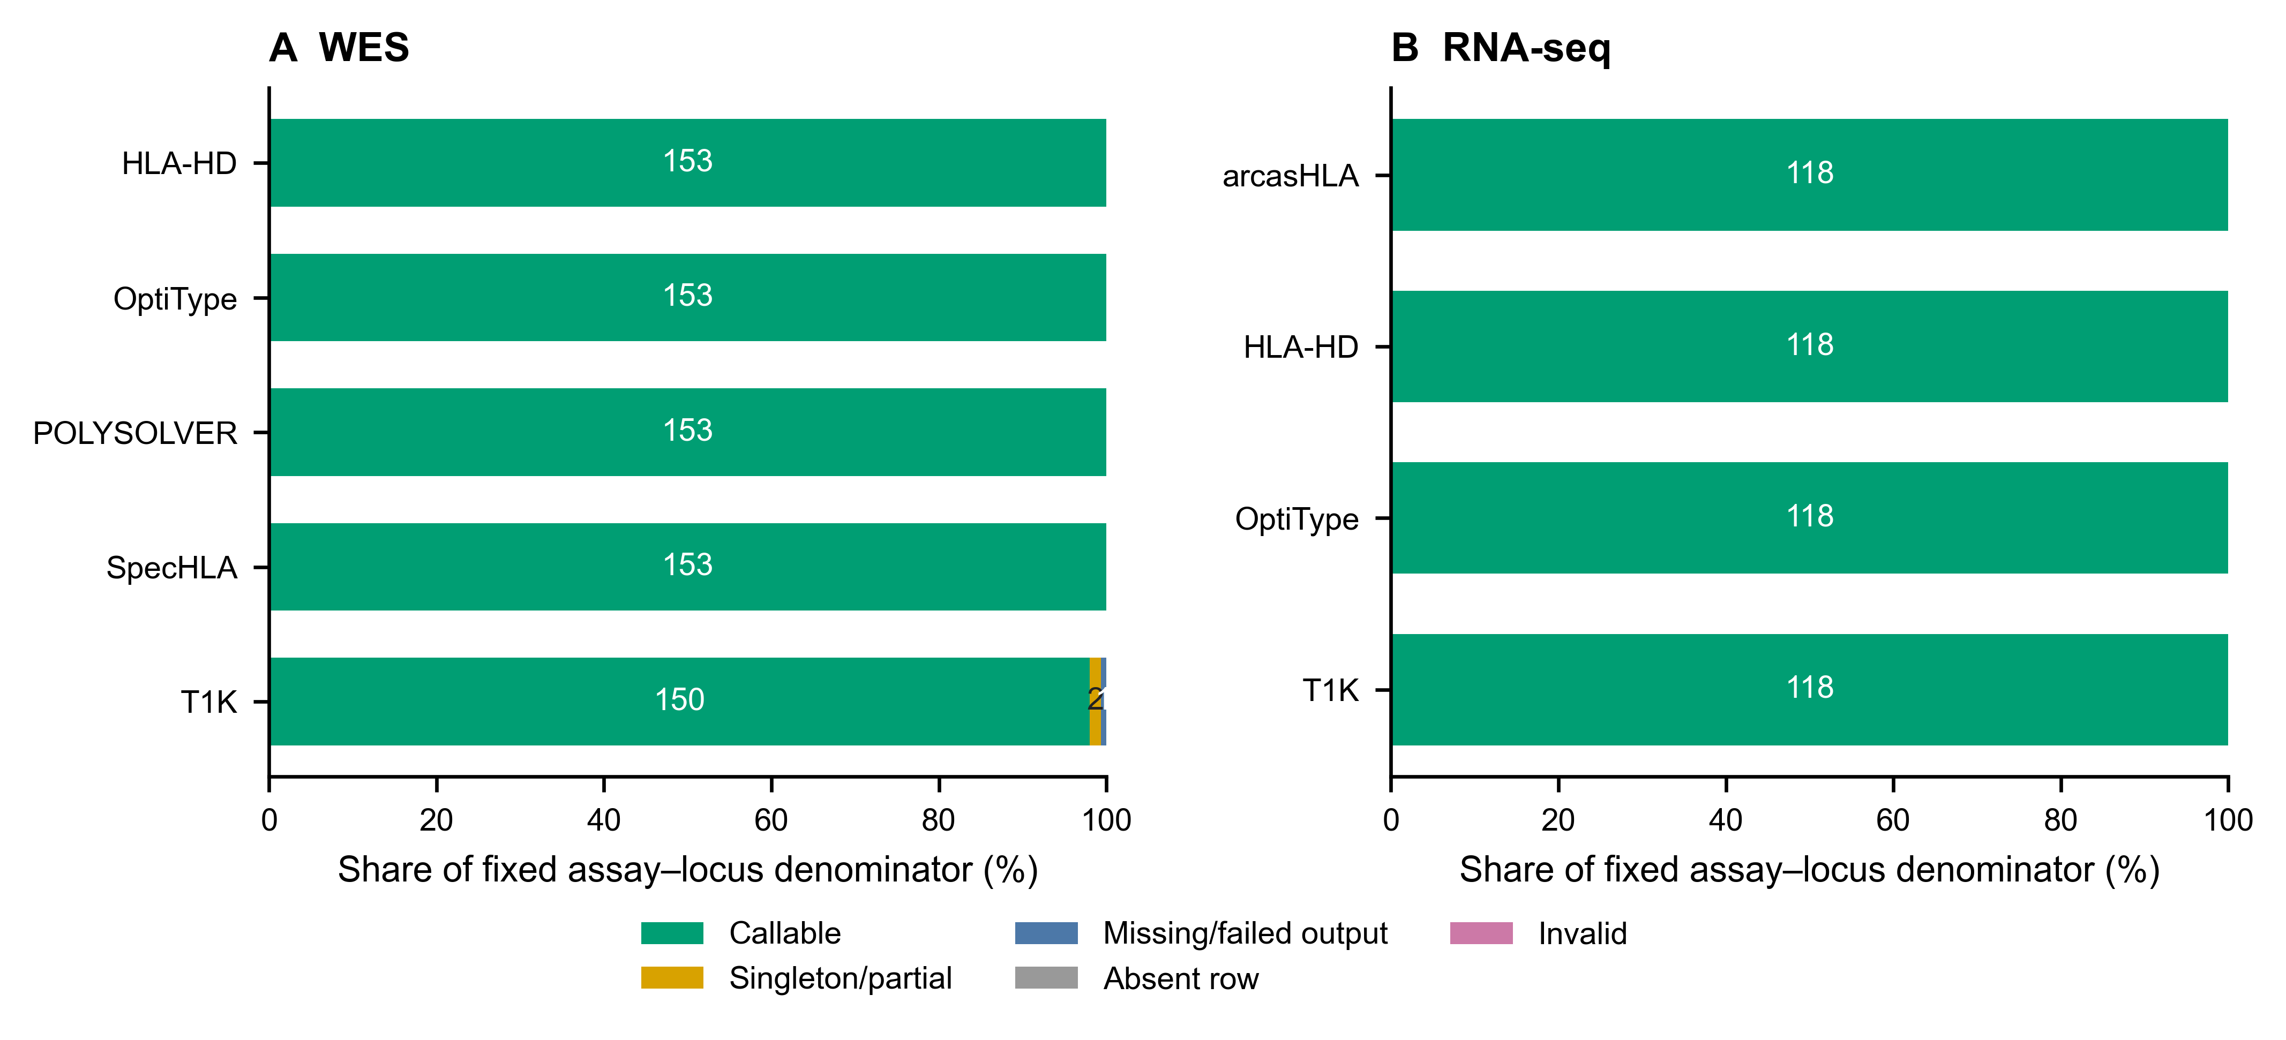
Supplementary Figure S1. Caller call-state composition. WES (A) and RNA-seq (B) bars partition each fixed assay–locus denominator into callable, singleton/partial, missing/failed-output, absent-row and invalid states; segment labels are counts. The normalized development table does not separate runtime failure from empty or missing output. No independent runtime-failure rate is inferred; Supplementary Table S10.1 gives rerun task dispositions.
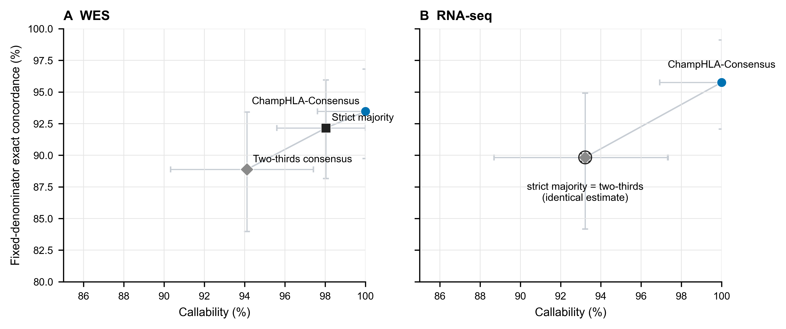
Supplementary Figure S2. Vote-threshold callability–concordance trade-off. WES (A) and RNA-seq (B) show ChampHLA-Consensus, strict majority and two-thirds consensus in threshold order. Horizontal and vertical bars are marginal 95% subject-cluster percentile bootstrap intervals for callability and fixed-denominator concordance. Both axes are truncated to the observed range. The blue circle denotes ChampHLA-Consensus, the dark square strict majority and the grey diamond two-thirds consensus. The identical RNA-seq strict-majority and two-thirds point estimates use a composite marker and shared label; no jitter is applied.
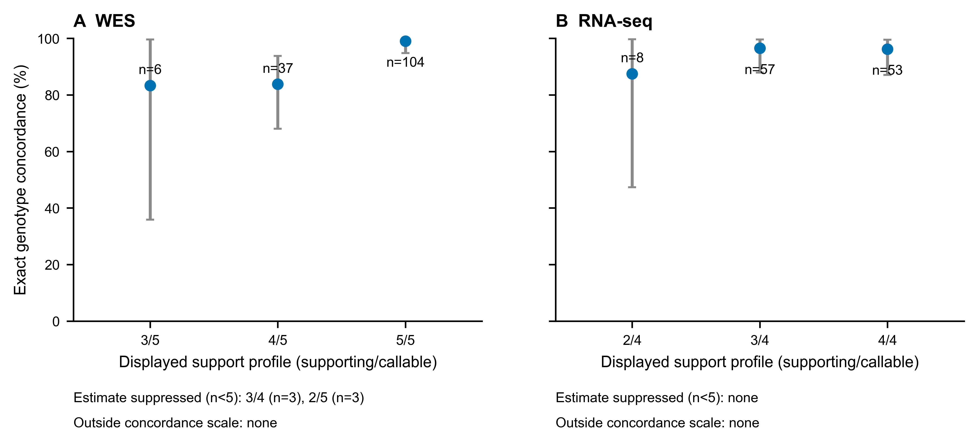
Supplementary Figure S3. Support-profile concordance. WES (A) and RNA-seq (B) use unreduced k-of-n profiles. Points and exact 95% binomial intervals are shown only for strata with at least five loci. Profiles with fewer than five loci remain listed with their denominators but their percentages and intervals are suppressed. The 0/0 profile is a non-call state outside the concordance scale. These strata are descriptive, not calibrated probabilities.
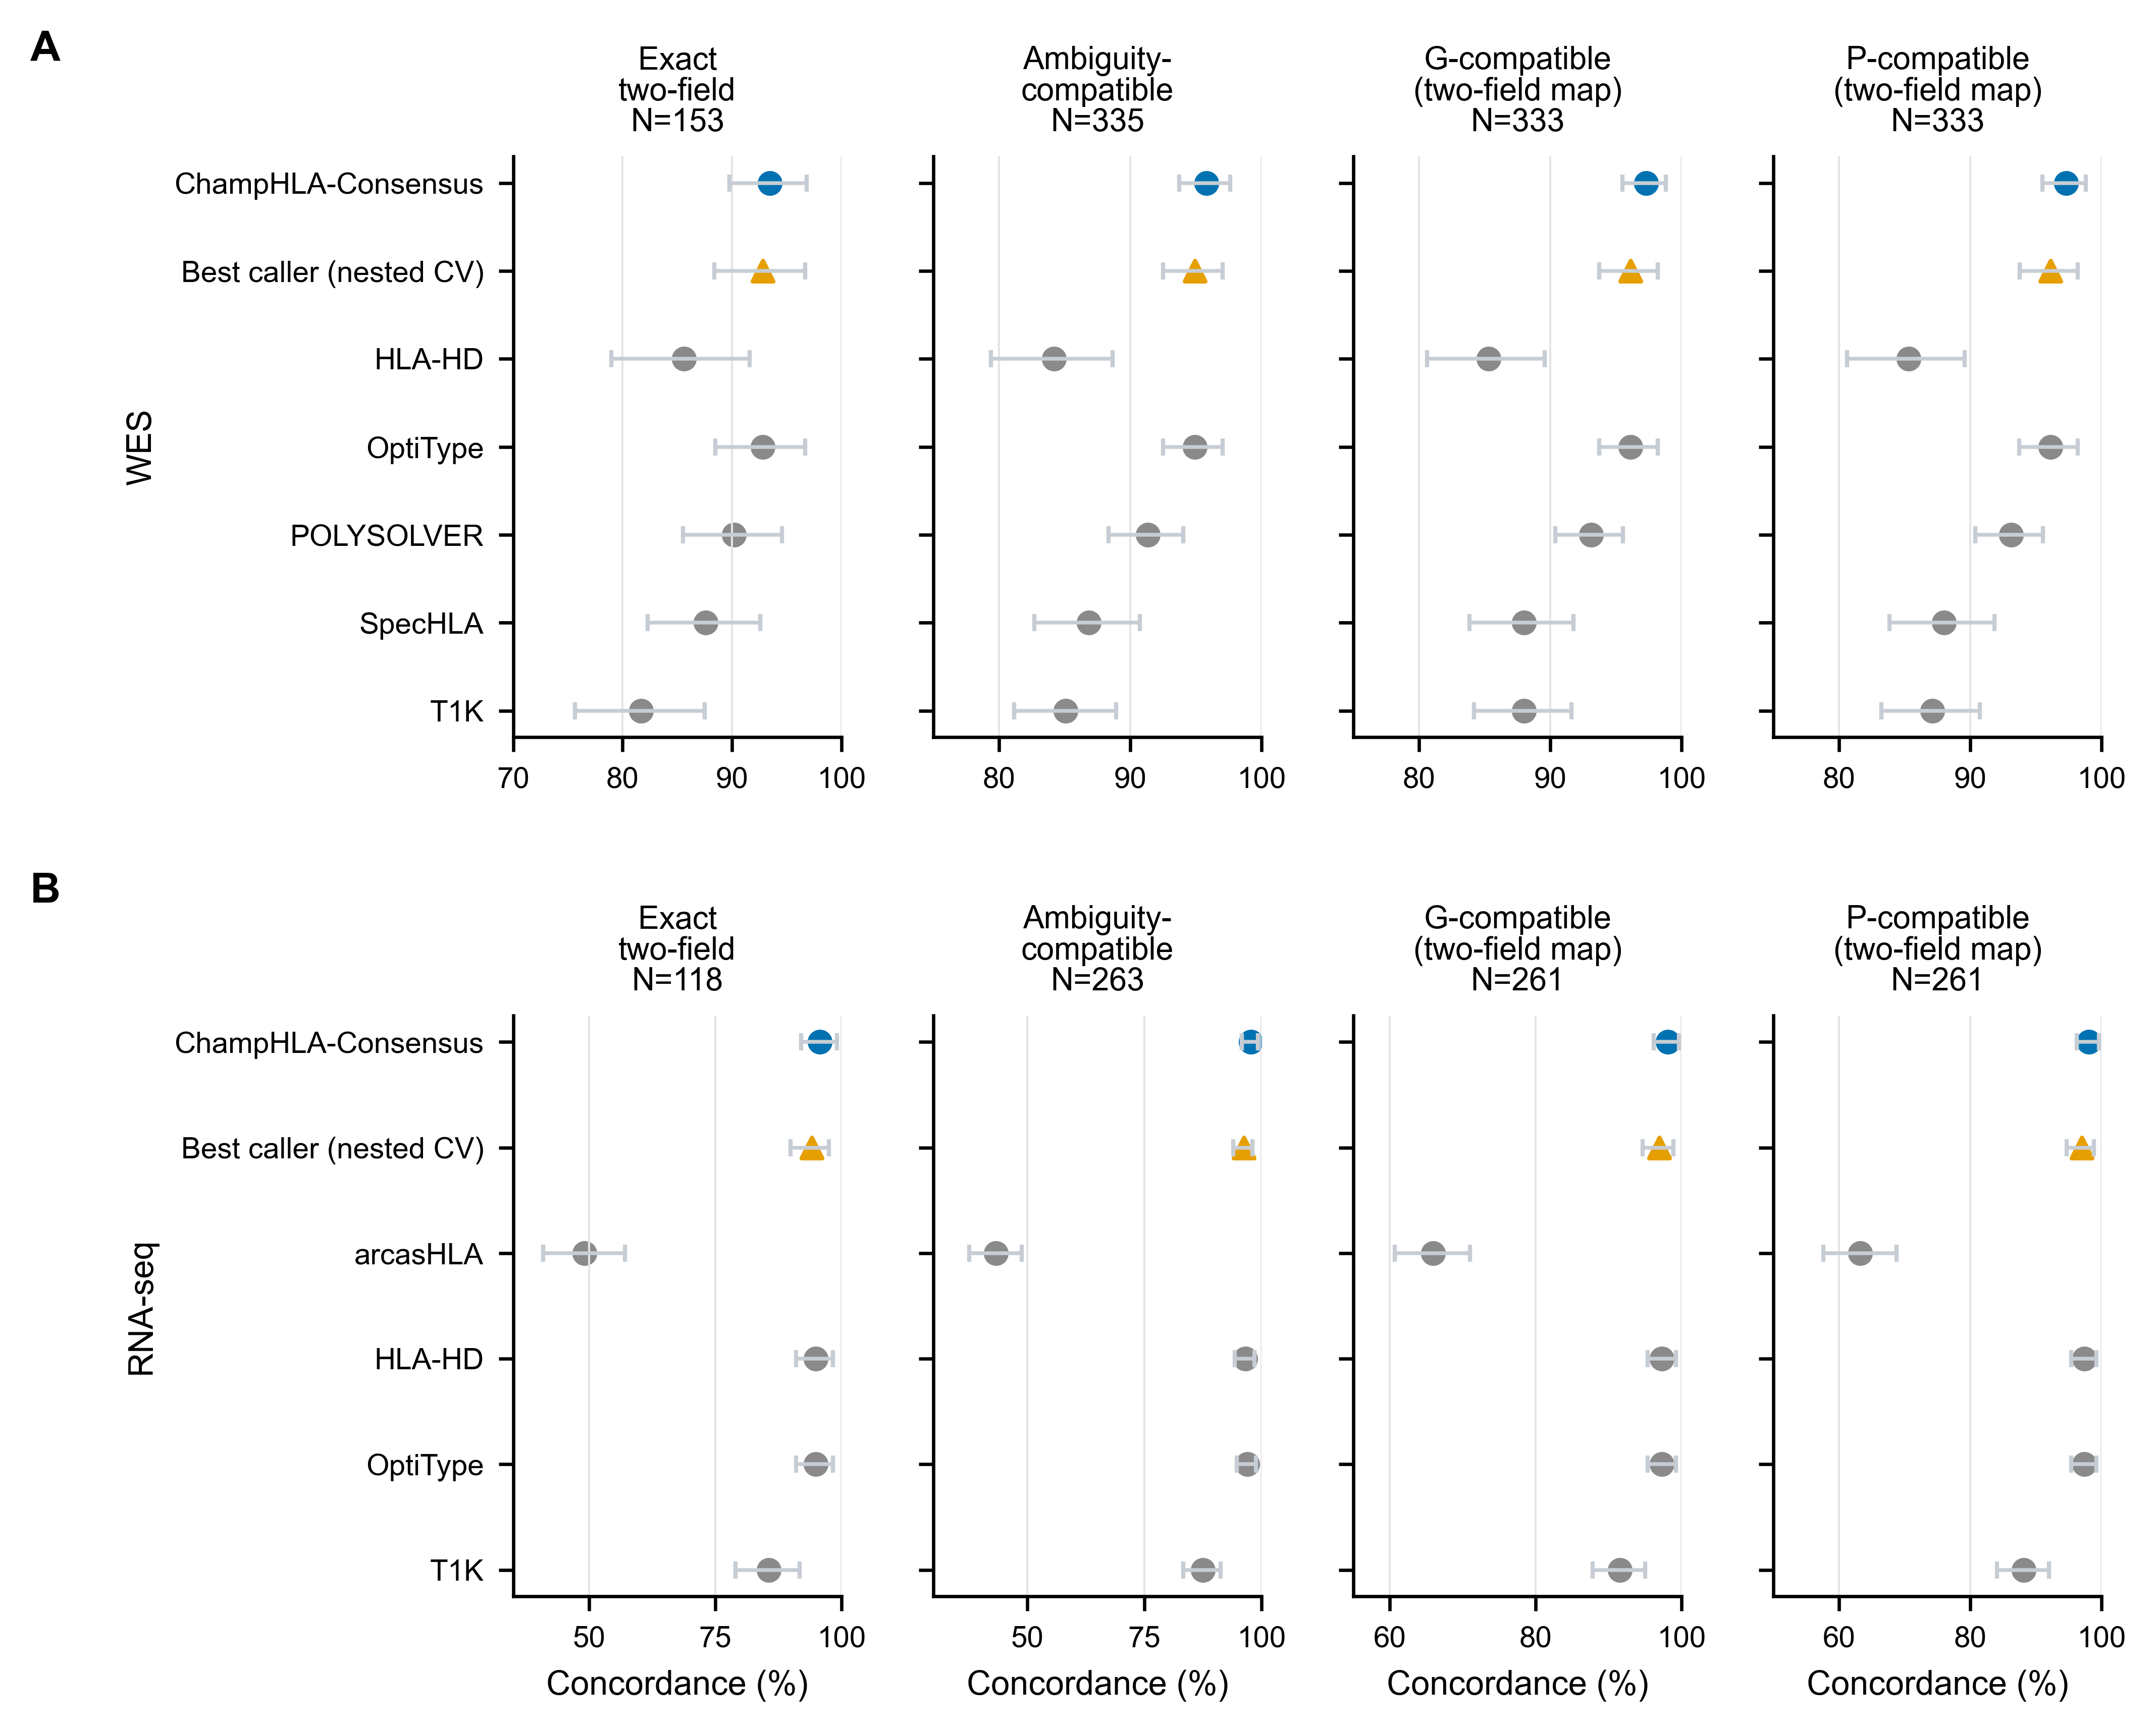
Supplementary Figure S4. Truth-definition sensitivity. WES (A) and RNA-seq (B) compare exact two-field, ambiguity-compatible, G-compatible under a two-field mapping and P-group-compatible under a two-field mapping endpoints. Points and bars are estimates and 95% subject-cluster percentile bootstrap intervals. Each facet states its own denominator; estimates across different truth definitions are not connected or treated as paired. Each percentage axis is truncated below 100% to the observed range and stops at 100%. Colours and shapes follow Figure 2.
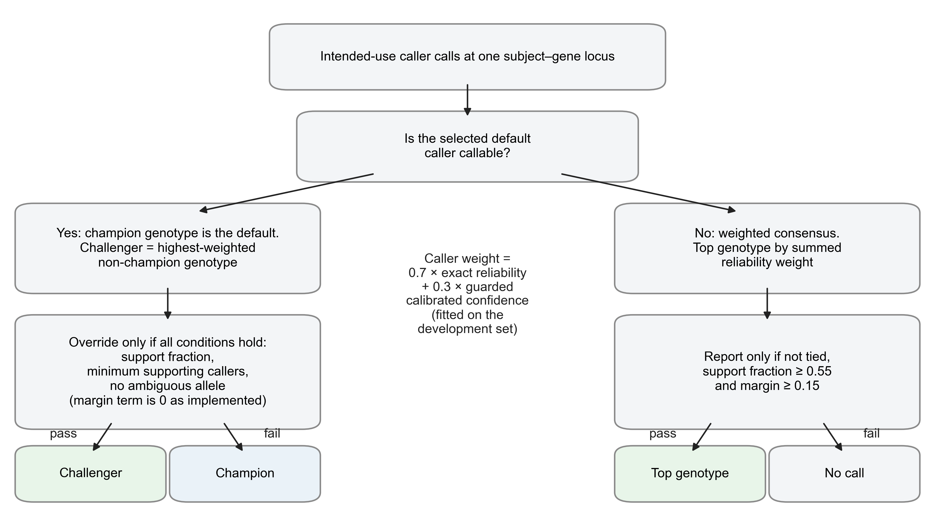
Supplementary Figure S5. Champion–challenger decision flow. The exploratory fitted comparator defined in Supplementary S7.1. When the gene's selected champion caller is callable, its genotype is reported unless the highest-weighted alternative passes every override condition; the declared margin criterion is inactive as implemented (S7.1). When the champion has no call, a reliability-weighted consensus is reported only if it is untied and clears fixed support and margin thresholds. Weights and champions were fitted in the earlier analysis on the superseded development denominators.
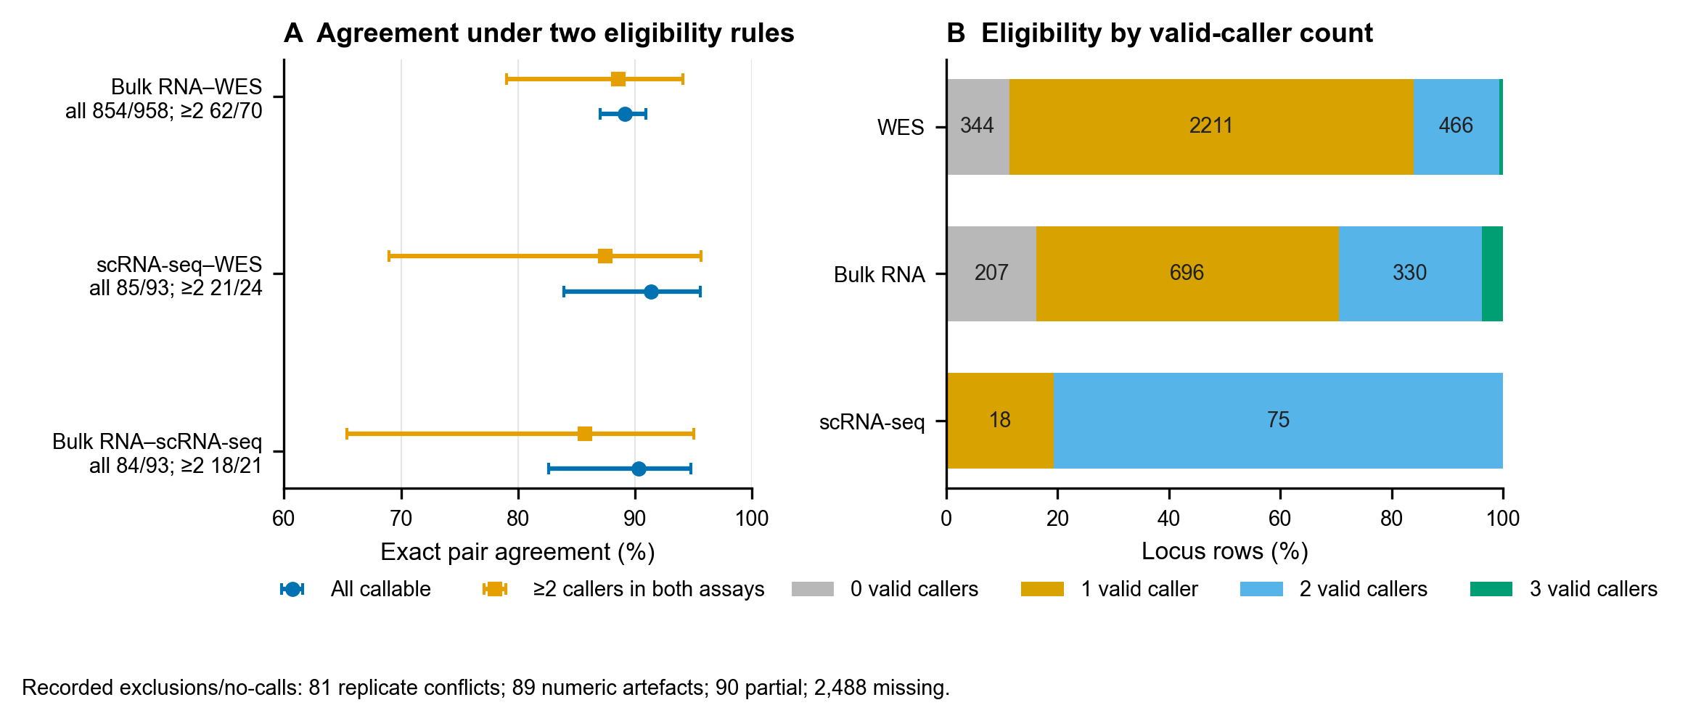
Supplementary Figure S6. Exploratory FIMM cross-modality agreement and eligibility. (A) Specimen-level exact unordered two-field agreement with Wilson 95% intervals for two coequal definitions: all complete callable pairs, and pairs with at least two valid callers in both assays. Counts are agreement/overlap; their denominator difference reflects caller availability, not biological sample selection. (B) Locus-row composition by the number of valid callers. Zero valid callers means missing consensus evidence, and one valid caller is not a vote. Because the callers are shared, panel agreement is not independent HLA truth. The recorded replicate-conflict, numeric-artefact, partial and missing counts are printed below the endpoint panel.
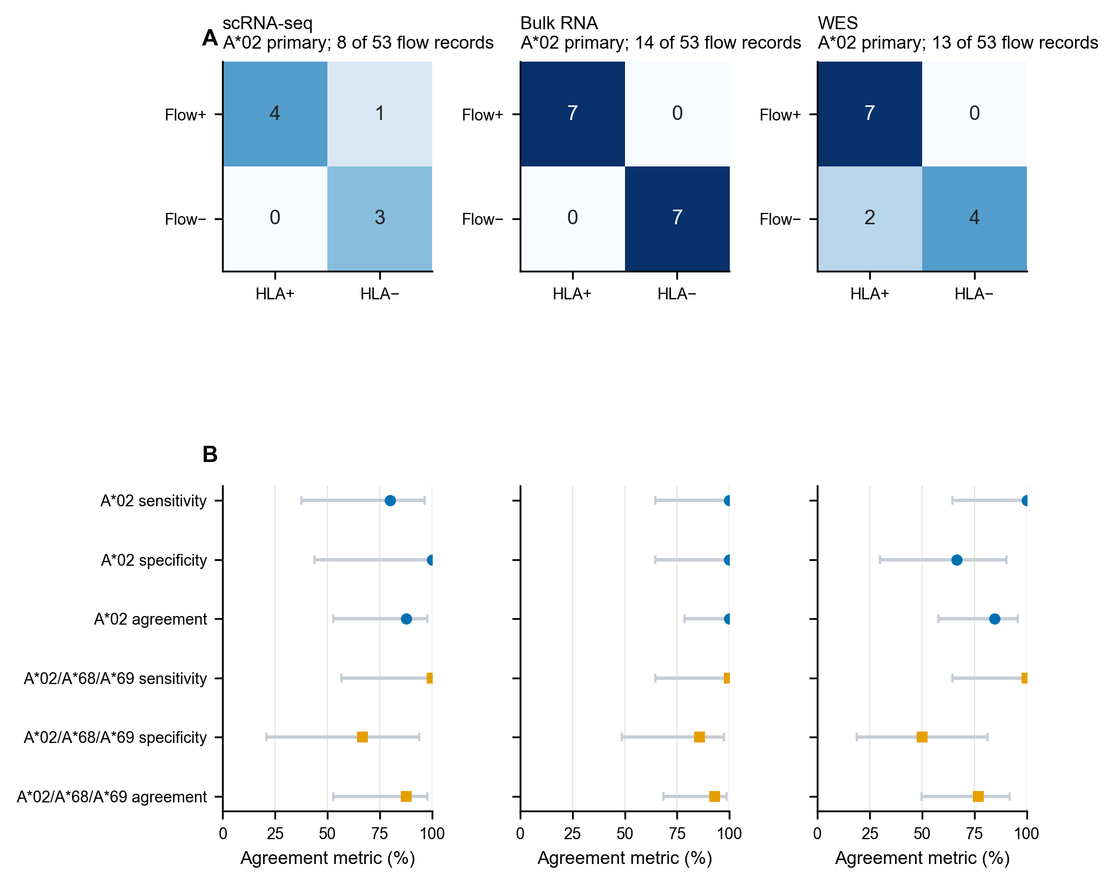
Supplementary Figure S7. Exploratory FIMM BB7.2 serogroup agreement. (A) Primary A*02 confusion matrices for scRNA-seq, bulk RNA and WES; panel titles give the informative linked donors out of all 53 flow records. (B) Sensitivity, specificity and overall agreement with Wilson 95% intervals, under the A*02 primary mapping and the A*02/A*68/A*69 cross-reactivity sensitivity mapping. BB7.2 supplies serogroup-level evidence only; linkage is incomplete, and the endpoint is not allele-level accuracy.
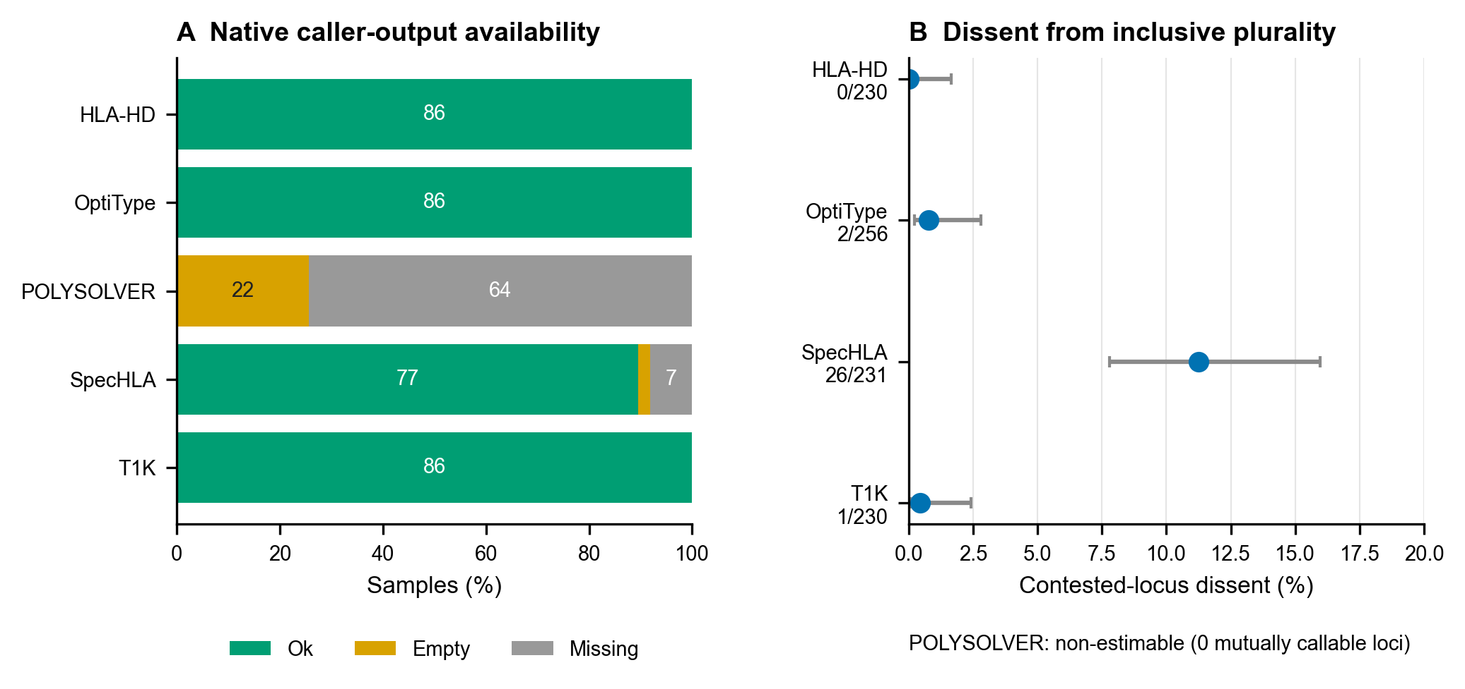
Supplementary Figure S8. Exploratory VenEx WES diagnostics. (A) Native caller-output availability across 86 samples. (B) Contested-locus dissent from the inclusive ChampHLA plurality, with Wilson 95% intervals. POLYSOLVER is shown as non-estimable at zero mutually callable loci. Dissent is not error against truth.
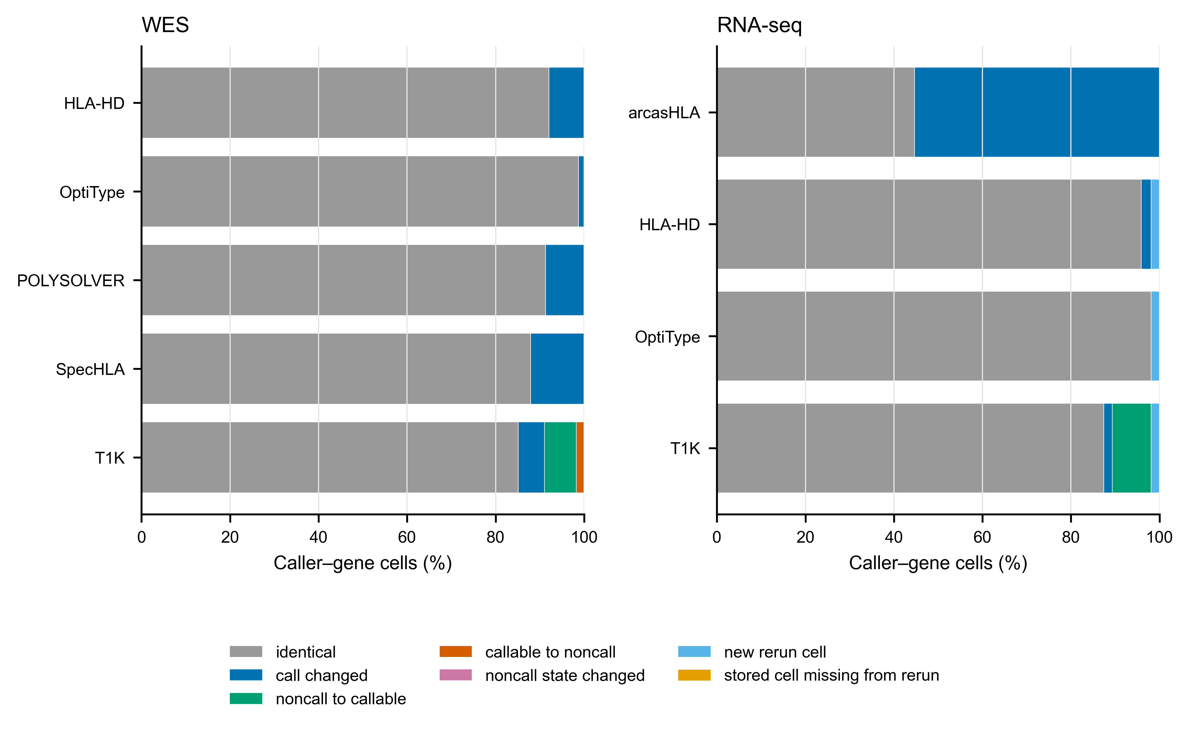
Supplementary Figure S9. Stored-to-v3.5.0 caller-cell changes. WES (A) and RNA-seq (B) bars partition each panel caller's caller–gene cells by how the v3.5.0 rerun call relates to the historical stored call. Categories are identical, call changed, non-call to callable, callable to non-call, and present only in the rerun. Values are percentages of that caller's cells, and the counts are in Supplementary Table S10.2. The figure is aggregate-only and uses no reference typing.

S10. Reproducibility and software details

Full-cohort v3.5.0 rerun audit tables
These aggregate tables are populated only after the documented 236-run roster has passed checks of file checksums, workflow provenance and caller coverage. They contain no subject identifiers and are not used as interim performance evidence.
Supplementary Table S10.1. Caller-task disposition by assay and caller.
Assay | Caller | Recorded caller task disposition | Caller tasks
RNA-seq | arcasHLA | outputs present | 106
RNA-seq | HLA-HD | outputs present | 106
RNA-seq | OptiType | outputs present | 106
RNA-seq | T1K | outputs present | 106
WES | HLA-HD | outputs present | 130
WES | OptiType | outputs present | 130
WES | POLYSOLVER | outputs present | 130
WES | SpecHLA | outputs present | 130
WES | T1K | outputs present | 130

Supplementary Table S10.2. Stored-to-v3.5.0 caller-cell changes by assay and caller.
Assay | Caller | Stored-to-rerun cell state | Caller–gene cells
RNA-seq | arcasHLA | call changed | 176
RNA-seq | arcasHLA | identical | 142
RNA-seq | HLA-HD | call changed | 7
RNA-seq | HLA-HD | identical | 305
RNA-seq | HLA-HD | new rerun cell | 6
RNA-seq | OptiType | identical | 312
RNA-seq | OptiType | new rerun cell | 6
RNA-seq | T1K | call changed | 6
RNA-seq | T1K | identical | 278
RNA-seq | T1K | new rerun cell | 6
RNA-seq | T1K | noncall to callable | 28
WES | HLA-HD | call changed | 31
WES | HLA-HD | identical | 359
WES | OptiType | call changed | 5
WES | OptiType | identical | 385
WES | POLYSOLVER | call changed | 34
WES | POLYSOLVER | identical | 356
WES | SpecHLA | call changed | 47
WES | SpecHLA | identical | 343
WES | T1K | call changed | 23
WES | T1K | callable to noncall | 7
WES | T1K | identical | 332
WES | T1K | noncall to callable | 28

Supplementary Figure S9 shows the same counts as proportions of each caller's cells. Supplementary Table S10.3 classifies every changed cell without the reference typing. We classify cells by zygosity transition, replacement of one or both alleles, change in allele group (first field) and, for T1K, agreement with a release 3.5.0 parser rule in the sample's checksummed audit. The classification also records whether another caller changed at the locus and whether more other panel callers' rerun genotypes match the stored or rerun pair. Cells present only in the rerun are excluded.
In WES, OptiType changed least. Most changed allele pairs in the other callers replace one allele of a heterozygous pair. Only a minority change homozygous calls to heterozygous ones. Most changes therefore lack the haplotype-loss pattern repaired by read rescue. Most changed WES cells are the only change at their locus. That points to caller-specific responses rather than a swapped sample input.
Most T1K changes of call state follow a release 3.5.0 parser rule: either a partial call became a native homozygous declaration, or the quality filter reduced a pair. For HLA-HD, SpecHLA, T1K and OptiType in WES, the rerun call more often matches the other callers; for POLYSOLVER, the stored call more often does. In RNA-seq, the stored arcasHLA call matched more of the other callers in almost every changed cell, consistent with the deployment defect described in the main-text Limitations.
The historical run recorded neither its read handling nor its caller executables and databases. We therefore cannot separate effects of the rerun's read route (HLA-read rescue and realignment to primary chr6) from caller-version or database differences. This classification is descriptive and was not used to choose any input, caller or rule.

Supplementary Table S10.3. Changes in caller outputs classified without reference genotypes.
Assay | Caller | Changed cells | Call state changed | Homozygous to heterozygous | Heterozygous to homozygous | One allele replaced | Both alleles replaced | Allele group changed | Follows a 3.5.0 T1K parser rule | Only changed caller at the locus | Rerun call matches more panel callers | Stored call matches more panel callers
RNA-seq | arcasHLA | 176 | 0 | 17 | 15 | 99 | 45 | 26 | – | 149 | 1 | 167
RNA-seq | HLA-HD | 7 | 0 | 1 | 0 | 4 | 2 | 1 | – | 2 | 4 | 2
RNA-seq | T1K | 34 | 28 | 0 | 0 | 5 | 1 | 4 | 28 | 10 | 28 | 5
WES | HLA-HD | 31 | 0 | 2 | 2 | 23 | 4 | 9 | – | 17 | 22 | 4
WES | OptiType | 5 | 0 | 1 | 1 | 3 | 0 | 2 | – | 2 | 4 | 1
WES | POLYSOLVER | 34 | 0 | 8 | 2 | 23 | 1 | 17 | – | 22 | 10 | 21
WES | SpecHLA | 47 | 0 | 4 | 0 | 40 | 3 | 32 | – | 32 | 30 | 7
WES | T1K | 58 | 35 | 1 | 1 | 19 | 2 | 9 | 35 | 45 | 39 | 8

Inputs for reproducing the analysis
- data/development/normalized_caller_calls.tsv, which contains no reference genotypes;
- data/development/normalized_secondary_calls.tsv, for previously generated exploratory predictions; and
- a downloaded public truth file whose checksum must match the specified value.
One command (scripts/run_local_verification.sh) regenerates selected truth, primary and secondary predictions, the comparison with reference genotypes, statistics, S12 restored analyses (given the recovered caller table), tables, figures, claim audit and DOCX. The exploratory FIMM and VenEx aggregates are regenerated only inside the controlled environment that holds the patient data. Release mode fails if scientific stages are skipped, artifacts are stale, prediction inputs contain truth columns, active artifacts contain WGS results or scientific placeholders remain unresolved. Outstanding author declarations and archival details are recorded separately in the author completion checklist.
The raw-read-to-caller Nextflow workflow is an external dependency outside this verified analysis. For the historical caller run, exact caller executable versions, container digests, scheduler job identifiers and measured historical caller resource use remain unavailable; historical costs were neither reconstructed nor estimated. The v3.5.0 rerun that supplies the primary inputs records the following for every sample (provenance/development_rerun_v350/truth_free_collection/sample_run_provenance.tsv):
- the workflow release commit;
- the scheduler job identifier; and
- checksummed manifests of its inputs, container images, workflow files and result files.
Two later single-sample test runs on HG00096 provide current workflow, container and scheduler evidence. These operational measurements do not reconstruct development-cohort use or establish cohort requirements. The analysis used Python 3.11.15, NumPy 1.26.4, SciPy 1.14.1, Matplotlib 3.9.2 and python-docx 1.2.0. The analysis can be reproduced from normalized outputs. Regenerating those outputs requires re-running the workflow from reads, outside the verified analysis.

Caller-run and current-workflow provenance
The development callers were run in April and May 2026 with an unarchived pre-release ChampHLA deployment on CSC – IT Center for Science (CSC) infrastructure, by inference the Puhti cluster, since no job of this project on its successor system predates July 2026. The stored T1K representation is consistent with a parser change made on 18 April 2026 (commit 304abfc), so the whole caller run cannot be assigned to the earlier 7 April tree. The stored development calls lack the read-loss pattern described below. POLYSOLVER, the most affected caller, matched the vote's WES total in those outputs, but its historical read route is unrecorded. The v3.5.0 rerun includes the read rescue, and there POLYSOLVER scored 138/153.
The current workflow (release 3.5.0, differing from release 3.4.1 only in the T1K parser) uses SAMtools 1.21 and BWA 0.7.19 from CSC's Roihu software-module collection (bio-apps release v202603). Caller images are Singularity conversions of public Docker and BioContainers images, specified by SHA-256 in configs/caller_resources_v2.json; SpecHLA uses a native installation. The official IPD-IMGT/HLA 3.65.0 resources used for the G-group and nomenclature sensitivity analyses are identified by their upstream release tag and locally checksummed. The single-sample task measurements below do not reconstruct historical development-run resource use or establish cost or scaling.

HG00096 re-run against the stored development calls
On 19 September 2026, HG00096 was run with pre-release revision 91f035f6f0. All 12 RNA-seq caller–gene calls from the Geuvadis BAM matched the stored calls, whereas 4 of 12 WES calls from an HLA-region pre-extract matched; the WES denominator was four callers by three genes because SpecHLA was absent. On 9 October 2026, release 3.3.0 (tag v3.3.0, commit 360a449) was run on the whole-exome CRAM and matched 5 of 15 stored calls. These two WES routes lost reads: the GRCh38 alignments place many reads from non-reference HLA alleles on HLA-allele and chromosome 6 alternate-haplotype contigs, so the second haplotype disappeared.
Also on 9 October, the release-3.4.0-equivalent WES tree 15f45cf collected those reads and realigned them to chromosome 6. Release tag v3.4.0 (commit 2a72a4b) differs from that run tree only by version strings and the changelog. All five callers then reported the same genotype at all three genes and 11 of 15 calls matched the stored calls. The four differences were HLA-HD at HLA-B and HLA-C, SpecHLA at HLA-C and T1K at HLA-B. The 9 October RNA-seq run used release 3.4.0 on the Geuvadis BAM and matched 11 of 12 stored calls; arcasHLA reported a different HLA-C allele. These one-subject diagnostics did not explain the four old/new WES differences through read rescue.

Current single-sample workflow test measurements. Two successful HG00096 runs on the CSC Roihu cluster are reported. Both used pre-release revisions that break exact ties toward the last-sorting pair, unlike release 3.4.0. The RNA-seq run also used a locally modified seq2HLA module; the table gives revisions and image hashes. The DNA caller route used a WGS-derived mate-aware HLA BAM, not WES reads; it therefore does not estimate WES runtime. The RNA-seq route used paired FASTQ. Nextflow realtime and peak_rss are task-level trace fields. Slurm Elapsed, TotalCPU and batch-step MaxRSS are reported separately because their definitions and instrumentation differ. Disagreement between the measurement sources is retained; neither smaller nor larger values are selected. Version fields are reported as emitted. OptiType produced usage text; T1K and arcasHLA produced empty fields, leaving those versions unresolved. SpecHLA ran from a native local installation; the other caller rows used the named SIF.
Route and actual input | Caller | Version output | Execution artifact | SIF SHA-256 (first 12) | Workflow revision | Slurm job | Nextflow realtime | Nextflow peak RSS, GB | Slurm elapsed | Slurm TotalCPU | Slurm MaxRSS, GB
DNA route (WGS-derived HLA BAM) | POLYSOLVER | v4 | polysolver | b4f39a6dd86d | 987f5eb | 1427634 | 4 min 39 s | 1.40 | 4 min 41 s | 20 min 30 s | 3.82
DNA route (WGS-derived HLA BAM) | HLA-HD | HLA-HD version 1.4.0 | hlahd | 8fb9fa5ec339 | 987f5eb | 1427636 | 1 min 3 s | 0.93 | 1 min 6 s | 4 min 42 s | 7.12
DNA route (WGS-derived HLA BAM) | SpecHLA | 1.0.7 | /projappl/project_2008084/SpecHLAx | native install | 987f5eb | 1427637 | 6 h 13 min 26 s | 1.00 | 6 h 14 min 34 s | 31 min 45 s | 2.42
DNA route (WGS-derived HLA BAM) | Kourami | 0.9.6 | kourami | c267052e9621 | 987f5eb | 1427638 | 2 min 0 s | 5.90 | 2 min 2 s | 22 min 17 s | 7.55
DNA route (WGS-derived HLA BAM) | OptiType | unresolved (usage output) | optitype | 7f3f32904a25 | 987f5eb | 1427643 | 25.8 s | 0.51 | 28 s | 32.331 s | 1.55
DNA route (WGS-derived HLA BAM) | T1K | unresolved (empty output) | t1k | e34c4433021c | 987f5eb | 1427644 | 1 min 26 s | 3.00 | 1 min 29 s | 7 min 47 s | 3.51
RNA-seq route (paired FASTQ) | OptiType | unresolved (usage output) | optitype | 7f3f32904a25 | ce31c74 (modified) | 1410979 | 9 min 29 s | 8.50 | 9 min 33 s | 9 min 50 s | 21.03
RNA-seq route (paired FASTQ) | T1K | unresolved (empty output) | t1k | e34c4433021c | ce31c74 (modified) | 1410980 | 14 min 8 s | 11.30 | 14 min 12 s | 1 h 3 min 3 s | 12.60
RNA-seq route (paired FASTQ) | seq2HLA | 2.3 | seq2hla | e64318d6806f | ce31c74 (modified) | 1410981 | 12 min 12 s | 0.11 | 12 min 15 s | 1 h 31 min 1 s | 2.39
RNA-seq route (paired FASTQ) | HLA-HD | HLA-HD version 1.4.0 | hlahd | 8fb9fa5ec339 | ce31c74 (modified) | 1410983 | 19 min 12 s | 5.40 | 19 min 18 s | 2 h 51 min 52 s | 10.40
RNA-seq route (paired FASTQ) | arcasHLA | unresolved (empty output) | arcashla | 60c42737ccb8 | ce31c74 (modified) | 1410984 | 5 min 58 s | 10.80 | 6 min 3 s | 9 min 8 s | 11.34

All rows describe one sample and successful tasks only. They are not monetary costs, historical development-cohort measurements, scaling estimates or accuracy evidence. Raw traces, task commands, launch wrappers, workflow source, version files, container inspection output and scheduler records are preserved under provenance/compute_smoke/raw; their hashes and row-level provenance are recorded in artifacts/compute_smoke_benchmark.tsv.

S11. Practical guide to running ChampHLA
This section describes the workflow release in the pipeline repository (Data and software availability). The commands below were checked against that release's parameter definitions; they are usage guidance, not part of the verified evidence chain of this paper.

S11.1 Requirements and inputs
The workflow requires Nextflow and either Docker or Singularity. Callers run from containers; in the deployment used here SpecHLA ran from a native installation (Supplementary S10). HLA-HD and T1K need separately obtained reference databases, and the workflow stops at start-up if a requested caller's database path is not set. Input is either a directory (--input with --input_type bam, cram or fastq) or a CSV samplesheet (--input_samplesheet) with columns sample_id,bam_path, sample_id,cram_path or sample_id,fastq_1,fastq_2. CRAM input also needs --reference_fasta.
The workflow wraps eight callers (main Table 1), each with its own process, container, preprocessing, invocation and parser. A sequencing mode (DNA, bulk RNA-seq, PacBio HiFi or Oxford Nanopore) and the resolved assay determine which callers run. Unless a caller list is given, the workflow runs the assay's reference panel, declared in one configuration file so that a partial installation can be detected. DNA-only callers are skipped for RNA-seq input. The long-read modes currently run T1K only and, like WGS (Supplementary S8), are not evaluated here. Each run also writes an HTML report.
From release 3.4.0, every DNA BAM or CRAM passes through a read-rescue step before any caller. In one streaming pass, it collects reads from the chromosome 6 MHC window, every HLA-allele and chromosome 6 alternate-haplotype contig, and unplaced reads. It keeps complete pairs and realigns them to primary chromosome 6 with bwa. This needs --hla_rescue_reference, a primary chromosome 6 FASTA with a bwa index, built by the workflow's build_hla_rescue_reference.sh script. Release 3.3.0 lacked this step and lost the second haplotype on GRCh38 alignments that carry such contigs (main Methods, Study design). Alignments without those contigs keep their alignments.

S11.2 Reproducing the evaluated rule
The consensus step is off by default. When enabled, it defaults to calibrated weighting and a gene list including class II genes. The paper profile enables the evaluated rule: equal weights, the assay's reference panel (--tools unset), HLA-A, -B and -C voting, and Methods call states (--mv_call_states paper). Combine it with an execution profile:
# WES, BAM samplesheet, Slurm cluster with Singularity
nextflow run main.nf \
--input_samplesheet samples.csv \
--seq_type dna --run_modality wes \
--extract_hla_region \
--singularity_cache_dir /path/to/cache \
--outdir results_wes \
-profile slurm,singularity,paper -resume
# Bulk RNA-seq, paired FASTQ samplesheet, local Docker
nextflow run main.nf \
--input_samplesheet rna_samples.csv \
--seq_type rna --optitype_seq_type rna \
--outdir results_rna \
-profile docker,paper
The workflow parity test (<https://github.com/uoozcan/ChampHLA/blob/71f037d/tests/test_paper_parity.py>) feeds stored raw development outputs through consensus with these settings. It requires the ChampHLA-Consensus call, including abstentions, at all 708 loci (workflow commit 71f037d; release tag under Data availability). Earlier workflow revisions broke exact ties in the opposite lexicographic order and abstained on caller-declared homozygotes; both are corrected in that commit.

S11.3 Execution profiles and resources
Profiles are provided for local Docker (docker), Singularity (singularity), generic Slurm clusters (slurm) and the CSC Roihu and Puhti systems (roihu, puhti), plus test and stub profiles. Caller processes carry one of three resource labels; failed tasks are retried with resources multiplied by the attempt number, capped by --max_cpus, --max_memory and --max_time. -resume reuses completed tasks when samples are added or a run is restarted.
Label | CPUs | Memory | Time | Scales on retry
process_low | 2 | 8 GB | 2 h | No
process_medium | 8 | 32 GB | 8 h | Yes
process_high | 16 | 64 GB | 16 h | Yes

S11.4 Outputs
Each caller writes its native output to its own directory under --outdir. When the consensus step is enabled, the consensus/ directory contains the files below, and report/ contains an HTML run report.
File | Contents
aggregated_calls.tsv | One row per sample, caller and gene: sample, tool, modality, gene, allele1, allele2, is_callable
consensus_calls.tsv | One row per sample and gene: sample, gene, allele1, allele2, total_weight, agreeing_tools, contributing_tools, consensus_status, chosen_by, warnings
consensus_calls_clinical_warnings.tsv | Loci flagged by the consensus step, with a warning code and description
runtime_weights.json | The caller weights applied in the run (all 1.0 under --weighting equal)

S12. Disagreement classes, cross-assay agreement, per-gene concordance and caller calibration
These analyses appeared in earlier drafts. They describe historical stored outputs, not the v3.5.0 rerun. scripts/restored_analyses.py computed them from exact-endpoint loci in the historical joined development table and wrote artifacts/restored_analyses/ with an input-checksum manifest. They are not recomputed from rerun inputs. Their numbers are reconciled against the archived historical result registry (provenance/development_rerun_v350/) and are reported as provenance only. All four are post hoc and descriptive. S12.4 is also exploratory: its probabilities were calibrated on superseded 390-locus WES and 321-locus RNA-seq sets, including WGS rows, not current exact loci.

S12.1 Disagreement among caller outputs
Using callable panel outputs alone, we assigned loci to classes: no callable caller; a single callable caller; unanimity among two or more callers; one-allele conflict, where every dissenting genotype shares one allele with the reported pair; or two-allele conflict, where at least one shares none. In RNA-seq, one-allele conflicts are the pattern expected when one allele of a heterozygous genotype is under-sampled. Intervals are exact Clopper–Pearson 95% intervals.
Assay | Class | Loci | Consensus correct | Concordance, % (95% CI)
WES | No callable caller | 0 | — | —
WES | Single callable caller | 0 | — | —
WES | Unanimous | 93 | 90 | 96.8 (90.9–99.3)
WES | One-allele conflict | 57 | 51 | 89.5 (78.5–96.0)
WES | Two-allele conflict | 3 | 2 | 66.7 (9.4–99.2)
RNA-seq | No callable caller | 0 | — | —
RNA-seq | Single callable caller | 3 | 3 | 100.0 (29.2–100.0)
RNA-seq | Unanimous | 102 | 98 | 96.1 (90.3–98.9)
RNA-seq | One-allele conflict | 13 | 12 | 92.3 (64.0–99.8)
RNA-seq | Two-allele conflict | 0 | — | —

In WES, all callable callers agreed at 93 of 153 loci, where ChampHLA-Consensus was correct at 90 (96.8%). At the 57 loci where every dissenting caller differed from the reported genotype at one allele, it was correct at 51 (89.5%), and 3 loci had a dissenting genotype sharing no allele with it. In RNA-seq, callers agreed unanimously at 102 of 118 loci (98 correct; 96.1%), one-allele conflicts occurred at 13 loci with 12 correct (92.3%), and 3 loci had a single callable caller, all of which were correct.

S12.2 Cross-assay agreement
Loci of the 50 subjects with exact reference typing in both assays. The pooled vote is a post hoc plurality over the calls of both panels, with each caller contributing one vote per assay and the same lexicographic tie-break; it is shown for comparison only.
Stratum | Loci | WES consensus correct | RNA-seq consensus correct | Pooled vote correct
All shared loci | 116 | 110 | 111 | 111
WES and RNA-seq calls agree | 115 | 110 | 110 | 110
WES and RNA-seq calls disagree | 1 | 0 | 1 | 1
HLA-A | 38 | 37 | 37 | 37
HLA-B | 39 | 37 | 37 | 37
HLA-C | 39 | 36 | 37 | 37

The WES and RNA-seq consensus calls agreed at 115 of the 116 loci, of which 110 were correct. At the one locus where they disagreed, the RNA-seq call was correct and the WES call was not. The pooled vote was correct at 111 of 116 loci, compared with 110 for WES and 111 for RNA-seq consensus alone. Both panels share callers, and the pooled rule was examined post hoc. Cross-assay agreement is therefore a consistency check, not independent truth; the pooled vote is not validated.

S12.3 Per-gene caller concordance
Exact two-field concordance on the fixed denominator, so a no-call counts as incorrect; cells give correct/loci (percent).
Assay | Method | HLA-A | HLA-B | HLA-C | All
WES | HLA-HD | 40/50 (80.0) | 45/52 (86.5) | 41/51 (80.4) | 126/153 (82.4)
WES | OptiType | 48/50 (96.0) | 48/52 (92.3) | 44/51 (86.3) | 140/153 (91.5)
WES | POLYSOLVER | 47/50 (94.0) | 50/52 (96.2) | 46/51 (90.2) | 143/153 (93.5)
WES | SpecHLA | 46/50 (92.0) | 33/52 (63.5) | 44/51 (86.3) | 123/153 (80.4)
WES | T1K | 37/50 (74.0) | 43/52 (82.7) | 33/51 (64.7) | 113/153 (73.9)
WES | ChampHLA-Consensus | 48/50 (96.0) | 50/52 (96.2) | 45/51 (88.2) | 143/153 (93.5)
RNA-seq | arcasHLA | 35/38 (92.1) | 38/40 (95.0) | 36/40 (90.0) | 109/118 (92.4)
RNA-seq | HLA-HD | 36/38 (94.7) | 37/40 (92.5) | 37/40 (92.5) | 110/118 (93.2)
RNA-seq | OptiType | 36/38 (94.7) | 36/40 (90.0) | 37/40 (92.5) | 109/118 (92.4)
RNA-seq | T1K | 29/38 (76.3) | 31/40 (77.5) | 31/40 (77.5) | 91/118 (77.1)
RNA-seq | ChampHLA-Consensus | 37/38 (97.4) | 38/40 (95.0) | 38/40 (95.0) | 113/118 (95.8)

In WES the least concordant caller was T1K for HLA-A and HLA-C and SpecHLA for HLA-B, whereas in RNA-seq no caller led for every gene: HLA-HD and OptiType tied for HLA-A and HLA-C, and arcasHLA led for HLA-B.

S12.4 Caller calibration (exploratory)
Out-of-fold calibrated probabilities from the recovered caller table were scored against exact correctness at current loci. The table reports scored loci over callable loci. We excluded six of 115 callable HLA-HD RNA-seq loci because their calibrated probabilities were not preserved. ECE is the expected calibration error over five equal-width probability bins. POLYSOLVER and SpecHLA report no confidence value. The calibration models were fitted against earlier development labels, so these values describe agreement between stated confidence and observed concordance on this resource only. The original caller table is checksum-verified but absent from this checkout. We retain the calibration table as a checksum-verified historical artifact; other S12 tables were computed from the historical joined locus table.
Assay | Caller | Scored/callable loci | Mean probability | Observed concordance | Brier score | ECE
WES | HLA-HD | 153/153 | 0.796 | 0.824 | 0.150 | 0.082
WES | OptiType | 153/153 | 0.922 | 0.915 | 0.079 | 0.007
WES | POLYSOLVER | 0/153 | — | — | — | —
WES | SpecHLA | 0/153 | — | — | — | —
WES | T1K | 142/142 | 0.858 | 0.796 | 0.158 | 0.077
RNA-seq | arcasHLA | 118/118 | 0.913 | 0.924 | 0.070 | 0.011
RNA-seq | HLA-HD | 109/115 | 0.948 | 0.954 | 0.044 | 0.007
RNA-seq | OptiType | 115/115 | 0.937 | 0.948 | 0.050 | 0.011
RNA-seq | T1K | 105/105 | 0.880 | 0.867 | 0.117 | 0.014

S13. Background and design rationale
This section expands the background and design rationale summarized in the main text. It contains no results.

S13.1 Why HLA typing is hard, and why callers disagree
The classical class I genes HLA-A, HLA-B and HLA-C present intracellular peptides to CD8-positive T cells. The classical class II genes HLA-DR, HLA-DQ and HLA-DP present extracellular peptides to CD4-positive helper T cells [1]. Together they are the main route by which adaptive immunity distinguishes self from infected, transformed or transplanted cells.
This immune role explains the region's extreme polymorphism and the consequences of typing errors. In unrelated-donor haematopoietic cell transplantation, matching is counted per allele: a donor matched at both alleles of HLA-A, -B, -C and -DRB1 is an 8/8 match, and adding HLA-DQB1 gives a 10/10 match [2, 3].
Three properties of the MHC make short-read typing difficult.
- Diversity. The allele space is large and keeps growing with every IPD-IMGT/HLA release [8]. Reads from an allele that is poorly represented in a single linear reference are lost or misplaced before any caller sees them.
- Paralogy. The region also contains pseudogenes, the class I chain-related genes MICA and MICB, and non-classical HLA-like loci. Reads from a polymorphic site of a classical gene can therefore align as well, or better, to a paralogous sequence.
- Expression. RNA-seq samples expressed copies rather than genomic ones. When one allele of a heterozygote is weakly expressed, a caller can under-represent or miss it.
No single alignment strategy, reference space or scoring model handles all three equally well across genes, assays and populations. That is why callers built on different evidence disagree, and why their rankings change between assays.

S13.2 Caller choice as a selection problem
For a given assay, users must choose a caller before they can assess its accuracy on their data. Published rankings depend on the assay, the gene and the dataset, so the best caller for a new cohort is usually unknown in advance. Combining callers without fitted parameters avoids choosing a single caller.
Fitted integration policies bring costs that an equal-weight vote does not:
- parameters that must be estimated;
- a training resource that must resemble the target data;
- a decision path that a user cannot easily audit.
With one labelled development resource, any apparent gain of a fitted policy cannot be separated from fitting to that resource. We therefore report fitted policies only as exploratory comparators (Supplementary S7).

S13.3 Harmonization is not a neutral preprocessing step
A vote aggregates its panel. A harmonization convention shared by several panel members is concentrated by voting. Completing a single reported allele into a homozygous pair is the clearest example. The completion is correct when the caller's own format declares homozygosity. It is wrong when a missing second allele marks a failed or partial call. Whether the convention helps or harms depends on the input, not on the voting rule.
Harmonization deserves the same scrutiny as the integration rule. This benchmark therefore completes single alleles only where the caller declares homozygosity and reports the abstain-all alternative beside it (Supplementary S2).

S13.4 Why "no significant difference" is not equivalence
A criterion phrased as the absence of a significant improvement passes automatically wherever a comparison is underpowered. In some comparisons, too few subjects had nonzero score differences for the sign-flip test to reach significance at any effect size (detectability table in Supplementary S3; power table in Supplementary S7). The development results therefore support "could not be distinguished from" and never "equivalent to". Equivalence would need a pre-specified margin and a test designed for it.

S13.5 Deployed tools, database vintage and nomenclature
Callers were evaluated as deployed, each with its own bundled IPD-IMGT/HLA release (Table 1 and Supplementary S6). This is how the tools are distributed, but it confounds the comparison. Database vintage can contribute to apparent caller disagreement; a caller cannot call an allele absent from its bundled database. The effect is not symmetric across callers. Rankings therefore describe deployed tools, not algorithms. Rebuilding all callers against one database release would be a different study.
For the same reason, every step that compares alleles uses declared nomenclature resources [8, 40]:
- truth normalization, call normalization and the G-group and P-group sensitivity mappings each use a checksummed release;
- concordance is scored on the unordered genotype, not on two independent alleles, so partial credit cannot hide an ambiguous or failed call;
- set-valued (ambiguity-compatible) endpoints are reported beside the exact endpoint rather than replacing it.

S13.6 Workflow engineering as part of the method
Reproducibility contributes to the method.
- Each caller runs as its own containerized process with a checksummed image.
- Inputs are defined by manifests.
- The release, the panel and the consensus rule are declared in versioned configuration (Supplementary S10 and S11).
Other groups can run the same release on the same public inputs or a new cohort without changing workflow code. The documented rerun manifests record what was executed for every development sample.

S13.7 Scope and outlook
HLA allele frequencies differ across ancestry groups, and callers developed or validated mainly on European panels may behave differently elsewhere. The development resource is too small for population-stratified inference. We report pooled results and interpret population differences in reference retention as properties of the reference, rather than callers (Supplementary S1).
Class II typing matters for transplantation. The workflow already exposes HLA-DRB1, HLA-DQB1 and HLA-DQA1 for voting, but truth-backed class II evaluation awaits suitable reference typing. The same applies to:
- higher-field typing;
- re-extracted whole-genome inputs;
- long-read and pangenome-graph callers;
- downstream uses such as neoantigen prediction.

S14. Interpreting the retrospective benchmark

Why the development results are exploratory
The analysis plan changed after development results had been seen. Each change is recorded in a dated decision file in the paper repository, and Supplementary S7 tabulates the direction and size of every change.
An analysis plan specified on 31 August 2026, before the planned comparison of predictions with reference genotypes, named a two-thirds-guarded champion–challenger rule as the primary method, corrected for multiplicity across WGS, WES and RNA-seq together, and required the primary method to outperform its comparators. This was not the analysts' first sight of truth: an earlier analysis had already joined truth to these caller outputs to fit the champions and weights. On the current scoring definition the previous primary method did not outperform: it scored 141/153 against the vote's 143/153 in WES (Holm p=1.0) and tied the vote at 113/118 in RNA-seq.
The equal-weight plurality vote was then made primary, with multiplicity corrected within each assay and invalid WGS excluded (8 September; documented 18 September). Single-allele handling was revised three times, ending with caller-declared homozygotes completed (18 September to 8 October). After a structured review, the reference parser was changed to exclude unresolved reference genotypes and predictions were finalized before reference genotypes were selected for evaluation (28 September). We then withheld the RNA-seq input that failed identity checks, refitted the nested-CV comparator and made the exact sign-flip test govern significance instead of the cluster-t test (8–9 October). The significant comparisons did not change. The full rerun followed (13–25 October). A corrected T1K parser was released in workflow release 3.5.0, and every development caller was re-run with it. The collector was corrected to complete caller-declared homozygotes before activation; the revised results were checked before manuscript revision. The arcasHLA deployment defect found afterwards was reported as it stands rather than corrected. These safeguards document the history but cannot undo prior exposure to development truth. None of the development results is confirmatory. A separate extension cohort with no overlapping subjects was specified with its analysis plan before any comparison with reference genotypes; an amendment specifying release 3.5.0, the analysis code and the input manifest was documented on 26 October, and the roster is being processed, with the one-time comparison with reference genotypes deferred until the documented plan is publicly deposited. The NCI-60 application is being regenerated under a separate decision documented the same day (Supplementary S9.6).

Applying the method to a new dataset
Use the same assay-specific caller panel, allele normalization and missing-call rules described in Methods and Supplementary S11. Retain no-calls when reporting concordance, and report callability separately. Inspect tied or sparsely supported genotypes before downstream use. The benchmark does not validate consensus genotyping for clinical decisions; laboratory confirmation and independent evaluation are needed for that purpose.

