ChampHLA: auditable plurality consensus for cross-assay short-read HLA typing
Abstract
HLA genotyping from short-read sequencing is sensitive to assay design, reference representation, and caller-specific failure modes. We present ChampHLA, an auditable workflow that executes compatible caller panels, preserves native evidence, harmonises complete, partial, and missing calls, and applies ChampHLA-Consensus, a pair-level plurality consensus, as a selection-free default. The plurality rule itself is intentionally simple and is not claimed as a novel voting algorithm. The contributions are its reproducible implementation, a truth-blind evidence architecture, cross-assay benchmarking, and explicit tests of where simple consensus succeeds or fails. Development evidence supports the use of plurality for WES and bulk RNA-seq, while historical WGS results were invalidated by an input-extraction defect. A corrected three-modality rerun is therefore a prerequisite for the final performance claim. ChampHLA is intended for research use in HLA-A/B/C typing, not clinical decision-making.
Introduction
Class-I HLA typing is a demanding short-read inference problem. Extensive polymorphism, sequence similarity among loci, alternative reference contigs, multimapping, and uneven assay coverage can produce errors that differ across callers [@Robinson2020; @Szolek2014]. A tool that performs well in exome data may not lead in RNA-seq or whole-genome data. Selecting one caller globally therefore risks hiding an assay-specific tradeoff, while a complex integration model can add instability without improving an already strong consensus.
ChampHLA is organized around a simpler operational question: can a transparent pair-level vote provide a robust default without choosing a winner in advance? The workflow runs only modality-compatible tools, preserves their native outputs and provenance, and reduces complete calls to canonical unordered two-field HLA-A/B/C pairs. Every complete caller receives equal weight. The highest-support pair is emitted and exact ties are resolved deterministically. This rule is deliberately unsurprising; scientific value comes from making the entire comparison traceable and from locating the assay boundary at which the default stops being reliable.
The study addresses three linked questions. First, how much does individual caller performance vary by assay? Second, how closely does selection-free plurality track the strongest observed caller without selecting that caller? Third, do more elaborate integration policies reliably improve on plurality? The comparison is guarded by a truth firewall, fixed denominators, donor-level inference, modality-specific multiplicity families, and explicit invalid-data states.
Results
An auditable workflow separates evidence generation from evaluation
ChampHLA emits one record for each caller, subject, assay, and locus, including the native source hash and normalized call state. A native missing second allele remains partial instead of being converted to homozygosity. Partial and missing outputs cannot vote, and each plurality result reports contributing callers, support, ties, missingness, parser version, and source hashes. Prediction files contain no truth and must be frozen before the one-time truth join. The result registry resolves every reported result to one canonical artifact row and its source artifact rather than trusting a checksum alone (Figure 1).
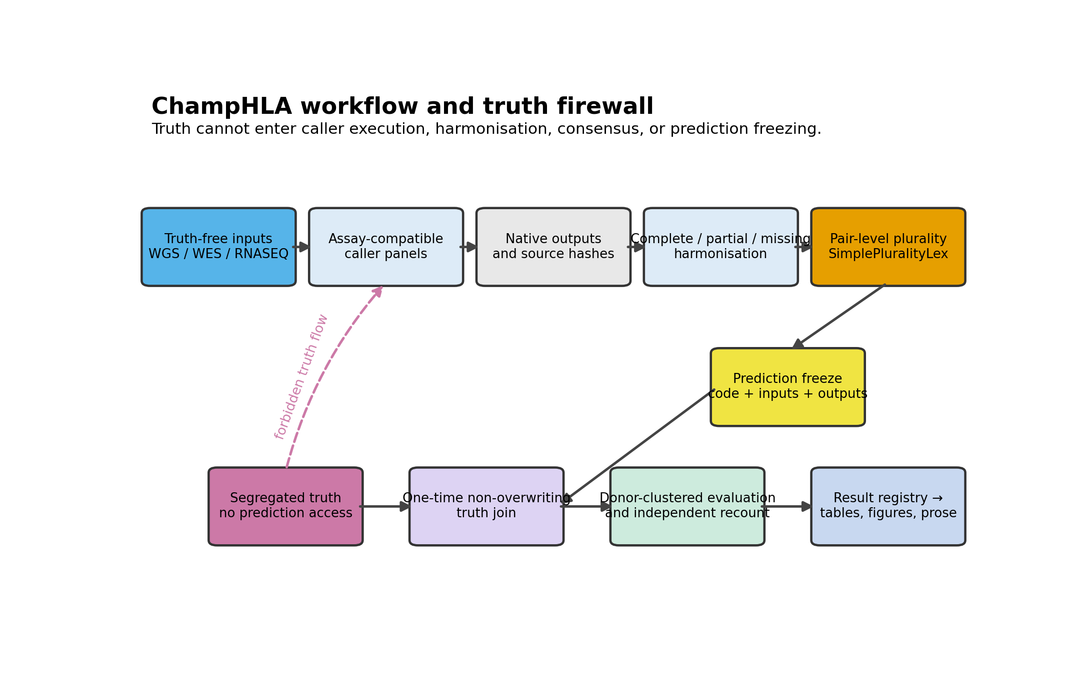
Figure 1. Workflow and truth firewall. Truth-free WGS, WES, and RNA-seq inputs flow through assay-compatible callers, native-output preservation, call-state harmonisation, pair-level plurality, and an immutable prediction freeze. Segregated truth can enter only the one-time non-overwriting join; the dashed path marks forbidden truth access during prediction.
Individual-caller performance is assay dependent
The development comparison showed that the caller with the highest observed accuracy differed by modality. Because “best observed caller” is selected after viewing outcomes, it is reported descriptively; confirmatory inference retains every frozen deployable caller in the modality-specific family. Exhaustive caller results and the candidate-generation oracle are assigned to the supplement so the main comparison does not turn a post-selection summary into a prospective claim.
Pair-level plurality is the recommended selection-free default
In the existing development artifacts, pair-level plurality produced 365 correct WES genotypes among 390 eligible loci [RESULT:DEV_WES_CONSENSUS] and 306 correct RNA-seq genotypes among 321 eligible loci [RESULT:DEV_RNA_CONSENSUS]. These denominators and the choice to foreground plurality were visible before the primary amendment; the estimates are therefore provisional development evidence rather than prospective confirmation.
Modality | Pair-level plurality | Best observed caller | Strongest integration comparator | Interpretation
WES | 365/390 [RESULT:DEV_WES_CONSENSUS] | generated in the corrected head-to-head | generated in the corrected head-to-head | provisional development evidence
bulk RNA-seq | 306/321 [RESULT:DEV_RNA_CONSENSUS] | generated in the corrected head-to-head | generated in the corrected head-to-head | provisional development evidence
WGS | excluded | awaiting corrected rerun | awaiting corrected rerun | no valid performance result
The corrected same-resource version of this table is generated from the registry and same-resource evaluation output; later donor-independent results are registered and reported as a separate prospective evidence layer. The table will include fixed-denominator accuracy, call rate, paired comparator-minus-plurality difference, simultaneous confidence interval, and Holm-adjusted inference. No WGS estimate enters the main table until the full-CRAM production audit passes.
More complex integration did not establish a reliable advantage
The historical ablations include raw Champion–Challenger, Guarded CC, MV-floor, MetaConsensus, RefFormer, EvidenceGatedCC, and weighted variants. The number of retained integration and historical-ablation methods is generated from the comparator manifest rather than typed into the manuscript. RefFormer failed its frozen retention decision [RESULT:REFFORMER_GATE], and EvidenceGatedCC failed its development decision [RESULT:EGCC_GATE]. These results support preserving the methods as informative ablations, not promoting them to a headline algorithm. Complete head-to-head and baseline-ladder results remain visible in the supplement.
The historical WGS lane identified a technical boundary, not a method result
The historical WGS input was constructed from a chromosome-restricted slice that omitted HLA alternate-contig alignments and mates outside the selected interval. All performance records derived from that lane are marked invalid. They remain discoverable for diagnosis but are excluded from gates, pooled estimates, primary figures, and performance language. The corrected WGS lane starts from the full CRAM, keeps relevant alternate contigs, preserves mates, and runs the frozen five-caller panel before any truth access.
Three explicit gates replace an ambiguous retention decision
The evaluation reports three outcomes. no_comparator_holm_superior asks whether any frozen comparator has a Holm-significant positive advantage over plurality; this is a superiority screen and does not establish equivalence. consensus_noninferior_2pp evaluates the predeclared prospective margin using simultaneous donor-clustered upper confidence bounds. Finally, three_modality_claim_ready requires all modalities to be valid, prospective, adequately sized, complete across comparator records, and technically audited. The current development analysis does not satisfy the final gate.
Methods
Study design and evidence roles
Every dataset is assigned a role before predictions are evaluated: development, same-resource confirmation, independent validation, exploratory, or invalid. Donor-independent cohorts and new-library cohorts that reuse donors are analyzed separately. Repeated tissues and libraries share a donor cluster. Computational, imputed, circular, and RNA-informed truth sources cannot enter an accuracy denominator for the affected assay.
The same-resource benchmark uses the 1000 Genomes resource [@1000Genomes2015]. The independent WGS lane is based on the Human Pangenome Reference Consortium resource [@Liao2023], and the small independent RNA-seq feasibility lane uses NCI-60 material [@Adams2005]. These source citations identify the cohorts; they do not convert an unfinished lane into validation evidence.
The imported discovery program tracks dataset lanes through inventory, metadata verification, truth verification, executability, prediction freeze, and evaluation. HPRC Release 2 supplies a feasible truth-blind WGS roster, but evaluation awaits independently audited phased-assembly truth. The strict NCI-60 RNA panel is exploratory and under the confirmation target. CCLE WES overlap is metadata-verified but lacks complete accuracy-eligible A/B/C truth. Controlled candidates remain blocked until authorization, mapping, truth independence, and data-use terms are documented.
Figure 2 maps these evidence roles and current lane states without presenting an aspirational cohort as completed or pooling across independence strata.
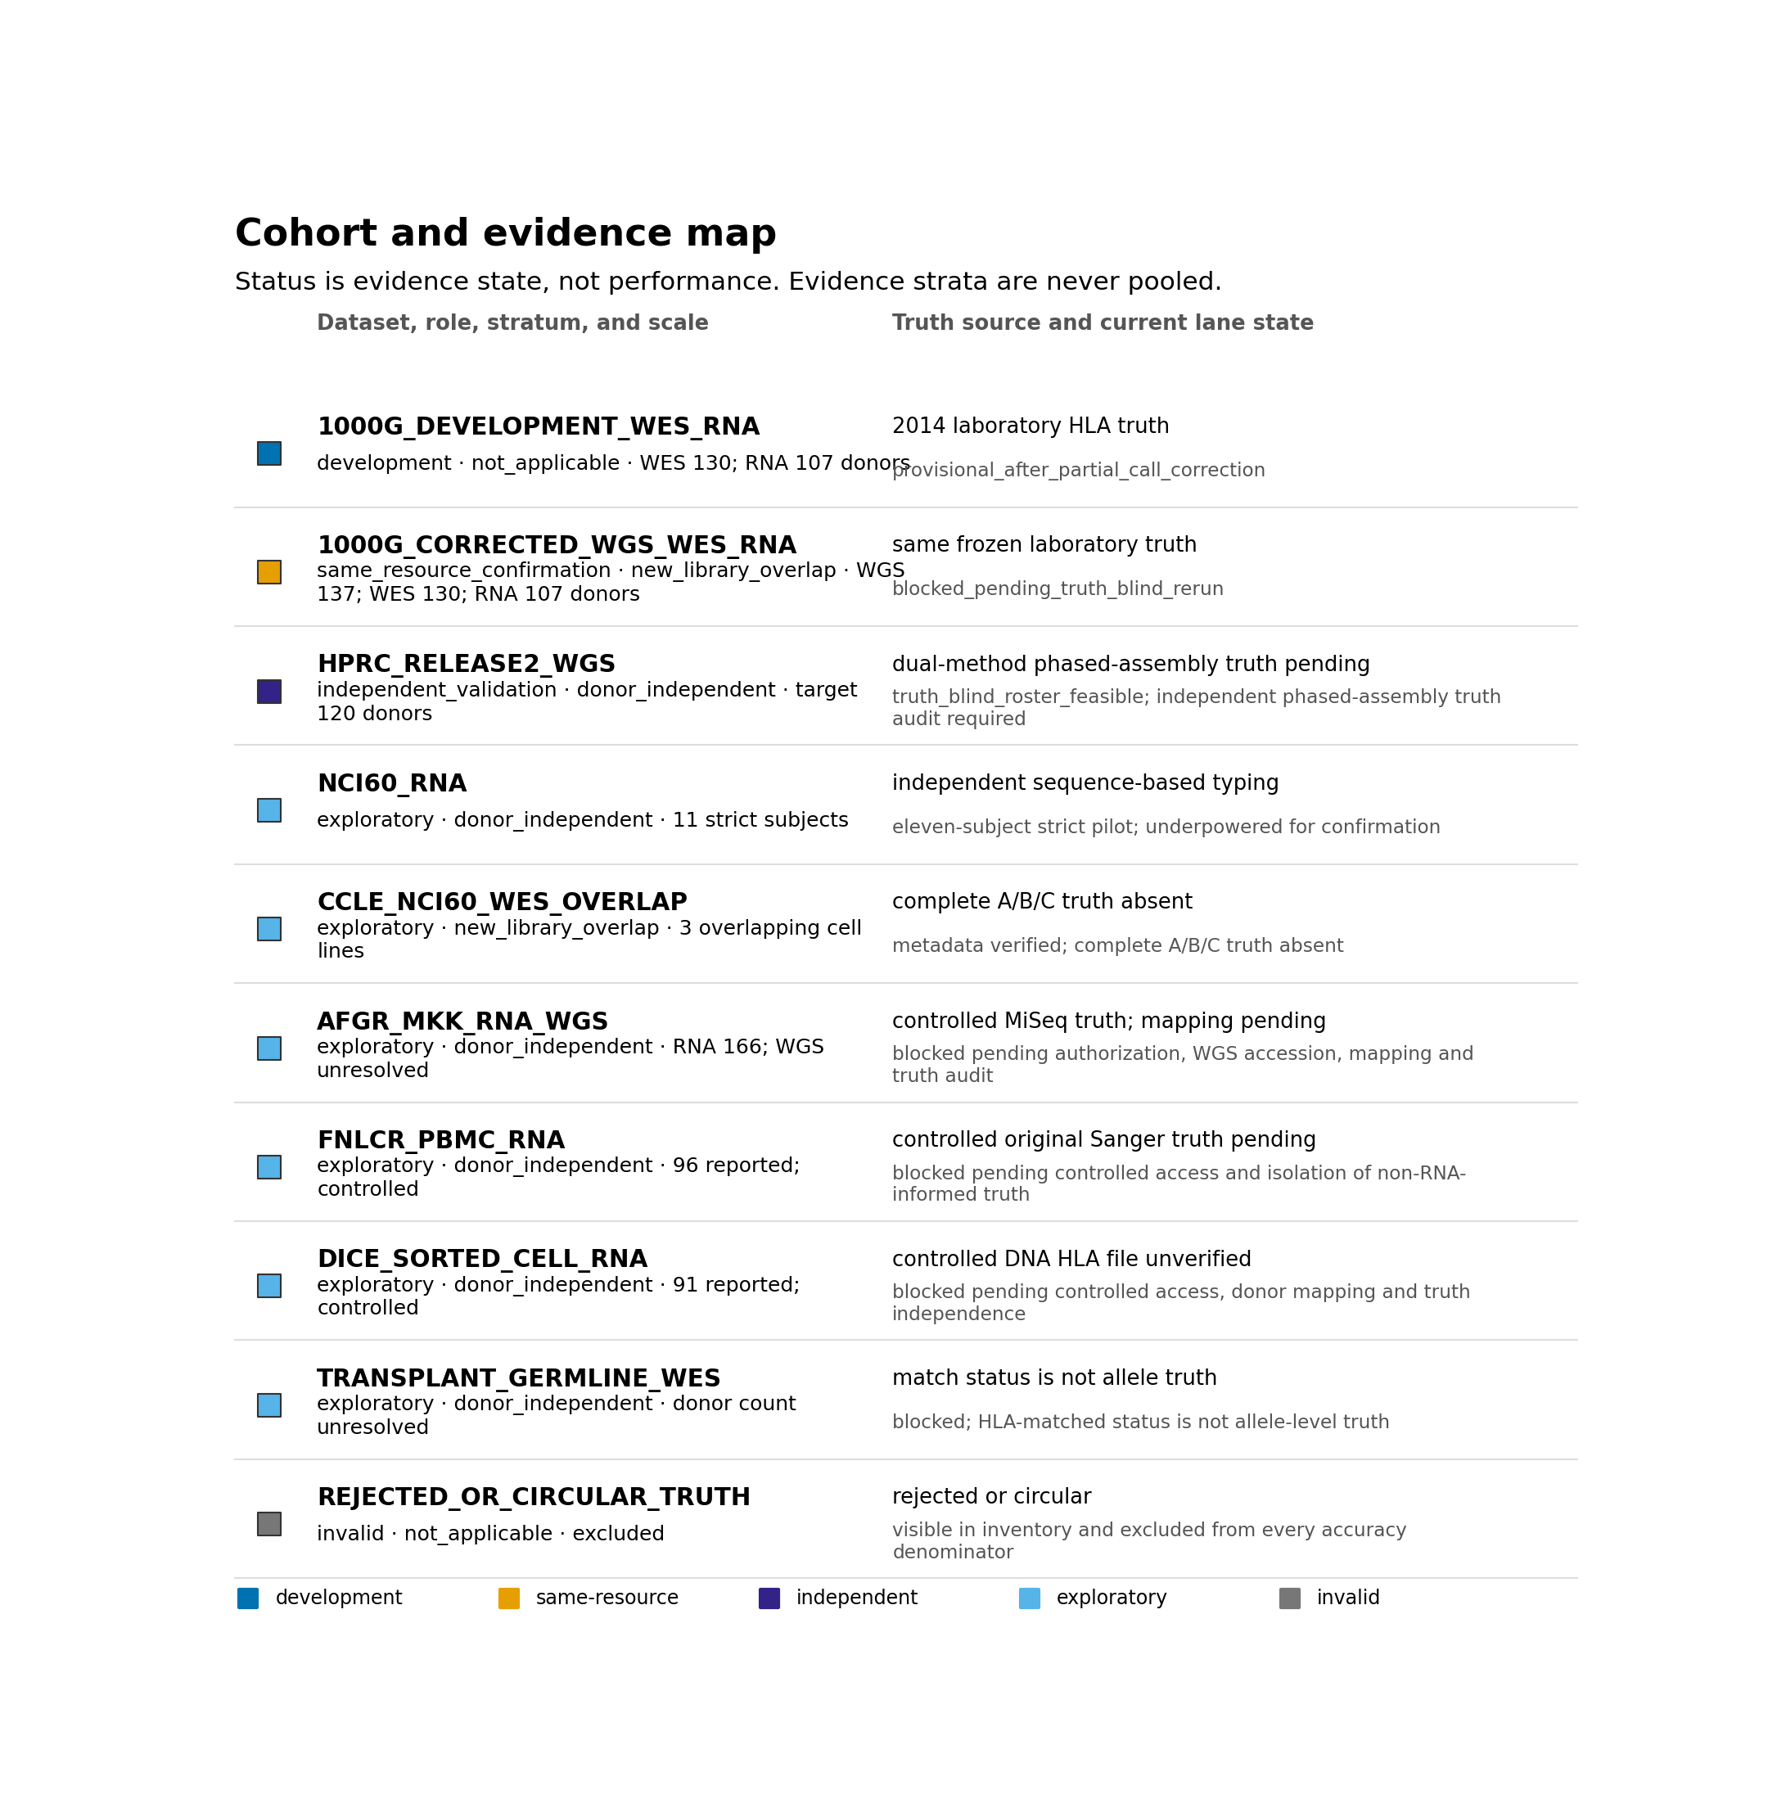
Figure 2. Cohort and evidence map. Dataset roles, independence strata, available or target scale, truth source, and current lane state are shown separately. Color encodes evidence role rather than performance; same-resource, donor-independent, exploratory, and invalid evidence are not pooled.
Harmonisation and plurality
The full algorithm, call-state contract, endpoints, and truth firewall are defined in manuscripts/shared/shared_methods.md. Briefly, each complete canonical pair receives one equal vote from its caller; partial and missing calls receive none. Maximum support wins, lexicographic ordering resolves an exact top tie, and absence of a complete pair returns no_evidence. SimplePluralityLex remains the machine identifier. “Pair-level plurality consensus” is the scientific name, and MajorityVote is a legacy input alias.
Outcomes and statistical analysis
The primary outcome is exact unordered two-field genotype accuracy at the fixed eligible-truth denominator. Secondary outcomes include callability, called-only accuracy, allele accuracy, ties, partial calls, missingness, per-gene and population results, and resource use. Each method is compared with plurality on paired loci. Tests and simultaneous intervals cluster by donor; Holm adjustment is performed within each frozen modality-specific deployable family. The candidate oracle is descriptive and separate.
Corrected rerun and release control
The corrected same-resource WGS, WES, and RNA-seq lanes are rerun end to end after the partial-call correction. Remote WGS CRAM extraction permits two five-hour attempts only for allowlisted transport failures. Each attempt has an immutable staging-ledger row and separate stderr; unsuccessful attempts and their partial BAMs are quarantined and excluded. Because full CRAMs are streamed rather than retained, their manifest checksums are recorded as upstream-declared identities, not as locally verified values; extracted HLA BAMs and indexes are hashed locally. Execution fails closed for missing processes, empty outputs, resource mismatches, or incomplete caller/locus records. WGS additionally requires a complete native-output audit and named stratified human review before truth can be joined. Code, configurations, panels, predictions, and provenance are then frozen; truth is joined once; registry rows, tables, prose, and release hashes are regenerated from the evaluated artifacts.
Caller databases are recorded component by component rather than assigned a single repository-wide IPD-IMGT/HLA release. The frozen panel intentionally contains different caller-specific releases, including a heterogeneous SpecHLA bundle; the versioned caller/reference attestation is authoritative. The frozen assay-compatible panels comprise HLA-HD [@Kawaguchi2017], Kourami [@Lee2018], OptiType [@Szolek2014], POLYSOLVER [@Shukla2015], SpecHLA [@Wang2023], T1K [@Song2023], and arcasHLA [@Orenbuch2020]. Each caller is used only in the modalities declared in the frozen panel manifest.
Discussion
The current evidence motivates pair-level plurality as ChampHLA's recommended default for WES and bulk RNA-seq development data. That recommendation is about transparency and robustness to caller choice, not novelty of the voting rule. The data also show why a cross-assay conclusion cannot be inferred from WES and RNA-seq alone: input construction and caller compatibility can dominate the WGS comparison.
The revised architecture turns that limitation into a testable boundary. The corrected same-resource WGS, WES, and RNA-seq lanes can establish benchmark readiness, but cannot establish prospective noninferiority. The predeclared two-percentage-point noninferiority conclusion is reserved for genuinely prospective, donor-independent cohorts. If valid corrected WGS underperforms, plurality will be described as a strong WES/RNA-seq default with a demonstrated WGS limitation. If WGS integrity fails again, the paper will remain a software and benchmark report without a finalized cross-assay performance claim.
The scope is restricted to research-only HLA-A/B/C typing from the evaluated short-read designs. Class II loci, long reads, single-cell pseudobulk, transplant outcomes, loss of heterozygosity, HLA evolutionary divergence, and clinical safety are outside the primary claim.
Data and software availability
The release bundle will include source code, compact fixtures, comparator and environment manifests, dataset roles, native-output checksums, frozen predictions, one-time join evidence, registry-backed tables, statistical outputs, and claim-audit records. A DOI-ready bundle is released only after the author amendment, corrected rerun, WGS technical and human-review gates, cross-platform tests, manuscript audits, and clean repository freeze all pass.
References
Adams S, Robbins F-M, Chen D, et al. HLA class I and II genotype of the NCI-60 cell lines. Journal of Translational Medicine. 2005;3:11. doi:10.1186/1479-5876-3-11.
The 1000 Genomes Project Consortium. A global reference for human genetic variation. Nature. 2015;526:68–74. doi:10.1038/nature15393.
Kawaguchi S, Higasa K, Shimizu M, Yamada R, Matsuda F. HLA-HD: an accurate HLA typing algorithm for next-generation sequencing data. Human Mutation. 2017;38:788–797. doi:10.1002/humu.23230.
Lee H, Kingsford C. Kourami: graph-guided assembly for novel human leukocyte antigen allele discovery. Genome Biology. 2018;19:16. doi:10.1186/s13059-018-1388-2.
Liao W-W, Asri M, Ebler J, et al. A draft human pangenome reference. Nature. 2023;617:312–324. doi:10.1038/s41586-023-05896-x.
Orenbuch R, Filip I, Comito D, Shaman J, Pe'er I, Rabadan R. arcasHLA: high resolution HLA typing from RNAseq. Bioinformatics. 2020;36:33–40. doi:10.1093/bioinformatics/btz474.
Robinson J, Barker DJ, Georgiou X, Cooper MA, Flicek P, Marsh SGE. IPD-IMGT/HLA Database. Nucleic Acids Research. 2020;48:D948–D955. doi:10.1093/nar/gkz950.
Shukla SA, Rooney MS, Rajasagi M, et al. Comprehensive analysis of cancer-associated somatic mutations in class I HLA genes. Nature Biotechnology. 2015;33:1152–1158. doi:10.1038/nbt.3344.
Song L, Bai G, Liu XS, Li B, Li H. T1K: efficient and accurate KIR and HLA genotyping with RNA-seq. Genome Research. 2023;33:923–931. doi:10.1101/gr.277585.122.
Szolek A, Schubert B, Mohr C, Sturm M, Feldhahn M, Kohlbacher O. OptiType: precision HLA typing from next-generation sequencing data. Bioinformatics. 2014;30:3310–3316. doi:10.1093/bioinformatics/btu548.
Wang S, Wang M, Chen L, Pan G, Wang Y, Li S. SpecHLA enables full-resolution HLA typing from sequencing data. Cell Reports Methods. 2023;3:100589. doi:10.1016/j.crmeth.2023.100589.

