Website provider: 000webhost

Hostname: testhedonion.comxa.com

IP address: 31.170.160.209

How to login to FTP server

FTP user name: a3783940

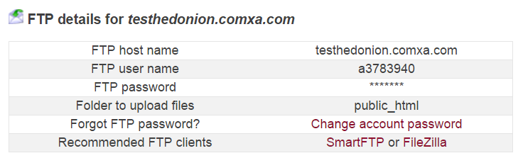

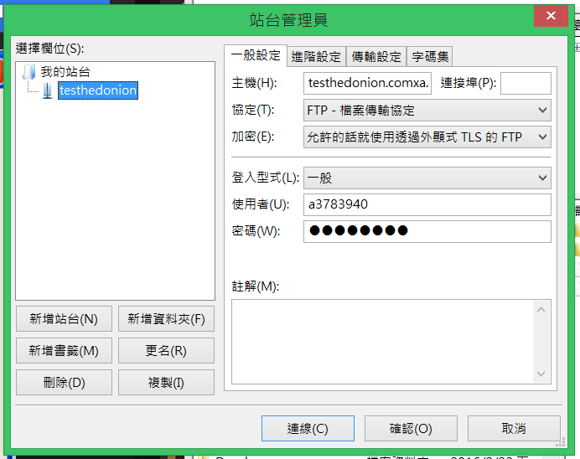

My database

