**SEG 3125**

**Assignment 1**

**Videotaped Cooperative Interface**

**Evaluation**

Prepared by Group39:

* Haoxin Zeng 300248305
* Sky Jiang 300217544
* Yucheng Chen 300194614

Date: 2024.03.01

**1- Summary of the Evaluation Procedures**

This evaluation involves a web application developed during the current course （SEG3125） at the University of Ottawa. In this system, barbers can be selected online, appointments can be made and payments can be made all using the online functionality of the hair salon.

This assessment is an online assessment on February 25th at 3pm. Both subjects were students with good computer skills and were using the system for the first time. The first subject is Jinxian, university with good computer skills. The second subject is Xialiang, also familiar with computer and is the first time using the system.

In order to ensure effective communication, inquiries, and feedback exchange with the participants, the evaluation procedure was interactive and collaborative. The user interface evaluation included observing users' actions and verbal expressions as they performed predefined tasks via screen sharing. In order to gather participants' perspectives on encountered issues, a survey was maintained throughout the evaluation. To solicit their opinions and feedback regarding the system, specific surveys and communication sessions were conducted after the evaluation.

**Pseudo Code of the Steps Performed by User 1:**

1.1 Scrolling page and click nav button:

-Scroll down and up

-Click <<About us>> button

-Click <<News>> button

-Click <<Open hours>> button

-Scroll down and check the barbers

*End result:*

User will jump to the YouTube video when they click all the buttons on the navigation bar. After scrolling down, the user will be able to view the current barber.

*User’s comments and interaction:*

-Scared by the Youtube video.

-Not satisfied with the homepage image.

1.2 Appointment（unfilled）:

-Click <<Book now>> link

-Click<<Next: payment info>>

*End result:*

User will be asked to fill in all the necessary information.

*User’s comments and interaction:*

-User are curious about what happens if they don't fill it out.

1.3 Appointment（filled）:

-Click <<Book now>> link

- Type “user1” next to <<Name>> text field

- Type “test1@email.com” next to <<Email>> text field

- Type “2024/02/25” next to <<Date>> text field

- Type “15:00” next to <<Time>> text field

- Type “1” next to <<Number of Guests>> text field

- Click on the <<Select your service>> and click <<Haircut>>

- Click on the <<Barber>> and click <<Herta>>

- Click<<Next: payment info>>

->It will jump to the payment page

*End result:*

The user will be directed to the payment page

*User’s comments and interaction:*

-User ask what happens if they don't follow the email formatting.

1.4 Payment:

- Type “Name” next to <<Name on Card>> text field

- Type “1234567898765432” next to <<Card number>> text field

- Type “1234” next to <<Expiration date>> text field

- Type “123” next to <<CVV>> text field

*End result:*

User will be redirected to a “specially designed” confirmation submission page.

*User’s comments and interaction:*

- User ask about the security of entering payment info in the system.

- User ask what happens if they don't follow the format for entering the card number.

**Pseudo Code of the Steps Performed by User 2:**

2.1 Scrolling page and click nav button:

-Scroll down and up

-Click <<About us>> button

-Click <<News>> button

-Click <<Open hours>> button

-Scroll down and check the barbers

*End result:*

Users will jump to the youtube video when they click all the buttons on the navigation bar. After scrolling down, the user will be able to view the current barber.

*User’s comments and interaction:*

-Scared by the youtube video.

-Not satisfied with the page’s color.

2.2 Appointment（unfilled）:

-Click <<Book now>> link

-Click<<Next: payment info>>

*End result:*

User will be asked to fill in all the necessary information.

*User’s comments and interaction:*

- User ask if they need to fill in all the information.

2.3 Appointment（filled）:

-Scroll down to barber section

-Click <<Book now>> link under the barber Sai Tama

- Type “user2” next to <<Name>> text field

- Type “test2@email.com” next to <<Email>> text field

- Type “2024/02/25” next to <<Date>> text field

- Type “15:00” next to <<Time>> text field

- Type “1” next to <<Number of Guests>> text field

- Click on the <<Select your service>> and click <<Coloring>>

- Click on the <<Barber>> and click <<Sai Tama>>

- Click<<Next: payment info>>

->It will jump to the payment page

*End result:*

The user will be directed to the payment page.

*User’s comments and interaction:*

- User ask if they need to fill in all the information.

2.4 Payment:

- Type “Name” next to <<Name on Card>> text field

- Type “1234567898765432” next to <<Card number>> text field

- Type “1234” next to <<Expiration date>> text field

- Type “123” next to <<CVV>> text field

*End result:*

Users will be redirected to a “specially designed” confirmation submission page.

*User’s comments and interaction:*

- User ask about the security of entering payment info in the system.

- Users say that there is no validation of inputs in the payment function, and that they can enter the card number and expiration date instead of the normal payment.

***2- Malfunctions list***

1. After clicking Book Now, all input fields display exclamation marks before user input
2. On the Appointment page, the submit button should be directly displayed at the bottom without requiring the user to scroll down
3. The system should prevent users from selecting a past time for appointments
4. The main page does not contain any introductory messages informing the user about the overall system and its services.
5. The input fields do not check for email format
6. Before making a payment, the user is not informed about the detailed payment amount (confirmation page)
7. Images are obviously generated by GPT. It's better to choose a real photo
8. Function single and simple
9. CC info field needs further validation
10. Only supports CC. Should support payment method.
11. No text field validation. Risk of SQL injection.
12. Better add animation and shadow for images
13. The website layout (such as the barber's image) is abnormal on the mobile device.

***3- Five Most Significant Malfunctions***

1. The website layout (such as the barber's image) is abnormal on the mobile device.

**Description:**

Users attempted to view the site on different devices, and when using a mobile device, the formatting of the site was misaligned and the barber's photo did not appear in the correct location, which degraded the user's browsing experience.

**Significant Questions Answered**

1. How is the malfunction manifested?

The barber's image is displayed improperly on mobile devices, affecting the site's visual layout.

1. At what stage in the interaction is it occurring?

This occurs as soon as the website is accessed on a mobile device.

1. At what level of the user interface is it occurring?

The issue is present at the presentation of the user interface.

1. Why is it occurring?

It is likely due to a lack of proper responsive design or a coding error that fails to adjust the image and layout for different screen sizes.

**Result of Malfunction Analysis:**

The inadequate mobile interface design detracts from the user experience, potentially affecting the site's accessibility and usability on smaller screens.

**Recommendations for Changes:**

Implement a responsive web design framework that ensures all elements scale appropriately across different devices. The barber's image should adjust seamlessly within the given viewport without losing aspect ratio or quality. Testing across various devices and screen sizes should be conducted to guarantee a uniform and functional user experience.

1. No text field validation. Risk of SQL injection.

**Description:**

The website's text fields lack validation, presenting a significant security risk in the form of potential SQL injection attacks. Users may inadvertently or maliciously enter SQL code that the system could execute, leading to unauthorized data access or other security breaches.

**Significant Questions Answered**

1. How is the malfunction manifested?

The malfunction manifests as an absence of error handling or filtering input in text fields.

1. At what stage in the interaction is it occurring?

This security occurs at the data entry point, where users input information into the text fields.

1. At what level of the user interface is it occurring?

This malfunction is occurring at the presentation level of the user interface.

1. Why is it occurring?

The cause is likely due to an oversight in backend development, where input validation measures were not properly implemented.

**Result of Malfunction Analysis:**

The absence of input validation mechanisms exposes the website to SQL injection threats, which could compromise the integrity and confidentiality of the database.

**Recommendations for Changes:**

It is crucial to implement validation for all text fields, ensuring that inputs are sanitized. This includes using prepared statements, stored procedures, and employing frameworks that automatically handle these concerns.

1. The main page does not contain any introductory messages informing the user about the overall system and its services.

**Description:**

The homepage does not provide enough information to introduce the service and guide the user through the process.

As shown in figure 1, the main page consists of the following:

* Title
* Navi bar
* Book button
* Introduction of the barber (at the bottom of the page)

Upon the initial visit to the hair salon's website, clients were greeted with a polished and professional image of the salon's interior, suggesting a place of comfort and quality service. However, it quickly became apparent that the site's functionality was not as clear-cut as its aesthetics. There was a conspicuous absence of any direct instructions or guidance on how to navigate the site for booking purposes. This omission led to an inevitable reliance on customer support to walk first-time visitors through the booking process.

Furthermore, the "Our Barber" section, while personalizing the experience by showcasing the barbers, lacked clear pathways for clients to select and schedule an appointment with their preferred stylist. The section showcased caricatures of the barbers, which, while whimsical, did not contribute to understanding the services or the expertise of the barbers. The price list, although informative, stood isolated with no immediate way to act upon the information. This static presentation risked leaving clients uncertain of their next steps, potentially discouraging them from proceeding with a booking.

This feedback suggests an immediate need for a more intuitive user interface with evident call-to-action features that guide the client seamlessly from interest to booking, ensuring that the website's design aligns with its purpose of facilitating the appointment scheduling process.

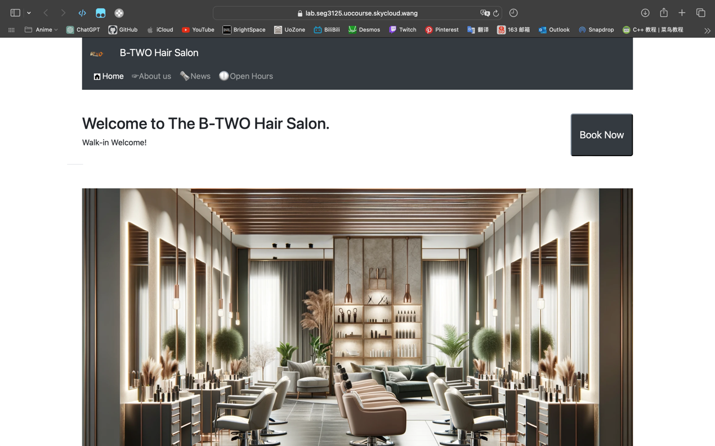

Figure 1. The main mage

**Significant Questions Answered**

1. How is the malfunction manifested?

The users were unable to determine the process for booking hair salon appointments, necessitating verbal assistance from the staff to navigate the website.

1. At what stage in the interaction is it occurring?

The confusion arises during the initial interaction with the website when users are expected to understand and navigate the booking system. (The appointment button appears in multiple places.)

1. At what level of the user interface is it occurring?

This malfunction is occurring at the presentation level of the user interface.

1. Why is it occurring?

The problem stems from a lack of clear, actionable information and guidance for booking appointments, leading to user confusion.

**Result of Malfunction Analysis:**

The main page layout and content, while aesthetically pleasing, do not fulfill the needs of the user, particularly those new to the website. The core function of the site—to facilitate the booking of hair salon services—is not immediately apparent, missing both in text and related imagery. Users arrive expecting a clear pathway to book services but find none prominently displayed.

**Recommendations for Changes:**

To remedy this, a prominent, intuitive booking interface should be incorporated into the main page, possibly through a dynamic booking widget that captures the user's attention immediately. This could be complemented by a step-by-step guide or a brief tutorial video that explains the booking process. Moreover, personalizing the stylist section with real images of the barbers and a brief introduction to their skills could provide users with a sense of trust and familiarity, encouraging them to book an appointment.

1. Before making a payment, the user is not informed about the detailed payment amount (confirmation page)

**Description:**

Users encounter a critical issue at checkout due to the absence of a detailed payment summary. After selecting services, they proceed to pay without seeing a complete breakdown of costs. This lack of transparency at a crucial decision point causes confusion and potential mistrust, as clients are not able to confirm the total amount before committing to payment. The site's current flow omits a confirmation step, which is a standard e-commerce practice and necessary for ensuring customer confidence and satisfaction.

Figure 2. checkout page

**Significant Questions Answered**

1. How is the malfunction manifested?

Users are unable to see the detailed payment amount before finalizing the transaction, leading to uncertainty and potential distrust in the payment process.

1. At what stage in the interaction is it occurring?

This issue arises at the finalization stage of the booking process, just before the user is expected to commit to the payment.

1. At what level of the user interface is it occurring?

This malfunction is occurring at the presentation level, where detailed financial information should be confirmed.

1. Why is it occurring?

The omission likely occurs due to an oversight in the design of the checkout process, where the final step lacks a detailed breakdown of costs for the user’s review before payment is processed.

**Result of Malfunction Analysis:**

The absence of a detailed confirmation page before payment processing is a significant gap in the user interface. This leads to a lack of transparency that can erode user confidence and satisfaction. Users expect to review a breakdown of charges to ensure accuracy and to feel secure that there are no hidden fees or errors before they make a payment.

**Recommendations for Changes:**

To correct this, the website must incorporate a confirmation page that itemizes the total cost, including service charges, taxes, and any other fees, before the user finalizes the payment. This page should be clear, concise, and require user confirmation to proceed. It would also be beneficial to include an editable feature where users can review and modify their service choices if necessary. Providing this level of clarity and control will improve trust and user experience, encouraging repeat bookings.

1. Only supports CC. Should support payment method.

**Description:**

The Payment method only support credit card. The subject found the page only accepts credit card which he doesn’t hold one. The subject also found all field of credit card info is not validated well. When the subject entered a random number, the submission is successful. The subject tried to enter an expiration date that already pasted. But the system still accepted.

**Significant Questions Answered**

1)How is the malfunction manifested?

The user can only use credit card payment, which should support online transaction with CVV. The user can enter any invalid credit card info to continue.

2)At what stage in the interaction is it occurring?

When the user goes to payment form while testing the booking function.

3)At what level of the user interface is it occurring?

At the functional and usability level.

4)Why is it occurring?

The malfunction occurs because of the incomplete payment function of the website. The form is a simple input field that doesn’t use any bank api to validate the card info.

**Result of Malfunction Analysis:**

The payment form function seems not completed. It requires further validation with bank API. The form should also give user the content of accepting method. The user may don’t have supported credit card and have to end the appointment process.

**Recommendations for Changes:**

Validate the credit card info by using bank API or use third-party payment system to gather the payment info. Add more common payment method, such as Interac, Alipay and PayPal.

***4- Proposal***

Based on user feedback and an extensive review, we found a bunch of things that need to be improved. We've proposed a bunch of updates and redesigns to improve user experience and security. First, we acknowledge the need for more authentic visual content. Also, the system pages will be brighter, which can make it easier to navigate and look better. Our current system is limited in functionality, so we're going to expand payment options based on existing credit card systems. Additionally, this change makes transactions more convenient for users, as well as meeting users' broad preferences.

As well as improving the security, we recommend implementing validation checks on all text fields to prevent SQL injections. And we'll add animations and shadows to images to make the interface more dynamic. As a result of these improvements, not only does the interface look better, but it's easier to use too. At last, our team noticed a problem with mobile devices. This will be fixed, and all images will be optimized for different screen sizes and resolutions to provide a seamless experience.

Our objective is to improve our interface into a more reliable, engaging, and user-friendly one through the changes we suggest. Hence, our system will keep on improving the UI interface and functionality allowing the users to clearly view the content, easily use the appointment feature, and make a payment in a more reliable environment.