A
CSCI222
Assignment 1

Team A3

CSCI222 Assignment 1 Report

Team Number : Team A3
 | Student Number | Name | Email Address
1 | 5498399 | (Team Leader)  Chin Tian Zhi Timothy | Tel : 97337107  Email : chin_tian_zhi_timothy@yahoo.com
2 | 5498442 | Kenneth Huang Shun Yang | Ft_kenneth_huang@yahoo.com
3 | 5498715 | Yee Yik Fei | yikfei@yahoo.com
4 | 5282767 | Ng Hui En | huien92@yahoo.com.sg
5 | 5498387 | Marcus Chen Feng | Marcus_chen3@hotmail.com
6 | 5498508 | Muhammad Jamal Bin Radwan | Jamalrad156@yahoo.com
7 | 5498636 | Soh Yu Xuan | yuxuannn@gmail.com

Contents
No table of contents entries found.

Project Overview

- "Vision"

The purpose of the Warehouse Management System is to provide efficient bookkeeping of stock in a Warehouse environment. The system has a login feature that allows the personnel with the corresponding privileges to login in to the system while safely securing the data stored in the system. In the case where there are 3 unsuccessful login attempts, the user will be locked out of the system. Someone who is of an admin privilege would have to login to the system and change the user locked out status and change his password so that the user would be able to login.

Another purpose of the software, is the ability to add/update records, edit records, searching and display of stock based on price range and quantity. There are four options the stock can be displayed, daily summary, weekly summary, monthly summary and yearly summary. The software can also add transactions, remove transactions and search transactions.

- Initial Use-Case Model

There are 2 actors. The Manager and Admin. The Manager is the main user of the system that should interact with the system on a daily basis. Manager will be using all the functionalities the system has to offer.

The Admin is needed to maintain the system and to facilitate the unlocking of accounts upon 3 failed login attempts.
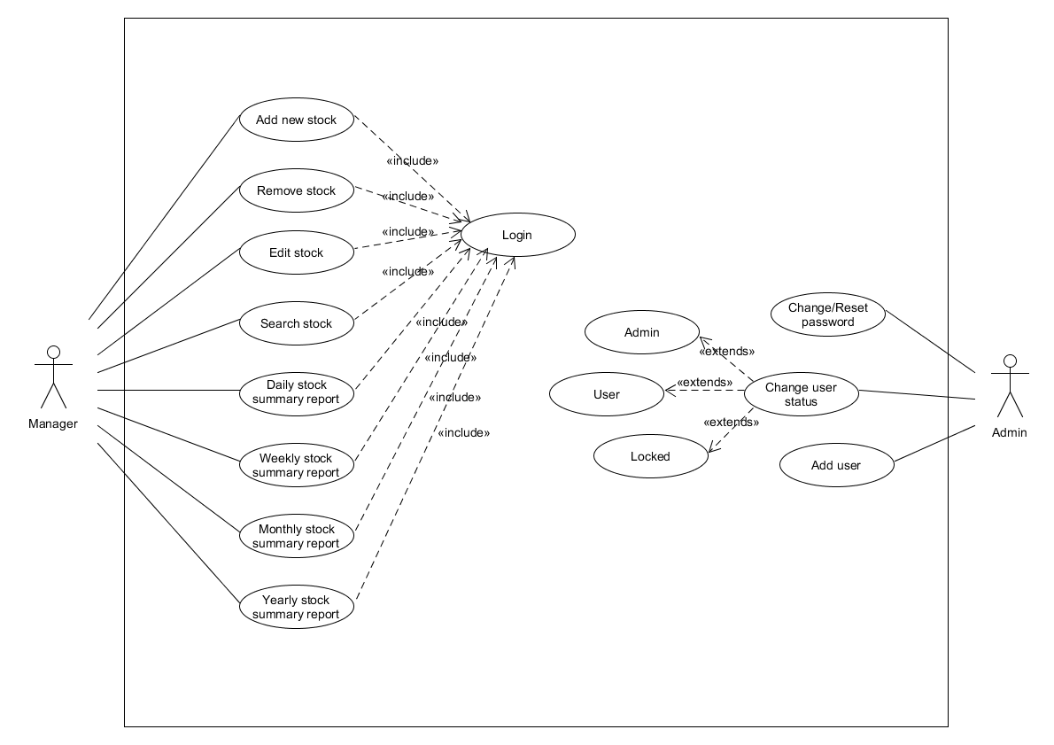
// update

- Project Plan

Roles and Responsibility

\

Team Number : Team A3

 | Student Name | Role | Artefacts
1 | Chin Tian Zhi TImothy | Team Lead/Manager | Use Case, Minutes of Meetings, Sequence Diagram
2 | Kenneth Huang Shun Yang | Designer/implementer/ Documentation | SRS Introduction, Class Diagram
3 | Yee Yik Fei | Designer/implementer/ Documentation | SRS Non Functional Requirements, SRS Other Requirements, Sequence Diagram
4 | Ng Hui En | Designer/implementer/ Documentation | SRS External Interface Requirements, Component Diagram
5 | Marcus Chen Feng | System Integration and testing | SRS System Functions, Sequence Diagram
6 | Muhammad Jamal Bin Radwan | Designer/implementer/ Documentation | Gantt Chart planning, Sequence Diagram
7 | Soh Yu Xuan | Lead Designer/Implementer | SRS Overall Description, Activity Workflow Diagram

Risk Analysis and Counter Measures

 | Impact Type | Risk Seriousness (%) | Likelihood of Occurrence (%) | WBS  (affected work / task ) | Risk Description
1 | Deadline | 80% | 5% | Completion | All team members fall sick and unable to complete their tasks on time.
2 | Deadline | 90% | 10% | Completion | All team members start to argue and fight amongst each other delaying actual work done.
3 | Deadline | 60% | 5% | Completion | Some team members are new or still not used to C++ and have not learnt the appropriate tools to properly code.
4 | Deadline | 20% | 2% | Completion | Computer breaks down and needs to be repaired. Slows down the progress of the project.
5 | Successful Completion of Task | 90% | 0.5% | Completion | Team member comes down with terminal illness, fatal accident or needs hospitalization.
6 | Successful Completion of Task | 85% | 1% | Completion | Team member quits school.
7 | Deadline | 20% | 5% | Completion | Team member has work outside of school and cannot attend project meetings.
8 | Deadline | 70% | 10% | Completion | Poor planning to support the development of the project.

 | Risk Description | Proposed Mgmt Plan | (Possible) Reduction in Risk Seriousness (%)
1 | All team members fall sick and unable to complete their tasks on time. | Plan 1 : Advise member to be vigilant and try not to fall sick. | -25%
1 |  | Plan 2 : Provide free medical healthcare. | -25%
2 | All team members start to argue and fight amongst each other delaying actual work done. | Plan 1 : Leader mediates and controls the discussions between members to hindering actual work. | -50%
2 |  | Plan 2 : Impose penalties if work is delayed. ( lesser group contribution in peer eval) | -30%
3 | Some team members are new or still not used to C++ and have not learnt the appropriate tools to properly code. | Plan 1 : Stronger members can take out time to educate and help weaker team members. | -15%
3 |  | Plan 2 : Stronger members can team up with the weaker members. The stronger members will cover the weaknesses of the other person. | -30%
4 | Computer breaks down and needs to be repaired. Slows down the progress of the project. | Plan : Backup data to cloud storage everytime someone accesses the files. | -60%
5 | Team member comes down with terminal illness or fatal accident. | Plan : Have members team up so they know what each other is doing. The other person will be updated to their progress and work done. | -20%
6 | Team member quits school. | Plan : Create a system to record a detailed description of the progress of a member’s work done in the project. | -50%
7 | Team member has work outside of school and cannot attend project meetings. | Plan : Plan meetings on days where members do not have work scheduled. | -75%
8 | Poor planning to support the development of the project. | Plan : Have the leader plan the project and to over see the planning to make sure everything is on track. | -50%

Design Artefacts - Use Cases (Iteration 1)

Design Artefacts - Use Cases (Iteration 2)

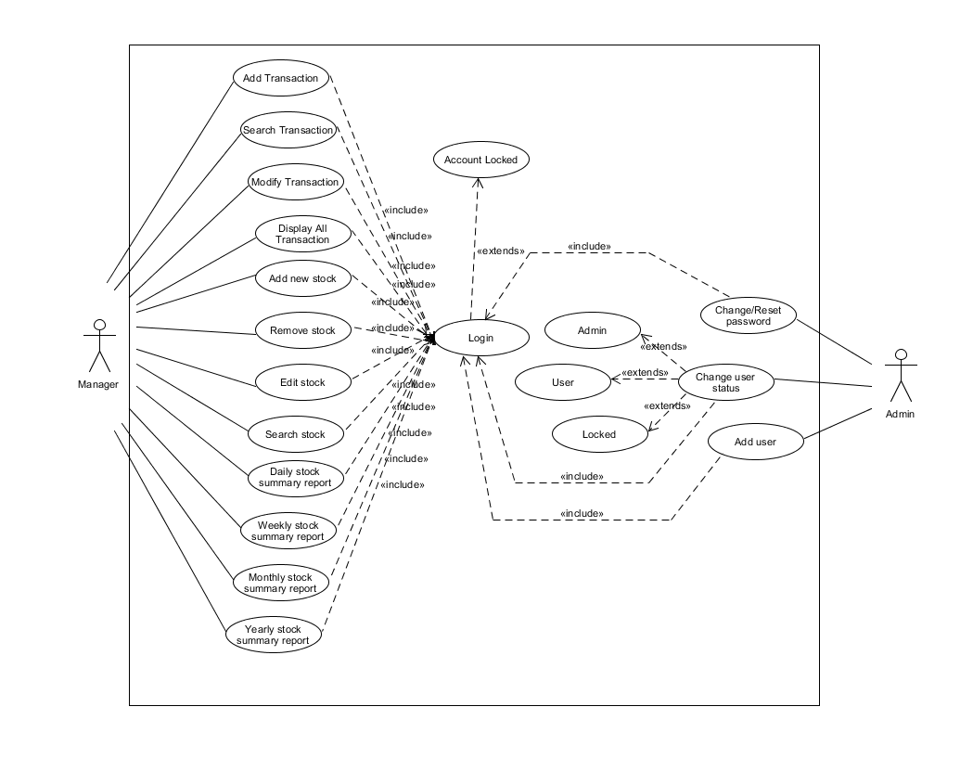

Design Artefacts - Activity Workflows (Iteration 1)

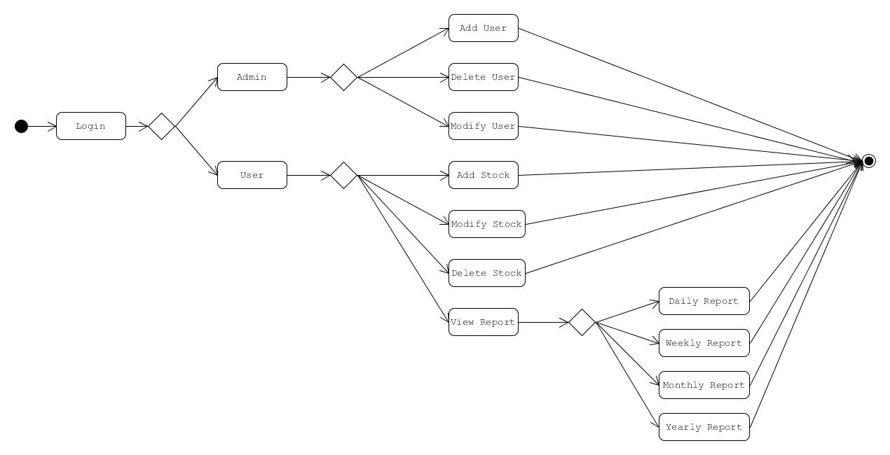

Design Artefacts - Activity Workflows (Iteration 2)

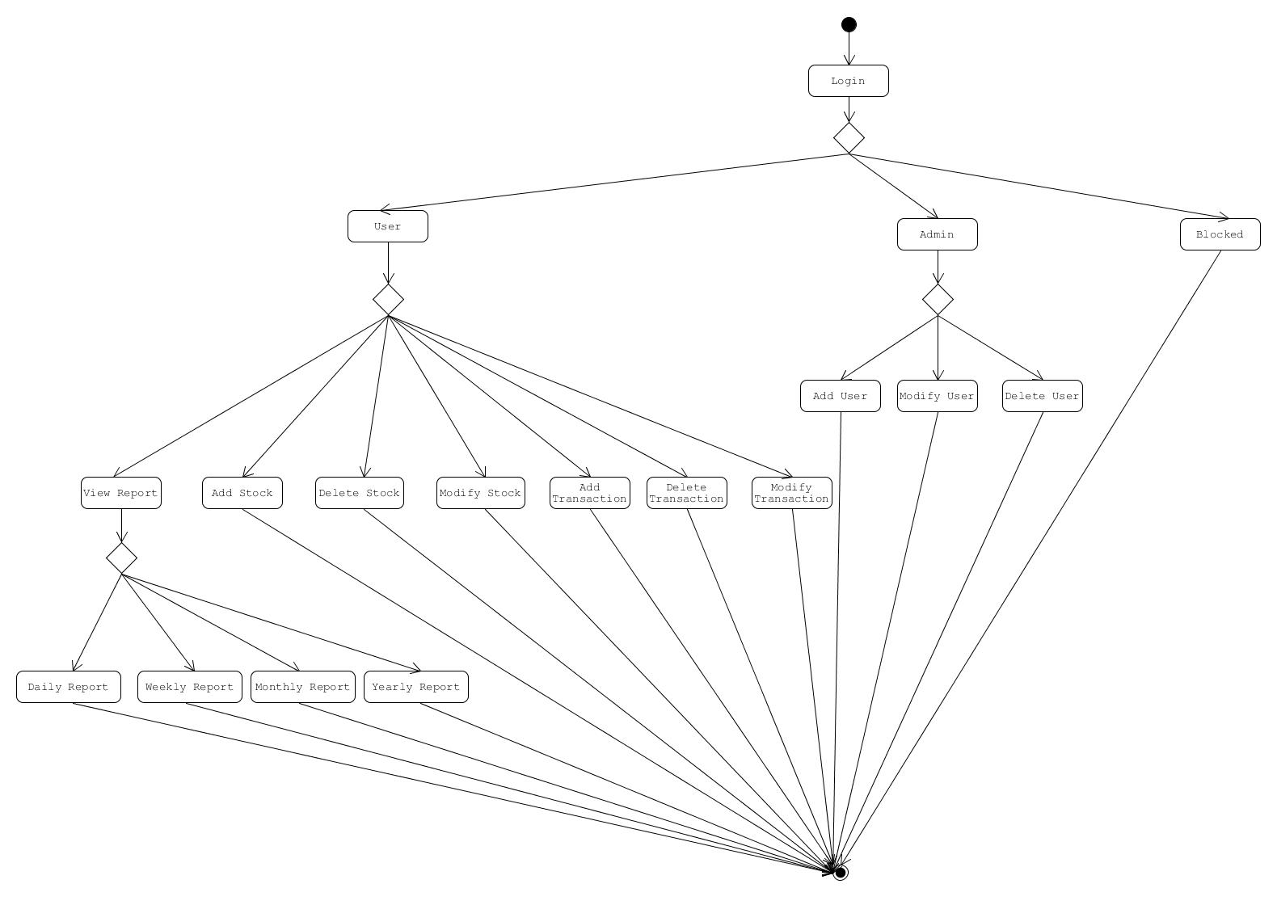

Design Artefacts – Activity Diagrams (Iteration 3)

Activity Overview
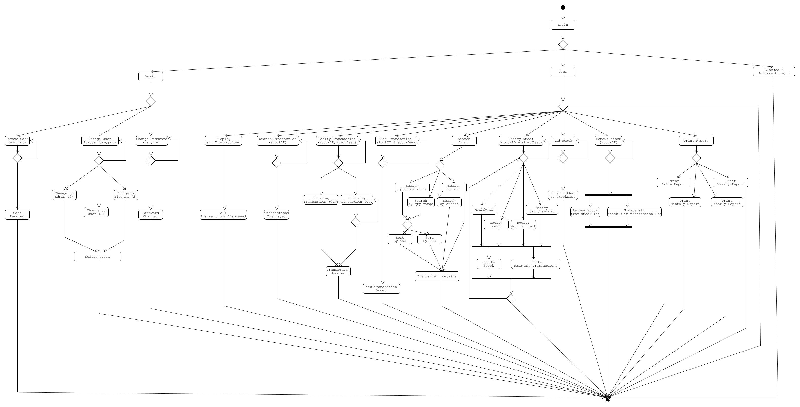

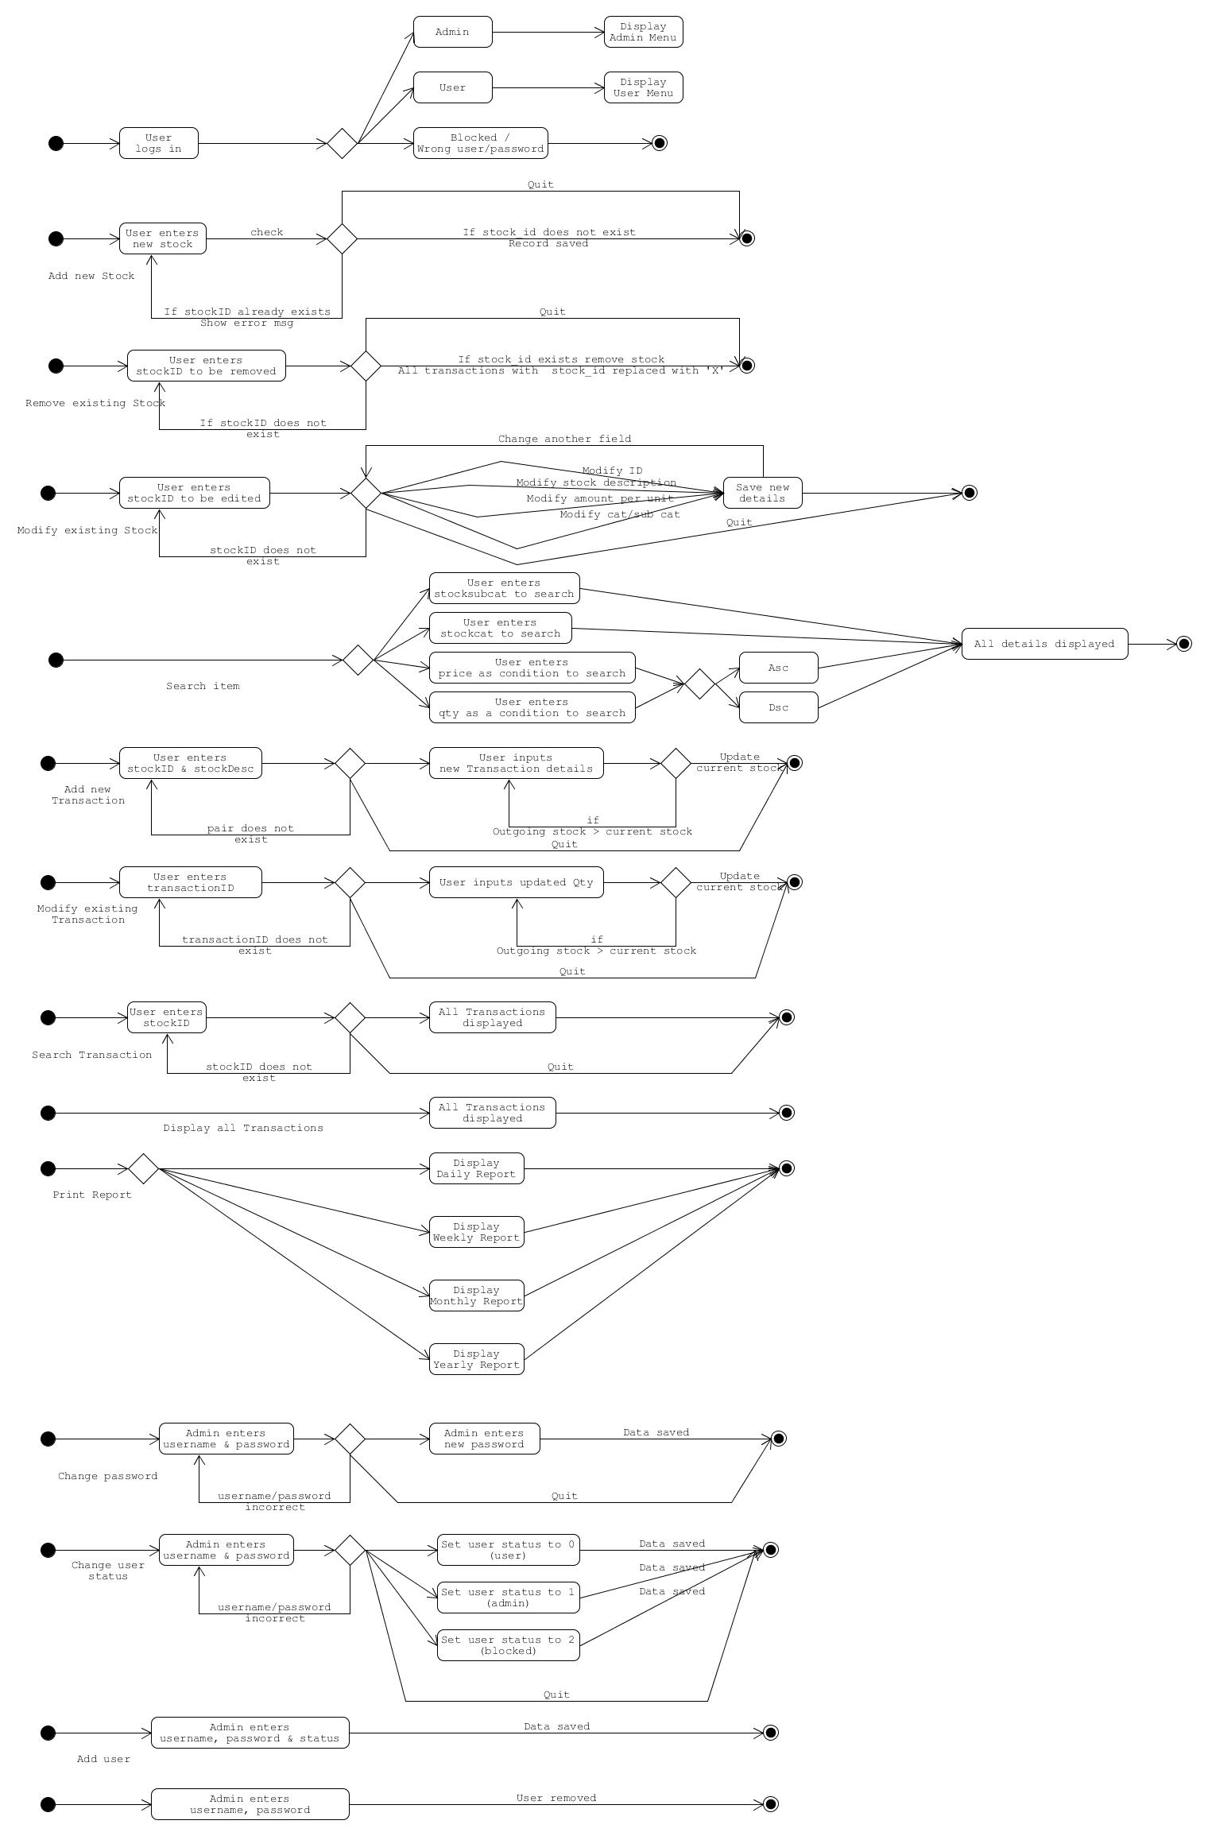

Design Artefacts - Component Diagrams (Iteration 1)

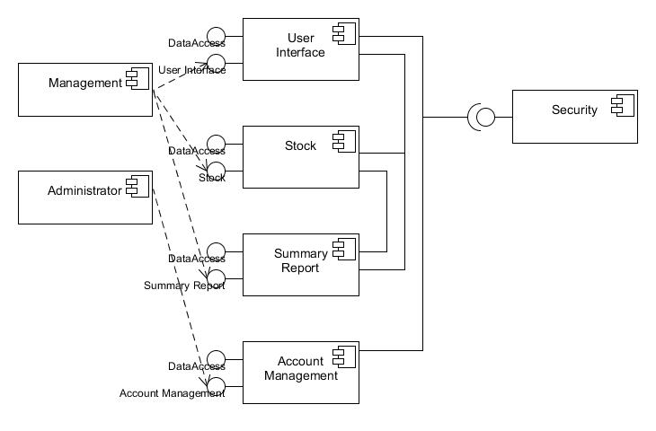

Design Artefacts - Component Diagrams (Iteration 2)

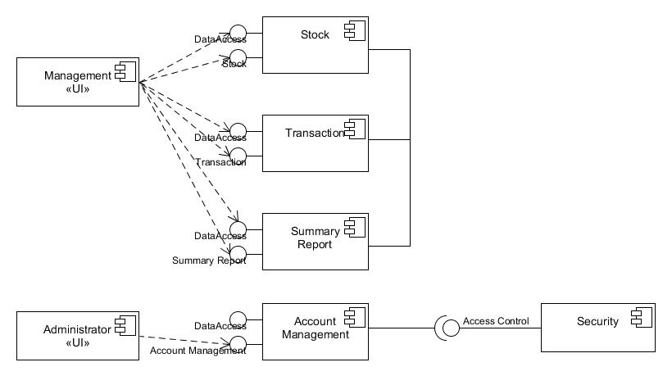

Design Artefacts - Class Diagrams (Iteration 1)

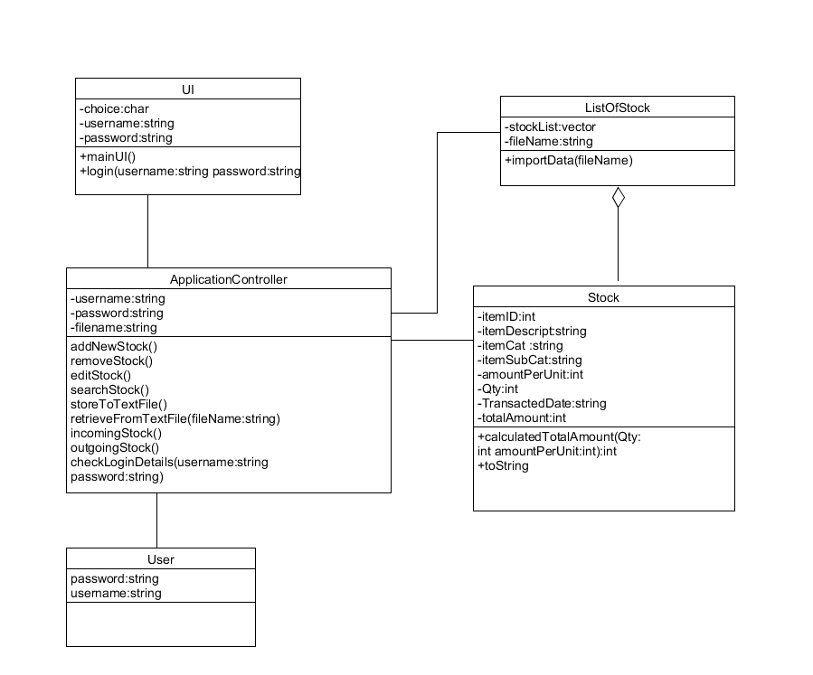

Design Artefacts - Class Diagrams (Iteration 2)

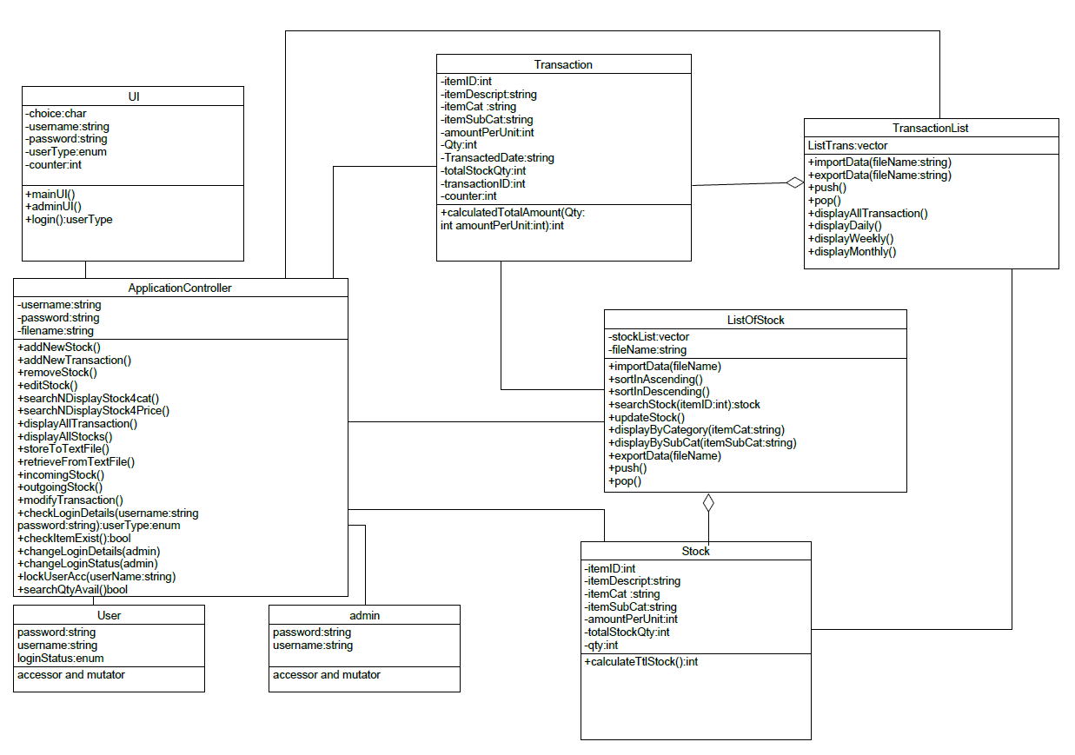

Design Artefacts - Class Diagrams (Iteration 3)
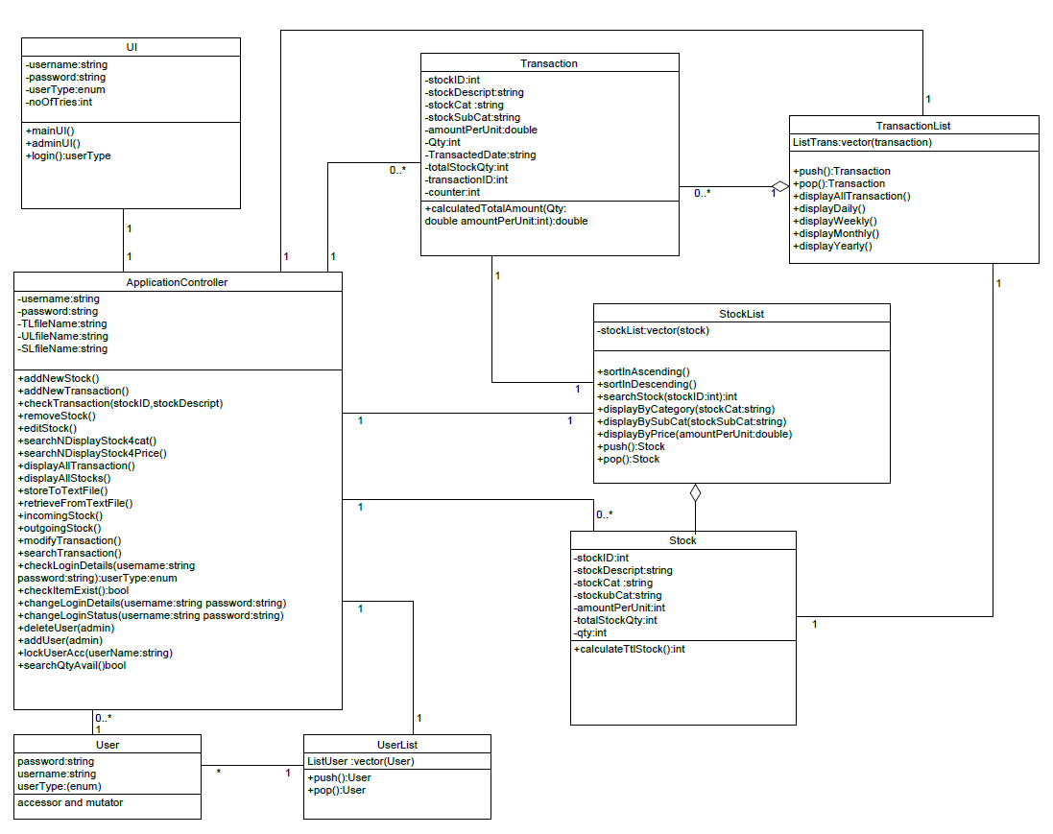

User -> Userlist (aggregation)

Design Artefacts – Sequence Diagrams (Iteration 1)

Sequence : Account Locked
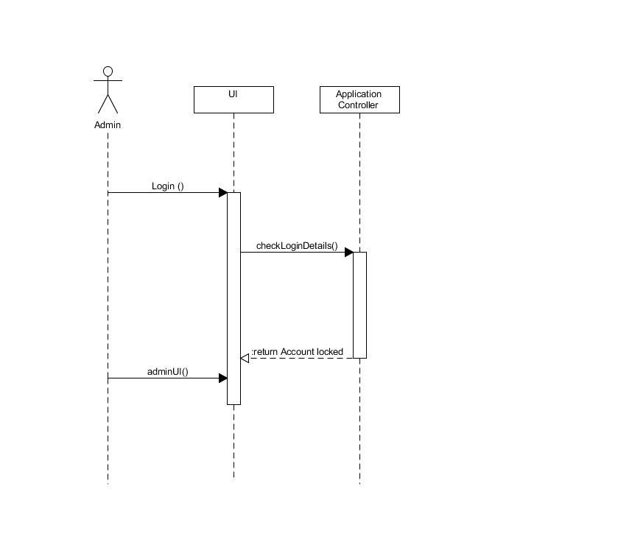

Design Artefacts – Sequence Diagrams (Iteration 1)

Sequence : Add User
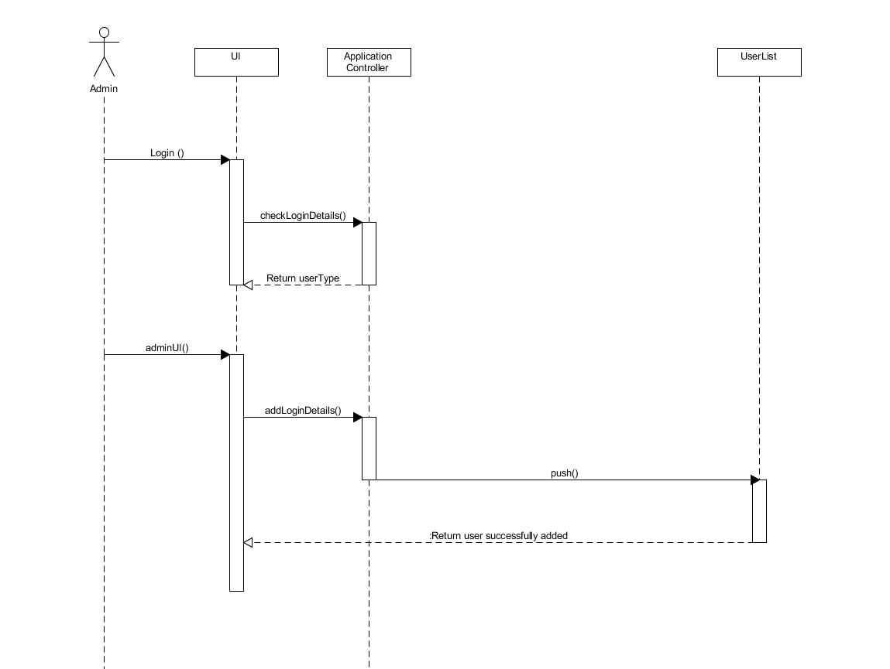

Design Artefacts - Sequence Diagrams (Iteration 1)

Sequence : Change Password
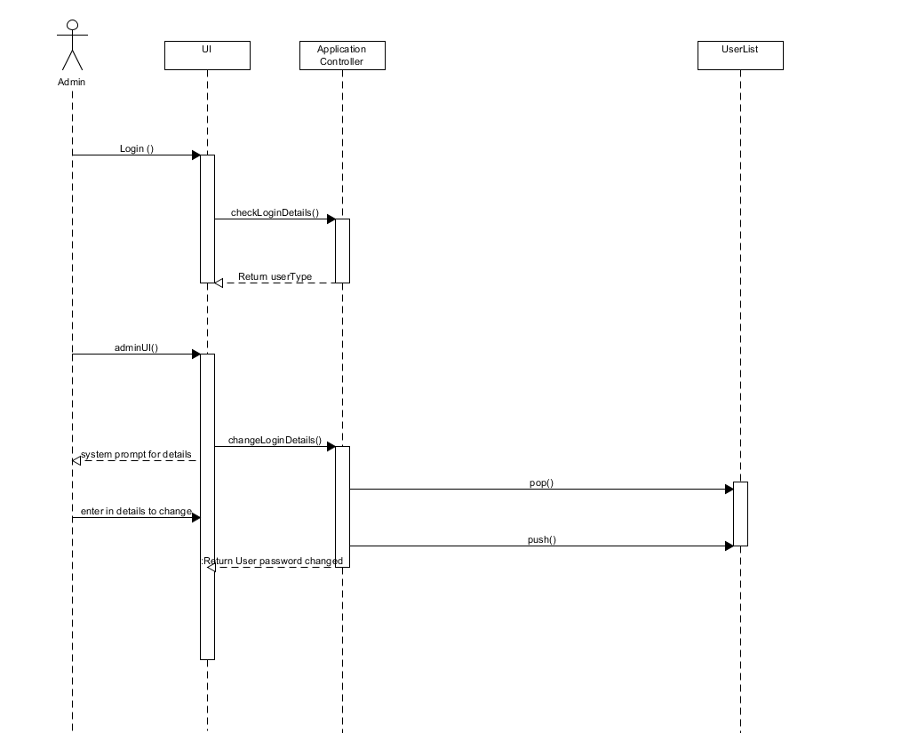

Design Artefacts - Sequence Diagrams (Iteration 1)

Sequence : Change User Status
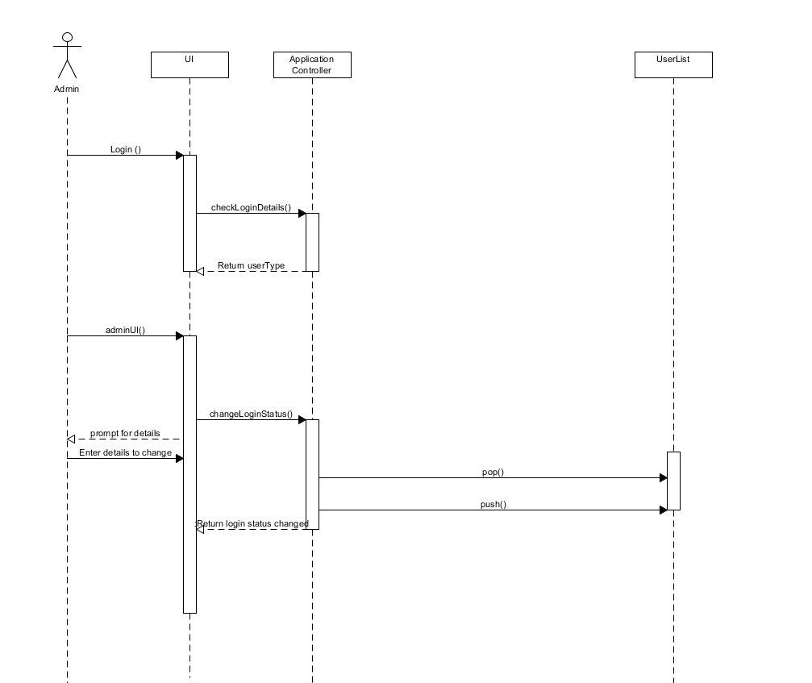

Design Artefacts - Sequence Diagrams (Iteration 1)

Sequence: edit item

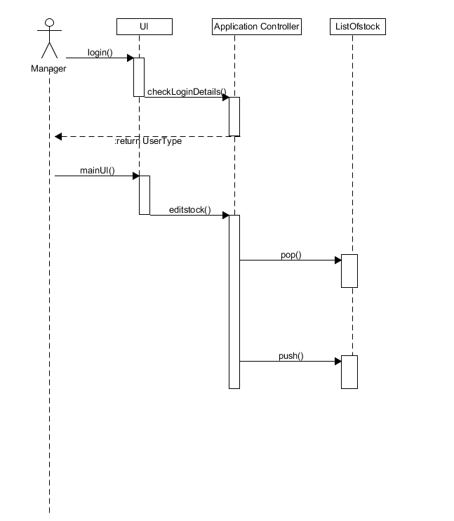

Design Artefacts - Sequence Diagrams (Iteration 1)

Sequence: search item
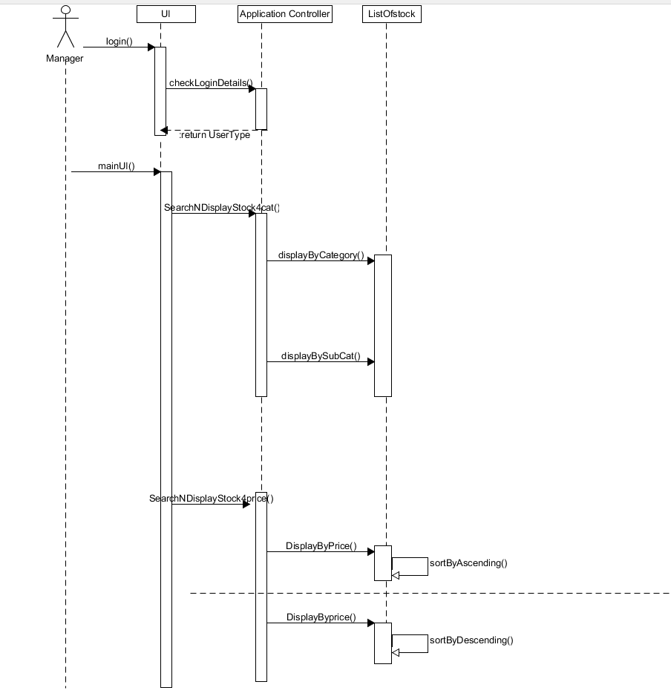

Design Artefacts - Sequence Diagrams (Iteration 2)

Sequence : Account Locked

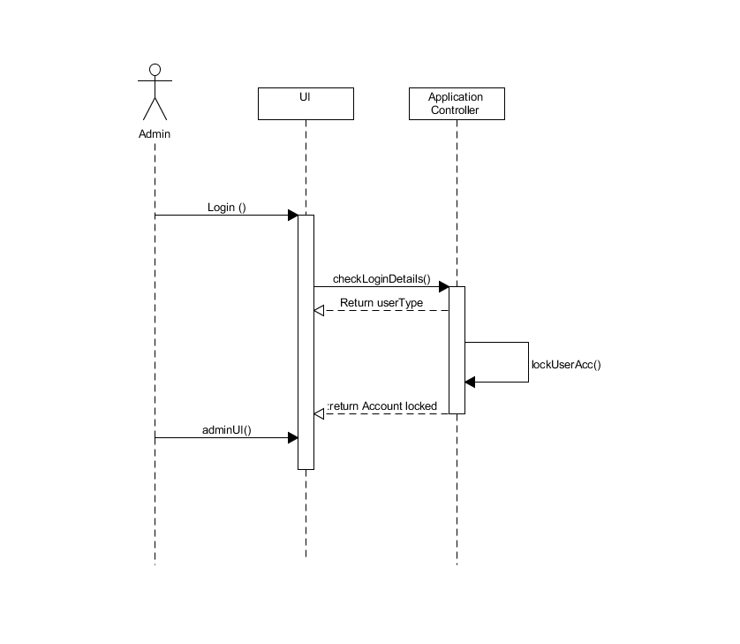
Design Artefacts - Sequence Diagrams (Iteration 2)

Sequence : Add User

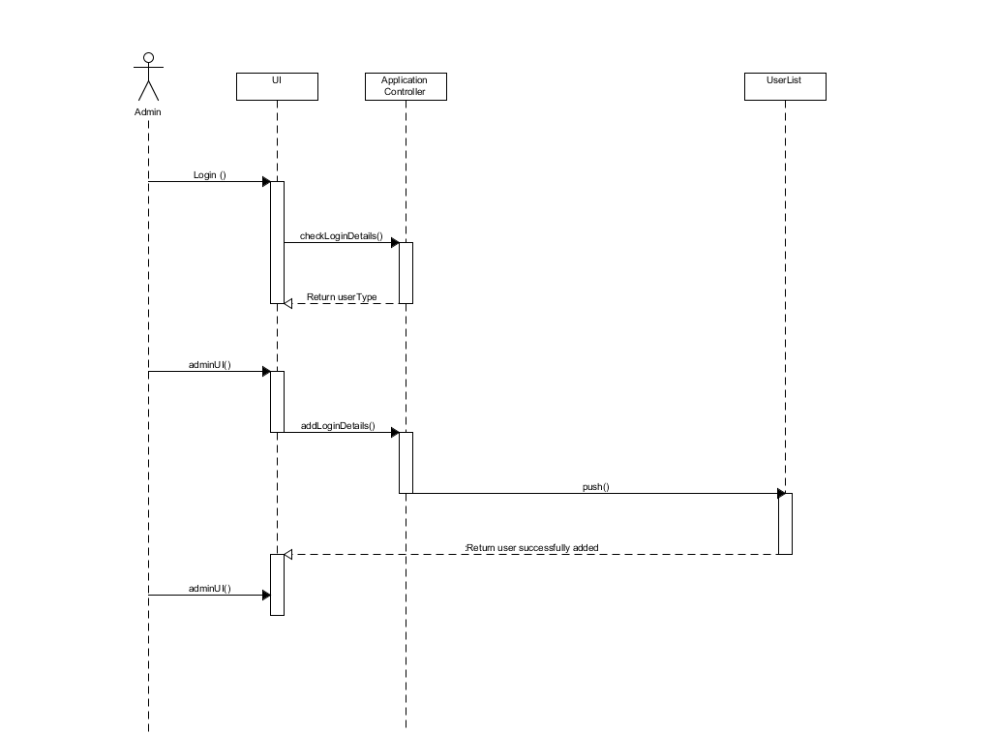

Design Artefacts - Sequence Diagrams (Iteration 2)

Sequence : Change Password

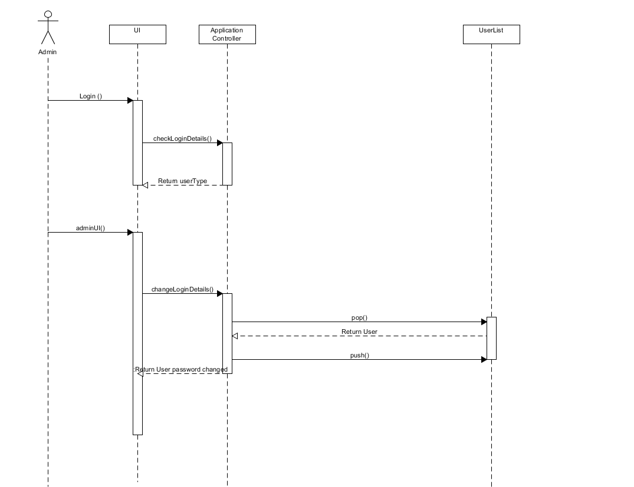

Design Artefacts - Sequence Diagrams (Iteration 2)

Sequence : Change User Status
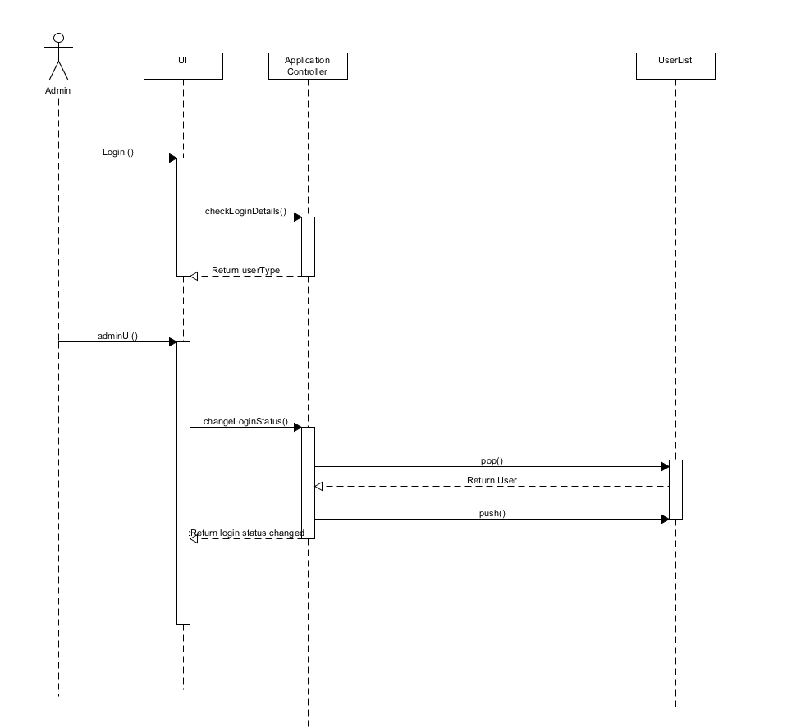

Design Artefacts - Sequence Diagrams (Iteration 2)

Sequence: Edit item 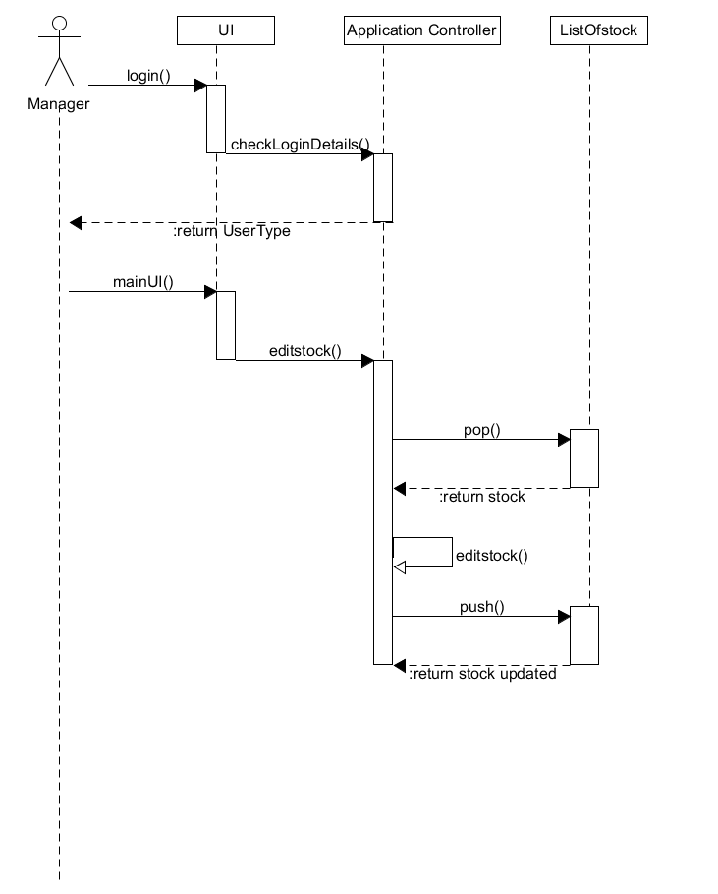

Design Artefacts - Sequence Diagrams (Iteration 2)

Sequence: Search item

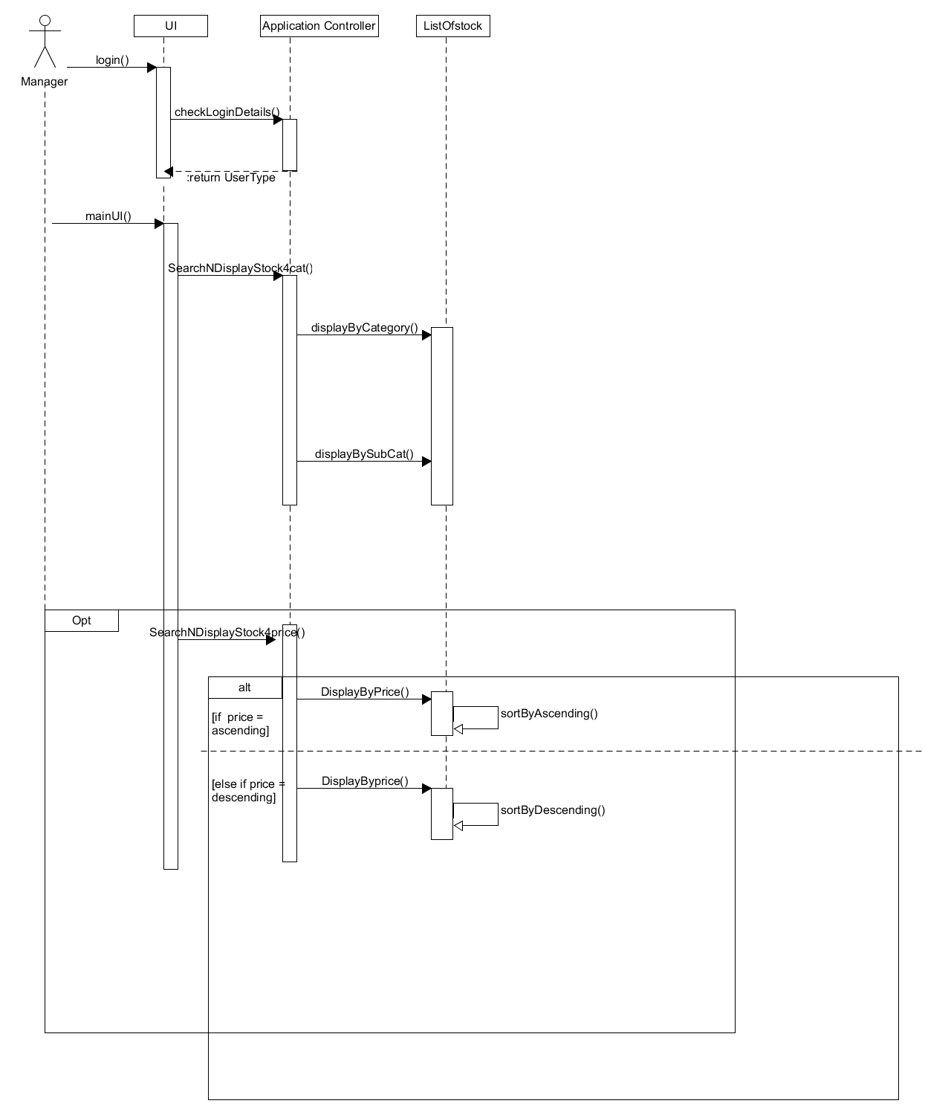

Design Artefacts – Data Dictionary (Iteration 2)

Class (Name) | Attribute Name | Description | Type | Format | Range | Req’d | Related Class(es) | Nature of relationship
ApplicationController | userName | Username of user | String |  |  | Y | User ,userList , UI | Association
ApplicationController | password | Password of user | String |  |  | Y | User ,userList , UI | Association
ApplicationController | ULFileName | Filename for User List | String |  |  | Y | User List | Association
ApplicationController | SLFileName | Filename for stock list | string |  |  | Y | Stock List | Associtation
ApplicationController | TLFileName | filename for transaction list | String |  |  | Y | Transaction LIst | Association
UI | username | Username of user | string |  |  | Y | ApplicationController | Associaiton
UI | password | Password of user | String |  |  | Y | ApplicationController | Associaiton
UI | noOfTries | The variable to count the number of time user tries to login | int |  |  | Y
UI | userType | User is admin,user or block | Enum |  |  | Y | ApplicationController | Association
User | userName | Username of user | String |  |  | Y | UserList | Association
User | password | Password of user | String |  |  |  | UserList | Association
User | userType | User is admin,user or block | Enum |  |  | Y | UserList | Association
Stock | stockID | ID for each stock | Int |  |  | Y | ListOfStock, TransactionList, Transaction | Association
Stock | stockDescript | Description of stock | String |  |  | Y | ListOfStock, TransactionList, Transaction | Association
Stock | stockCat | Category of stock | String |  |  | Y | ListOfStock, TransactionList, Transaction | Association
Stock | stockSubCat | Sub Category of stock | String |  |  | Y | ListOfStock, TransactionList, Transaction | Association
Stock | amountPerUnit | Amount per unit of stock | Double |  |  | Y | ListOfStock, TransactionList, Transaction | Association
Stock | totalStockQty | Total quantity of stock | Int |  |  | Y | ListOfStock, Transaction | Association
StockList | stockList | A vector of stock | Stock |  |  | Y | Stock | Aggregation
UserList | UserList | Vector of user | User |  |  | Y | User | Association
Transaction | stockID | ID for each stock | Int |  |  | Y | ListOfStock, TransactionList, Stock | Association
Transaction | stockDescript | Description of stock | String |  |  | Y | ListOfStock, TransactionList, Stock | Association
Transaction | stockCat | Category of stock | String |  |  | Y | ListOfStock, TransactionList, Stock | Association
Transaction | stockSubCat | Sub Category of stock | String |  |  | Y | ListOfStock, TransactionList, Stock | Association
Transaction | amountPerUnit | Amount per unit of stock | Double |  |  | Y | ListOfStock, TransactionList, Stock | Association
Transaction | totalStockQty | Total quantity of stock | Int |  |  | Y | ListOfStock, TransactionList, Stock | Association
Transaction | Qty | Amount of quantity of each transaction | Int |  |  | Y | TransactionList | Aggregation
Transaction | transactionID | Id of each transaction | Int |  |  | Y | TransactionList | Aggregation
Transaction | counter | Counter for transactionID | Int |  |  | Y | TransactionList | Aggregation
 | TransactedDate | Date of transaction | Date |  |  | Y | TransactionList | Aggregation
TransactionList | ListTrans | Vector of transaction | Transaction |  |  | Y | Transaction | Aggregation

Data Dictionary(Application Controller)

Class description
The application controller class contains all methods and functions that drive the application

Method description
-addNewStock()
- will add new stock that doesn’t exist in the stock database in to the list of stock
-checkItemExists():bool
- used to check if stock exist in the listOfStock based on the stockID

-addNewTransaction()
- add new transactions
-checkTransaction(stockID,stockDescript):bool
- implemented during add new transaction ,will check in the list of stock if stockID matches with its own stock description. Return true if matches else return false. This prevent the user from enter a correct stock ID but a different stock description which will result in incorrect transaction.
-removeStock()
- remove Stock from list of stock
-editStock()
- modify all values of stocks
-searchNDisplayStock4Cat()
- search List of stock and Display based on category
-searchNDisplayStock4Price()
- search list of stock and Display based on amount per unit
-displayAllTransaction()
- Display function that has has sub menu of daily,weekly,monthly ,yearly or all transaction that user wishes to display
-displayAllStock()
- Display all stock in list of stock

-storeToTextFile()
- A generic function to store vectors of UserList,TransactionList,StockList in to its individual text file.
-retrieveFromTextFile()
- A generic function to retrieve value from User List, transaction list stock list text file and store it into its respective vector
-incomingStock()
- Will add the qty to the the total stock qty of the specified stock based on the qty entered in new transaction
-outcomingStock()
- Will minus the qty to the the total stock qty of the specified stock based on the qty entered in new transaction
-modifyTransaction()
- If by any chance the user enter the wrong qty or amount per unit on a new transaction , this function will all the user to change that specific transaction based on transactionID.
-searchTransaction()
- Used in conjunction with modifyTransaction() to search for the transaction that u wish to modify.
-checkLoginDetails(username,password)
- Function used to change if username and password matches. If matches login
-changeLoginDetails(username,password)
- Change the password of user
-changeLoginStatus(username,password)
- An admin function.Change the userType enum 2 back to 1, from locked out to user. Or change a userType from user to admin
-deleteUser()
- Delete user from list of user
-addUser()
- Add user from list of user
-lockUserAcc(username)
- If user enter wrong pw more than 3 time this function change the enum status of user to locked
-searchQtyAvail():bool
- Search the total Qty of stock if current stock is < the outgoing stock .Return false.

Data Dictionary(Transaction)
Class description
The transaction class contain all attribute to store all required data for new transactions and method to calculate total cost of each transacation

Method Description
calculatedTotalAmount(Qty, amoutPerUnit
- Calculated the total cost of the transaction based on Qty*amountPerUnit

Data Dictionary(TransactionList)
Class description
The transactionList class contain all method to display Daily ,Weekly,Monthly Yearly or all transaction in the transactionList text file

Method Description
Push()
- modified transaction will be push back in to the vector of transaction
Pop()
- selected transaction will be retrieved

displayAllTransaction()
- display all transaction that stored in the transactionList text file
displayDaily()
- display all transaction that stored in the text file that are all made on the same day
displayWeekly()
- display all transaction that stored in the text file that are all made in the same week
displayMonthly()
- display all transaction that stored in the text file that are all made in the same month
displayYearly()
- display all transaction that stored in the text file that are all made in the same year

Data Dictionary(Stock)
Class description
Contains all attribute store all required data for new stock and method to calculate total qty of each stock

Method description
calculateTtlStock():int
- method to calculate the total qty each stock that is stored in the warehouse

Data Dictionary(StockList)
Class description
Contains all method to display stock based on their category, subcategory, price. Search for a specific stock based on stock id and able to sort the list in ascending or descending order based on price.
Method description
searchStock(stockID):int
- search for stock if it exist or not . if exist ,where is the stock in stockList and return the position index
displayByCategory(stockCat)
- display all stock based on category
displayBySubCat(stockSubCat)
- display all stock based on sub category
displayByPrice(amountPerUnit)
- display all stock by price.
Push()
- modified stock will be push back in to the vector of stock
Pop()
- selected stock will be retrieved
Appendix A - Formal Meeting Records

Inception Phase - Iteration 1

Team A3 Meeting – 2 February 2017
Meeting called to order at 9:45am by Leader, Timothy Chin.
Members Present:
Yu Xuan, Kenneth Yang, Yik Fei, Timothy Chin, Hui En, Marus Chen, Jamal Bin Radwan
Members Not Present:
None
Reading of Agenda:
To Allocate roles and responsibility
Plan the gantt chart.
To read up on the project, its scope and functionality and assign tasks.
Businesses:
- Motion from Yu Xuan: To select the members roles and responsibility
Role | Name
Team Lead/Manager | Timothy Chin
Lead Designer/Implementer | Yu Xuan
Designer/implementer/ Documentation | Kenneth Huang, Yik Fei, Hui En, Jamal Bin Radwan
System Integration and testing | Marcus feng

- Motion from Timothy: To read through Assignment 1 document to clearly define what tasks need to be done. To do the project, Netbeans subversion has been decided to be installed.
The unbuntu program will be distributed by and sent to every other member. SRS document, Initial UseCase, Gant Chart planning, all the diagrams listed in the word document.

Discussed initial use-case diagram and finished the initial use-case diagram.

Discuss Gannt chart-planning(Jamal has been decided to plan)

Look through the SRS report and decide who does which sections.

- Motion from Timothy: To split workload.
Name | Tasks
Kenneth | SRS Introduction
Yu Xuan | SRS Overall Description
Marcus | SRS System Features
Hui En | SRS External Interface Requirements
Timothy | Use Case
Jamal | Gantt Chart
Yik Fei | SRS Non-Functional Requirements & Other Requirements

- Assessment of minutes:
Minutes lasted 4 hours. Able to achieve listed agenda although it took a long time.
- Agenda for next meeting
Next meeting called on 7 February. Evaluate current progress of the project development. Check/validate SRS document, first iteration of diagrams.

Meeting adjourned at 1:45pm.
Meetings submitted by Leader, Timothy Chin

Elaboration Phase - Iteration 1

Team A3 Meeting – 7 February 2017
Meeting called to order at 3:00pm by Leader, Timothy Chin.
Members Present:
Yu Xuan, Kenneth Yang, Yik Fei, Timothy Chin, Hui En, Marus Chen, Jamal Bin Radwan
Members Not Present:
None
Reading of Agenda:
Approve previous meeting’s minutes
Check on current progress of project
Change or edit previous tasks split
Assign rest of the project tasks
Businesses:
- Previous meeting’s minutes approved.

- Motion from Timothy to check current progress on project:
Checked all members’ tasks and asked them to finalize changes and send to Timothy when done.
Timothy will compile the SRS and the report and look through and check.

- Assign the rest of the project tasks:

Name | Task
Timothy | Risk Analysis, Sequence Diagram (Chg Reset Pwd, Chg User, Add User)
Yu Xuan | Activity Workflow Diagram
Hui En | Component Diagram
Kenneth | Class Diagram
Jamal | Sequence Diagram
Yik Fei | Sequence Diagram (Edit Stock, Search Stock)
Marcus | Sequence Diagram
.
- Assessment of minutes:
Minutes lasted 3 hours.
- Agenda for next meeting
Next meeting called on 7 February. Evaluate current progress of the project development. Check first iteration of diagrams.

Meeting adjourned at 6:11pm.
Meetings submitted by Leader, Timothy Chin

Elaboration Phase - Iteration 2

Team A3 Meeting – 16 February 2017
Meeting called to order at 3:30pm by Leader, Timothy Chin.
Members Present:
Yu Xuan, Kenneth Yang, Yik Fei, Timothy Chin, Hui En, Marus Chen, Jamal Bin Radwan
Members Not Present:
None
Reading of Agenda:
Assess progress of project.
Evaluate if any changes need to be made.
Ask everyone to start adding to the report when done.
Businesses:
- Motion from Timothy to Checking of members’ current progress:
  - Checking of Activity Workflow Diagram finalized.
  - Checking of Component Diagram finalized.
  - Checking of Class Diagram finalized.
  - Checking of Sequence Diagram finalized.
  - Some Sequence Diagrams progress is still underway.

- Assessment of minutes:
Minutes lasted 3 hours and 45 minutes.

- Agenda for next meeting
There should be no more meetings. Work should be completed and compiled by 20 Feb. If need be, meeting will be called on 20 February to add finishing touches.

Meeting adjourned at 6:45pm.
Meetings submitted by Leader, Timothy Chin

Appendix B - Individual Work Diaries

Team Member 1 : Timothy Chin

Inception Phase - Iteration 1

Date : 6/2/2017 to 6/2/2017
No. | Description | Date | Time
1 | Create the initial Use Case diagram using UMLET. | 6/2 | 40mins
2 | Look through the previous meeting’s minutes to check if there is anything discrepancies. | 6/2 | 30mins
3 | Check through the initial use case to see if there’s anything to add. | 6/2 | 30mins
4 | Start progress on the risk analysis and think of countermeasures. | 6/2 | 1hr30mins

Elaboration Phase - Iteration 1

Date : 8/2/2017 to 12/2/2017
No. | Description | Date | Time
1 | Finalizing of UseCase Diagram using UMLET | 8/2 | 30mins
2 | Look through the previous meeting’s minutes to check if there is anything discrepancies. | 8/2 | 15mins
3 | Checking of other member’s work | 10/2 | 1hr
4 | Do Sequence UseCase scenario | 11/2 | 30mins
5 | Start abit on the Sequence Diagram | 12/2 | 30mins

Elaboration Phase - Iteration 2

Date : 16/2/2017 to 16/2/2017
No. | Description | Date | Time
1 | Checking and assessing member’s work. | 16/2 | 1hr40mins
2 | Check through SRS and add in last part. | 16/2 | 10mins
3 | Start finalizing the Sequence Diagram. | 16/2 | 1hr10mins

Team Member 2 : Yee Yik Fei

Inception Phase - Iteration 1

Date: 5/2/2017 to 5/2/2017
No. | Description | Date | Time
1 | Research on the SRS document part given functional and nonfunctional along with other requirements stated. | 5/2 | 1hr
2 | Added the information that I found of functional to the SRS document | 5/2 | 15mins
3 | Nonfunctional and other requirements was also added after checking thru | 5/2 | 20mins
4 | Checking thru the part of SRS if it fits to the requirement of the software | 5/2 | 10mins

Elaboration Phase - Iteration 1

Date: 8/2/2017 to 11/2/2017
No. | Description | Date | Time
1 | Reading thru the initial class diagram and use case diagram | 8/2 | 30mins
2 | sketching out the draft sequence diagram base on the given use case scenario. | 8/2 | 20mins
3 | Implementing the basic sequence diagram on Umlet | 8/2 | 30mins
4 | Plotting the 2nd iteration of the sequence diagram | 11/2 | 20mins

Elaboration Phase - Iteration 2

Date: 14/2/2017 to 16/2/2017
No. | Description | Date | Time
1 | Implementing the 2nd iteration of the sequence diagram | 14/2 | 1hr15mins
2 | Making changes to the sequence diagram regarding some of the function name base on class diagram. | 15/2 | 15mins
3 | Checking the flow of sequence with team member | 15/2 | 20mins
4 | Finalizing sequence diagram | 16/2 | 15mins

Team Member 3 : Soh Yu Xuan
Inception Phase - Iteration 1

Date : 6/2/2017 to 7/2/2017
No. | Description | Date | Time
1 | Read through SRS Requirements, did a rough sketch of SRS requirements | 6/2 | 40mins
2 | Read through Assignment details, drew out possible functionalities and requirements | 6/2 | 40mins
3 | Completed SRS written component, drew out rough iteration of an Activity Diagram | 7/2 | 1hr
4 | First iteration for Activity Diagram completed, read up and planned required functionalities and processes of the application | 7/2 | 1hr30mins

Elaboration Phase - Iteration 1

Date : 8/2/2017 to 11/2/2017
No. | Description | Date | Time
1 | Second iteration for Activity Diagram started, discussed and planned program structure and required functionalities for the application | 8/2 | 40mins
2 | Rewritten SRS written component | 10/2 | 20mins
3 | Second iteration for Activity Diagram completed | 10/2 | 30mins
4 | Liaised with the rest of the team, third iteration for Activity Diagram started | 11/2 | 30mins

Elaboration Phase - Iteration 2

Date : 14/2/2017 to 16/2/2017
No. | Description | Date | Time
1 | Checked through requirements with Class and Use Case Diagrams, redid several aspects of the third iteration | 14/2 | 1hr10mins
2 | Started on the overview Activity Diagram | 14/2 | 40mins
3 | Checked Activity Diagram, added functionalities for Admin and user. Completed overview Activity Diagram | 15/2 | 40mins
4 | Third iteration for Activity Diagram completed | 16/2 | 1hr

Team Member 4 : Ng Hui En

Inception Phase - Iteration 1

Date: 5 February to 5/2/2017
No. | Description | Date | Time
1 | Went through the template details of allocated SRS section and research on it | 5/2 | 1hr
2 | Written a draft of the external interface requirements | 5/2 | 15mins
3 | Refined the draft with better description after comparing with the actual software requirements | 5/2 | 45mins
4 | Finalised the SRS content | 5/2 | 10mins

Elaboration Phase - Iteration 1

Date: 10/2/2017 to 13/2/2017
No. | Description | Date | Time
1 | Research on how the component diagram works and understand the structure | 10/2 | 1hr
2 | Come up with the draft of component diagram with reference to the software requirements on paper | 13/2 | 45mins
3 | Drawing the first iteration of component diagram with UMLet | 13/2 | 30mins

Elaboration Phase - Iteration 2

Date: 16/2/2017 to 18/2/2017
No. | Description | Date | Time
1 | Edited the first iteration of the component diagram after checking with team members as some components | 16/2 | 1hr
2 | Referencing with other updated diagrams whether any other details need to be added | 16/2 | 30mins
3 | Finalised the second iteration of component diagram | 18/2 | 10mins

Team Member 'N' : Xxxx Xxxx

Inception Phase - Iteration 1

- Copy and Paste your formal meeting minutes for Inception Phase, iteration 1 here.
- You can refer to Assn 1 Qn Paper, Appendix B, bullet point 5 for a summary of contents to be included.
- Note: this section can span as many pages as necessary

Elaboration Phase - Iteration 1

- Copy and Paste your formal meeting minutes for Elaboration Phase, iteration 1 here.
- You can refer to Assn 1 Qn Paper, Appendix B, bullet point 5 for a summary of contents to be included.
- Note: this section can span as many pages as necessary

Elaboration Phase - Iteration 2

- Copy and Paste your formal meeting minutes for Elaboration Phase, iteration 2 here.
- You can refer to Assn 1 Qn Paper, Appendix B, bullet point 5 for a summary of contents to be included.
- Note: this section can span as many pages as necessary

Team Member 'N' : Xxxx Xxxx

Inception Phase - Iteration 1

- Copy and Paste your formal meeting minutes for Inception Phase, iteration 1 here.
- You can refer to Assn 1 Qn Paper, Appendix B, bullet point 5 for a summary of contents to be included.
- Note: this section can span as many pages as necessary

Elaboration Phase - Iteration 1

- Copy and Paste your formal meeting minutes for Elaboration Phase, iteration 1 here.
- You can refer to Assn 1 Qn Paper, Appendix B, bullet point 5 for a summary of contents to be included.
- Note: this section can span as many pages as necessary

Elaboration Phase - Iteration 2

- Copy and Paste your formal meeting minutes for Elaboration Phase, iteration 2 here.
- You can refer to Assn 1 Qn Paper, Appendix B, bullet point 5 for a summary of contents to be included.
- Note: this section can span as many pages as necessary

Team Member 'N' : Xxxx Xxxx

Inception Phase - Iteration 1

- Copy and Paste your formal meeting minutes for Inception Phase, iteration 1 here.
- You can refer to Assn 1 Qn Paper, Appendix B, bullet point 5 for a summary of contents to be included.
- Note: this section can span as many pages as necessary

Elaboration Phase - Iteration 1

- Copy and Paste your formal meeting minutes for Elaboration Phase, iteration 1 here.
- You can refer to Assn 1 Qn Paper, Appendix B, bullet point 5 for a summary of contents to be included.
- Note: this section can span as many pages as necessary

Elaboration Phase - Iteration 2

- Copy and Paste your formal meeting minutes for Elaboration Phase, iteration 2 here.
- You can refer to Assn 1 Qn Paper, Appendix B, bullet point 5 for a summary of contents to be included.
- Note: this section can span as many pages as necessary

Appendix C - Evidence of using VCS (Version Control Software)

Version Control Software used : (E.g. Netbeans subversion, TortiseSVN, etc)

Note 1 : The following screenshots can span as many pages as necessary

Note 2 : Please ensure that all the wordings / text in your screen shots are clearly visible

Screenshot #1 - Contents in the VCS's Root Folder containing all Repository Project Files

< Paste Screenshot #1 image here >

Screenshot #2 - VCS's listing of all the latest source files currently being managed

< Paste Screenshot #2 image here >

Screenshot #3 - Example using VCS's to check-out source files (it may be necessary to do >1 screen capture, depending on the software used)

< Paste Screenshot #3 image(s) here >

Screenshot #4 - Example using VCS's to check-in source files (it may be necessary to do >1 screen capture, depending on the software used)

< Paste Screenshot #4 image(s) here >

Screenshot #5 - Example using VCS's to display the change history / log (it may be necessary to do >1 screen capture, depending on the software used)

< Paste Screenshot #5 image(s) here >

