A
CSCI222
Assignment 1

Team A3

CSCI222 Assignment 1 Report

Team Number : Team A3
 | Student Number | Name | Email Address
1 | 5498508 | (Team Leader)  Muhammad Jamal | Tel : 93834557  Email : jamalrad156@yahoo.com
2 | 5498442 | Kenneth Huang Shun Yang | ft_kenneth_huang@yahoo.com
3 | 5498715 | Yee Yik Fei | yikfei@yahoo.com
4 | 5282767 | Ng Hui En | huien92@yahoo.com.sg
5 | 5498387 | Marcus Chen Feng | Marcus_chen3@hotmail.com
6 | 5498399 | Chin Tian Zhi Timothy | chin_tian_zhi_timothy@yahoo.com
7 | 5498636 | Soh Yu Xuan | yuxuannn@gmail.com

Contents
- Project Overview
- Roles and Responsibility
- Risk Analysis and Counter Measures
- Design Artefacts – Use Case (Iteration 1)
- Design Artefacts – Use Case (Iteration 2)
- Design Artefacts – Activity Workflows (Iteration 1)
- Design Artefacts – Activity Workflows (Iteration 2)
- Design Artefacts – Activity Workflows, Overview (Iteration 3)
- Design Artefacts – Activity Workflows, (Iteration 3)
- Design Artefacts – Sequence Diagrams (Iteration 1)
- Design Artefacts – Sequence Diagrams (Iteration 2)
- Data Dictionary
- Appendix A (Formal Meeting Records)
- Appendix B (Individual Work Diaries)
- Appendix C (Evidence of VCS)

Project Overview

- "Vision"

The purpose of the Warehouse Management System is to provide efficient bookkeeping of stock in a Warehouse environment. The system has a login feature that allows the personnel with the corresponding privileges to login in to the system while safely securing the data stored in the system. In the case where there are 3 unsuccessful login attempts, the user will be locked out of the system. Someone who is of an admin privilege would have to login to the system and change the user locked out status and change his password so that the user would be able to login.

Another purpose of the software, is the ability to add/update records, edit records, searching and display of stock based on price range and quantity. There are four options the stock can be displayed, daily summary, weekly summary, monthly summary and yearly summary. The software can also add transactions, remove transactions and search transactions.

- Initial Use-Case Model

There are 2 actors. The Manager and Admin. The Manager is the main user of the system that should interact with the system on a daily basis. Manager will be using all the functionalities the system has to offer.

The Admin is needed to maintain the system and to facilitate the unlocking of accounts upon 3 failed login attempts.
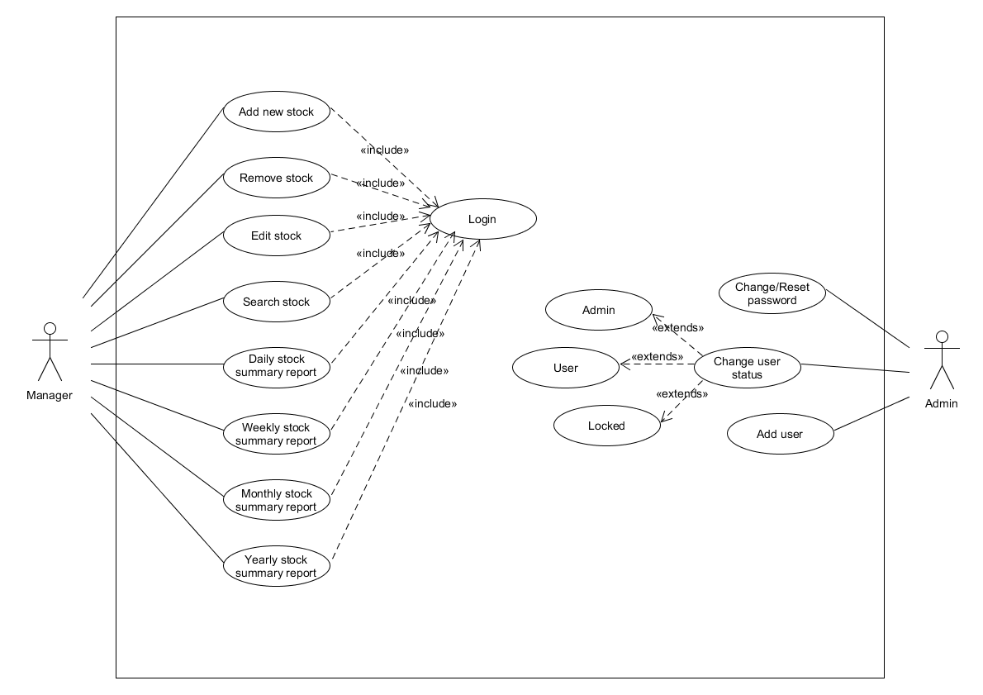

- Project Plan
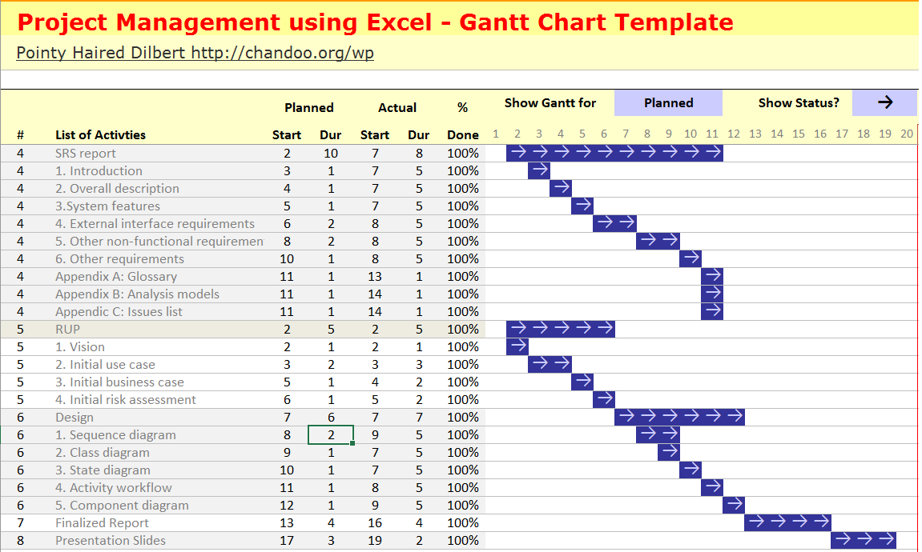

Roles and Responsibility

Team Number : Team A3

 | Student Name | Role | Artefacts
1 | Muhammad Jamal | Team Lead/Manager | Use Case, Minutes of Meetings, Sequence Diagram
2 | Soh Yu Xuan | Lead Designer/Implementer | SRS Introduction, Class Diagram
3 | Kenneth Huang | Designer/implementer/ Documentation | SRS Non Functional Requirements, SRS Other Requirements, Sequence Diagram
4 | Timothy Chin | Designer/implementer/ Documentation | SRS External Interface Requirements, Component Diagram
5 | Marcus Chen | Designer/implementer/ Documentation | SRS System Functions, Sequence Diagram
6 | Ng Hui En | Designer/implementer/ Documentation | Gantt Chart planning, Sequence Diagram
7 | Yee Yik Fei | System Integration and testing | SRS Overall Description, Activity Workflow Diagram

Risk Analysis and Counter Measures

 | Impact Type | Risk Seriousness (%) | Likelihood of Occurrence (%) | WBS  (affected work / task ) | Risk Description
1 | Deadline | 80% | 5% | Completion | All team members fall sick and unable to complete their tasks on time.
2 | Deadline | 90% | 10% | Completion | All team members start to argue and fight amongst each other delaying actual work done.
3 | Deadline | 60% | 5% | Completion | Some team members are new or still not used to C++ and have not learnt the appropriate tools to properly code.
4 | Deadline | 20% | 2% | Completion | Computer breaks down and needs to be repaired. Slows down the progress of the project.
5 | Successful Completion of Task | 90% | 0.5% | Completion | Team member comes down with terminal illness, fatal accident or needs hospitalization.
6 | Successful Completion of Task | 85% | 1% | Completion | Team member quits school.
7 | Deadline | 20% | 5% | Completion | Team member has work outside of school and cannot attend project meetings.
8 | Deadline | 70% | 10% | Completion | Poor planning to support the development of the project.
9 | System | 70% | 10% | System Functionality | Coding language may not support certain functionality required in the system
10 | System | 100% | 2% | System Security | Breach of user id, password and subsequently details via brute force hacking
11 | Data | 30% | 10% | System Data | Cloud server used to store user / admin logs are insufficient / too slow / unreliable

 | Risk Description | Proposed Mgmt Plan | (Possible) Reduction in Risk Seriousness (%)
1 | All team members fall sick and unable to complete their tasks on time. | Plan 1 : Advise member to be vigilant and try not to fall sick. | -25%
1 |  | Plan 2 : Provide free medical healthcare. | -25%
2 | All team members start to argue and fight amongst each other delaying actual work done. | Plan 1 : Leader mediates and controls the discussions between members to hindering actual work. | -50%
2 |  | Plan 2 : Impose penalties if work is delayed. (lesser group contribution in peer evaluation) | -30%
3 | Some team members are new or still not used to C++ and have not learnt the appropriate tools to properly code. | Plan 1 : Stronger members can take out time to educate and help weaker team members. | -15%
3 |  | Plan 2 : Stronger members can team up with the weaker members. The stronger members will cover the weaknesses of the other person. | -30%
4 | Computer breaks down and needs to be repaired. Slows down the progress of the project. | Plan : Backup data to cloud storage everytime someone accesses the files. | -60%
5 | Team member comes down with terminal illness or fatal accident. | Plan : Have members team up so they know what each other is doing. The other person will be updated to their progress and work done. | -20%
6 | Team member quits school. | Plan : Create a system to record a detailed description of the progress of a member’s work done in the project. | -50%
7 | Team member has work outside of school and cannot attend project meetings. | Plan : Plan meetings on days where members do not have work scheduled. | -75%
8 | Poor planning to support the development of the project. | Plan : Have the leader plan the project and to oversee the planning to make sure everything is on track. | -50%
9 | Coding language may not support certain functionality required in the system | Plan : Study requirements carefully to ensure functionality in the language is sufficient to meet needs | -10%
10 | Breach of user id, password and subsequently details via brute force hacking | Plan : Two factor authentication (via sms) to verify that it's the correct user logging in | -2%
11 | Cloud server used to store user / admin logs are insufficient / too slow / unreliable | Plan : Ensure data type stored can be ported over to another cloud storage provider easily | -10%

Design Artefacts - Use Cases (Inception Iteration 1)

Design Artefacts - Use Cases (Elaboration Iteration 2)

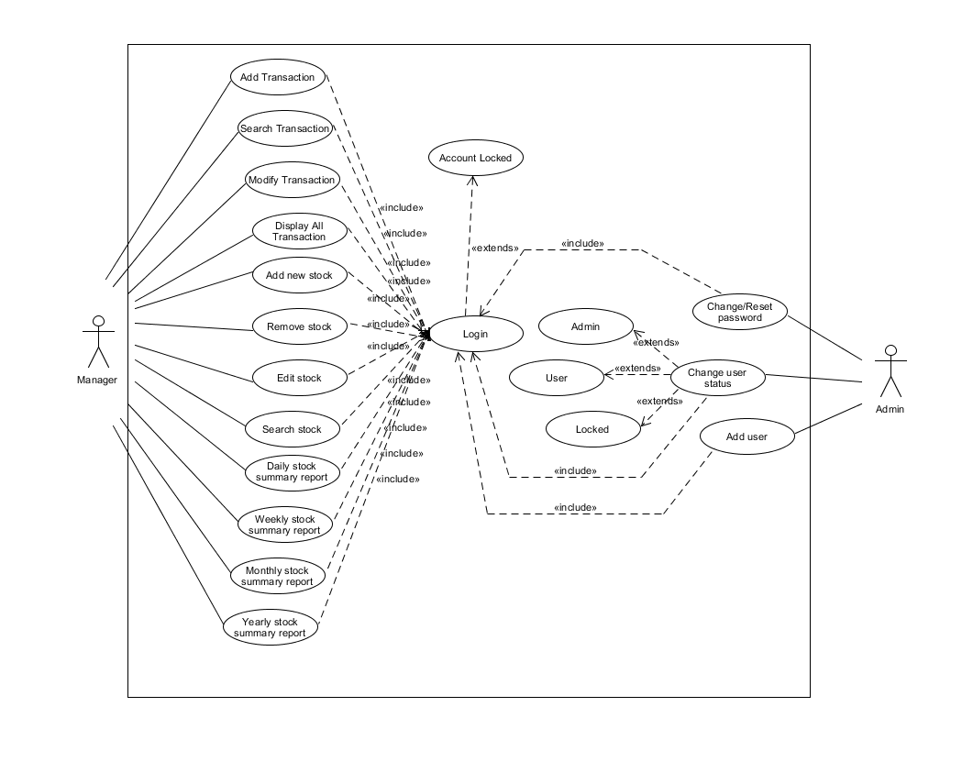
- Added in more use cases

Design Artefacts - Use Cases (Construction Iteration 1)

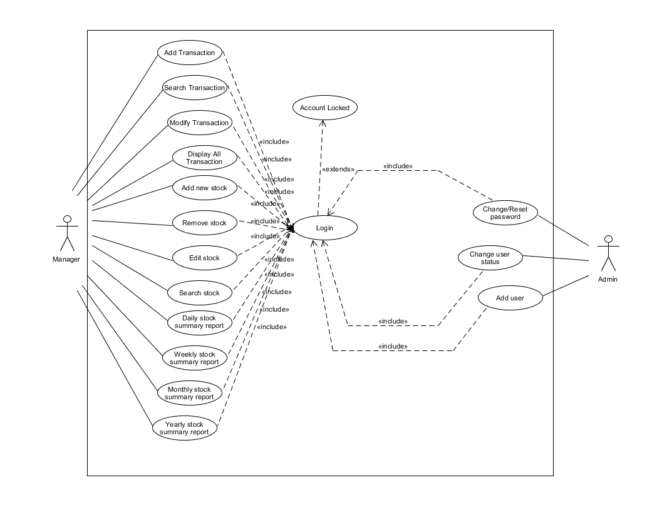

- Removed change user status <<excludes>>

Design Artefacts - Activity Workflow (Elaboration Iteration 1)

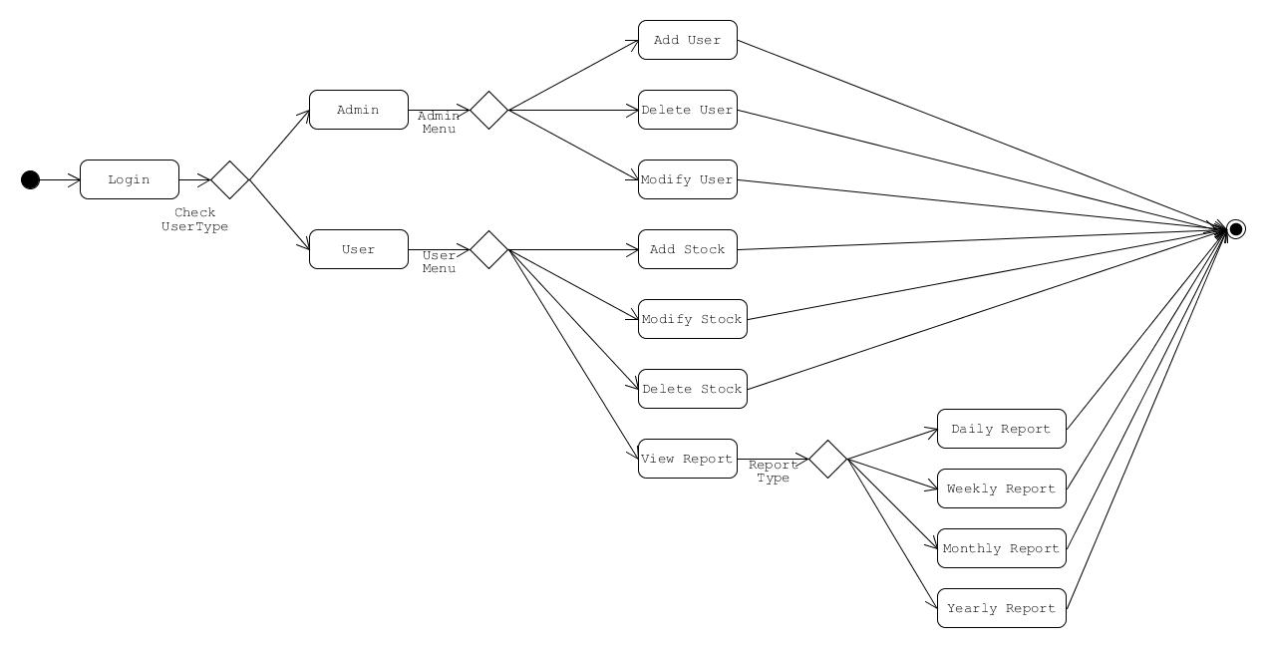

Design Artefacts - Activity Workflow (Elaboration Iteration 2)

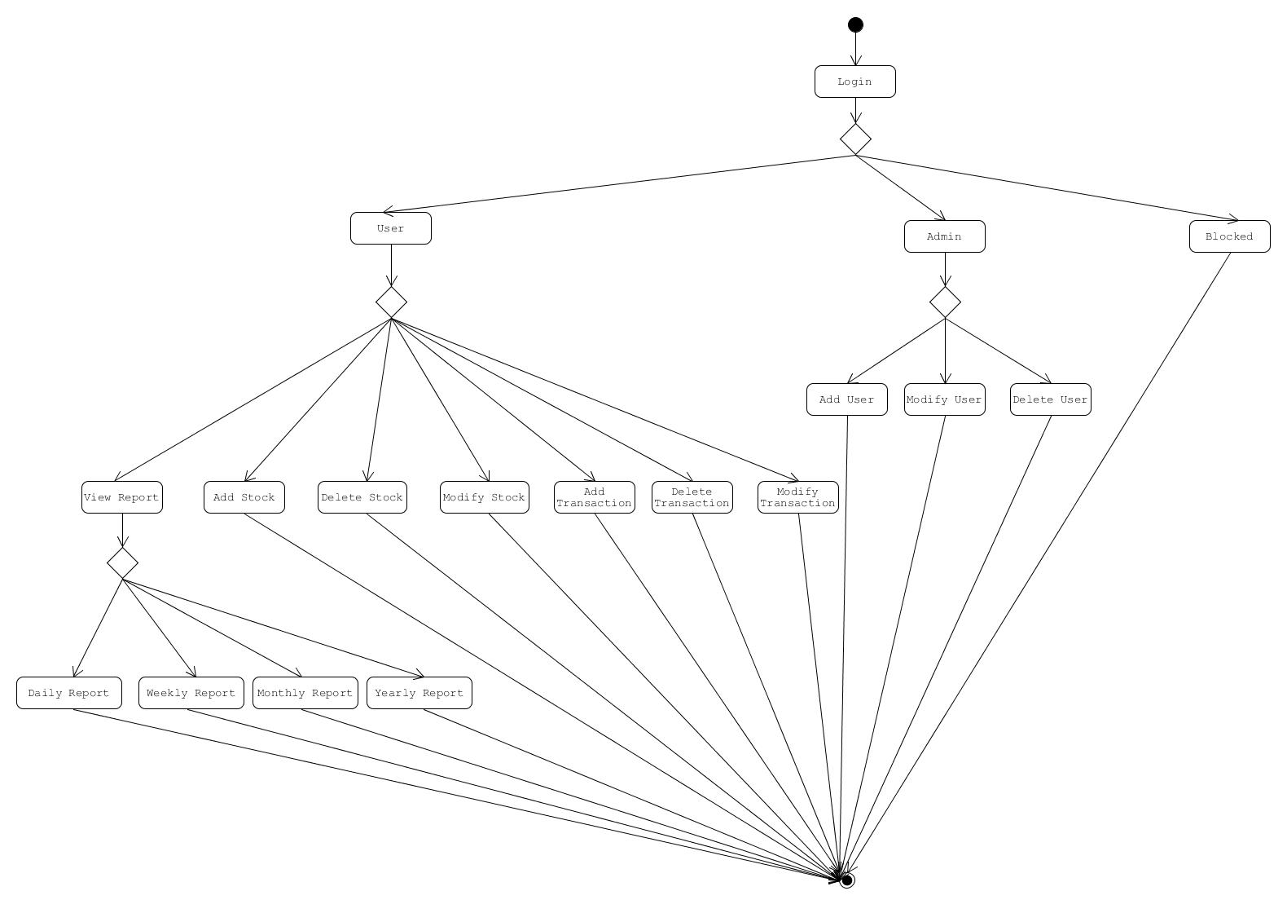

Design Artefacts – Activity Diagrams (Elaboration Iteration 2)

Activity Overview
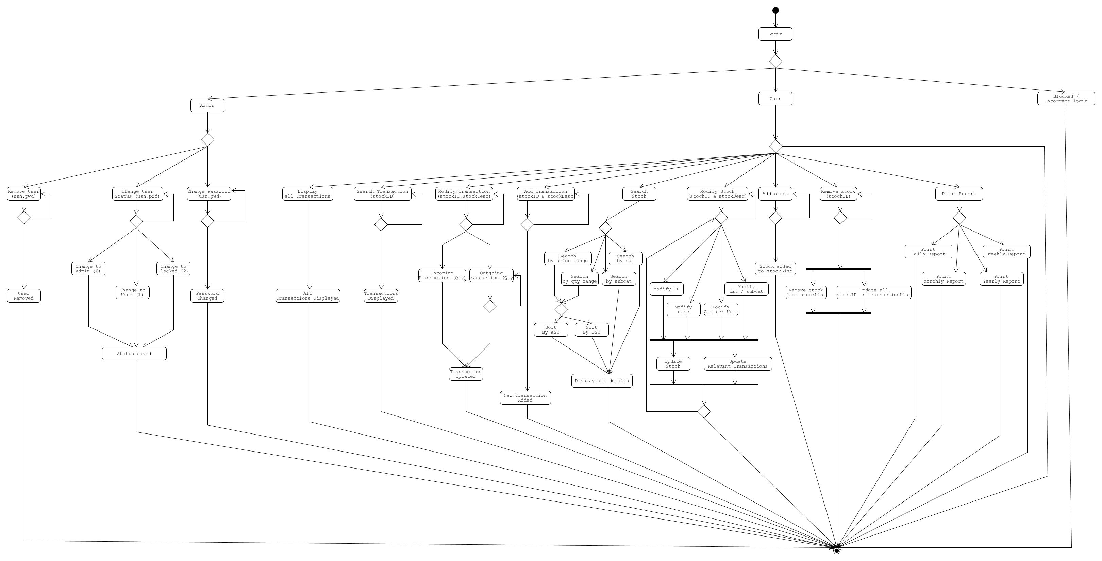

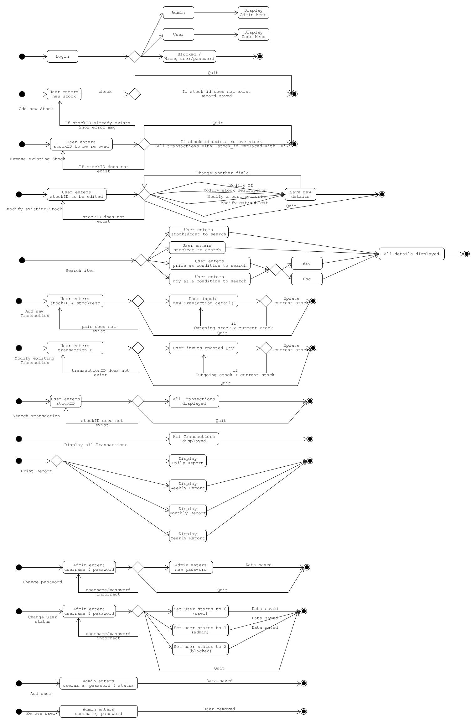
Design Artefacts - Component Diagrams (Elaboration Iteration 1)
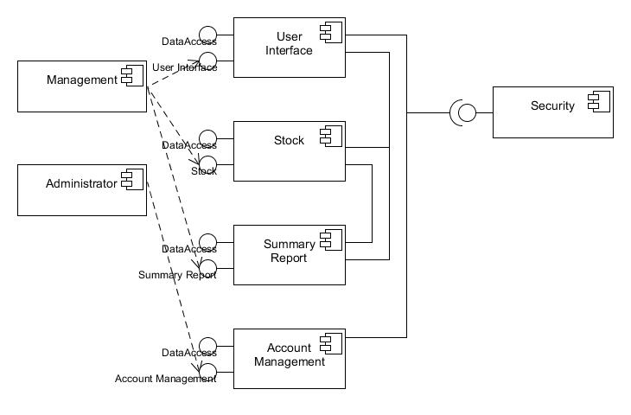
Design Artefacts - Component Diagrams (Elaboration Iteration 2)

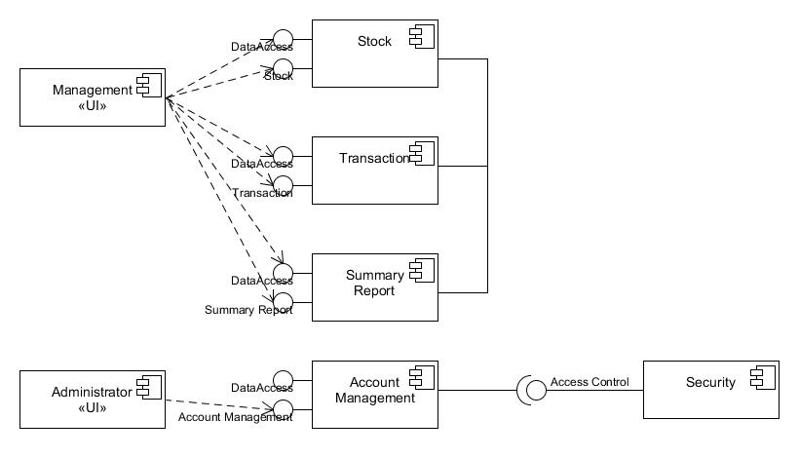
Design Artefacts - Component Diagrams (Elaboration Iteration 2)
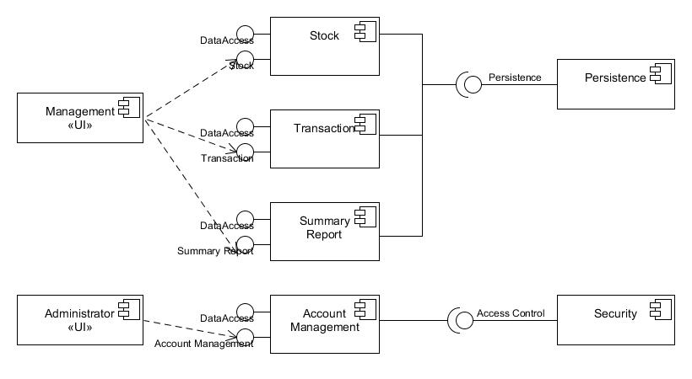

Design Artefacts - Class Diagrams (Inception Iteration 1)
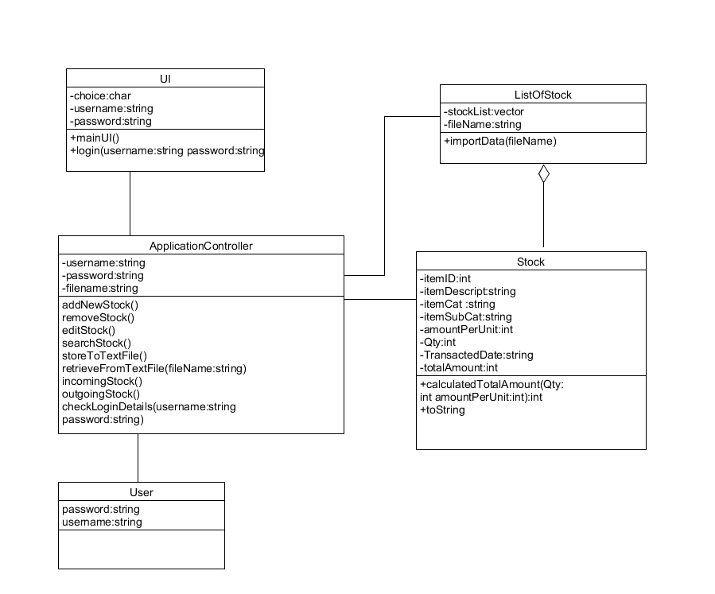

Design Artefacts - Class Diagrams (Elaboration Iteration 1)

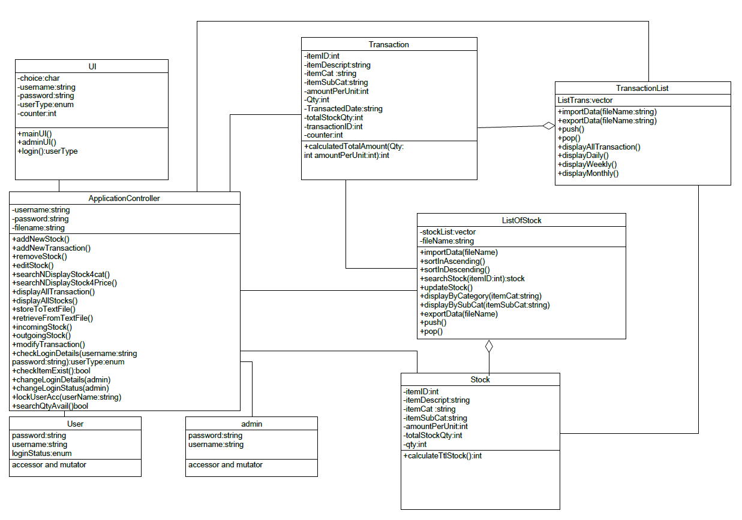

Design Artefacts - Class Diagrams (Elaboration Iteration 2)
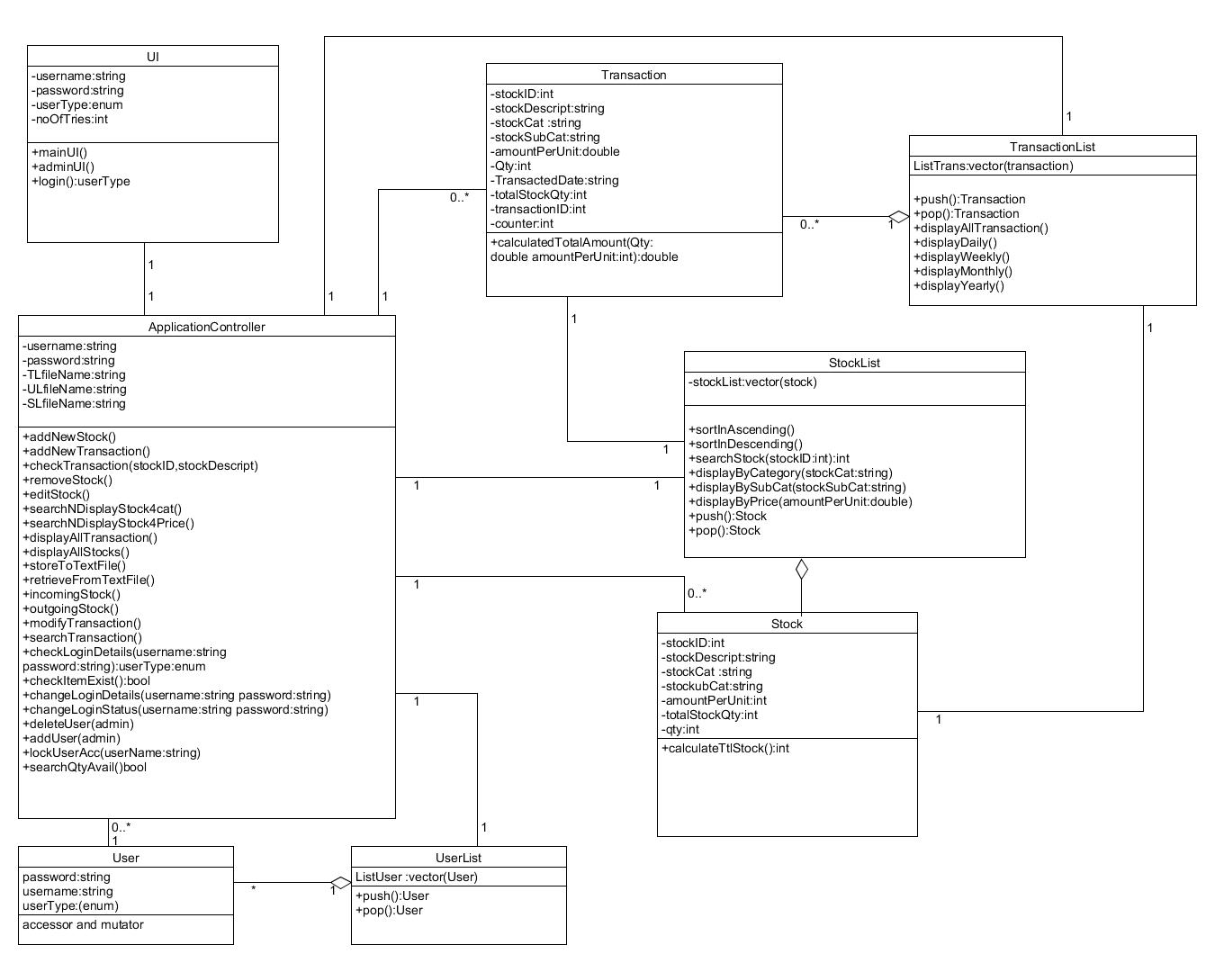

User -> Userlist (aggregation)

Design Artefacts - Class Diagrams (Construction Iteration 1)
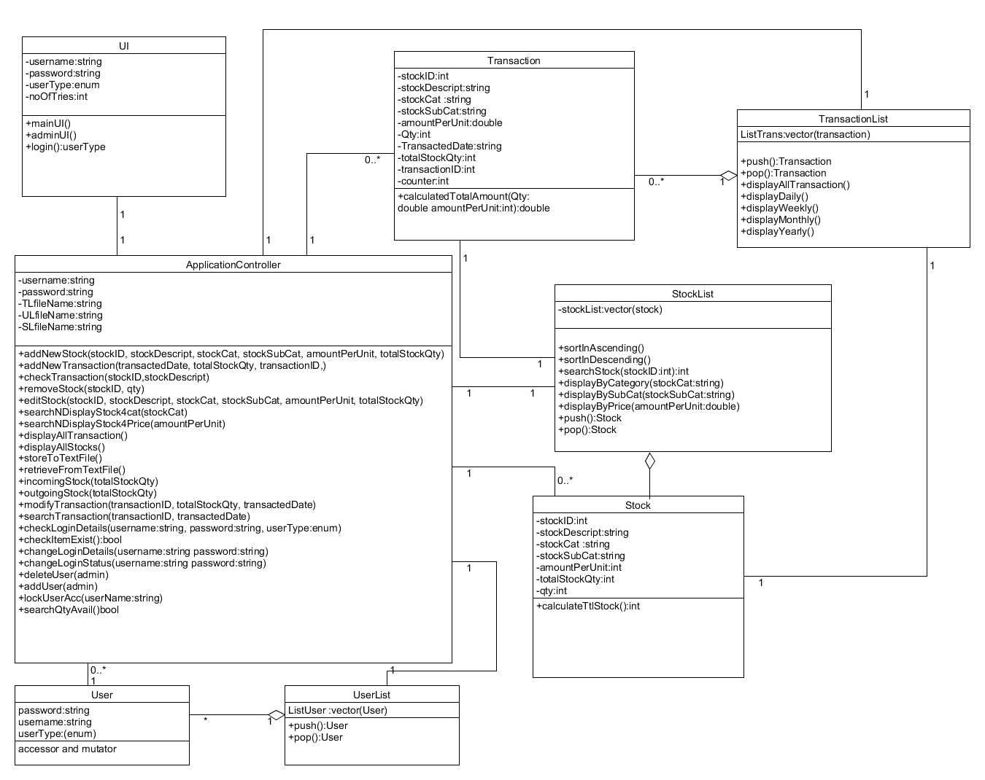

- Added in arguments for applicationController

Design Artefacts – Sequence Diagrams (Elaboration Iteration 1)
Sequence : Account Locked
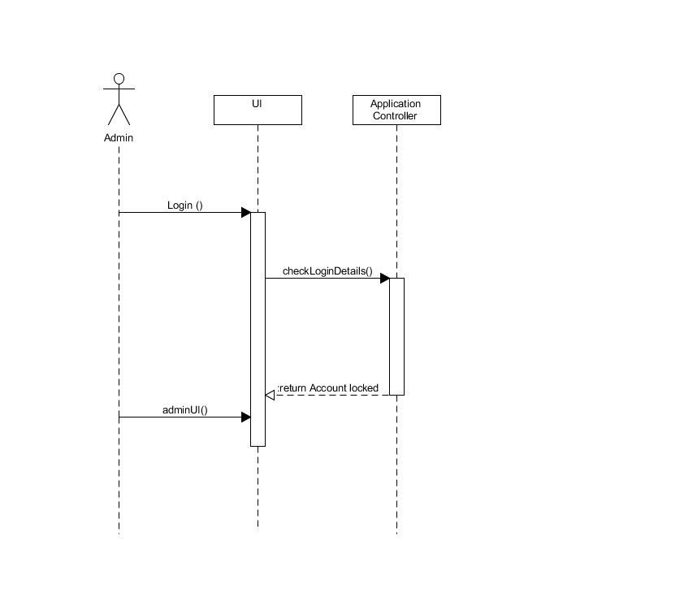
Design Artefacts – Sequence Diagrams (Elaboration Iteration 1)
Sequence : Add User
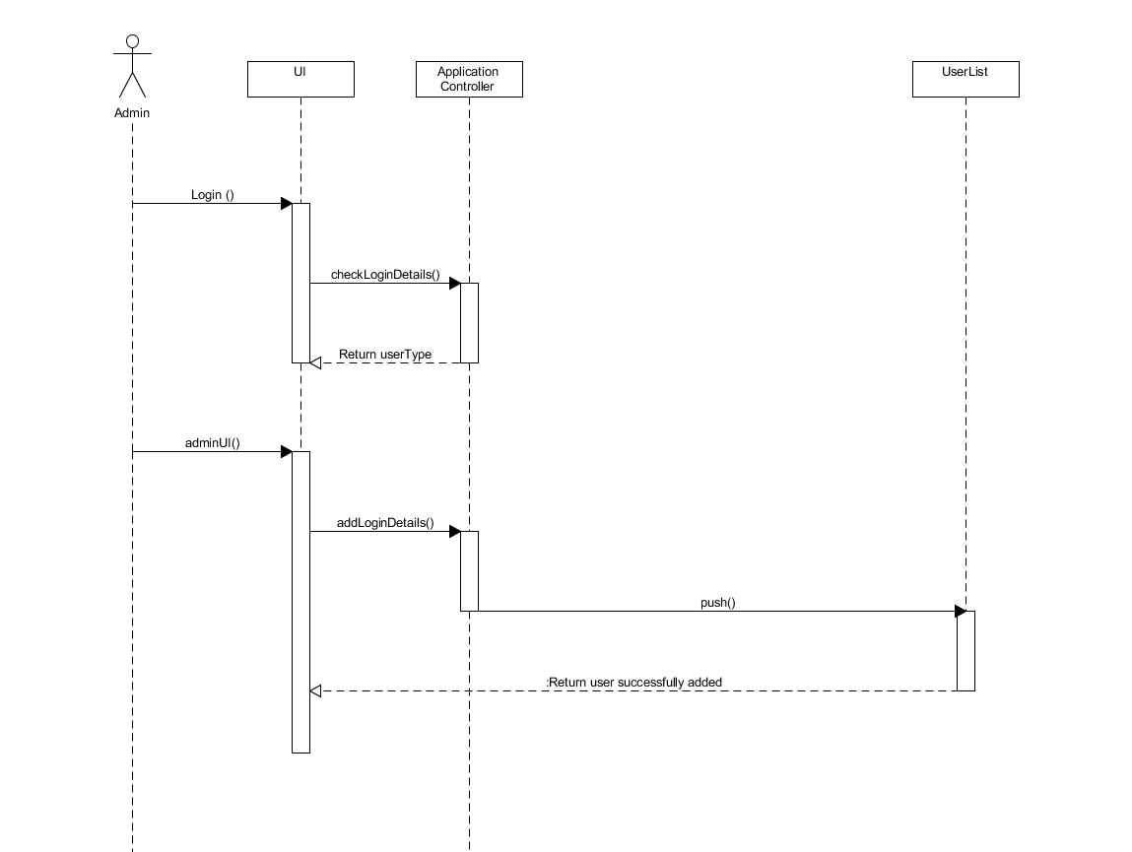

Design Artefacts - Sequence Diagrams (Elaboration Iteration 1)
Sequence : Change Password
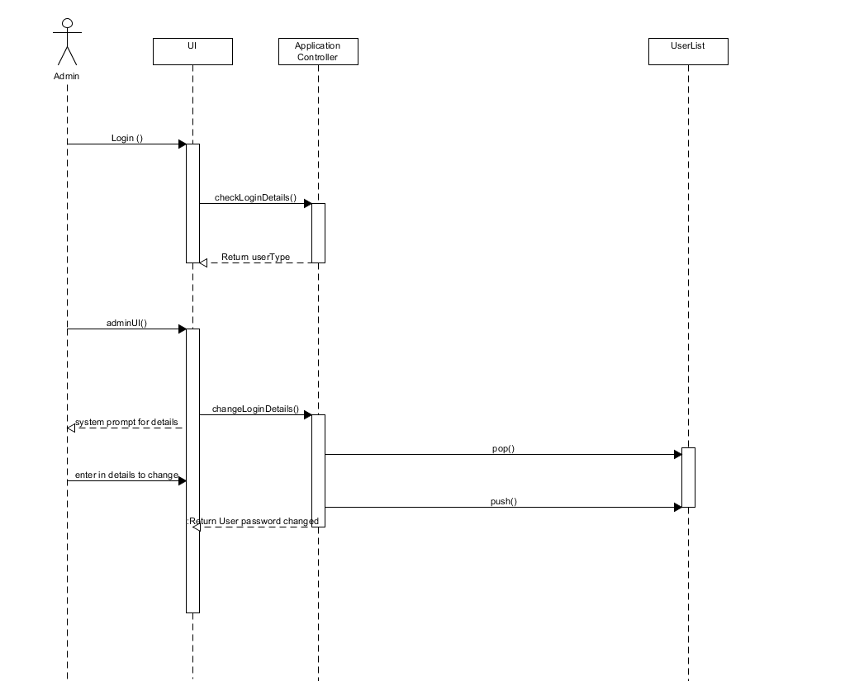
Design Artefacts - Sequence Diagrams (Elaboration Iteration 1)
Sequence : Change User Status
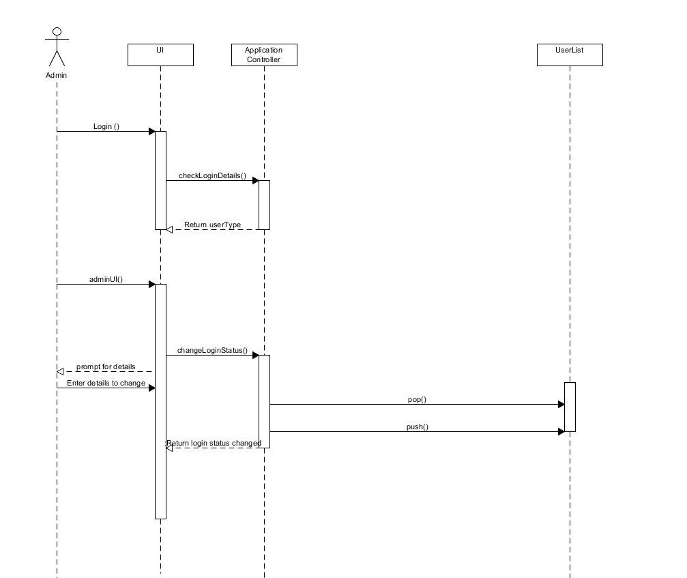

Design Artefacts - Sequence Diagrams (Elaboration Iteration 1)
Sequence: Add Stock, Remove Stock

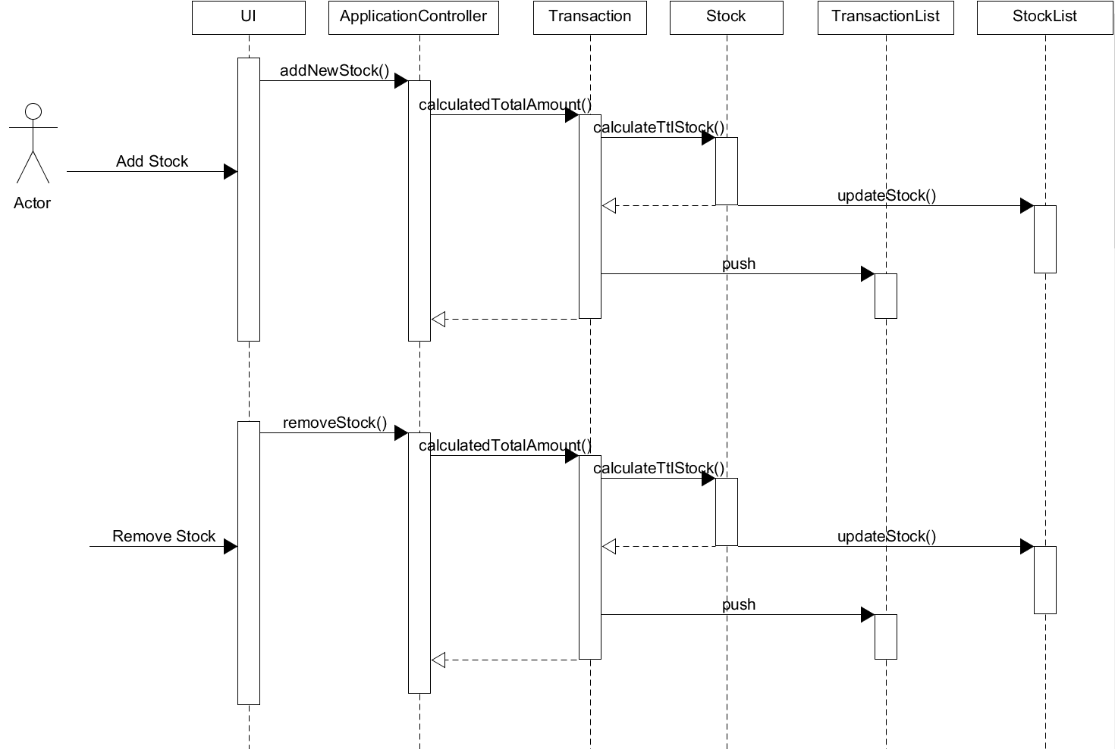
Design Artefacts - Sequence Diagrams (Elaboration Iteration 1)
Sequence: Edit stock
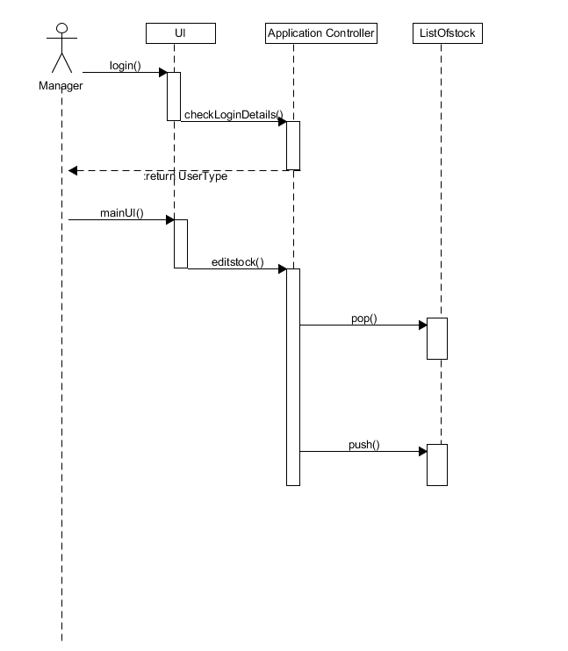

Design Artefacts - Sequence Diagrams (Elaboration Iteration 1)
Sequence: Search stock
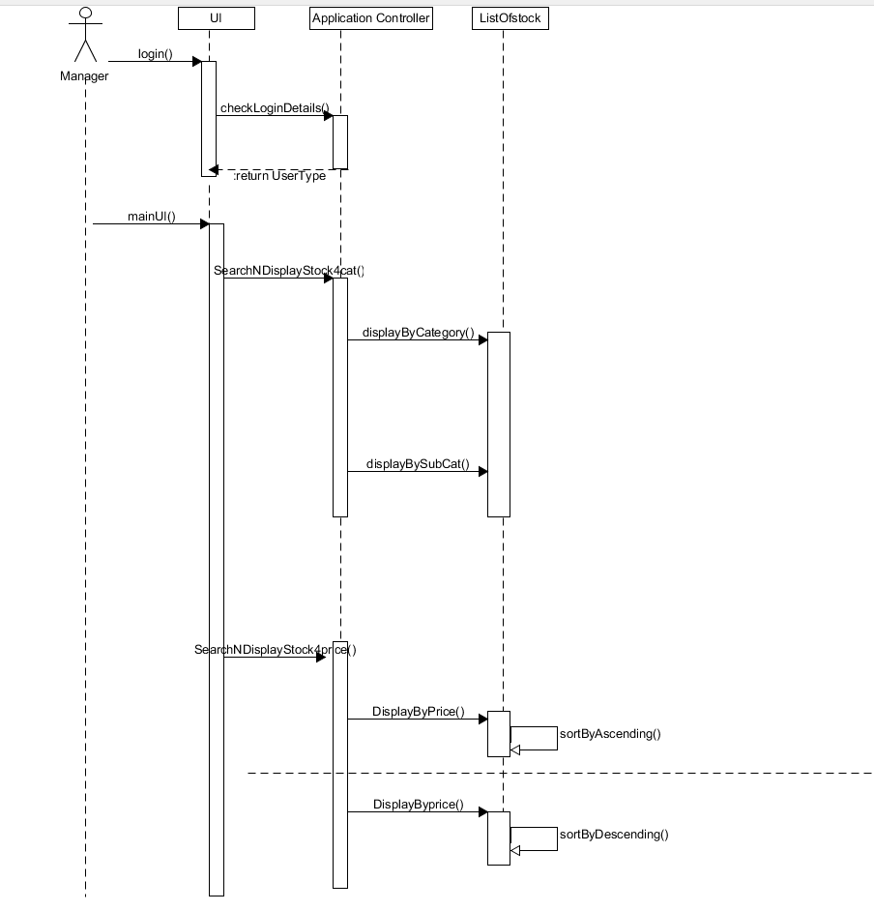
Design Artefacts - Sequence Diagrams (Elaboration Iteration 1)
Sequence: Add transaction, search transaction
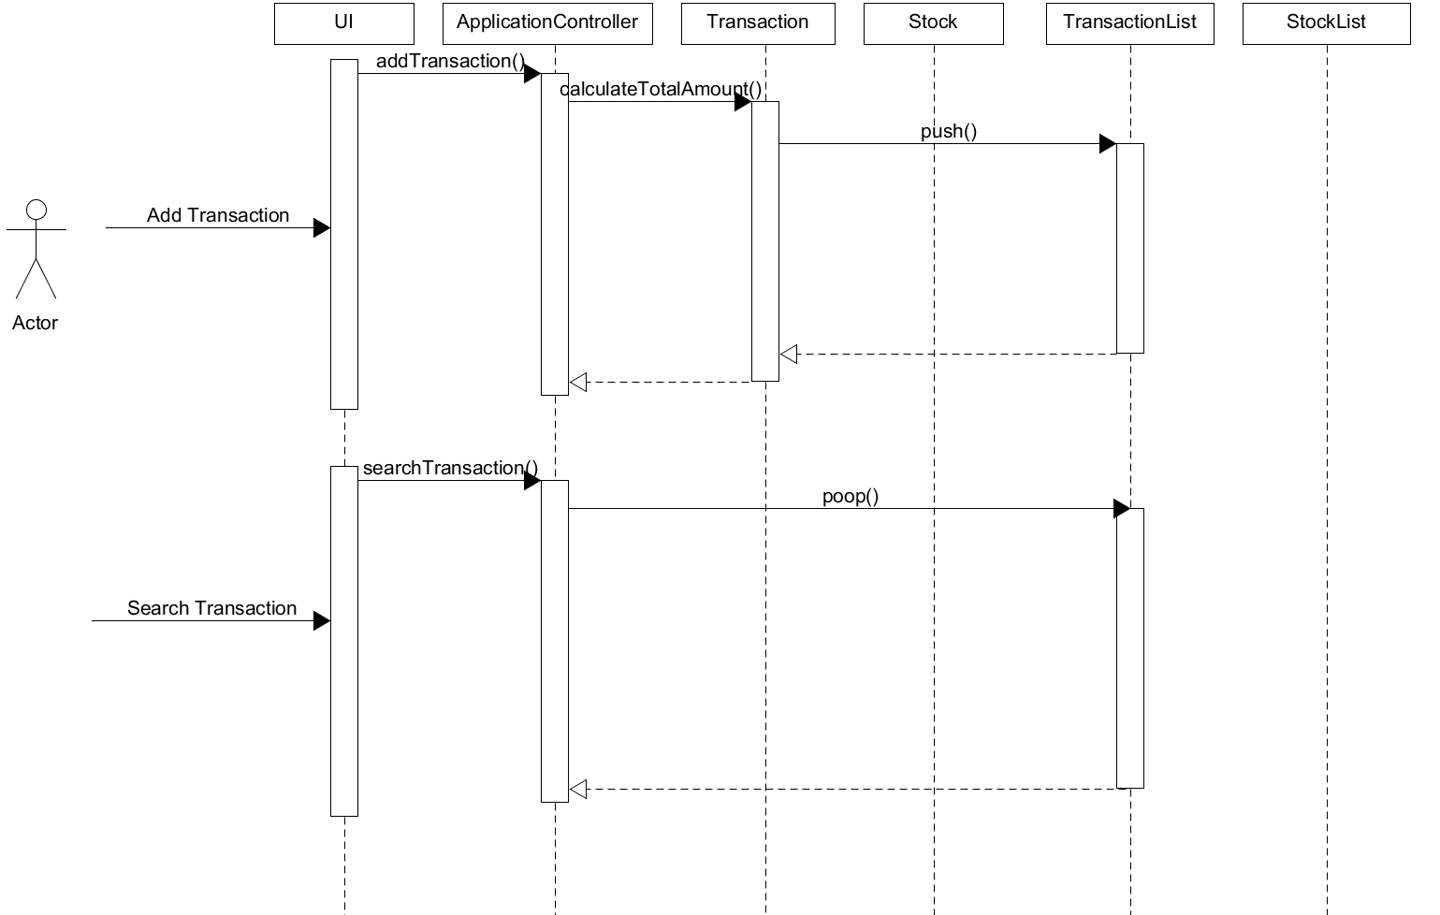

Design Artefacts - Sequence Diagrams (Elaboration Iteration 1)
Sequence: Display summary reports
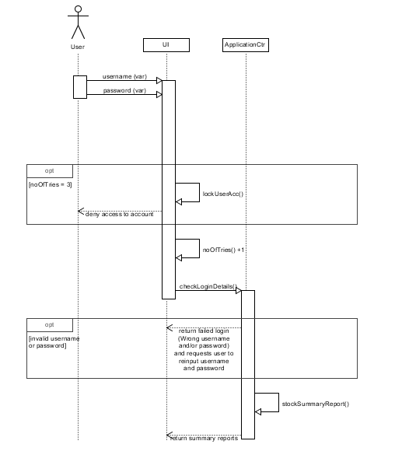
Design Artefacts - Sequence Diagrams (Elaboration Iteration 1)
Sequence: Modify transaction, display transaction
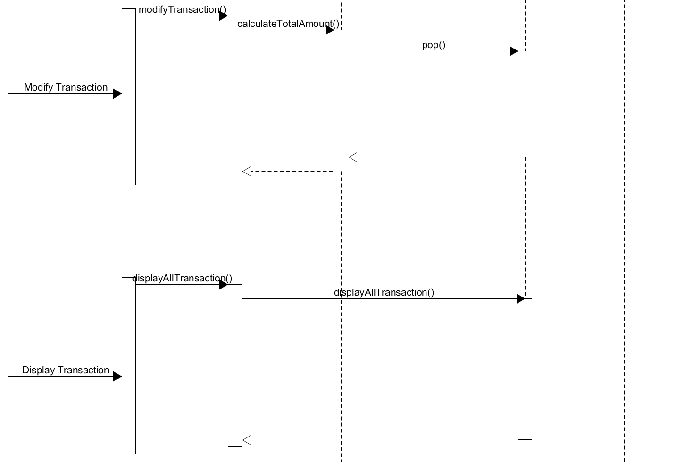

Design Artefacts - Sequence Diagrams (Elaboration Iteration 2)
Sequence : Account Locked
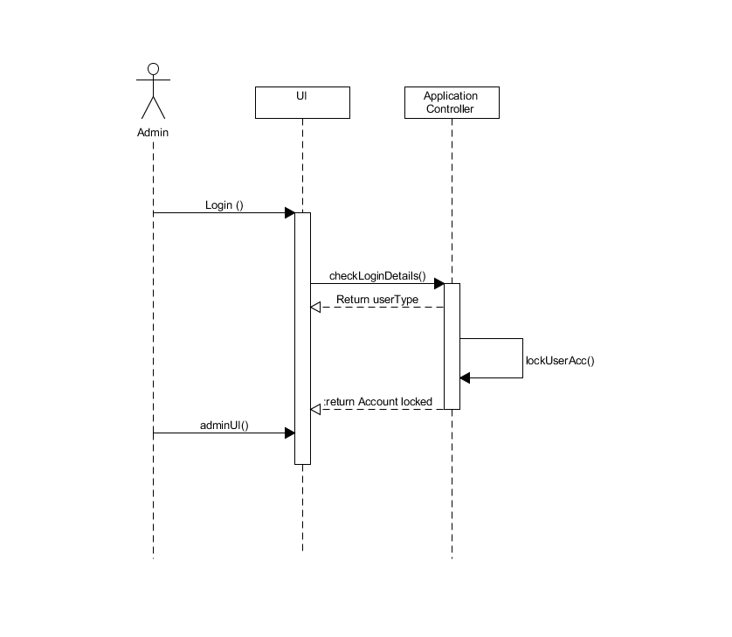
Design Artefacts - Sequence Diagrams (Elaboration Iteration 2)
Sequence : Add User
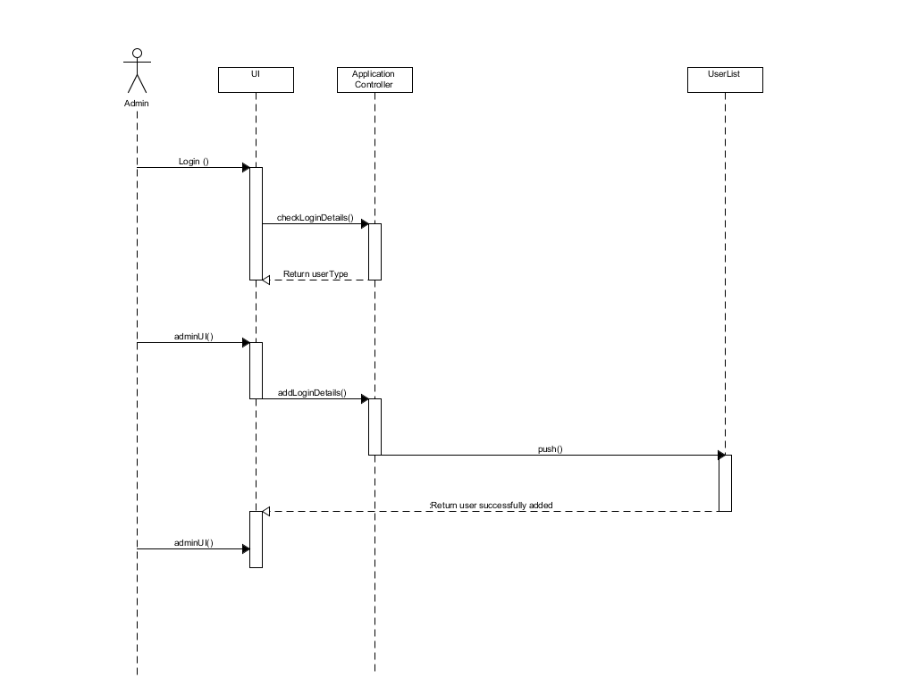

Design Artefacts - Sequence Diagrams (Elaboration Iteration 2)
Sequence : Change Password
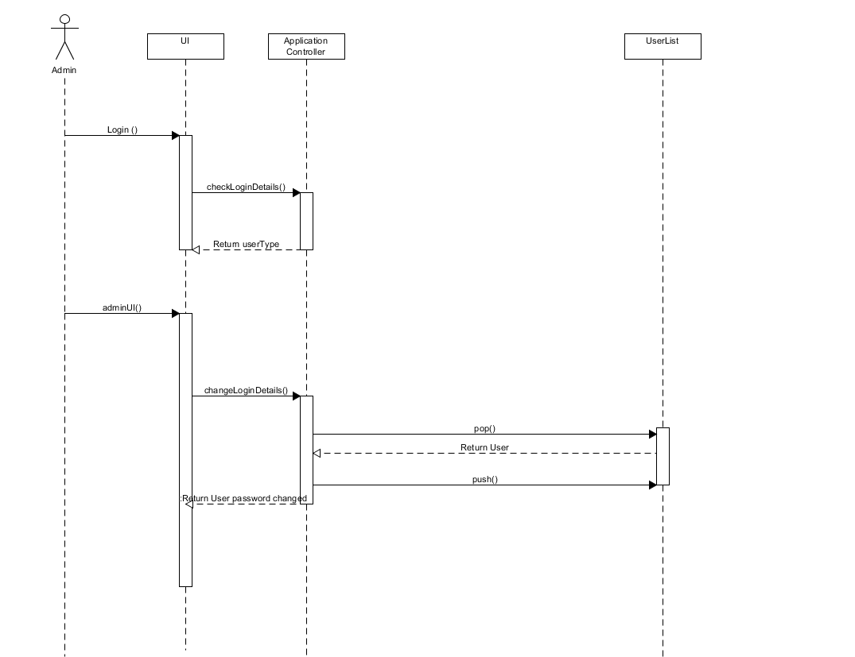
Design Artefacts - Sequence Diagrams (Elaboration Iteration 2)
Sequence : Change User Status
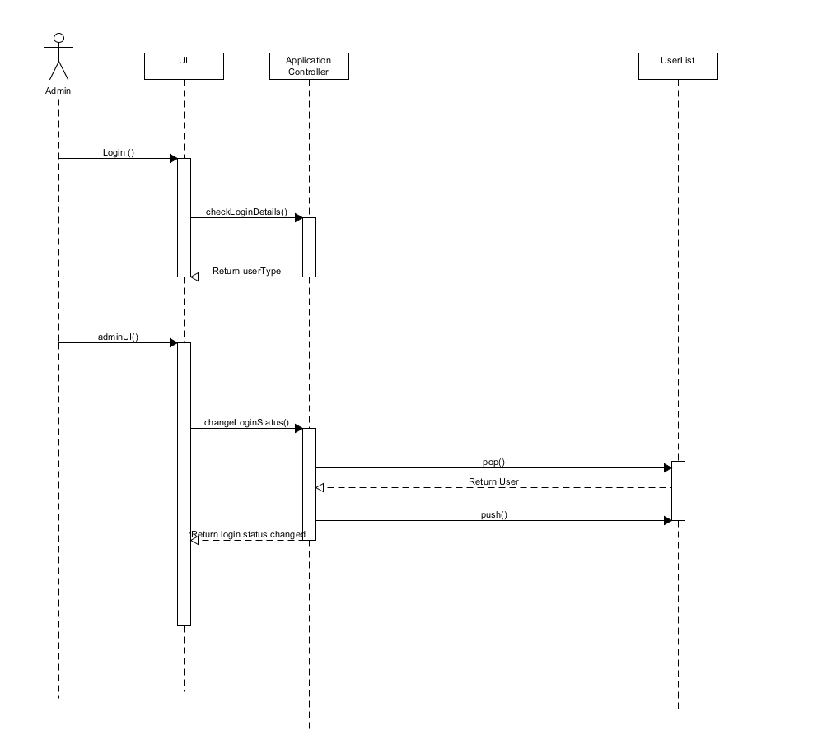

Design Artefacts - Sequence Diagrams (Elaboration Iteration 2)
Sequence: Add new stock, remove stock
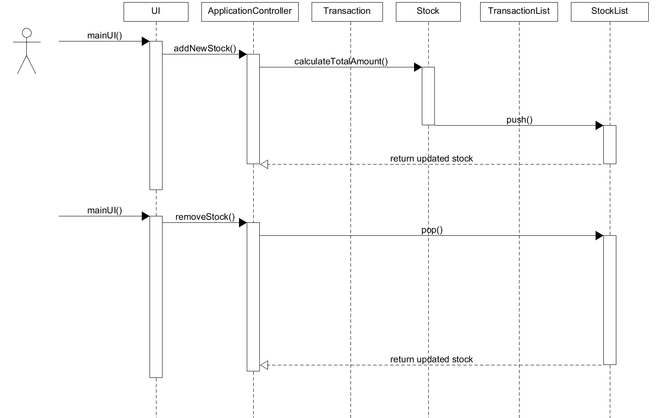
Design Artefacts - Sequence Diagrams (Elaboration Iteration 2)
Sequence: Edit item 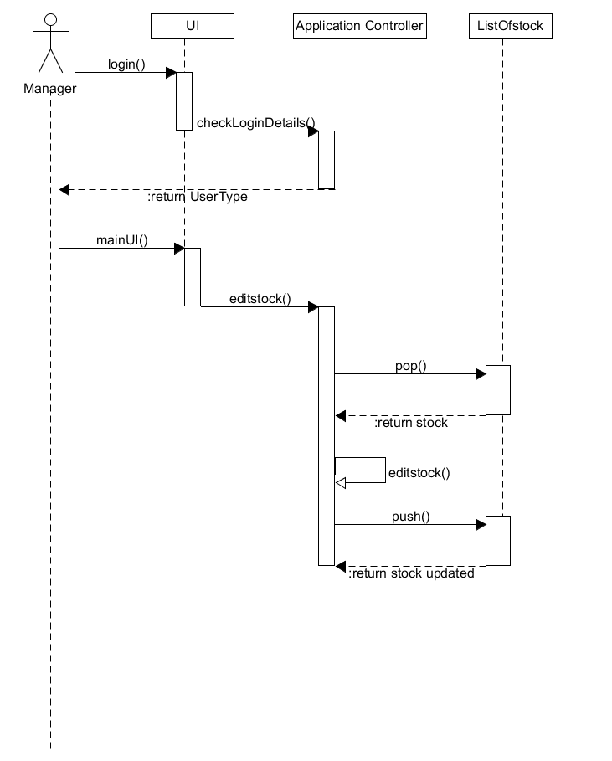

Design Artefacts - Sequence Diagrams (Elaboration Iteration 2)
Sequence: Search item
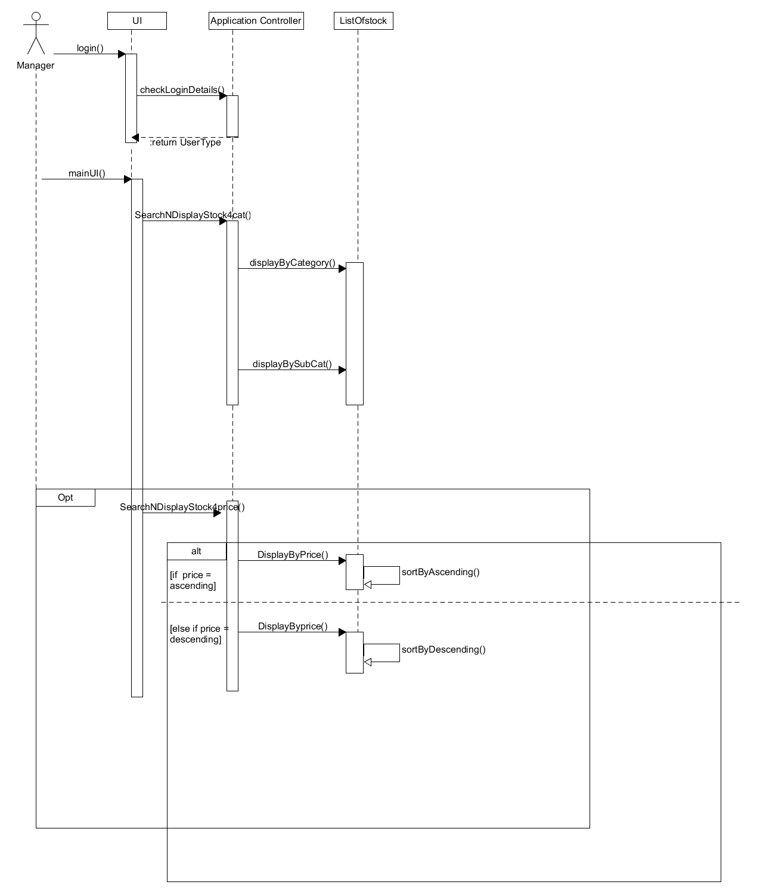
Design Artefacts - Sequence Diagrams (Elaboration Iteration 2)
Sequence: Display daily summary report
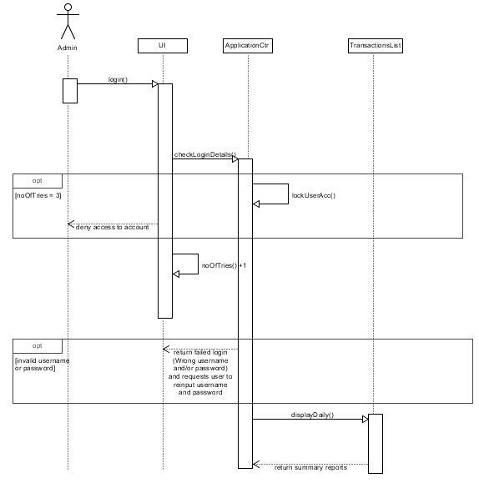

Design Artefacts - Sequence Diagrams (Elaboration Iteration 2)
Sequence: Display weekly summary report
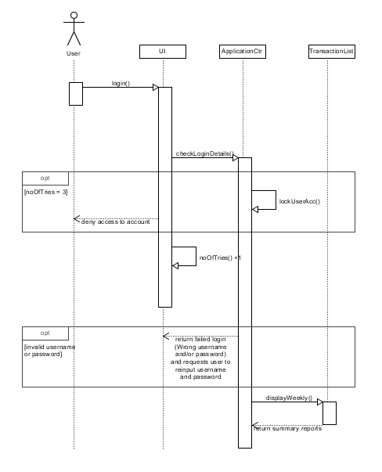
Design Artefacts - Sequence Diagrams (Elaboration Iteration 2)
Sequence: Display monthly summary report

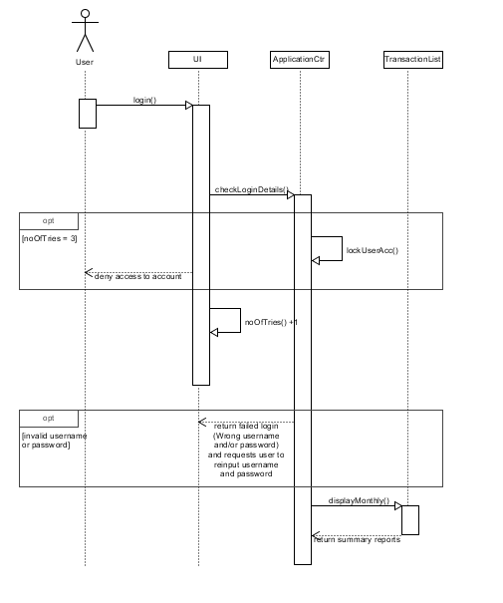

Design Artefacts - Sequence Diagrams (Elaboration Iteration 2)
Sequence: Display yearly summary report
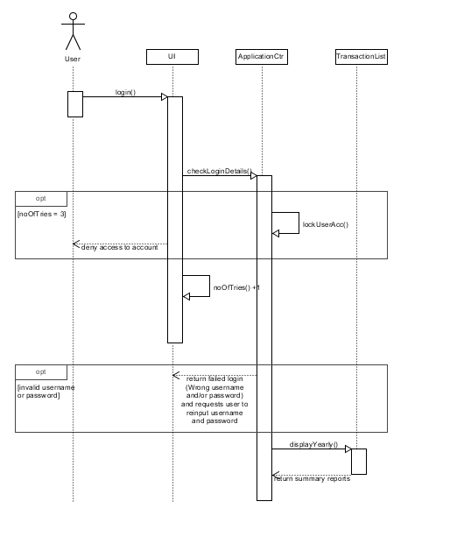
Design Artefacts - Sequence Diagrams (Elaboration Iteration 2)
Sequence: Add new transaction, search transaction
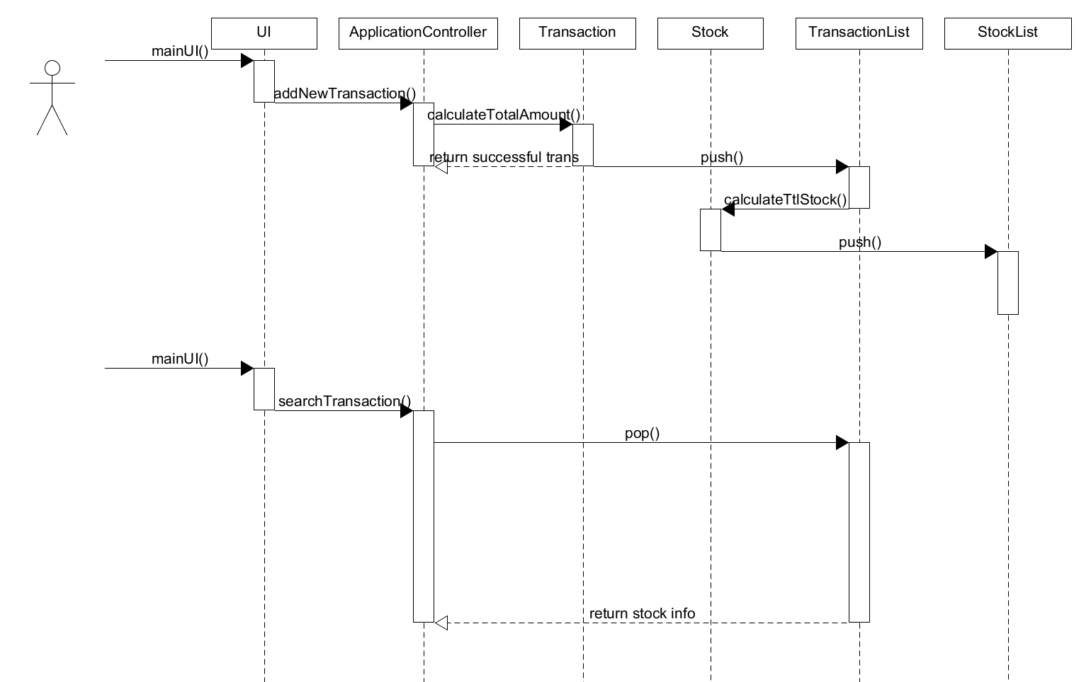

Design Artefacts - Sequence Diagrams (Elaboration Iteration 2)
Sequence: Modify transaction. Display all transaction
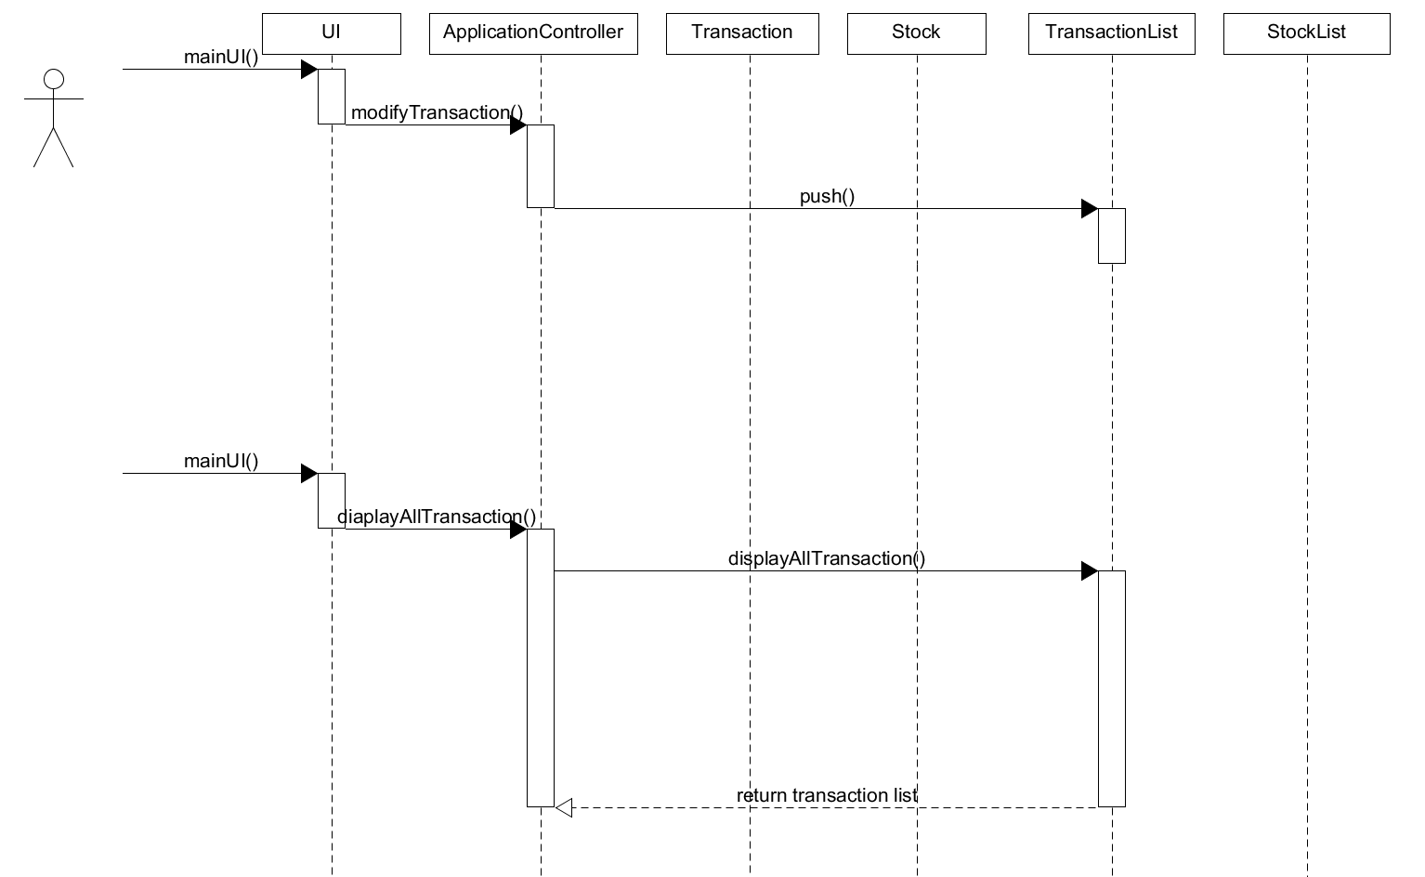

Design Artefacts - Deployment Diagrams (Construction Iteration 1)

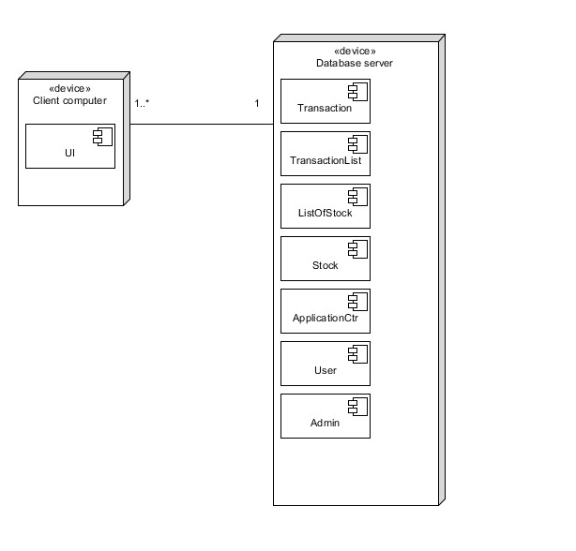

Design Artefacts – Data Dictionary (Elaboration Iteration 2)

Class (Name) | Attribute Name | Description | Type | Format | Range | Req’d | Related Class(es) | Nature of relationship
ApplicationController | userName | Username of user | String |  |  | Y | User ,userList , UI | Association
ApplicationController | password | Password of user | String |  |  | Y | User ,userList , UI | Association
ApplicationController | ULFileName | Filename for User List | String |  |  | Y | User List | Association
ApplicationController | SLFileName | Filename for stock list | string |  |  | Y | Stock List | Associtation
ApplicationController | TLFileName | filename for transaction list | String |  |  | Y | Transaction LIst | Association
UI | username | Username of user | string |  |  | Y | ApplicationController | Associaiton
UI | password | Password of user | String |  |  | Y | ApplicationController | Associaiton
UI | noOfTries | The variable to count the number of time user tries to login | int |  |  | Y
UI | userType | User is admin,user or block | Enum |  |  | Y | ApplicationController | Association
User | userName | Username of user | String |  |  | Y | UserList | Association
User | password | Password of user | String |  |  |  | UserList | Association
User | userType | User is admin,user or block | Enum |  |  | Y | UserList | Association
Stock | stockID | ID for each stock | Int |  |  | Y | ListOfStock, TransactionList, Transaction | Association
Stock | stockDescript | Description of stock | String |  |  | Y | ListOfStock, TransactionList, Transaction | Association
Stock | stockCat | Category of stock | String |  |  | Y | ListOfStock, TransactionList, Transaction | Association
Stock | stockSubCat | Sub Category of stock | String |  |  | Y | ListOfStock, TransactionList, Transaction | Association
Stock | amountPerUnit | Amount per unit of stock | Double |  |  | Y | ListOfStock, TransactionList, Transaction | Association
Stock | totalStockQty | Total quantity of stock | Int |  |  | Y | ListOfStock, Transaction | Association
StockList | stockList | A vector of stock | Stock |  |  | Y | Stock | Aggregation
UserList | UserList | Vector of user | User |  |  | Y | User | Association
Transaction | stockID | ID for each stock | Int |  |  | Y | ListOfStock, TransactionList, Stock | Association
Transaction | stockDescript | Description of stock | String |  |  | Y | ListOfStock, TransactionList, Stock | Association
Transaction | stockCat | Category of stock | String |  |  | Y | ListOfStock, TransactionList, Stock | Association
Transaction | stockSubCat | Sub Category of stock | String |  |  | Y | ListOfStock, TransactionList, Stock | Association
Transaction | amountPerUnit | Amount per unit of stock | Double |  |  | Y | ListOfStock, TransactionList, Stock | Association
Transaction | totalStockQty | Total quantity of stock | Int |  |  | Y | ListOfStock, TransactionList, Stock | Association
Transaction | Qty | Amount of quantity of each transaction | Int |  |  | Y | TransactionList | Aggregation
Transaction | transactionID | Id of each transaction | Int |  |  | Y | TransactionList | Aggregation
Transaction | counter | Counter for transactionID | Int |  |  | Y | TransactionList | Aggregation
 | TransactedDate | Date of transaction | Date |  |  | Y | TransactionList | Aggregation
TransactionList | ListTrans | Vector of transaction | Transaction |  |  | Y | Transaction | Aggregation

Data Dictionary(Application Controller)

Class description
The application controller class contains all methods and functions that drive the application

Method description
-addNewStock()
- will add new stock that doesn’t exist in the stock database in to the list of stock
-checkItemExists():bool
- used to check if stock exist in the listOfStock based on the stockID

-addNewTransaction()
- add new transactions
-checkTransaction(stockID,stockDescript):bool
- implemented during add new transaction ,will check in the list of stock if stockID matches with its own stock description. Return true if matches else return false. This prevent the user from enter a correct stock ID but a different stock description which will result in incorrect transaction.
-removeStock()
- remove Stock from list of stock
-editStock()
- modify all values of stocks
-searchNDisplayStock4Cat()
- search List of stock and Display based on category
-searchNDisplayStock4Price()
- search list of stock and Display based on amount per unit
-displayAllTransaction()
- Display function that has has sub menu of daily,weekly,monthly ,yearly or all transaction that user wishes to display
-displayAllStock()
- Display all stock in list of stock

-storeToTextFile()
- A generic function to store vectors of UserList,TransactionList,StockList in to its individual text file.
-retrieveFromTextFile()
- A generic function to retrieve value from User List, transaction list stock list text file and store it into its respective vector
-incomingStock()
- Will add the qty to the the total stock qty of the specified stock based on the qty entered in new transaction
-outcomingStock()
- Will minus the qty to the the total stock qty of the specified stock based on the qty entered in new transaction
-modifyTransaction()
- If by any chance the user enter the wrong qty or amount per unit on a new transaction , this function will all the user to change that specific transaction based on transactionID.
-searchTransaction()
- Used in conjunction with modifyTransaction() to search for the transaction that u wish to modify.
-checkLoginDetails(username,password)
- Function used to change if username and password matches. If matches login
-changeLoginDetails(username,password)
- Change the password of user
-changeLoginStatus(username,password)
- An admin function.Change the userType enum 2 back to 1, from locked out to user. Or change a userType from user to admin
-deleteUser()
- Delete user from list of user
-addUser()
- Add user from list of user
-lockUserAcc(username)
- If user enter wrong pw more than 3 time this function change the enum status of user to locked
-searchQtyAvail():bool
- Search the total Qty of stock if current stock is < the outgoing stock .Return false.

Data Dictionary(Transaction)
Class description
The transaction class contain all attribute to store all required data for new transactions and method to calculate total cost of each transacation

Method Description
calculatedTotalAmount(Qty, amoutPerUnit
- Calculated the total cost of the transaction based on Qty*amountPerUnit

Data Dictionary(TransactionList)
Class description
The transactionList class contain all method to display Daily ,Weekly,Monthly Yearly or all transaction in the transactionList text file

Method Description
Push()
- modified transaction will be push back in to the vector of transaction
Pop()
- selected transaction will be retrieved

displayAllTransaction()
- display all transaction that stored in the transactionList text file
displayDaily()
- display all transaction that stored in the text file that are all made on the same day
displayWeekly()
- display all transaction that stored in the text file that are all made in the same week
displayMonthly()
- display all transaction that stored in the text file that are all made in the same month
displayYearly()
- display all transaction that stored in the text file that are all made in the same year

Data Dictionary(Stock)
Class description
Contains all attribute store all required data for new stock and method to calculate total qty of each stock

Method description
calculateTtlStock():int
- method to calculate the total qty each stock that is stored in the warehouse

Data Dictionary(StockList)
Class description
Contains all method to display stock based on their category, subcategory, price. Search for a specific stock based on stock id and able to sort the list in ascending or descending order based on price.
Method description
searchStock(stockID):int
- search for stock if it exist or not . if exist ,where is the stock in stockList and return the position index
displayByCategory(stockCat)
- display all stock based on category
displayBySubCat(stockSubCat)
- display all stock based on sub category
displayByPrice(amountPerUnit)
- display all stock by price.
Push()
- modified stock will be push back in to the vector of stock
Pop()
- selected stock will be retrieved
Appendix A - Formal Meeting Records

Inception Phase - Iteration 1

Team A3 Meeting – 2 February 2017
Meeting called to order at 9:45am by Leader, Timothy Chin.
Members Present:
Yu Xuan, Kenneth Yang, Yik Fei, Timothy Chin, Hui En, Marus Chen, Jamal Bin Radwan
Members Not Present:
None
Reading of Agenda:
To Allocate roles and responsibility
Plan the gantt chart.
To read up on the project, its scope and functionality and assign tasks.
Businesses:
- Motion from Yu Xuan: To select the members roles and responsibility
Role | Name
Team Lead/Manager | Timothy Chin
Lead Designer/Implementer | Yu Xuan
Designer/implementer/ Documentation | Kenneth Huang, Yik Fei, Hui En, Jamal Bin Radwan
System Integration and testing | Marcus feng

- Motion from Timothy: To read through Assignment 1 document to clearly define what tasks need to be done. To do the project, Netbeans subversion has been decided to be installed.
The unbuntu program will be distributed by and sent to every other member. SRS document, Initial UseCase, Gant Chart planning, all the diagrams listed in the word document.

Discussed initial use-case diagram and finished the initial use-case diagram.

Discuss Gannt chart-planning(Jamal has been decided to plan)

Look through the SRS report and decide who does which sections.

- Motion from Timothy: To split workload.
Name | Tasks
Kenneth | SRS Introduction
Yu Xuan | SRS Overall Description
Marcus | SRS System Features
Hui En | SRS External Interface Requirements
Timothy | Use Case
Jamal | Gantt Chart
Yik Fei | SRS Non-Functional Requirements & Other Requirements

- Assessment of minutes:
Minutes lasted 4 hours. Able to achieve listed agenda although it took a long time.
- Agenda for next meeting
Next meeting called on 7 February. Evaluate current progress of the project development. Check/validate SRS document, first iteration of diagrams.

Meeting adjourned at 1:45pm.
Meetings submitted by Leader, Timothy Chin

Elaboration Phase - Iteration 1

Team A3 Meeting – 7 February 2017
Meeting called to order at 3:00pm by Leader, Timothy Chin.
Members Present:
Yu Xuan, Kenneth Yang, Yik Fei, Timothy Chin, Hui En, Marus Chen, Jamal Bin Radwan
Members Not Present:
None
Reading of Agenda:
Approve previous meeting’s minutes
Check on current progress of project
Change or edit previous tasks split
Assign rest of the project tasks
Businesses:
- Previous meeting’s minutes approved.

- Motion from Timothy to check current progress on project:
Checked all members’ tasks and asked them to finalize changes and send to Timothy when done.
Timothy will compile the SRS and the report and look through and check.

- Assign the rest of the project tasks:

Name | Task
Timothy | Risk Analysis, Sequence Diagram (Chg Reset Pwd, Chg User, Add User)
Yu Xuan | Activity Workflow Diagram
Hui En | Component Diagram
Kenneth | Class Diagram
Jamal | Sequence Diagram
Yik Fei | Sequence Diagram (Edit Stock, Search Stock)
Marcus | Sequence Diagram
.
- Assessment of minutes:
Minutes lasted 3 hours.
- Agenda for next meeting
Next meeting called on 7 February. Evaluate current progress of the project development. Check first iteration of diagrams.

Meeting adjourned at 6:11pm.
Meetings submitted by Leader, Timothy Chin

Elaboration Phase - Iteration 2

Team A3 Meeting – 16 February 2017
Meeting called to order at 3:30pm by Leader, Timothy Chin.
Members Present:
Yu Xuan, Kenneth Yang, Yik Fei, Timothy Chin, Hui En, Marus Chen, Jamal Bin Radwan
Members Not Present:
None
Reading of Agenda:
Assess progress of project.
Evaluate if any changes need to be made.
Ask everyone to start adding to the report when done.
Businesses:
- Motion from Timothy to Checking of members’ current progress:
  - Checking of Activity Workflow Diagram finalized.
  - Checking of Component Diagram finalized.
  - Checking of Class Diagram finalized.
  - Checking of Sequence Diagram finalized.
  - Some Sequence Diagrams progress is still underway.

- Assessment of minutes:
Minutes lasted 3 hours and 45 minutes.

- Agenda for next meeting
There should be no more meetings. Work should be completed and compiled by 20 Feb. If need be, meeting will be called on 20 February to add finishing touches.

Meeting adjourned at 6:45pm.
Meetings submitted by Leader, Timothy Chin

Construction Phase - Iteration 1
Team A3 Meeting – 24 February 2017
Meeting called to order at 1200hrs by Leader, Jamal.
Members Present:
Yu Xuan, Kenneth Yang, Yik Fei, Timothy Chin, Hui En, Marcus Chen, Timothy
Members Not Present:
None
Reading of Agenda:
Inherit role from former leader, Timothy
Reshuffle allocated roles
Revise project requirements and reallocate tasks
Acquired relevant files from previous owner for newly appointed roles
Briefed team about areas of improvement from previous phase and tasks to be completed by next meeting
Businesses:
- Motion from Yuxuan to reshuffle members roles and responsibilities:
Role | Name
Team Lead/Manager | Jamal
Lead Designer/Implementer | Yu Xuan
Designer/implementer/ Documentation | Kenneth, Timothy, Hui En, Marcus
System Integration and testing | Yik Fei

- Motion from Yuxuan to split workload:

Name | Task
Jamal | Update gantt chart, update risk analysis, update use case, sequence diagram, update class diagram
Yu Xuan | Implement system (Login)
Timothy | Implement system (Stock)
Kenneth | Implement system (Transaction)
Hui En | Component diagram
Marcus | Deployment diagram
Yik Fei | Activity diagram

- Assessment of minutes:
Meeting lasted for 3 hours.

- Agenda for next meeting
Next meeting on 25 February 2017
To be completed by next meeting:
    - Initial system design
    - First iteration of diagrams

Meeting adjourned at 1500hrs.
Meetings submitted by Leader, Jamal

Construction Phase - Iteration 2
Team A3 Meeting – 25 February 2017
Meeting called to order at 1400hrs by Leader, Jamal.
Members Present:
Yu Xuan, Kenneth Yang, Yik Fei, Timothy Chin, Hui En, Marcus Chen, Timothy
Members Not Present:
None
Reading of Agenda:
Check progress of project
Change previous tasks split

Businesses:
- Motion from Jamal to revise workload:
Name | Task
Jamal | Gantt chart, Risk analysis, Use case, Sequence diagram, Class diagram
Yu Xuan | Implement system (Login)
Timothy | Implement system (Stock)
Kenneth | Implement system (Transaction)
Hui En | Component diagram, Activity diagram
Marcus | Deployment diagram, Sequence diagram
Yik Fei | Activity diagram

- System implementation has progress, but still behind schedule
- First iteration of diagrams for construction phase done, but remaining diagrams delayed

- Assessment of minutes:
Meeting lasted for 4 hours.

- Agenda for next meeting
Next meeting on 25 February 2017
To be completed by next meeting:
    - Initial system design
    - First iteration of diagrams

Meeting adjourned at 1800hrs.
Meetings submitted by Leader, Jamal

Appendix B - Individual Work Diaries

Team Member 1 : Timothy Chin

Inception Phase - Iteration 1

Date : 6/2/2017 to 6/2/2017
No. | Description | Date | Time
1 | Create the initial Use Case diagram using UMLET. | 6/2 | 40mins
2 | Look through the previous meeting’s minutes to check if there is anything discrepancies. | 6/2 | 30mins
3 | Check through the initial use case to see if there’s anything to add. | 6/2 | 30mins
4 | Start progress on the risk analysis and think of countermeasures. | 6/2 | 1hr30mins

Elaboration Phase - Iteration 1

Date : 8/2/2017 to 12/2/2017
No. | Description | Date | Time
1 | Finalizing of UseCase Diagram using UMLET | 8/2 | 30mins
2 | Look through the previous meeting’s minutes to check if there is anything discrepancies. | 8/2 | 15mins
3 | Checking of other member’s work | 10/2 | 1hr
4 | Do Sequence UseCase scenario | 11/2 | 30mins
5 | Start abit on the Sequence Diagram | 12/2 | 30mins

Elaboration Phase - Iteration 2

Date : 16/2/2017 to 16/2/2017
No. | Description | Date | Time
1 | Checking and assessing member’s work. | 16/2 | 1hr40mins
2 | Check through SRS and add in last part. | 16/2 | 10mins
3 | Start finalizing the Sequence Diagram. | 16/2 | 1hr10mins

Team Member 2 : Yee Yik Fei

Inception Phase - Iteration 1

Date: 5/2/2017 to 5/2/2017
No. | Description | Date | Time
1 | Research on the SRS document part given functional and nonfunctional along with other requirements stated. | 5/2 | 1hr
2 | Added the information that I found of functional to the SRS document | 5/2 | 15mins
3 | Nonfunctional and other requirements was also added after checking thru | 5/2 | 20mins
4 | Checking thru the part of SRS if it fits to the requirement of the software | 5/2 | 10mins

Elaboration Phase - Iteration 1

Date: 8/2/2017 to 11/2/2017
No. | Description | Date | Time
1 | Reading thru the initial class diagram and use case diagram | 8/2 | 30mins
2 | sketching out the draft sequence diagram base on the given use case scenario. | 8/2 | 20mins
3 | Implementing the basic sequence diagram on Umlet | 8/2 | 30mins
4 | Plotting the 2nd iteration of the sequence diagram | 11/2 | 20mins

Elaboration Phase - Iteration 2

Date: 14/2/2017 to 16/2/2017
No. | Description | Date | Time
1 | Implementing the 2nd iteration of the sequence diagram | 14/2 | 1hr15mins
2 | Making changes to the sequence diagram regarding some of the function name base on class diagram. | 15/2 | 15mins
3 | Checking the flow of sequence with team member | 15/2 | 20mins
4 | Finalizing sequence diagram | 16/2 | 15mins

Team Member 3 : Soh Yu Xuan
Inception Phase - Iteration 1

Date : 6/2/2017 to 7/2/2017
No. | Description | Date | Time
1 | Read through SRS Requirements, did a rough sketch of SRS requirements | 6/2 | 40mins
2 | Read through Assignment details, drew out possible functionalities and requirements | 6/2 | 40mins
3 | Completed SRS written component, drew out rough iteration of an Activity Diagram | 7/2 | 1hr
4 | First iteration for Activity Diagram completed, read up and planned required functionalities and processes of the application | 7/2 | 2hr30mins

Elaboration Phase - Iteration 1

Date : 8/2/2017 to 11/2/2017
No. | Description | Date | Time
1 | Second iteration for Activity Diagram started, discussed and planned program structure and required functionalities for the application | 8/2 | 40mins
2 | Rewritten SRS written component | 10/2 | 20mins
3 | Second iteration for Activity Diagram completed | 10/2 | 1hr30mins
4 | Liaised with the rest of the team, third iteration for Activity Diagram started | 11/2 | 45mins

Elaboration Phase - Iteration 2

Date : 14/2/2017 to 16/2/2017
No. | Description | Date | Time
1 | Checked through requirements with Class and Use Case Diagrams, redid several aspects of the third iteration | 14/2 | 1hr10mins
2 | Started on the overview Activity Diagram | 14/2 | 40mins
3 | Checked Activity Diagram, added functionalities for Admin and user. Completed overview Activity Diagram | 15/2 | 40mins
4 | Third iteration for Activity Diagram completed | 16/2 | 1hr

Team Member 4 : Ng Hui En

Inception Phase - Iteration 1

Date: 5 February to 5/2/2017
No. | Description | Date | Time
1 | Went through the template details of allocated SRS section and research on it | 5/2 | 1hr
2 | Written a draft of the external interface requirements | 5/2 | 15mins
3 | Refined the draft with better description after comparing with the actual software requirements | 5/2 | 45mins
4 | Finalised the SRS content | 5/2 | 10mins

Elaboration Phase - Iteration 1

Date: 10/2/2017 to 13/2/2017
No. | Description | Date | Time
1 | Research on how the component diagram works and understand the structure | 10/2 | 1hr
2 | Come up with the draft of component diagram with reference to the software requirements on paper | 13/2 | 45mins
3 | Drawing the first iteration of component diagram with UMLet | 13/2 | 30mins

Elaboration Phase - Iteration 2

Date: 16/2/2017 to 18/2/2017
No. | Description | Date | Time
1 | Edited the first iteration of the component diagram after checking with team members as some components | 16/2 | 1hr
2 | Referencing with other updated diagrams whether any other details need to be added | 16/2 | 30mins
3 | Finalised the second iteration of component diagram | 18/2 | 10mins

Team Member 5 : Kenneth Huang

Inception Phase - Iteration 1

Date : 3/2/2017 to 3/2/2017
No. | Description | Date | Time
1 | Research on SRS documentation and assignment 3 requirement | 3/2 | 40mins
2 | Completed SRS introduction component | 3/2 | 2 hrs
3 | Checked SRS introduction for any error | 3/2 | 30mins
4 | First iteration on Class diagram done | 3/2 | 1hr30mins

Elaboration Phase - Iteration 1

Date : 8/2/2017 to 8/2/2017
No. | Description | Date | Time
1 | Rewrote SRS introduction component as it was done wrongly as SRS doc is meant to describe the software not the document itself. | 8/2 | 1hr
2 | Started planning on Class Diagram iteration 2 | 8/2 | 30mins
3 | Completed Class Diagram iteration 2 after adding in transaction ,transactionList and admin class and the functions need | 8/2 | 3hrs

Elaboration Phase - Iteration 2

Date : 16/2/2017 to 16/2/2017
No. | Description | Date | Time
1 | Started and completed the third iteration of class diagram | 16/2 | 2hr
2 | Started on Data Dictionary and completed Data Dictionary | 16/2 | 3hr

Team Member 6 : Marcus Chen

Inception Phase - Iteration 1

Date : 3/2/2017 to 3/2/2017
No. | Description | Date | Time
1 | Read through the assignment requirements and looked up various SRS templates | 3/2 | 45mins
2 | Wrote a draft of the SRS component | 3/2 | 1 hrs
3 | Finished the final copy of the SRS | 3/2 | 1h30mins

Elaboration Phase - Iteration 1

Date : 8/2/2017 to 8/2/2017
No. | Description | Date | Time
1 | Read up on the use of UMLET | 8/2 | 1hr
2 | Wrote down the classes and functions used for sequence diagram | 8/2 | 30mins
3 | Finished the first draft of sequence diagram | 8/2 | 2hrs

Elaboration Phase - Iteration 2

Date : 16/2/2017 to 16/2/2017
No. | Description | Date | Time
1 | Edited draft due to changes in class diagram | 16/2 | 30hr
2 | Finished sequence diagram | 16/2 | 3hr

Team Member 7 : Muhammad Jamal

Inception Phase - Iteration 1

Date : 7/2/2017 to 7/2/2017
No. | Description | Date | Time
1 | Created initial Gantt chart | 7/2 | 45mins
2 | Researched proper steps for a cool and dope sequence diagram | 7/2 | 1h 15mins

Elaboration Phase - Iteration 1

Date : 8/2/2017 to 8/2/2017
No. | Description | Date | Time
1 | Created draft of sequence diagram | 8/2 | 1h
2 | Consulted group leader for constructive criticism on initial sequence diagram | 8/2 | 15mins
3 | Got reprimanded, did a better one for final sequence diagram iteration 1 | 8/2 | 45mins

Elaboration Phase - Iteration 2

Date : 16/2/2017 to 16/2/2017
No. | Description | Date | Time
1 | Updated on new functions implemented, primarily on transactions | 16/2 | 15mins
2 | Created iteration 2 and final sequence diagram | 16/2 | 1h 30mins
3 | Updated Gantt chart | 16/2 | 15mins

Appendix C - Evidence of using VCS (Version Control Software)

Version Control Software used : GitHub

Screenshot #1 - Contents in the VCS's Root Folder containing all Repository Project Files

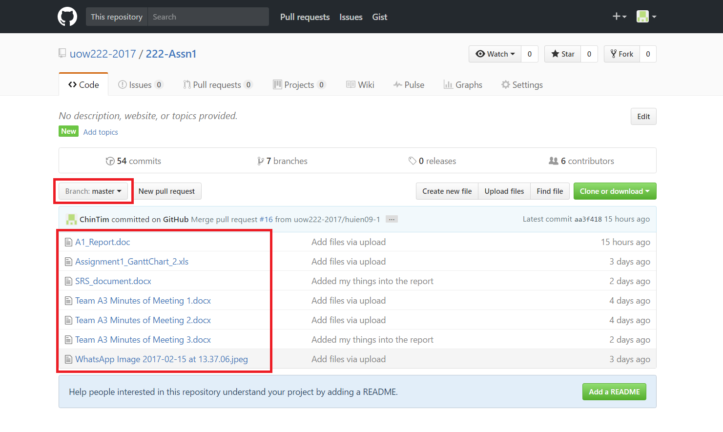

The master branch contains all the original files.

Branches will be able to merge to the master to update files.

Screenshot #2 - VCS's listing of all the latest source files currently being managed
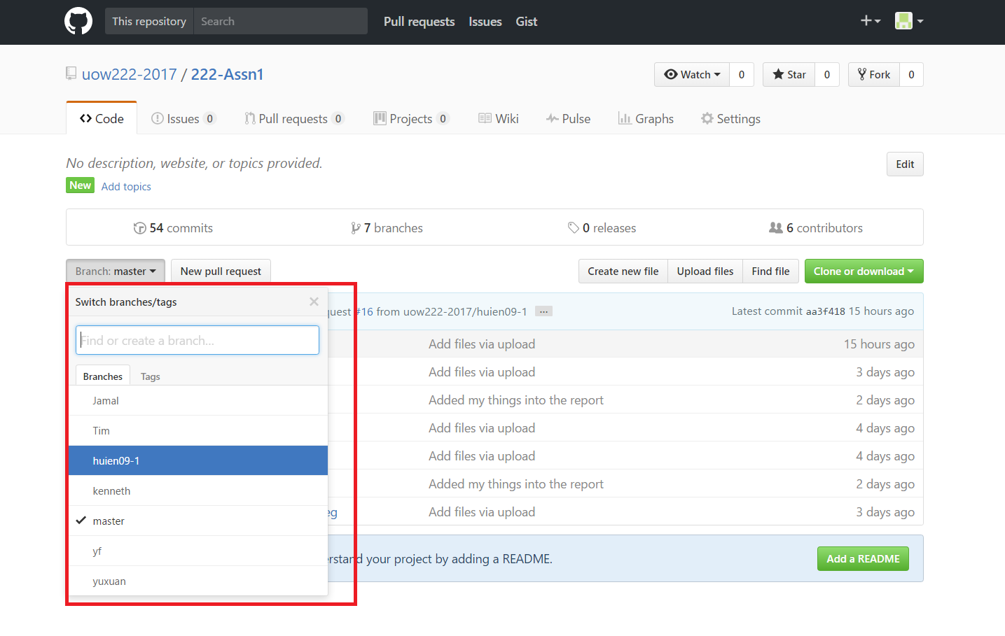

- Branches have been made to manage the files.
- Each member has his/her own branch to edit.

- The branches are copies of the master.
- Any changes goes to the branch first.

Screenshot #3 - Example using VCS's to check-out source files (it may be necessary to do >1 screen capture, depending on the software used)

- Go to the master branch (contains the latest updated files)
- Click on the file you wish to download

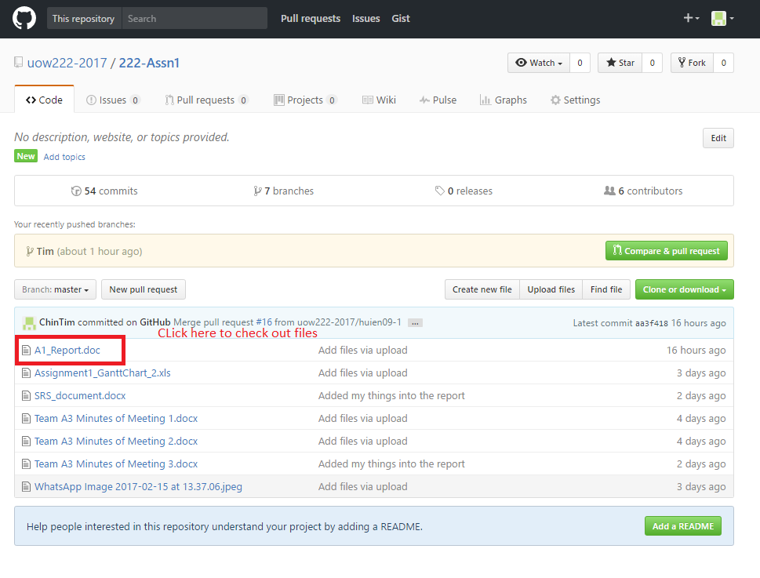

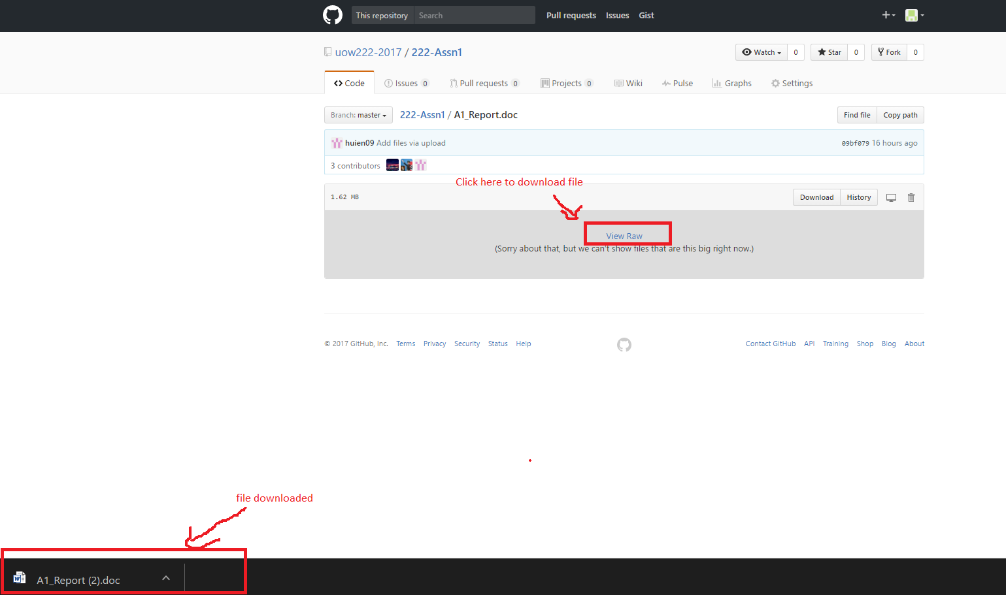

- Begin adding stuff into the files.

Screenshot #4 - Example using VCS's to check-in source files (it may be necessary to do >1 screen capture, depending on the software used)

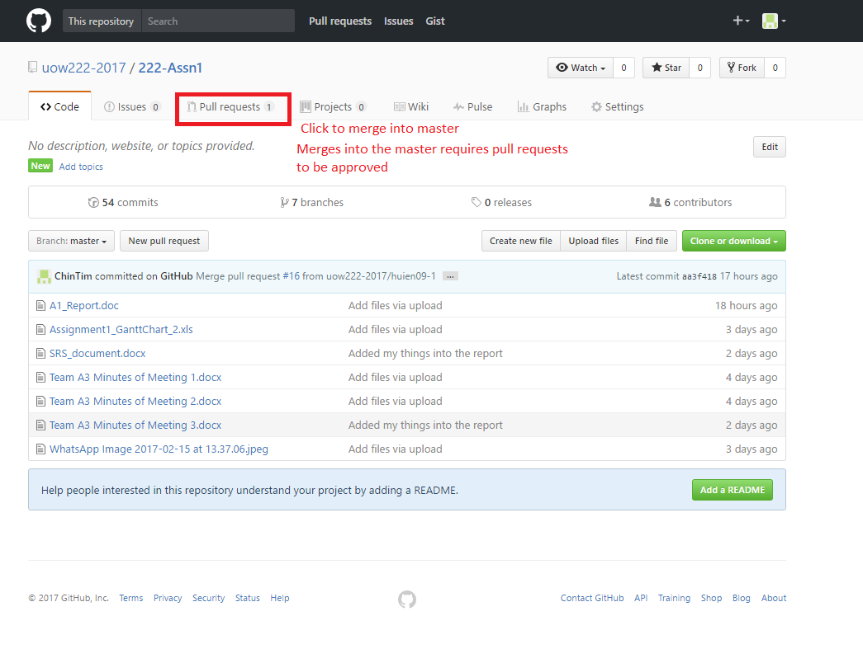

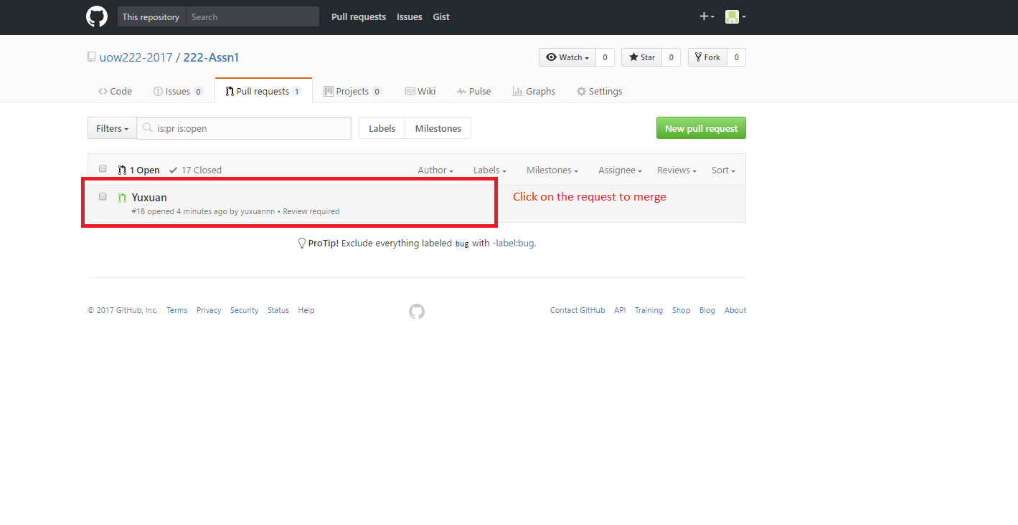
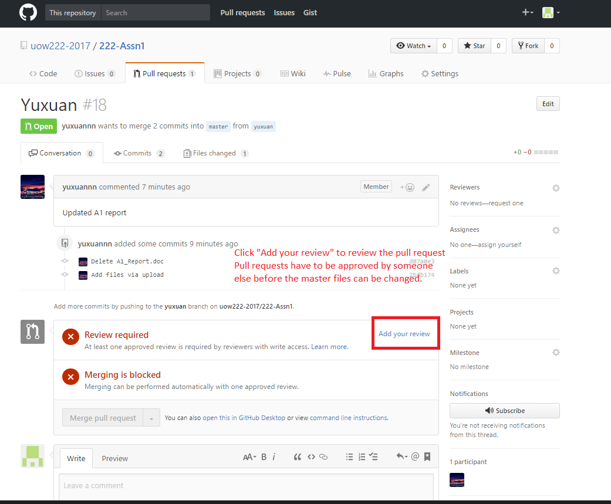

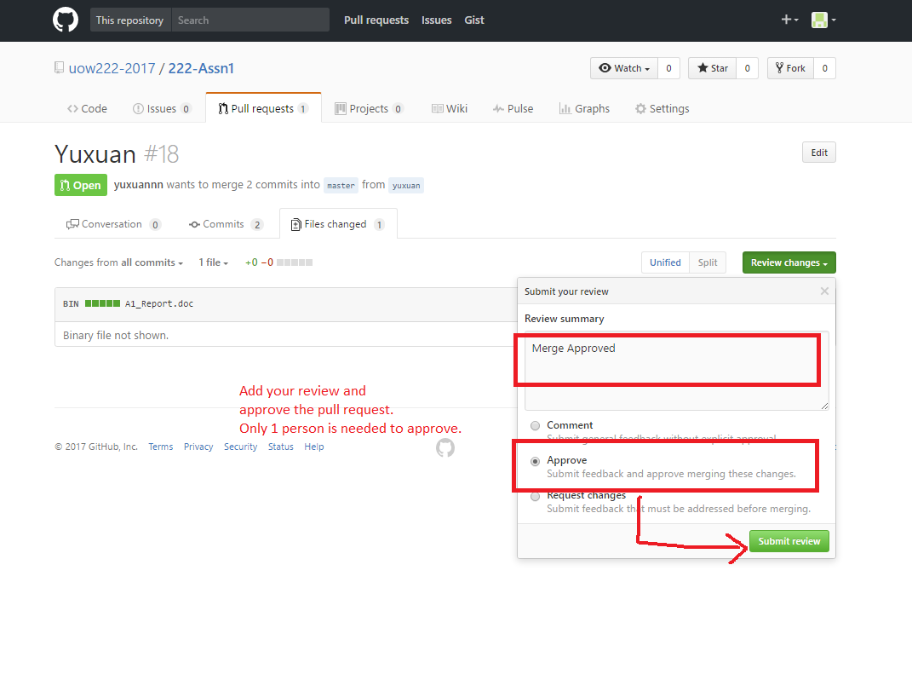

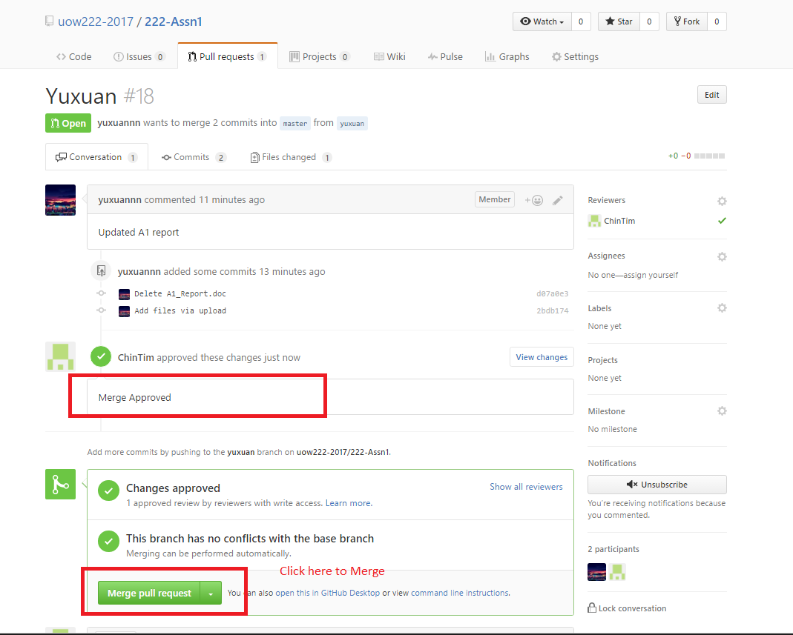

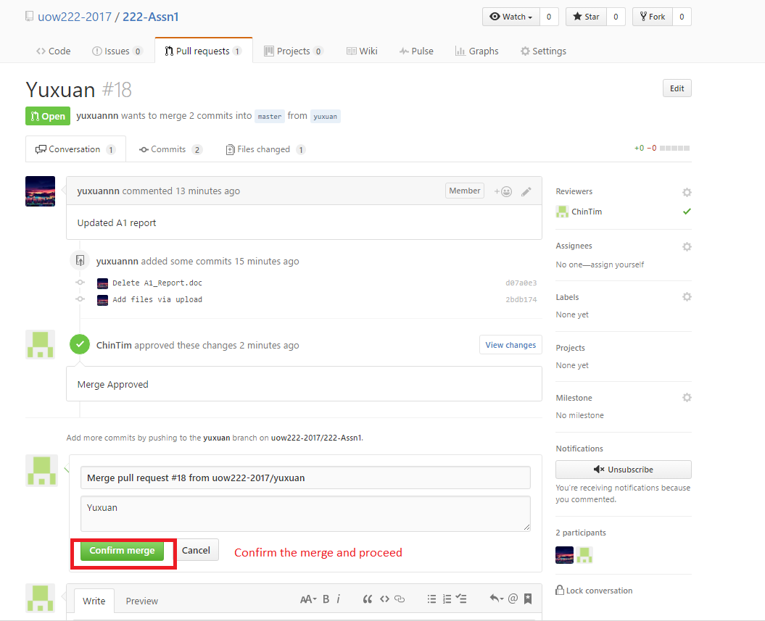

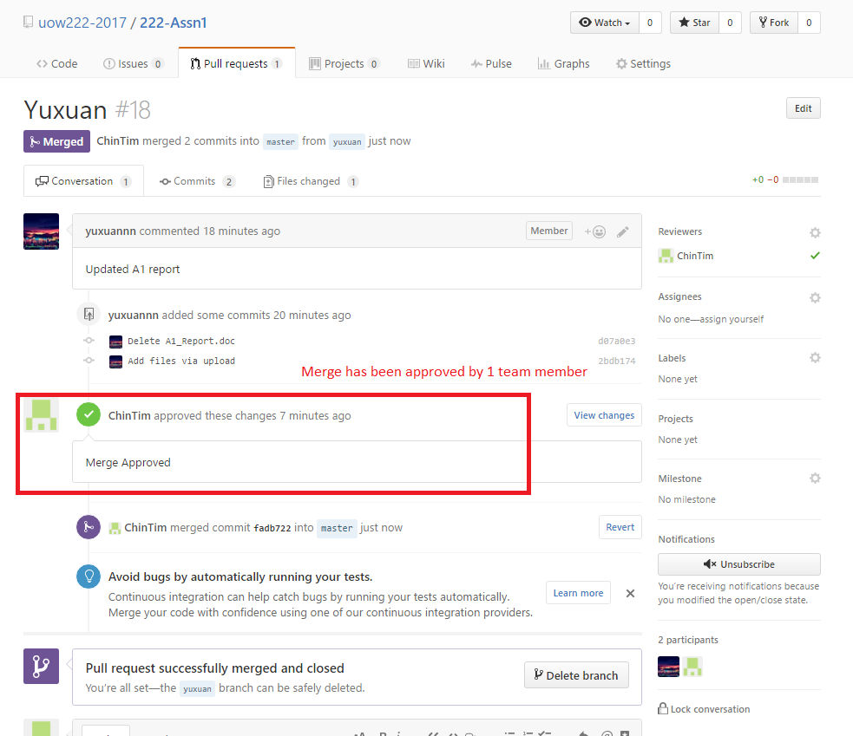

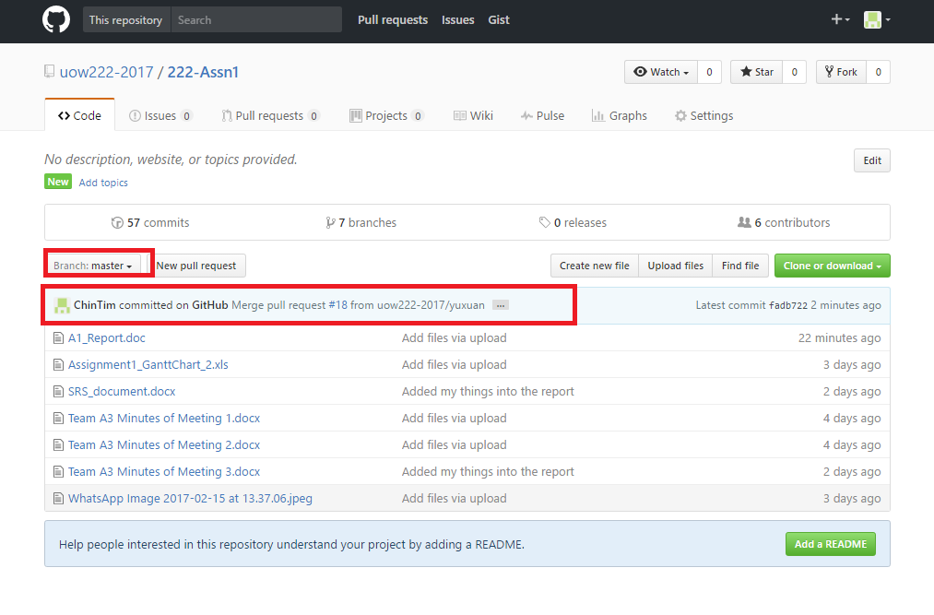

Screenshot #5 - Example using VCS's to display the change history / log (it may be necessary to do >1 screen capture, depending on the software used)

