

MINER’S REVENGE SCHEDULE of EVENTS
Friday (July 10th)
Pre-riding the trails is allowed any time.
5:00pm - 7:00pm Registration
5:00pm - 7:00pm Ride with the Enduro & XC Race Directors - Start @ The Main Stage
6:00pm - 9:00pm Self guided pre-rides (The mine is OPEN)
8:15pm - 10:00pm Dumpster Downhill @ the Fairground Chalet
Saturday (July 11th)
Trails are CLOSED until 2pm or Enduro Finish
7:00 am - 10:00 am Breakfast by The Adventure Mountain Horse Club @ Fairground Chalet
8:00 am - 9:00 am & 4-6:00 pm Registration
9:00am - Enduro Volunteer Meeting
9:50 am - Prerace Enduro Meeting @ The Main Stage
10:00 am Lake Superior Gravity Enduro Race - Start
2:00 - 4:00pm Kids Adventure Ride Start @ The Main Stage
2:00 - 3:30 pm Shuttles @ Fairground Chalet
3:45 pm DH Rider’s Meeting @ Fairground Chalet
4:00 pm Lake Superior Gravity Downhill Race - Start @ Fairground Chalet
5:00 - 8:00 pm Dinner is served @ The Main Stage
7:00 pm Enduro & DH Awards @ The Main Stage
7:30 - 10:00pm Live Music by Northern Daze @ The Main Stage
Sunday ( July 12)
8:00 am Registration
9:00 am Cross Country Race - Mass Start @ The Main Stage
11:30 am Cut off at Split/Finish Line
11:45 am Mine Will be Closed to ALL Racers
XC and Triple Crown Awards to Follow @ The Main Stage

DIRECTIONS

Event Address
Adventure Mountain
200 Adventure Ave.
Greenland, MI 49929

From Houghton, MI
VIEW IN GOOGLE MAPS
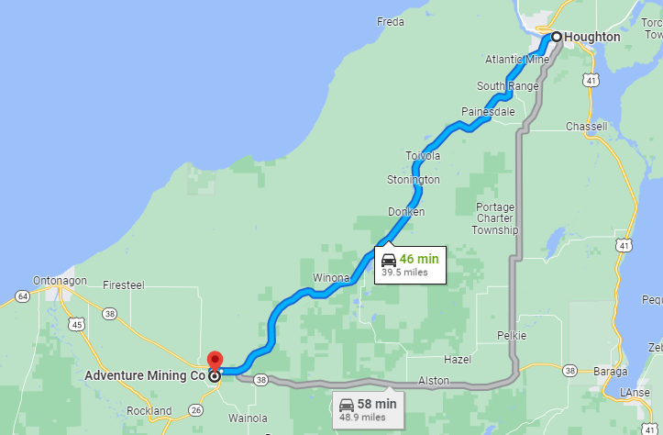

From Marquette, MI
VIEW IN GOOGLE MAPS
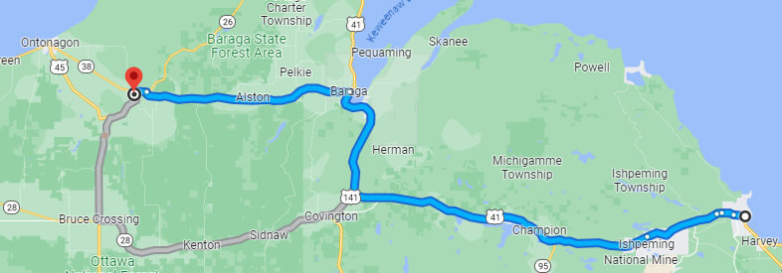

From Duluth, MN
VIEW IN GOOGLE MAPS
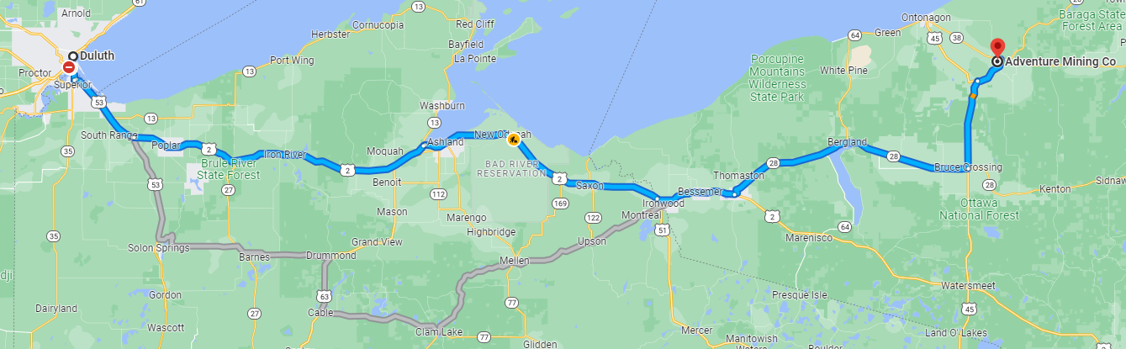

EVENT DESCRIPTIONS

DUMPSTER DH
Is it you, or is it your bike? Come try a run on one of our terrible bikes or bring your own to our Dumpster Downhill happening at 8:15 PM on Friday night! Participants will be judged on performance, general swag, and just how ridiculous their bicycle is.

DOWN HILL (LSGS EVENT)
The Downhill (DH) consists of two timed runs, best 1 of 2 times wins. Practice runs will be on Saturday afternoon before the race. Shuttles will be provided on Saturday. Awards will be given for the overall men and women as well as the U16 girls and boys. Timing provided by Superior Timing.

CROSS COUNTRY RACES: 1, 2, and 3 Lap Events
Get ready for an exhilarating race on our challenging race course, where riders will tackle one lap of thrilling terrain. Each lap features a whopping 1000 feet of vertical climbing, testing the endurance and strength of participants. The course is filled with technical sections, rocky trails, and rooty pathways, providing an exciting challenge for riders who have a fondness for handbuilt singletrack. Don't forget to bring your light, as this race promises an adrenaline-fueled adventure that will push your skills to the limit.

Steep climbs, rolling singletrack, fun descents, and riding with bats. Part of the 6 mile lap is through the underground mine. Because of the total darkness a helmet and a GOOD light are required for the Cross Country (XC) race. Final lap cutoff is 11:30 am at the split/finish. Awards will be given out by age group and gender for 1, 2, and 3 lap races. The age groups are 18U, 18-35, and 36+. Timing is provided by Superior Timing.

BLACK DIAMOND YOUTH ADVENTURE COURSE (Ages 5 – 13)
Test your chutzpah on our youth adventure course - it’s rocky, rooty, and probably even a little bit muddy. There will be prizes to be found along the way!

ENDURO (LSGS EVENT): 3, 4, and 6 Stage Events
The Enduro is a stage-race format where the goal is to accumulate the lowest combined time from a series of individually timed sections. The transfers are not timed, but you will have cut-off times.

Awards will be given to the top three men and top three women overall in the beginner (3 stage), sport (4 stage), and expert (6 stage) events, the top three male and female U16 riders, and the top three male and female 40+ riders. Timing provided by Superior Timing.

TRIPLE CROWN
Can you survive a weekend of riding at the mine? Awarded to the fastest male and female in the DH, Long XC, and Expert Enduro events. You must race in all three events to qualify!
Triple Crown Scoring: For each event, participants receive a score based on their time divided by the slowest time of all triple crown participants in that event. The total score for all events is added up and the lowest score wins (the highest possible score would be 3).

EVENT INFORMATION & RULES

Dumpster DH
All racers must register/check-in to receive your number plate at the registration tent no later than Friday at 7 PM.

- All Participants:
  - 8:15 pm Pre-ride meeting
- Only riders who are registered will be allowed to compete.
- Helmets are required. Full-face helmets are recommended.

Enduro
All racers must register/check-in to receive your number plate and timing chip at the registration tent no later than Saturday at 9:00AM.

Enduro Stage Orders
You must begin your race with the stage assigned to your race class. Start the race with the assigned stage to help keep congestion to a minimum! Don’t try to skip to a different stage or you may be disqualified. Each stage must be started within the time period given for your class.

- Expert Class
  - Pre-race meeting at 9:50 AM at the Main Stage.
  - Morning start - 10:00 PM at the Main Stage.
  - Required Expert class morning stage order
      - Hammerdown - Mine- Neffs
      - Lions Back
      - Miners DH
  - The second block of stages will go live at 11:30AM or when the setup is completed.
  - Required Expert class afternoon stage order
      - Huntz
      - Scenic Piste
      - Dangerous Curves
- Sport Class
  - Pre-race meeting at 9:50 AM at the Main Stage.
  - Morning start - 10:00 PM at the Main Stage.
  - Required Sports class morning stage order
      - Lions Back
      - Hammerdown - Mine - Neffs
  - The second block of stages will go live at 11:30AM or when the setup is completed.
  - Required Sport class afternoon stage order
      - Scenic Piste
      - DangerousCurves
- Beginner Class
  - Pre-race meeting at 9:50 AM at the Main Stage.
  - Morning start - 10:00 AM at the Main Stage.
  - Required Beginner class Morning stage order
      - Lions Back
      - Hammerdown - Mine - Neffs
  - The second block of stages will go live at 11:30AM or when the setup is completed.
  - Required Beginner class afternoon stage order
      - Scenic Piste

Enduro Transfer Descriptions
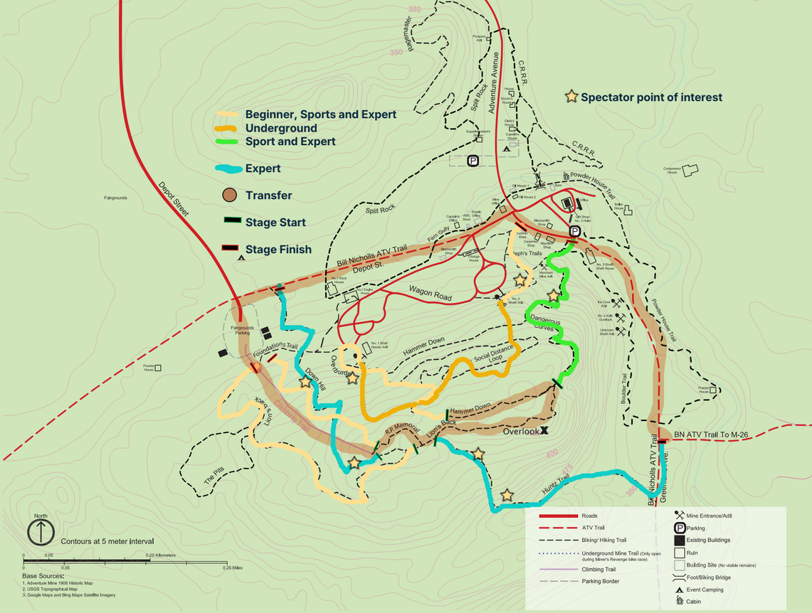
- Adventure Mountain transfer is a push up the ski hill piste to the Rob Peters Memorial Rear Entry Trail (Note: Rob is not actually dead, he just needs to be teased). Please use caution crossing the DH trail when the evening stages are active. Please be courteous to other racers and provide them space for a clean run.
- Adventure mountain transfer provides access to:
  - Lions Back
  - HuntsTrail
  - Dangerous Curves
  - Miners DH
  - Scenic Piste
  - Hammerdown - Mine - Neffs

Enduro Stage Descriptions
- Lions back DH: The downhill direction of everybody's favorite(?) XC climb.
- Huntz trail: Big rock rolls to high speed camber and tech with a fast atv trail finish
- Scenic Piste: Wide open sections of ski piste for wide open grassy DH. Practice your flat turns on grass.
- Full Dangerous curves: A tight twisty off camber trail flows into the steep dangerous curves decent
- Miners DH: A lap down the revamped DH course. Berms, drops, jumps and gaps! Full send!
- Hammerdown - Mine - Neffs: Bring your lights!! This stage will begin near the top of the Hammerdown trail, then link up with a new short section of trail. After blasting some loamy turns you can enter the mine in the #1 Adit and race underground and out the #2 Adit. Stay Right as you exit to catch the start of Neffs trail and shred your way toward the registration area.
- Enduro courses will be marked with RED tape

Enduro Race Rules
- Racers must begin with an assigned first stage set order according to your race class.
- Racers may choose their own route to get to the start of each timed stage.
- Suggested transitions are recommended but not required.
- Racers may not ride uphill on the timed stages.
- Racers must use the same bike for the whole event. NO E-BIKES.
- Racers must ride their bikes for the whole event (no vehicle shuttles).
- Racers will be released onto timed stages at no less than 30 second intervals.
- Slower racers must get out of the way for faster racers to pass on timed stages.
- Faster racers, please announce when you are approaching a fellow racer. Be courteous.
- No aid will be provided on course. Riders must carry their own water and supplies.
- Time cut-off: No one may start a timed morning downhill stage after 11:30AM and afternoon downhill stage after 1:30PM
- You must return your timing chip after your final stage at the Registration tent to have your times recorded! No chip = DNF. We’ll have a bucket.
- In case of a crash or injury:
  - If you come upon a racer who has crashed, make sure they are ok. If they say they are ok, continue racing. If they are not ok, or do not respond, please stop to assist and assess the situation. Stay with the injured racer. Gather as much information as you can and stop the next racer. Relay the information to them and have them complete the stage in a safe manner and pass the information off to the volunteers at the start or end of the stage if there is an injured racer on course.
  - A racer who has lost significant time on a stage while assisting an injured rider may be granted a chance to re-ride the stage.
  - Racing will be stopped on a stage if the medical volunteers are dispatched. The overall time cut-off will be extended if necessary at the discretion of the race officials

The Enduro is going underground - DON’T FORGET YOUR LIGHT!

BLACK DIAMOND YOUTH ADVENTURE COURSE
Get ready for an exciting afternoon filled with hiking, biking, climbing, and mild spelunking as you embark on a thrilling scavenger hunt.
Event Details:
- Date: Saturday July 11th
- Time: 2:00 PM
- Starting Location: Registration Tent
Scavenger Hunt Overview:
The scavenger hunt consists of a guided ride to several interesting mine locations where you can collect tokens to trade in for prizes!

Down Hill Race
All racers must register/check-in to receive your number plate and timing chip at the registration tent no later than Saturday 5:30 PM.
- All Racers:
  - 3:45 pm Down Hill Pre-race meeting @ The Fairground Chalet
  - 4:00 pm Lake Superior Gravity Series Down Hill Race @ Fairground Chalet
  - The race will be 2 timed runs, best single-time wins.
- All riders need to do the first run - the second run is optional.
- All riders need to be done with the first run before the second lap will start.
- Racers will be released onto the timed stages at no less than 30 second intervals.
- Slower racers must get out of the way for faster racers to pass on timed stages.
- Faster racers, please announce when you are approaching a fellow racer. Be courteous.
- No aid will be provided on course. Riders must carry their own water and supplies.
- You must return your timing chip after your final stage at the Registration tent to have your times recorded! No chip = DNF. We’ll have a bucket.
- In case of a crash or injury:
If you come upon a racer who has crashed, make sure they are ok. If they say they are ok, continue racing. If they are not ok, or do not respond, please stop to assist and assess the situation. Stay with the injured racer. Gather as much information as you can and stop the next racer. Relay the information to them and have them complete the stage in a safe manner and pass the information off to the volunteers at the start or end of the stage if there is an injured racer on course.
- A racer who has lost significant time on a stage while assisting an injured rider may be granted a chance to re-ride the stage.

- Racing will be stopped on a stage if the medical volunteers are dispatched. The overall time cut-off will be extended if necessary at the discretion of the race officials
- The DH race course will be marked with YELLOW tape and pin flags

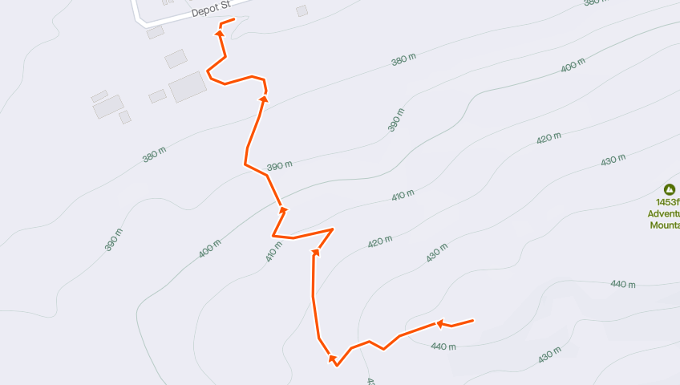

https://www.strava.com/routes/3112758440900740552

Down Hill Race Spectator Guide
- For rider and spectator safety, please do NOT cross in areas that are taped.
- In key sections, spectator crossing zones and viewing areas will be marked.
- Please respect the riders and race course markings so we can all have a fun and safe experience

Cross Country Races
All racers must register/check-in to receive your number plate at the registration tent no later than 8:30 AM. Mass start begins Sunday at 9:00 AM.

- All Races (1, 2, and 3 laps)
  - Line up by registration area
  - Pre-race announcement at 8:55 AM
  - Mass start at 9:00 AM
- NO E-BIKES.
- Slower racers must get out of the way for faster racers to pass
https://strava.app.link/Fp9klOV6eBb
XC Lap (without roll out)
- Faster racers, please announce when you are approaching a fellow racer. Be courteous.

- Water and Gatorade will be provided at the main stage, on top of the Lions Back, and at the bottom of Ragemaster. Riders are expected to carry their own nutrition and supplies.
- Time cut-off: No one may start a new lap after 11:30 AM.
- Mine closes at 11:45 AM
- In case of a crash or injury:
If you come upon a racer who has crashed, make sure they are ok. If they say they are ok, continue racing. If they are not ok, or do not respond, please stop to assist and assess the situation. Stay with the injured racer. Gather as much information as you can and stop the next racer. Relay the information to them and have them pass the information off to the medic/volunteers at the next aid station.

XC Course Description
The start lap will go up the ATV trail towards Wagon Road. Next is the entrance to the mine - hopefully you remembered to bring a light! Then a fun singletrack section which takes you across the ski hill and onto the Lions Back. Halfway up the Lions Back you'll take a 'break' and check a little of the newest section of hand cut trail - the Pitts. This tight, rocky, rooty trail will test your stamina before sending you back to finish the brutal Lions Back climb. At the top, high five your favorite aid station volunteer and roll on down to Poker Run. From Poker Run you'll hit Hammer Down, Social Distance, and the infamous Dangerous Curves. Find your inner balance by dodging boulders on Boulder and pedal fast through Powder House. Wave at your fans as you pass the main stage aid station before taking a quick bob into Fern Gully. Don't forget to check out our Foundations as you’re racing by. If the trails are dry you can test your climbing and decent skills on Ragemaster and if they are wet we will let you enjoy Splitrock instead. Then past the aid station, and onto CRR1 once more. This will take you across the bridge and over the finish line. If you are doing the 2 or 3 lap race, continue on Neph’s trail towards Wagon Road and do it all again.

The XC course will be marked with BLUE tape.

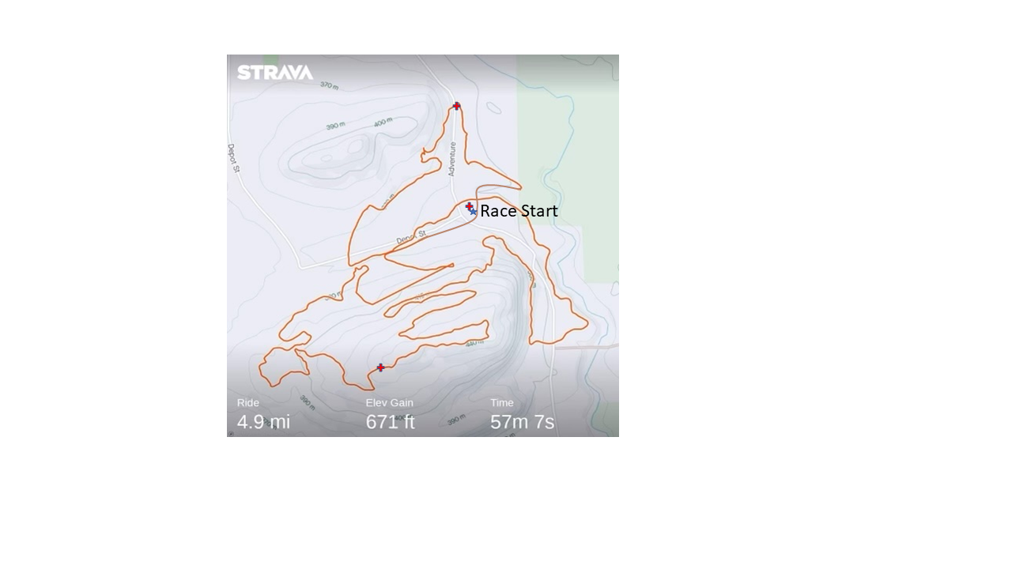

Other Information

Registration
Registration is available at https://www.bikesignup.com/Race/MI/Greenland/MinersRevenge

Refund Policy
Refunds are not allowed for this race. Transfers are allowed until the day before the race. There is a $5 processing fee.

Swag & Giveaway
Each participant will receive a food ticket ($10 value) to be used Saturday at any vendor. Participants who signed up prior to May 31st will also receive a Miners Revenge T-shirt.

Food
At the Miners' Revenge bike race, we want to ensure that everyone, including participants, spectators, and volunteers, has a fantastic culinary experience. We've made it convenient for everyone by allowing food vouchers to be used at all vendors. This means that whether you're a volunteer or participant you can enjoy a delicious meal using your voucher at either vendor.
Saturday Schedule:
- 8:00am - 10:00am
  - The Adventure Mountain Horse Club will be serving coffee, juice, breakfast burritos, and bakery at the chalet.
- 12:00 pm - 8:00 pm
  - The Otter Belly Lodge will be serving dinner at the main stage area.
Note: There will not be any food onsite Sunday.

VOLUNTEERS

How To Volunteer
Volunteers play a vital role in making the Miners' Revenge event a huge success year after year. As a token of our appreciation, all volunteers will receive fantastic perks for their dedicated support. Firstly, you'll enjoy the convenience of free camping for the entire weekend, allowing you to fully immerse yourself in the event atmosphere. Additionally, you'll receive a stylish Miners' Revenge t-shirt that you can proudly wear as a badge of honor. We want to make sure you're well-fed and energized throughout your volunteer experience, so we'll also provide you with a food voucher to enjoy delicious meals from our diverse selection of vendors.

We truly value our volunteers and recognize that without your enthusiasm, hard work, and commitment, this event wouldn't be possible. SoKe loves volunteers, and we are incredibly grateful for your contributions. By joining our dedicated team of volunteers, you'll become an essential part of the Miners' Revenge family, helping create memorable experiences for participants and spectators alike.

Please consider signing up as a volunteer today to secure your spot and be part of this incredible event. Visit our website at https://runsignup.com/Race/Volunteer/MI/Greenland/MinersRevenge to register as a volunteer for Miners' Revenge. Together, we can make this year's event the best one yet!

Volunteer Check-In
As a valued volunteer, it is essential to check in at the registration desk prior to your assigned time slot. Checking in allows us to ensure that all necessary paperwork and information are in order, and it also provides an opportunity for us to provide you with any last-minute updates or instructions. The registration desk will be located by the main stage.

When you arrive, please present yourself to the friendly registration staff who will guide you through the check-in process. They will provide you with your volunteer t-shirt, food voucher, and details about your shift.

Checking in is crucial to ensure a smooth and organized volunteering experience. It allows us to maintain accurate records of volunteer attendance, ensuring that all positions are appropriately staffed. By checking in, you can also take the opportunity to ask any questions you may have, clarify your assigned duties, and familiarize yourself with the event layout and schedule.

Thank you for your understanding and cooperation. We greatly appreciate your commitment to making Miners' Revenge a fantastic event for everyone involved. We look forward to seeing you at the registration desk prior to your scheduled volunteer shift.

ADVENTURE CAMPGROUND

Beginning Thursday, you will have the option to camp on-site (200 Adventure Ave, Greenland, MI). If you wish to camp, SoKe provides temporary camping permits specifically for the event. To secure your camping spot, you can make a reservation through the race store. All reserved sites will be clearly marked. Upon arrival, please check in at the registration area to receive your designated site number. Any sites that have not been reserved will be allocated on a first-come, first-served basis. If you have reserved a site then it has already been assigned in the campsite document.

Campground Expectations
- Please treat the campground facilities with the same care and respect as you would treat your own home.
- Adhere to the posted speed limits for all motorized vehicles, ensuring that your speed remains below 15 mph.
- Leave your campsite in the same condition as you found it, or even cleaner if possible.
- If you are a smoker, kindly pick up your cigarette butts and dispose of them in the garbage. Additionally, be considerate of fellow campers downwind, as the smell of cigarette smoke differs from that of campfire smoke.
- Garbage disposal:
  - You will find garbage and recycling barrels conveniently placed throughout the campground.
  - Should these barrels become full, please inform us so that we can address the situation.
- Fire safety:
  - No Fires are allowed at the Fairgrounds
  - Only utilize the designated fire pit and refrain from creating additional fire locations.
  - Remain vigilant while your fire is burning and ensure that it is completely extinguished before leaving.
  - We have an abundant supply of firewood, so please use the existing stockpile.
- Pet policy:

  - If you are accompanied by a pet, kindly clean up after them and keep them on a leash when necessary.

General Site Guidelines
• Please don't climb on historic foundations.
• If you find historic artifacts please leave them where they lie.
• No spectators inside the mine.

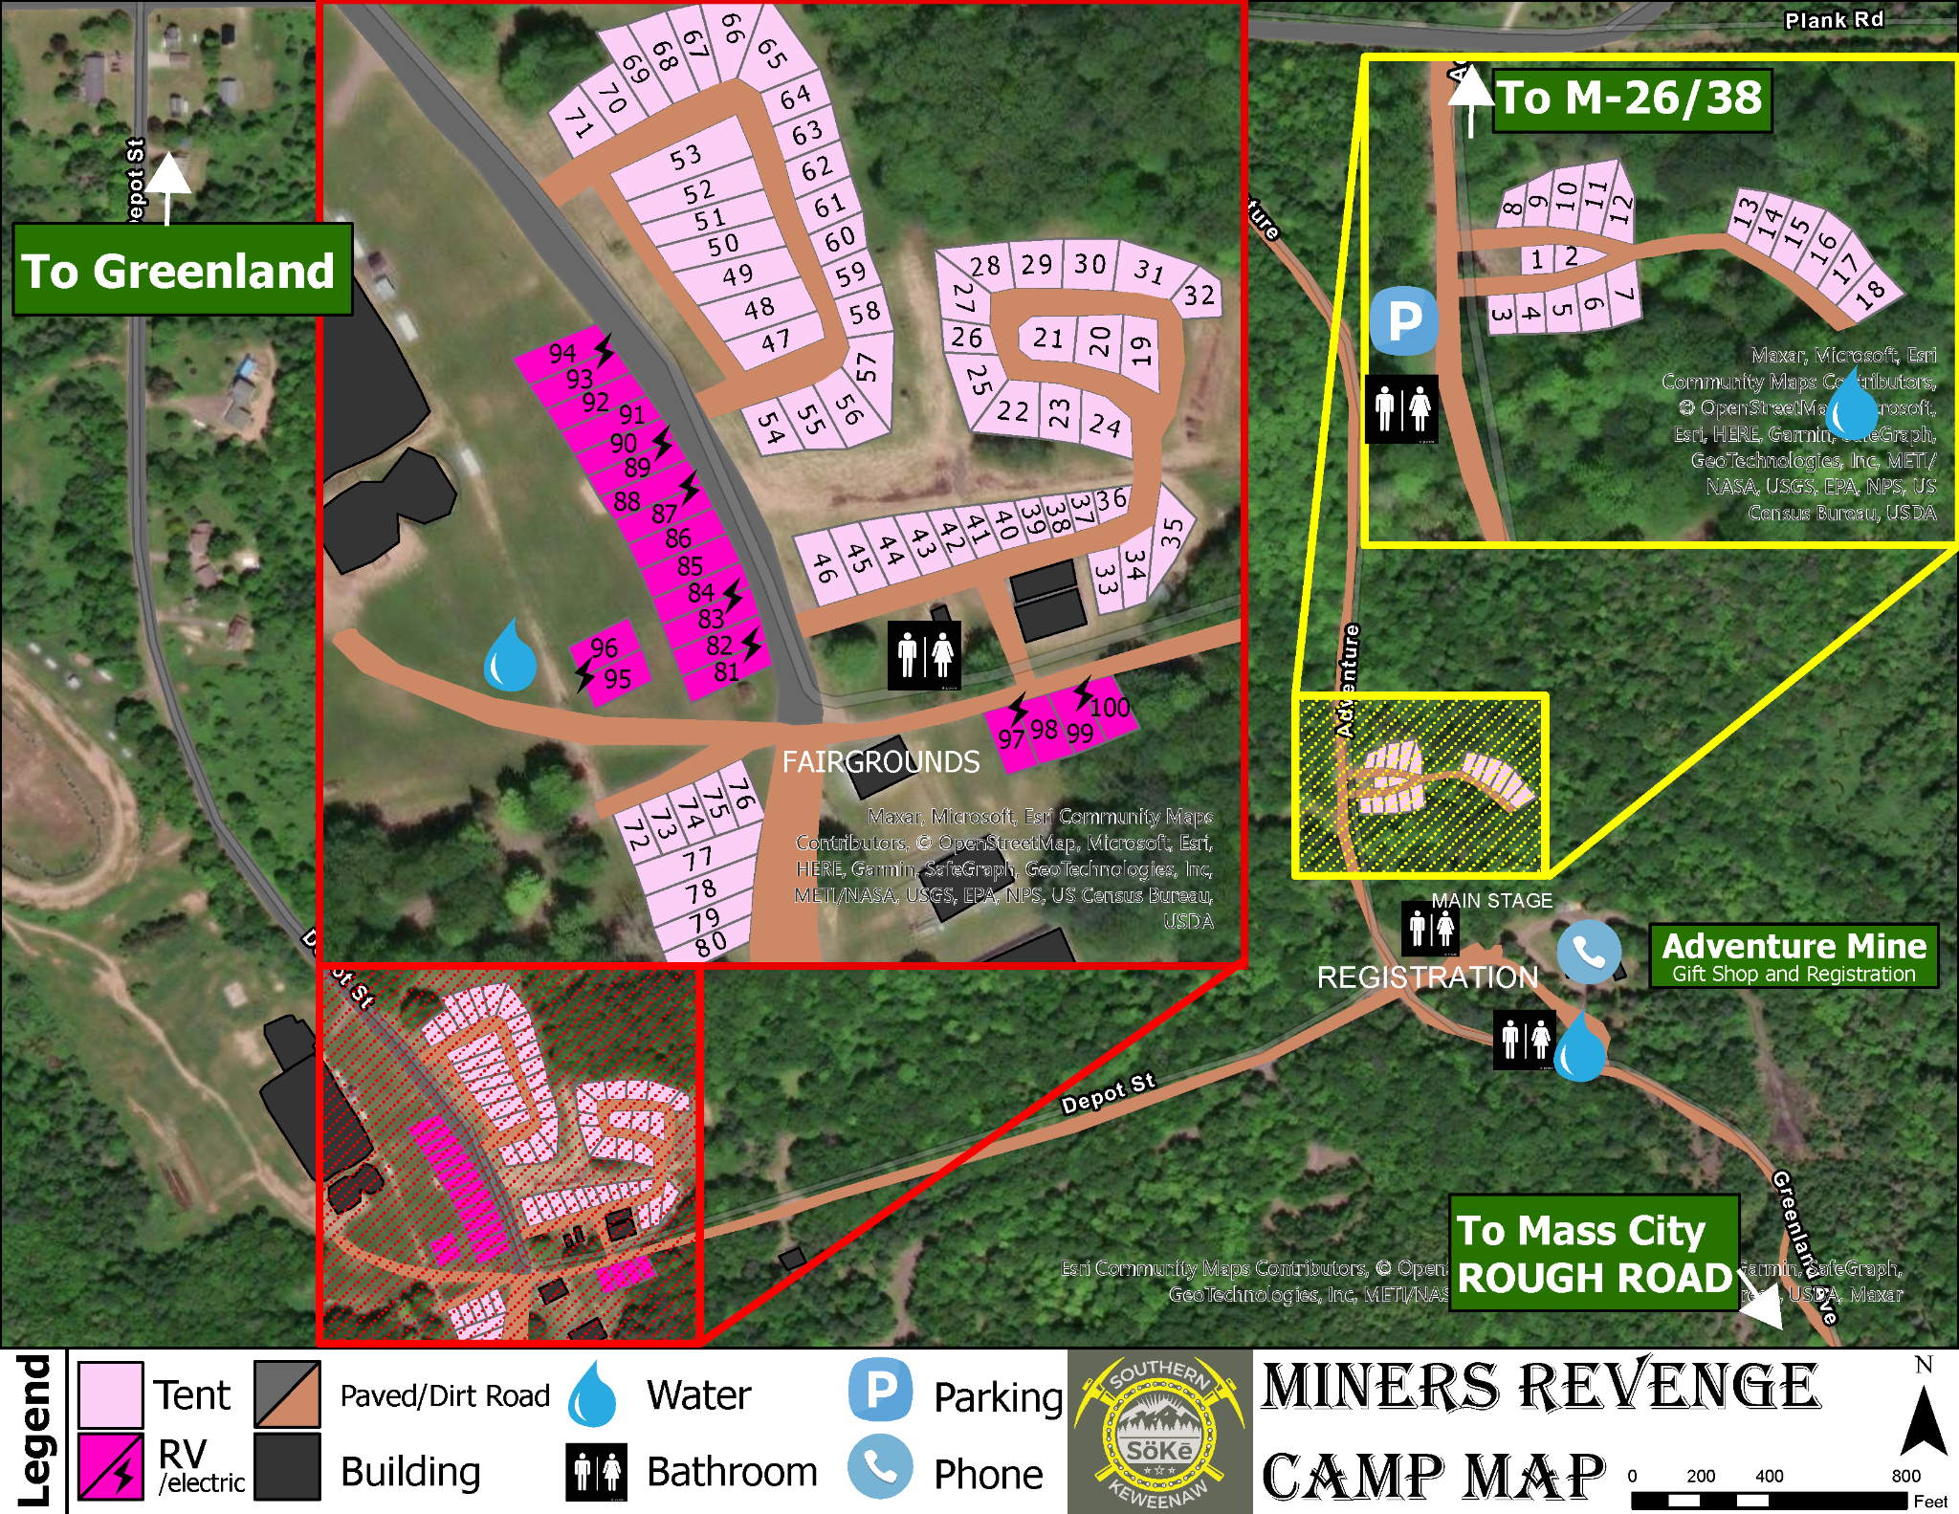


ADDITIONAL POLICY

POLICY STATEMENT ON LIGHTNING/INCLEMENT WEATHER

Purpose
To implement a lightning safety policy to ensure the safety of all participants, staff, volunteers, and fans at SOKE trails in the case that lightning or severe weather occurs.

Chain of Command
Individuals are responsible for their own actions and are encouraged to make smart choices. During SOKE sponsored events the Executive Event Director is responsible for monitoring weather and communication of incoming storms. They will inform the specific race directors and volunteers as necessary of threatening lightning conditions. The decision to terminate a SOKE activity in the event of lightning, severe weather, and/or storms will be made by the Executive Event Director..

Criteria for Detection, Suspension, or Resumption of an Event
The policy of SOKE Trails Club will be as follows:

In relation to decisions regarding the starting, suspension, or resumption of an event due to lightning or inclement weather, the following guidelines should be utilized:

- The Executive Event Director is the designated spotter for events. A spotter’s responsibilities include monitoring weather reports and utilizing Weather Bug and/or Flash to Bang Method to determine proximity of the storm, as well as notifying the race directors and volunteers when threatened.
  - Flash to Bang Method
    - Determines the proximity of lightning activity by counting. When lightning is observed, begin counting. Once the thunder, also known as the “bang,” is heard, counting stops. Take the number counted to and divide it by five. This quotient is the distance from your location to the lightning measured in miles.
      - Example: Flash (lightning observed) to bang (thunder heard) count of 30 seconds equals a distance of 6 miles.
  - Alert the chain of command when the storm is 15 miles, 8 miles, and 6 miles away. If lightning is observed at 8 miles or less personnel should inform participants and seek low ground. Weather alerts for event personnel are below.
    - Lightning 15 miles away: “Heads up the lightning is within 15 miles.”
    - Lightning 8 miles away: “Begin safety procedures, the lightning is within 8 miles.”
    - Lightning 6 miles away : “Now in danger; safety procedures should be complete-lightning is within 6 miles of site.”
    - “All clear”: Lightning has not been detected at 8 miles for 30 minutes.
    - If lightning continues to be detected within a 8 mile radius for over 30 minutes the Executive Event Director will determine if the event remains in lightning delay or will implement a new course of action.

- Once an event has begun, the decision to suspend and subsequently resume activity is the responsibility of the Executive Event Director. If an event is suspended due to lightning, it is required to wait at least 30 minutes after the last lightning strike in the restricted distance (6 miles).
  - Race Directors and Volunteers should be alerted when the lightning is detected 15 miles from the competition area. Race Directors and Volunteers should be updated when the lightning approaches 8 miles from the competition area, activity should be suspended, and safety procedures should begin. All individuals must be completely within an identified safe location when the distance between the edge of the lightning storm and the location of the outdoor activity reaches 8 miles.

- Decisions regarding the starting, suspension, and resumption of a contest are to be made independent of considerations related to any participant gaining a competitive advantage. In all cases, the safety and welfare of the participants and spectators are the single most important considerations.

