Team Tatin
Exploring NYC Citibike and Weather Data in the year of 2015
https://github.com/up276/BigData2K16/

Vincent Chabot
Urjit Patel
Christina Bogdan

Abstract:

The main objective of our project was to explore how different weather conditions - particularly rain and temperature - impact Citibike ridership throughout New York city in the year of 2015. We explored these weather features in conjunction with two main views of the Citibike data: aggregation over hour and weekday. We were then able to create an interactive tool using javascript’s D3.js library that allows users to explore patterns in the data for themselves. We highlight some key data points in our report below, and encourage readers to explore the data further here , where we have uploaded a demo of our tool for citibike - weather analysis based on weekdays.

Introduction:

The main focus of our project was our interactive D3 map. With it, we hoped to empower users to explore any intuitions that they have about the connections between weather and Citibike rides and extract useful information. There are hundreds of interesting insights that can be uncovered by examining weather and Citibike data together. At the same time, the average person may not have the technical background necessary to mine insights from the data themselves. Rather than tell this person what insights are important for them to understand, we wanted to allow anyone to be able to understand how the two datasets relate on their own - this was our motivation for creating the map. A big data infrastructure was necessarily to handle the 2015 Citibike data. Our weather dataset was relatively small, but the Citbike data was around 3GB in total. To manage this, we performed many map reduce tasks to aggregate our data. This was done on NYU’s Dumbo server.

Experimental Techniques/Methods:

In order to successfully create our interactive visualization, we needed to perform an inner join on our Citibike and weather data, and then aggregate the data along the fields that we wanted to be available to explore. See below for visualization of the process we implemented:

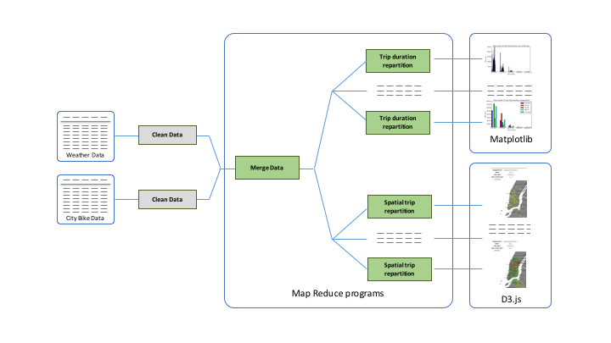

Data Cleaning:

The weather dataset required a lot of cleaning before it was ready to be joined with the Citibike data. The dataset contains many fields that we did not want to use for our analysis, and cryptic column headers. Furthermore, there were many rows with missing data. Missing data was represented by the ‘***’ symbol:

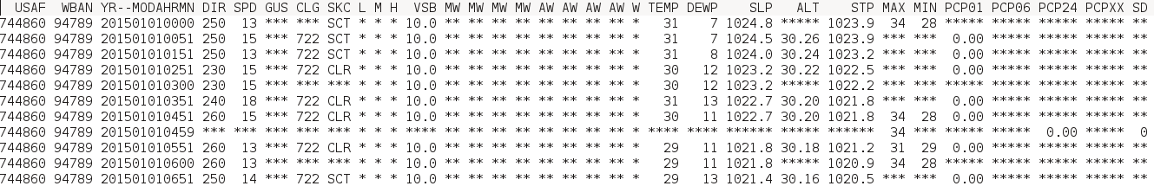
original weather data

In processing the weather data, we performed the following tasks:

- Replace all ‘***’ fields with a blank (“”)
- From the YR--MODAHRMN, extract four additional columns: YEAR, MONTH, DAY, HOUR
- Aggregate all data to the hour level:
- The dataset contains the minutes feature, but readings are taken approximately once an hour
- To bring the data up to the hour level (one line per hour), we only selected the most recent reading for the hour (e.g. if there is a reading at 10:01 and 10:58 AM, choose the reading at 10:58 AM)
- Extract a RAIN column from the PCP01 column:
  - The PCP01 column counts the amount of rainfall that occurred in the past hour. If this count want greater than zeor, we set the binary variable RAIN to 1, otherwise 0
  - There are also PCP06 and PCP24 columns that count the amount of rainfall in the past one 6 and 24 hours, respectively. We could have used these for further analysis in the future
- Crete temperature buckets based on the temperature field

To clean our Citibike data, we performed the following tasks:

- Concatenate twelve original data files into one file
- Aggregate data up to hour level from minute level
- Pivot the data so that for each trip, we have two rows: one representing conditions at the beginning of the trip, and one representing conditions at the end of the trip (before, it was one trip per line)

All of our data cleaning was performed through Python. We were able to clean the weather data locally because it was rather small (13341 rows), but the Citibike data we cleaned on HPC. Our cleaning scripts can be found here.

Map Reduce Tasks:

We used map reduce techniques on NYU’s HPC Dumbo server (through Hadoop) to join our data and aggregate it over several views. All of our tasks had the following configurations:

Cluster Configuration:

Number of nodes: 6
Mappers: 4
Reducers: 1

We performed three main types of map reduce tasks:

- Join Citibike and Weather Data

To perform this join, we took the columns from our pivoted Citibike data file as well as a select set from out weather data file and performed an inner join. Map reduce was totally necessary here, as joining data expands is size and takes a lot of computational power. Our joined file had the following columns:

YR--MODAHR - full date field from weather data file
RAIN - binary variable indicating if it rained in the past hour or not
SPD - wind speed (mph)
temp_bucket - bucketed temperatures (five total)
PCP06 - inches of rainfall in past six hours
TEMP - recorded temperature
SD - snow depth
PCP01 - inches of rainfall in past hour
SKC - sky cover
GUS - wind gust speed (mph)
DEWP - dewpoint
PCP24 -inches of rainfall in past 24 hours
year
month
day
hour
trip_type - binary indicating of line represents beginning of a trip or end
bikeid - ID code of citibike
birth_year - birth year of citibike rider
usertype - type of user of rider (subscriber, one day pass, etc)
station_id - station id for corresponding trip start or end
latitude - trip start/end latitutde
longitude - trip start/end longitude
station_name - trip start/end station name
launch_time - time of trip start/end
tripduration - length of trip
gender - gender of rider

Here, our joining key was the YR--MODAHR field
- Aggregate joined data by Hour and Weekday for D3 input

We needed to perform this aggregation to generate the fields we needed for our D3 visualization. Our input file was the joined Citibike and weather file that we created previously. We generated two data files - one aggregated by hours and one by day of the week Our final fields were:

station_id - the identifier of the station
station_name - the name of the station
latitude
longitude
trip_type - binary variable indicating of line represents beginning or end of a trip
RAIN - binary variable indicating if it is raining or not
temp_bucket - one of five temperature buckets
hour - hour of the day (1-24)
gender - gender of the rider

The code we used to generate this map reduce can be found here.

- Aggregate joined data by trip duration and either gender, rain, hour, and temperature

On top of the data that we aggregated for use in D3, we aggregated our data along the gender/rain/hour/temperature fields so that we could visualaze it using MatPlotLib. WIth these aggregations, we extracted two fields per aggregated file: trip duration and either gender/rain/hour/temperature. The scripts we used to generate this are found here.

Results and Discussion:

We believe that our visualization was a success. The process of creating the visualization also forced us to think deeply about the dataset. For example, we quickly realized while building our map that the distribution of trip numbers by station for different hours/weather conditions was very skewed toward the smaller end of the line:

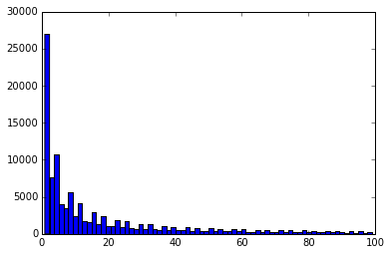
Counts of trip numbers in our aggregated data file for D3 - super biased toward <10 trips/line

We also had to think deeply about the data when deciding how to best represent it for our visualization. Originally, we thought it would be a good idea to represent points on our map with opacity rather than color:

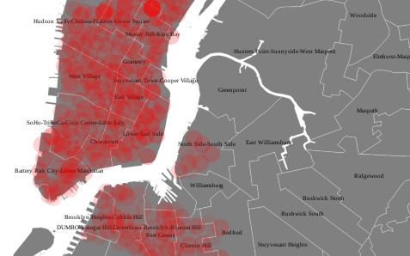

But we quickly realized that color would be a more effective way to do this. We developed a visualization tool with D3 and represented the data on New York City. Below is how our visualization tool looks like,

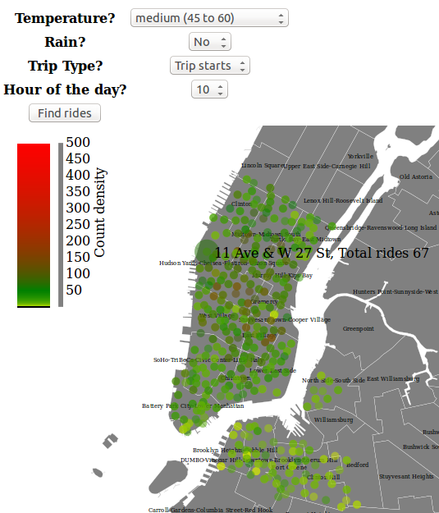

Main Features of our visualization :
- New York Map integration and Data representaion
- Dynamic filters for different weather conditions, Weekday, Hour of the day, Gender
- Density plot based on the ride counts
- Information about the station ( name, ride counts ) will pop up on mouse hover

The size of our data did present some issues when we created our visualization - even after aggregating the joined weather/Citibike dataset, the files were rather big (200k+ rows). This rendered our visualization slow to load. We tried to overcome this by reducing the number of fields in our aggregated datasets, and also using different datasets to generate different views instead of generating just one large view. We also bucketed the temperature field, and made rain a binary variable. Making these two continuous variables discrete helped us reduce the size of our data.

The majority of our other problems had to do with data cleaning - we needed to be creative when it came to shaping the data to fit our needs. For example, we wanted to represent possible changing weather conditions for stop times and end times for the Citibike data, so we needed to modify the data from being 1 trip/line to being 1 trip start/trip end per line.

Demo of our final visualization tool can be found here. Basically we did our analysis based on week days and hours of the days. Here are some interesting insights we extracted from it:

- CitiBike Trips distribution at “temp > 75” and “no rain”

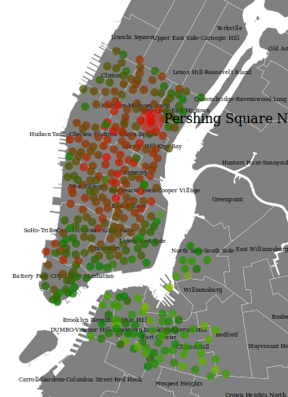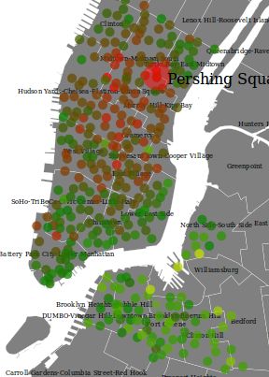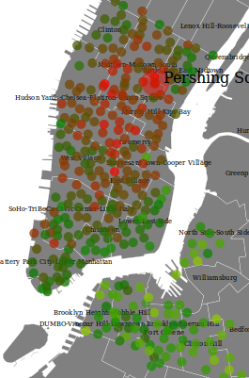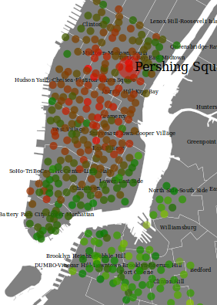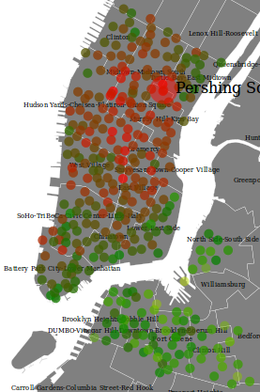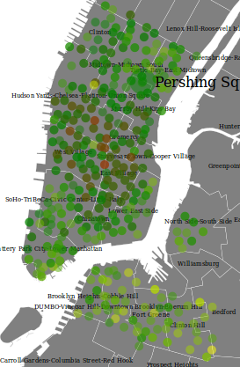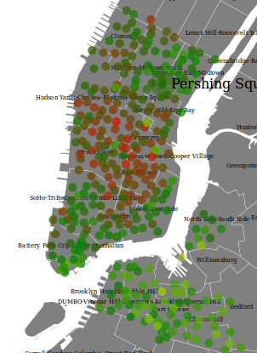
Sunday Monday Tuesday Wednesday Thursday Friday Saturday

We can see that on Friday frequency of rides decreases by major percent. Also we observed that we have much more density in middle area of the Manhattan compare to edges. Brooklyn citi bike rides density seems much more lesser than Manhattan overall. We observed this for both rain/ no rain conditions and all temperature values like very low( <30 ), low ( 30-45 ), medium (45-60), high (60-75) and very high( >75 ).

2. Rain makes the biggest impact of density of rides per station :-

We noticed that in rain is the very important factor which really affects the citi bike rides. We observed the rain effect on rides in all our analysis.

Sample taken for Saturday - Medium Temp. ( 45-60 F)

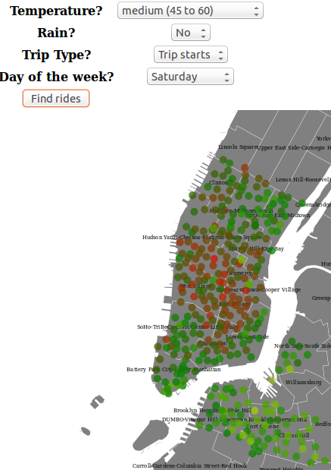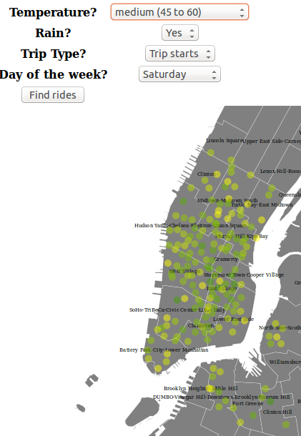
No Rain Rain

3. Gender Based Analysis :-

We noticed that females ( Specially in Brooklyn ) are more sensitive towards rain. We observed high proportional decrement in female riders when it rains, on the other hand side for male riders we observed less proportional decrement.

Analysis sample on Wednesday - Medium Temperature ( 45-60 F)

Male Female
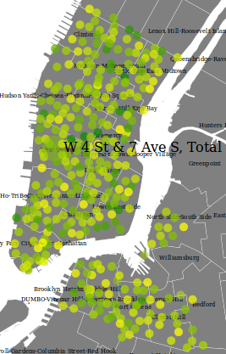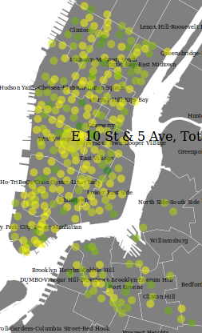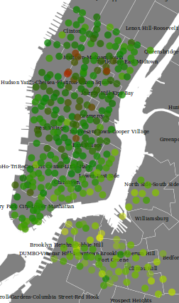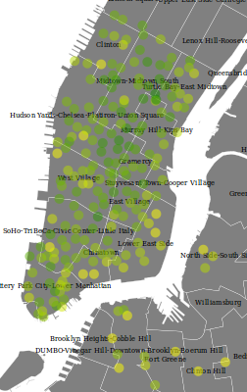
Rain No Rain Rain No Rain

Our research shows that, In general, there are more female riders than male riders. But we observed very strange behaviour, Specifically on Friday female citi bike riders are lesser than male riders. This totally inverse results on Friday shows very interesting behaviour of females.

Both samples are taken at medium temperature (45 - 60 F)

Male Female
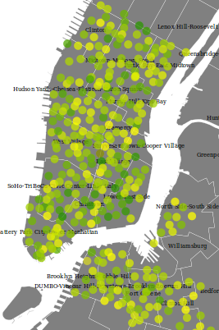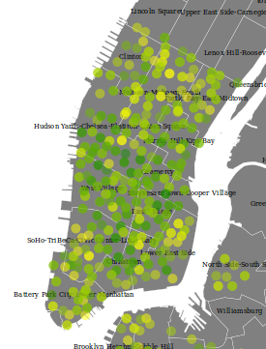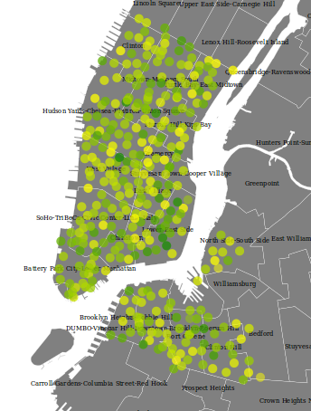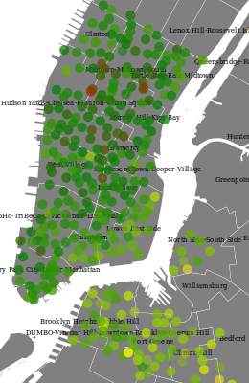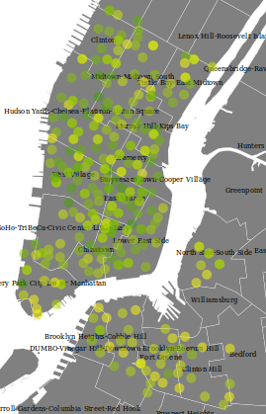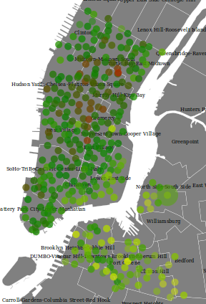
Tuesday Friday Sunday Tuesday Friday Sunday

We can see that on Tuesday and Sunday we have more female riders, but not on Friday.

4. Analysis of Trips - Rain Correlation based on hour of the day

We thought that It would be interesting If we can see how the distribution of rides is getting changed with the hour of day. Also It would be interesting If we can see how different weather condition affects the ride distribution.

Sample taken at No Rain - Medium Temperature

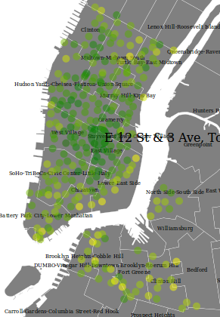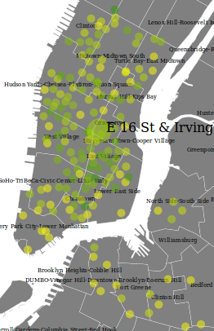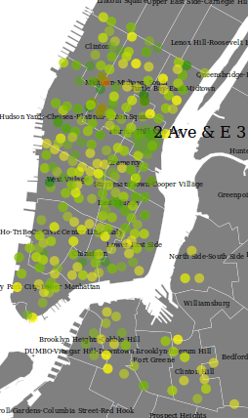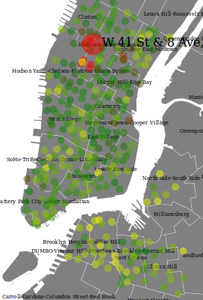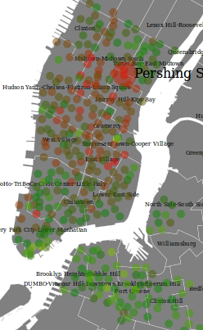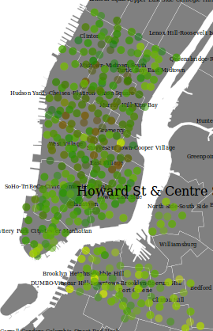
Midnight 3 am 5 am 6 am 9 am 10 am
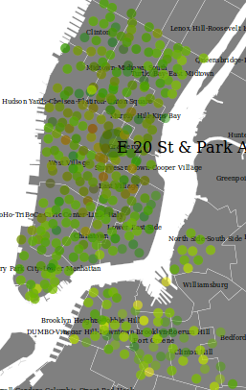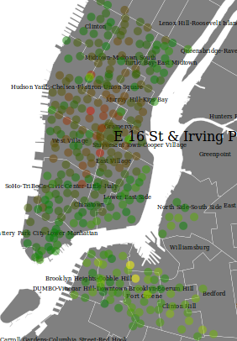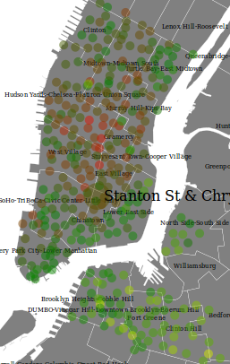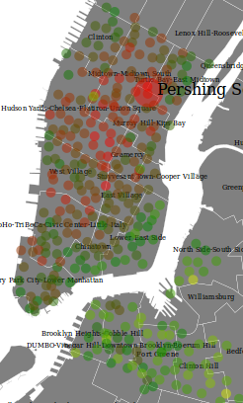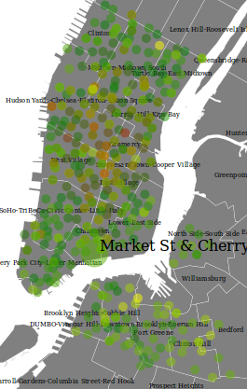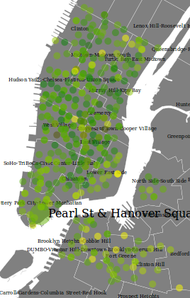
11 am 12 pm 3 pm 6 pm 8 pm 11 pm

Sample taken at Rain - Medium Temperature

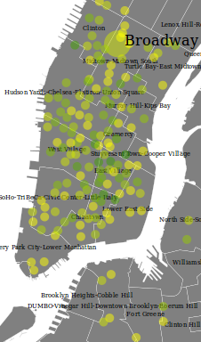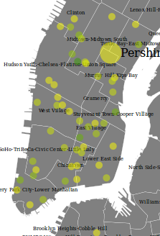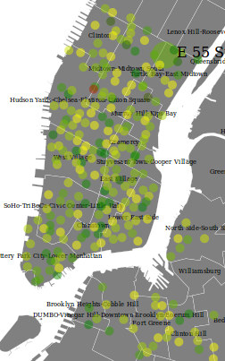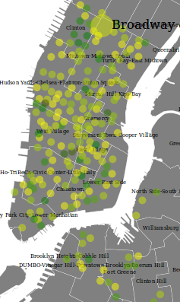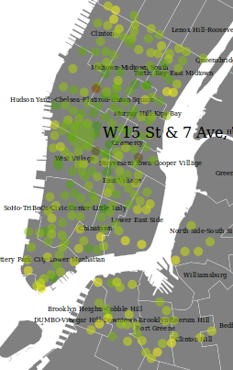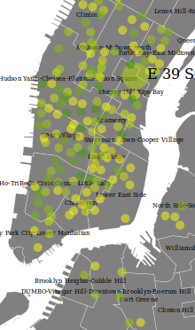
Midnight 3 am 6 am 3 pm 8 pm 11 pm

We observed that If it rains “at night”, It highly affects the number of rides. On the other hand side If it rains in a day, It of course affects the people but due to daily routine of people, we still can see high amount of rides.

Apart from this correlation, We can see some pretty interesting distribution here. From midnight to 5 am, rides continuously decreases. From 5 am to 9 am, It continuously increases. We can see some red dots near 33rd to 42nd street at 6 am. Which shows that these stations are getting in high demand early morning. From 9 am to 3 pm we can see some reduction in use. Again from 3 pm to 6 pm we can see some increment. From 6 pm we can again see continuous reduction.

Some insights :

- Busy hours - morning 6 am - 9 am, 5 pm - 7 pm.
- Busy stations - stations near West 34/42 street and Pershing Square North Station

5. Gender Based Analysis for Day hour

As expected, we observed very less female riders during night. But on the other side during the busy hours, we can see that there are more female riders than male riders.

Sample taken at Medium Temperature and No Rain

3 AM ( night) 6 PM ( Busy Hour )
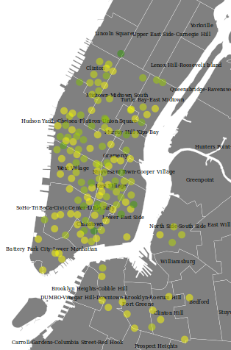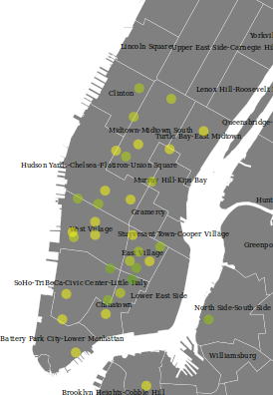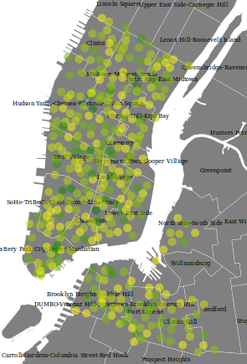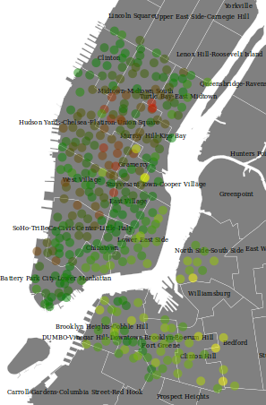
Male Female Male Female

With hour analysis, we observed same thing as we did in day based analysis. We observed that rain affects females more than it does to male. Below example explains this,

Sample taken at 5 PM, Medium Temperature

No Rain Rain
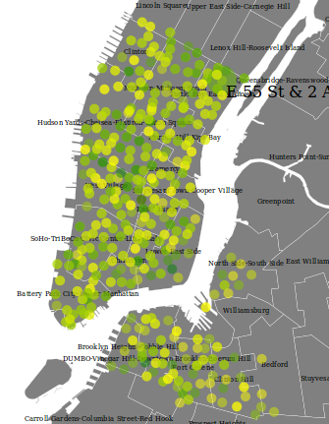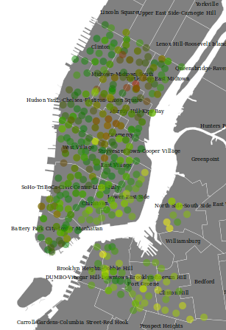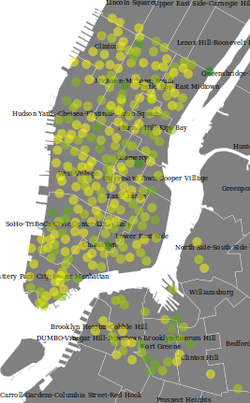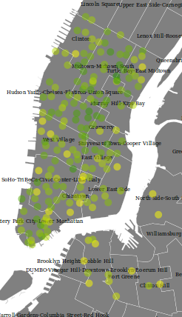
Male Female Male Female

6. The distribution of the trips duration is very different according to the gender (most of rides from women users are between 0-15 minutes when most of rides from men users are between 15 and 30 minutes) :
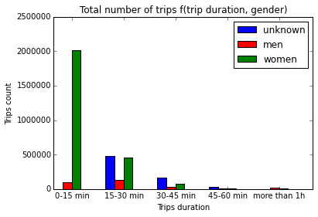
7. The distribution of the trips duration is relatively similar according to the hour of the day (more rides in the early morning and late afternoon, with few rides around noon), but with some interesting facts. For instance, most of the rides are less than 15 min. The bucket 15-30 min is also quite important but above 45 min, there are very few rides. We may conclude that very few customer use it for recreational purposes but more as a transportation way. Therefore, we might conclude that other bike rentals are not our main competitors as they mainly offer bikes for recreational purposes, but our competitors would rather be other transportation services as MTA or cab services. We can also observe a high number of 15-30 min and 30-45 min rides in the morning, which we could associate to rides of people on their way to work, but we don’t find the same pic late in the afternoon as we could expect. Maybe some user enjoy going to work by bike in the morning but come back from work with a different transportation mean. Nevertheless, this seems to be an interesting pattern of how customers use the citybike service.

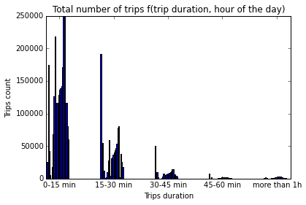

8. The results presented below make sense - the CitiBike system is designed in such a way to encourage shorter trips over longer trips, so it makes sense that the 0-15 min bucket is the biggest. We seem to have a missing data issue for the 30-45 window, however. The lower frequency of trips for the 60-75 bucket may also be attributed to the fact that there are generally fewer days where the temperature is in this range compared to cold days - maybe we could have normalized the data to account for this.
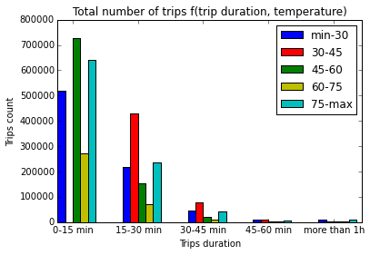

Individual Contributions:

Urjit Patel: Map Reduce for CitiBike - Weather Data Merging, D3 Designing/Implementation, Report
Vincent Chabot: Map Reduce for Matplotlib input, Matplotlib visualization, poster
Christina Bogdan: Map Reduce for D3 input, data cleaning/aggregation, report writing

Summary/Conclusions:
Ultimately, our tool was most useful for noticing the changes in distributions for trips based on whether it is raining or not. We know that as we are dealing with maps, Spatial Indexing here could play very crucial role in finding the points inside some boundary. But as all Citi bikes active stations falls under Manhattan only, we decided not to use indexing just to search based on Manhattan and Brooklyn area. But Of course If we had more time, from learning perspective we would like to implement a search based on Spatial Indexing. Also we would have changed the way that we organized our color scaling to account for the fact that the changes in distribution of riders when it is raining or not is much more significant than that for different weather conditions.

---------------------------------------------------------------------------------------------------------------------------
Status Updates

Topic: Exploring Urban Interactions
Data: Citibike + Weather Data

- Weather Dataset from NYC (year of 2015)

Available at: https://nyu.box.com/s/4lkrxs9rdsfjzpu1gh9nwen89jxtc9dd
Metadata available at: https://nyu.box.com/s/461edjve0obbsefcpaygb1h9z8yc49c4
Temporal data is in GMT (hour resolution).
Single dataset for the entire city.

Available at: https://www.citibikenyc.com/system-data ("Citi Bike Trip Histories" section)
Collect all the data from 2015.
Temporal data is in EST (second resolution).
Spatial data is in GPS.

Tasks

- Correlation between weather and number of trips
- Correlation between weather and type of users (gender/age)

Timeline:
Week 1
- Data collection - collecting 2015 data from Citi Bike and downloading the weather data
- Data cleaning - aggregating time to same units, and other cleaning necessities
Week 2-3
- Data understanding and exploratory analysis
- Develop scripts to explore correlations within data on local systems
Week 4
- Test scripts on the cloud
Week 5
- Write down results in report

Status Report:
No issues. Aggregating time to units was difficult but process finished smoothly

Status Report and Preliminary Results:

Problem definition: Find out the correlation between number of citi rides and different weather conditions such as rain, temperature and visualize it with D3.

First task we performed was to individual data cleaning task on citi bike data and weather data.

Data Cleaning:

- Citi Bike data:
- Data was distributed in individual files, hence we aggregated it into one file having all the citi bike data
- Second step, we performed some feature engineering as an example converting date into multiple columns like day, hour, year etc. Also removed unnecessary data
- Created a key with date-hour combination - Multiple rows having the same key )

- Weather data:
- Understood the meta data and filtered out necessary data according to the problem requirement.
- Did some feature engineering to make the table compatible for merge
- Created a key with date-hour combination - Unique key )

Data Merging using MapReduce:

- Developed Mapper and reducer scripts and Merged citi bike data and weather data based on Key value using these Mappers and Reducers.

Finding count for different combination of Citi bike features and Weather data using MapReduce:

- Developed mapper and reducer scripts according to specific requirement to get the ride counts for different conditions.

Current development:

- Currently working on visualization part. We decided to go with D3 rather than using some visualization software. Currently facing some issues but development is on the track of improvement.

