DCT-SAFE: A Reproducible Digital Cyber Twin for Safe Adaptive Intrusion Detection Under Concept Drift and Unreliable Feedback
Upendra Kumar Singh
Department of Computer Science and Engineering, Sri Ram Murti Smarak College of Engineering & Technology, Bareilly, Uttar Pradesh, India

Abstract
Machine-learning-based intrusion detection systems (IDSs) are frequently evaluated under static train/test assumptions even though operational traffic evolves and adaptation data may arrive late or contain incorrect labels. Recent research has addressed concept drift, continual learning, memory replay, and adaptive intrusion detection, but the decision to update a deployed detector remains a security-sensitive operation [1]–[11]. This paper presents DCT-SAFE, a reproducible Digital Cyber Twin framework for evaluating adaptive IDS behavior under controlled concept drift, delayed feedback, and feedback contamination. The framework explicitly separates drift detection, persistence verification, feedback acceptance, model updating, and cooldown control. A controlled cyber twin is used to evaluate static, gradual, abrupt, oscillating, stealth, and hybrid attack-evolution patterns. External validation is performed on CIC-IDS2017 using a temporally ordered streaming protocol [17]. Across 120 paired synthetic runs, drift-only adaptation provides a mean Attack-F1 gain of 0.034353 over the static reference. Persistence+Cooldown retains 89.85% of this gain while reducing adaptation events by 50.82% and false adaptations from 0.2 to zero per run. F1 gain per adaptation event increases by 82.70%. Ablation results show that anchor replay alone produces a substantially smaller mean Attack-F1 gain (0.004986) than drift-only adaptation (0.034745). CIC-IDS2017 family analysis shows selective rather than universal recovery, with the clearest positive changes for PortScan and Web Attack–Brute Force. The contribution is therefore framed as a reproducible methodology for evaluating safe adaptive behavior and operational update efficiency, rather than as a universally superior IDS classifier.
Keywords: intrusion detection; concept drift; Digital Twin; continual learning; delayed feedback; feedback contamination; adaptive IDS; streaming cybersecurity; CIC-IDS2017; operational safety

1. Introduction
Network intrusion detection is increasingly deployed in environments in which traffic distributions, services, user behavior, and attack strategies change over time. The stationarity assumption underlying conventional batch learning is therefore difficult to maintain in operational networks. Recent IDS surveys identify concept and feature drift as important sources of performance degradation and emphasize continuous monitoring and adaptation [1], [2]. General concept-drift research further shows that reliable systems should distinguish detection, localization, and interpretation of changes rather than treating every distributional difference as an immediate model-update trigger [3], [4].
Recent IDS research has explored incremental learning, continual learning, drift-aware ensembles, replay, strategic forgetting, and adaptive deep models. Shyaa et al. demonstrated drift-guided streaming IDS adaptation [5], while SPIDER introduced semi-supervised continual learning with limited annotation requirements [6]. Strategic Selection and Forgetting refreshes memory around drifted patterns [7], A-NIDS combines unsupervised drift detection with generative replay [8], and recent work has investigated task-aware memory replay [9], incremental contrastive learning [10], and concept-drift-adaptive LSTM detection [11]. These studies demonstrate that adaptation can improve resilience, but they also motivate a separate question: when should a model be allowed to update from feedback that is delayed, sparse, or potentially wrong?
Digital Twins provide a controlled environment in which changing network states and attacks can be reproduced without repeatedly disturbing a live system. Recent cybersecurity research has combined Digital Twins with federated learning [12], zero-touch security and explainability [13], industrial SCADA IDS [14], and self-adaptive wireless IDS [15]. A 2025 survey identifies Digital Twins as an expanding security technology and highlights the need for systematic evaluation methodologies [16]. DCT-SAFE uses the Digital Twin differently: as a reproducible experimental instrument for isolating the chain from observed drift to feedback acceptance and model update.
The central principle is therefore: Detect Drift ≠ Accept Feedback ≠ Update Model. A drift detector provides evidence that the current stream differs from a reference state; it does not establish that feedback is trustworthy or that an update is justified. Persistence verification and cooldown constrain repeated updates, while delayed and contaminated feedback are explicit experimental factors. This distinction is consistent with the broader literature on drift monitoring and adaptive IDSs [3], [4], [8]–[11].

1.1 Contributions
- A reproducible Digital Cyber Twin protocol for controlled adaptive IDS evaluation under multiple drift patterns.
- An explicit separation of drift detection, persistence verification, delayed feedback, model updating, and cooldown control.
- A controlled feedback-contamination protocol that prevents current-window ground truth from driving the update decision.
- A statistical evaluation using paired runs, bootstrap confidence intervals, Wilcoxon signed-rank testing, and effect size.
- External validation on CIC-IDS2017 with attack-family-level analysis rather than a single aggregate F1 score.
- Operational metrics that quantify adaptation benefit per update, false adaptations, and adaptation-frequency reduction.
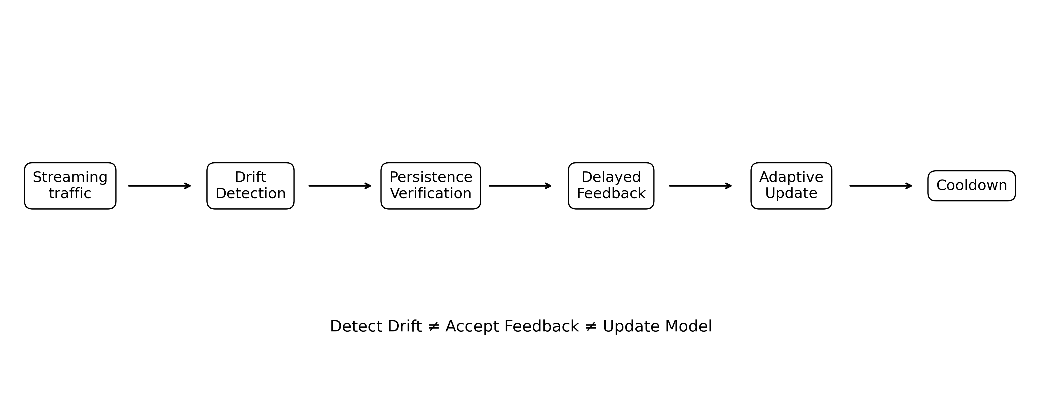
Fig. 1. DCT-SAFE processing chain. The framework deliberately separates evidence of drift from acceptance of delayed feedback and from the decision to update the model.

2. Related Work

2.1 Concept drift and streaming IDS
Concept drift refers to changes in the data-generating process over time. In IDS, such changes may be gradual, abrupt, recurring, or associated with emerging attack behavior. Shyaa et al. evaluated multiple drift patterns in streaming IDS settings [5]. Their later survey identified concept and feature drift as an important but fragmented area in IDS research [1]. Hinder et al. provided systematic treatments of drift detection [3] and drift localization/explanation [4]. These studies support explicit drift monitoring, but they do not imply that every detected drift should immediately trigger a security-model update.

2.2 Continual learning and adaptive IDS
SPIDER uses semi-supervised continual learning with limited annotation and a privacy-aware memory mechanism [6]. SSF uses strategic sample selection and forgetting to refresh memory around drifted patterns [7]. A-NIDS detects data drift through a bypass clustering task and uses generative replay to reduce catastrophic forgetting [8]. Task-Aware Memory Replay prioritizes relevant historical samples while addressing computational overhead [9]. CAEAID uses incremental contrastive learning, adaptive flow anomaly detection, and model updating for concept drift in IoT networks [10]. DSALSTM combines statistical and divergence-based drift monitoring with adaptive learning on CIC-IDS2017 [11]. These approaches motivate evaluating not only accuracy but also when updates occur and what operational burden they create.

2.3 Digital Twins for cybersecurity
Salim et al. combined Digital Twins and federated learning for zero-day cyberthreat detection in IoT networks [12]. A Digital Twin-enabled zero-touch security framework integrates attack simulation, IDS, trust, and explainability [13]. Sayghe proposed a DT-driven IDS for industrial SCADA using process simulation, sensor modeling, attack injection, and hybrid anomaly detection [14]. IDS-Twin uses a lightweight replay engine to emulate streaming traffic and a self-adaptive anomaly detector for wireless networks [15]. Qureshi et al. reviewed security-enhancing Digital Twins and identified open research directions [16]. DCT-SAFE complements these works by using the twin specifically to study the safety and efficiency of adaptive update decisions.

2.4 Research gap
Direction | Typical emphasis | Remaining issue | DCT-SAFE
Drift-aware IDS [5], [8], [11] | Detection/adaptation | Update decision often coupled to drift | Separate drift evidence from update
Continual learning [6]–[10] | Retention/new-task learning | Feedback reliability and update frequency less explicit | Delayed/contaminated feedback + operational metrics
Digital Twin IDS [12]–[16] | Simulation/deployment | DT often used as architecture | DT as reproducible evaluation laboratory
This work | Safe adaptive evaluation | — | Persistence + cooldown + statistical/operational analysis

3. DCT-SAFE Framework

3.1 Framework principle
DCT-SAFE models adaptive IDS operation as five controlled stages: (i) drift detection from unlabeled current-stream features, (ii) persistence verification over consecutive windows, (iii) delayed-feedback eligibility, (iv) model update using only eligible feedback, and (v) cooldown after an update. This structure follows the broader observation that drift monitoring is distinct from drift response [3], [4], while complementing continual-learning methods that manage evolving data and memory [6]–[10].

3.2 Synthetic Digital Cyber Twin
The cyber twin represents network flows using eight features: packet rate, mean packet size, flow duration, connection rate, failed connections, byte rate, mean inter-arrival time, and unique destinations. The baseline contains 1,500 benign and 1,500 DoS flows. The evaluation stream contains 5,000 flows, with the attack regime beginning at flow 2,000 and processed using 250-flow windows. Six scenarios represent static, gradual, abrupt, oscillating, stealth, and hybrid attack evolution. These are controlled simulations and are not presented as replicas of a specific operational network.

3.3 Drift detection and threshold calibration
The drift score is computed from standardized feature-distribution shifts between the current window and a reference state. The threshold is calibrated on a separate benign calibration stream. The current window is predicted before any update derived from delayed feedback. This prevents target leakage and preserves the separation between drift monitoring and feedback-driven adaptation [3], [4].

3.4 Delayed and contaminated feedback
Feedback delays of one and five windows are evaluated. Contamination levels of 0% and 40% alter labels available to the update mechanism, while evaluation ground truth remains unchanged. Current-window labels are never used to decide whether the current window should trigger an update.

3.5 Persistence and cooldown
Persistence requires two consecutive drift-positive windows before an update is eligible. Cooldown suppresses repeated adaptation for two windows following an update. The objective is not to maximize F1 but to reduce unnecessary model changes and false adaptations. This operational perspective complements adaptive IDS research in which drift response, replay, and retraining introduce computational or memory considerations [8]–[11].

4. Experimental Design
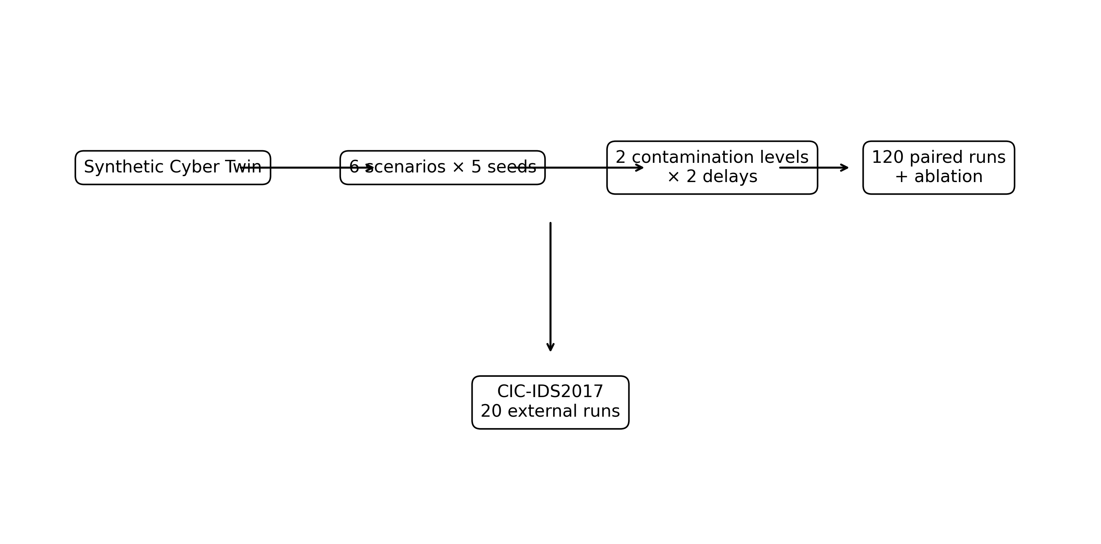
Fig. 2. Experimental design and completed evaluation matrix. All reported quantitative results are from completed runs.
The final operational comparison contains 120 paired runs: six scenarios × two contamination levels × two feedback delays × five seeds (42, 123, 2024, 3407, and 7777). The ablation contains 180 runs for each policy. Static and adaptive configurations use identical initial training and stream realization within each pair.

4.1 Metrics and statistics
Attack-F1 is the standard positive-class F1 computed over the full evaluation window. Macro-F1 is complementary. Operational measures include adaptation events, false adaptations, accepted feedback, and F1 gain per adaptation event. Paired differences are summarized using bootstrap 95% confidence intervals; the Wilcoxon signed-rank test provides paired non-parametric inference; Cohen's dz summarizes paired effect magnitude.

4.2 External validation: CIC-IDS2017
CIC-IDS2017 contains labeled network flows from a five-day capture. The official dataset description states that Monday contains only benign traffic, while attacks are introduced on later days, including brute force, DoS, Web Attack, Infiltration, Botnet, DDoS, and scan traffic [17]. This makes the dataset useful for streaming external validation, but its temporal attack composition creates an important causal limitation: some future attack families are absent from the initial training period. Improvements for those families are therefore interpreted as the combined effect of adaptation and learning from delayed labels, not as a pure causal estimate of concept-drift recovery.

5. Results

5.1 Ablation
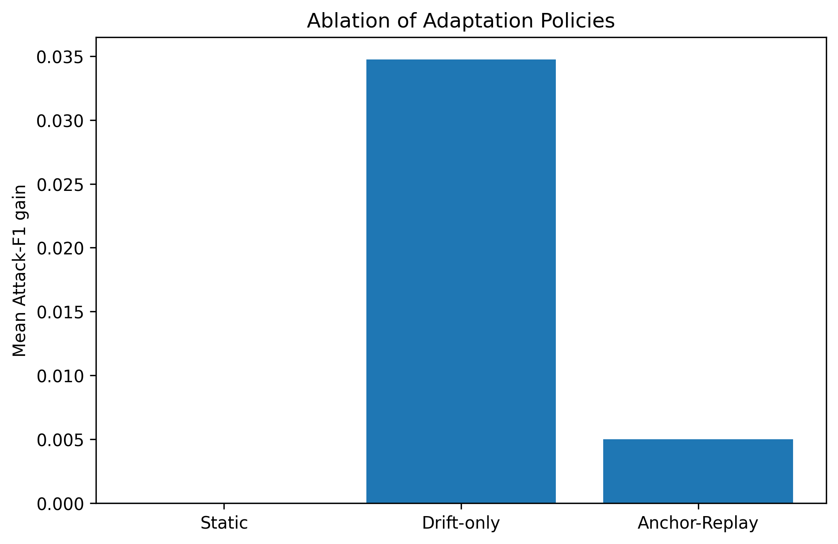
Fig. 3. Ablation of static, drift-only, and anchor-replay policies.
Across 180 runs per policy, drift-only adaptation achieved a mean Attack-F1 gain of 0.034745, whereas anchor-replay achieved 0.004986. The static configuration has zero adaptation gain by definition. The ablation indicates that the principal performance benefit comes from drift-triggered adaptation rather than replaying delayed feedback alone.
Policy | Runs | Mean Δ Attack-F1 | Events/run
Static | 180 | 0.000000 | 0.0
Drift-only | 180 | +0.034745 | 12.2
Anchor-Replay | 180 | +0.004986 | 12.2

5.2 Persistence + Cooldown
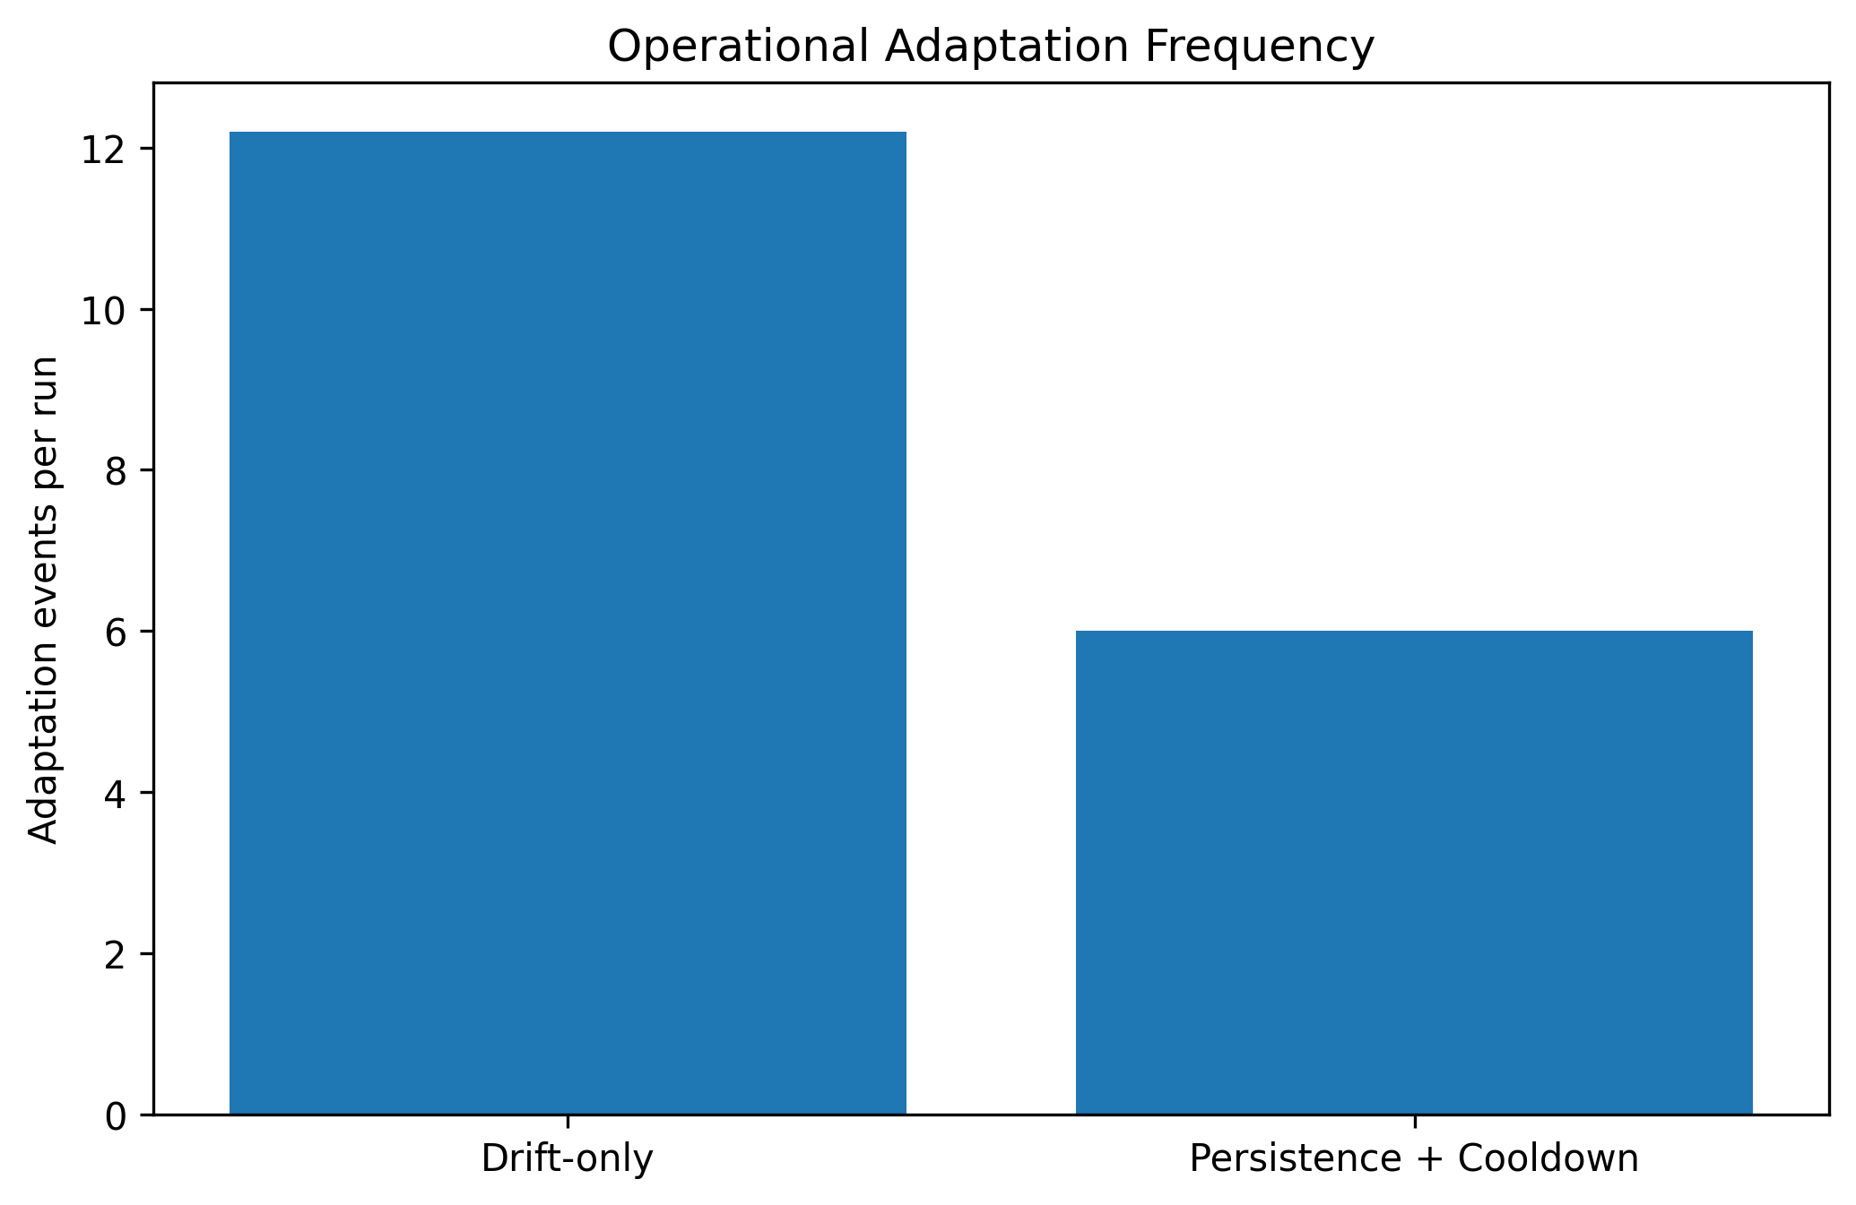
Fig. 4. Adaptation frequency under drift-only and Persistence+Cooldown.
Across 120 paired runs, drift-only adaptation provides a mean Attack-F1 gain of 0.034353, whereas Persistence+Cooldown provides 0.030867, retaining 89.85% of the drift-only benefit. Adaptation events decrease from 12.2 to 6.0 per run, a 50.82% reduction. False adaptations decrease from 0.2 to zero per run. F1 gain per adaptation event increases from 0.002816 to 0.005144, an 82.70% increase.
Metric | Drift-only | Persistence + Cooldown
Attack-F1 gain | +0.034353 | +0.030867
Macro-F1 gain | +0.023533 | +0.021080
Adaptation events/run | 12.2 | 6.0
False adaptations/run | 0.2 | 0.0
Benefit retention | — | 89.85%
Event reduction | — | 50.82%
F1 gain/event | 0.002816 | 0.005144
The paired difference (Persistence+Cooldown minus Drift-only) is −0.003486 with bootstrap 95% CI [−0.005057, −0.002021], Wilcoxon p=0.017552, and Cohen's dz=−0.412914. The conservative policy therefore incurs a small statistically detectable reduction in aggregate F1 benefit while substantially reducing update frequency. It should not be described as more accurate than unrestricted adaptation.

5.3 CIC-IDS2017 family-level validation
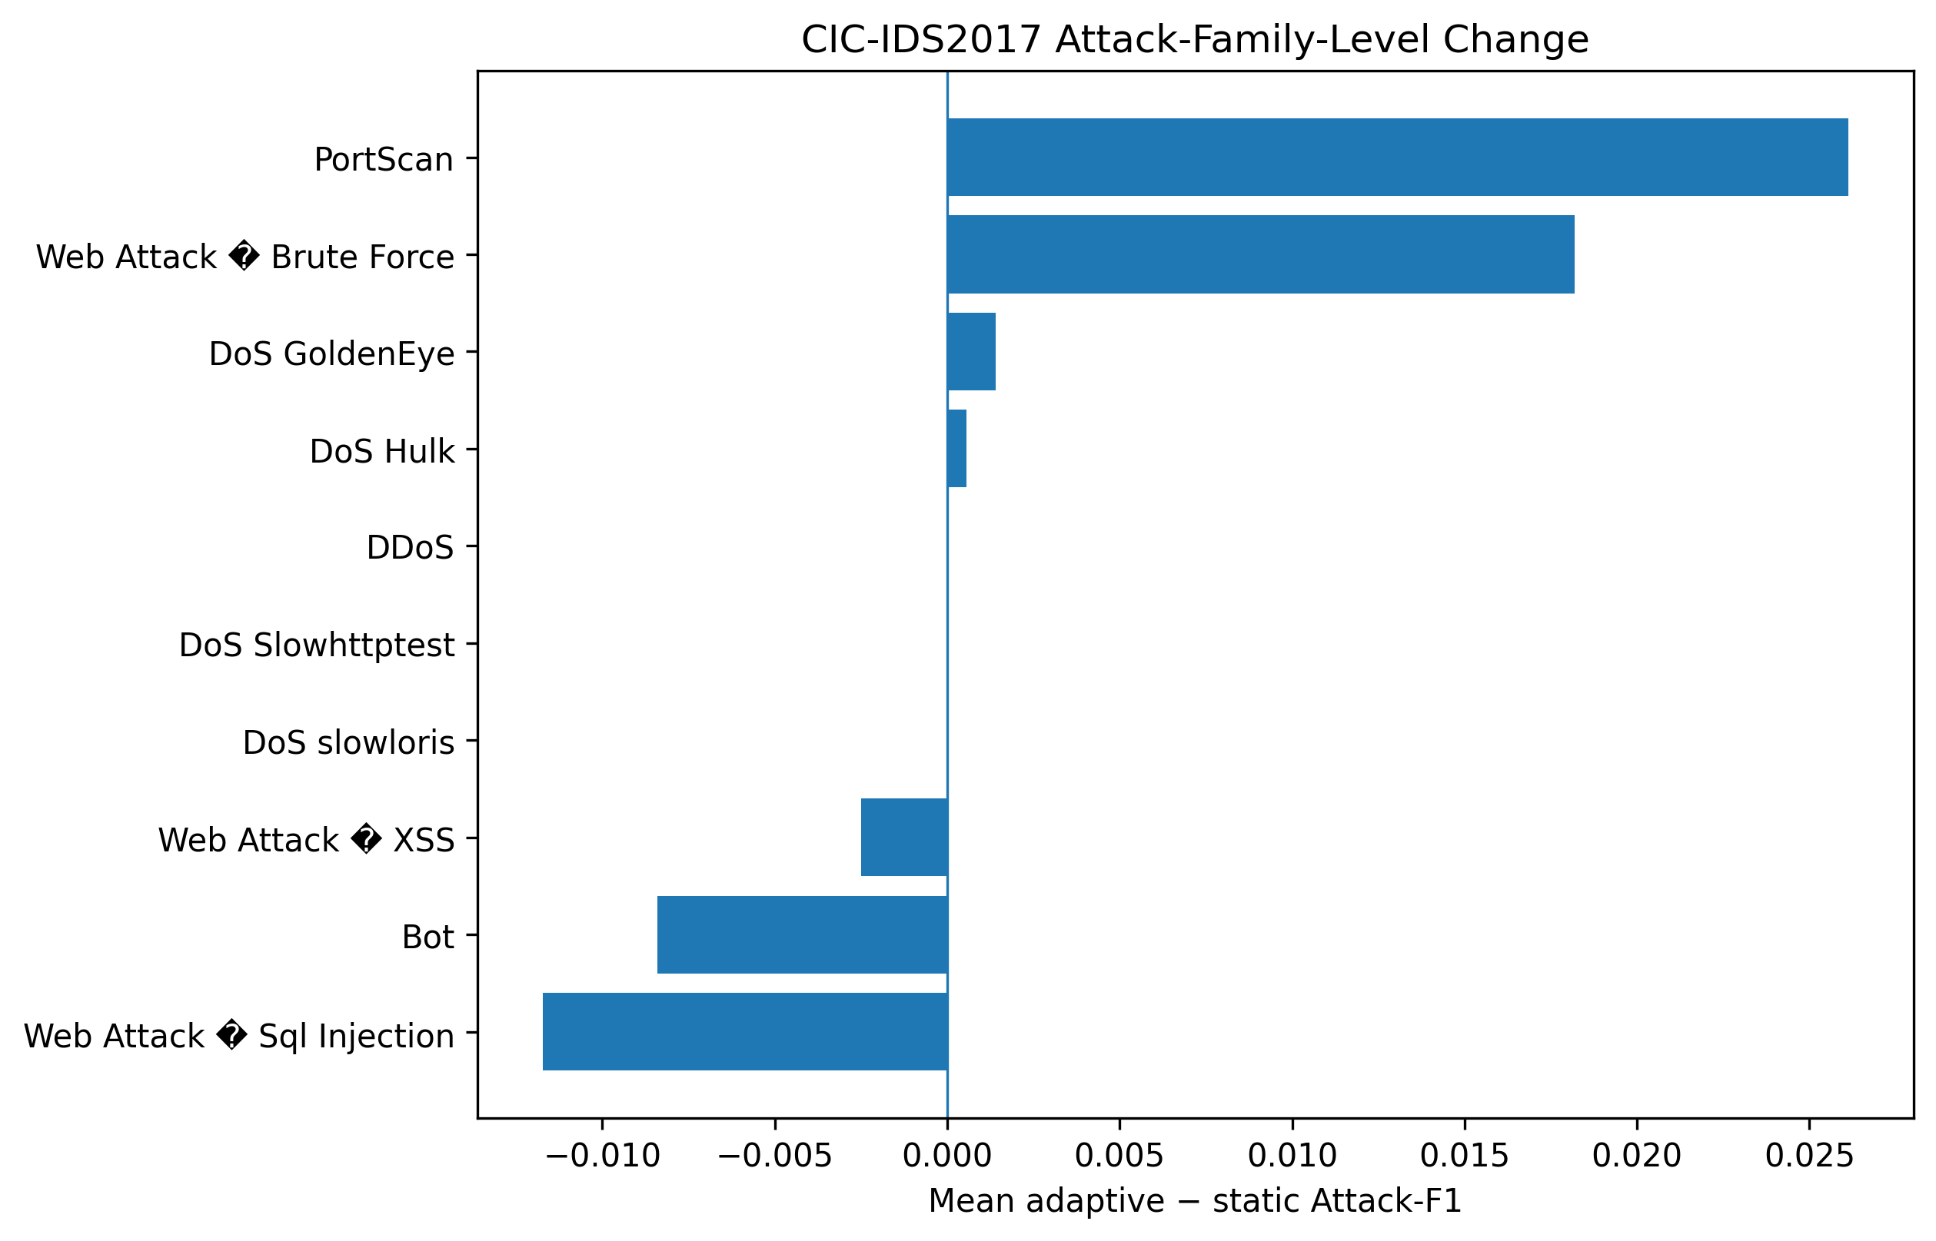
Fig. 5. Mean adaptive-minus-static Attack-F1 change by CIC-IDS2017 attack family; very rare families are excluded from the plot.
The fresh 20-run family analysis demonstrates selective recovery. PortScan shows the clearest positive mean change (+0.026127), followed by Web Attack–Brute Force (+0.01819). DoS Hulk shows a small positive change (+0.000552), while DDoS and several other families are close to zero. Bot, Web Attack–XSS, and SQL Injection show negative aggregate changes. Rare families are not used for strong statistical conclusions.
Because several future attack families are absent from the Monday–Tuesday training period, delayed feedback can introduce information about previously unseen attack families. The external experiment therefore validates the adaptive protocol under a realistic labeled-flow benchmark, but it does not isolate concept-drift adaptation from unseen-family learning [17].

6. Discussion
The combined evidence supports three conclusions. First, drift-triggered adaptation provides the main performance benefit in the controlled cyber twin, whereas anchor replay alone provides much less benefit. Second, persistence and cooldown trade a modest amount of aggregate F1 gain for a large reduction in update frequency and false adaptations. Third, external attack-family behavior is heterogeneous, making a single aggregate score insufficient for understanding adaptive IDS behavior.
Recent adaptive IDS methods emphasize drift detection, continual learning, replay, or retraining [6]–[11]. DCT-SAFE does not claim superior classifier accuracy over these methods. Instead, it evaluates a transferable operational dimension: how much detection benefit is obtained per update and how often the update mechanism acts on potentially unreliable feedback. This is complementary to methods that emphasize memory retention or catastrophic-forgetting control [7]–[10].
The Digital Cyber Twin also has a methodological role. Existing DT security systems demonstrate that twins can support attack simulation, zero-day evaluation, and adaptive detection [12]–[16]. DCT-SAFE uses a twin to replay controlled streams under different update policies, delays, contamination levels, and seeds, making the adaptation policy the principal experimental variable.

7. Recent-Literature Positioning
Reference | Year | Core emphasis | Relation to DCT-SAFE
Shyaa et al. [5] | 2023 | Drift-guided streaming IDS | DCT-SAFE separates drift evidence from update safety
SPIDER [6] | 2024 | Semi-supervised continual IDS | DCT-SAFE adds delayed/contaminated feedback evaluation
SSF [7] | 2025 | Strategic selection/forgetting | DCT-SAFE quantifies update frequency and benefit
A-NIDS [8] | 2025 | Unsupervised drift + replay | DCT-SAFE adds persistence/cooldown control
TAMR [9] | 2025 | Task-aware replay | DCT-SAFE measures benefit per adaptation
CAEAID [10] | 2025 | Incremental contrastive IoT IDS | DCT-SAFE focuses on feedback/update safety
DSALSTM [11] | 2026 | Concept-drift adaptive LSTM | DCT-SAFE emphasizes delayed feedback and operational risk
DTFL-CD [12] | 2024 | Digital Twin + FL | DCT-SAFE uses DT as evaluation laboratory
DT + ZTN/XAI [13] | 2024 | DT cybersecurity simulation | DCT-SAFE focuses on adaptive update decisions
DT-ID SCADA [14] | 2025 | DT-driven industrial IDS | DCT-SAFE focuses on update control
IDS-Twin [15] | 2025 | Self-adaptive DT IDS | DCT-SAFE adds contamination/persistence analysis
Qureshi et al. [16] | 2025 | DT security survey | Provides broader DT-security context

8. Threats to Validity and Limitations
- Synthetic cyber-twin data are controlled simulations and cannot substitute for operational network traffic.
- CIC-IDS2017 has day-wise attack composition; unseen-family learning and concept-drift adaptation cannot be perfectly separated.
- The primary reported learner is Logistic Regression. The incomplete matched Random Forest experiment is deliberately excluded from quantitative claims.
- Feedback contamination is modeled at controlled rates; real-world feedback errors may be correlated or adversarial.
- The framework measures operational adaptation efficiency but does not establish deployment safety or immunity to poisoning attacks.
- A second dataset would strengthen generalization claims, but the present work deliberately focuses on one deeply analyzed external benchmark.

9. Reproducibility and Data Availability
All reported runs use fixed seeds and explicit configuration parameters. The analysis package contains run-level CSV files, ablation results, operational statistical results, and CIC-IDS2017 family-recovery outputs. The final repository should expose preprocessing, scenario-generation equations, configuration files, requirements, seeds, commands, and generated figures. CIC-IDS2017 is publicly available through the Canadian Institute for Cybersecurity and includes labeled flow CSV files [17].

10. Conclusion
DCT-SAFE presents a reproducible Digital Cyber Twin methodology for evaluating adaptive intrusion detection under concept drift, delayed feedback, and unreliable feedback. The central distinction is that detecting a distributional change is not equivalent to accepting feedback or updating a security model. In 120 paired controlled runs, drift-only adaptation produced a mean Attack-F1 gain of 0.034353, while Persistence+Cooldown retained 89.85% of that gain and reduced adaptation events by 50.82%. False adaptations decreased to zero per run and F1 gain per adaptation event increased by 82.70%. Ablation showed that anchor replay alone did not reproduce the benefit of drift-triggered adaptation. CIC-IDS2017 family analysis demonstrated selective rather than universal improvement and highlighted the confounding effect of previously unseen attack families. The contribution is therefore a reproducible evaluation framework and operationally constrained update policy, not a claim of universally superior classifier accuracy.

References
[1] M. A. Shyaa, N. F. Ibrahim, Z. Zainol, R. Abdullah, M. Anbar, and L. Alzubaidi, “Evolving cybersecurity frontiers: A comprehensive survey on concept drift and feature dynamics aware machine and deep learning in intrusion detection systems,” Engineering Applications of Artificial Intelligence, vol. 137, 109143, 2024, doi: 10.1016/j.engappai.2024.109143.
[2] F. Hinder, V. Vaquet, and B. Hammer, “One or two things we know about concept drift—a survey on monitoring in evolving environments. Part A: detecting concept drift,” Frontiers in Artificial Intelligence, vol. 7, 1330257, 2024, doi: 10.3389/frai.2024.1330257.
[3] F. Hinder, V. Vaquet, and B. Hammer, “One or two things we know about concept drift—a survey on monitoring in evolving environments. Part B: locating and explaining concept drift,” Frontiers in Artificial Intelligence, vol. 7, 1330258, 2024, doi: 10.3389/frai.2024.1330258.
[4] L. Chambers, M.-M. Gaber, and H. Ghomeshi, “Deepstreamensemble: streaming adaptation to concept drift in deep neural networks,” International Journal of Machine Learning and Cybernetics, vol. 16, pp. 3955–3976, 2025, doi: 10.1007/s13042-024-02492-x.
[5] M. A. Shyaa, Z. Zainol, R. Abdullah, M. Anbar, L. Alzubaidi, and J. Santamaría, “Enhanced Intrusion Detection with Data Stream Classification and Concept Drift Guided by the Incremental Learning Genetic Programming Combiner,” Sensors, vol. 23, no. 7, 3736, 2023, doi: 10.3390/s23073736.
[6] S. K. Amalapuram, B. R. Tamma, and S. S. Channappayya, “SPIDER: A Semi-Supervised Continual Learning-based Network Intrusion Detection System,” in IEEE INFOCOM 2024, pp. 571–580, 2024, doi: 10.1109/INFOCOM52122.2024.10621428.
[7] X. Zhang, R. Zhao, Z. Jiang, H. Chen, Y. Ding, E. C. H. Ngai, and S.-H. Yang, “Continual Learning with Strategic Selection and Forgetting for Network Intrusion Detection,” in IEEE INFOCOM 2025, 2025, doi: 10.1109/INFOCOM55648.2025.11044615.
[8] C. Zha, Z. Wang, Y. Fan, B. Bai, Y. Zhang, S. Shi, and R. Zhang, “A-NIDS: Adaptive Network Intrusion Detection System Based on Clustering and Stacked CTGAN,” IEEE Transactions on Information Forensics and Security, vol. 20, pp. 3204–3219, 2025, doi: 10.1109/TIFS.2025.3551643.
[9] N. F. A. H. Fathima, A. Khraisat, S. Ibrahim S. P., and G. Li, “Adaptive memory replay for network intrusion detection: Tackling data drift and catastrophic forgetting,” Computer Networks, vol. 272, 111712, 2025, doi: 10.1016/j.comnet.2025.111712.
[10] Z. Yin, H. Chen, H. Ma, T. Hu, and L. Bai, “CAEAID: An incremental contrast learning-based intrusion detection framework for IoT networks,” Computer Networks, vol. 262, 111161, 2025, doi: 10.1016/j.comnet.2025.111161.
[11] “DSALSTM: A Concept Drift-Adaptive LSTM Framework for Real-Time Network Intrusion Detection,” in 2025 7th International Conference on Frontier Technologies of Information and Computer, 2025, doi: 10.1109/ICFTIC68075.2025.11324708.
[12] M. M. Salim, D. Camacho, and J. H. Park, “Digital Twin and federated learning enabled cyberthreat detection system for IoT networks,” Future Generation Computer Systems, vol. 161, pp. 701–713, 2024, doi: 10.1016/j.future.2024.07.017.
[13] R. Kumar et al., “Digital Twins-enabled Zero Touch Network: A smart contract and explainable AI integrated cybersecurity framework,” Future Generation Computer Systems, 2024, doi: 10.1016/j.future.2024.02.016.
[14] A. Sayghe, “Digital Twin-Driven Intrusion Detection for Industrial SCADA: A Cyber-Physical Case Study,” Sensors, vol. 25, no. 16, 4963, 2025, doi: 10.3390/s25164963.
[15] H. El Alami and D. B. Rawat, “IDS-Twin: Digital Twin-Based Intrusion Detection Systems for Wireless Networks,” IEEE Networking Letters, vol. 7, no. 4, pp. 255–259, 2025, doi: 10.1109/LNET.2025.3606789.
[16] A. R. Qureshi, A. Asensio, M. Imran, J. Garcia, and X. Masip-Bruin, “A survey on security enhancing Digital Twins: Models, applications and tools,” Computer Communications, vol. 238, 108158, 2025, doi: 10.1016/j.comcom.2025.108158.
[17] I. Sharafaldin, A. H. Lashkari, and A. A. Ghorbani, “Toward Generating a New Intrusion Detection Dataset and Intrusion Traffic Characterization,” ICISSP, 2018; CIC-IDS2017 dataset, Canadian Institute for Cybersecurity.
[18] “Leveraging Explainable AI for Adaptive Adversarial DoS Attack Detection in 6G IoT Networks,” IEEE WCNC 2025, doi: 10.1109/WCNC61545.2025.10978796.
[19] “An Online Transfer Learning Model for Intrusion Detection using FT-Transformer and KSWIN-Driven Concept Drift Detection Mechanism,” IEEE ICCEA 2024, doi: 10.1109/ICCEA62105.2024.10603489.
[20] G. N. Costa, A. De Paola, S. Drago, P. Ferraro, and G. Lo Re, “A Concept Drift Stream Generator for Intrusion Detection Systems,” CEUR Workshop Proceedings, 2025.

Final Pre-Submission Checks
- Add all co-authors, institutional emails, ORCID IDs, funding, conflict-of-interest, and data/code availability statements required by the target journal.
- Use the journal's exact manuscript template and reference style.
- Audit every DOI and bibliographic field against the publisher/Crossref before submission.
- Do not report the incomplete Random Forest run as a result.
- Do not claim Persistence+Cooldown has higher F1 than Drift-only.
- Do not claim CIC-IDS2017 proves pure concept-drift recovery because unseen-family learning is a documented confound.
- Release the complete reproducibility package with source code, configurations, raw run-level outputs, seeds, and exact commands.

